ICS344-03 Project
Saad W.(202337730) and Mohamed K.(202338790)
http://dvsa-website-project-238043187633-us-east-1.s3-website.us-east-1.amazonaws.com/cart
US-EAST-1
12-4-2026
Lesson 2: Broken Authentication

Goal and Vulnerability Summary

This lesson demonstrates a Broken Authentication vulnerability caused by improper handling of JSON Web Tokens (JWTs) in the DVSA application. The main affected component is the JWT authentication logic within the AWS Lambda backend, which processes requests coming through API Gateway. The vulnerability allows an attacker to modify identity claims inside a JWT and impersonate another user without needing a valid signature. As a result, the attacker can gain unauthorized access to sensitive data such as another user’s orders stored in DynamoDB. The main weakness is that the backend trusts JWT payload data without properly verifying the token’s signature, leading to complete authentication bypass and user impersonation .

Why This Works / Root Cause

This vulnerability occurs because the backend decodes the JWT token but does not verify its signature before trusting the payload. A JWT consists of three parts: header, payload, and signature. The signature is meant to ensure that the token has not been modified and was issued by a trusted source. However, in this case, the application only reads the payload and directly uses fields such as username and sub for authorization decisions. Because of this, an attacker can decode the token, modify these identity fields, re-encode the payload, and send it back to the server. Since the signature is not validated, the system accepts the modified token as valid, enabling unauthorized access and user impersonation .

Environment and Setup

The vulnerability was tested using a deployed DVSA instance running in AWS. The frontend is hosted on an S3 website endpoint, and backend requests are handled through Amazon API Gateway, which forwards requests to the DVSA Lambda function responsible for order management. The primary API endpoint used in this demonstration was the /order route, accessed through the API Gateway invoke URL.

The test required two user accounts within the application: one acting as the attacker (User B) and another as the victim (User C). Both users were created through the DVSA web interface and used to place orders so that data would be available for testing. Authentication tokens (JWTs) were captured using the browser’s Developer Tools (Network tab) by inspecting API requests made when accessing the “My Orders” page.

The tools used in this demonstration included:
- Browser DevTools (to capture JWT tokens)
- curl (to send API requests)
- jq (to format JSON responses)
- python3 (to decode and modify JWT payloads)

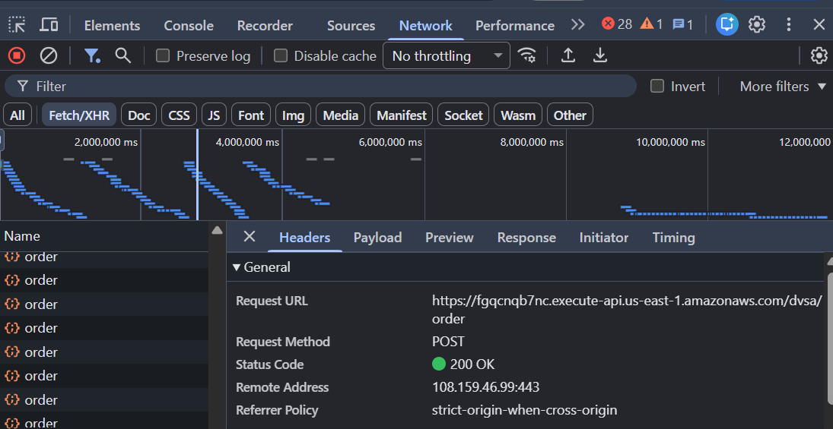

Reproduction Steps

The attack begins by creating two accounts in the DVSA application. The attacker logs in as User B and places an order, and then logs in as User C (the victim) and places another order. This ensures that both users have associated data in the system.

Next, the attacker captures their own JWT token (TOKEN_B) and the victim’s token (TOKEN_C) using the browser’s Developer Tools. The tokens are extracted from the Authorization header of API requests made when viewing orders.

To confirm normal behavior, the attacker sends a request to the orders API using their original token. The response correctly returns only the attacker’s own orders, confirming that the system behaves properly under normal conditions.

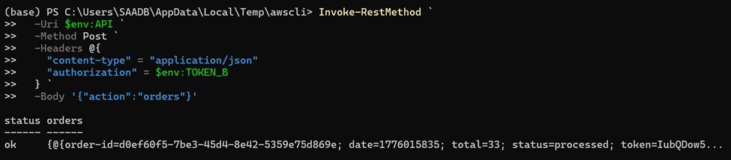

The attacker then decodes the JWT payload using a Python script. After decoding, the attacker modifies the username and sub fields to match the victim’s identity. The payload is then re-encoded and combined with the original header and signature to create a forged token (FAKE_AS_C).

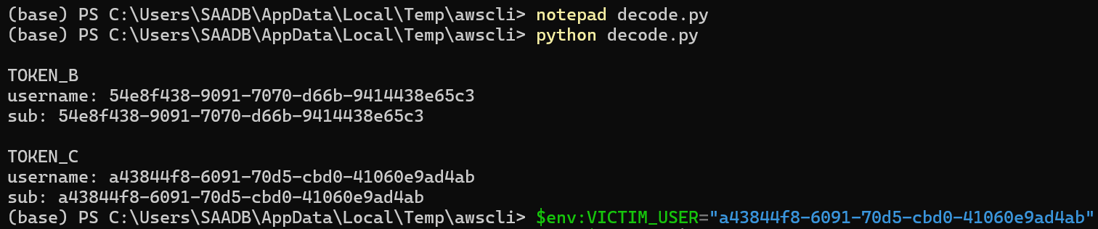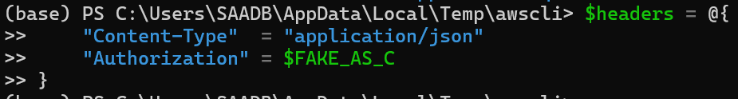

Using the forged token, the attacker sends another request to the orders API. Despite the token being tampered with, the backend accepts it and returns the victim’s order list instead of the attacker’s.

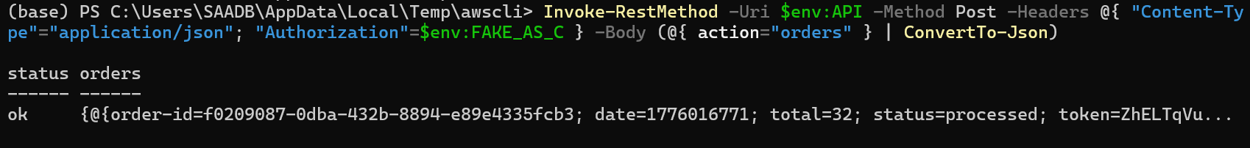
Finally, the attacker extracts a specific order ID from the victim’s data and sends another request to retrieve full order details. The backend again processes the request successfully and returns sensitive information belonging to the victim.

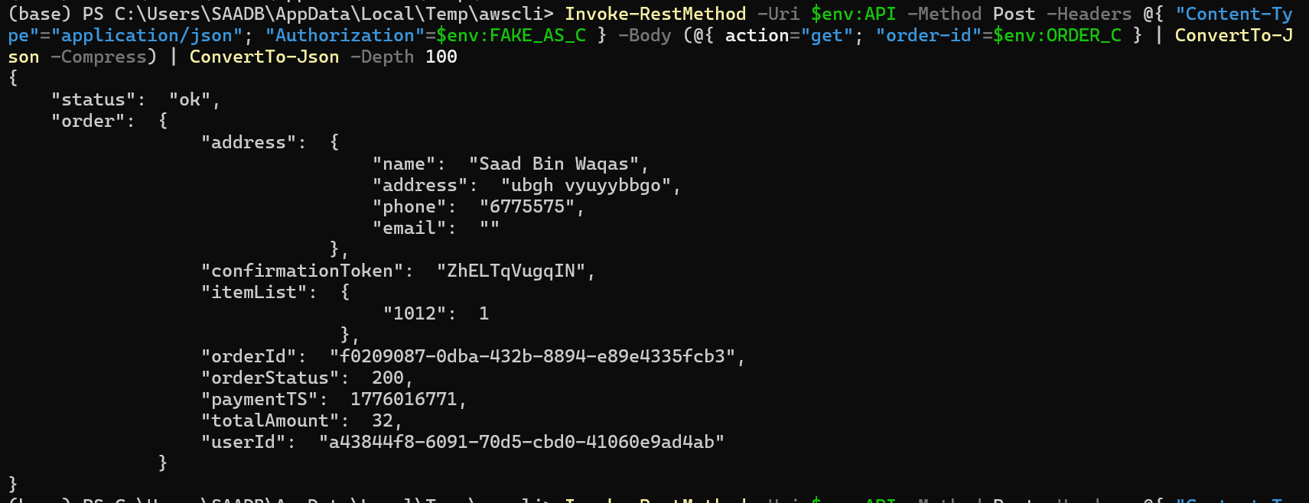

Evidence and Proof

The vulnerability is confirmed by the fact that a modified JWT payload allows access to another user’s data without requiring a valid signature. The key evidence is that the forged token, which was created without access to any secret key, is still accepted by the backend and used to authorize requests. The system returns the victim’s order list and detailed order information, even though the attacker only changed the payload fields. This demonstrates that the backend is not verifying the JWT signature and is instead trusting unvalidated user input for authentication decisions .

Fix Strategy / Probable Mitigation

The appropriate fix for this vulnerability is to implement proper JWT verification in the backend. The application must validate the token’s signature using a trusted key provided by the identity provider, such as Amazon Cognito. Additionally, important claims such as issuer, audience, and expiration time should be checked to ensure the token is valid.

The backend should never trust the payload of a JWT without verification. Secure libraries that enforce signature validation should be used instead of simple decoding functions. Any request containing a tampered or unverifiable token should be rejected with an HTTP 401 Unauthorized response. Applying these fixes ensures that attackers cannot forge tokens or impersonate other users.

Code / Config Changes

To fix the vulnerability, the JWT handling logic in the backend Lambda function responsible for processing order requests was modified to enforce proper token verification. Previously, the application used a decoding approach that extracted the payload without validating the signature. This behavior allowed attackers to modify identity claims and bypass authentication.

The fix was applied in the AWS Lambda function named DVSA-ORDER-MANAGER, specifically in the part of the code that processes incoming requests and extracts the user identity from the JWT.

Before the fix, the application simply decoded the token and directly trusted the payload fields such as username and sub. After the fix, the authentication logic was updated to verify the token’s signature using a trusted public key provided by the identity provider. In addition, validation checks were added to ensure that the token was issued by a trusted source and had not expired.

The main logic change was:
- Removing unsafe decoding-only behavior
- Adding strict JWT signature verification
- Enforcing validation of issuer and token claims

These changes ensure that only legitimate, untampered tokens are accepted by the system.

[Screenshot Placeholder 6: Code editor showing updated JWT verification logic in Lambda function]
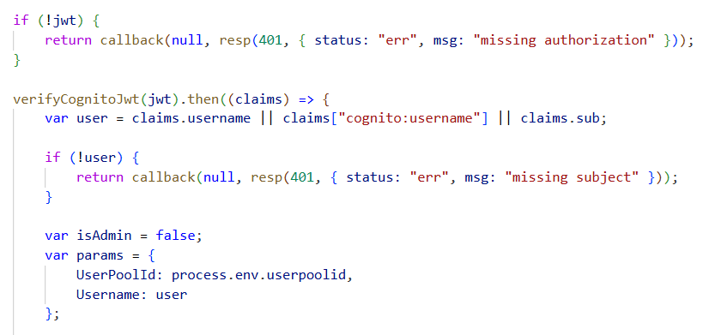
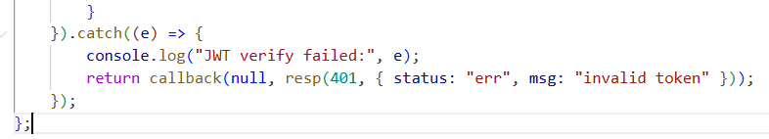

Verification After Fix

After applying the fix, the same attack steps were repeated to verify whether the vulnerability was resolved. The forged JWT token, which previously allowed access to another user’s data, was used again to send a request to the API.

This time, the backend rejected the request and returned an Unauthorized (401) response, indicating that the token was invalid. This confirms that the system no longer accepts tampered tokens.

At the same time, a valid JWT token belonging to the attacker was tested to ensure normal functionality still worked. The system correctly returned only the attacker’s own data, confirming that the fix did not break legitimate behavior.

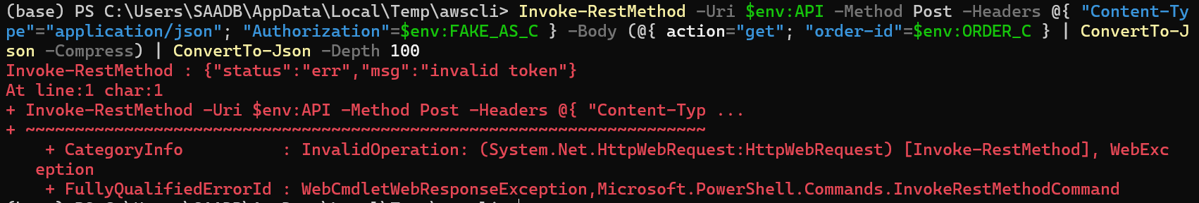

Structured Operation and Security Analysis

1) Intended Logic and Security Rule(s)

Under normal conditions, a user sends a request to the /order API endpoint through API Gateway, which forwards the request to the Lambda function. The Lambda function must verify the JWT token before extracting any identity information. Only after successful verification should the system allow access to user-specific data stored in DynamoDB.

The main security rules are:
- The system must verify the JWT signature before trusting any identity claims
- The system must not allow users to access resources belonging to other users
- The system must reject any tampered or invalid tokens

2) Evidence Sources and Behavior Trace

The analysis was based on multiple sources, including browser DevTools for capturing tokens, API request and response outputs, decoded JWT payloads, and terminal commands used for testing.

The behavior comparison is as follows:
- Normal Behavior:
When a valid token is used, the system returns only the authenticated user’s orders.
- Exploit Behavior:
When a forged token is used, the system incorrectly returns another user’s orders.
- Post-Fix Behavior:
When the same forged token is used after the fix, the system rejects the request and returns an Unauthorized response.

3) Deviation Analysis and Classification

The exploit behavior represents a clear deviation from the intended security rules. The system incorrectly allows access to another user’s data because it trusts unverified JWT payloads. This violates the rule that authentication tokens must be validated before use.

This case is classified as:
Intentional misuse / security-relevant abuse, since the attacker deliberately manipulates the token to exploit the vulnerability.

4) Explainable Fix and Post-Fix Validation

The incorrect assumption in the system was that decoding a JWT is sufficient for authentication. The fix corrects this by enforcing full signature verification before any identity data is used.

The fix was applied directly in the Lambda function handling authentication. After the fix, all tokens must pass verification checks before being accepted.

Post-fix testing confirms that:
- Forged tokens are rejected
- Valid tokens continue to work normally
- Users can no longer access other users’ data

Vulnerability | Intended Rule(s) | Artifacts Used to Infer Rule | Normal Behavior Evidence | Exploit Behavior Evidence
Broken Authentication | JWT must be verified before use; users can only access their own data | Browser DevTools, decoded JWT payload, API requests and responses, terminal output | When User B sends a request with a valid token, the system returns only User B’s own orders | When the forged token is used after modifying the username and sub claims, the system returns User C’s orders

Vulnerability | Why This Is a Deviation | Deviation Class | Fix Applied (Where) | Post-Fix Verification | Optional Latency Before / After Logging
Broken Authentication | The exploit violates the intended rule because the backend trusts unverified JWT payload claims and allows one user to impersonate another user | Intentional misuse / security-relevant abuse | Added proper JWT signature verification in the DVSA-ORDER-MANAGER Lambda function authentication logic | After the fix, the forged token is rejected with Unauthorized, while a valid token still returns only the legitimate user’s own data | N/A

Takeaway / Lessons Learned

This lesson highlights the importance of properly implementing authentication mechanisms in serverless applications. JWT tokens provide security only when their signatures are verified. Simply decoding the payload without validation introduces a critical vulnerability that allows complete authentication bypass. This demonstrates that even widely used security mechanisms can become dangerous if implemented incorrectly. Proper verification, strict validation, and secure design principles are essential to prevent such attacks and protect user data.

