ICS344-03 Project
Saad W.(202337730) and Mohamed K.(202338790)
http://dvsa-website-project-238043187633-us-east-1.s3-website.us-east-1.amazonaws.com/cart
US-EAST-1
15-4-2026
LESSON #4: Insecure Cloud Configuration

Goal and Vulnerability Summary

The goal of this lesson was to demonstrate an Insecure Cloud Configuration vulnerability in the DVSA application. The application uses an S3 bucket to store order receipts, which are processed by backend Lambda functions.

Due to misconfigured permissions, the S3 bucket allowed unauthorized users to upload files. These uploads triggered backend processing without proper validation. This allowed an attacker to inject malformed or malicious object keys into the system, influencing backend execution.

This vulnerability shows that improper cloud configuration can expose backend systems to unauthorized input and potential exploitation.

Why This Works / Root Cause

The vulnerability exists due to two primary issues:

• The S3 bucket was configured with overly permissive write access, allowing unauthorized users to upload objects

• The backend Lambda function trusted object key structure without validating input

The system assumes that all uploaded files follow a valid format. However, since the bucket allows external uploads, attackers can control object keys and cause unexpected behavior. This violates the fundamental security rule that all external input must be treated as untrusted. This issue is primarily caused by cloud misconfiguration rather than application logic flaws.

Environment and Setup

The vulnerability was tested using a DVSA deployment in AWS.

Components:

• Amazon S3 (receipt storage bucket)

• AWS Lambda (receipt processing function: DVSA-SEND-RECEIPT-EMAIL)

• Amazon API Gateway (frontend API)

• DynamoDB (order data storage)

Tools used:

• AWS CLI (to upload files to S3)

• AWS Console (S3, Lambda, CloudWatch)

• CloudWatch Logs (to observe backend execution)

• Local command prompt (Windows)

Reproduction Steps

1. Identify the S3 receipts bucket in AWS: dvsa-receipts-bucket-562825150177-us-east-1

2. Create a local test file: echo test > empty.txt

3. Upload the file using AWS CLI: aws s3 cp empty.txt s3://dvsa-receipts-bucket-562825150177-us-east-1/2026/04/23/test.raw
Figure 1) Successfull S3 Upload

4. Confirm that the file appears in the S3 bucket.

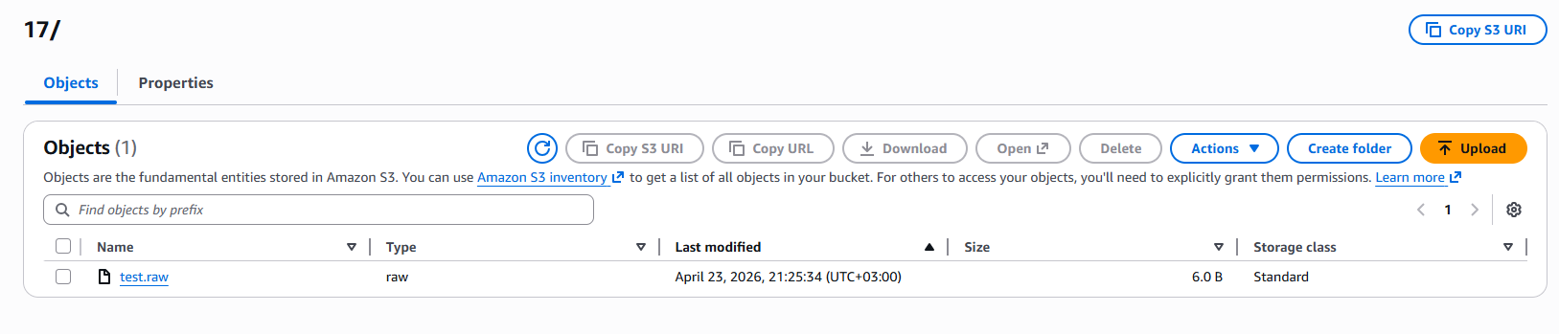
Figure 2) Uploaded File Visible in S3

5. Observe that the upload triggers the DVSA-SEND-RECEIPT-EMAIL Lambda function via CloudWatch logs.

6. Upload a malformed filename: aws s3 cp empty.txt s3://dvsa-receipts-bucket-562825150177-us-east-1/2026/04/23/badfile.raw

7. Inspect CloudWatch logs and observe error:

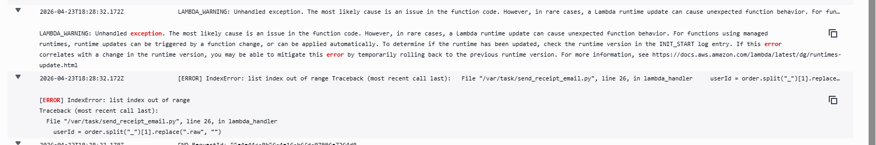
Figure 3) CloudWatch Error Log: IndexError: List Index Out of Range

Evidence and Proof

The vulnerability is confirmed through the following observations:

1. Unauthorized Upload

The S3 bucket accepted file uploads without proper restrictions.


Figure 4) Succesful Upload

3. Improper Input Handling

Malformed filenames caused runtime errors in the Lambda function.


Figure 5) IndexError Log

These findings demonstrate that:

• External users can write to the bucket

• Uploaded files trigger backend processing

• Input is not validated before processing

This confirms the presence of an Insecure Cloud Configuration vulnerability.

Fix Strategy / Probable Mitigation
The vulnerability can be mitigated by enforcing strict access control on the S3 bucket. In this implementation, the primary fix applied was restricting write access using a bucket policy, preventing unauthorized uploads.

Additionally, input validation in the Lambda function is recommended as a defense-in-depth measure but was not implemented in this exercise.

Code / Config Changes
- S3 Bucket Policy Update

The bucket policy was modified to restrict write access to only the receipt-processing Lambda role.

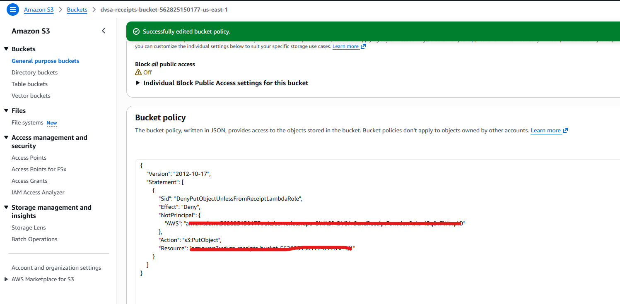
Figure 6) Updated Bucket Policy

Verification After Fix

After applying the bucket policy fix, the system was tested again.

1. Upload Attempt After Fix

The same AWS CLI upload command was executed.

Result: AccessDenied error with explicit deny.
Figure 7) AccessDenied Output

2. Backend Protection

Since unauthorized uploads were blocked, backend receipt-processing logic could no longer be triggered externally.

These results confirm that:

• Unauthorized access to the S3 bucket is prevented

• Backend processing cannot be triggered by external users

• The vulnerability is mitigated through configuration changes

Structured Operation and Security Analysis
1) Intended Logic and Security Rules
• Only authorized services should write to S3
• Backend must validate all external input
• Object keys must not be trusted

2) Evidence Sources
• AWS CLI output
• CloudWatch logs
• S3 bucket contents

3) Behavior Comparison

Normal:
Authorized uploads processed successfully

Exploit:
Unauthorized uploads accepted and caused errors

Post-Fix:
Unauthorized uploads blocked and errors prevented

4) Deviation Classification

Insecure Cloud Configuration + Improper Input Validation

Summary Tables

Table 1
Vulnerability | Intended Rule(s) | Artifacts Used to Infer Rule | Normal Behavior Evidence | Exploit Behavior Evidence
Insecure Cloud Configuration | Only authorized entities should write to S3 | S3 uploads, CloudWatch logs | Valid uploads processed successfully | Unauthorized uploads accepted and triggered backend

Vulnerability | Why This Is a Deviation | Deviation Class | Fix Applied (Where) | Post-Fix Verification | Optional Latency Before / After Logging
Insecure Cloud Configuration | Untrusted users can write to S3 and influence backend execution | Security-relevant misuse | S3 bucket policy | AccessDenied error and no backend execution

Takeaway / Lessons Learned
This lesson demonstrates that cloud misconfiguration can introduce critical vulnerabilities even when application code appears secure.
Key lessons:
• Cloud resources must be properly secured
• S3 permissions should follow least privilege
• External input must always be validated
• Backend systems must not trust object keys
Secure configuration is essential to prevent unauthorized access and protect backend processing.

