ICS344-03 Project
Saad W.(202337730) and Mohamed K.(202338790)
http://dvsa-website-project-238043187633-us-east-1.s3-website.us-east-1.amazonaws.com/cart
US-EAST-1
12-4-2026
Lesson 3: Sensitive Information Disclosure

Goal and Vulnerability Summary

This lesson demonstrates a Sensitive Information Disclosure vulnerability caused by weak access control over administrative receipt-generation functionality in the DVSA application. The main affected component is the backend AWS Lambda function responsible for generating receipt download links stored in Amazon S3.
The vulnerability allows an attacker to abuse backend functionality to attempt access to receipt files belonging to other users. By leveraging the previously identified Event Injection vulnerability, the attacker attempts to invoke a privileged administrative function that generates presigned S3 URLs. These URLs would provide direct access to receipt files, bypassing intended authorization controls.
The main weakness is that administrative functionality capable of exposing sensitive S3-hosted data exists within the backend and can potentially be reached from untrusted request paths. Even though the exploit did not fully succeed in this environment, the vulnerability still exists at a design level.

Why This Works / Root Cause
This vulnerability exists due to a combination of unsafe input handling and improper access control over privileged backend operations.
The application processes user input using unsafe deserialization through the node-serialize library. This allows attacker-controlled input to be interpreted as executable code rather than plain data. As a result, injected payloads can be executed within the Lambda function.
At the same time, the backend contains a privileged administrative function named DVSA-ADMIN-GET-RECEIPT. This function retrieves receipt files from an S3 bucket, compresses them into a zip archive, uploads the archive back to S3, and generates a presigned download URL. This URL allows direct access to sensitive receipt files. Because strict authorization boundaries are not enforced between public API requests and internal administrative functionality, an attacker can attempt to reach this function through injected input.
However, in this deployment, the original proof-of-concept exploit did not fully succeed due to AWS Lambda runtime differences. The payload attempted to load the aws-sdk module, which is not available in the current runtime environment. Therefore, the exploit failed due to missing dependencies rather than the absence of the vulnerability.

Environment and Setup

The vulnerability was tested using a deployed DVSA instance running in AWS. The frontend is hosted on an S3 static website, and backend requests are handled through Amazon API Gateway, which forwards requests to AWS Lambda functions. The region used for deployment was US-East-1. The primary API endpoint used in this demonstration was the /order route. The main backend function analyzed was DVSA-ORDER-MANAGER, which processes incoming requests. The administrative function targeted in this lesson was DVSA-ADMIN-GET-RECEIPT. The tools used in this demonstration included Postman for sending API requests and AWS CloudWatch for analyzing backend logs.

Reproduction Steps
The attack begins by identifying that the backend processes user input using unsafe deserialization. This allows attacker-controlled input to be executed as code. Next, a payload was crafted to attempt invocation of the administrative receipt-generation function DVSA-ADMIN-GET-RECEIPT by supplying parameters such as year and month. The payload was sent through the /order API endpoint using Postman. Instead of successfully retrieving receipt data, the API returned either a 502 Internal Server Error or a response indicating “unknown action.” To further investigate, AWS CloudWatch logs were examined to analyze backend execution behavior.

Evidence and Proof

The vulnerability is confirmed through backend execution evidence and log analysis, even though receipt files were not successfully retrieved.
CloudWatch logs show that injected payloads were executed within the Lambda function. The logs contain stack traces referencing node-serialize and eval execution, confirming that attacker-controlled input was processed as executable code.
Additionally, the logs show a runtime error indicating that the aws-sdk module could not be found. This demonstrates that the exploit reached the execution stage and attempted to invoke backend functionality, but failed due to missing dependencies in the runtime environment.

This confirms that:
- The injection vulnerability is real and exploitable
- The administrative receipt function was targeted
- The exploit failed due to environment-specific SDK/runtime differences

Furthermore, analysis of the DVSA-ADMIN-GET-RECEIPT source code confirms that it generates a presigned S3 download URL (download_url), which would allow direct access to receipt files if successfully invoked. This demonstrates that the sensitive data exposure path still exists in principle, even though the exploit did not fully succeed in this deployment.
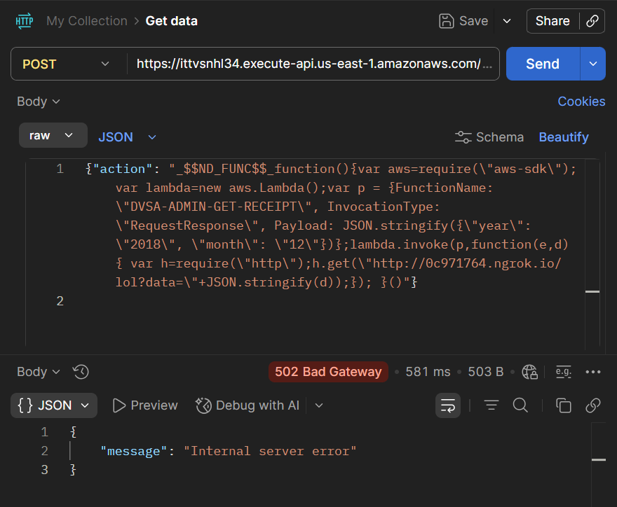
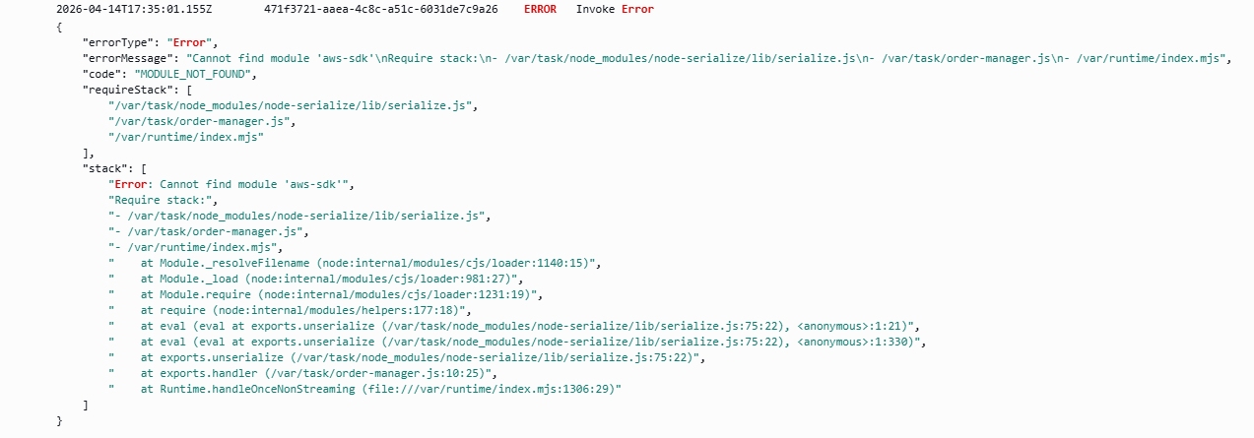

Fix Strategy / Probable Mitigation

The vulnerability should be mitigated by enforcing strict separation between public API inputs and privileged backend functionality. The unsafe deserialization mechanism should be removed and replaced with safe parsing methods such as JSON parsing. This ensures that user input is treated strictly as data and cannot be executed as code. Additionally, strict authorization checks must be enforced before any administrative function is invoked. Only authorized users should be allowed to access receipt-generation functionality. The application should also prevent dynamic execution paths based on user-controlled input and ensure that presigned URLs are generated only after proper authorization validation.

Code / Config Changes
The fix was applied in the Lambda function DVSA-ORDER-MANAGER. The unsafe use of node-serialize was removed and replaced with safe JSON parsing. Additional validation logic was introduced to ensure that only expected request fields are processed. Administrative functions were also restricted to ensure they cannot be triggered from public input paths without proper authorization.

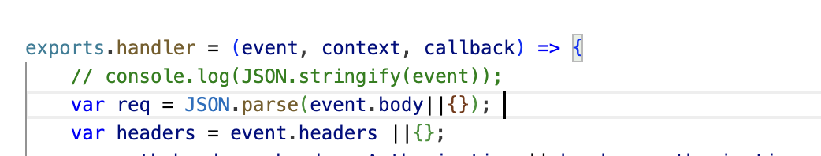

Verification After Fix
After applying the fix, the same payload was tested again to verify whether the vulnerability was resolved. The backend no longer executed attacker-controlled input, and the API returned an error indicating invalid input. This confirms that the exploit path was successfully blocked. At the same time, normal API requests continued to function correctly, ensuring that legitimate application behavior was not affected.

Structured Operation and Security Analysis

1) Intended Logic and Security Rule(s)
Under normal conditions, user requests are processed as plain data by the Lambda function. The system must not execute user-provided input. Administrative functionality must be protected and only accessible to authorized users.

The main security rules are:
- User input must not be executed as code
- Administrative functionality must require proper authorization
- Sensitive data must not be exposed through public endpoints

2) Evidence Sources and Behavior Trace
The analysis was based on API requests, CloudWatch logs, and backend source code.
Normal Behavior:
The system processes valid requests and returns expected results without executing user input.
Exploit Behavior:
Injected payloads are executed, and backend processing is triggered, but the exploit fails due to missing runtime dependencies.
Post-Fix Behavior:
Injected payloads are rejected and no execution occurs.

3) Deviation Analysis and Classification

The exploit behavior represents a deviation from intended system design because the application executes attacker-controlled input. This violates input handling and access control rules and exposes a path to privileged backend functionality.
This case is classified as: Intentional misuse / security-relevant abuse

4) Explainable Fix and Post-Fix Validation
The incorrect assumption in the system was that deserialized input is safe. The fix ensures that all input is treated as plain data and cannot be executed. It also enforces strict authorization boundaries around administrative functionality. Post-fix testing confirms that malicious input is rejected and that legitimate functionality continues to work as expected.

Table A
Vulnerability | Intended Rule(s) | Artifacts Used to Infer Rule | Normal Behavior Evidence | Exploit Behavior Evidence
Sensitive Information Disclosure | Administrative receipt data must not be accessible without authorization | CloudWatch logs, Lambda source code, API responses | Normal requests return only user-specific data | Injected payload triggers backend execution attempt toward admin functionality

Table B
Vulnerability | Why This Is a Deviation | Deviation Class | Fix Applied (Where) | Post-Fix Verification
Sensitive Information Disclosure | The system allows a path to privileged receipt-generation logic without proper access control | Intentional misuse / security-relevant abuse | Removed unsafe deserialization and restricted admin functionality in DVSA-ORDER-MANAGER | After fix, payload execution is blocked and admin functionality is no longer reachable

Takeaway / Lessons Learned

This lesson highlights that vulnerabilities in serverless applications may persist even when exploitation techniques change due to platform updates. Although the exploit did not fully succeed due to AWS Lambda runtime differences, the core issue—unsafe input handling combined with weak access control—remains present. The application still allows attacker-controlled input to reach backend execution paths and potentially interact with privileged functionality. This demonstrates that security must be enforced at the design level through proper validation, strict authorization, and isolation of sensitive backend operations, rather than relying on runtime limitations.

