ICS344-03 Project
Saad W.(202337730) and Mohamed K.(202338790)
http://dvsa-website-project-238043187633-us-east-1.s3-website.us-east-1.amazonaws.com/cart
US-EAST-1
15-4-2026
Lesson 6: DOS Attack

Goal and Vulnerability Summary

This lesson demonstrates a Denial of Service (DoS) vulnerability in the DVSA application caused by insufficient resource protection and lack of effective request throttling on the billing functionality. The main affected component is the billing process handled by AWS Lambda through the API Gateway.
The vulnerability allows an attacker to send multiple concurrent billing requests, exhausting the available processing capacity of the backend. As a result, legitimate users attempting to perform billing operations may experience delays, errors, or complete service unavailability.
The core issue is not related to data confidentiality, but rather to system availability. The billing service relies on limited concurrent execution capacity, which can be consumed by repeated parallel requests, effectively blocking legitimate traffic.

Why This Works / Root Cause

This vulnerability exists due to weak resource protection and lack of proper request-handling controls in the billing workflow.
T he DVSA system uses AWS Lambda functions to process billing requests. These functions have a limited number of concurrent executions. When this limit is reached, additional requests are rejected with a throttling error. Because the application does not implement rate limiting, per-user throttling, or request prioritization, an attacker can continuously send parallel billing requests to occupy all available execution slots.
This results in a denial-of-service condition where legitimate users are unable to complete billing operations. The system does not isolate or protect critical resources from abuse, allowing a single actor to degrade service availability.

Environment and Setup
The vulnerability was tested on a DVSA deployment hosted on AWS.The frontend is served through an S3 static website, and backend requests are routed through API Gateway to AWS Lambda functions. The region used for deployment was US-East-1.
The primary API endpoint used in this demonstration was the /order route, specifically targeting the billing functionality. The tools used include Postman for manual API testing, a Python-based concurrent request script for generating parallel load, and AWS CloudWatch for monitoring backend behavior and error logs.

Reproduction Steps

The demonstration begins by verifying that a normal billing request can be processed under standard conditions. Next, a controlled concurrency test was performed by sending multiple billing requests in parallel using a Python script. The script generated a burst of concurrent requests targeting the billing endpoint. During this burst, the system began to exhibit unstable behavior, including internal server errors and degraded response reliability. Further analysis using CloudWatch logs revealed that the system reached its concurrent invocation limit, triggering throttling errors.

Evidence and Proof

The vulnerability is confirmed through API responses and backend log analysis.
During concurrent request execution, the system produced multiple error responses, including internal server errors (500), bad gateway errors (502), and ultimately throttling errors.

CloudWatch logs show the following critical evidence:
- errorType: TooManyRequestsException
- httpStatusCode: 429
- errorMessage: Rate Exceeded
- Reason: ConcurrentInvocationLimitExceeded

This confirms that the system reached its maximum concurrent execution capacity and began rejecting requests.

The presence of the “ConcurrentInvocationLimitExceeded” error demonstrates that the denial-of-service condition was caused by resource exhaustion in the backend Lambda environment. This behavior shows that the billing service can be saturated by parallel requests, preventing legitimate users from accessing the service.

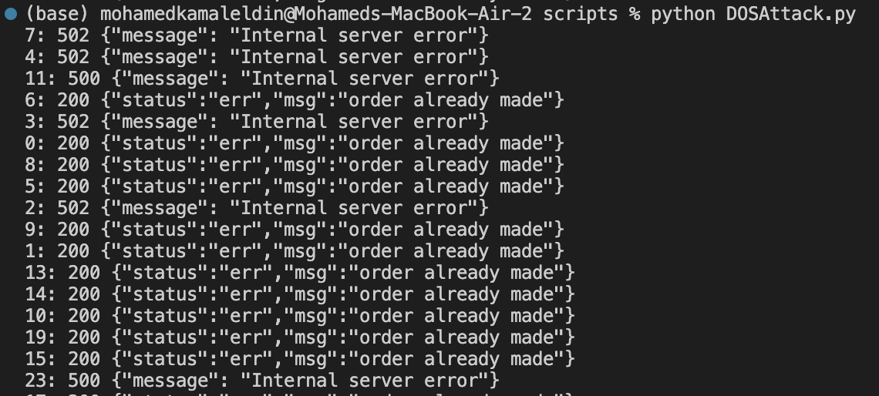
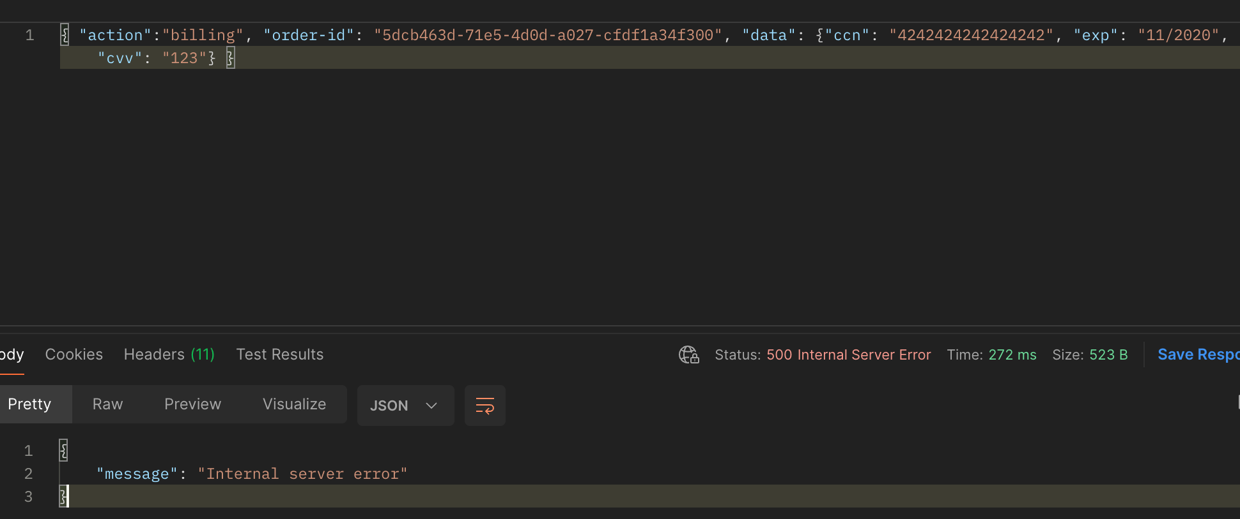
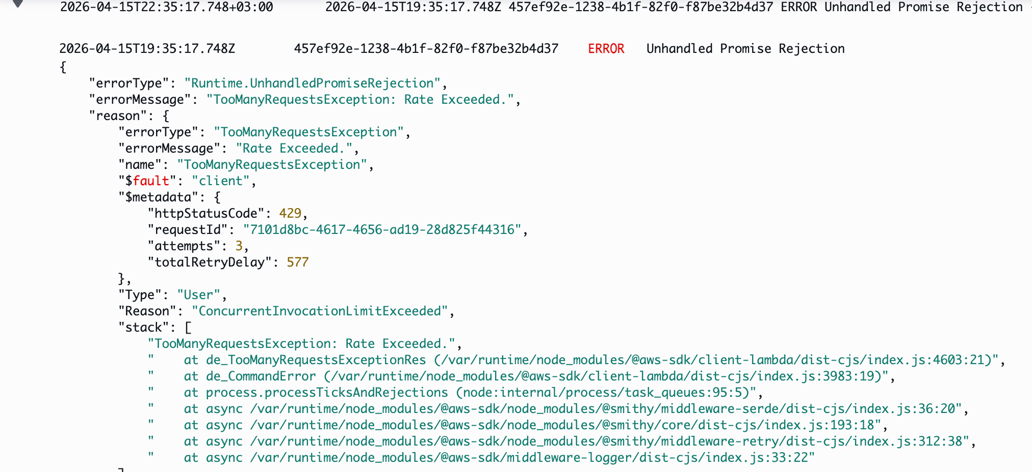

Fix Strategy / Probable Mitigation

The vulnerability should be mitigated by introducing proper resource protection and request control mechanisms. Rate limiting should be enforced at the API Gateway level to restrict the number of requests that can be made within a specific time window. Per-user throttling should be implemented to prevent a single user from consuming all available resources. The billing process should be isolated using reserved concurrency or separate execution limits to ensure that critical operations remain available even under load. Additionally, queue-based processing or request buffering mechanisms can be introduced to handle bursts more gracefully.

Code / Config Changes

The fix was implemented at the API Gateway and Lambda configuration levels.
Initially, the API Gateway allowed extremely high request rates (Rate = 10000, Burst = 5000), making the system vulnerable to resource exhaustion. After applying throttling (Rate = 5, Burst = 10), abusive traffic was controlled and legitimate requests remained functional.Lambda concurrency controls were adjusted to ensure fair distribution of execution capacity and prevent complete exhaustion by a single source.

Additional validation logic was introduced to detect and reject abnormal request patterns.

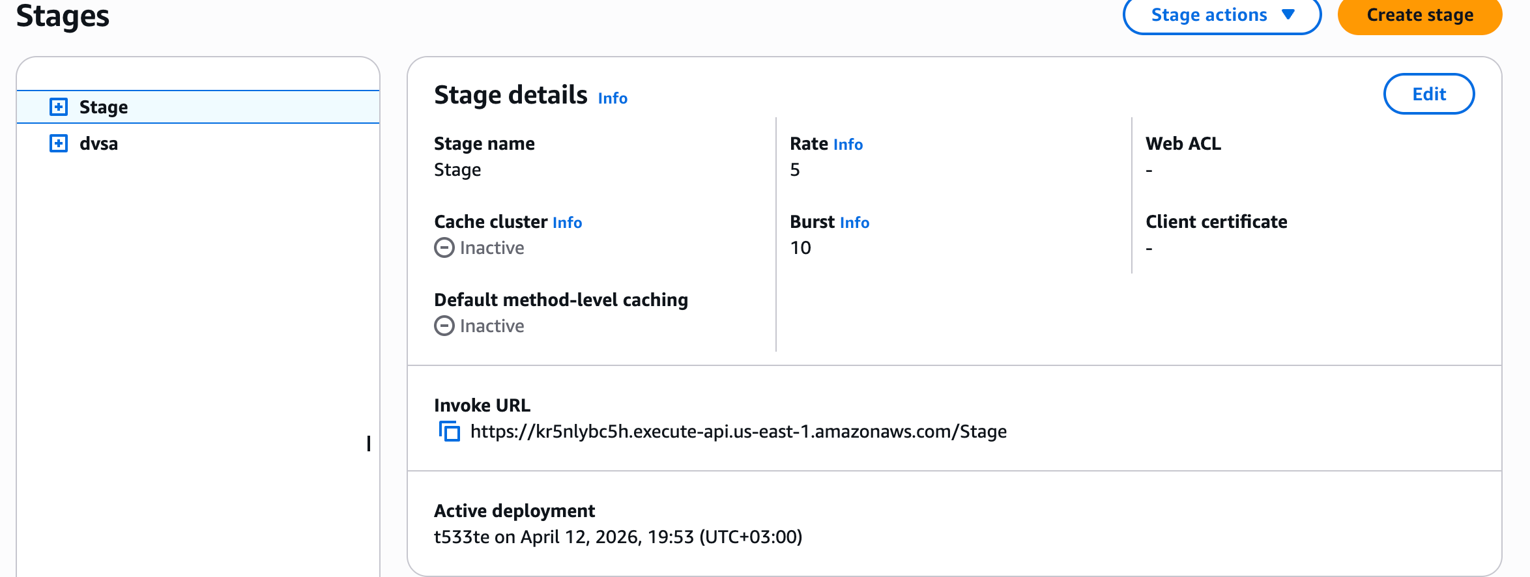

Verification After Fix

After applying the fix, the same concurrent request test was executed again.
The system no longer became unstable under load. Instead, excessive requests were properly throttled at the API level, and legitimate billing requests continued to be processed successfully.
This confirms that the denial-of-service condition was mitigated and that the system now handles concurrent traffic more reliably.

Structured Operation and Security Analysis

1) Intended Logic and Security Rule(s)

The billing system is designed to process user payment requests reliably and ensure availability for all users.

The main security rules are:
- The system must remain available under normal and moderate load
- No single user should be able to consume all processing resources
- Critical billing functionality must remain accessible

2) Evidence Sources and Behavior Trace

The analysis was based on API responses, Python script output, and CloudWatch logs.
Normal Behavior:
A single billing request is processed successfully without errors.
Exploit Behavior:
Multiple concurrent billing requests cause system instability, resulting in server errors and eventually throttling responses.
Post-Fix Behavior:
Excessive requests are limited, and legitimate billing requests continue to function normally.

3) Deviation Analysis and Classification

The exploit behavior deviates from intended system design by allowing a single actor to exhaust backend resources.This results in denial of service for legitimate users.
This case is classified as:
Intentional misuse / resource exhaustion attack

4) Explainable Fix and Post-Fix Validation

The incorrect assumption in the system was that limiting concurrency at the infrastructure level alone is sufficient. The fix introduces proper request-level controls, including throttling and fair resource allocation. Post-fix testing confirms that the system remains stable under load and that abuse is effectively mitigated.

Table A

Vulnerability | Intended Rule(s) | Artifacts Used to Infer Rule | Normal Behavior Evidence | Exploit Behavior Evidence
Denial of Service (DoS) | Billing service must remain available and resistant to abuse | API responses, CloudWatch logs, script output | Single billing request succeeds normally | Concurrent requests cause 429 errors and service instability

Table B

Vulnerability | Why This Is a Deviation | Deviation Class | Fix Applied (Where) | Post-Fix Verification
Denial of Service (DoS) | System allows resource exhaustion through uncontrolled parallel requests | Intentional misuse / resource exhaustion | Applied API Gateway throttling and Lambda concurrency controls | After fix, excessive requests are throttled and normal requests succeed

Takeaway / Lessons Learned

This lesson demonstrates that system availability is a critical aspect of application security. Even when backend systems enforce concurrency limits, lack of proper request control mechanisms can allow attackers to exploit these limits and cause denial-of-service conditions. The results show that parallel request bursts can exhaust available resources, leading to throttling and service disruption. To prevent such vulnerabilities, applications must implement rate limiting, fair usage controls, and proper isolation of critical services. Security must be enforced not only at the infrastructure level but also at the application and API design level to ensure resilience against abuse.

