ICS344-03 Project
Saad W.(202337730) and Mohamed K.(202338790)
http://dvsa-website-project-238043187633-us-east-1.s3-website.us-east-1.amazonaws.com/cart
US-EAST-1
15-4-2026
Lesson 10: Unhandled Exceptions

Goal and Vulnerability Summary
This lesson demonstrates an information disclosure vulnerability caused by improper error handling in the DVSA application. The issue occurs when backend Lambda functions return raw error responses directly to the client without sanitization.
When malformed or incomplete requests are sent, the system exposes internal details such as stack traces, file paths, function names, and line numbers. This allows an attacker to gain insight into the backend implementation and system architecture.
The vulnerability exists because the application does not properly handle exceptions and instead forwards internal error messages directly to the user.

Why This Works / Root Cause
The vulnerability occurs due to the absence of proper exception handling in the backend Lambda functions. Instead of catching errors and returning safe responses, the application returns the raw exception output.
As a result:
- Internal file paths are exposed
- Stack traces are visible
- Backend logic is revealed
- Debugging information is leaked
This creates an information disclosure vulnerability that can assist attackers in understanding and exploiting the system.

Environment and Setup
The vulnerability was tested on a deployed DVSA instance hosted in AWS. The frontend is served through an S3 static website, while backend requests are handled via API Gateway and AWS Lambda functions.
The main endpoint used for testing was the /order API.
The tools used in this demonstration included:
Postman (to send malformed requests)
Browser DevTools (to observe requests and responses)
AWS CloudWatch (to verify backend errors)

Reproduction Steps
The vulnerability can be reproduced by sending a malformed request that omits required parameters.
A request was sent with the shipping action but without providing the required orderId field. This caused the backend Lambda function to throw an exception when attempting to access a missing key in the request object.
Because the application does not handle exceptions properly, the raw error response was returned to the client.

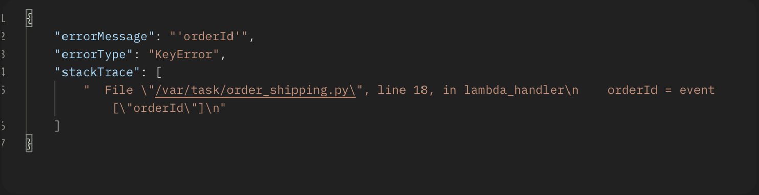

Evidence and Proof
The response returned by the system clearly demonstrates the vulnerability.
The API response included:
- errorType: KeyError
- errorMessage: "orderId"
- A full stack trace
- Internal file path /var/task/order_shipping.py
- Line number and code snippet causing the error
This confirms that the system exposes internal implementation details directly to the user.
Such information can be used by attackers to understand backend logic and identify potential weaknesses in the system.

Fix Strategy / Probable Mitigation
The vulnerability can be mitigated by implementing proper exception handling and sanitizing all error responses.
Instead of returning raw exceptions, the application should:
- Wrap logic in try-except blocks
- Log detailed errors internally (e.g., CloudWatch)
- Return generic error messages to the client
For example, instead of returning stack traces, the system should respond with:
“An error occurred while processing the request”
This prevents exposure of sensitive internal details.

Code / Config Changes
The fix involves modifying the Lambda functions to handle exceptions properly.
Before the fix, the application directly returned error responses from backend functions. After the fix, all logic is wrapped in exception handling blocks.
The updated implementation ensures that:
- Internal errors are logged securely
- Users receive sanitized responses
- Stack traces and file paths are not exposed

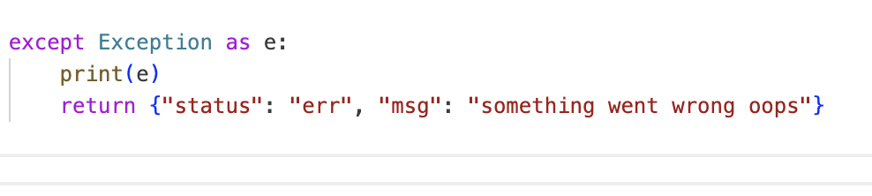

Verification After Fix
After applying the fix, the same malformed request was sent again.
This time:
- The system returned a generic error message
- No stack trace or internal file paths were exposed
- Detailed errors were only visible in CloudWatch logs
This confirms that the vulnerability was successfully mitigated.

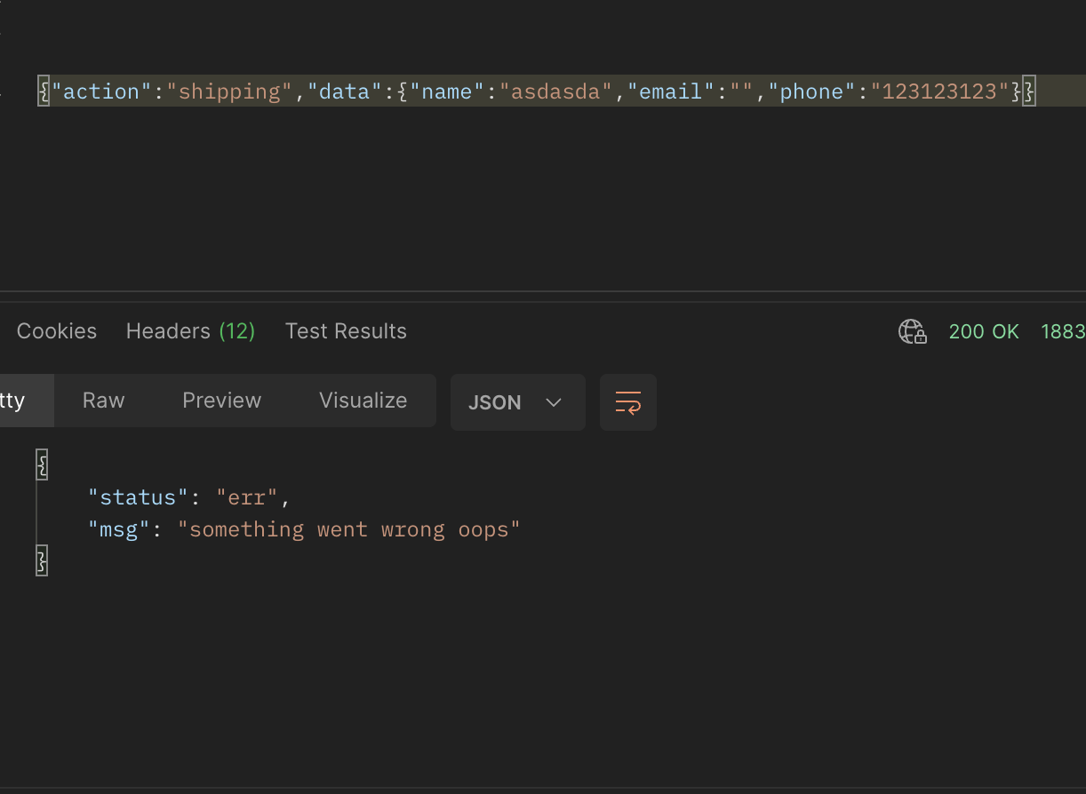

Structured Operation and Security Analysis

1) Intended Logic and Security Rule(s)
The system should handle errors securely without exposing internal details to users.
The main rules are:
Errors must not reveal internal implementation details
Stack traces must not be exposed
Sensitive debugging information must remain internal

2) Evidence Sources and Behavior Trace
Normal Behavior:
The system processes valid requests and returns clean responses without exposing internal details.
Exploit Behavior:
Malformed requests trigger exceptions that reveal stack traces, file paths, and backend logic.
Post-Fix Behavior:
The system returns generic error messages while logging detailed errors internally.

3) Deviation Analysis and Classification
The exploit behavior represents a deviation from secure design principles because the system exposes sensitive internal information that should remain hidden.
This vulnerability is classified as:
Unintentional information disclosure due to improper error handling

4) Explainable Fix and Post-Fix Validation
The issue was caused by missing exception handling. The fix introduces proper error handling and response sanitization, ensuring that sensitive information is not exposed.
After applying the fix, all error responses are sanitized, and the vulnerability is no longer exploitable.

Summary Tables

Table 1
Vulnerability | Intended Rule(s) | Artifacts Used to Infer Rule | Normal Behavior Evidence | Exploit Behavior Evidence
Unhandled Exceptions (Information Disclosure) | Errors must not expose internal details or stack traces | API error response, stack trace, file path /var/task/order_shipping.py | Clean response without internal details | KeyError returned with stack trace, file path, and code line exposed

Table 2
Vulnerability | Why This Is a Deviation | Deviation Class | Fix Applied (Where) | Post-Fix Verification | Optional Latency Before / After Logging
Unhandled Exceptions | System returns raw backend errors revealing sensitive information | Unintentional information disclosure | Backend Lambda error handling (try-except and response sanitization) | Only generic error messages returned | N/A

Takeaway / Lessons Learned
This lesson highlights the importance of proper error handling in secure application design. Even when application logic is correct, exposing internal errors can provide attackers with valuable information about the system. Implementing structured exception handling and sanitizing responses is essential to prevent information leakage and maintain system security.

