实验结果

方向图测试结果：

测试日期 : 2021-04-06

测试人 : 巫锐，何杨柳

测试内容 : 喇叭天线

极化方式 : 垂直极化

旁瓣宽度--- 频谱1

-3db : 28.03

-6db : 43.03

-10db : 57.06

-15db : 235.99

前后比 : 1.32

轴比0: 0.00

轴比1: 6.00

轴比2: 7.00

轴比3: 3.00

轴比4: 7.00

轴比5: 6.00

轴比6: 6.00

轴比7: 10.00

轴比8: 5.00

轴比9: 9.00

轴比10: 8.00

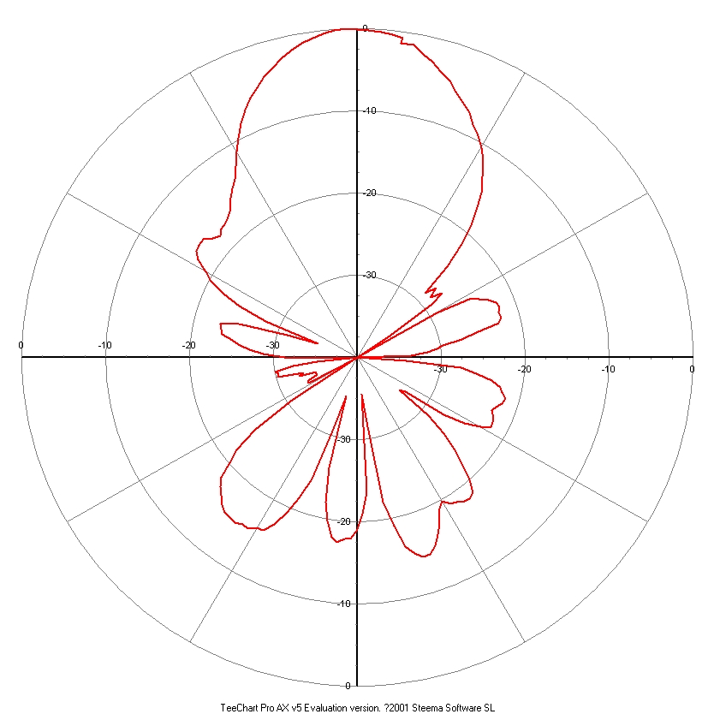

|  |  |  |  |
| --- | --- | --- | --- |
| 角度(曲线1-marker1) | 幅度(曲线1-marker1) | 角度(曲线1-marker2) | 幅度(曲线1-marker2) |
| 最大: 360.20 | 最大: -34.42 | 最大: 360.20 | 最大: 0.00 |
| 0.00 | -35.83 | 0.00 | 0.00 |
| 2.30 | -35.83 | 2.30 | 0.00 |
| 4.29 | -36.67 | 4.29 | 0.00 |
| 6.30 | -37.35 | 6.30 | 0.00 |
| 8.30 | -38.37 | 8.30 | 0.00 |
| 10.31 | -39.05 | 10.31 | 0.00 |
| 12.21 | -40.00 | 12.21 | 0.00 |
| 14.27 | -40.92 | 14.27 | 0.00 |
| 16.33 | -41.79 | 16.33 | 0.00 |
| 18.22 | -42.90 | 18.22 | 0.00 |
| 20.22 | -43.85 | 20.22 | 0.00 |
| 22.23 | -44.91 | 22.23 | 0.00 |
| 24.24 | -46.12 | 24.24 | 0.00 |
| 26.27 | -47.83 | 26.27 | 0.00 |
| 28.30 | -49.18 | 28.30 | 0.00 |
| 30.34 | -51.30 | 30.34 | 0.00 |
| 32.23 | -53.08 | 32.23 | 0.00 |
| 34.31 | -55.64 | 34.31 | 0.00 |
| 36.20 | -59.03 | 36.20 | 0.00 |
| 38.21 | -63.16 | 38.21 | 0.00 |
| 40.22 | -61.84 | 40.22 | 0.00 |
| 42.25 | -63.10 | 42.25 | 0.00 |
| 44.28 | -61.63 | 44.28 | 0.00 |
| 46.32 | -63.49 | 46.32 | 0.00 |
| 48.20 | -70.16 | 48.20 | 0.00 |
| 50.28 | -75.28 | 50.28 | 0.00 |
| 52.19 | -63.49 | 52.19 | 0.00 |
| 54.25 | -59.05 | 54.25 | 0.00 |
| 56.27 | -58.27 | 56.27 | 0.00 |
| 58.27 | -57.30 | 58.27 | 0.00 |
| 60.30 | -56.64 | 60.30 | 0.00 |
| 62.33 | -56.38 | 62.33 | 0.00 |
| 64.21 | -56.74 | 64.21 | 0.00 |
| 66.27 | -56.55 | 66.27 | 0.00 |
| 68.35 | -57.04 | 68.35 | 0.00 |
| 70.25 | -59.95 | 70.25 | 0.00 |
| 72.33 | -61.79 | 72.33 | 0.00 |
| 74.19 | -64.07 | 74.19 | 0.00 |
| 76.22 | -64.85 | 76.22 | 0.00 |
| 78.26 | -66.06 | 78.26 | 0.00 |
| 80.30 | -68.02 | 80.30 | 0.00 |
| 82.19 | -76.84 | 82.19 | 0.00 |
| 84.25 | -84.40 | 84.25 | 0.00 |
| 86.34 | -68.58 | 86.34 | 0.00 |
| 88.25 | -62.01 | 88.25 | 0.00 |
| 90.33 | -60.08 | 90.33 | 0.00 |
| 92.19 | -58.20 | 92.19 | 0.00 |
| 94.24 | -56.96 | 94.24 | 0.00 |
| 96.28 | -56.65 | 96.28 | 0.00 |
| 98.20 | -56.08 | 98.20 | 0.00 |
| 100.25 | -56.27 | 100.25 | 0.00 |
| 102.32 | -56.84 | 102.32 | 0.00 |
| 104.25 | -57.16 | 104.25 | 0.00 |
| 106.32 | -56.63 | 106.32 | 0.00 |
| 108.26 | -56.47 | 108.26 | 0.00 |
| 110.29 | -56.35 | 110.29 | 0.00 |
| 112.18 | -57.50 | 112.18 | 0.00 |
| 114.22 | -59.36 | 114.22 | 0.00 |
| 116.29 | -61.97 | 116.29 | 0.00 |
| 118.18 | -67.39 | 118.18 | 0.00 |
| 120.25 | -68.05 | 120.25 | 0.00 |
| 122.19 | -63.42 | 122.19 | 0.00 |
| 124.29 | -60.56 | 124.29 | 0.00 |
| 126.22 | -58.39 | 126.22 | 0.00 |
| 128.26 | -56.53 | 128.26 | 0.00 |
| 130.30 | -54.37 | 130.30 | 0.00 |
| 132.19 | -52.98 | 132.19 | 0.00 |
| 134.26 | -52.66 | 134.26 | 0.00 |
| 136.19 | -52.76 | 136.19 | 0.00 |
| 138.26 | -53.19 | 138.26 | 0.00 |
| 140.21 | -53.37 | 140.21 | 0.00 |
| 142.29 | -54.18 | 142.29 | 0.00 |
| 144.22 | -53.57 | 144.22 | 0.00 |
| 146.27 | -51.94 | 146.27 | 0.00 |
| 148.32 | -50.80 | 148.32 | 0.00 |
| 150.24 | -49.65 | 150.24 | 0.00 |
| 152.31 | -48.95 | 152.31 | 0.00 |
| 154.22 | -48.89 | 154.22 | 0.00 |
| 156.31 | -49.60 | 156.31 | 0.00 |
| 158.25 | -50.65 | 158.25 | 0.00 |
| 160.19 | -53.43 | 160.19 | 0.00 |
| 162.30 | -56.50 | 162.30 | 0.00 |
| 164.20 | -65.90 | 164.20 | 0.00 |
| 166.26 | -69.90 | 166.26 | 0.00 |
| 168.17 | -58.03 | 168.17 | 0.00 |
| 170.26 | -55.36 | 170.26 | 0.00 |
| 172.19 | -53.49 | 172.19 | 0.00 |
| 174.27 | -52.29 | 174.27 | 0.00 |
| 176.23 | -52.25 | 176.23 | 0.00 |
| 178.34 | -51.82 | 178.34 | 0.00 |
| 180.28 | -52.33 | 180.28 | 0.00 |
| 182.29 | -54.20 | 182.29 | 0.00 |
| 184.29 | -56.43 | 184.29 | 0.00 |
| 186.29 | -60.55 | 186.29 | 0.00 |
| 188.33 | -69.53 | 188.33 | 0.00 |
| 190.20 | -65.50 | 190.20 | 0.00 |
| 192.23 | -58.73 | 192.23 | 0.00 |
| 194.29 | -55.93 | 194.29 | 0.00 |
| 196.19 | -53.83 | 196.19 | 0.00 |
| 198.25 | -51.83 | 198.25 | 0.00 |
| 200.27 | -50.54 | 200.27 | 0.00 |
| 202.27 | -50.43 | 202.27 | 0.00 |
| 204.29 | -49.82 | 204.29 | 0.00 |
| 206.17 | -49.92 | 206.17 | 0.00 |
| 208.22 | -49.56 | 208.22 | 0.00 |
| 210.26 | -49.68 | 210.26 | 0.00 |
| 212.32 | -49.84 | 212.32 | 0.00 |
| 214.21 | -50.34 | 214.21 | 0.00 |
| 216.28 | -51.13 | 216.28 | 0.00 |
| 218.30 | -51.70 | 218.30 | 0.00 |
| 220.31 | -52.65 | 220.31 | 0.00 |
| 222.18 | -54.51 | 222.18 | 0.00 |
| 224.21 | -56.17 | 224.21 | 0.00 |
| 226.26 | -59.33 | 226.26 | 0.00 |
| 228.31 | -65.22 | 228.31 | 0.00 |
| 230.23 | -76.31 | 230.23 | 0.00 |
| 232.30 | -74.27 | 232.30 | 0.00 |
| 234.20 | -67.87 | 234.20 | 0.00 |
| 236.21 | -68.00 | 236.21 | 0.00 |
| 238.24 | -69.17 | 238.24 | 0.00 |
| 240.26 | -69.16 | 240.26 | 0.00 |
| 242.31 | -69.25 | 242.31 | 0.00 |
| 244.20 | -67.15 | 244.20 | 0.00 |
| 246.25 | -67.78 | 246.25 | 0.00 |
| 248.17 | -64.66 | 248.17 | 0.00 |
| 250.24 | -64.87 | 250.24 | 0.00 |
| 252.17 | -64.47 | 252.17 | 0.00 |
| 254.21 | -66.69 | 254.21 | 0.00 |
| 256.24 | -69.61 | 256.24 | 0.00 |
| 258.27 | -81.44 | 258.27 | 0.00 |
| 260.17 | -72.42 | 260.17 | 0.00 |
| 262.24 | -65.74 | 262.24 | 0.00 |
| 264.29 | -63.18 | 264.29 | 0.00 |
| 266.23 | -61.52 | 266.23 | 0.00 |
| 268.16 | -60.37 | 268.16 | 0.00 |
| 270.24 | -59.38 | 270.24 | 0.00 |
| 272.27 | -58.02 | 272.27 | 0.00 |
| 274.30 | -57.77 | 274.30 | 0.00 |
| 276.19 | -57.64 | 276.19 | 0.00 |
| 278.25 | -59.76 | 278.25 | 0.00 |
| 280.18 | -65.67 | 280.18 | 0.00 |
| 282.24 | -69.41 | 282.24 | 0.00 |
| 284.17 | -62.66 | 284.17 | 0.00 |
| 286.25 | -59.05 | 286.25 | 0.00 |
| 288.19 | -56.71 | 288.19 | 0.00 |
| 290.23 | -54.70 | 290.23 | 0.00 |
| 292.28 | -53.51 | 292.28 | 0.00 |
| 294.18 | -52.07 | 294.18 | 0.00 |
| 296.26 | -51.28 | 296.26 | 0.00 |
| 298.17 | -51.12 | 298.17 | 0.00 |
| 300.24 | -51.14 | 300.24 | 0.00 |
| 302.19 | -51.88 | 302.19 | 0.00 |
| 304.30 | -52.37 | 304.30 | 0.00 |
| 306.22 | -51.87 | 306.22 | 0.00 |
| 308.28 | -51.73 | 308.28 | 0.00 |
| 310.17 | -51.46 | 310.17 | 0.00 |
| 312.25 | -50.86 | 312.25 | 0.00 |
| 314.17 | -49.85 | 314.17 | 0.00 |
| 316.26 | -49.01 | 316.26 | 0.00 |
| 318.18 | -48.32 | 318.18 | 0.00 |
| 320.28 | -46.98 | 320.28 | 0.00 |
| 322.22 | -45.56 | 322.22 | 0.00 |
| 324.17 | -44.24 | 324.17 | 0.00 |
| 326.23 | -42.80 | 326.23 | 0.00 |
| 328.29 | -41.48 | 328.29 | 0.00 |
| 330.21 | -40.34 | 330.21 | 0.00 |
| 332.28 | -39.46 | 332.28 | 0.00 |
| 334.19 | -38.46 | 334.19 | 0.00 |
| 336.29 | -37.77 | 336.29 | 0.00 |
| 338.24 | -36.97 | 338.24 | 0.00 |
| 340.20 | -36.24 | 340.20 | 0.00 |
| 342.31 | -35.66 | 342.31 | 0.00 |
| 344.21 | -35.24 | 344.21 | 0.00 |
| 346.28 | -34.84 | 346.28 | 0.00 |
| 348.21 | -34.54 | 348.21 | 0.00 |
| 350.30 | -34.42 | 350.30 | 0.00 |
| 352.24 | -34.51 | 352.24 | 0.00 |
| 354.18 | -34.57 | 354.18 | 0.00 |
| 356.29 | -34.70 | 356.29 | 0.00 |
| 358.26 | -34.91 | 358.26 | 0.00 |
| 360.20 | -35.21 | 360.20 | 0.00 |

数据与误差分析

测量方向图中出现最大值的位置与理论方向基本一致，但在其他位置仍有较大误差。主要由于实际空间的电磁波与反射波干扰，其次是测试仪器与设备存在系统误差，但是该测量结果总体上能够反映理论现象。若要更高的准确度，测量应在暗室中进行，以减少空间中其他物体发射的的电磁与反射波的影响。