**Installation**

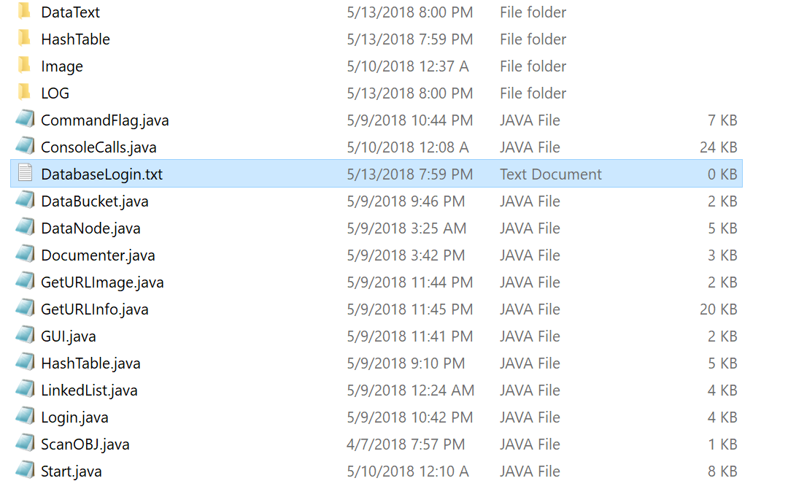

Step 1:

Make sure all provided java files and folders and DatabaseLogin.txt are in the same folder.

TIP: The folders DataText, HashTable, Image and LOG are checked at the start of the program to see if the exist if they don't then the program will create them.

Step 2: CD into the folder where all the contents are in and type in

* + javac Start.java
  + java Start

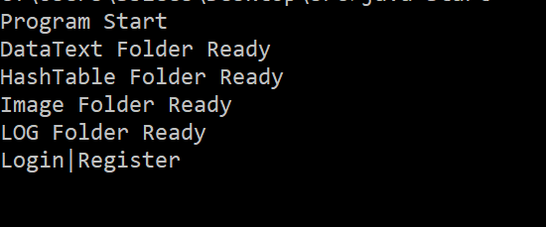Once done you should see this.

And after your all set to start using LimeWired!