**Core services of AWS:**

1. **EC2**- **Elastic cloud compute**: EC2 is an amazon service which is basically a server and can be used for running applications, creating virtual machines, install software etc. In a nutshell EC2 is used for computing in AWS. In EC2 the instances can be scaled based on the requirements. If the load on the server is more, it will be scaled accordingly and if the load is less, instance will be reduced. EC2 instances are priced per hour basis based on type of instance and image on the server (windows or Linux).
2. **S3 – Simple storage service:** S3 is an amazon service which is used for storage. All the type of files can be uploaded to S3 bucket. The maximum size of file can be up to 5 TB. Bucket can be used to :
   1. Trigger events when objects are added, modified or deleted.
   2. Preserve older versions of objects.
   3. Replicate objects across regions.
   4. It can be accessed via URL:

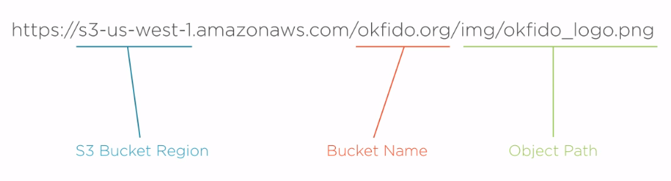

To solve the latency problem, aws offers a caching service for S3 which is called as cloudFront.S3 is priced based on the below points:

1. Amount of data stored in s3 bucket.
2. Number of requests made to s3 bucket.
3. Amount of data from/to S3 bucket.
4. Based on geographical location.
5. **RDS – Relational database service:**  It is a service by AWS which is used to manage most of the famous Relational databases. By managing it means software updates, patches, backups etc. There are below databases which are supported under AWS RDS service.
   1. MySQL
   2. PostgreSQL
   3. SQL server
   4. Oracle
   5. Maria db
   6. Amazon Aurora

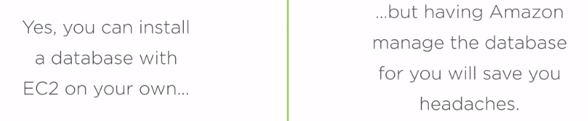

AWS takes security very serious due to which for each service configured on AWS , a security wall or fire wall needs to be configured which will allow the apps which are given access to use AWS services . External systems or unauthorized apps cannot use AWS services.

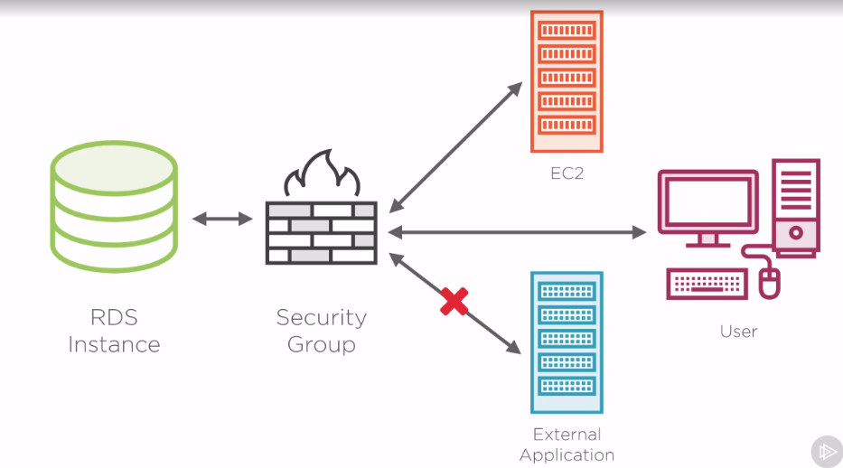

While choosing RDS instance we need to choose the appropriate EC2 instance on which RDS will run. The pricing is dependent on:

1. Type of database
2. Region
3. Type of EC2 instance

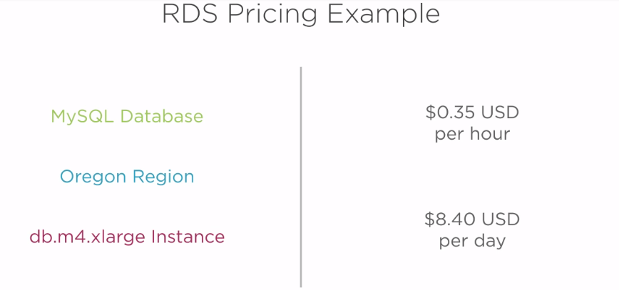

1. **Route53 –** It is a dns service which is used to convert URLs into IP address for the services to communicate to each other. All the services communicate via IP address.
2. **ElasticBean Stack -**  It is a service which is used for deploying and running apps on EC2. We can directly deploy the services on EC2 without using elasticbean stack but it requires manual configurations , manual code deployment , manual monitoring etc. With elasticbean stack all these can be automated. Elasticbean stack is used for easy deployments with web console and can aggregate the logs from multiple ec2 instances and helps in monitoring the apps.

Based on the below diagram we can see that using elastic bean stack we can configure different environment with different ec2 instance and run applications. Elastic bean stack is free as it uses s3,ec2 and load balancers which are paid.

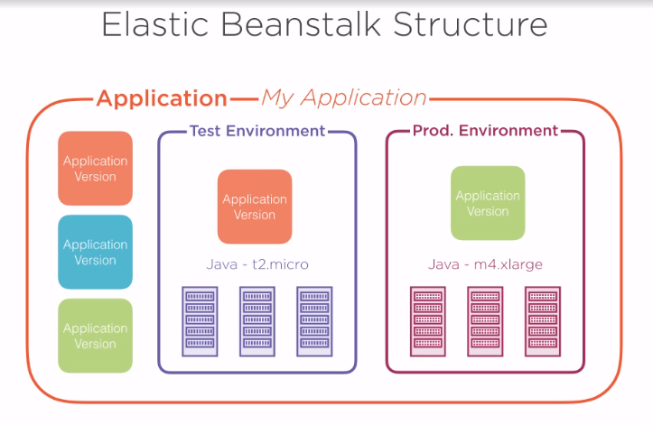

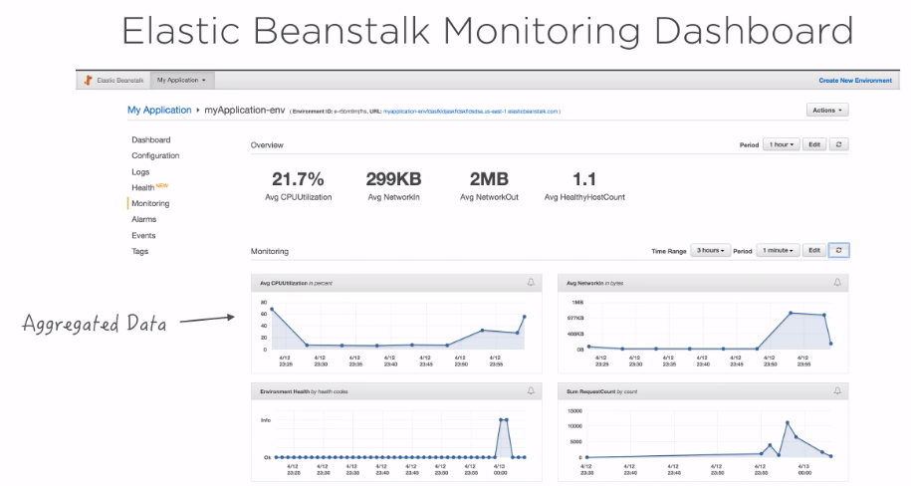

1. **DynamoDB –** It’s is NOSQL database service provided by AWS. It supports both document type database like Mongodb and keyvalue type database like redis. In dynamo db we don’t need to think about EC2 instances and database installation like RDS but we just have to pay for data storage and query execution on database. Below is the pricing model for DynamoDB:

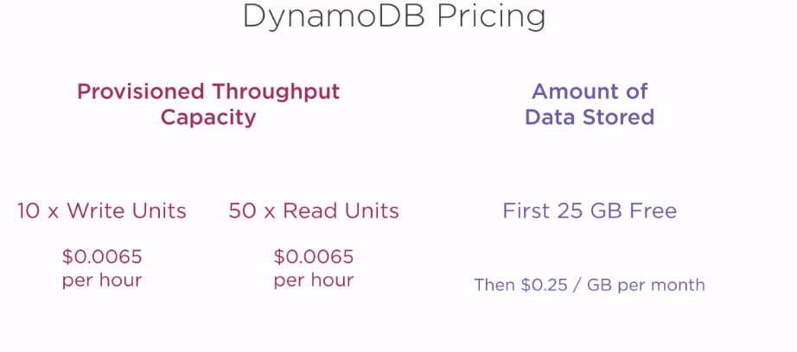

1. **Redshift –** It’s a dataware house solution. Data can be moved to redshift from various sources like RDS, dynamo dB and S3 buckets after performing ETL operations on the data. Redshift is mainly focused on scalability and performance and thus it contains cluster of instances. In redshift the CPU, network configurations, stores all are top notch so that with highest configurations, it can service hugh data volumes. Red shift also provides high security. One of the best features is dataware housing encryption and creating virtual private cloud so that the requests from any service can come via VPC. The pricing is based on the infra and the redshift service usage.

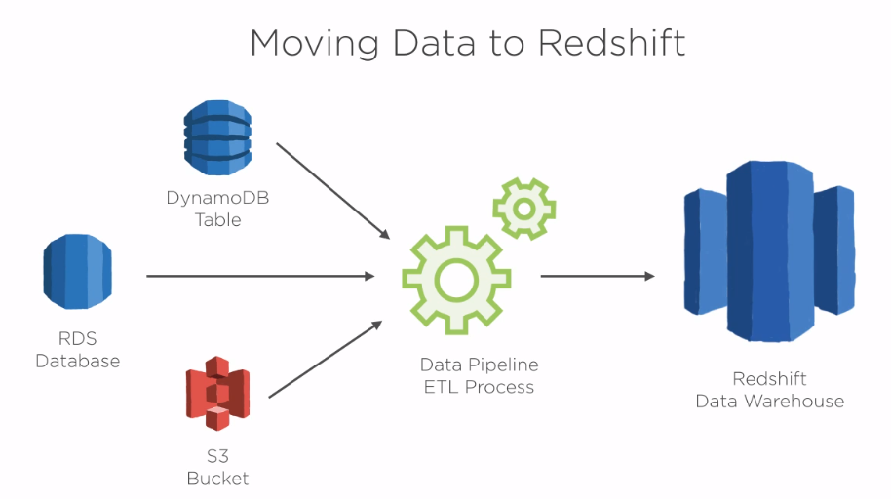

1. **Virtual Private Cloud (VPC) -** AWS VPC provides an isolated space in the cloud which consists of public subnet and a private subnet. There are few services which should not needs to be accessed via internet hence these applications are kept in private subnet and there might be some services which needs to be accessed via internet and can use security groups to make it secure hence these are kept in public subnet. Both public and private subnets can be accessed via EC2 tunneling.

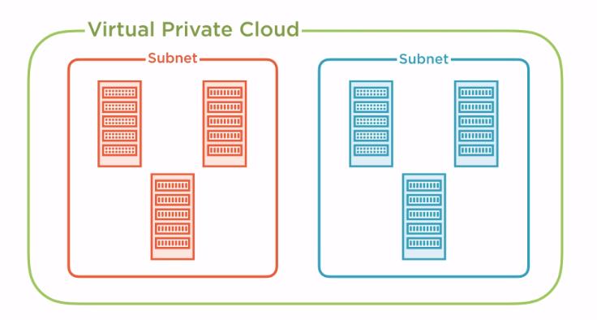

1. **Cloudwatch-** It’s an AWS monitoring and alarm service which is integrated with other AWS services. Using this service we can raise alerts based on various metrics set for different services. Also logs can be sent to Cloudwatch and we can filter criteria to trigger a mail or sms based on the type / frequency of exception happening in the process/service. Pricing is based on functionality of cloud watch like raising alarms, ingesting logs, show dashboards and region.

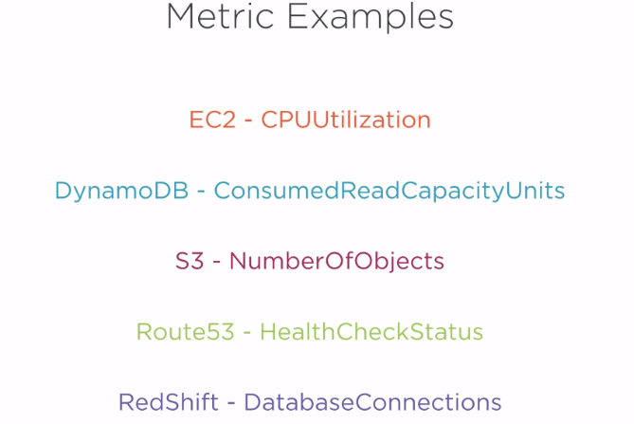

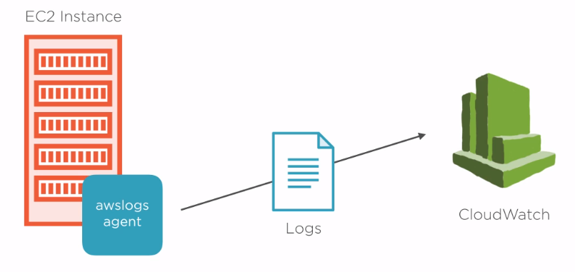

1. **CloudFront –** It’s a content delivery network which helps to serve files globally with very fast connections (low latency rates). Cloud front works with S3, EC2, Load balancers and Route53. There are some settings and configurations that need to be done so that content can be shared from the nearest server location.

