(Ver encabezado en pptx)

[Overview](http://www.sc-camp.org/2020/index.html) [Program](http://www.sc-camp.org/2020/program.html) [Registration](http://www.sc-camp.org/2020/application.html) [Pictures](http://www.sc-camp.org/2020/pictures.html) [Information](http://www.sc-camp.org/2020/information.html) [Committee](http://www.sc-camp.org/2020/committee.html) [Sponsors](http://www.sc-camp.org/2020/sponsors.html)

* [School Mission](http://www.sc-camp.org/2020/index.html#school-mission)
* [Content](http://www.sc-camp.org/2020/index.html#content)
* [Organization](http://www.sc-camp.org/2020/index.html#organization)
* [Participants](http://www.sc-camp.org/2020/index.html#participants)
* [Registration](http://www.sc-camp.org/2020/index.html#registration)
* [Location](http://www.sc-camp.org/2020/index.html#location)
* [Contact](http://www.sc-camp.org/2020/index.html#contact)

Keynotes :

All keynotes schedule will be confirmed Thursday November 26th

**Live:**

* **Understanding Failures in Supercomputers** by **Dr. Esteban Meneses (CENAT, CR)**

**(Ver el excel adjunto con el resto de charlas, dia y hora)**

**On Demand (Pre recorded):**

**(ver el excel adjunto)**

## School Mission

SC-Camp is a summer school and non-profit event about Super Computing and Distributed Systems. It proposes a series of courses around the thematic of High-Performance Computing with an important focus on practical sessions (more than half of the time). It targets Master and PhD students in the field of Computer Sciences, Engineering and any other fields that could benefit from HPC (Physics & Material Sciences, Biology/Bioinformatics, Finance, etc.).

Taking advantage of the Internet and high speed networks available today, one can exploit high performance computing infrastructures from anywhere, even located in the middle of the nature. SC-Camp is an initiative of researchers inspired by this idea that offers undergraduate and master students state-of-the-art lectures and programming practical sessions upon High Performance and Distributed Computing topics. It is an itinerant school, bringing the HPC knowledge to a different place every year.

SC-Camp is a non-profit event, addressed to all students including those that lack of financial backup, so we try to keep the cost for the students as low as possible.

## Content

The supercomputing and distributed systems school focus on the following topics:

* Distributed Systems: Grid/Cluster/Cloud/Volunteer Computing
* Distributed parallel programming with MPI
* Shared Memory parallel programming with OpenMP
* Accelerators: GPUs with CUDA, XeonPhi
* Debugging, Profiling and Performance Optimization
* Data Analysis with R
* Resource/Job Management & Scheduling
* Big Data
* Reproducible Research
* Advanced Computing

Please check the detailed program [here](http://www.sc-camp.org/2020/program.html): (to be published Thursday 26h November 2020)

## Organization

SC-Camp 2020 – Virtual features 6 days of scientific sessions, during which several programming practical sessions will be held and a collaborative project. This year, due to the worldwide COVID19 pandemic the SC-Camp will be virtual, hosted by. RENATA in Colombia.

The main goal of SC-CAMP 2020 Virtual is to support the strengthening of the Colombian Advanced Computing Network (LaRedCCA – Red Colombiana de Computación de Avanzada). For this reason the most part of the talks and courses will be in spanish this year.

We welcome applications of undergraduate (preferable in Senior year) or master students from all areas of Engineering and Computational Sciences with strong interest upon High Performance and Distributed Computing. Due to the advanced content of lectures some basic notions of Parallel and Distributed Computing along with programming skills are desirable. All courses and lectures will be held in English, thus a good knowledge of English -both oral and written- is mandatory. The scientific and steering committee will evaluate the application forms based on the applicant’s scientific background and their motivation letter. This year, we will accept a maximum of 50 students.

## Participants

Master and PhD students in the field of Computer Science, or any other domain working with HPC (Physics, Material Science, Biology/Bioinformatics, Finance, etc.), who are already familiar with programming. SC-Camp is the perfect event to learn all about Distributed and Parallel programming, from basics to the most advanced level, offering a thoughtful practical experience in High Performance Systems to assimilate the concepts

## Registration

Please check the registration procedure on [www.renata.edu.co](http://www.renata.edu.co)

## Location

The SC-Camp 2020 will be hosted by the National Colombian NRE RENATA.

Please check all the details on the site [www.renata.edu.co](http://www.renata.edu.co)

## Contact

* Homepage: <http://www.sc-camp.org/2020>
* Email: [academica@renata.edu.co](mailto:academica@renata.edu.co)

**Sponsors**

**Organizers**

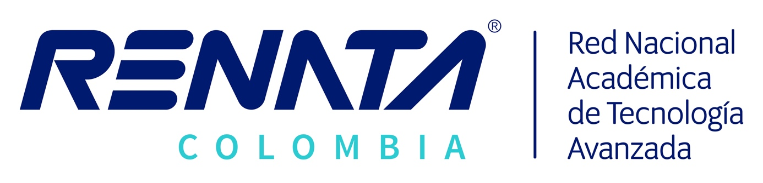



**Acknowledgment**







**Archives**

[SC-Camp 2010](http://www.sc-camp.org/2010/index.html)  
[SC-Camp 2011](http://www.sc-camp.org/2011/index.html)  
[SC-Camp 2012](http://www.sc-camp.org/2012/index.html)  
[SC-Camp 2013](http://www.sc-camp.org/2013/index.html)  
[SC-Camp 2014](http://www.sc-camp.org/2014/index.html)  
[SC-Camp 2015](http://www.sc-camp.org/2015/index.html)  
[SC-Camp 2016](http://www.sc-camp.org/2016/index.html)  
[SC-Camp 2017](http://www.sc-camp.org/2017/index.html)  
[SC-Camp 2018](http://www.sc-camp.org/2018/index.html)  
[SC-Camp 2019](http://www.sc-camp.org/2019/index.html)

Copyright © 2020, **SC Camp** | for more information [contact@sc-camp.org](mailto:contact@sc-camp.org)

Enregistrer