Supporting Information
Effect of Hydrogen-Bonding Networks of Water on Temperature and Relative Humidity Dependence of Proton Conductivity in Metal-Organic Frameworks
My V. Nguyen,^{§a,e} Hieu C. Dong,^{§a,b} Duc Nguyen-Manh,^{c} Nam H. Vu,^{b,d} Thuat T. Trinh^{f} and Thang B. Phan*^{a,b}

ªCenter for Innovative Materials and Architectures (INOMAR), Ho Chi Minh City, Vietnam.
^{b}Vietnam National University-Ho Chi Minh (VNU-HCM), Ho Chi Minh City, Vietnam.
^{c}Culham Centre for Fusion Energy, United Kingdom Atomic Energy Authority, OX143DB, Abingdon, UK
^{d}Faculty of Materials Science and Technology, Ho Chi Minh City, Vietnam
^{e}Ho Chi Minh City University of Education, Ho Chi Minh City, Vietnam
^{f}Department of Civil and Environmental Engineering, Norwegian University of Science and Technology, S.P Andersen vei 5, 7491-Trondheim, Norway
§These authors contributed equally

*To whom correspondence should be addressed:
pbthang@inomar.edu.vn

Section S1. Characteristics of MOF-801
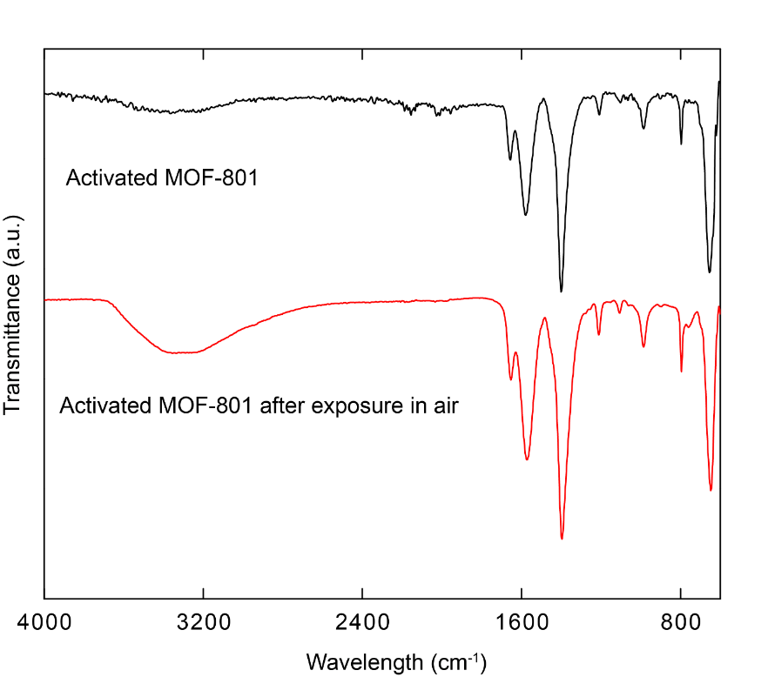
Figure S1. FT-IR spectra of activated MOF-801 (black) and activated MOF-801 after exposure in air (red).
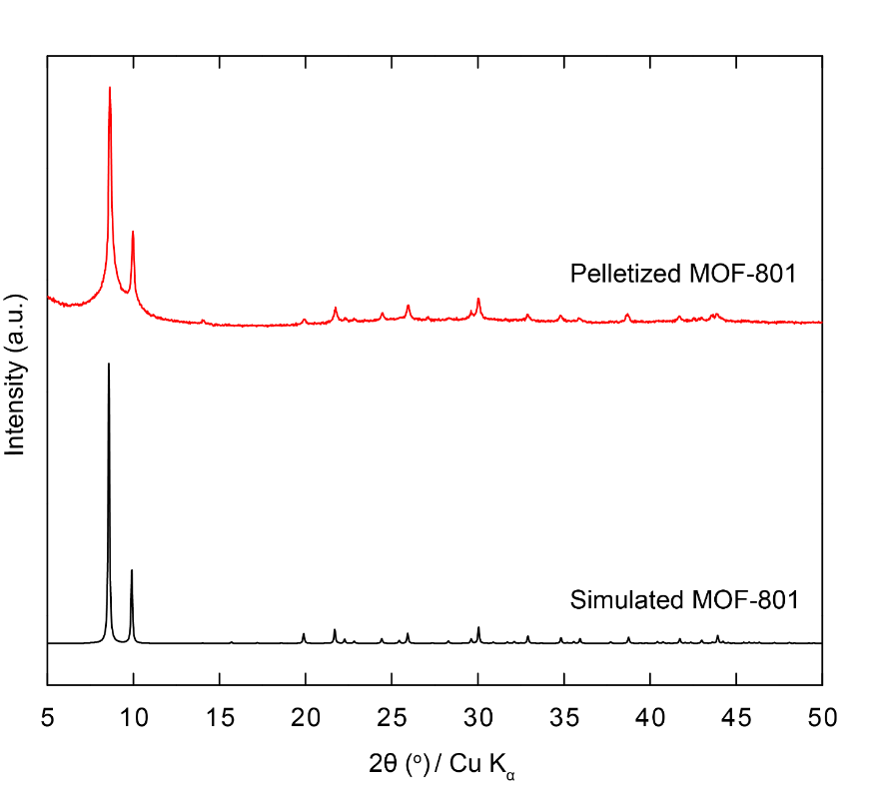
Figure S2. PXRD pattern of MOF-801 (black) in comparison with pelletized MOF-801 (red).
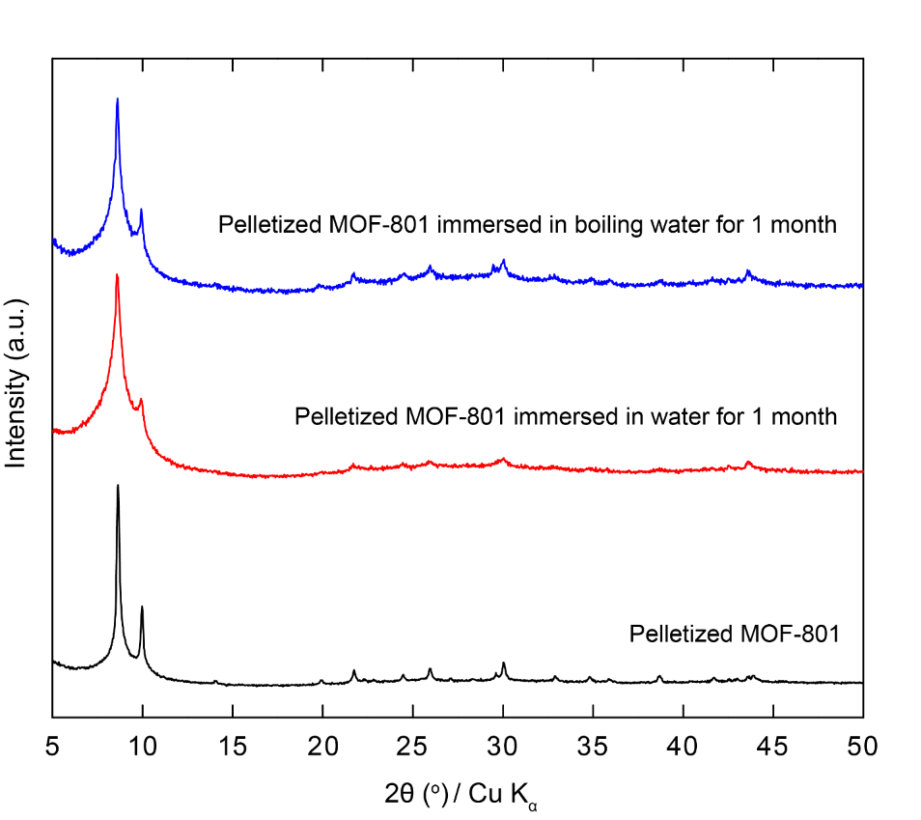
Figure S3. PXRD pattern of pelletized MOF-801 (black) in comparison with pelletized MOF-801 in water for 1 month (red) and in boiling water for 1 month (blue)

Section S2. Proton Conduction Study
It is noted that the impedance of the electric wire without pelleted sample was collected in order to correct for the inductive effect. The correction was carried out by subtracting the experimental impedance of pelletized sample from the experimental impedance of the electric wire in order to obtain the pure impedance of pelletized sample.
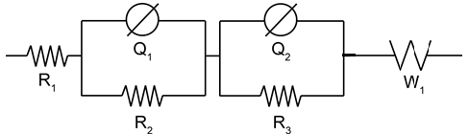
Figure S4. An equivalent circuit used for fitting. Schematic representations: W1, Warburg diffusion element; Q1/Q2, imperfect capacitor; R1, Contact resistor; R2, bulk resistor; R3, grain boundary resistor.
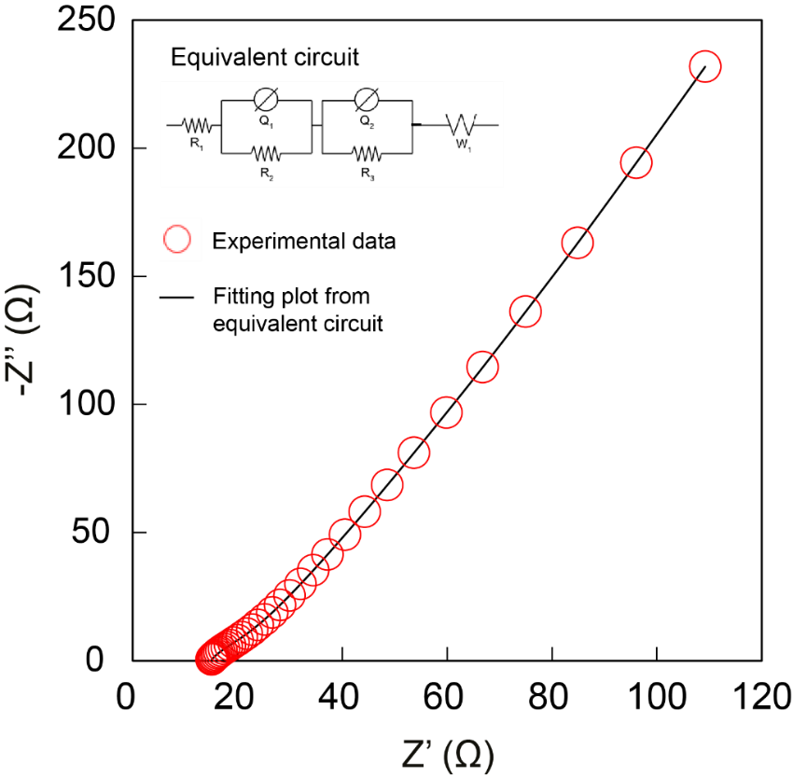
Figure S5. Nyquist plot derived from equivalent circuit (black line) and experimental Nyquist plot (red circles) of pelletized MOF-801 under 98% RH and 80 °C. Frequency ranged from 1 MHz to 10 Hz.

Table S1. Conductivity of pelletized MOF-801 at 50 ºC from 60 to 98% RH.
Relative humidity (%) | σ (S cm⁻¹)
60 | 4.49 x 10⁻⁸
70 | 2.08 x 10⁻⁷
80 | 6.01 x 10⁻⁷
90 | 1.53 x 10⁻⁶
95 | 2.08 x 10⁻⁵
98 | 8.84 x 10⁻⁴

Figure S6. Nyquist plot of pelletized MOF-801 at 50 °C under relative humidity varied from 60 to 98 %RH
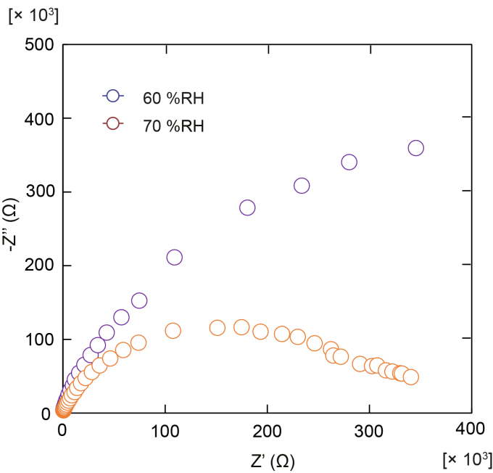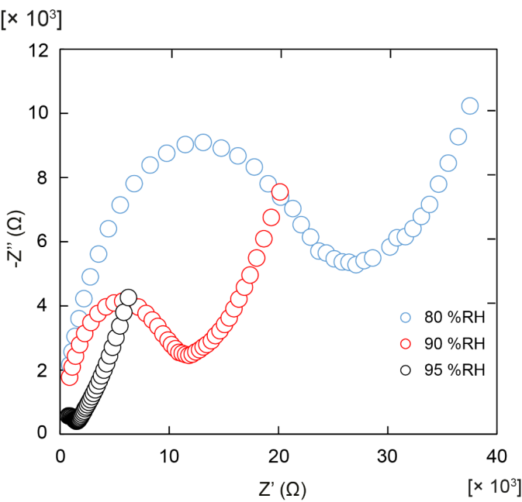
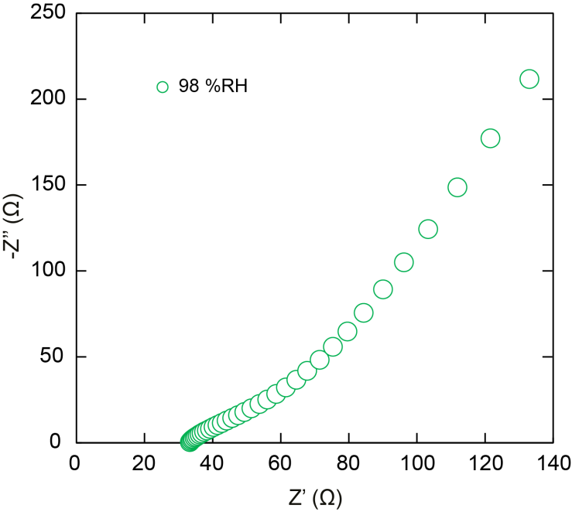

Table S2. Conductivity of pelletized MOF-801 at 60 ºC from 60 to 98% RH.

Relative humidity (%) | σ (S cm⁻¹)
60 | 8.84 x 10⁻⁸
70 | 4.55 x 10⁻⁷
80 | 1.12 x 10⁻⁶
90 | 3.56 x 10⁻⁶
95 | 2.40 x 10⁻⁵
98 | 1.05 x 10⁻³

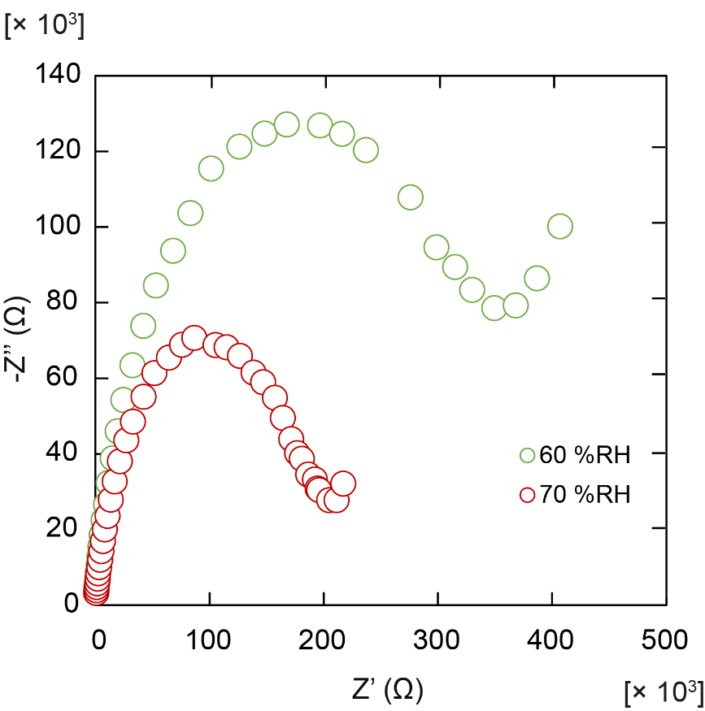

Figure S7. Nyquist plot of pelletized MOF-801 at 60 °C under relative humidity varied from 60% to 70%.

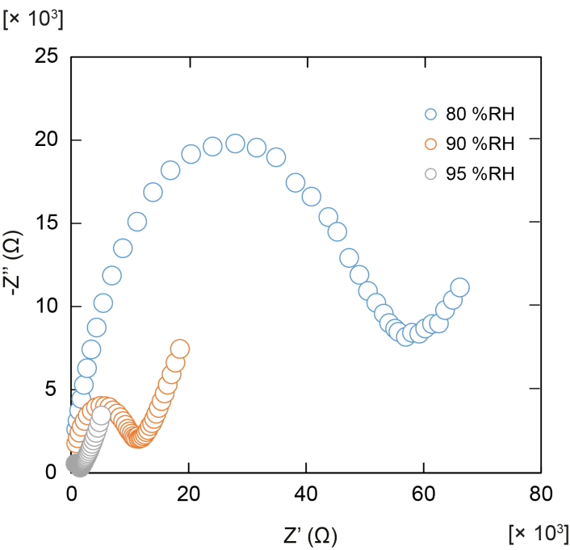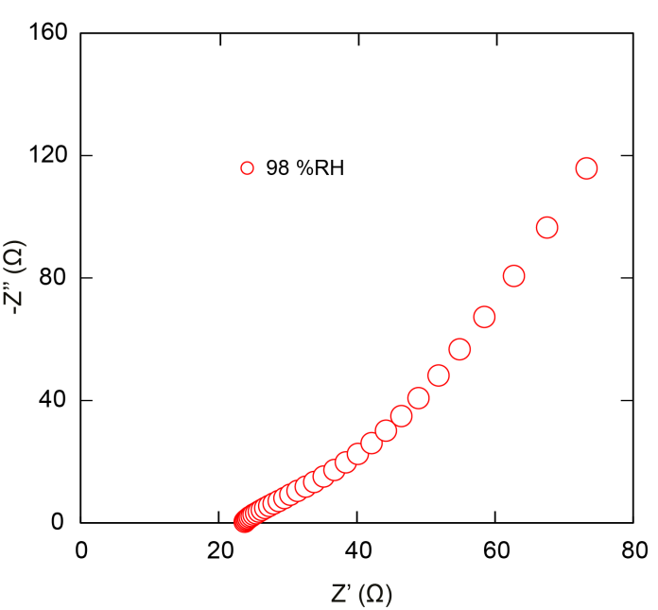
Figure S8. Nyquist plot of pelletized MOF-801 at 60 °C under relative humidity varied from 80% to 98%.

Table S3. Conductivity of pelletized MOF-801 at 70 ºC from 60 to 98% RH.
Relative humidity (%) | σ (S cm⁻¹)
60 | 2.60 x 10⁻⁷
70 | 1.05 x 10⁻⁶
80 | 2.45 x 10⁻⁶
90 | 7.06 x 10⁻⁶
95 | 2.86 x 10⁻⁵
98 | 1.31 x 10⁻³

Figure S9. Nyquist plot of pelletized MOF-801 at 70 °C under relative humidity varied from 60% to 98%
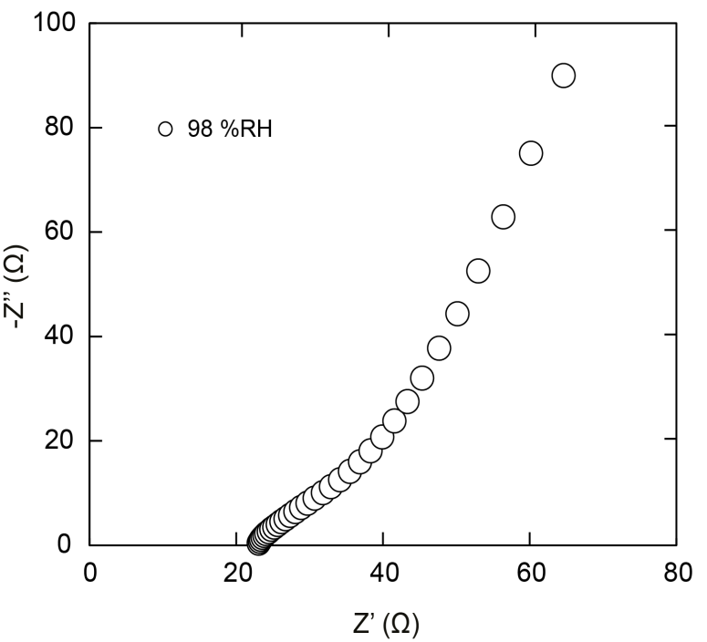

Table S4. Conductivity of pelletized MOF-801 at 80 ºC from 60 to 98% RH.
Relative humidity (%) | σ (S cm⁻¹)
60 | 6.25 x 10⁻⁷
70 | 2.22 x 10⁻⁶
80 | 4.69 x 10⁻⁶
90 | 1.28 x 10⁻⁵
95 | 3.34 x 10⁻⁵
98 | 1.58 x 10⁻³

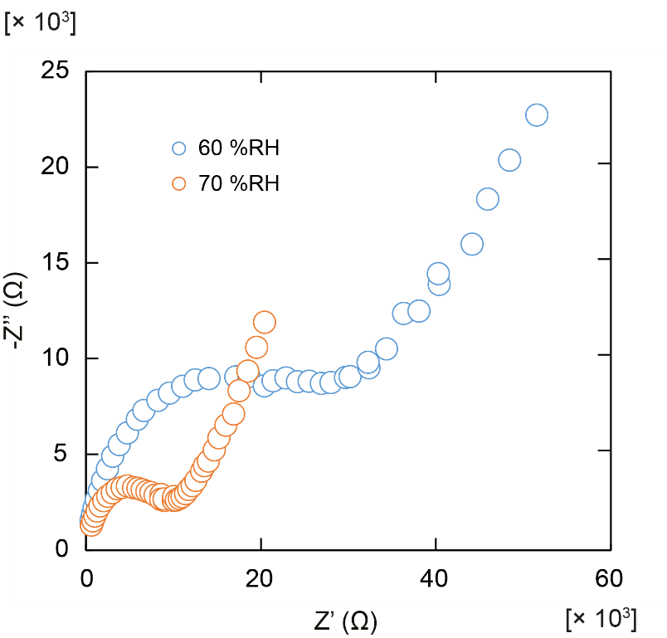

Figure S10. Nyquist plot of pelletized MOF-801 at 80 °C under relative humidity varied from 60% to 70%.
Figure S11. Nyquist plot of pelletized MOF-801 at 80 °C under relative humidity varied from 80% to 98%.
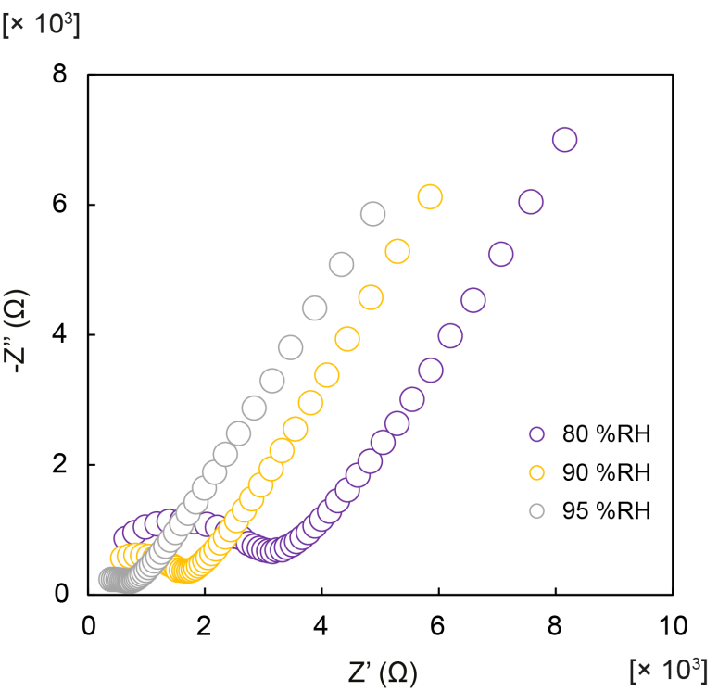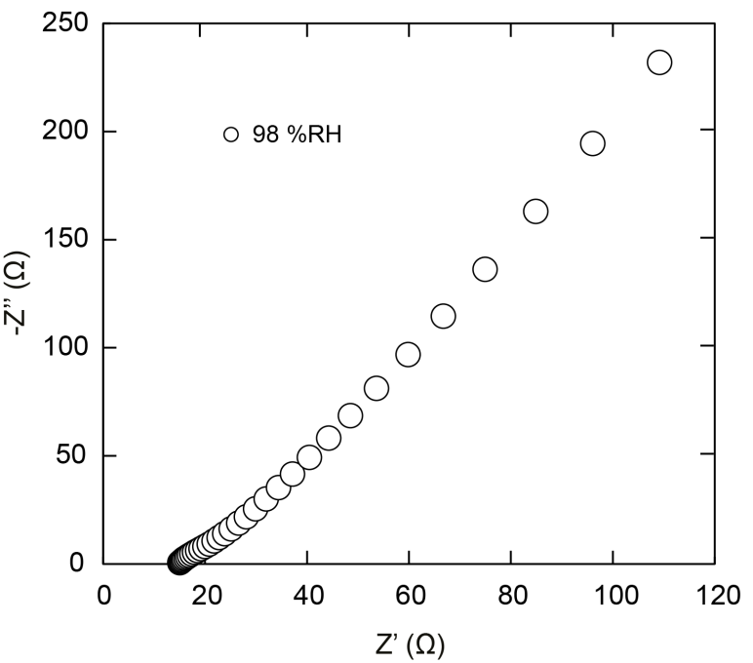

Table S5. Conductivity of pelletized MOF-801 at 90 ºC from 60 to 98 %RH.

Relative humidity / % | σ / S cm⁻¹
60 | 1.32 x 10⁻⁶
70 | 5.73 x 10⁻⁶
80 | 1.02 x 10⁻⁵
90 | 2.03 x 10⁻⁵
95 | 4.18 x 10⁻⁵
98 | 1.82 x 10⁻³

Figure S12. Nyquist plot of pelletized MOF-801 at 90 °C under relative humidity varied from 60% to 98%.
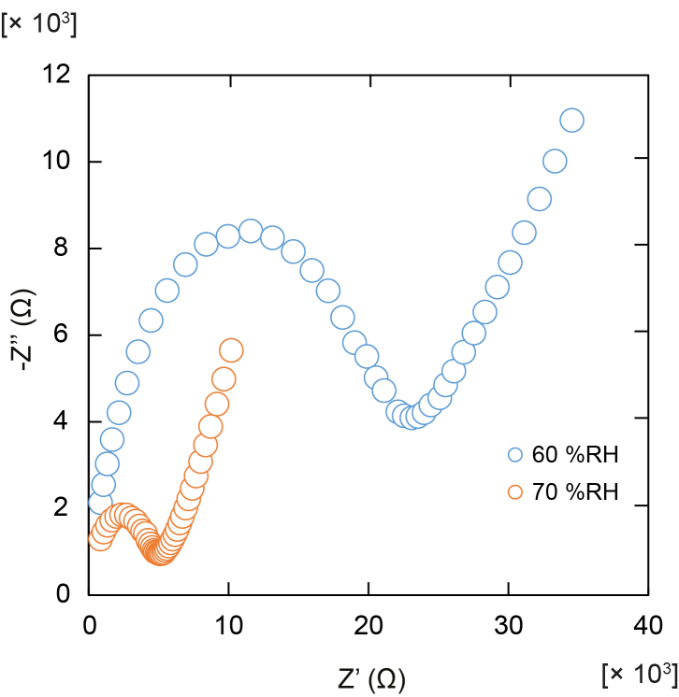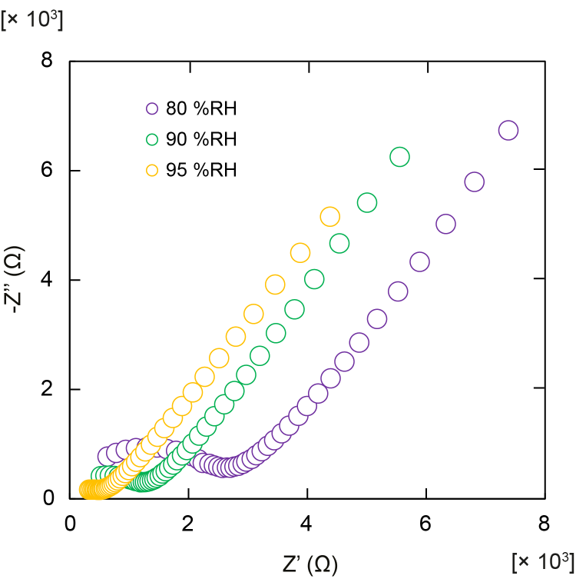
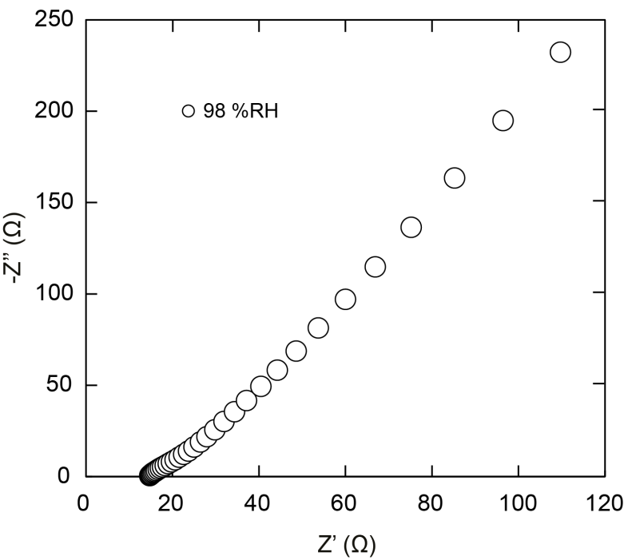

Section S3. Activation energy of materials under different relative humidities from 50 ºC to 90 ºC.

Table S6. Proton conduction of pelletized MOF-801 under 60, 70, 80, 90, 95 and 98 % RH from 50 to 90 ºC.
60 %RH
Temperature (ºC) | σ (S cm⁻¹)
50 | 4.49 x 10⁻⁸
60 | 8.84 x 10⁻⁸
70 | 2.60 x 10⁻⁷
80 | 6.25 x 10⁻⁷
90 | 1.32 x 10⁻⁶
70 %RH
Temperature (ºC) | σ (S cm⁻¹)
50 | 2.08 x 10⁻⁷
60 | 4.55 x 10⁻⁷
70 | 1.05 x 10⁻⁶
80 | 2.22 x 10⁻⁶
90 | 5.73 x 10⁻⁶
80 %RH
Temperature (ºC) | σ (S cm⁻¹)
50 | 6.01 x 10⁻⁷
60 | 1.12 x 10⁻⁶
70 | 2.45 x 10⁻⁶
80 | 4.69 x 10⁻⁶
90 | 1.02 x 10⁻⁵
90 %RH
Temperature (ºC) | σ (S cm⁻¹)
50 | 1.53 x 10⁻⁶
60 | 3.56 x 10⁻⁶
70 | 7.06 x 10⁻⁶
80 | 1.28 x 10⁻⁵
90 | 2.03 x 10⁻⁵

95 %RH
Temperature (ºC) | σ (S cm⁻¹)
50 | 2.08 x 10⁻⁵
60 | 2.40 x 10⁻⁵
70 | 2.86 x 10⁻⁵
80 | 3.34 x 10⁻⁵
90 | 4.18 x 10⁻⁵
98 %RH
Temperature (ºC) | σ (S cm⁻¹)
50 | 8.84 x 10⁻⁴
60 | 1.05 x 10⁻³
70 | 1.31 x 10⁻³
80 | 1.58 x 10⁻³
90 | 1.82 x 10⁻³

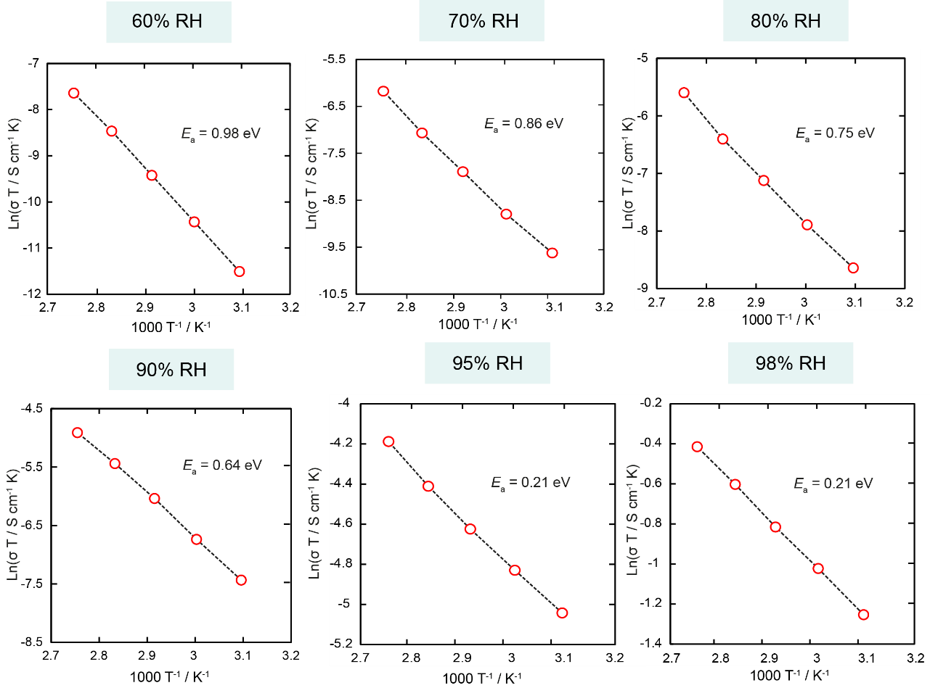
Figure S13. Arrhenius plot of MOF-801 at 60, 70, 80, 90, 95 and 98 %R
Section S4. Stability of materials after ac impedance analysis.
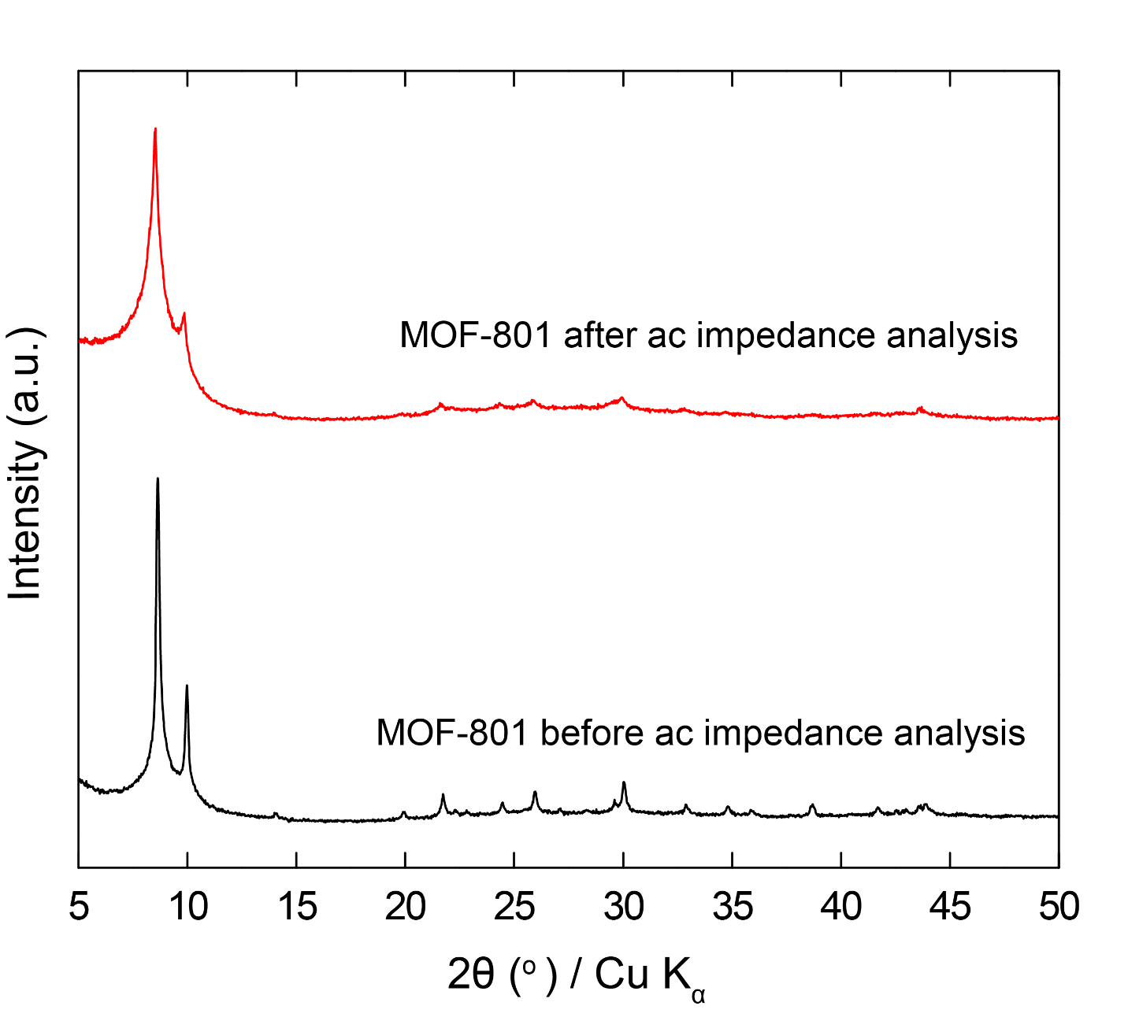
Figure S14. PXRD pattern of MOF-801 before ac impedance analysis (black) in comparison with MOF-801 after ac impedance analysis (blue).

Computational methods
We utilize the package RASPA¹ as implemented which based on Grand Canonical Monte Carlo ^{2,3} method to investigate water absorption isotherm and molecular dynamics (MD). The net atomic electrostatic charge of the framework structure via Bader charge analysis code based on DFT calculations which is developed by Henkelman researched group (Table S7).⁴⁻⁷ Lennard-Jones parameters which describe non-bonding interactions of water molecule and framework atoms are provided from semi-empirical force field which is appropriate for MOF applications,⁸ and we listed the above parameters in Table S8 for convenience. A Lennard-Jones cutoff of 12 Å was employed. Lorentz-Berthelot General² the mixed rule is used for determining Lenard Jones parameters for potentials with different chemical species.
DFT calculations: MOF-801 configuration is optimized by ionic relaxation method at constant volume with the lattice parameter taken from the experimental data as a single crystal structure, a =17.8348 Å in the cubic space group, ${Pn}^{\overline{3}}$ (No. 201). Electronic structure calculations on a cubic unit-cell of MOF-801 (24 Zr, 128 O, 96 C and 48 H) are executed Vienna Ab Initio Simulation Package (VASP). ⁹⁻¹² The Perdew-Burke-Ernzerhof^{13,14}(PBE) parameterization is used to describe the exchange-correlation description within generalized-gradient approximations (GGA)^{15,16}. Total energy difference between self-consistent-field (SCF) loops is set 10⁻⁵ eV and force convergence criterion is 10⁻² eVÅ⁻¹. We consider the cut-off energy of 400 eV which affords computational feasibility for a larger structure as MOF-801. The optimized structure is employed to analyze the net atomic electrostatic charge.
Molecular dynamics: Two MD simulation method NVT and NVT is employed at 50°C to research the proton transfer process in MOF-801. To enhance reliability for our calculation, the number of MD steps for the production run is 1× 10⁶ for both above method and gap-time between each step is 0.5 fs. Six high-humidity point is considered including 60%, 70%, 80%, 90%, 95%, 98% which are examined by our experimental group. We verified that TIP4P/2005 force field appropriate to the water absorption calculation at several above high-humidity (Fig. S15). The number of water molecular in MOF-801 for MD process is calculated from the previous experimental adsorption results¹⁷ and is shown Table S9. For analyzing proton transfer process, every 500 steps we select one configuration in the last 25 × 10⁴ steps from 1× 10⁶ MD step. Consequently, there are a total of 500 configurations which allow us to perform reliable statistical results.
Isotherm calculation: The simulation temperature for isotherm curve is fixed at 55 °C which is the highest temperature for water uptake data in the previous experimental report.¹⁷ The pressure for system is calculated indirectly via humidity considering RH = P/P_{o}, where RH is relative humidity (%), P and P_{o} are pressure for system and saturated pressure of water at 55 °C, respectively. Simulations carried out using TIPnP water models to find out the water molecular model which is most appropriated with the experimental results. We suggest to employ three featured water model including: TIP3P,¹⁸ TIP4P/2005¹⁹ and TIP5P.²⁰ The electrostatic charge interactions were considered by the Ewald summation technique with an accuracy of 10⁻⁶ modeling long-interaction. In all our simulations, we perform 5 × 10⁴ MC step of initial equilibration and 5 × 10⁵ cycles for the production run. With 2 term of cycle for GCMC simulation, we recognize that only 3 × 10⁵ cycles of assembling are needed to reach the saturation of water molecule into MOF-801.
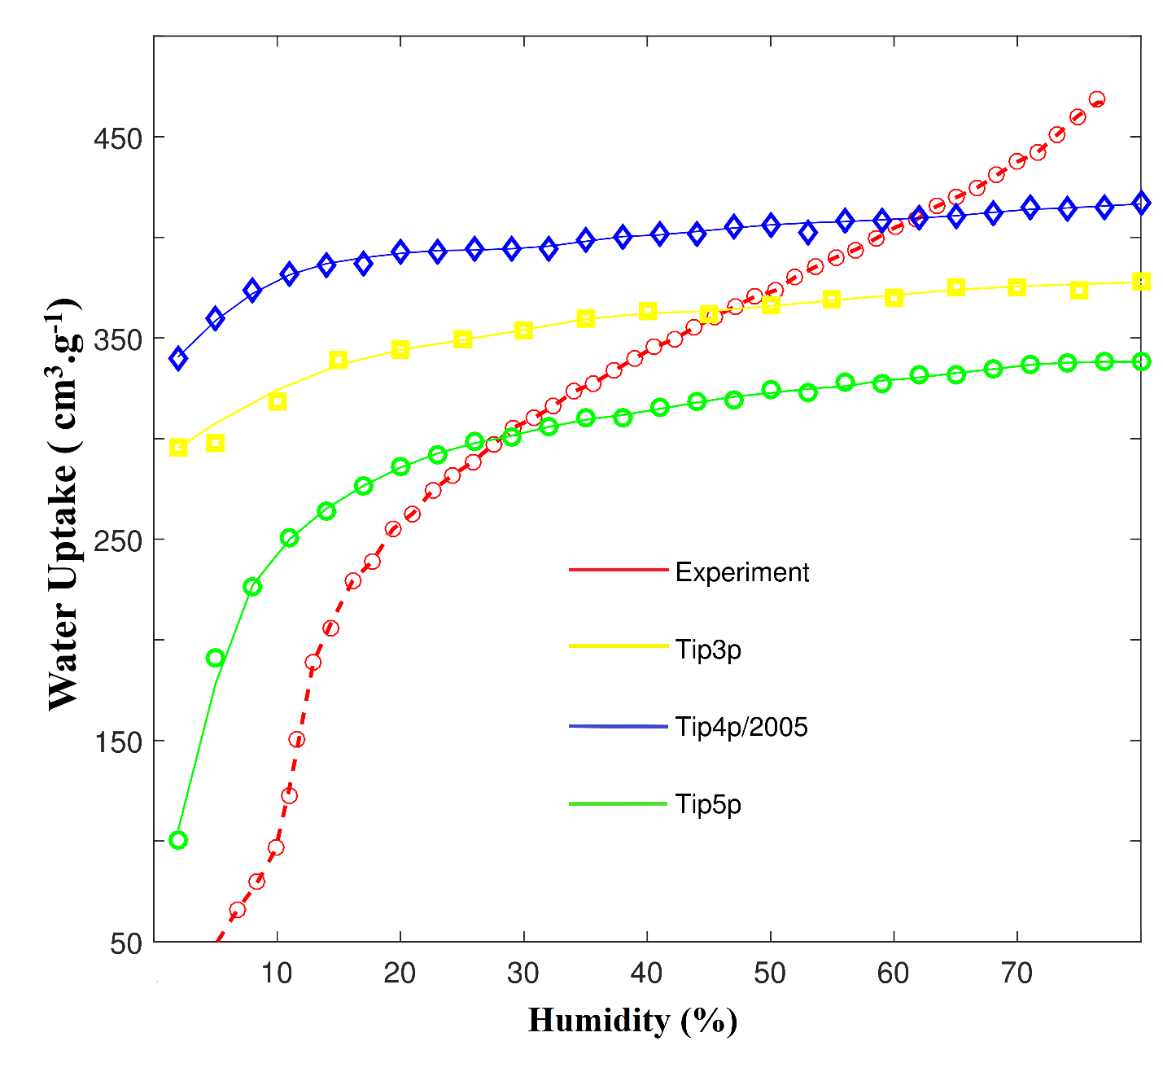
Figure S15. Isotherm curve from GCMC simulation of MOF-801 with three force field of water molecular (TIP3P, TIP4P/2005, TIP5P) and experiment results at 55 °C.

Atom | Charge | Atom | Charge | Atom | Charge | Atom | Charge | Atom | Charge | Atom | Charge
Zr1 | 2.618 | O27 | -0.979 | O77 | -1.106 | O127 | -0.992 | C49 | 0.032 | H3 | 0.132
Zr2 | 2.626 | O28 | -0.977 | O78 | -1.104 | O128 | -0.992 | C50 | -0.011 | H4 | 0.134
Zr3 | 2.618 | O29 | -0.980 | O79 | -1.093 | C1 | 1.469 | C51 | -0.038 | H5 | 0.145
Zr4 | 2.619 | O30 | -0.979 | O80 | -1.095 | C2 | 1.463 | C52 | -0.036 | H6 | 0.146
Zr5 | 2.620 | O31 | -0.977 | O81 | -1.118 | C3 | 1.422 | C53 | 0.011 | H7 | 0.107
Zr6 | 2.623 | O32 | -0.979 | O82 | -1.114 | C4 | 1.441 | C54 | -0.031 | H8 | 0.142
Zr7 | 2.623 | O33 | -1.102 | O83 | -1.115 | C5 | 1.454 | C55 | -0.062 | H9 | 0.174
Zr8 | 2.623 | O34 | -1.111 | O84 | -1.111 | C6 | 1.433 | C56 | 0.006 | H10 | 0.135
Zr9 | 2.618 | O35 | -1.097 | O85 | -1.117 | C7 | 1.455 | C57 | -0.039 | H11 | 0.132
Zr10 | 2.617 | O36 | -1.091 | O86 | -1.113 | C8 | 1.438 | C58 | -0.033 | H12 | 0.142
Zr11 | 2.618 | O37 | -1.085 | O87 | -1.123 | C9 | 1.424 | C59 | 0.045 | H13 | 0.089
Zr12 | 2.615 | O38 | -1.095 | O88 | -1.117 | C10 | 1.461 | C60 | 0.037 | H14 | 0.127
Zr13 | 2.619 | O39 | -1.111 | O89 | -1.111 | C11 | 1.467 | C61 | -0.014 | H15 | 0.140
Zr14 | 2.616 | O40 | -1.106 | O90 | -1.115 | C12 | 1.423 | C62 | 0.031 | H16 | 0.121
Zr15 | 2.621 | O41 | -1.101 | O91 | -1.113 | C13 | 1.469 | C63 | -0.037 | H17 | 0.139
Zr16 | 2.613 | O42 | -1.094 | O92 | -1.114 | C14 | 1.467 | C64 | -0.050 | H18 | 0.148
Zr17 | 2.617 | O43 | -1.104 | O93 | -1.114 | C15 | 1.436 | C65 | -0.003 | H19 | 0.126
Zr18 | 2.618 | O44 | -1.106 | O94 | -1.114 | C16 | 1.453 | C66 | -0.007 | H20 | 0.126
Zr19 | 2.619 | O45 | -1.109 | O95 | -1.111 | C17 | 1.465 | C67 | -0.019 | H21 | 0.147
Zr20 | 2.613 | O46 | -1.107 | O96 | -1.117 | C18 | 1.470 | C68 | -0.034 | H22 | 0.157
Zr21 | 2.615 | O47 | -1.093 | O97 | -1.111 | C19 | 1.435 | C69 | -0.015 | H23 | 0.134
Zr22 | 2.618 | O48 | -1.095 | O98 | -1.112 | C20 | 1.442 | C70 | -0.022 | H24 | 0.132
Zr23 | 2.617 | O49 | -1.105 | O99 | -1.112 | C21 | 1.462 | C71 | -0.028 | H25 | 0.140
Zr24 | 2.615 | O50 | -1.108 | O100 | -1.113 | C22 | 1.464 | C72 | -0.026 | H26 | 0.146
O1 | -1.114 | O51 | -1.097 | O101 | -1.111 | C23 | 1.418 | C73 | -0.021 | H27 | 0.144
O2 | -1.114 | O52 | -1.113 | O102 | -1.114 | C24 | 1.435 | C74 | -0.013 | H28 | 0.130
O3 | -1.116 | O53 | -1.104 | O103 | -1.114 | C25 | 1.442 | C75 | -0.030 | H29 | 0.142
O4 | -1.127 | O54 | -1.111 | O104 | -1.109 | C26 | 1.466 | C76 | -0.041 | H30 | 0.155
O5 | -1.122 | O55 | -1.098 | O105 | -0.985 | C27 | 1.416 | C77 | -0.032 | H31 | 0.126
O6 | -1.117 | O56 | -1.089 | O106 | -0.992 | C28 | 1.428 | C78 | -0.024 | H32 | 0.148
O7 | -1.111 | O57 | -1.110 | O107 | -0.992 | C29 | 1.441 | C79 | 0.004 | H33 | 0.123
O8 | -1.118 | O58 | -1.106 | O108 | -0.992 | C30 | 1.417 | C80 | -0.029 | H34 | 0.139
O9 | -1.118 | O59 | -1.090 | O109 | -0.992 | C31 | 1.465 | C81 | -0.029 | H35 | 0.141
O10 | -1.119 | O60 | -1.092 | O110 | -0.989 | C32 | 1.462 | C82 | -0.055 | H36 | 0.107
O11 | -1.112 | O61 | -1.093 | O111 | -0.987 | C33 | 1.432 | C83 | -0.014 | H37 | 0.139
O12 | -1.111 | O62 | -1.084 | O112 | -0.987 | C34 | 1.413 | C84 | 0.095 | H38 | 0.091
O13 | -1.115 | O63 | -1.109 | O113 | -0.987 | C35 | 1.471 | C85 | -0.023 | H39 | 0.136
O14 | -1.115 | O64 | -1.092 | O114 | -0.986 | C36 | 1.444 | C86 | -0.010 | H40 | 0.142
O15 | -1.123 | O65 | -1.092 | O115 | -0.981 | C37 | 1.474 | C87 | -0.016 | H41 | 0.127
O16 | -1.122 | O66 | -1.096 | O116 | -0.984 | C38 | 1.447 | C88 | -0.036 | H42 | 0.108
O17 | -1.117 | O67 | -1.109 | O117 | -0.990 | C39 | 1.428 | C89 | -0.021 | H43 | 0.142
O18 | -1.112 | O68 | -1.099 | O118 | -0.989 | C40 | 1.436 | C90 | -0.021 | H44 | 0.131
O19 | -1.118 | O69 | -1.114 | O119 | -0.992 | C41 | 1.456 | C91 | -0.031 | H45 | 0.147
O20 | -1.121 | O70 | -1.099 | O120 | -0.988 | C42 | 1.448 | C92 | -0.050 | H46 | 0.161
O21 | -1.117 | O71 | -1.085 | O121 | -0.992 | C43 | 1.421 | C93 | -0.022 | H47 | 0.146
O22 | -1.113 | O72 | -1.094 | O122 | -0.994 | C44 | 1.458 | C94 | -0.021 | H48 | 0.135
O23 | -1.111 | O73 | -1.112 | O123 | -0.993 | C45 | 1.473 | C95 | -0.022 | H3 | 0.139
O24 | -1.122 | O74 | -1.114 | O124 | -0.988 | C46 | 1.467 | C96 | -0.034 | H4 | 0.150
O25 | -0.977 | O75 | -1.096 | O125 | -0.995 | C47 | 1.425 | H1 | 0.132 | H5 | 0.132
O26 | -0.977 | O76 | -1.093 | O126 | -0.988 | C48 | 1.426 | H2 | 0.134 | H6 | 0.134
Table S7. The net atomic electrostatic charge of MOF-801 is analyzed from DFT calculation.

Table S8. Lennard-Jones parameters for MOF-801 and water molecular for TIP3P¹⁸, TIP4P/2005¹⁹, TIP5P²⁰ (with UFF force field for O_{framework}).

Atom | σ (Å) | Ɛ (k_{B})
O_{framework} | 3.033 | 48.158
C_{framework} | 3.473 | 47.856
H_{framework} | 2.846 | 7.648
Zr_{framework} | 2.783 | 34.722
O_{water-TIP3P} | 3.150 | 76.541
O_{water-TIP4P/2005} | 3.151 | 93.199
O_{water-TIP5P} | 3.120 | 80.510

Table S9. Number of water molecular is calculate from water uptake which is reference from the experimental adsorption results¹⁷ for MOF-801 at 50°C

Humidity | 60% | 70% | 80% | 90% | 95% | 98%
Water-uptake (cm³/g)  (The experimental results) | 419 | 452 | 473 | 499 | 506 | 509
Number of water molecular | 102 | 109 | 114 | 121 | 122 | 123

Hydrogen bond Type | Strong | Moderate | Weak
Interaction Type | Strongly Covalent | Mostly Electrostatic | Electrostatic/dispersion
Bond lengths O_{donor}-O_{aceptor} (Å) | 2.2 – 2.5 | 2.5 – 3.2 | 3.2 – 4.0
Bond angles (Degree) | 170 - 180 | >130 | > 90
Table S10. Strong, moderate and weak hydrogen bonds following the classification of Jeffrey.²¹
Table S11. Average Number of Hydrogen bond and Bond length in a unit-cell of MOF-801 at the several humidity from NVT simulation.
Humidity |  |  | 60% | 70% | 80% | 90% | 95% | 98%
Hydrogen Bond Types | Strong | Average number of hydrogen bond | 0.06 | 0.07 | 0.06 | 0.06 | 0.12 | 0.11
 |  | Average bond length  O_{donor}-O_{aceptor} (Å) | 2.48 | 2.48 | 2.47 | 2.47 | 2.48 | 2.47
 | Moderate | Average number of hydrogen bond | 121.42 | 129.78 | 138.06 | 144.70 | 148.02 | 148.14
 |  | Average bond length  O_{donor}-O_{aceptor} (Å) | 2.80 | 2.81 | 2.81 | 2.79 | 2.79 | 2.78
 | Weak | Average number of hydrogen bond | 93.5 | 112.51 | 121.64 | 144.96 | 141.36 | 149.96
 |  | Average bond length  O_{donor}-O_{aceptor} (Å) | 3.63 | 3.61 | 3.60 | 3.60 | 3.60 | 3.60

References

- D. Dubbeldam, S. Calero, D. E. Ellis, R. Q. Snurr, Mol. Simul., 2016, 42, 81.
- M. P. Allen and D. J. Tildesley, Oxford Science Publications, Clarendon Press, 1987.
- O. P. A. Partykiejew, S. Sokolowski, Wiley-VCH GmbH & Co. KGaA, Weinheim, 2016.
- W. Tang, E. Sanville, G. Henkelman, J. Phys.: Condens. Matter, 2009, 21, 084204.
- E. Sanville, S. D. Kenny, R. Smith, G. Henkelman, J. Comp. Chem., 2007, 28, 899.
- G. Henkelman, A. Arnaldsson, H. Jónsson, Comput. Mater. Sci., 2006, 36, 354.
- M. Yu, D. R. Trinkle, J. Chem. Phys., 2011, 134, 064111.
- J. E. Jones, Proc. Royal Soc. Lond. A, 1924, 106, 463.
- G. Kresse, J. Hafner, Phys. Rev. B, 1993, 47, 558-561.
- G. Kresse, J. Hafner, Phys. Rev. B, 1994, 49, 14251-14269.
- G. Kresse, J. Furthmüller, Comput. Mater. Sci., 1996, 6, 15-50.
- G. Kresse, J. Furthmüller, Phys. Rev. B, 1996, 54, 11169-11186.
- J. P. Perdew, K. Burke, M. Ernzerhof, Phys. Rev. Lett., 1996, 77, 3865-3868.
- J. P. Perdew, K. Burke, M. Ernzerhof, [Phys. Rev. Lett.,1996, 77, 3865]. Phys. Rev. Lett., 1997, 78, 1396-1396.
- P. E. Blöchl, Phys. Rev. B, 1994, 50, 17953-17979.
- G. Kresse, D. Joubert, Phys. Rev. B, 1994, 59, 1758-1775.
- H. Furukawa, F. Gandara, Y. B. Zhang, J. Jiang, W. L. Queen, M. R. Hudson, O. M. Yaghi, J. Am. Chem. Soc., 2014, 136, 4369.
- D. J. Price, C. L. A Brooks, J. Chem. Phys., 2004, 121, 10096.
- J. L. F. Abascal, C. Vega, J. Chem. Phys., 2005, 123, 234505.
- S. W. Rick, J. Chem. Phys., 2004, 120, 6085.
- G. A. Jeffrey, An Introduction to Hydrogen Bonding, Oxford University Press, Oxford, 1997.

