--Question 26
Select [SalesOrderID] As ordernumber,
[ProductID] ,
[OrderQty] As quantity,
Sum([OrderQty]) Over (Order by [SalesOrderID], [ProductID]) As total,
Avg(Cast([OrderQty] As Decimal(5 , 2))) As Avg,
Count (*) Over (Order by [SalesOrderID], [ProductID]) As count
From [Sales].[SalesOrderDetail]
Where [SalesOrderID] In (43659, 43664)
And [ProductID] like '71%'
Group by SalesOrderID, ProductID , OrderQty ;
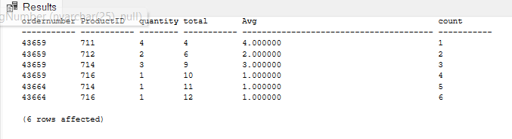
--Question 27
Select [SalesOrderID] ,
Sum([UnitPrice] * [OrderQty]) As Orderidcost
From [Sales].[SalesOrderDetail]
Group By[SalesOrderID]
Having Sum([UnitPrice] * [OrderQty]) > 100000;
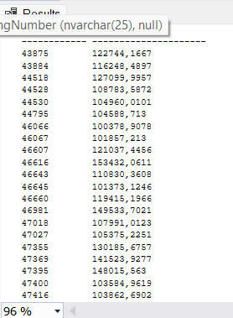
--Question 28
Select [ProductID],
[Name]
From [Production].[Product]
Where [Name] like 'Lock Washer%'
Order by ProductID Asc;
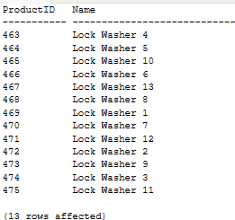

--Question 29
Select [ProductID],
[Name],
[Color]
From [Production].[Product]
Order by [ListPrice]; 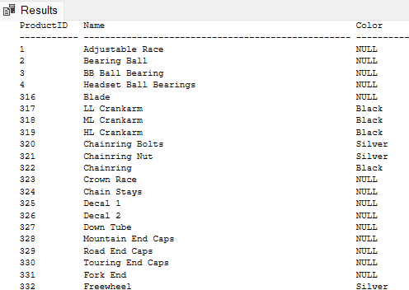

--Question 30
Select [BusinessEntityID],
[JobTitle],
[HireDate]
From HumanResources.Employee
Order by Year(HireDate) Asc;

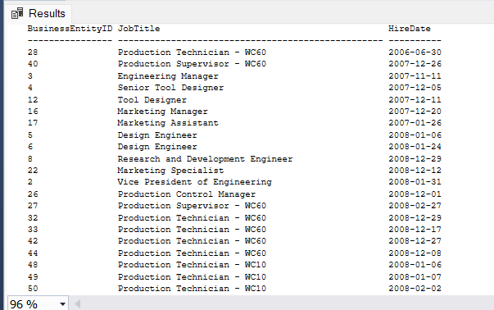

--Question 31
Select [LastName] ,[FirstName] From [Person].[Person]
Where [LastName] like 'R%'
Order by [FirstName] Asc , [LastName] Desc;
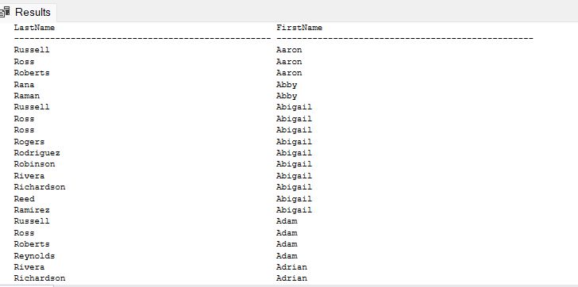

--Question 32
SELECT
[BusinessEntityID],
[SalariedFlag]
FROM [HumanResources].[Employee]
ORDER BY [SalariedFlag],
CASE WHEN [SalariedFlag] = 1 THEN [BusinessEntityID] END DESC,
CASE WHEN [SalariedFlag] = 0 THEN [BusinessEntityID] END ASC;

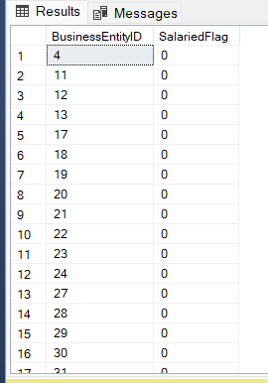

--Question 33
SELECT
sp.[BusinessEntityID],
p.[LastName],
st.[Name] AS TerritoryName,
cr.[Name] AS CountryRegionName
FROM Sales.SalesPerson sp
JOIN Person.Person p
ON sp.BusinessEntityID = p.BusinessEntityID
JOIN Sales.SalesTerritory st
ON sp.TerritoryID = st.TerritoryID
JOIN Person.CountryRegion cr
ON st.CountryRegionCode = cr.CountryRegionCode
ORDER BY
CASE
WHEN cr.Name = 'United States' THEN st.Name
ELSE cr.Name
END;

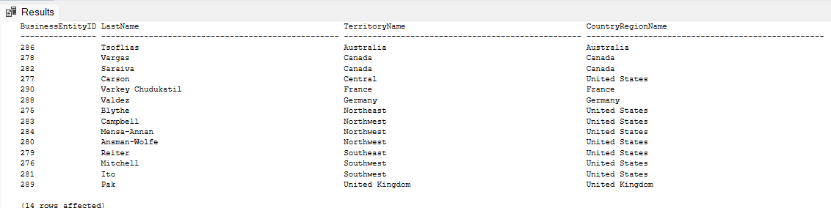

--Question 34
SELECT
p.FirstName,
p.LastName,
ROW_NUMBER() OVER (ORDER BY a.PostalCode) AS [Row Number],
RANK() OVER (ORDER BY a.PostalCode) AS [Rank],
DENSE_RANK() OVER (ORDER BY a.PostalCode) AS [Dense Rank],
NTILE(4) OVER (ORDER BY a.PostalCode) AS [Quartile],
e.SalesYTD,
a.PostalCode
FROM
Sales.SalesPerson AS e
JOIN HumanResources.Employee AS hr ON e.BusinessEntityID = hr.BusinessEntityID
JOIN Person.Person AS p ON e.BusinessEntityID = p.BusinessEntityID
JOIN Person.Address AS a ON e.BusinessEntityID = a.AddressID
WHERE
e.TerritoryID IS NOT NULL
AND e.SalesYTD <> 0
ORDER BY
a.PostalCode;

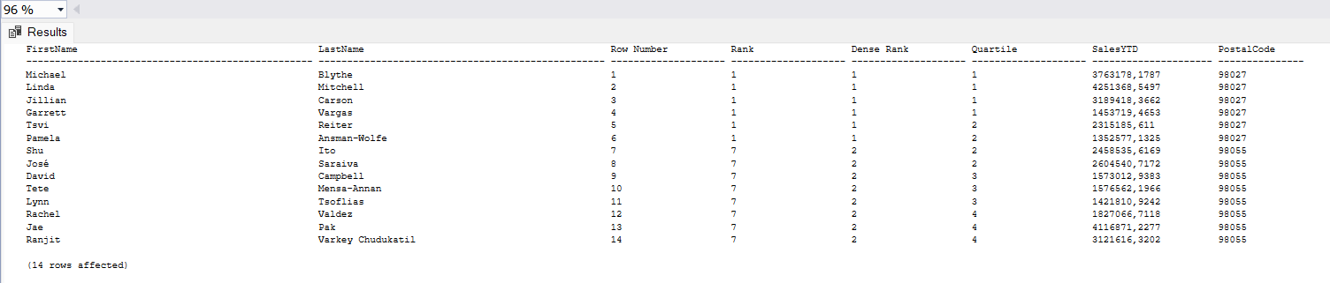

--Question 35
SELECT *
FROM [HumanResources].[Department]
ORDER BY [DepartmentID]
OFFSET 10 ROWS;
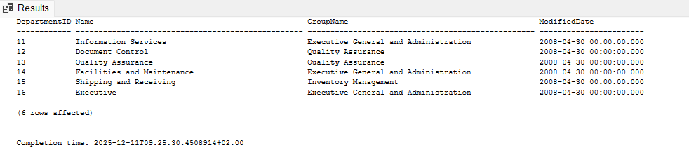

--Question 36
SELECT *
FROM [HumanResources].[Department]
ORDER BY [DepartmentID]
OFFSET 5 ROWS
FETCH NEXT 5 ROWS ONLY;
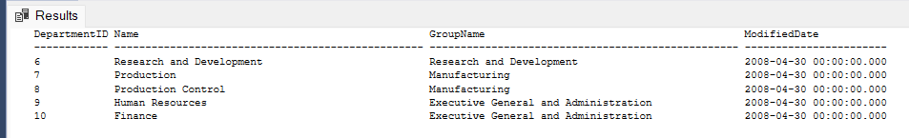
--Question 37
SELECT [Name],
[Color],
[ListPrice]
FROM [Production].[Product]
WHERE Color = 'Red' or Color ='Blue';
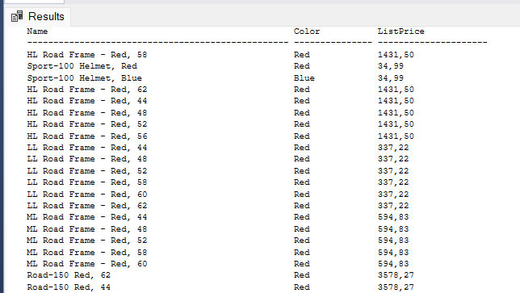

--Question 38
SELECT
p.Name ,
sod.SalesOrderID
FROM Production.Product p
FULL OUTER JOIN Sales.SalesOrderDetail sod
ON p.ProductID = sod.ProductID
ORDER BY
p.Name;
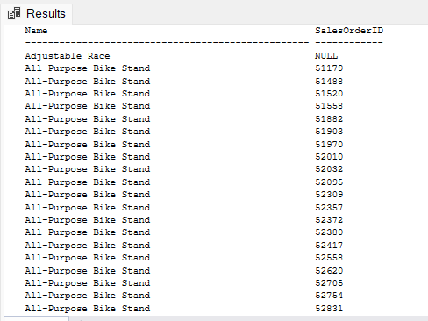

--Question 39
SELECT
p.Name AS ProductName,
s.SalesOrderID
FROM
Production.Product p
LEFT JOIN
Sales.SalesOrderDetail s
ON
p.ProductID = s.ProductID
ORDER BY
p.Name;

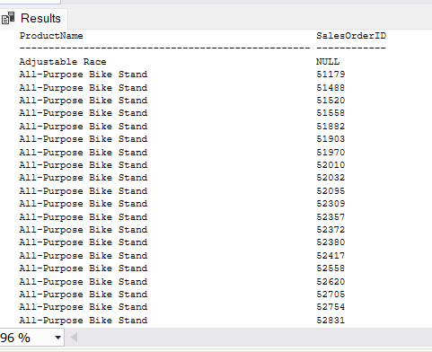

--Question 40
SELECT
p.Name AS ProductName,
s.SalesOrderID
FROM
Production.Product p
LEFT JOIN
Sales.SalesOrderDetail s
ON
p.ProductID = s.ProductID
WHERE
s.SalesOrderID IS NOT NULL
ORDER BY
p.Name;
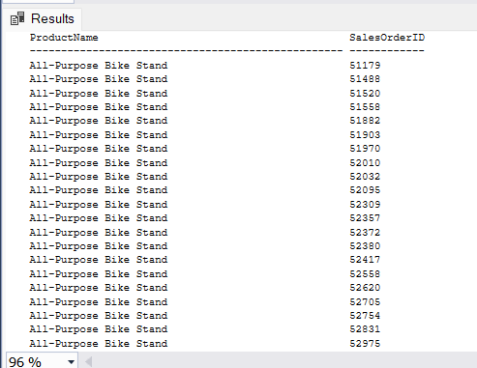

--Question 41
SELECT
t.Name AS territory,
sp.BusinessEntityID
FROM
Sales.SalesPerson sp
LEFT JOIN
Sales.SalesTerritory t
ON
sp.TerritoryID = t.TerritoryID
ORDER BY
t.Name;

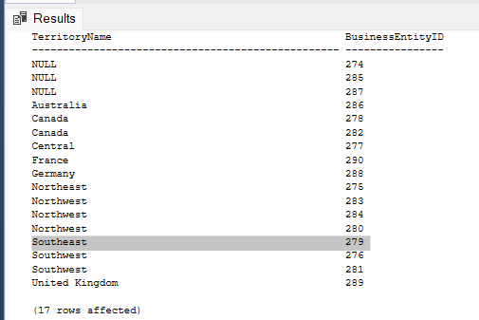

--Question 42
SELECT
p.FirstName + ' ' + p.LastName AS FullName,
a.City
FROM
HumanResources.Employee e
JOIN
Person.Person p
ON e.BusinessEntityID = p.BusinessEntityID
JOIN
Person.BusinessEntityAddress bea
ON e.BusinessEntityID = bea.BusinessEntityID
JOIN
Person.Address a
ON bea.AddressID = a.AddressID
ORDER BY
p.LastName,
p.FirstName;

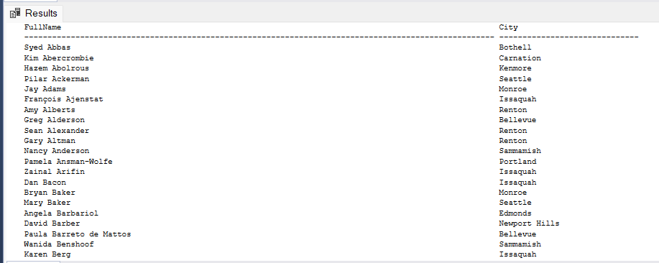

-- Question 43
SELECT d.BusinessEntityID,d.FirstName,d.LastName
FROM
(
SELECT BusinessEntityID,FirstName,LastName,PersonType
FROM Person.Person
) AS d
WHERE d.PersonType = 'IN' AND d.LastName = 'Adams'
ORDER BY d.FirstName ASC;
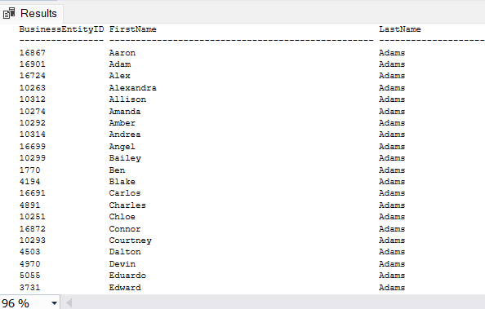

-- Question 44
SELECT BusinessEntityID,
FirstName,
LastName
FROM Person.Person
WHERE BusinessEntityID <= 1500 AND LastName LIKE 'Al%' AND FirstName LIKE 'M%';
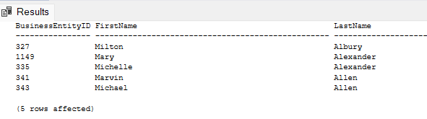

-- Question 45
SELECT
p.ProductID,
p.Name,
p.Color
FROM
Production.Product p
JOIN
(SELECT 'Blade' AS ProductName
UNION ALL SELECT 'Crown Race'
UNION ALL SELECT 'AWC Logo Cap') AS dt
ON
p.Name = dt.ProductName;

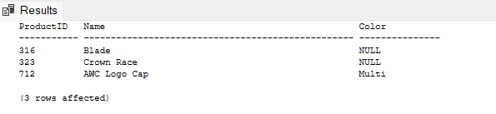

-- Question 46
SELECT SalesPersonID,
COUNT(SalesOrderID) AS TotalSales,
YEAR(OrderDate) AS SalesYear
FROM Sales.SalesOrderHeader
WHERE SalesPersonID IS NOT NULL
GROUP BY SalesPersonID, YEAR(OrderDate)
ORDER BY SalesPersonID, YEAR(OrderDate);
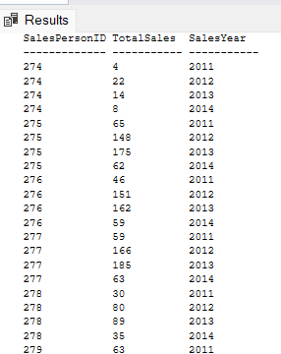

-- Question 47
SELECT
AVG(TotalSales) AS [Average Sales Per Person]
FROM
(
SELECT SalesPersonID,
COUNT(SalesOrderID) AS TotalSales
FROM Sales.SalesOrderHeader
WHERE SalesPersonID IS NOT NULL
GROUP BY SalesPersonID
) AS SalesTotals;
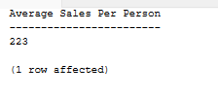
--Question 48
SELECT *
FROM Production.ProductPhoto
WHERE LargePhotoFileName LIKE '%green_%';
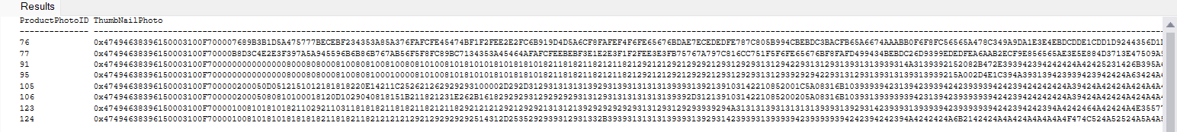

-- Question 49
SELECT
a.AddressLine1,
a.AddressLine2,
a.City,
a.PostalCode,
sp.CountryRegionCode
FROM Person.Address a
INNER JOIN Person.StateProvince sp
ON a.StateProvinceID = sp.StateProvinceID
WHERE sp.CountryRegionCode <> 'US'
AND a.City LIKE 'Par%'
ORDER BY a.City , a.AddressLine1;
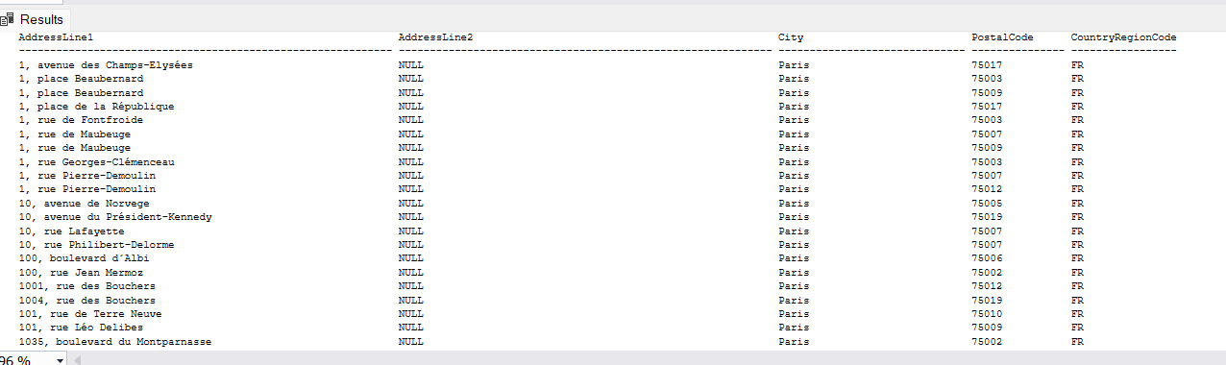

--Question 50
SELECT TOP 20 JobTitle,
HireDate
FROM HumanResources.Employee
ORDER BY HireDate DESC;
