Meetings

# Meeting 1 Introductions

The first meeting about the project allowed the client, my supervisor and I to meet each other and get some overall requirements for the project. The main requirements for the application as specified by the client was:

* Clarified the problem of information about antibiotic medicine is hard to find quickly when in places like hospitals with poor signal and no internet connection. App needs to work offline and easy to access.
* IOS application preferred but both IOS and Android wanted.
* Colour coded to easily refer to the pathogens and activity codes.
* Would like a disclaimer at the start.
* Suggestions on what antibiotics to use and what are dangerous in combination.
* Emphasis on visual warnings such as red to indicate bad combinations.

Other various interface design and database structures were discussed with supervisor. A site created for this purpose was looked at for some information on the subject.

# Meeting 2 Refining Requirements

The second meeting the interface I designed was commented on and refined to suit the client. Changes were made such as navigating on the pathogen and drug view to have a more segmented interface rather than all the information on one view. A colour coded side bar was added and a tabbed heading navigation was added to the top of the view. Also an extra feature was discussed to be able to test your selection of antibiotics to see if there are any issues such as needing to check kidney function when using a certain combination of drugs. The image below is my client’s drawings editing my own.

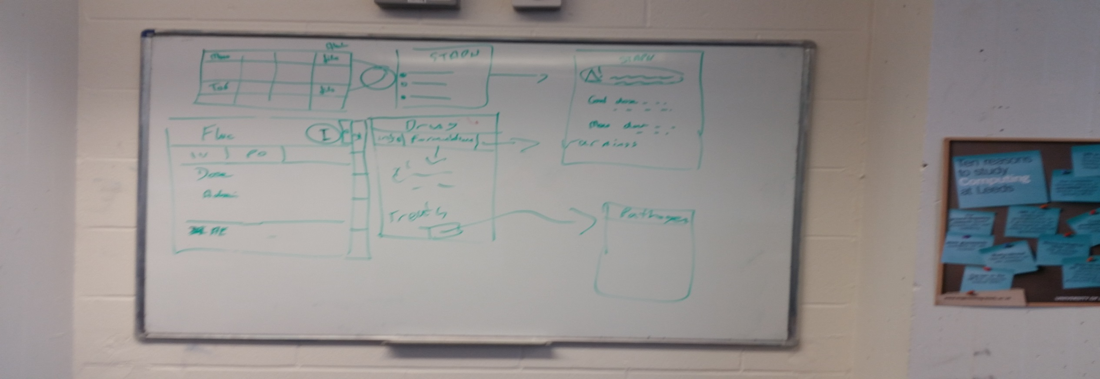

# Meeting 3 Data structure

This was a shorter meeting about structure of the drug and pathogen objects. The fields of each object was discussed to make sure I had the correct idea and the client made me a help sheet to know what each drug and pathogen should have about them. The database structure was also discussed but agreed that this should be though about and implemented in the second iteration and just to get the mobile app running first. A deadline was set to have a working version of the mobile app by the 24th of February.

# Meeting 4 Presentation of First Iteration

I showed the app to my client in meeting room 715 with my supervisor in the SoC reception. The client was very impressed and offered some constructive criticism on the interface and the operation. The main points were:

* The ordering of which fields appeared on the drug detail view of the app.
* It should be more obvious if it is for adult or paediatric.
* Colour scheme was liked but few changes wanted such as no turquoise.
* The dose is not a number but a block of text so needs a field not a label.
* Titles like “treatment for” should be replaced with more standard medical terminology like “indications”.
* A search feature would be really helpful to be able to search for brand names of a drug if you didn’t know the generic name.
* First and second line drugs should be less structured so one column on the picker is best, to prevent arguments between different experts, instead of two.
* A pathogen spectrum button should be added as the indications should be a block of text not a list of the pathogens. So I suggested that the button will take you to another view with a list of the pathogens which was agreed.
* The originally intended ability to embed links into the text has been decided not to be implemented as having lots of links in a small block of text may lead to users pressing them by accident causing frustration. All the information will be accessed by the navigation already provided as well as a few buttons here and there.