School of Computing 

COMP*<XXXX>* Scoping and Planning Document

|  |  |
| --- | --- |
| **Student Name: Matthew Watson** | |
| **Programme of Study: IT** | |
| **Provisional Title of Project:** NHS01 The Leeds Method of Management antibiotic app. | |
| **Name of External Company** (if any)**: NHS** | |
| **Supervisor Name: Brandon Bennett** | |
| **Type of Project: Software Product.** | |
| ***NOTE to student****: ensure you have followed the instructions in the VLE for the writing of this report and you have discussed the content with the supervisor well in advance of the deadline for submission.*  ***An electronic version*** *of this report in pdf must also be submitted via the appropriate module folder in the VLE; with filename of the format*  *<surname><year>-MPR ( e.g. SMITH15-MPR.pdf)* | |
| **Signature of Student:** | **Date:** |
| **Assessor** *(leave blank)***:** | |
|  | |

Contents

2 Introduction to project 1

2.1 Problem statement 1

2.2 Possible solution 1

2.2.1 Figure one. 2

2.3 How to demonstrate the quality of the solution 3

3 Scope for this project 3

3.1 Aim 3

3.2 Objectives 3

3.2.1 Must Have: 4

3.2.2 Should Have: 4

3.2.3 Could Have: 4

2.3 Deliverables 4

4 Project schedule 5

4.1 Methodology 5

4.2 Tasks, milestones and timeline 5

4.3 Risk assessment 5

5 References 6

5.1 Appendix A. How ethical issues are addressed 7

# Introduction to project

The reason for this project is to create mobile applications for use by health care professionals to look up treatments for Lung infections. People with cystic fibrosis are vulnerable to lung infections that are usually harmless to healthy people. Cross-infection can be deadly to people with cystic fibrosis, this means they need extra care and need quick treatment to make sure they have a better quality of life [1]. To treat these infections combinations of toxic antibiotics have to be used. Doctors can sometimes struggle to find information quickly about choosing the right antibiotics for a specific pathogen. The main aim of the mobile applications is to allow fast access of this information while working in hospitals where there may be no internet connection thus making it hard to get the information. The mobile application will update when a connection is present then will store this information on the device to be used even if there is no internet connection. This will enable doctors to have a quick reference guide on hand.

## Problem statement

The problem is bad internet connectivity in hospitals making it hard to for doctors to have quick access to information. This particular problem is the access to information on antibiotics to treat lung infections. There is a need for a quick reference guide on a mobile device that can be updated by an expert. The application needs to update when a connection is present but work offline. There needs to be an admin system to allow an expert to update the information on the mobile applications.

## Possible solution

This project relies on the following modules of my degree program; Distributed Systems, Mobile Development, Core Programming, Network and IT management, Software engineering, Graphical User Interfaces and Usability Design.

A possible solution to this is to create an IOS and possibly an Android application with administration system and server. There is a lot of debate over which operating system is more popular but all agree that IOS and Android hold most of the market in comparison with Windows Phone, Blackberry etc.[2][3]. Part of the solution is to create a RESTful server application to handle the updating and storage of the information. The final part of the solution will be a website or application to handle the administration of the data on the RESTful server with a secure login to make sure only experts have access to edit this critical information. A diagram of the solution is shown below in figure one.

### Figure one.

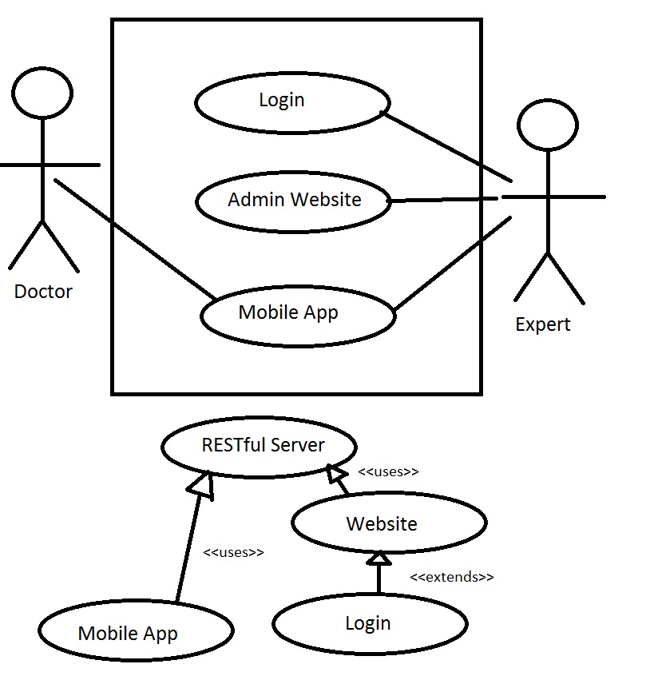

The application should be able to display all the critical information at a glance while offering further information on request.

The method of the mobile app solution follows the following steps:

* Mobile application checks for internet connection.
* If connection exists asks for an update using a get request to the RESTful web service.
* The RESTful server parses a structured XML file back to the app which contains all the details of the antibiotic objects and pathogen objects.
* The XML file is then translated by the app to create the objects for the app to display and use.

The method of the admin application or web app follows the following steps:

* The login is checked to make sure only an expert can edit the data to be shown on the app.
* The website uses a “get” request from the RESTful web service to current the current version of the data and displays all the objects in a readable manner. If non-exists it will ask for the expert to create one.
* The admin app will then ask if the expert wants to edit or create the data.
* The admin app display will be a set of fields that can be filled in either about an antibiotic or a pathogen this data is used to create the objects. It should be structured in such a way that it’s easy for an expert to just “fill in the gaps”. This should just display common properties of the drug or pathogen that can create the objects for the app.
* Once the data has been created or edited the app will then post or update the server to have the most up to date data this will be parsed in XML like the app receives the information.

## Why REST?

Having a RESTful layer means that any application from any operating system can communicate with the server meaning that if needed other developers can look at the API and create their own app that displays the data the way they want it. REST is stateless meaning doesn’t rely on traditional methods of communicating with a server as it doesn’t create a session of persistent connections, it just uses HTTP perform operations on a web service. The benefit of this is speed and scalability as the application can just use a URI to get the exact data it wants without having to follow server protocols and rules or search though a database for data. Another advantage is loose coupling which means it can be platform independent as HTTP can communicate with mostly all devices that can connect to the internet. The client wants this system to be used much after I have finished the system so this is the best way in my opinion for the system to be used easily. I think this because if the app becomes outdated, any developer can just read the API and get the human readable data to be used in their app to be used any way they want. This data will be in XML so any platform can use the data to display the information.

## Why is the main focus IOS, for the mobile App?

The main reason for focusing on IOS is because the client believes this is what most of the students will want to use but an Android app will be strived for if possible. Another good reason to develop IOS is because of the amount of devices you create the app for is very limited, just versions of IPhone/IPad. This makes it easier to test and create interfaces as you are only doing it for a few devices unlike Android which has many different companies such as (HTC, Samsung, Sony etc.) which all have many versions of their devices with varying screen sizes and different versions of the operating systems [5]. As this is quite a short term project IOS definitely seems like the best solution for this reason alone as it will be much faster and safer to create an high quality application that works on IOS devices. If there is time at the end an Android application will be made to a popular device and screen size but catering to all the devices on Android is out of the scope of this project.

## How to demonstrate the quality of the solution

The success of the project will be judged on if the doctors can quickly find the information without guidance. The code of the app should be easily readable and commented to allow other developers to develop it further. The expert should be able to easily understand how to fill in the information. The API should be well documented so others can make apps that can communicate with the server easily. However the admin application should only be able to be used by an authorised person so the post, update and delete requests should be restricted and secure. The application should display the correct data and be easily digestible.

## Scope for this project

The project will deliver a mobile application in IOS and possibly Android with the ability to update over the internet but be used offline. The project will also deliver an admin system that the updates can be easily created without needing knowledge of what is going on in the background. The admin system will be a webpage accessing a RESTful server. The mobile applications will also use the RESTful server to update. The main clientele of the app will be student doctors, other doctors needing this information and the client who requested the app. This app will be released on the app store, if possible, so many others interested in the field may also consume the information.

## Aim

The aim is to create mobile applications that are easy to use and enable health care professionals to quickly access information about antibiotics and pathogens. Also to make sure the system has a long life span and could be expanded to provide information on other types of drugs and diseases. This system should be a generic concept that could be applied to any set of drug and pathogens so could be used widely by health care professionals and people interested in the field.

## Objectives

### Objective One –Research and Gathering Requirements.

Gather minimum requirements from the client to clarify the problem and what is expected from this software. Background research of mobile applications will also be conducted to justify choice of operating system to develop the mobile application for. This research is crucial to the design phase as development of this mobile application for all operating systems will not be possible in the time given to develop this software.

Background research will also be into the existing libraries and how the application should be structured. This research will be to compare possible core components of the software analysing advantages and disadvantages to pick the most suitable approach to develop the software.

### Objective two – Prototyping interface for mobile application.

Produce a prototype designs to show the client. Starting with a low fidelity design that can be easily edited and changed. From the feedback from the client produce a working prototype in IOS as this is the clients preferred operating system. This objective is to make sure the application is looking how the client wants.

### Objective three – Backend implementation of server and mobile application.

From the prototype design and implement some code to create a class/object structure for each piece of data that needs to be displayed. Then parse this data from the server to be displayed on the user interface of the mobile application. The data will be a small sample taken off of the client’s website that holds the data of the drugs.

### Objective four – Database connection

Connect the server to a database either from extracting the already existing data the client has or redesigning the database to suit the features of the mobile application.

### Objective five – Test/ evaluate

Test Applications and perform evaluation this will be done with the help of student doctors supplied by the client. The test will see if the data is accurate and the users can understand how to use the application. This testing will also help identify if there are any unknown bugs and correct them.

## Minimum Requirements

### Must Have:

* IOS Mobile application with ability to operate with no internet connection but update when one is present.
* Way to update information on Mobile application, a server to connect to. This server needs to be homogeneous, have the ability to communicate with various applications on different operating systems and devices.
* Administration system that is easy to create update information for the Mobile Applications, a website system with secure login for example.

### Should Have:

* Available on Apple App Store.
* Administration website so it can be accessed from anywhere.
* Server should be able to not only send the data in XML format but in other MIME types as well.

### Could Have:

* Graphics to make the application more aesthetically pleasing.
* Android Mobile application with ability to operate with no internet connection but update when one is present.
* Cacheable website to be able to use on operating systems that have not been developed in this project e.g. Windows Phone, Blackberry, Desktop computers running various operating systems.

## Deliverables

What I aim to deliver for the project:

* The project report containing information about the project, the justifying of the choices made in development and evaluation of the software.
* IOS mobile application code, working application and documentation on how to use the application.
* The RESTful server/web service with API. The documentation to this is a crucial part of the system as well as the code and instructions on how to use it.
* Database containing all the information the mobile application will display with an interface for administration of the database and documentation of how to use it.

## Project management Methodology

This project is planned to follow and agile methodology having each iteration producing some working software. The reason for doing this is that working with a client plans can change often and following a waterfall approach it doesn’t allow for changes to the plan during implementation. I want the ability to cater to the client’s needs and change the project when needed to make sure the requirements they need are being met.

## Project Schedule

As seen in the Gantt chart in figure 2 the project has been broken down into a series of tasks that need to be completed by certain dates. They are as follows:

### Background reading and requirements gathering. 26/01/15 – 31/01/15.

This is the first task of the project which aims to get the minimum requirements to make a start on developing the software. This task is also to evaluate these requirements and research into what needs to be done to be able to meet the requirements. Meetings with the client and supervisor will be the main source get these requirements.

Goals:

* Find out exactly what the application needs to do and what information it needs to display.
* Research into how the information about the drugs could be stored, how could it be transferred from the server to the application.
* See if any code libraries are needed to be able to implement the application and compare different them to see which ones are best suited to be used.
* Organise future meetings with client and supervisor.

### Planning and Scoping Document. 03/02/15 – 07/02/15

This task is to produce a planning document to be show to an assessor to give an overview of the project. Show how the project will; be planned out, the deliverables expected and the objectives of the project. This feedback will help the first section of the project.

### Deadline for Planning and Scoping Document. 09/02/15

This is first mini deadline to have the planning done by this point.

### First Iteration of Development (IOS Prototype). 10/02/15 – 23/02/15

This the first 14 day iteration where the first prototype will be made to show to the client. Meetings should be more frequent during this iteration if possible.

Goals:

* Design a low fidelity prototype that can be easily changed such as pencil drawing on paper. This can be shown to the client and a basic idea of the interface can be validated.
* Once design is agreed upon create the first working software prototype to show functionality to the client.
* Create structured classes/objects to store the data about the drugs and pathogens.
* Create some test data to fill the fields of the prototype application.
* Report should include details about mobile applications and justify why IOS was chosen.
* Report should include what libraries were used to create the application.

### MILESTONE 1 Review progress 24/02/15

It was decided with the client to have progress meetings every two weeks to show the progress of the application. By the first milestone there should be a working mobile application in IOS that can show details about a group of drugs and pathogens.

### Second Iteration Server Implementation 25/02/15- 10/03/15

This iteration is to create a REST web service that can deliver the mobile applications data through a HTTP get request. The mobile application should be able to understand its repose and display the data.

Goals:

* Create structured objects on the server to store details of each drug/pathogen.
* Server can save objects to and XML file and send them to the application when a URL is accessed.
* Mobile application can access data by using a HTTP response to receive the data.
* Mobile application can save the received data as an XML file and extract objects from that XML file.
* Report should include details about rest and the justification of this choice.
* Report should include the libraries and programming language used to create the server.

### MILESTONE 2 Review progress 10/03/15

The Application should be able to get data from a server and display it. The client will then validate that it working correctly.

### Third Iteration Database Implementation 11/03/15 – 24/03/15

The server should be able to interface with a database to create many objects filled with data about drugs and pathogens to be saved to an XML file and passed to the mobile application on request.

Goals:

* Server can parse the entire database of data to the mobile application.
* Server can interface with database to fill objects with data.
* Server can query the database when certain URL’s are entered.
* Database can be edited with an administration interface
* Report should reflect choice of database server or a local database stored on the rest server.
* Report should include details of the libraries used to communicate with the database.

### MILESTONE 3 Review progress with client.

This should be delivery of the basic working system where the data from the database can be displayed on the application. The client will validate if this is what was intended for the application. If any changes need to be made they will be done in the fourth iteration.

### Progress Deadline 24/03/15

The application will be presented to assessor to show that can display the data and communicate with the server. The progress can be then validated by the assessor and comment if any changes are needed.

### Forth Iteration Make Changes 25/03/15- 07/04/15

This iteration will be to make any changes requested by the client to the interface or operation. Features such as comparing drugs, viewing details about each pathogen that a particular drug treats will be added.

Goals:

* Add extra features requested by the client.
* Make changes requested by the client.
* Have a fully working system.
* Add details of implementation into report.

### MILESTONE 4 Review Progress with client 07/04/15

This milestone will be to check that the client is ready for the application to be deployed. This is because once the IOS curation process is very strict and it has to be fully developed before it goes on to the IOS Application Store and won’t allow any major changes after this point.

### Evaluation stage 08/04/15 – 14/04/15

This is going to be the live testing stage. The client has said they can provide students to test the application to see if the mobile application works properly, find any unknown bugs and get some feedback on the interface. Changes will be made if needed.

### Fifth Iteration Polish and deploy 15/04/15 - 21/04/15

This iteration will be concerned with making sure the application passes the curation process and can be released on the IOS Application Store.

Goals:

* Get on the IOS Application Store
* Add evaluation to report.

### Extra Time 22/04/15- 05/05/15

This part of the schedule is for if any of the iterations over run I know I have an extra 14 days to alter the schedule if I encounter a problem. This could be a difficult bug to solve, long wait on the curation process or the client not being available when needed and halts progress. Days can be added to other iterations and deducted from this time to make sure the project is completed on time. This time will also be used for the report and presentation.

### Finishing report and presentation. 06/05/15 – 10/05/15

By this time the report should be almost finished and just needs proof reading and some minor alterations. The presentation should also be at this stage.

### DEADLINE 11/05/15

Everything has to be completed and handed in on this date.

## Risk assessment

There are many risks involved with this project as it relies on many outside factors such as the application stores and the client’s needs for the project. An example of this is if the client is unavailable for a long period of time it might be hard to get all the criteria needed to make the application successful or even test it with the servers he wants to use. To minimize this risk we are having lots of meetings at the start to make sure there is good understanding of the requirements for the project. Thus meaning if the client is unavailable the project can proceed without client input. The client is also providing the servers so timing and planning will need to be perfect to make sure the servers are able to run my applications etc. as well as all the security procedures that will be needed. This is quite a big risk and may cause problems later on in the project but to minimize the risk the client has specified I can choose what type of server I want and he will get it minimizing potential compatibly issues if I did not know what server was going to be used.

There is also a major security risk as this application is going to be available publicly and handles data that can affect people’s lives. For example if a malicious user managed to get past the security of the log in and have access the data they could change crucial information about the dosages etc. which may lead to inexperienced doctors providing the fatal doses of the drugs. This means the security will have to be tested thoroughly to make sure the data for the app is secure as possible.

Below is a risk assessment table to give more details of the risks.

|  |  |  |  |  |
| --- | --- | --- | --- | --- |
| Risk | Probability of Risk | Amount of impact on project | Preventative Measures | Stakeholders affected |
| Malicious Users corrupting the data or breaking the application. | Low | High | Security features such as a log in feature and server not allowing any requests other than GET from the mobile app. | People using the app. Creator. Client. Application store. University. |
| Budget costs of servers and publishing the application on the App stores being too high to successfully implement. | Low | High | Appropriate planning during the final phase of the project. Once everything is implemented and working locally costing can be predicted of how to publish it on the system in the hospital and on the application store(s). This will help keep the costs down to be able to implement the system efficiently. | Client. Creator. |
| Client Unavailable for some stages of implementation and testing. | Medium | Low | Planning around the client’s busy schedule to make sure requirements are met. Get most of the key requirements at the beginning the “must haves” to make sure all the important functional features are in the project. | Client. Creator. |
| Data is not correct in application | Low | High | As some doctors may be prescribing toxic drugs based on information in this application is key that is validated and checked. Failing to do this may result in overdoses of drugs leading to illness even death. | People using the app. Creator. Client. Application store. University. |

# References

**[1] Cysticfibrosis.org.uk. 'Cross-Infection - Cystic Fibrosis Trust'. N.p., 2015. Web. 29 Jan. 2015.**

**[2] Arthur, Charles. 'Three Graphs To Stop Smartphone Fans Fretting About 'Market Share''. The Guardian. N.p., 2014. Web. 29 Jan. 2015.**

**[3]Marketshare.hitslink.com. 'Operating System Market Share'. N.p., 2015. Web. 29 Jan. 2015.**

**[4]Taylor, Bryan. 'What Are The Advantages/Disadvantages Of Using REST API Over Native Libraries? - Quora'. Quora.com. N.p., 2015. Web. 10 Feb. 2015.**

**[5]** **Hata, Kosuke. 'Why Do Mobile App Developers Tend To Build On IOS First Rather Than Other Platforms Like Android? - Quora'. Quora.com. N.p., 2015. Web. 11 Feb. 2015.**

# Appendix A. How ethical issues are addressed

## Working with NHS member of Staff and other members of the medical faculty.

The client works for the NHS, no personal details of the client will be published in this report. No personal details of any other member of the faculty, students or otherwise, testing the applications will be published. This application does not deal with patient data so that ethical issue does not need to be addressed.

## The Data in the Application can affect people’s lives

As doctors may be using this application to prescribe drugs the information in the application will have to be correct and a disclaimer will be shown not to base all judgement on the information about the drugs in the application. Links will be put into the application to the website where the information is being held to allow additional confirmation when an internet connection is present.