FamPlan Demo Outline and Lab 4 and 5 Checklist
Banana Five-O · Draft, 31 October 2026 · Checked against main with the commute update, a clean test run and the live site, which does not have the update yet
The live demo fits 20 minutes: the 14 minutes of demo the team agreed, about 5 minutes on design and traceability, and a short close (Lab 5 §3.1). The video script is ready to record this weekend.
Sort out these first:
- OneMap login, before recording: a spec note says the team's renewed token expires on Sunday 1 Nov at 18:04 Singapore time. Confirm the live site uses account login, or record before then.
- Commute update: both of Ilham's commute items are fixed and merged to main, and both scripts now show them. The live site does not have them until Edward applies the database migration and deploys. Re-shoot the live-site screenshots after that.
- Administrator login: Edward's part needs a live administrator account, and whether one exists is still unconfirmed.
- AI report: this Lab 4 deliverable is not in the repo on any branch.
- Old script: FamPlan_Demo_Script.docx still describes an older build, so several of its lines are wrong. See Claims to use and drop.
About the screenshots: "Live site" shots come from famplan-amber.vercel.app on 31 Oct, before the commute update, so they still show Transit and Drive until re-shot. Screens that need a login come from a local test copy with test accounts and real public data, so replace them once a live account is ready. The architecture and design layer figures come from SRS v1.6 and the other diagrams from the Lab 3 and Lab 4 documents, so swap in Ilham's re-renders when they are done.

Run of show
Time | Presenter | Part | Use cases | On screen
0:00–2:00 | Apollo | Problem, value, actors, stack, register and log in | UC-1.1, UC-1.2 | Landing, use case diagram, Register
2:00–5:00 | Raph | Family priorities and search | UC-2.1, UC-3.1, UC-3.2 | Preferences, Explore
5:00–9:00 | Ilham | Selected location, radius, map, commute | UC-4.1, UC-4.2, UC-5.1, UC-5.2 | Profile, Commute
9:00–12:00 | Athena | Score, comparison, shortlist | UC-6.1, UC-6.2, UC-6.3 | Profile, Compare, Shortlist
12:00–14:00 | Edward | Data monitoring | UC-7.1 | Data sync dashboard
14:00–16:30 | Edward | SE practices, system design, future upgrades | None | Slides: SRS §8.2, §9.4
16:30–19:00 | Ilham | Traceability for one use case | UC-6.1 | SRS, VS Code, terminal, test document
19:00–19:30 | Apollo | Close | None | Landing
19:30–20:00 | All | Buffer, then Q&A | None | None

The chat table stops at Edward with 14 minutes, so this outline gives the design slot to Edward and traceability to Ilham, as in the old script. Change these if the team split them differently.
UC-1.3 to UC-1.5 (reset password, manage account, delete account) are mentioned, not shown. The live site has no email service configured, so a password reset cannot complete there.
If the TA holds us to the 15 minutes in Lab 4 §2.6, start already signed in, compare two neighbourhoods instead of three, and give design and traceability 90 seconds each.

Live demo script
Every part follows one family, the Tans: a toddler, a child starting Primary 1, a parent working at one-north, and grandparents in Bedok. Each presenter shows one step of their decision and adds one engineering or design point.
Land these six star features. Each pairs value for the family with an engineering or design point.
Star feature | Shown by | Why it matters, and the point to make
A score that explains itself | Athena | Families see why a neighbourhood fits, not just a number. Design: 8 weighted criteria, missing data disclosed, and one versioned configuration.
Exact address search | Raph, Ilham | A family is choosing a home, not a zone. Design: OneMap resolves the address, and the radius, counts and score all recalculate from that coordinate.
Commute for the whole family | Raph | Each destination has its own travel mode, and every destination moves the ranking. Design: a simple average that is easy to explain.
Data that refreshes itself | Edward | 9 public datasets update daily with no uploads. Engineering: validated snapshots stay live when a provider fails, as happened with Overpass.
Live routes that stay honest | Ilham | OneMap routes in 4 modes, and the app says when step-free data or routing is unavailable.
Built to scale and extend | Apollo, Edward | A new source is one adapter. 283 automated tests. In a local load test, one server handled 1,000 simulated users with no failed requests.
This covers the teacher's notes: value proposition in Apollo's opening, architecture and stack in Apollo's part near the start, engineering points in each "Point to add", and design choices on exact search and the commute average.

Apollo, 0:00–2:00: the problem and who it serves
Script | Visual reference
Show  Landing page. Scroll slightly so the counters run.  Say  FamPlan is for couples planning a family in Singapore. Today they check childcare, schools, clinics, MRT and commute across separate sites. FamPlan puts them in one place, with a score for their own family that they can explain. | 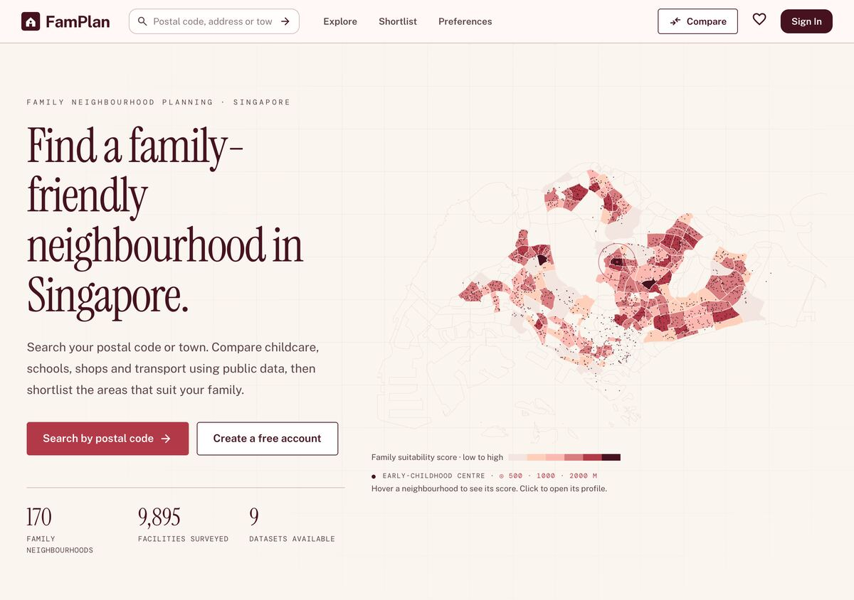  Live site
Show  Hover a neighbourhood on the landing map.  Say  This is real public data, not sample data.  Point to add  170 neighbourhoods, 9,895 facilities and 9 datasets. We list residential subzones with at least three early-childhood centres. | 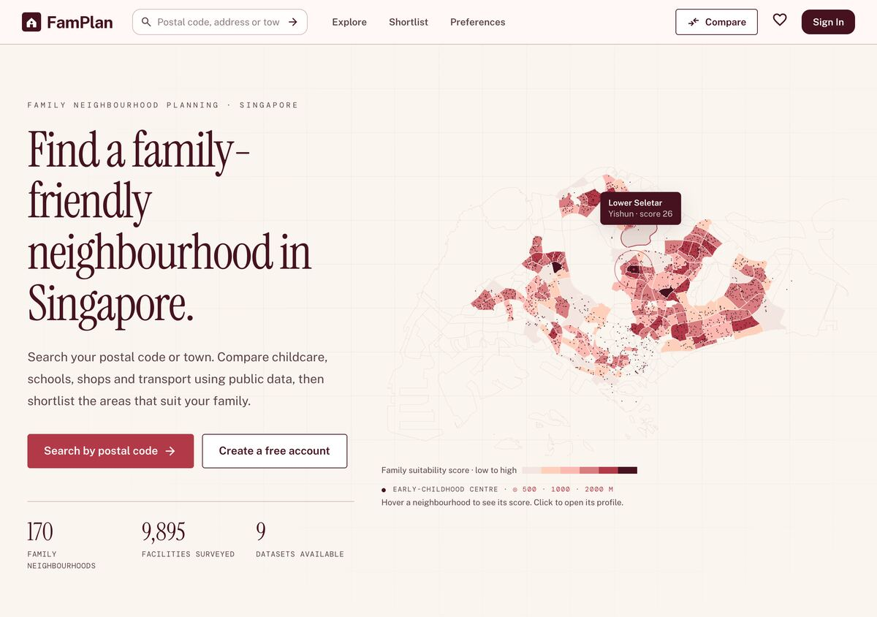  Live site, with a neighbourhood hover label
Show  Use case diagram, then the architecture figure with one line on the stack.  Say  There are three actors: visitor, registered user and data administrator. FamPlan is built with React and TypeScript, an Express API and PostgreSQL through Prisma, with Leaflet and OneMap for maps.  Point to add  16 use cases. Hosted on Vercel in Singapore. In a local load test, one server handled 1,000 simulated users browsing with no failed requests. | 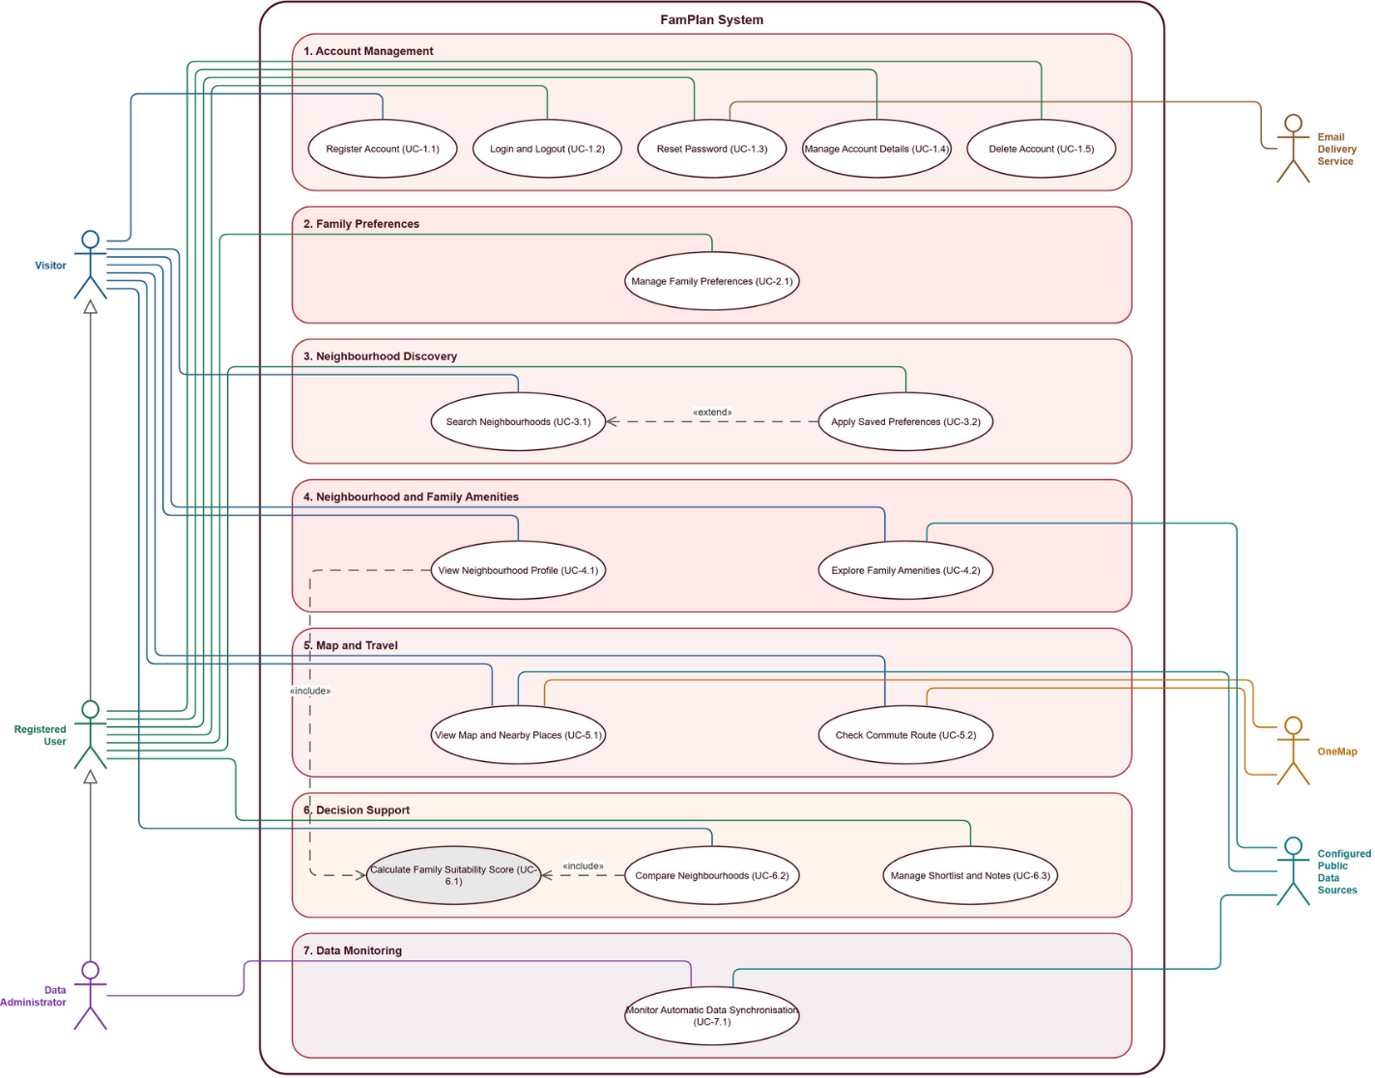  Use Case Descriptions v1.0, Figure 1
Show  Register, tick consent, log in.  Say  Visitors can search, view, compare, check commutes and try weights for one visit. Registered users also save preferences, a shortlist and private notes.  Point to add  Passwords need at least 10 characters, with a letter and a number, and are hashed with Argon2id. Sessions are HTTP-only. | 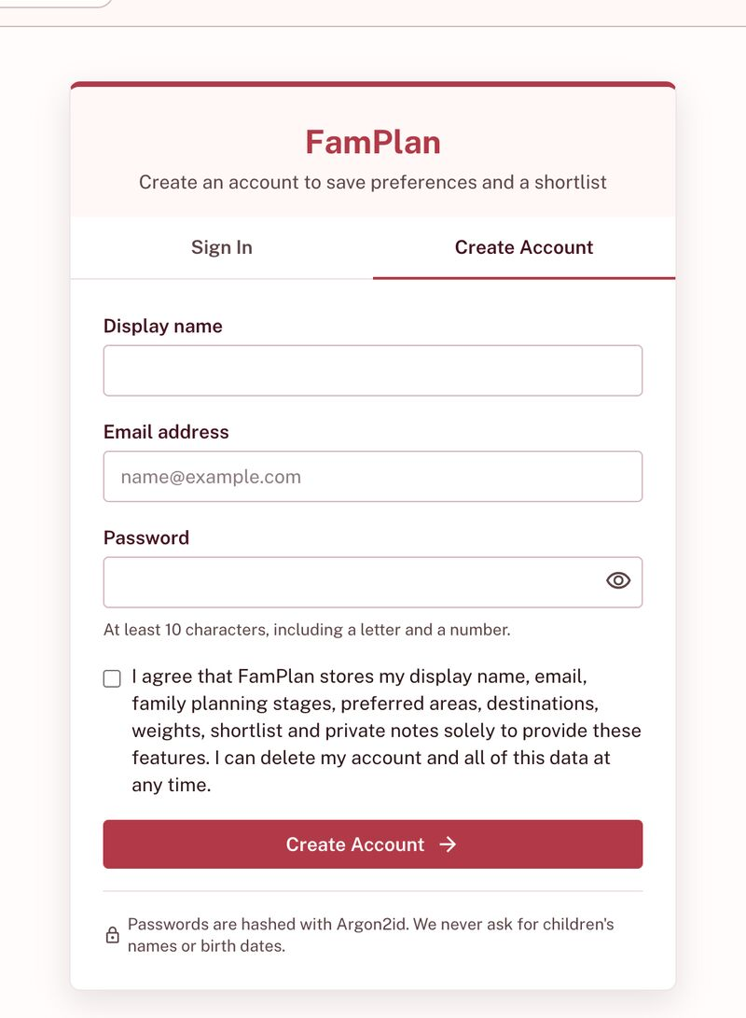  Live site

Raph, 2:00–5:00: family priorities and search
Script | Visual reference
Show  Preferences: tick Preschool and Primary school, click Suggest from stages.  Say  Weights are this family's priorities: 0 means ignore, 5 means essential. FamPlan suggests a starting point from their stages.  Point to add  We ask for planning stages only, never children's names, birth dates or medical details. | 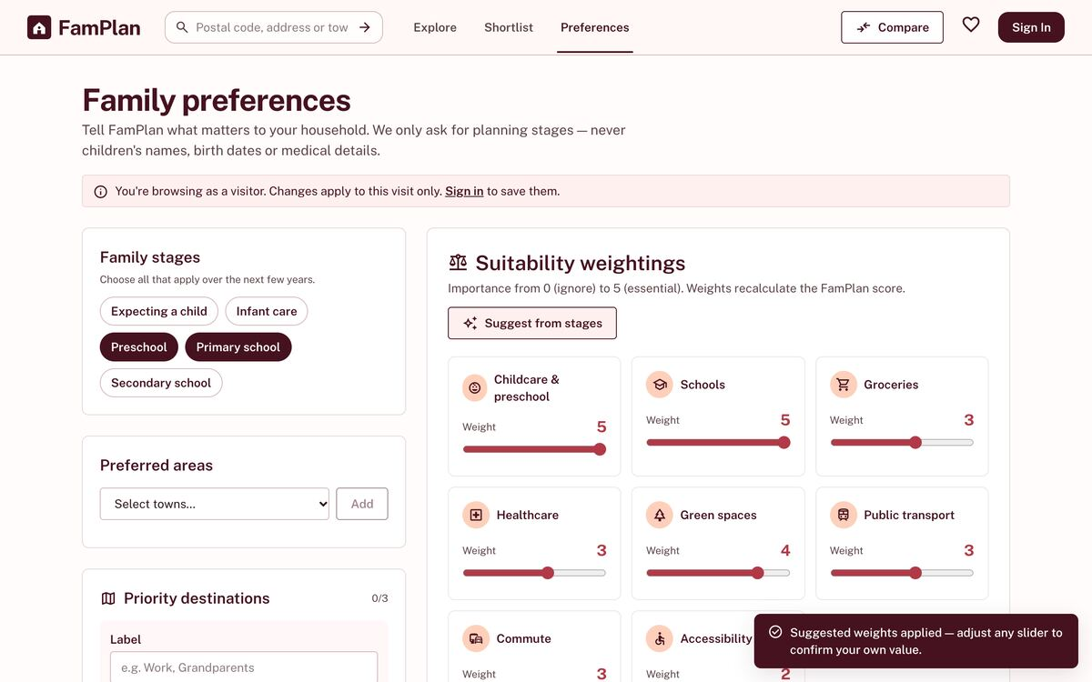  Live site, visitor view
Show  Move Green spaces to 5. Add the label Work with postal code 138632, choose Car as its travel mode, then click Save preferences.  Say  Moving a weight marks it as confirmed, so later suggestions keep it. Each destination has its own travel mode, because one parent might drive while the other takes the MRT.  Point to add  One validation schema is shared by client and server, so they cannot disagree. | 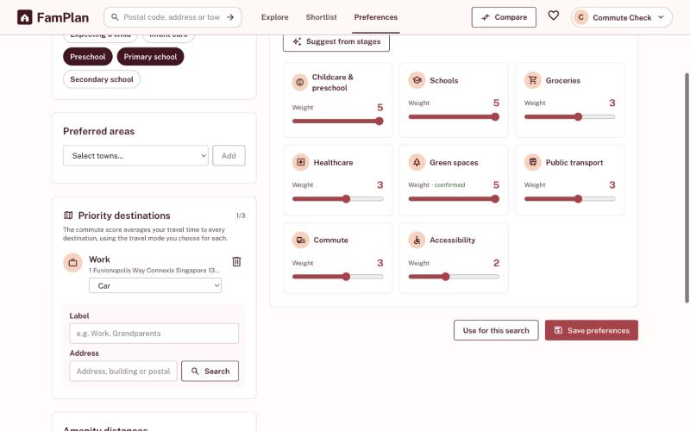  Local test copy, signed in
Show  Explore: Apply my preferences.  Say  The ranking now follows this family's priorities, and the list narrows to their family stages.  Point to add  Top three on the local copy: Kebun Bahru 98, Serangoon Central 96, Jelebu 92 (31 Oct; recheck before the demo). | 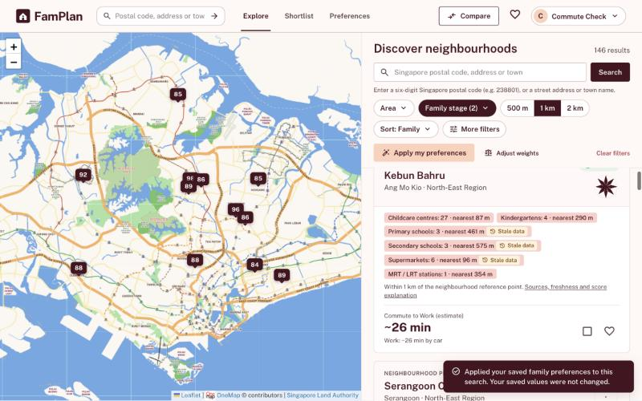  Local test copy, signed in
Show  Preferences: add the label Grandparents with Bedok MRT, keep Public transport, then click Save preferences. Explore: Apply my preferences.  Say  Every destination counts now. The commute score averages both trips, each by its own travel mode, so the ranking changes.  Point to add  Katong replaces Jelebu in the top three on the local copy (31 Oct; recheck). Design choice: a simple average, because it needs no extra input and is easy to explain in the breakdown. | 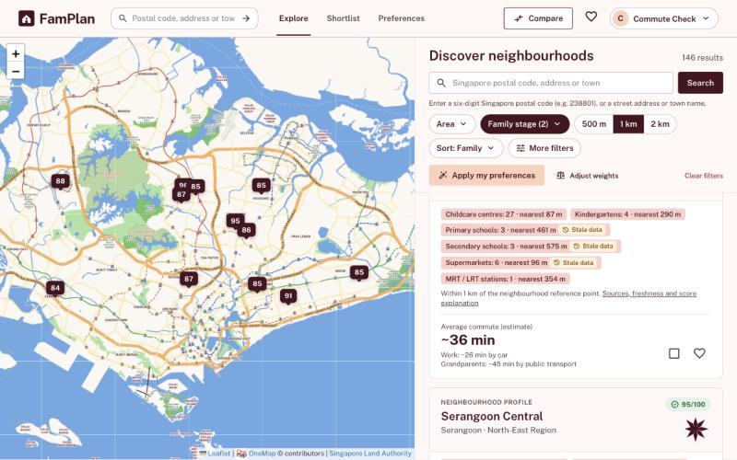  Local test copy, signed in
Show  Search postal code 529510.  Say  A family thinks in addresses, not planning zones, so a postal code goes straight to the exact place.  Point to add  Design choice: we added exact search because a town centre can be far from the home being considered. How: OneMap turns the postal code into a coordinate, and FamPlan recalculates the radius, counts and score from it. | 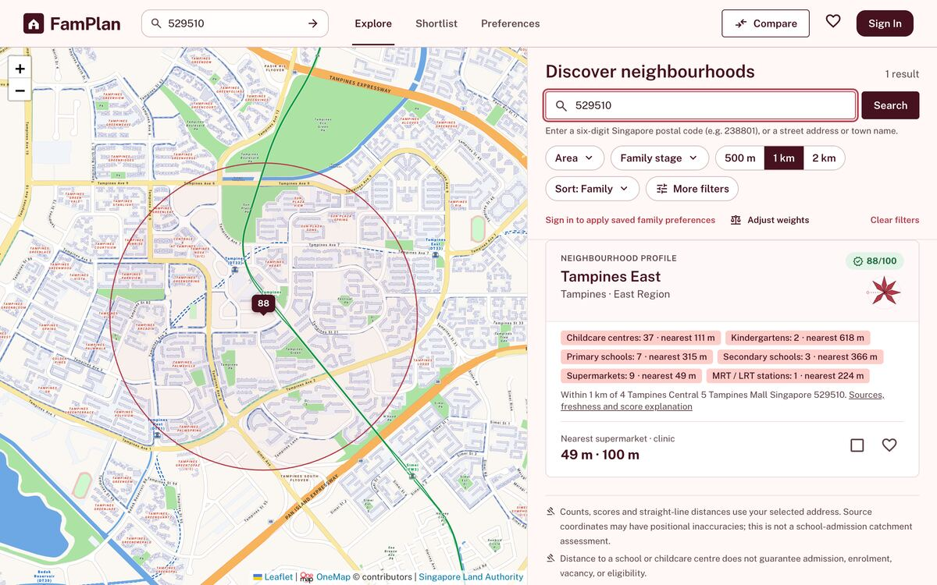  Live site
Show  Search the place name Tampines Mall, pick the first of the 3 matches.  Say  Several places match, so FamPlan asks instead of guessing.  Point to add  OneMap resolves the address. A provider outage is never reported as "no such place". | 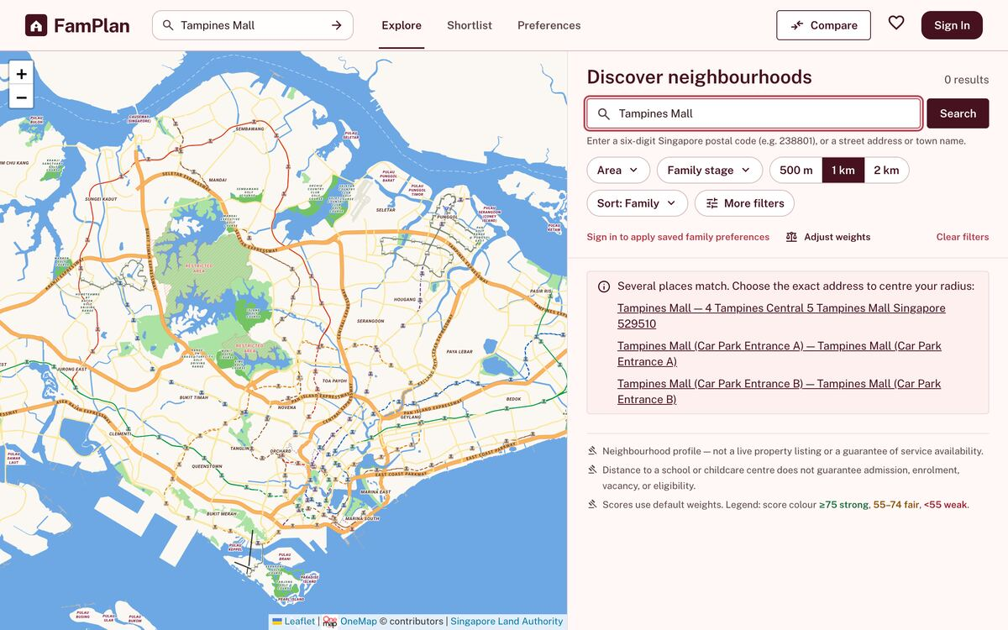  Live site

Ilham, 5:00–9:00: the selected location and the commute
Script | Visual reference
Show  Open the Tampines East result.  Say  Radius calculations start from the selected address, not the centre of the zone.  Point to add  Tampines East scored 83 from its reference point and 88 from this address on default weights (31 Oct; recheck before the demo). | 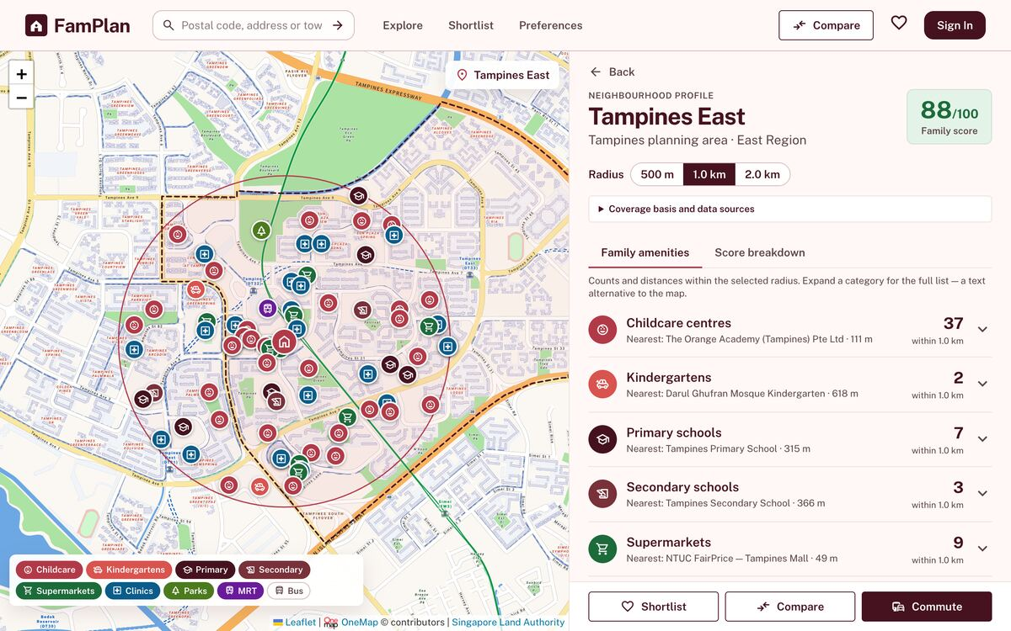  Live site, 1 km
Show  Radius 500 m, 1 km, 2 km.  Say  The map circle and the counts update together.  Point to add  Inclusion uses unrounded great-circle metres; rounding is for display only. It is not a walking distance or a school catchment. | 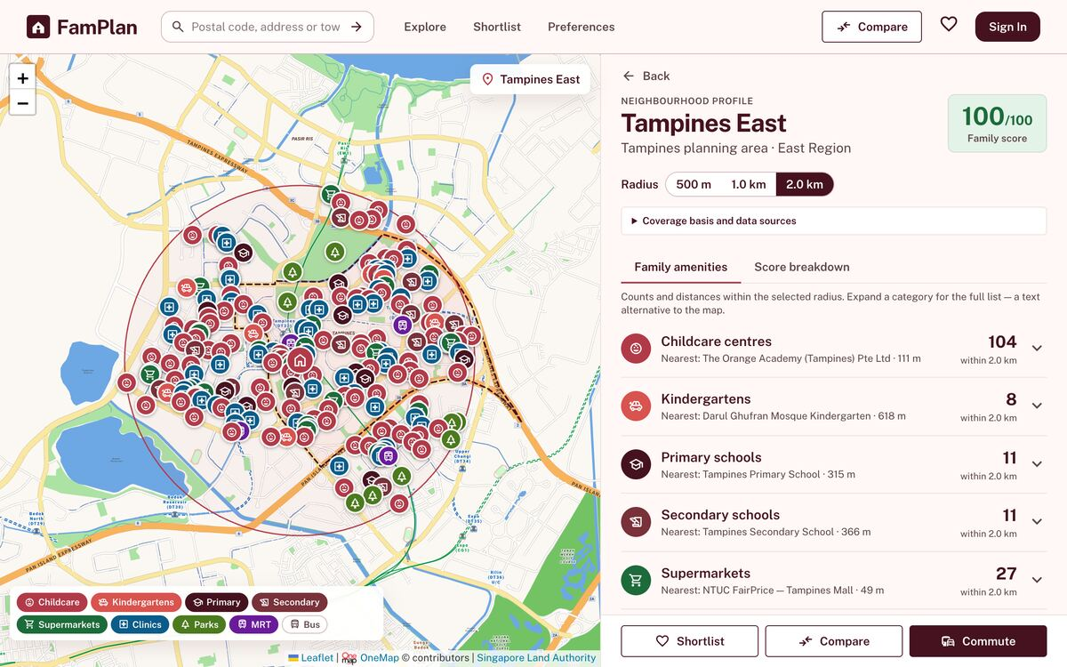  Live site, 2 km. Childcare count on 31 Oct: 13 at 500 m, 37 at 1 km, 104 at 2 km.
Show  Toggle map layers, click a marker, expand Childcare centres.  Say  Each entry in the list names its data source, and the list is an accessible alternative to the map.  Point to add  Source and retrieval dates are under Coverage basis and data sources. 9 amenity categories. | 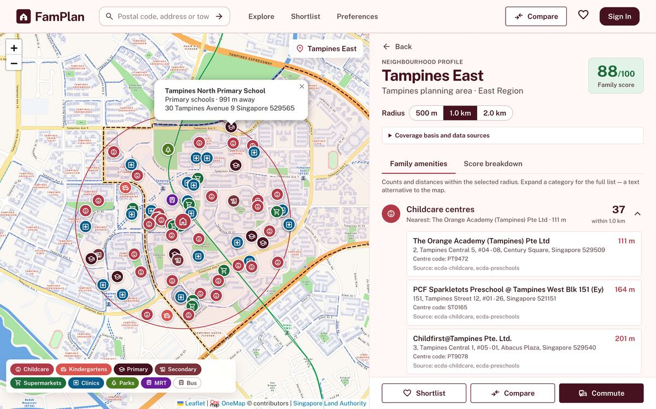  Live site, marker popup and expanded list
Show  Commute: the saved destination Work opens on Car. Then click Public transport, Walk and Cycle.  Say  These are live routes from OneMap. The score uses the mode saved in preferences, so changing it here is only a preview.  Point to add  If routing is unavailable, the page shows a labelled estimate instead of failing. | 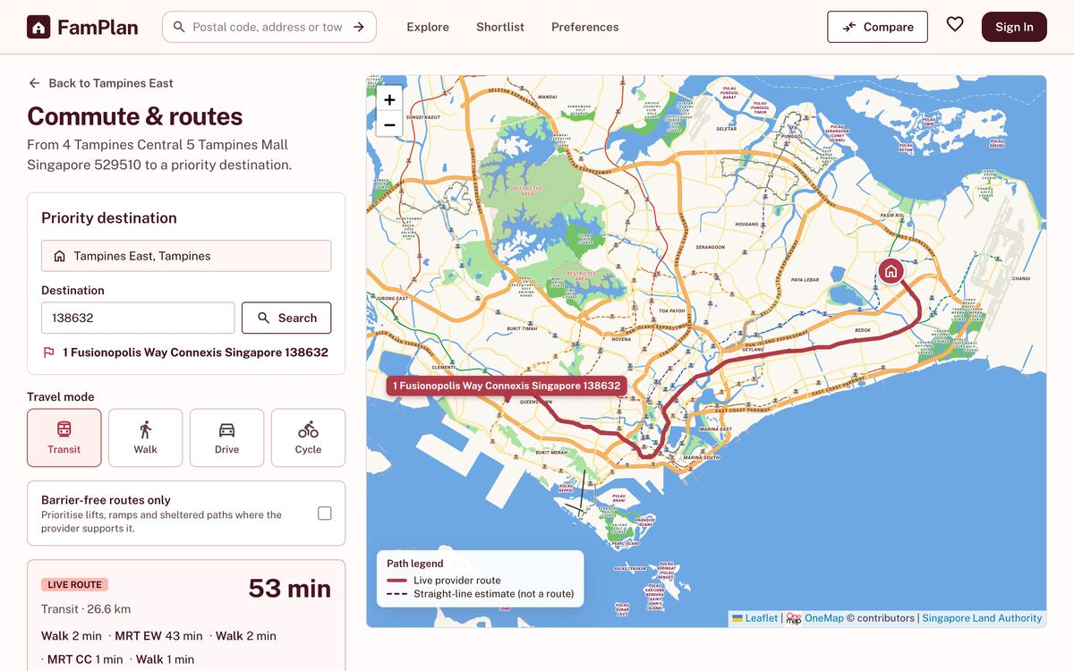  Live site before the update, Live route badge at the bottom left. Re-shoot after deploying.
Show  Tick Barrier-free routes only.  Say  OneMap supplies no step-free data, so FamPlan says that instead of guessing.  Point to add  The accessibility score is a bus-stop proxy, not verified step-free access. | 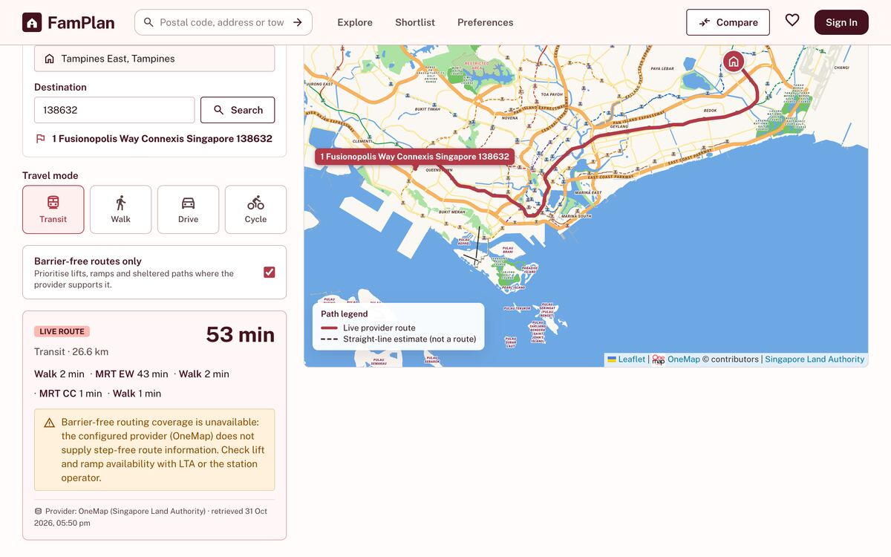  Live site

Athena, 9:00–12:00: score, comparison and shortlist
Script | Visual reference
Show  Score breakdown tab on the profile.  Say  The score compares neighbourhoods for this family. It does not promise a school place or a childcare vacancy.  Point to add  Each criterion shows its raw value, normalised value, weight and contribution. The Commute row lists each trip and its travel mode. | 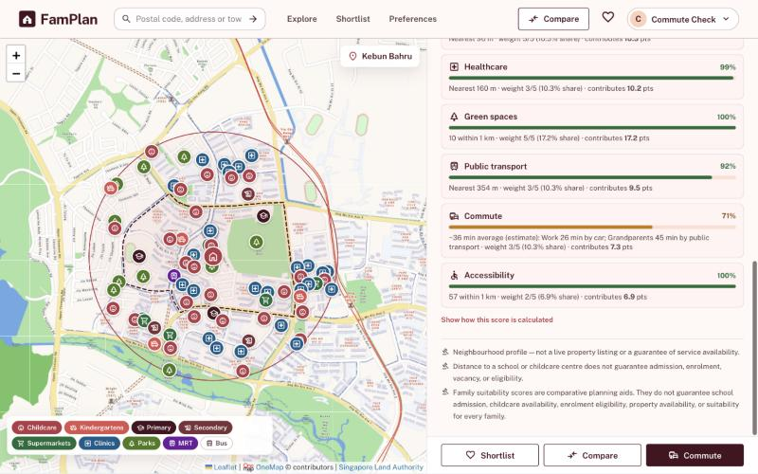  Local test copy, signed in, two destinations
Show  Switch to a signed-out window on the same profile and point at the Commute row. Once a destination is saved, commute is no longer missing, so this needs the signed-out view.  Say  Missing data is disclosed, not hidden.  Point to add  Commute is excluded until a destination is set, and its weight is redistributed. | 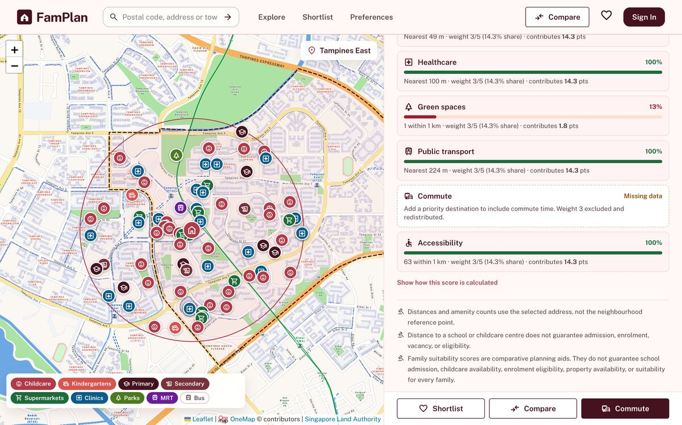  Live site, signed out
Show  Click Show how this score is calculated.  Say  The same inputs always give the same score.  Point to add  The rules live in one versioned configuration, famplan-score-v1.2, recorded with the dataset versions. | 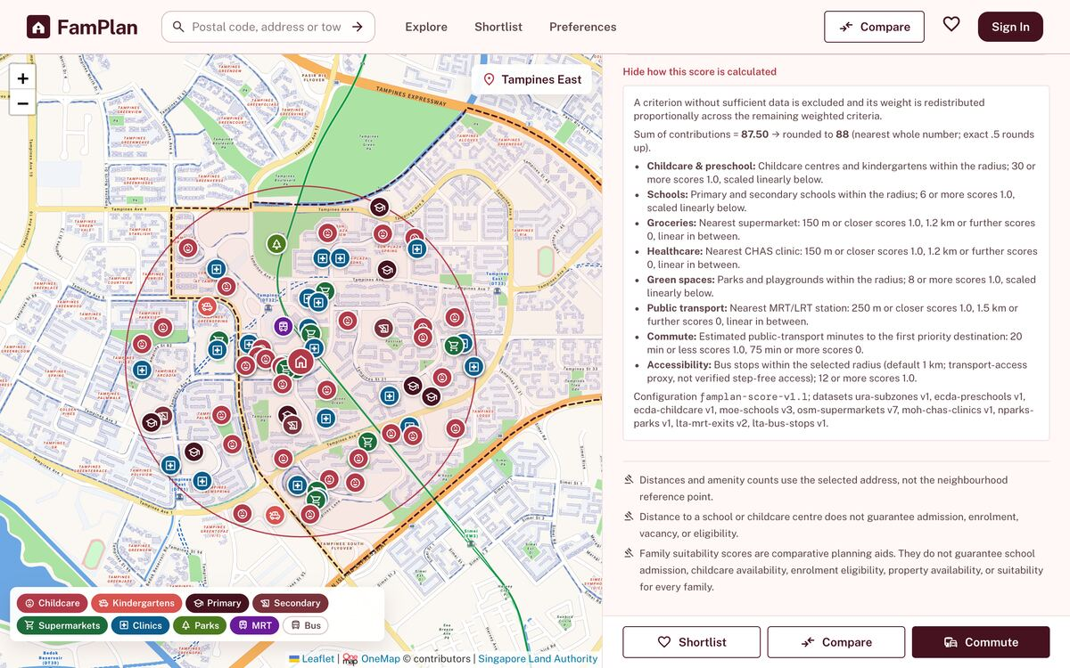  Live site
Show  Add 3 neighbourhoods to Compare.  Say  Compare puts 2 to 4 neighbourhoods side by side.  Point to add  Saved comparisons and shortlists work at neighbourhood level, so a score can differ from the exact-address view. Say this out loud. | 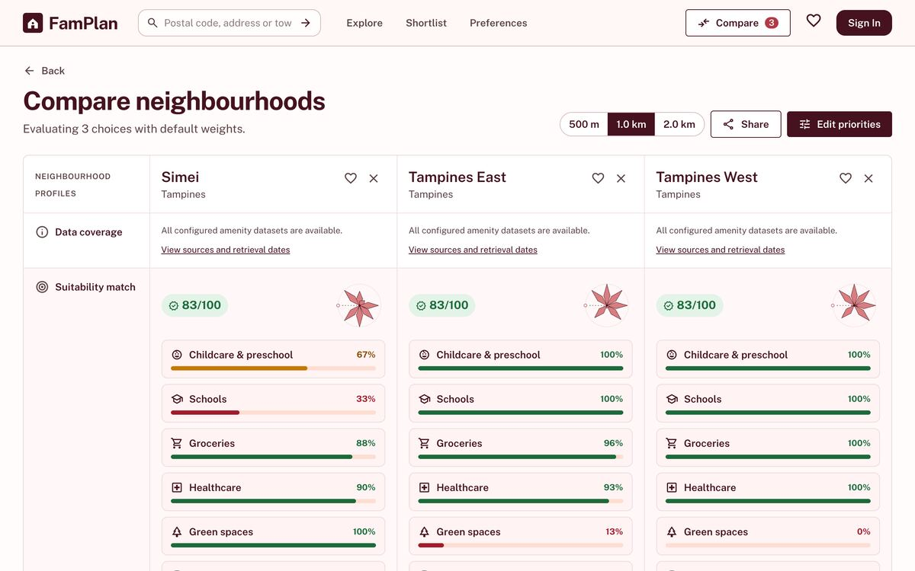  Live site, default weights
Show  Save two, open Shortlist, add a note.  Say  The shortlist holds up to 10 neighbourhoods, each with a private note of up to 500 characters.  Point to add  The limit is enforced in both the API and PostgreSQL. | 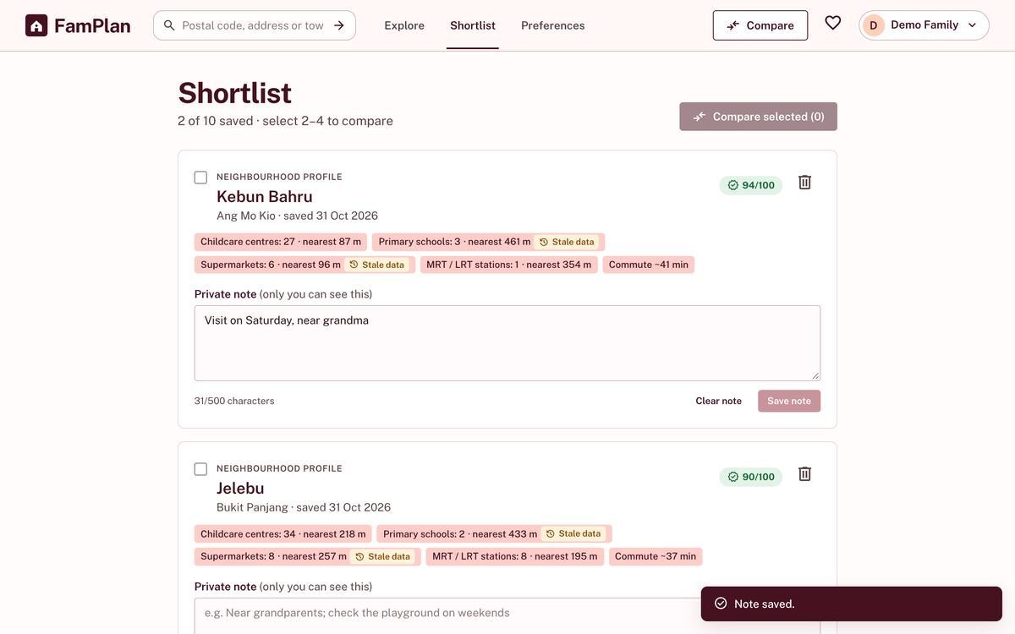  Local test copy, signed in

Edward, 12:00–14:00: keeping the data trustworthy
Script | Visual reference
Show  Data sync dashboard, signed in as administrator.  Say  The administrator never uploads data by hand. All 9 sources refresh automatically every day.  Point to add  Each source has its own overnight window, and a database lease prevents duplicate runs. | 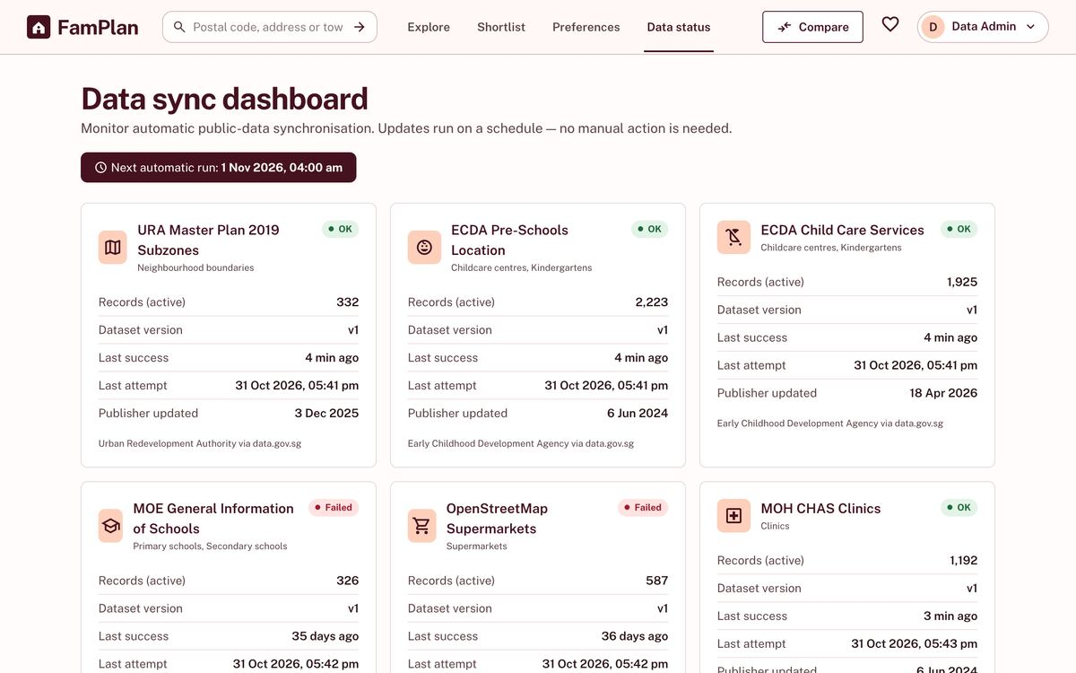  Local test copy. The live dashboard will differ, so replace this shot.
Show  Source status cards.  Say  Each source shows its status, last success and record count.  Point to add  Delayed after 26 hours, Stale after 31 days. | 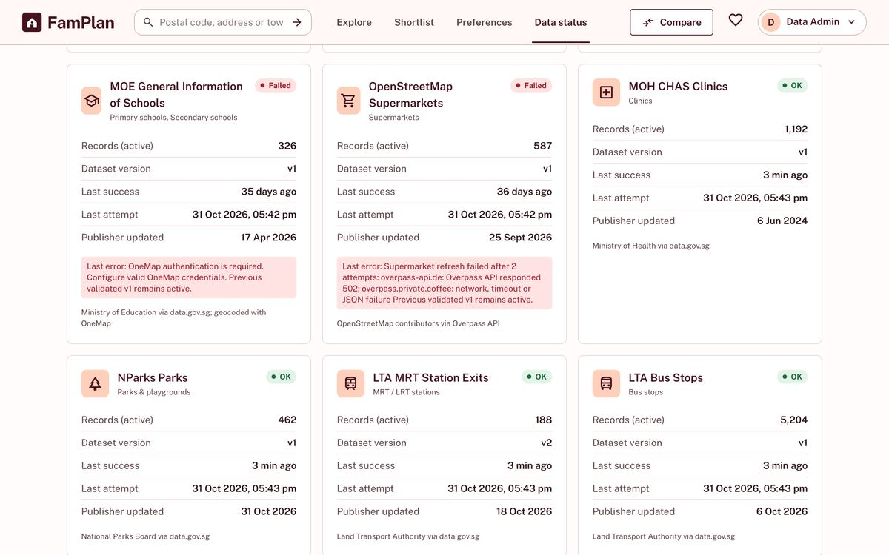  Local test copy, 31 Oct. These failures are real: both Overpass servers failed during our refresh, and MOE failed because the local copy has no OneMap login.
Show  Sync history.  Say  Every run is logged with its outcome and the records added, changed and removed.  Point to add  New data must pass validation before it becomes active. | 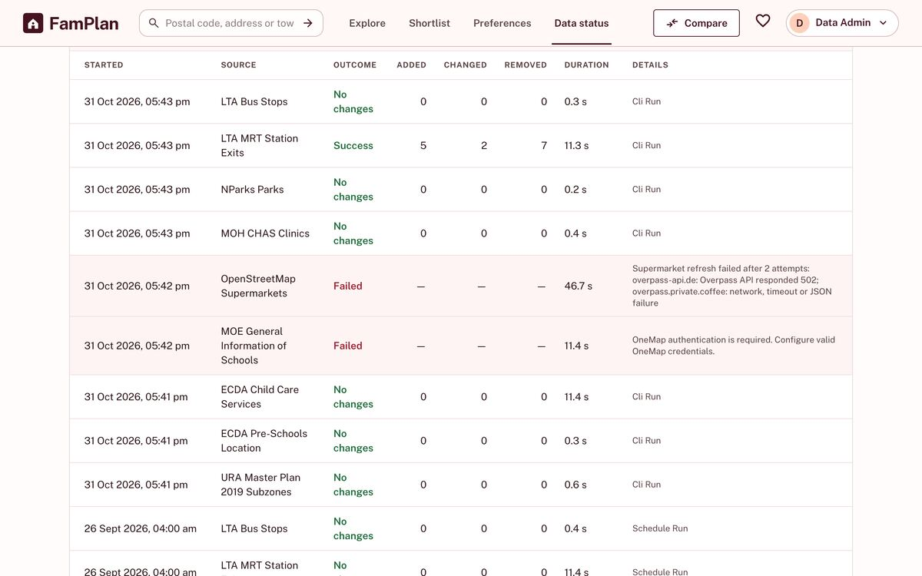  Local test copy
Show  Filter history to OpenStreetMap Supermarkets.  Say  When a provider fails, the previous validated snapshot stays live, so families never see an empty map.  Point to add  Real case: Overpass returned HTTP 502. The snapshot held, and we added failover to one mirror. | 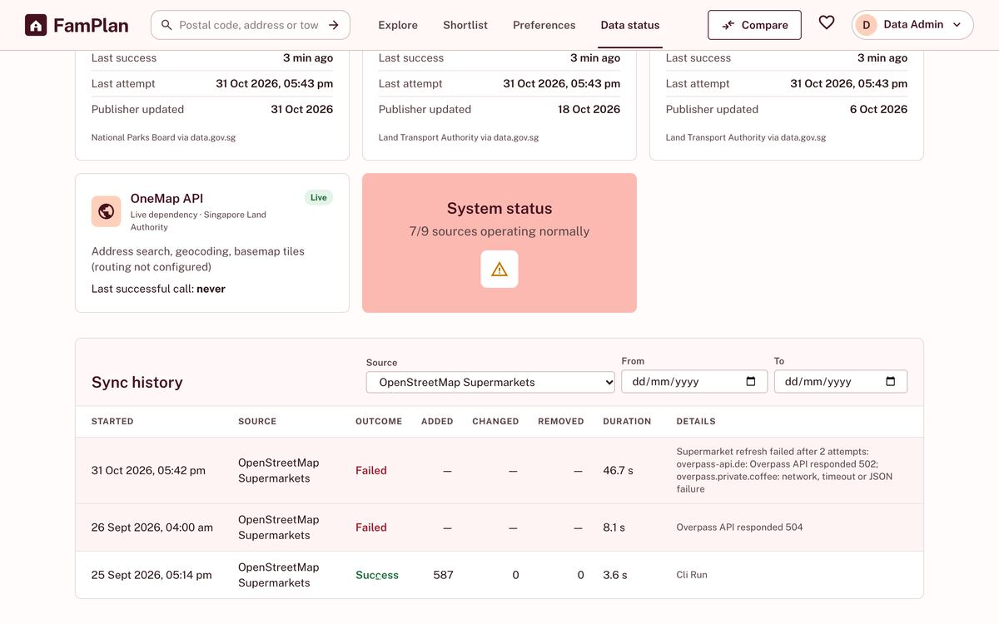  Local test copy, filtered to supermarkets

Edward, 14:00–16:30: SE practices, design and upgrades
Script | Visual reference
Show  Slide: SRS §8.2 architecture, enlarged.  Say  React boundary pages, Express controllers, domain entities, and PostgreSQL through Prisma. | 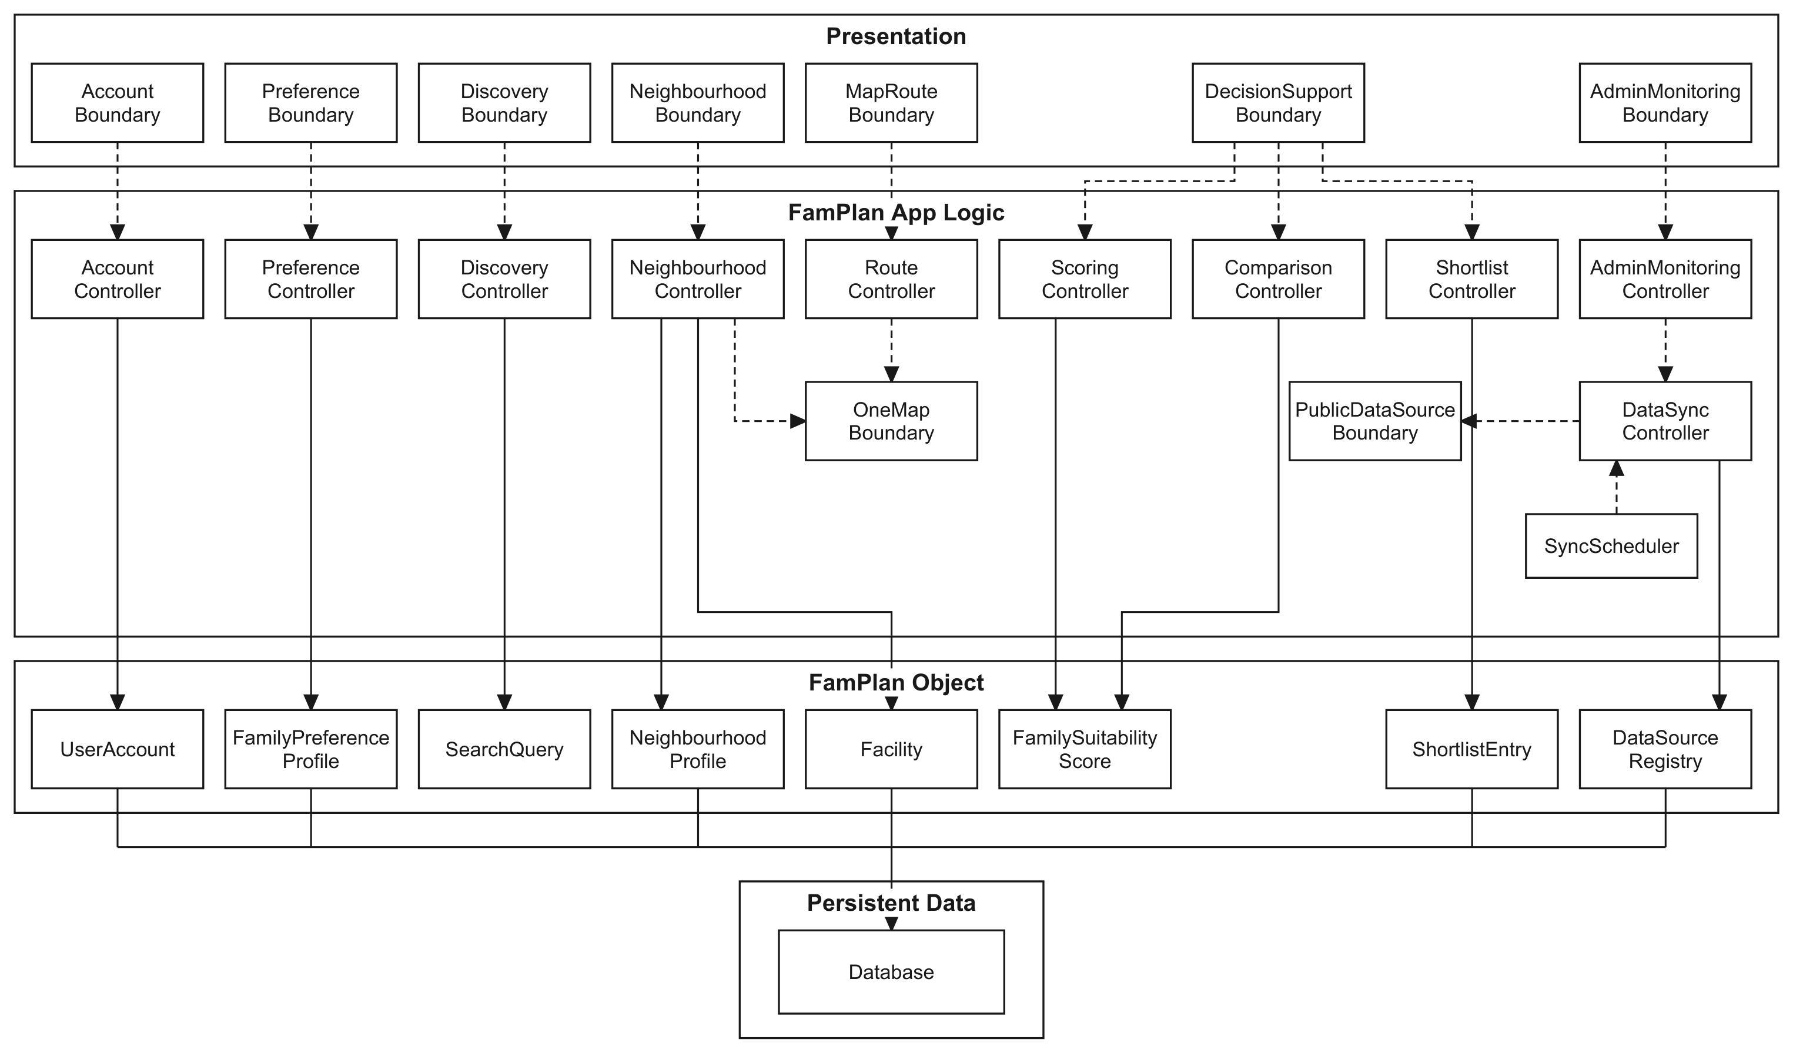  SRS v1.6 §8.2. Full size in the appendix.
Show  Slide: SRS §9.4 design layer.  Say  Each data source sits behind one Adapter. Scoring rules are a Strategy, selected from the versioned configuration. | 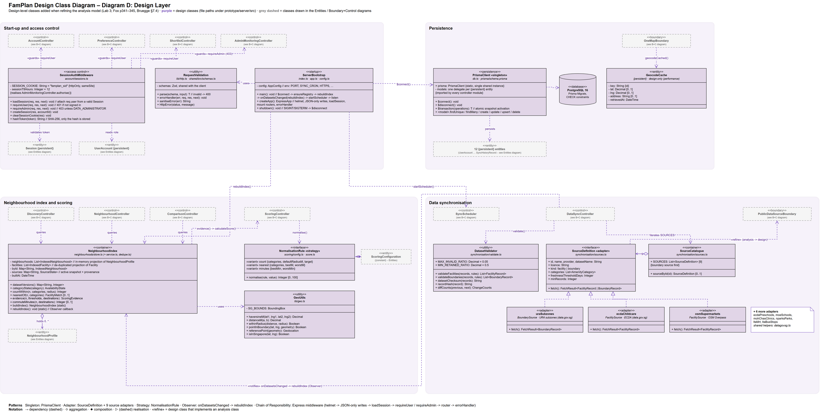  SRS v1.6 §9.4. Full size in the appendix.
Show  Slide: practices.  Say  Feature branches and pull requests, database migrations, automated tests, and a design and verification note per change in prototype/specs.  Point to add  283 automated tests, with at least 80% branch coverage enforced on the core modules. State here which parts used AI assistance (FAQ 3). | 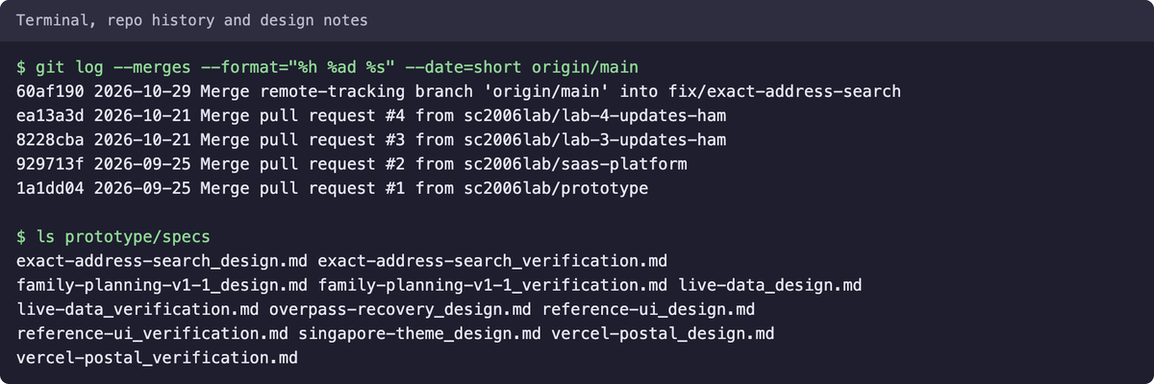  Repo history and design notes on 31 Oct
Show  Slide: future upgrades.  Say  A new data source is one adapter, one daily job and a category label. Retuning the score is a new configuration version.  Point to add  When we narrowed scope, billing and workspaces came out cleanly, with a migration that stops rather than lose data. | 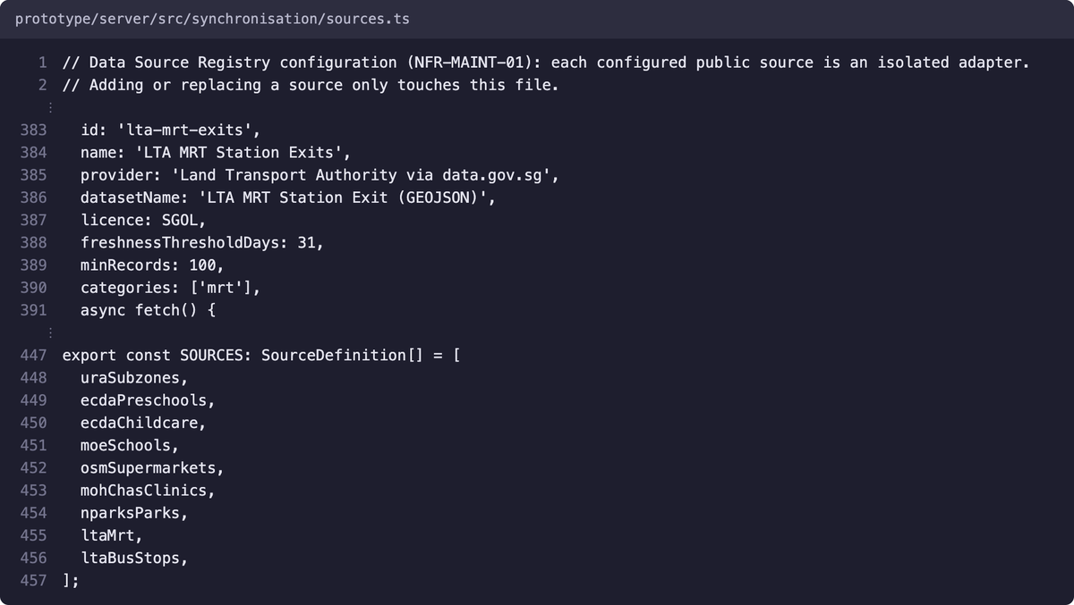  Real code: sources.ts

Ilham, 16:30–19:00: traceability for UC-6.1
Script | Visual reference
Show  Use case: UC-6.1 on the diagram.  Say  The score is included by UC-4.1 and UC-6.2, so one class serves both. | 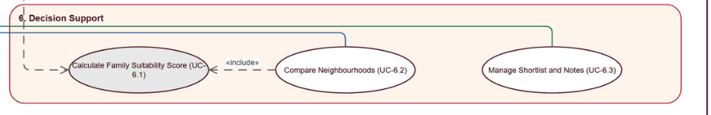  Use Case Descriptions v1.0, Figure 1 (crop)
Show  Requirements: FR-DEC-01 to FR-DEC-03.  Say  Score from weights and normalisation rules, itemised contributions, and missing data disclosed. | 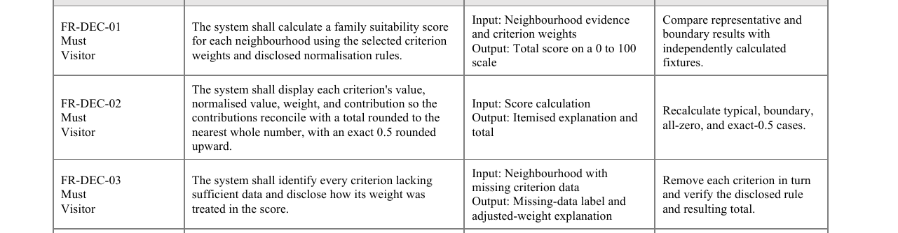  SRS v1.5 §4.6 (crop)
Show  Design: SRS Table 9.5.2 and §9.4.  Say  ScoringController, with NormalisationRule as the Strategy. | 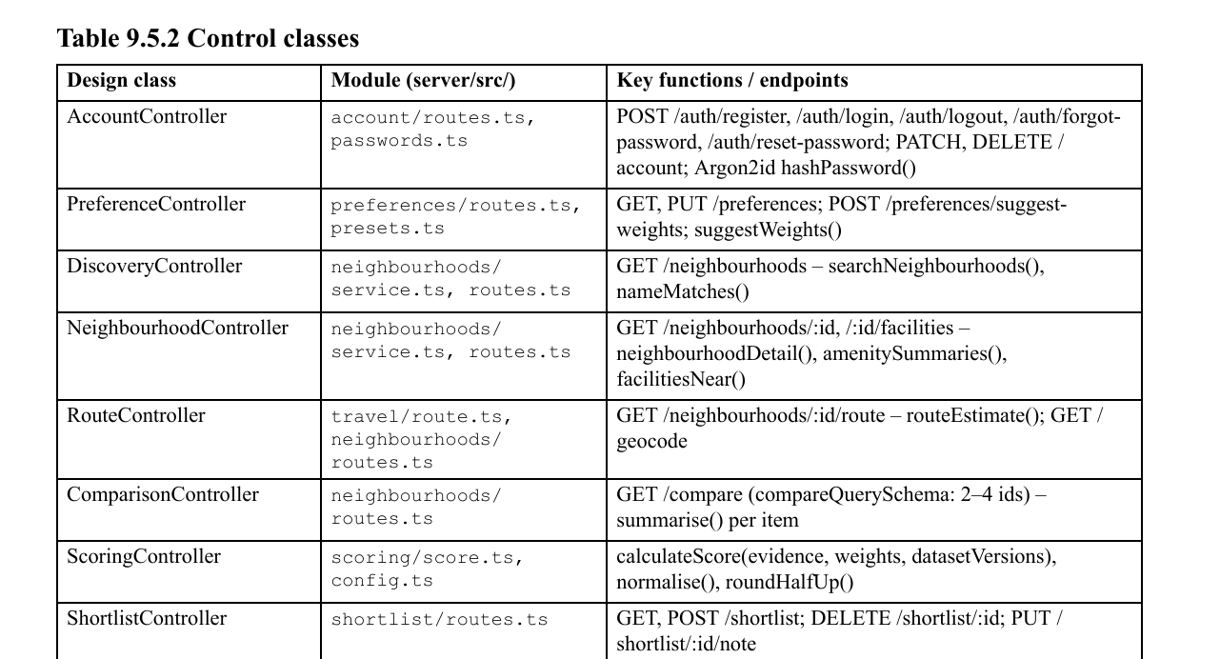  SRS v1.5 Table 9.5.2 (crop)
Show  Code: server/src/scoring/score.ts, calculateScore() and assertValidScoringInput().  Say  The input guard exists because black-box test design showed the class relied on the API to reject bad weights. | 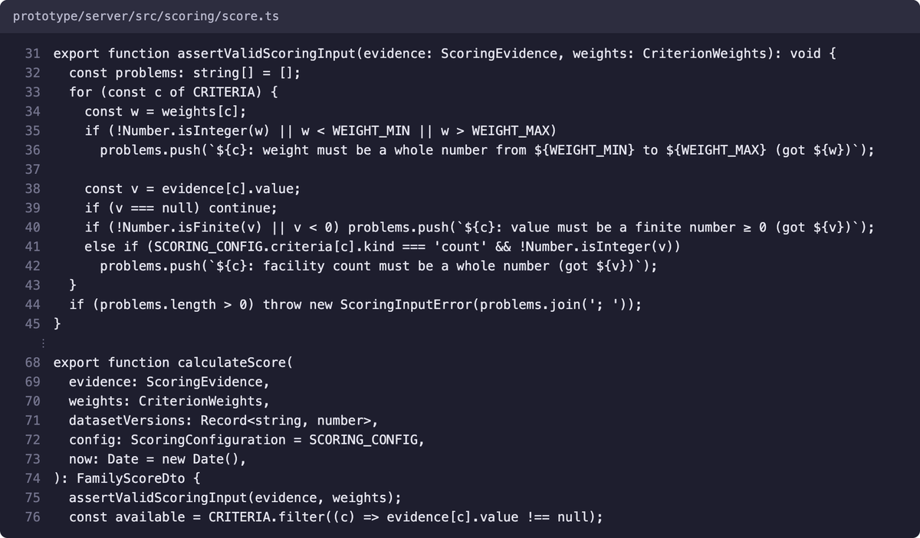  Real code: score.ts
Show  Black-box tests: test document §2.  Say  42 cases from equivalence classes and boundary values, such as 149, 150 and 151 metres. | 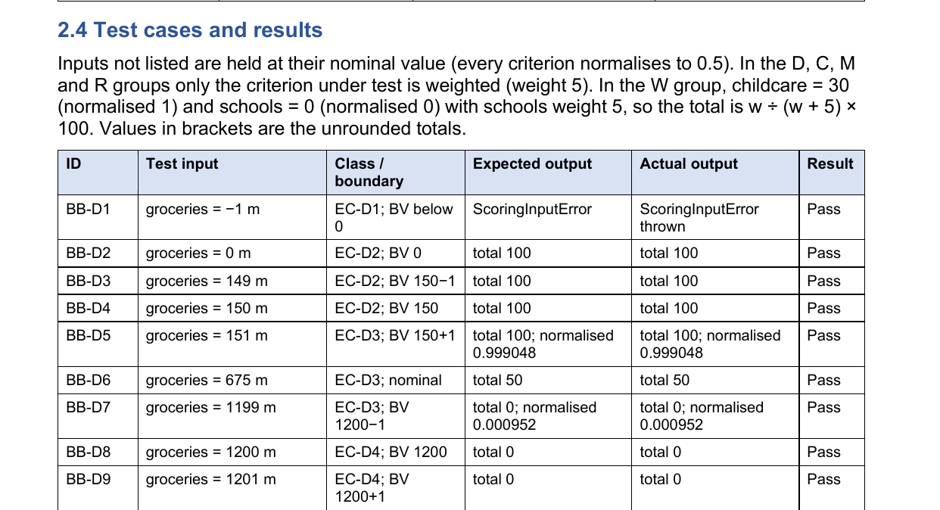  Test document v1.0 §2.4 (crop)
Show  White-box tests: test document §3.  Say  9 basis-path cases. Cyclomatic complexity is 9 for calculateScore() and 5 for dedupeFacilities(). | 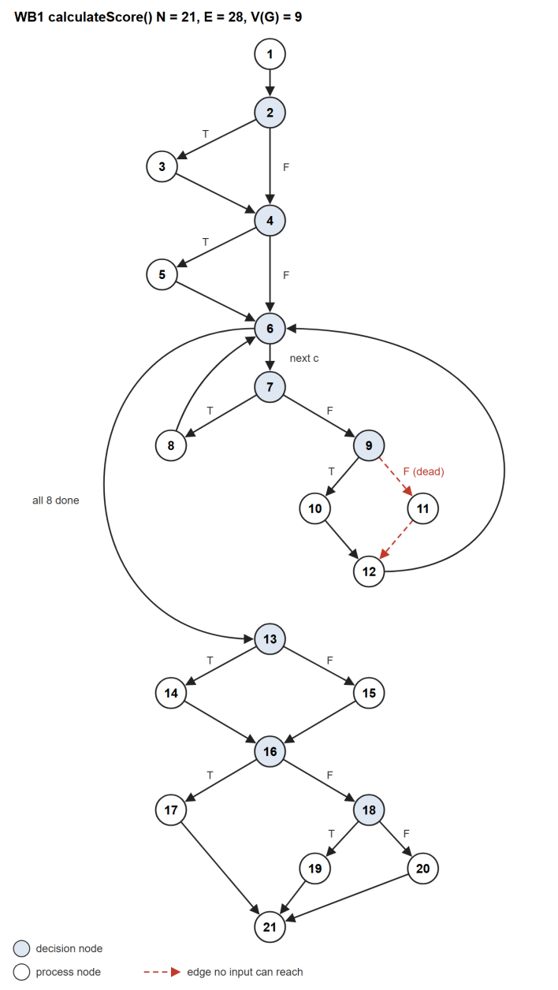  Test document v1.0, Figure 1
Show  Live run: npx vitest run test/scoring.blackbox.test.ts test/whitebox.test.ts in prototype/server.  Say  Both files run without a database, so this is safe to run live. | 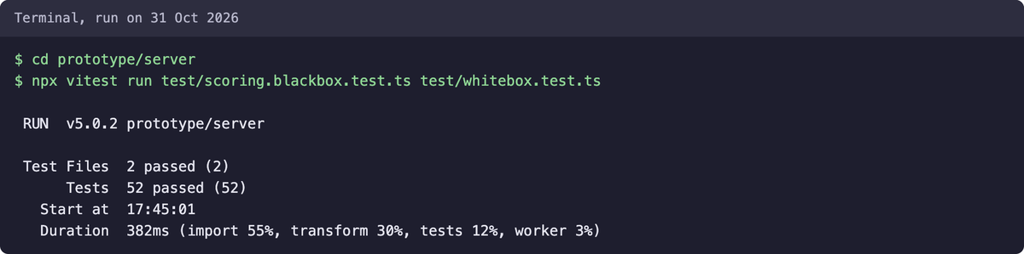  Real run on 31 Oct: 52 tests passed

Apollo, 19:00–19:30: close
On the landing page: "The Tans went from separate sites to one shortlist they understand. FamPlan runs on public data that refreshes itself, a score that explains itself, and a design that makes new sources cheap to add."
The old script's Q&A and failure-plan tables are still useful once the answers are reassigned to this presenter list and corrected with the claims table below.

Demo video script
This is the full voice-over, word for word, for one narrator. Each row is one clip, so you can record screen and voice separately and retake a single clip. It meets the 5 to 7 minutes in Lab 5 §3.3. At an easy reading pace it runs about 6:50. If the TA holds us to the five minutes in Lab 4 §3.4.4, drop the clips marked "can be cut" to reach about 6:10. Keep clip 4, because the teacher asked for the architecture near the start.

Before recording
- OneMap: on the live site, run a postal search for 138632 and a commute route. If either fails or shows Estimate, sort out the OneMap login first. If the site uses a static token, record before Sunday 1 Nov at 18:04.
- Administrator login: confirm one works on the live site. Otherwise record clips 20 to 22 from a local copy and say so on screen.
- Registration: use a fresh email alias, and pause recording while typing the password. Never show passwords, or the Vercel or OneMap dashboards.
- Windows: one signed-out window, one for the new registered account, and one for the administrator. Load Explore and a profile first, because the first call after idle is slow.
- Screen: 1920 × 1080, browser zoom about 110%, bookmarks bar hidden, notifications off.
- Commute update: record after Edward deploys it, because both scripts now show travel modes and two destinations. Until then, the live site shows the old labels and scores only the first destination.
- AI disclosure: decide whether to add a closing line on AI assistance (FAQ 3 and 4). It is not in the script below.
- Submit: export 1080p. If it is too large for the repo, upload to YouTube as unlisted and put the link in the index file (Lab 5 §3.3.3). Keep a local copy as the live-demo backup.

Voice-over, clip by clip
Script | Visual reference
Clip 1 · 0:00–0:25  On screen  Landing page. Scroll slowly until the counters run.  Voice-over  Choosing where to raise a family is one of the biggest decisions a couple makes in Singapore. You end up checking childcare, schools, clinics, supermarkets, MRT and commute times across separate websites. FamPlan brings all of that into one place, and gives each neighbourhood a family score you can actually explain. | Live site
Clip 2 · 0:25–0:36  On screen  Hover a few neighbourhoods on the map.  Voice-over  It covers 170 family neighbourhoods, built from nine public datasets, including ECDA, MOE, MOH, NParks and LTA. | Live site
Clip 3 · 0:36–0:59  On screen  Use case diagram, full screen.  Voice-over  FamPlan has three kinds of user. A visitor can search, view profiles, compare neighbourhoods and check commutes without an account. A registered user can also save preferences, a shortlist and private notes. A data administrator monitors the automatic data updates. That makes 16 use cases in total. | Use Case Descriptions v1.0, Figure 1
Clip 4 · 0:59–1:22  On screen  Architecture figure, full screen.  Voice-over  Under the hood, it has a React and TypeScript front end, an Express API and PostgreSQL through Prisma, with Leaflet and OneMap for maps. It is deployed on Vercel in Singapore, and in a local load test one server handled 1,000 simulated users with no failed requests. | SRS v1.6 §8.2
Clip 5 · 1:22–1:45  On screen  Register page. Fill in the name and email, cut while typing the password, tick consent, submit.  Voice-over  Let's follow one family, the Tans. They have a toddler, a child starting Primary 1, and a parent who works at one-north. They create an account. The password needs at least 10 characters, and they agree to how their data is used before anything is stored. | Live site
Clip 6 · 1:45–2:05  On screen  Preferences. Tick Preschool and Primary school, click Suggest from stages.  Voice-over  Next, they tell FamPlan what matters to them. They pick the Preschool and Primary school stages, and FamPlan suggests weights. Zero means ignore, five means essential. FamPlan only asks for planning stages, never children's names, birth dates or medical details. | Live site, visitor view. A registered account sees Save preferences.
Clip 7 · 2:05–2:23  On screen  Move Green spaces to 5. Add the label Work and postal code 138632, choose Car, and click Save preferences.  Voice-over  They move a slider to set their own priority, and that choice is kept even if they ask for suggestions again. Then they add one-north as a destination, using its postal code, choose how they get there, and save. | Local test copy, signed in
Clip 8 · 2:23–2:47  On screen  Explore. Click Apply my preferences. In Preferences, add Grandparents at Bedok MRT by Public transport and save. In Explore, apply again.  Voice-over  On the Explore page, Apply my preferences ranks neighbourhoods by this family's weights, and narrows the list to their family stages. They also visit grandparents in Bedok by public transport, so they add that too. The commute score averages both trips, and Katong moves into their top three. | Local test copy, signed in
Clip 9 · 2:47–3:06  On screen  Search 529510, then search Tampines Mall and show the three matches.  Voice-over  Families think in addresses, not planning zones, so we added exact search. A postal code goes straight to that address. A place name works too. Tampines Mall matches three places, so FamPlan asks which one instead of guessing. | Live site
Clip 10 · 3:06–3:20  On screen  Pick the first match. Pause on the radius circle and the notice.  Voice-over  Once they choose, OneMap resolves the coordinate, and the radius, counts and score all start from that address, not the centre of the zone. | Live site
Clip 11 · 3:20–3:41  On screen  Open the profile. Click 500 m, 1 km, then 2 km.  Voice-over  This is the profile for that address. Switching the radius from 500 metres to one kilometre to two kilometres updates the map circle and every count together. These are straight-line distances, so FamPlan does not present them as walking routes or school catchments. | Live site, 2 km
Clip 12 · 3:41–3:59 · can be cut  On screen  Toggle a map layer, click a marker, expand Childcare centres.  Voice-over  The map layers show each type of facility. Click a marker for its details, or expand a category for a text list, which is an accessible alternative to the map. Each entry names its data source. | Live site
Clip 13 · 3:59–4:15  On screen  Commute page. Saved destination Work opens on Car. Click Public transport, Walk, Cycle.  Voice-over  Now the commute. It opens on one-north by car, the mode they saved, with a live OneMap route showing each leg. They can preview public transport, walking and cycling too. | Live site
Clip 14 · 4:15–4:31  On screen  Back to Public transport. Tick Barrier-free routes only and pause on the notice.  Voice-over  If they ask for barrier-free routes, FamPlan says that OneMap does not supply step-free data, rather than guessing. And if routing is ever unavailable, it shows a clearly labelled estimate. | Live site
Clip 15 · 4:31–4:44  On screen  Profile. Score breakdown tab. Scroll through the rows.  Voice-over  Here is what makes FamPlan different. The score breakdown shows each criterion's raw value, its normalised value, its weight and what it contributes. | Local test copy, signed in, two destinations
Clip 16 · 4:44–4:55  On screen  Signed-out window, same profile. Pause on the Commute row.  Voice-over  If data is missing, FamPlan says so. Here, without a destination, commute is excluded and its weight is redistributed. | Live site, signed out
Clip 17 · 4:55–5:14  On screen  Click Show how this score is calculated. Pause on the configuration line.  Voice-over  The rules sit in one versioned configuration, so the same inputs and the same data always give the same score. And the score is a comparison aid. It never promises a school place or a childcare vacancy. | Live site
Clip 18 · 5:14–5:25  On screen  Add three neighbourhoods to Compare and open it.  Voice-over  The Tans pick three neighbourhoods and compare them side by side. FamPlan can compare up to four. | Live site, default weights
Clip 19 · 5:25–5:38  On screen  Save two, open Shortlist, type a note and save it.  Voice-over  They save two to their shortlist and add a private note. The shortlist holds up to 10 neighbourhoods, each with its own note. | Local test copy, signed in
Clip 20 · 5:38–5:53  On screen  Administrator window. Data sync dashboard, scroll the source cards.  Voice-over  Finally, the data administrator. There is no upload button here. All nine datasets refresh automatically every day, and each one shows its status, last success and record count. | Local test copy. Live will differ.
Clip 21 · 5:53–6:05  On screen  Scroll to Sync history.  Voice-over  Every run is logged, with the records added, changed and removed. New data must pass validation before it goes live. | Local test copy
Clip 22 · 6:05–6:16  On screen  Filter by source. Pause on a Failed row if there is one, or on the source card if not.  Voice-over  If a provider fails, the last validated data stays active, so families never see an empty map. | Local test copy, filtered to supermarkets
Clip 23 · 6:16–6:37 · can be cut  On screen  Design layer figure, full screen.  Voice-over  This comes from the design. Each data source sits behind its own adapter, and the scoring rules live in one versioned configuration, so adding a source or retuning the score stays a small change. More than 280 automated tests back this up. | SRS v1.6 §9.4
Clip 24 · 6:37–6:50  On screen  Back to the landing page.  Voice-over  So the Tans went from separate websites to one shortlist they understand. That is FamPlan, from team Banana Five-O. Thanks for watching. | Live site

Claims to use and drop
These were checked against the current code, a clean test run and the live site on 31 Oct.
Claim | Status | What to say instead
Handles 1000+ users | Local only | Say: "In a local load test, one server handled 1,000 simulated users browsing with no failed requests and a p95 of about 1.3 seconds." It was read-only and not on Vercel, so do not say the live site handles 1,000+ users. Evidence is in the test document §4.3.
Sync at 4 am daily | Out of date | On Vercel, each source runs once a day in its own overnight window, and timing is approximate.
Stale after 24 hours | Wrong | Stale after 31 days. Delayed after 26 hours.
famplan-score-v1.0 | Out of date | famplan-score-v1.2, effective 31 Oct.
Team workspaces and paid plans show extensibility | Removed | Delete this line. The code is gone. Use the scope-change story instead.
Docker deployment | Out of date | Vercel and Neon PostgreSQL. Docker is only an optional local setup.
170 tests, all passing | Out of date | 283 tests pass: 255 server and 28 client, on 31 Oct.
UC-6.1 is included by Search | Wrong | The use case document says it is included by UC-4.1 and UC-6.2.
Every marker shows its source and date | Overstated | List entries name their source. Dates are under Coverage basis and data sources. The marker popup shows name, distance and address.
Verified accessible routes | Overstated | OneMap supplies no step-free data, and the accessibility score is a bus-stop proxy. The app says so.
Travel modes and multiple commute destinations | Confirmed | On main, tested, and checked in the app on a local copy on 31 Oct. Not on the live site until the update is deployed.
9 data sources | Confirmed | 9 adapters with 9 daily jobs. OneMap is a separate live service on top.
170 neighbourhoods | Confirmed | Live site total. The landing page also shows 9,895 facilities.
16 use cases | Confirmed | Use Case Descriptions v1.0.
Data refreshes automatically | Confirmed | All 9 sources were retrieved between 01:50 and 08:47 Singapore time on 31 Oct.
At least 80% branch coverage | Confirmed | Enforced per file for the NFR-MAINT-02 modules. The coverage run passes at 93.88% overall.
Live routes in 4 modes | Confirmed | Public transport, walk, car and cycle all returned OneMap routes on 31 Oct. The live site labels them Transit and Drive until the update is deployed.

Fix before the demo
Both commute items are fixed on main and reach the live site after the deploy below. Registration, saved preferences, the shortlist and the admin pages were not run on the live site, because they need accounts. All of them ran on a local copy, so the live paths still need a run-through.
- Deploy the commute update. Edward has the Vercel account. Run npm run db:deploy against the production database first, then deploy from prototype/. Deploying without the migration breaks signed-in preferences.
- Commute mode in preferences: done. Each destination saves a travel mode, and search and the score use it. The score version is now famplan-score-v1.2.
- Multiple destinations in ranking: done. The commute score, sort and filter use the average across all saved destinations, with equal weight.
- OneMap login on Vercel. Postal search and routing work today. A spec note says the team's renewed token expires on 1 Nov at 18:04 Singapore time, and static tokens last only 3 days. Whoever owns the Vercel project should confirm ONEMAP_EMAIL and ONEMAP_PASSWORD are set. The project was not visible from the Vercel account used for this check.
- Live accounts. The README says never to run the demo seed on production, so demo@famplan.sg and admin@famplan.sg may not exist there. Edward should confirm an administrator login, and we should set up a prepared registered account.
- Failed sync row. Do not force a failure on the live site. Look for a real one in Sync history. If there is none, describe it in one sentence and point to server/test/sync.test.ts.
- Diagrams. SRS v1.6 enlarges the system architecture figure on its own landscape page. Ilham is re-rendering SRS §9.2 and §9.3.
- Traceability laptop. In prototype, run npm ci and npm run build -w shared once before the demo, so the two test files run cleanly live.
- Warm-up. The first API call after idle took 2.8 s, against about 70 ms when warm. Load Explore and one profile 5 minutes before starting.
- Backups. The old script's Lab4/Prototype_Screenshots folder is not in the repo. Use the screenshots in this document or drop that line, and keep the video saved locally.
- Rehearsal. Run the full 20 minutes twice with a timer, once switching to the backup video.

Lab 4 checklist
Lab 4 is due before the Lab 5 session starts, when its marks lock (FAQ 9). The AI report is the largest piece left.
Deliverable | Manual | Status | What is left
AI report (PDF) | §3.3.4, §4 | Not in repo | Not on any branch. Run both experiments and write both reflections (steps below).
Demo video | §3.4.4 | Not in repo | Script is in this document. Record 5 to 7 minutes this weekend. That also meets Lab 5 §3.3 and gives us the live-demo backup.
Demo script | §3.4, §4 | Needs update | This outline is updated for the commute work, and a PDF is in Lab4/. Add authors and re-export.
Test cases and results | §3.2, §4 | Done | v1.1 is in Lab4/. Re-run on 31 Oct with 283 tests, and adds commute tests and a local load test. It notes that the two scoring test files run 52 tests against the 51 cases listed.
Working prototype | §4 | Needs update | Visitor search, profile and commute flows work on the live site. The commute gaps are closed on main, so deploy the update.
Author names | §3.5.2 | Needs update | The test document has them. Add them to the demo script and the AI report.
AI disclosure | FAQ 3 | To confirm | Confirm any other AI use is disclosed in SRS §1.6, and that each presenter can explain the code behind their part.
Source code | §3.1.4, §4 | Done | On main under prototype/. Merge any late fixes.

AI report steps
- Rebuild the control class (§3.3.2). On a throwaway branch, delete server/src/scoring/score.ts. Ask an in-IDE agent such as Cline to rebuild it from the tests, SRS and diagrams. Judge it with the 52 black-box and white-box tests. If it fails, retry with only the function bodies removed. Do not merge this branch.
- Run a second experiment (§3.3.3). The commute update was built with an AI agent on 31 Oct and fits the manual's "feature you didn't have time to complete" option, so it can be written up here. Otherwise, pick another unfinished feature.
- Write two reflections (§3.3.4). For each one, cover the prompts, materials supplied, any iteration, the outcome, and whether it met expectations. If the AI fell short, add what might have helped.
- Submit. Combine both into one PDF with author names and put it in Lab4/.

Lab 5 checklist
Lab 5 documents are due at 23:59 on the Sunday of demo week. Two items were missing from the team's notes: the index file and the meeting minutes.

Documents and code
Deliverable | Manual | Status | What is left
Final SRS, including the use case model | §3.2.2 | Needs update | v1.6 is in Lab5/. It adds travel modes, the enlarged architecture figure and the Vercel and cron wording, and removes the billing, workspace and Docker lines. Still to add: exact address search and Ilham's re-rendered figures. Lab5/FamPlan_SRS_v1.6_Word_Changes.md lists the same changes for the Word file.
Class diagrams of key classes | §3.2.2 | Needs update | Currently SRS §9.1 to §9.4. §9.1 and §9.4 now show travel modes (Lab5/figures). Redraw to match the final code: billing and workspaces are gone, and the serverless, cron, Overpass and postal modules are new.
Dialog map | §3.2.2 | To confirm | In SRS §10 and Lab2/DialogMap.pdf. Its pages line up with today's routes. Recheck the transitions for the exact-address search flow.
Source code and tests | §3.2.1 | Needs update | main holds the code and 283 passing tests. No final source zip exists yet. Build it after the last merge, without node_modules or .env.
Index file | §3.2.3 | Not in repo | One page linking every deliverable, including the video link.
Meeting minutes | §3.2.2 | Not in repo | Submit any the team has kept.
Authors and declaration form | FAQ 12 | To do | Name the authors on each document and fill in the form. SRS §1.6 lists Ron and Anh, while the chat table says Apollo and Raph, so confirm the official names.
Release tag and backup | Overview appendix, FAQ 13 | To do | The repo has no tags yet. Tag the final version, and keep a backup because repo access ends at the deadline.

Demo
Deliverable | Manual | Status | What is left
Slides | §3.1.5, §3.1.6 | Not in repo | A short deck on SE practices, system design and traceability. The Edward and Ilham tables above give the content.
Rehearsal | §3.1.1 | To do | About 20 minutes: live demo, design overview, and traceability for UC-6.1.
Demo video | §3.3 | Not in repo | 5 to 7 minutes, uploaded or linked. Same recording as Lab 4.

Individual
Deliverable | Manual | Status | What is left
Peer review | §3.4, FAQ 11 | To do | Each member submits alone, without discussing it. Justify any score of 1 or 2. Details come before the Lab 5 session.

Appendix: full-size diagrams
These are the current figures at page width, for slides and for spotting what needs redrawing. The system architecture and design layer figures come from SRS v1.6. The others come from the Lab 3 documents, so they predate Ilham's re-renders.

Use case diagram
Use Case Descriptions v1.0, Figure 1

System architecture
SRS v1.6 §8.2

Boundary and control subsystems
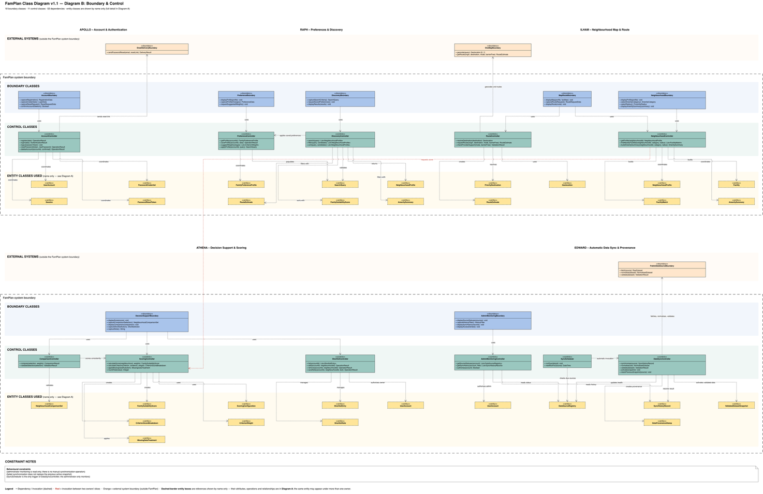
SRS v1.5 §9.2. Being re-rendered by Ilham.

Robustness view
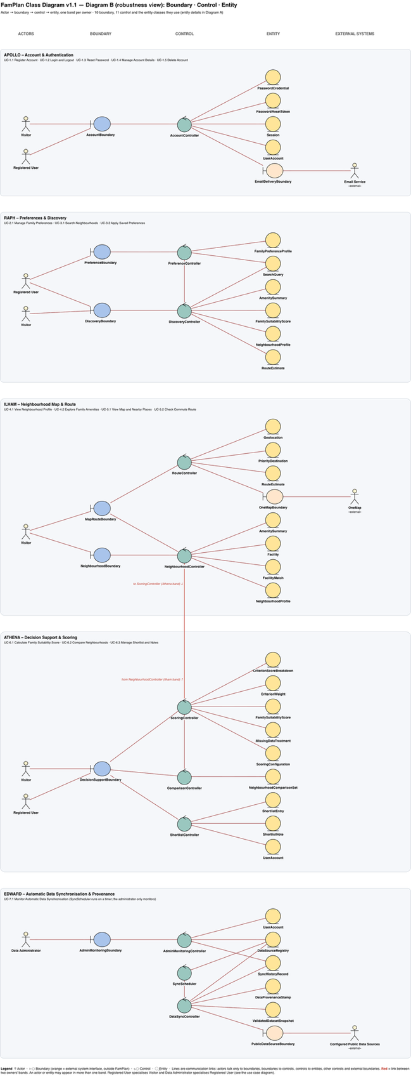
SRS v1.5 §9.3. Being re-rendered by Ilham.

Design layer
SRS v1.6 §9.4

Dialog map
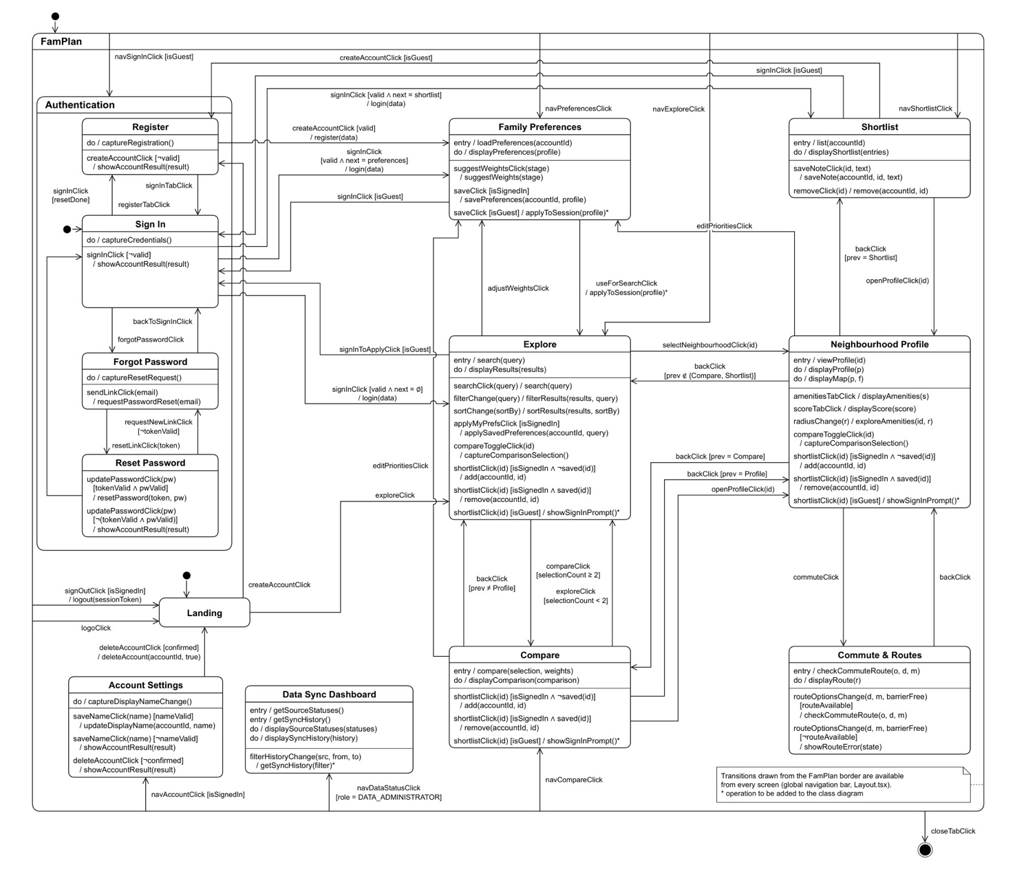
SRS v1.5 §10

