Software Requirements Specification
for
FamPlan
Version 1.0 - Lab 1 Submission
Prepared by Banana Five-O
NTU SC2006 Software Engineering
8 September 2026
Table of Contents
Table of Contents ii
Revision History ii
1. Introduction 1
1.1 Purpose 1
1.2 Document Conventions 1
1.3 Intended Audience and Reading Suggestions 1
1.4 Product Scope 1
1.5 References 1
2. Overall Description 2
2.1 Product Perspective 2
2.2 Product Functions 2
2.3 User Classes and Characteristics 2
2.4 Operating Environment 2
2.5 Design and Implementation Constraints 2
2.6 User Documentation 2
2.7 Assumptions and Dependencies 3
3. External Interface Requirements 3
3.1 User Interfaces 3
3.2 Hardware Interfaces 3
3.3 Software Interfaces 3
3.4 Communications Interfaces 3
4. System Features 4
4.1 System Feature 1 4
4.2 System Feature 2 (and so on) 4
5. Other Nonfunctional Requirements 4
5.1 Performance Requirements 4
5.2 Safety Requirements 5
5.3 Security Requirements 5
5.4 Software Quality Attributes 5
5.5 Business Rules 5
6. Other Requirements 5
Appendix A: Glossary 5
Appendix B: Analysis Models 5
Appendix C: To Be Determined List 6

Revision History
Name | Date | Reason For Changes | Version
Banana Five-O | 8 September 2026 | Initial SRS for Lab 1 submission | 1.0

Introduction

Purpose
This Software Requirements Specification defines the Lab 1 requirements for FamPlan version 1.0. It covers the complete planned web application: account and preference management, HDB resale profile search, market and location information, decision support, an indicative HFE pre-check, and data-source administration. It also records the external interfaces, quality constraints, domain vocabulary, initial use-case model, traceability, and interface mockups used to validate the requirements.

Document Conventions
Each functional requirement has a unique FR identifier and states one testable capability using shall. Each non-functional requirement has a unique NFR identifier and states a measurable constraint using must or must not. Must and Should in the Priority field are MoSCoW classifications: Must is required for the agreed minimum product; Should is important but may be deferred only through a documented scope decision. Registered User inherits Visitor behaviour, and Data Administrator inherits Registered User behaviour.

Intended Audience and Reading Suggestions
This document is intended for the project team, teaching staff, assessors, developers, testers, and future maintainers. Readers seeking product context should start with Sections 1 and 2. Developers should continue through the interfaces and system features in Sections 3 and 4. Testers should use the verification statements, Section 5, and Appendix B. Domain terminology is defined in Appendix A, while Appendix C records the user-interface mockups used during requirements refinement.

Product Scope
FamPlan is a responsive web application that helps Singapore households decide which HDB resale block-and-flat profiles are worth considering against their own priorities rather than price alone. It brings together historical resale evidence, block information, nearby schools and amenities, commute estimates, accessibility information, and a temporary indicative HFE pre-check. Users can compare profiles through a transparent suitability score whose weights they control. Every externally sourced result identifies its provider and relevant date, missing evidence is distinguished from a zero value, and financial or eligibility guidance is clearly labelled as indicative rather than official. FamPlan is not a listing marketplace, valuation service, transaction platform, financial adviser, or official HDB assessment channel.

References
Reference | Purpose
SC2006 Lab 1 Manual | Defines the required Lab 1 activities and deliverables.
FamPlan Functional and Non-functional Requirements | Source record for the 58 FRs and 29 NFRs consolidated here.
FamPlan Data Dictionary | Source record for the domain terms in Appendix A.
FamPlan Use Cases version 1.0 | Companion report containing 19 full use-case descriptions.
FamPlan Use Case Diagram version 4 corrected | Initial UML use-case model in Appendix B.
FamPlan UI Mockups | Lab 1 interaction concepts reproduced in Appendix C.

Team Contributions and AI Use
Member | Username | Team Leader | Lab 1 Contribution
POLOYAPOY RON JOSHUA ABES | POLO0002 | Yes | Data Dictionary
LIM RUI XIAN EDWARD | ELIM095 | No | Functional and Non-functional Requirements
LE VIET HOANG ANH | HOANGANH003 | No | Use Case Diagram
ATHENA LIM HUI RU (LIN HUIRU) | ALIM102 | No | Initial Use Case Model
MUHAMMAD ILHAM BIN IRWAN | MUHA0313 | No | UI Mockups
AI-use disclosure: OpenAI Codex assisted with consolidating team-authored artifacts, consistency editing, and populating the supplied Word templates; the team reviewed and accepts responsibility for the final content.

Overall Description

Product Perspective
FamPlan is a new, self-contained decision-support application. Public housing, market, school, transport, and mapping information is currently distributed across separate government data sources. FamPlan consolidates that evidence into comparable block-and-flat profiles without presenting live sale listings. The application stores only account, preference, shortlist, note, and administration data that its documented functions require; answers entered during the indicative HFE pre-check remain session-only and are discarded on completion, cancellation, or inactivity timeout.

Product Functions
• Manage registration, authentication, password reset, display-name changes, and account deletion.
• Store housing preferences, destinations, amenity choices, accessibility needs, and criterion weights.
• Search, filter, label, and sort HDB resale block-and-flat profiles.
• Present profile details and historical market evidence with source and data-availability states.
• Show maps, nearby places, distances, travel estimates, and supported barrier-free routes.
• Calculate explainable suitability scores, compare profiles, and maintain a ten-profile shortlist with 500-character notes.
• Provide a temporary, versioned and explicitly indicative HFE pre-check linked to official HDB information.
• Monitor and refresh configured data sources while preserving the last validated dataset after failures.

User Classes and Characteristics
User Class | Characteristics and Permissions
Visitor | Unauthenticated member of the public. Can search, view profiles and evidence, compare profiles, inspect routes and amenities, and run the indicative HFE pre-check. Cannot save personal state.
Registered User | Authenticated account holder who inherits all Visitor functions and can save housing preferences, criterion weights, up to ten shortlisted profiles, and private notes of up to 500 characters.
Data Administrator | Privileged Registered User who can also view data-source status and history and request a refresh for one configured source at a time.
System (scheduled process) | Non-human actor that checks each configured source for available updates at least once every 24 hours and retains the last validated dataset after a failed refresh.

Operating Environment
FamPlan operates as a responsive web application accessed through a modern desktop or mobile browser over a network connection. Core pages must remain usable from 360 px to 1440 px viewport widths and should support the latest two stable versions available at test time of Chrome, Safari, Firefox, and Edge. The application relies on a server-side application and persistent data store for locally maintained product data; Lab 1 does not prescribe a specific hosting platform, operating system, framework, or database product.

Design and Implementation Constraints
The product must use authorised public data interfaces, respect provider rate limits, identify source and retrieval or update dates, and degrade only the functions that depend on an unavailable provider. HFE answers must never be written to persistent storage, analytics, error reports, or application logs. Passwords must be stored only as salted hashes. The transaction store must support at least 1,000,000 records, and administrative functions must be protected at both user-interface and API levels.

User Documentation
The Lab 1 product definition requires contextual labels, field-level validation guidance, source attribution, missing-data explanations, score explanations, and HFE limitations within the interface. A separate end-user manual, training course, or native mobile guide is outside the current milestone.

Assumptions and Dependencies
# | Assumption or constraint | Consequence if wrong
A-1 | data.gov.sg's HDB Resale Flat Prices and HDB Property Information datasets are the market and property source, joined on normalised block plus street, since the two datasets share no town key. | FR-MKT-01, FR-MKT-02, FR-MKT-03, FR-SRCH-01, FR-SRCH-02 and NFR-SCALE-01 all depend on this join. A bad join silently attributes transactions to the wrong block.
A-2 | OneMap is the geocoding, routing and nearby-amenity provider. Address search is free and unauthenticated; routing and protected theme queries require a free token. | FR-LOC-01 to FR-LOC-07, and FR-PREF-03. If the token terms change, every location feature is affected at once.
A-3 | OneMap's barrier-free access routing has real but partial coverage, so FR-LOC-06's unavailable-coverage path is required rather than optional. | FR-LOC-06. Treating coverage as complete could route a barrier-free request onto an inaccessible path.
A-4 | The MOE School Directory carries no coordinates, so every school is geocoded before it can appear as a nearby place or contribute to a distance. | FR-LOC-02, FR-LOC-04, and the schools criterion in FR-PREF-05 and FR-DEC-01.
A-5 | LTA DataMall's static train station dataset supplements OneMap for MRT and LRT coordinates where coverage is thin. | FR-LOC-02.
A-6 | The HFE ruleset is authored by the team from HDB's published general eligibility information and is illustrative. CPF grant category names are current, but no exact grant or loan amount is computed or presented as authoritative. | FR-HFE-03 to FR-HFE-08. Presenting an illustrative ruleset as authoritative would breach FR-HFE-08 directly.
A-7 | Published resale transactions are a sufficient basis for indicative market evidence. FamPlan reports what has sold, and does not model or predict future prices. | FR-MKT-07. Any wording that implies prediction would misrepresent what the data supports.
C-1 | HFE pre-check answers must never reach persistent storage, logs or analytics. This is enforced architecturally, through a request-scoped object with no serialiser to any sink, rather than by convention. | NFR-PRIV-01. A single stray log line breaches the requirement.
C-2 | The transaction store must scale to at least 1,000,000 rows with indexed queries on block, flat type and date. | NFR-SCALE-01, NFR-PERF-01.
C-3 | Every externally sourced output carries its provider and retrieval or update date as a structured field, not as interface text added afterwards. | NFR-DATA-01, NFR-TRANS-01.
C-4 | External providers are called within their published rate limits, and a provider failure degrades only the features that depend on it. | FR-RES-02, NFR-REL-03.

External Interface Requirements

User Interfaces
The interface uses consistent navigation, clearly labelled actions, visible keyboard focus, field-specific recovery messages, responsive layouts, and source or date information beside externally derived outputs. It distinguishes a block-and-flat profile from a live listing and distinguishes FamPlan guidance from official HDB decisions. The representative Lab 1 mockups are reproduced in Appendix C; they are requirements-elicitation evidence rather than implementation screenshots.

Hardware Interfaces
No specialised hardware interface is required. Users interact through a browser on a keyboard-, pointer-, or touch-capable device. Core workflows must remain keyboard operable and must not rely on device-specific sensors or native mobile capabilities.

Software Interfaces
Interface | Inbound Data or Service | FamPlan Use and Failure Behaviour
data.gov.sg - HDB Resale Flat Prices | Historical transactions and resale attributes | Supports search and market evidence. The last validated local dataset remains active after a failed refresh.
data.gov.sg - HDB Property Information | Block-level property attributes | Supports profile details through a normalised block-and-street join whose unmatched rate is monitored.
data.gov.sg - MOE School Directory | School names and addresses | Supports nearby-school evidence after geocoding; missing coordinates produce a category-specific unavailable state.
OneMap | Geocoding, map, routing, barrier-free coverage, and nearby-place data | Supports preferences, map, amenity, and commute functions. A provider outage does not disable unrelated local-data functions.
LTA DataMall | MRT and LRT station coordinates | Supplements station coverage used by the nearby-transport functions.
Email Delivery Service | Time-limited password-reset link delivery | Supports UC-1.3 only and must not reveal whether an address is registered.

Communications Interfaces
Client-server and external-service communication uses HTTPS with TLS 1.2 or newer. Plain HTTP must redirect without accepting credentials. External requests must use structurally validated parameters, observe provider rate limits, and end in controlled timeout or unavailable states. Password-reset email is the only email interface in scope; general alerts remain in-application. Scheduled source checks run at least once every 24 hours per configured source.

System Features
This section groups the 58 atomic functional requirements by user-visible feature. Each row identifies the actor, input, required output, and minimum verification evidence.

Account Management
Create and manage accounts, authentication, display names, and account deletion.
ID Priority Actor | Atomic Requirement | Input and Required Output | Verification
FR-ACC-01  Must  Visitor | The system shall create a user account after receiving valid registration details and consent to the stated data use. | Input: Name or display name, unique email address, password, consent  Output: Account confirmation or field-specific rejection | Register with valid, duplicate-email, malformed-email, weak-password, and missing-consent cases.
FR-ACC-02  Must  Registered User | The system shall authenticate a registered user with valid credentials. | Input: Email address and password  Output: Authenticated session or generic authentication failure | Test valid, incorrect-password, unknown-account, and locked-account cases.
FR-ACC-03  Must  Registered User | The system shall end the current authenticated session when the user logs out. | Input: Logout action  Output: Invalidated session and return to a public page | Confirm protected pages and APIs reject the old session after logout.
FR-ACC-04  Should  Registered User | The system shall support password reset through a time-limited, single-use link sent to the registered email address. | Input: Registered email address and new password  Output: Reset message without revealing whether the account exists; successful password change when the token is valid | Test known and unknown emails, expired token, reused token, and successful reset.
FR-ACC-05  Must  Registered User | The system shall allow a Registered User to update the display name stored on the account; email address and credentials are not editable through this function. | Input: New display name  Output: Updated display name and confirmation, or a field-specific validation error | Update the display name, then confirm attempts to change email or credentials through this function are rejected.
FR-ACC-06  Must  Registered User | The system shall delete the user's account, saved preferences, shortlists, and private notes after explicit confirmation. | Input: Delete request and confirmation  Output: Deletion acknowledgement and loss of account access | Create linked records, confirm deletion, and verify they are no longer retrievable.

Housing Preferences
Store household search preferences, destinations, accessibility choices, and criterion weights.
ID Priority Actor | Atomic Requirement | Input and Required Output | Verification
FR-PREF-01  Must  Registered User | The system shall store a minimum and maximum indicative purchase budget as part of the user's housing preferences. | Input: Minimum and maximum SGD amount  Output: Saved budget or field-specific validation error | Test valid bounds, negative values, non-numeric values, and minimum greater than maximum.
FR-PREF-02  Must  Registered User | The system shall store preferred towns, flat types, minimum floor area, and minimum remaining lease. | Input: Selected towns and flat types; numeric thresholds  Output: Saved housing criteria or validation errors | Save, reload, edit, and clear each criterion.
FR-PREF-03  Must  Registered User | The system shall store up to three priority destinations for commute comparison. | Input: Selected or searched destinations  Output: Saved destinations with resolved locations | Test zero through three destinations, a fourth destination, duplicates, and unresolved locations.
FR-PREF-04  Must  Registered User | The system shall store the user's amenity categories and barrier-free access preference. | Input: Amenity selections and accessibility choice  Output: Saved location preferences | Save and retrieve every supported selection and an empty selection.
FR-PREF-05  Must  Registered User | The system shall store an integer importance weight from 0 to 5 for affordability, remaining lease, commute, public transport, schools, amenities, and accessibility. | Input: Seven criterion weights  Output: Saved weights or field-specific validation errors | Test every boundary, non-integer values, omitted values, and the all-zero case.
FR-PREF-06  Must  Registered User | The system shall retrieve and update the user's saved preferences. | Input: View or edit action  Output: Current stored values and confirmed updates | Compare displayed values with persistence before and after an update.

Search and Discovery
Search, filter, label, sort, and validate HDB resale block-and-flat profiles.
ID Priority Actor | Atomic Requirement | Input and Required Output | Verification
FR-SRCH-01  Must  Visitor (Registered User inherits this use case) | The system shall search HDB resale profiles by town, street name, or block. | Input: Search text  Output: Matching block-and-flat profiles or a no-results state | Test exact, partial, case-insensitive, ambiguous, unknown, and empty queries.
FR-SRCH-02  Must  Visitor (Registered User inherits this use case) | The system shall filter search results by price range, flat type, town, floor-area range, and remaining-lease threshold. | Input: One or more filter values  Output: Profiles satisfying every active filter | Use a controlled dataset to verify single and combined filters and cleared filters.
FR-SRCH-03  Must  Registered User | The system shall allow saved housing preferences to be applied to the current search. | Input: Apply-preferences action  Output: Search criteria populated from the saved preference set | Compare applied filters with the current saved values.
FR-SRCH-04  Must  Visitor (Registered User inherits this use case) | The system shall identify every search result as a block-and-flat profile rather than a live property listing. | Input: Search results  Output: Block, street, town, flat type, and explicit profile label | Inspect all result-card variants and their accessible labels.
FR-SRCH-05  Must  Visitor (Registered User inherits this use case) | The system shall sort results by suitability score, historical median price, remaining lease, or estimated commute time where the chosen value is available. | Input: Sort criterion and direction  Output: Results in the selected order with unavailable values placed consistently | Test ascending and descending order, ties, and missing values for each criterion.
FR-SRCH-06  Must  Visitor (Registered User inherits this use case) | The system shall reject invalid or contradictory search criteria before executing a search. | Input: Search and filter values  Output: Field-specific explanation and no invalid request execution | Test malformed values and each contradictory-boundary combination.

Property and Historical Market Information
Present profile attributes, comparable transactions, historical statistics, provenance, and missing-data states.
ID Priority Actor | Atomic Requirement | Input and Required Output | Verification
FR-MKT-01  Must  Visitor (Registered User inherits this use case) | The system shall display the available block and flat-profile attributes for a selected result. | Input: Selected profile  Output: Address, town, flat type, available floor-area information, lease commencement year, and estimated remaining lease with source date | Compare displayed attributes with controlled source records.
FR-MKT-02  Must  Visitor (Registered User inherits this use case) | The system shall retrieve historical resale transactions comparable by the selected block and flat type. | Input: Selected profile and period  Output: Matching transaction set or explicit no-data state | Test exact matching and verify records from other blocks or flat types are excluded.
FR-MKT-03  Must  Visitor (Registered User inherits this use case) | The system shall calculate the transaction count, median price, minimum price, and maximum price for the selected comparable set. | Input: Comparable transaction set  Output: Four labelled aggregate values | Compare results with independently calculated fixtures, including odd, even, one-record, and empty sets.
FR-MKT-04  Must  Visitor (Registered User inherits this use case) | The system shall allow the historical analysis period to be changed among the latest 12, 36, and 60 months covered by the dataset. | Input: Period selection  Output: Recalculated records and aggregates for the selected period | Use dated boundary records to verify inclusion and exclusion for all periods.
FR-MKT-05  Must  Visitor (Registered User inherits this use case) | The system shall present the comparable transaction history as a time series that exposes price direction and transaction volume. | Input: Comparable records  Output: Accessible trend visualisation with time, price summary, and volume values | Compare plotted/table values with fixtures and verify a non-visual text or table equivalent.
FR-MKT-06  Must  Visitor (Registered User inherits this use case) | The system shall display the source, transaction coverage period, and last data-update date beside the historical analysis. | Input: Dataset metadata  Output: Visible attribution and dates | Inspect populated, stale, and unavailable metadata states.
FR-MKT-07  Must  Visitor (Registered User inherits this use case) | The system shall label every historical price range, trend, and aggregate as indicative market evidence rather than an official valuation or future-price prediction. | Input: Market output  Output: Visible limitation notice | Inspect every page and export where market outputs appear.
FR-MKT-08  Must  Visitor (Registered User inherits this use case) | The system shall distinguish no matching transactions, insufficient history of fewer than five matching transactions, and source unavailability instead of presenting a misleading zero value. | Input: Empty, small, or failed dataset result  Output: Correct explanatory state | Test zero, one, four, and five matching transactions and a failed source; verify the correct explanatory state and suppression of unsupported aggregates.

Location Travel and Amenities
Show maps, nearby places, distances, commute estimates, and barrier-free routing availability.
ID Priority Actor | Atomic Requirement | Input and Required Output | Verification
FR-LOC-01  Must  Visitor (Registered User inherits this use case) | The system shall display the selected block on an interactive map. | Input: Selected profile coordinates  Output: Map centred on a labelled block marker | Test correct coordinates, keyboard access, and missing-coordinate behaviour.
FR-LOC-02  Must  Visitor (Registered User inherits this use case) | The system shall retrieve nearby MRT stations, bus stops, schools, and supported daily-amenity categories for a selected block. | Input: Block coordinates and active categories  Output: Categorised nearby-place results or category-specific unavailable states | Compare returned places with controlled API fixtures for every category.
FR-LOC-03  Must  Visitor (Registered User inherits this use case) | The system shall allow nearby-place results to be limited to a 500 m, 1 km, or 2 km radius. | Input: Radius selection  Output: Results within the selected radius | Test places just inside, exactly on, and just outside each boundary.
FR-LOC-04  Must  Visitor (Registered User inherits this use case) | The system shall display the calculated distance from the selected block to each nearby place. | Input: Block and place coordinates  Output: Distance with unit and calculation basis | Compare displayed values with known coordinate fixtures and rounding rules.
FR-LOC-05  Must  Visitor (Registered User inherits this use case) | The system shall request a route and estimated travel time from the selected block to each chosen priority destination for the supported travel modes. | Input: Origin, destination, and travel mode  Output: Route, distance, duration, retrieval time, or an unavailable state | Test successful route, unsupported mode, invalid destination, timeout, and no-route responses.
FR-LOC-06  Must  Visitor (Registered User inherits this use case) | When barrier-free routing is requested, the system shall show a barrier-free route where the authorised provider supplies one, or state that coverage is unavailable. | Input: Origin, destination, barrier-free option  Output: Supported route with accessibility label or explicit coverage limitation | Test supported, unsupported, and partially covered route fixtures.
FR-LOC-07  Must  Visitor (Registered User inherits this use case) | The system shall display the provider and retrieval time for route and nearby-place information. | Input: External response metadata  Output: Visible provider attribution and retrieval time | Inspect fresh, cached, and unavailable results.

Decision Support and Shortlisting
Calculate transparent suitability scores, compare profiles, and manage a ten-profile shortlist with private notes.
ID Priority Actor | Atomic Requirement | Input and Required Output | Verification
FR-DEC-01  Must  Visitor (Registered User inherits this use case) | The system shall calculate a suitability score for each profile from the selected criterion weights and the disclosed normalisation rules. | Input: Profile evidence and criterion weights  Output: Total score on the documented scale | Compare results with hand-calculated boundary and representative fixtures.
FR-DEC-02  Must  Visitor (Registered User inherits this use case) | The system shall display each criterion's normalised value, user weight, and contribution so that the contributions reconcile with a total score rounded to the nearest whole number, with an exact 0.5 rounded upward. | Input: Score calculation  Output: Itemised score explanation and total | Recalculate boundary and representative scores, including exact 0.5 cases, and reconcile displayed contributions with the total.
FR-DEC-03  Must  Visitor (Registered User inherits this use case) | The system shall identify every criterion lacking sufficient data and disclose how its weight was treated in the score. | Input: Profile with missing criterion data  Output: Missing-data label and adjusted-weight explanation | Remove each criterion in turn and verify the total and explanation follow the documented rule.
FR-DEC-04  Must  Visitor (Registered User inherits this use case) | The system shall compare between two and four selected profiles in a common view. | Input: Two to four profile selections  Output: Side-by-side attributes, market evidence, location measures, and score breakdowns | Test 0-5 selections, removal, duplicate selection, and missing values.
FR-DEC-05  Must  Registered User | The system shall add a selected profile to the Registered User's shortlist, up to a maximum of ten profiles, without creating a duplicate entry. | Input: Add-to-shortlist action  Output: Persisted shortlist entry, already-saved state, or capacity explanation | Add profiles through the tenth entry, attempt an eleventh, add a duplicate, sign out, and confirm persistence after sign-in.
FR-DEC-06  Must  Registered User | The system shall remove a selected profile from the user's shortlist. | Input: Remove action  Output: Updated shortlist and confirmation | Remove an existing and a non-existing entry and verify persistent state.
FR-DEC-07  Should  Registered User | The system shall allow a private text note of up to 500 characters to be created, edited, and cleared for each shortlisted profile. | Input: Shortlist profile and note text  Output: Persisted note or validation error | Test create, update, clear, 499-, 500-, and 501-character values, unsafe markup, and access from another account.

Indicative HFE Pre-check
Provide temporary, versioned and explicitly non-official eligibility guidance with official-source links.
ID Priority Actor | Atomic Requirement | Input and Required Output | Verification
FR-HFE-01  Must  Visitor (Registered User inherits this use case) | The system shall start the indicative HFE pre-check only after the user acknowledges that it is general guidance and not an official HFE assessment. | Input: Acknowledgement action  Output: Started pre-check or continued explanatory screen | Test acknowledged and unacknowledged paths.
FR-HFE-02  Must  Visitor (Registered User inherits this use case) | The system shall collect, for the active pre-check session only, the citizenship, age, applicant relationship, assessed household income, relevant property ownership or disposal history, previous HDB loan or grant history, and target flat's remaining lease needed by the approved ruleset. | Input: Guided questionnaire responses  Output: Validated session state or field-specific errors | Test every field, conditional branch, omitted required answer, invalid range, and session-storage boundary.
FR-HFE-03  Must  Visitor (Registered User inherits this use case) | The system shall classify general HDB resale-purchase eligibility as potentially eligible, potentially ineligible, or requiring official assessment under the versioned ruleset. | Input: Valid session answers  Output: Classification with reasons and limitations | Run team-approved eligible, ineligible, boundary, and uncertain decision-table cases.
FR-HFE-04  Must  Visitor (Registered User inherits this use case) | The system shall identify which supported common CPF housing-grant categories may warrant further official checking. | Input: Valid session answers  Output: Potentially applicable categories, reasons, exclusions, and official link | Run a decision table covering every supported category and exclusion boundary.
FR-HFE-05  Must  Visitor (Registered User inherits this use case) | The system shall classify general HDB concessionary-loan readiness as potentially eligible, potentially ineligible, or requiring official assessment. | Input: Valid session answers  Output: Classification with reasons and limitations | Run team-approved income, ownership, loan-history, and uncertain cases.
FR-HFE-06  Must  Visitor (Registered User inherits this use case) | The system shall explain any identified remaining-lease implication for the intended purchase under the versioned ruleset. | Input: Applicant age and target remaining lease  Output: Applicable implication, reason, and official source | Test values below, on, and above every approved boundary.
FR-HFE-07  Must  Visitor (Registered User inherits this use case) | The system shall show the reason, official source, and ruleset effective date for each pre-check result. | Input: Pre-check result  Output: Traceable explanation and dated source link | Inspect every outcome branch and simulate unavailable rule metadata.
FR-HFE-08  Must  Visitor (Registered User inherits this use case) | The system shall state that the pre-check excludes exact grant or loan amounts, ethnic and SPR quota availability, bank underwriting, discretionary cases, and official approval. | Input: Pre-check screen and result  Output: Visible exclusion notice | Inspect the entry, questionnaire, and result views at supported screen sizes.
FR-HFE-09  Must  Visitor (Registered User inherits this use case) | The system shall provide a direct link to HDB's official HFE information or application path from the pre-check result. | Input: Completed or stopped pre-check  Output: Clearly labelled official-HDB link | Verify the configured target, label, and safe external-link behaviour.
FR-HFE-10  Must  Visitor (Registered User inherits this use case) | The system shall discard all pre-check answers when the user completes or cancels the check, or after 30 minutes of inactivity. | Input: Completion, cancellation, or inactivity timeout  Output: Cleared session answers | Inspect storage and logs after each event and at 29- and 30-minute boundaries.

Data Administration and System Resilience
Monitor and refresh configured sources, run scheduled checks, preserve validated data, and isolate provider failures.
ID Priority Actor | Atomic Requirement | Input and Required Output | Verification
FR-ADM-01  Must  Data Administrator | The system shall require an authenticated administrator role before displaying or executing administration functions. | Input: Authenticated session and requested function  Output: Authorised page or access denial | Test anonymous, ordinary-user, expired-admin, and active-admin sessions at UI and API levels.
FR-ADM-02  Must  Data Administrator | The system shall display each configured source's latest successful synchronisation time, latest attempted synchronisation time, record count, and current status. | Input: Administration-page request  Output: Source-status summary | Compare the view with controlled successful, failed, never-run, and partial states.
FR-ADM-03  Must  Data Administrator | The system shall allow a manual refresh to be requested for one configured source at a time. | Input: Source selection and refresh action  Output: Accepted job identifier or reason for rejection | Test valid source, unknown source, concurrent request, unauthorised request, success, and failure.
FR-ADM-04  Must  System (scheduled process) | The system shall check each configured source for an available update at least once every 24 hours. | Input: Scheduled trigger  Output: Recorded update check and refresh decision | Advance a test clock across the boundary and inspect schedule records.
FR-ADM-05  Must  Data Administrator | The system shall display synchronisation history containing source, start time, end time, outcome, records added or changed, and sanitised error summary. | Input: Source and optional date filter  Output: Matching history in reverse chronological order | Generate successes and failures and verify fields, ordering, filtering, and absence of secrets.
FR-RES-01  Must  System (scheduled process) | The system shall preserve the last validated local dataset when a refresh fails validation or cannot complete. | Input: Failed refresh  Output: Previous active version remains queryable and failure is recorded | Query before and after injected download, schema, and validation failures.
FR-RES-02  Must  System (scheduled process) | The system shall isolate an external route or nearby-place service failure so that account, saved shortlist, and locally cached housing-data functions remain usable. | Input: Simulated dependency failure  Output: Controlled unavailable state for affected feature; unrelated functions remain operational | Disable each dependency and execute all named unaffected workflows.
FR-RES-03  Must  Visitor (Registered User inherits this use case) | The system shall show the age of cached external information and a stale-data warning when the configured freshness threshold is exceeded. | Input: Cached result metadata  Output: Data age and, where applicable, stale warning | Test values immediately below, on, and above the configured threshold.

Other Nonfunctional Requirements
The following 29 measurable requirements constrain performance, scalability, usability, accessibility, compatibility, reliability, data quality, security, privacy, maintainability, testability, transparency, and responsible guidance.

Performance Requirements
ID and Priority | Measurable Requirement | Verification
NFR-PERF-01  Must | The 95th-percentile server response time for search and filter requests must not exceed 2 seconds during a 15-minute test with 100 concurrent simulated users against a database containing at least 1,000,000 historical transaction records, excluding external API calls. | Load-test report containing dataset size, concurrency, request count, errors, and percentile timings.
NFR-PERF-02  Must | The 95th-percentile response time for locally calculated scoring and comparison requests must not exceed 3 seconds under the NFR-PERF-01 workload. | Load-test report for representative two-, three-, and four-profile comparisons.
NFR-PERF-03  Should | The 95th-percentile end-to-end response time for a live route request must not exceed 5 seconds while the provider is within its documented normal operating conditions. | Timed integration tests with provider responses distinguished from local processing and controlled timeout tests.

Scalability Requirements
ID and Priority | Measurable Requirement | Verification
NFR-SCALE-01  Must | The deployed application must store, index, and query at least 1,000,000 historical transaction records without violating NFR-PERF-01 or NFR-PERF-02. | Seed the required volume, record index configuration, and execute the performance tests.
NFR-SCALE-02  Must | The deployed application must support at least 100 concurrent active users performing the representative search, profile, score, compare, shortlist, and cached-map workload without violating the applicable performance targets. | Mixed-workload load test with response and error statistics by operation.

Usability Requirements
ID and Priority | Measurable Requirement | Verification
NFR-USAB-01  Should | At least 80% of first-time representative users in a moderated test of at least 10 participants must complete search, select two profiles, and open their comparison within 3 minutes without facilitator assistance. | Signed usability protocol, anonymised observations, task times, completion rate, and issues.
NFR-USAB-02  Must | Every rejected user input must identify the affected field or action and state how the user can correct it; a generic error code alone is insufficient. | UI and API acceptance tests covering every documented validation error.

Accessibility Requirements
ID and Priority | Measurable Requirement | Verification
NFR-ACC-01  Must | The search, profile, comparison, shortlist, authentication, and indicative HFE workflows must conform to WCAG 2.1 Level AA. | Automated accessibility scan plus documented manual checks for labels, headings, contrast, errors, zoom, and screen-reader output.
NFR-ACC-02  Must | Every interactive function in the core workflows must be operable using only a keyboard and must expose a visible focus indicator. | Manual keyboard traversal using a documented checklist with no pointer input.

Compatibility Requirements
ID and Priority | Measurable Requirement | Verification
NFR-COMP-01  Must | Core pages must remain usable from 360 px to 1440 px viewport widths without horizontal scrolling of the primary page content. | Screenshot or browser test evidence at agreed boundary and intermediate widths.
NFR-COMP-02  Should | Core workflows must operate on the latest two stable versions available at test time of Chrome, Safari, Firefox, and Edge. | Compatibility matrix recording browser versions and pass or fail results.

Reliability Requirements
ID and Priority | Measurable Requirement | Verification
NFR-REL-01  Must | At least 99% of core requests must complete successfully during a continuous one-hour representative-load test, excluding requests whose sole failure is an injected or confirmed external-provider outage. | One-hour test report with request totals, failure classification, and evidence for exclusions.

Recoverability Requirements
ID and Priority | Measurable Requirement | Verification
NFR-REL-02  Must | Following an application restart, locally stored search, profile, account, preference, shortlist, and administration functions must become operational within 5 minutes without manual reconstruction of persistent data. | Timed restart-and-recovery exercise followed by data-integrity and smoke tests.

Fault isolation Requirements
ID and Priority | Measurable Requirement | Verification
NFR-REL-03  Must | Failure of one external dependency must not prevent use of unrelated functions backed by validated local data. | Dependency-failure matrix showing affected and unaffected workflows.

Data quality Requirements
ID and Priority | Measurable Requirement | Verification
NFR-DATA-01  Must | Every market, property, school, amenity, route, and eligibility output must display or link to its source and the applicable update, retrieval, or ruleset date. | Automated presence checks plus manual inspection of every output type and error state.

Data freshness Requirements
ID and Priority | Measurable Requirement | Verification
NFR-DATA-02  Must | Locally cached housing data older than 31 complete days must be visibly marked as stale until a newer validated dataset becomes active. | Set test data ages to 30, 31, and 32 complete days and verify boundary behaviour.

Reproducibility Requirements
ID and Priority | Measurable Requirement | Verification
NFR-DATA-03  Must | Identical profile inputs, user weights, ruleset version, and dataset version must produce identical aggregates, eligibility classifications, and suitability scores. | Repeat deterministic fixture tests across process restarts.

Transport security Requirements
ID and Priority | Measurable Requirement | Verification
NFR-SEC-01  Must | Every production client-server connection must use HTTPS with TLS 1.2 or newer, and plain HTTP must redirect to HTTPS without accepting credentials. | Protocol scan, redirect test, and attempted authentication over plain HTTP.

Credential security Requirements
ID and Priority | Measurable Requirement | Verification
NFR-SEC-02  Must | Passwords must be stored only as salted hashes using a current approved password-hashing algorithm and must never appear in application logs. | Inspect schema and configuration; scan logs after registration, login, failure, and reset tests.

Authorisation Requirements
ID and Priority | Measurable Requirement | Verification
NFR-SEC-03  Must | A non-administrator must be unable to read or invoke administration functions even when directly calling their endpoints. | Role-based access-control tests at both UI and API levels.

Authentication security Requirements
ID and Priority | Measurable Requirement | Verification
NFR-SEC-04  Must | An account must be locked from password authentication for 15 minutes after five consecutive failed login attempts; a successful login before the threshold must reset the counter. | Test attempts 1-6, successful reset, and 14-, 15-, and 16-minute boundaries.

Input security Requirements
ID and Priority | Measurable Requirement | Verification
NFR-SEC-05  Must | All user-controlled input must be allow-list or structurally validated before it is used in a database query, calculation, stored note, or external-service request. | Security tests for injection, unsafe markup, malformed coordinates, invalid ranges, and unexpected types.

Privacy Requirements
ID and Priority | Measurable Requirement | Verification
NFR-PRIV-01  Must | Answers to the indicative HFE pre-check must not be written to the application database, analytics events, error reports, or application logs. | Instrument storage and logging during every questionnaire branch and scan for submitted unique marker values.
NFR-PRIV-02  Must | Account details, saved preferences, shortlists, and notes must become irretrievable through the application within 24 hours after confirmed account deletion. | Delete a seeded account and test UI, API, and direct authorised data-store lookup at the deadline.

Data minimisation Requirements
ID and Priority | Measurable Requirement | Verification
NFR-PRIV-03  Must | Registration and preferences must not require personal information that is unnecessary for authentication, saved housing preferences, shortlisting, or declared course analytics. | Compare required fields with the approved data dictionary and attempt submission without optional fields.

Maintainability Requirements
ID and Priority | Measurable Requirement | Verification
NFR-MAINT-01  Must | Data-source endpoints and freshness thresholds, score criteria and normalisation constants, and indicative-HFE rules and source dates must be maintained as versioned configuration or isolated modules so that one category can be updated without changing unrelated workflow code. | Code review plus tests that replace one configuration category and show unaffected workflow tests still pass.

Testability Requirements
ID and Priority | Measurable Requirement | Verification
NFR-MAINT-02  Should | Automated tests must achieve at least 80% branch coverage for scoring, eligibility rules, transaction aggregation, and external-data transformation modules. | Coverage report generated by the project's documented test command.

Transparency Requirements
ID and Priority | Measurable Requirement | Verification
NFR-TRANS-01  Must | Every suitability score must expose the criterion values, weights, contributions, data versions, and missing-data treatment needed to reproduce it subject to documented rounding. | Recalculate representative outputs independently from the displayed explanation.

Responsible guidance Requirements
ID and Priority | Measurable Requirement | Verification
NFR-TRANS-02  Must | The user interface must visually and textually distinguish application-generated guidance from an official HDB eligibility decision, HFE letter, valuation, or financial recommendation. | Content review of every entry point, result, comparison, saved view, and printable or shareable output.

Business Rules
Rule | Value | Affected Requirements and Use Cases
Shortlist capacity | Maximum 10 profiles per Registered User | FR-DEC-05; UC-6.3
Private note length | 0 to 500 characters per shortlisted profile | FR-DEC-07; UC-6.3
Insufficient market history | Fewer than 5 matching transactions | FR-MKT-08; UC-4.2
Score rounding | Nearest whole number; an exact 0.5 rounds upward | FR-DEC-02; UC-6.1
Editable account detail | Display name only | FR-ACC-05; UC-1.4

Other Requirements
FamPlan covers HDB resale profiles only. It excludes live listings, offers, bookings, payments, seller or agent contact, official HFE assessment, exact grant or loan amounts, bank underwriting, quota availability, property valuation, future-price prediction, private property, rental property, user reviews, native mobile applications, and general outbound notifications. Historical and eligibility outputs must identify their limitations and direct users to the appropriate official source where applicable.
Appendix A Data Dictionary

1. Accounts and identity

User Account
Definition. A registered person's identity in the system, created by FR-ACC-01, authenticated by FR-ACC-02, edited by FR-ACC-05, deleted by FR-ACC-06.
Attributes.
• id (integer, primary key): 4821
• display_name (text, editable per FR-ACC-05): "J. Tan"
• email (text, unique): "j.tan@example.com"
• consent_given_at (timestamp): 2026-08-29T10:15:00
• created_at (timestamp)
• status (enum: active, deleted): active
Relationships. A User Account has one Password Credential, has zero or more Sessions, has at most one Saved Preference Profile, has zero or more Shortlist Entries, may hold an Administrator Role.
Note. NFR-PRIV-03 (data minimisation) means this entity carries only what authentication and the application's own features need. Which fields FR-ACC-05 allows editing is a team decision this document does not presume; only display_name is marked editable above.

Password Credential
Definition. The stored proof of a User Account's password, never the password itself.
Attributes.
• account_id (integer, foreign key)
• hash (text): a salted-hash output, never the plaintext
• salt (text)
• algorithm (text): "PBKDF2-HMAC-SHA256" or an equivalent current-approved algorithm
• rounds (integer): 120000
Relationships. Belongs to exactly one User Account.
Note. NFR-SEC-02 requires that this never appears in an application log. The algorithm and rounds fields exist so the hashing cost can be migrated later without breaking existing accounts.

Session
Definition. A live authenticated login, from FR-ACC-02 (created) to FR-ACC-03 (ended by logout) or expiry.
Attributes.
• token (text, opaque, primary key)
• account_id (integer, foreign key)
• created_at (timestamp)
• expires_at (timestamp)
• invalidated_at (timestamp, nullable)
Relationships. Belongs to one User Account.
Note. FR-ACC-03 requires that protected pages and APIs reject an old session immediately after logout, so invalidated_at must be checked as well as expires_at. Checking only expires_at leaves a logged-out token valid until it expires naturally.

Login Attempt
Definition. One authentication try, recorded so NFR-SEC-04's lockout rule can be enforced.
Attributes.
• email (text): keyed on the submitted email rather than the account id, since an unknown email must fail identically to a wrong password
• ts (timestamp)
• success (boolean)
Relationships. References an email address, not necessarily an existing User Account.
Note. NFR-SEC-04 specifies that five consecutive failures lock the account for 15 minutes, and that a success before the fifth failure resets the counter. The entity must support both "count recent failures" and "clear on success" queries.

Password Reset Token
Definition. A single-use, time-limited credential for FR-ACC-04's password reset flow.
Attributes.
• token (text, opaque, primary key)
• account_id (integer, foreign key)
• expires_at (timestamp)
• used_at (timestamp, nullable)
Relationships. Belongs to one User Account.
Note. FR-ACC-04 requires a reset message that does not reveal whether the account exists. The token is issued and emailed the same way whether or not the address is registered, so this entity's existence must not leak through response timing or content.

Administrator Role
Definition. The elevated privilege FR-ADM-01 gates every administration function behind.
Attributes.
• account_id (integer, foreign key, unique)
• granted_at (timestamp)
Relationships. Held by at most one row per User Account.
Note. NFR-SEC-03 requires this be enforced at the API level rather than hidden in the user interface. A non-admin calling an admin endpoint directly must still be refused.

Account Deletion Request
Definition. The record of FR-ACC-06's confirmed delete action, which NFR-PRIV-02 turns into a 24-hour irretrievability guarantee.
Attributes.
• account_id (integer)
• requested_at (timestamp)
• purged_at (timestamp, nullable): when the account, preferences, shortlist, and notes became unreachable through every path (user interface, API, and direct authorised data-store lookup)
Relationships. References one former User Account.
Note. NFR-PRIV-02 asks for data to be irretrievable through the application, which is a lower bar than physical erasure. A soft-delete followed by a hard purge job satisfies it, provided the purge completes inside the 24-hour window. purged_at is tracked separately from requested_at so that window can be verified.

2. Housing preferences

Budget Range
Definition. FR-PREF-01's minimum and maximum indicative purchase budget.
Attributes.
• min_budget_sgd (integer): 400000
• max_budget_sgd (integer): 600000
Relationships. Part of one Saved Preference Profile.
Note. FR-PREF-01's verification list includes "minimum greater than maximum" as a rejected case, so this pair is validated together rather than as two independent fields.

Preferred Town/Flat-Type Set
Definition. FR-PREF-02's stored towns, flat types, minimum floor area, and minimum remaining lease.
Attributes.
• towns (list of text): ["BUKIT MERAH", "TAMPINES"]
• flat_types (list of text): ["4 ROOM", "5 ROOM"]
• min_floor_area_sqm (number): 90.0
• min_remaining_lease_years (integer): 60
Relationships. Part of one Saved Preference Profile; narrows Search Query results (FR-SRCH-02).

Priority Destination
Definition. One of up to three commute-comparison destinations from FR-PREF-03, such as a workplace or a relative's home.
Attributes.
• slot (integer, 1 to 3)
• label (text): "Work"
• query_text (text): "Raffles Place MRT"
• resolved_lat, resolved_lon (number, nullable until geocoded)
• resolved_place_id (text, nullable): the geocoding provider's own identifier
Relationships. Part of one Saved Preference Profile; resolved via the geocoding step described under Geolocation (§4); used as the destination in a Route Estimate (§4).
Note. FR-PREF-03's verification covers an unresolved destination, so null values in resolved_lat and resolved_lon are a valid expected state rather than an error.

Amenity Preference Set
Definition. FR-PREF-04's selected daily-amenity categories and barrier-free access choice.
Attributes.
• amenity_categories (list of enum): ["hawker_centre", "supermarket", "clinic"]
• barrier_free_access (boolean)
Relationships. Part of one Saved Preference Profile; the categories match the Nearby Place categories in §4.

Criterion Weight
Definition. FR-PREF-05's seven user-set importance weights driving the suitability score.
Attributes. Seven integer fields, each 0 to 5: affordability, remaining_lease, commute, public_transport, schools, amenities, accessibility.
Relationships. Part of one Saved Preference Profile; consumed by Suitability Score (§5).
Note. FR-PREF-05's verification includes the all-zero case. Every weight at 0 is valid input rather than a rejected state, and the scoring logic in §5 must produce a defined result for it.

Saved Preference Profile
Definition. The container FR-PREF-06 retrieves and updates: one per account, gathering the five terms above.
Attributes. account_id (foreign key, unique), plus one Budget Range, one Preferred Town/Flat-Type Set, up to three Priority Destinations, one Amenity Preference Set, one Criterion Weight set.
Relationships. Belongs to one User Account. Applied to a Search Query (FR-SRCH-03).

3. The housing stock and market

Search Query
Definition. One search request: free text plus filters, the input FR-SRCH-01 through FR-SRCH-06 operate on. Request-scoped, not a stored entity.
Attributes. search_text (text, nullable); price_min/price_max (integer, nullable); flat_type (text, nullable); town (text, nullable); floor_area_min/floor_area_max (number, nullable); remaining_lease_min_years (integer, nullable); sort_by (enum: suitability_score, median_price, remaining_lease, commute_time); sort_direction (enum: asc, desc).
Relationships. Filters Block-and-Flat Profile; pre-filled from a Saved Preference Profile (FR-SRCH-03); orders results by Suitability Score, Market Aggregate's median price, Remaining Lease Estimate, or a Route Estimate's duration (FR-SRCH-05).
Note. FR-SRCH-06 requires invalid or contradictory criteria to be rejected before the query runs, for example price_min > price_max. The rejection carries a field-specific explanation, which is the validation-error shape NFR-USAB-02 requires throughout the system: name the field and state how to correct it. FR-SRCH-05's requirement that unavailable values be placed consistently also means the sort order must define where a profile with no commute-time data lands, rather than leaving it undefined.

Block-and-Flat Profile
Definition. One combination of block, street, and flat type that the application can show a valuation and comparison for. It is built from historical data and is not a live listing (FR-SRCH-04).
Attributes.
• join_key (text): normalised block plus street, for example "102|HENDERSON CRES"
• town (text): "BUKIT MERAH"
• flat_type (text): "4 ROOM"
• floor_area_info (text or range): "80 sqm", or a range where units differ
• lease_commence_year (integer): 1970
• remaining_lease_estimate (text): "43 years 01 months"
• source_date (date): the date the estimate was computed from
Relationships. Located in one Town; has many Resale Transactions; has one Remaining Lease Estimate.
Note. FR-SRCH-04 requires every result to carry an explicit label identifying it as a profile rather than a listing. This term is named "Profile" rather than "Listing" or "Unit" so the distinction stays visible in code as well as in the interface.

Block
Definition. A physical HDB block, and the join point between the resale-transaction data and the property-information data.
Attributes. blk_no (text): "102"; street (text): "HENDERSON CRES"; town_code (text): a source-specific code, see Note.
Relationships. Has many Block-and-Flat Profiles, one per flat type present.
Note. The two data.gov.sg datasets behind this entity (Assumption A-1) do not share a town key. The resale dataset names towns in full ("BUKIT MERAH") while the property-information dataset uses a three-letter code ("BM"). The only reliable join is normalised block number plus normalised street name. The unmatched rate must be measured during implementation and reported through the administration view (FR-ADM-02), since a silent drop in match rate degrades every market figure that depends on it.

Town
Definition. The HDB town a Block sits in.
Attributes. name (text): "BUKIT MERAH".
Relationships. Has many Blocks; filters Search Query (FR-SRCH-01, FR-SRCH-02).

Flat Type
Definition. The size class of a flat: 3 ROOM, 4 ROOM, 5 ROOM, EXECUTIVE, and so on.
Attributes. name (text).
Relationships. Applies to many Block-and-Flat Profiles; filters Search Query and Preferred Town/Flat-Type Set.

Remaining Lease Estimate
Definition. FR-MKT-01's estimated remaining lease for a Block-and-Flat Profile, always shown with the date it was computed from.
Attributes. years_months (text): "43 years 01 months"; source_date (date).
Relationships. Belongs to one Block-and-Flat Profile; feeds the min_remaining_lease_years filter in Preferred Town/Flat-Type Set and the remaining-lease scoring criterion in §5.
Note. Lease commencement in the source dataset is a year with no month, so any derived remaining-lease figure is accurate only to within twelve months. NFR-DATA-01 requires this to be stated on screen, not only in this document.

Resale Transaction
Definition. One historical HDB resale sale, and the evidence behind every market figure the application shows.
Attributes.
• month (text, YYYY-MM): "2026-07"
• join_key (text)
• flat_type (text)
• storey_range (text): "04 TO 06"
• floor_area_sqm (number)
• resale_price (integer, SGD)
• price_psm (number, derived): resale_price / floor_area_sqm
Relationships. Belongs to one Block-and-Flat Profile; aggregated into Market Aggregate.

Comparable Transaction Set
Definition. The subset of Resale Transactions FR-MKT-02 retrieves for a given profile and Analysis Period.
Attributes. A filtered list of Resale Transactions, plus the join_key, flat_type, and Analysis Period used to select them.
Relationships. Drawn from Resale Transaction; summarised by Market Aggregate.
Note. FR-MKT-02's verification requires confirming that records from other blocks or flat types are excluded, so the filter is an exact match on block and flat type rather than a nearby or fuzzy match.

Market Aggregate
Definition. FR-MKT-03's four computed figures for a Comparable Transaction Set, shown alongside a time series that exposes price direction and volume (FR-MKT-05).
Attributes. count (integer), median_price (integer), min_price (integer), max_price (integer), all in SGD and all computed over one Comparable Transaction Set; trend_points (list of {month, median_price, transaction_count}), the time-series data behind FR-MKT-05's visualisation and its required non-visual equivalent; and a Data Provenance Stamp carrying the source, coverage period, and last-update date FR-MKT-06 requires beside it.
Relationships. Computed from one Comparable Transaction Set; carries one Data Provenance Stamp (§4); labelled by Market Evidence Label.
Note. FR-MKT-03's verification names odd, even, one-record, and empty sets as cases to test. An empty set must produce the Data Availability State below rather than a zero. trend_points is structured data rather than a rendered chart, because FR-MKT-05 requires a non-visual equivalent, which is only possible if the underlying values remain queryable.

Analysis Period
Definition. FR-MKT-04's selectable window: the latest 12, 36, or 60 months the dataset covers.
Attributes. months (enum: 12, 36, 60).
Relationships. Selects which Resale Transactions form a Comparable Transaction Set.

Market Evidence Label
Definition. The framing FR-MKT-07 requires on every historical price, trend, or aggregate: indicative market evidence, never an official valuation or prediction.
Attributes. A fixed disclosure string rather than user data. It appears here because NFR-DATA-01 and NFR-TRANS-02 treat it as a required part of every market output's payload rather than optional interface copy.
Relationships. Attached to every Market Aggregate and time-series output shown to a user.

Data Availability State
Definition. FR-MKT-08's three-way distinction between no matching transactions, insufficient data, and source unavailable, replacing a misleading zero.
Attributes. state (enum: no_match, insufficient_data, source_unavailable, ok).
Relationships. Accompanies Market Aggregate and Suitability Score whenever the underlying data cannot support a real figure.
Note. FR-MKT-08 exists because a bare 0 or null where data is missing cannot be distinguished from a low or zero value, and the requirement forbids that ambiguity.

4. Location, travel, and amenities

Geolocation
Definition. A latitude and longitude pair, however obtained: geocoded from an address, returned by a data source, or entered directly.
Attributes. lat (number), lon (number).
Relationships. Attached to a Block, a Nearby Place, or a Priority Destination.
Note. Per Assumptions A-2 and A-4, neither the HDB property dataset nor the school directory dataset ships coordinates. Every Block and every school needs a separate geocoding step before it can appear on a map or have a distance computed.

Nearby Place
Definition. FR-LOC-02's retrieved MRT stations, bus stops, schools, and daily-amenity category results near a Block.
Attributes. category (enum): "mrt_station", "bus_stop", "school", "hawker_centre", and so on; name (text); location (Geolocation); source_provider (text).
Relationships. Near one Block, within a Proximity Radius; categorised to match Amenity Preference Set's categories.

Proximity Radius
Definition. FR-LOC-03's selectable search radius.
Attributes. metres (enum: 500, 1000, 2000).
Relationships. Bounds which Nearby Places are returned for a Block.

Distance Measurement
Definition. FR-LOC-04's calculated straight-line or routed distance from a Block to a Nearby Place.
Attributes. metres (number); basis (text): "straight-line" or a named routing method.
Relationships. Between one Block and one Nearby Place.
Note. FR-LOC-04 requires the calculation basis to be shown alongside the number, since a straight-line distance and a walking-route distance can differ substantially. Its verification compares displayed values against rounding rules, so both the basis and the rounding must be documented.

Route Estimate
Definition. FR-LOC-05's requested route and travel time from a Block to a Priority Destination, for a given travel mode.
Attributes. origin (Geolocation), destination (Geolocation), mode (enum: walk, drive, cycle, public_transport), distance_m (number, nullable), duration_s (number, nullable), retrieved_at (timestamp), state (enum: ok, unsupported_mode, invalid_destination, timeout, no_route).
Relationships. From one Block to one Priority Destination; carries a Data Provenance Stamp.

Barrier-Free Route Coverage Flag
Definition. FR-LOC-06's signal of whether a barrier-free route was returned or whether coverage is unavailable for that origin and destination pair.
Attributes. barrier_free_requested (boolean); covered (boolean); route (Route Estimate, nullable when not covered).
Relationships. Extends Route Estimate when barrier-free routing is requested.
Note. OneMap provides barrier-free access routing, introduced in March 2024 and covering roughly 6,000 km of accessible paths, so FR-LOC-06 is implementable. Coverage is not island-wide or indoor-complete, so covered = false is a common outcome the interface must report as FR-LOC-06 specifies, rather than falling back silently to a route that is not accessible.

Data Provenance Stamp
Definition. The provider name and retrieval time FR-LOC-07 and NFR-DATA-01 require on every externally sourced output.
Attributes. provider (text): "OneMap", "data.gov.sg", "LTA DataMall"; retrieved_at (timestamp).
Relationships. Attached to Route Estimate, Nearby Place, Remaining Lease Estimate, Market Aggregate, and HFE Result.
Note. retrieved_at is also what NFR-PERF-03 needs in order to separate a live route request's external-provider time from local processing time when measuring latency. The stamp is defined once here rather than per feature.

5. Decision support and shortlisting

Scoring Configuration
Definition. The system-wide normalisation constants and criterion definitions the suitability score is computed with. This is distinct from Criterion Weight, which is each user's personal 0 to 5 importance setting. NFR-MAINT-01 requires these kept as versioned configuration, separate from workflow code, so one can change without the other.
Attributes. version (text); effective_date (date); per-criterion normalisation method and constants, for example {criterion: "affordability", method: "budget_ratio", constants: {...}}.
Relationships. Referenced by every Suitability Score alongside ruleset_version; independent of Criterion Weight, which a Suitability Score also references.
Note. NFR-MAINT-01 names score criteria and normalisation constants as one configuration category and treats user weights as a separate concern. Updating how commute is normalised system-wide should not require touching any individual user's saved weight, which is why the two are separate entities.

Suitability Score
Definition. FR-DEC-01's single computed number for how well a Block-and-Flat Profile matches a user's Criterion Weight set.
Attributes. profile_id (foreign key), account_id (foreign key), ruleset_version (text), total_score (number), computed_at (timestamp).
Relationships. Computed from one Block-and-Flat Profile, one Criterion Weight set, and one Scoring Configuration; made of several Criterion Score Breakdowns.
Note. NFR-DATA-03 requires reproducibility: identical profile, weights, ruleset version, and dataset version must yield an identical score. Both ruleset_version and a dataset-version reference must therefore be stored alongside the score, or the requirement cannot be tested. NFR-PERF-02 places a 3-second budget on computing this locally, which constrains the computation rather than the shape of the entity.

Criterion Score Breakdown
Definition. FR-DEC-02's per-criterion detail: the normalised value, the user's weight, and the resulting contribution to the total.
Attributes. criterion (enum, one of the seven in Criterion Weight); normalised_value (number, typically 0 to 1); weight (integer, 0 to 5); contribution (number).
Relationships. Part of one Suitability Score.
Note. FR-DEC-02 requires the contributions to reconcile to the total subject only to documented rounding. The rounding rule itself should be recorded in the assumptions table once the team agrees one, since NFR-TRANS-01 makes it testable.

Missing-Data Treatment
Definition. FR-DEC-03's disclosure of how a criterion with insufficient data was handled in the score.
Attributes. criterion (enum); reason (text), for example "no route data available"; weight_treatment (text), for example "excluded and remaining weights renormalised".
Relationships. Attached to a Criterion Score Breakdown when that criterion's normalised_value could not be computed.

Profile Comparison Set
Definition. FR-DEC-04's transient selection of two to four profiles being compared side by side.
Attributes. profile_ids (list, length 2 to 4).
Relationships. References two to four Block-and-Flat Profiles, each with its own Market Aggregate, Nearby Place results, and Suitability Score.
Note. This is request-scoped and needs no database row of its own. It is listed because FR-DEC-04's verification (0 to 5 selections, duplicates, missing values) implies validation logic that has to live somewhere.

Shortlist Entry
Definition. FR-DEC-05's saved and FR-DEC-06's removable profile on a user's shortlist.
Attributes. account_id (foreign key), profile_id (foreign key), added_at (timestamp).
Relationships. Belongs to one User Account; references one Block-and-Flat Profile; has at most one Shortlist Note.
Note. FR-DEC-05 requires no duplicates, so the natural key is (account_id, profile_id).

Shortlist Note
Definition. FR-DEC-07's private text note on a shortlisted profile.
Attributes. shortlist_entry_id (foreign key), text (text, length-bounded), updated_at (timestamp).
Relationships. Belongs to one Shortlist Entry.
Note. FR-DEC-07's verification includes access from another account, so a note must be readable only by the owning account and never by shortlist_entry_id alone without an ownership check.

6. Indicative HFE pre-check
Every entity in this section exists only for the lifetime of one pre-check session. NFR-PRIV-01 states that answers must not be written to the application database, analytics events, error reports, or application logs. None of the terms below has a persistent table. They are described here so the in-memory or session-store shape is explicit.

HFE Session Input
Definition. FR-HFE-02's questionnaire answers, held only for the active session.
Attributes. citizenship (enum), age (integer), applicant_relationship (enum), assessed_household_income (number), property_ownership_history (structured, a list of past and current ownership records), disposal_history (structured), previous_hdb_loan_or_grant_history (structured), target_remaining_lease_years (number).
Relationships. Feeds HFE Result. Discarded per FR-HFE-10 on completion, cancellation, or 30 minutes of inactivity, whichever comes first.
Note. NOT PERSISTED. This must live in a request-scoped or session-store structure with no write path to any table, log, or analytics pipeline. A single debug log line containing this object breaches NFR-PRIV-01.

HFE Ruleset Version
Definition. The versioned set of income, citizenship, ownership, grant, and lease-implication rules that resale-purchase eligibility (FR-HFE-03), grant categories (FR-HFE-04), concessionary-loan readiness (FR-HFE-05), and the remaining-lease implication (FR-HFE-06) classify against.
Attributes. version (text), effective_date (date), and rule tables for resale-purchase eligibility thresholds, CPF housing-grant category conditions, concessionary-loan readiness thresholds, and remaining-lease-age implications.
Relationships. Referenced by every HFE Result, so a past result stays explainable after the ruleset changes.
Note. This is the one entity in this section that is persisted, because the ruleset is configuration rather than a user's answers. Assumption A-6 records that its values are illustrative until confirmed against HDB's published criteria.

HFE Result
Definition. The classification produced by FR-HFE-03, FR-HFE-04, FR-HFE-05, and FR-HFE-06, returned to the user per FR-HFE-07 and then discarded.
Attributes. eligibility_classification (enum: potentially_eligible, potentially_ineligible, requires_official_assessment); reasons (list of text); applicable_grant_categories (list, each with name, reason, and exclusions); loan_readiness_classification (the same three-way enum); remaining_lease_implication (text, nullable); ruleset_version (text); source_links (list of URLs to HDB's official pages).
Relationships. Computed from one HFE Session Input against one HFE Ruleset Version.
Note. NOT PERSISTED, under the same rule as HFE Session Input. FR-HFE-07 requires every result to carry its reason, official source, and ruleset effective date, so ruleset_version and source_links are first-class fields rather than values reconstructed afterwards.

HFE Disclosure Statement
Definition. The fixed acknowledgement and exclusion text FR-HFE-01, FR-HFE-08, and FR-HFE-09 require around the pre-check. It is not user data, and appears here for the same reason as the Market Evidence Label in §3.
Attributes. A fixed set of disclosure strings: the acknowledgement that the pre-check is general guidance and not an official HFE assessment; the exclusion list covering exact amounts, ethnic and SPR quota, bank underwriting, discretionary cases, and official approval; and the link to HDB's official HFE information.
Relationships. Shown before HFE Session Input collection begins and alongside every HFE Result.

7. Data administration and resilience

Data Source Registry
Definition. FR-ADM-02's configuration and live status for each external dataset the application depends on.
Attributes. source_id (text): "hdb_resale", "hdb_property", "moe_schools", "onemap", "lta_datamall"; name (text); sync_frequency_hours (integer): 24 per FR-ADM-04; freshness_threshold_days (integer): 31 per NFR-DATA-02; last_success_sync_at (timestamp, nullable); last_attempt_sync_at (timestamp, nullable); record_count (integer); status (enum: ok, stale, failed, never_run).
Relationships. Has many Sync History Records.

Sync Attempt / Sync History Record
Definition. FR-ADM-03's manual-refresh request and FR-ADM-05's resulting history entry.
Attributes. source_id (foreign key); requested_by (account_id, nullable when scheduled); start_time (timestamp); end_time (timestamp, nullable); outcome (enum: success, failure, in_progress); records_added (integer); records_changed (integer); error_summary (text, sanitised, see Note).
Relationships. Belongs to one Data Source Registry entry.
Note. FR-ADM-05's verification checks for the absence of secrets in the error summary, so this field must be sanitised before storage rather than only at display time.

Validated Dataset Snapshot
Definition. FR-RES-01's record of the last dataset version known to have passed validation, which the system keeps serving when a refresh fails.
Attributes. source_id (foreign key); version (text or timestamp); validated_at (timestamp); active (boolean).
Relationships. Belongs to one Data Source Registry entry.
Note. A failed refresh must not leave the system holding a mixture of old and new data. This term gives the currently-active, known-good version a concrete row, so new data can be swapped in only after validation succeeds.

Cache Freshness Marker
Definition. NFR-DATA-02's staleness flag and FR-RES-03's cached-data age display, wherever externally sourced information is shown.
Attributes. source_id (foreign key); data_age_days (number, derived); stale (boolean, derived from data_age_days > freshness_threshold_days).
Relationships. Derived from one Data Source Registry entry's last_success_sync_at.

Service Isolation Boundary
Definition. Not a stored row, but the documented map of which functions must keep working when one external dependency fails, per FR-RES-02 and NFR-REL-03.
Attributes. dependency (text): "onemap_routing", "onemap_themes"; affected_functions (list): ["route_estimate", "nearby_place"]; unaffected_functions (list): ["account", "shortlist", "cached_market_data"].
Relationships. References a Data Source Registry entry as the dependency in question.
Note. FR-RES-02's verification disables each dependency in turn and checks that every named unaffected workflow still runs, so the boundary between affected and unaffected has to be an explicit list. NFR-REL-02's five-minute post-restart recovery applies the same idea to a full restart: every entity that must survive one has to be genuinely persisted rather than held only in memory.

8. Actors and External Providers

Visitor and Household Applicant Data
Definition. Visitor is the unauthenticated public actor who can search, view profiles, compare profiles, and run the indicative HFE pre-check, but cannot save preferences or a shortlist. Household applicant data is information entered only within the temporary HFE session and is not a separate system actor.

Registered User
Definition. A Registered User is a person authenticated through a User Account without the Administrator Role. The actor inherits all Visitor use cases and can also save preferences, shortlist profiles, and maintain private notes.

Data Administrator
Definition. A Data Administrator is a User Account with the Administrator Role. This actor inherits Registered User and Visitor capabilities and can view synchronisation status and request source refreshes.

External Data Provider
Definition. A named source of data the application does not own, cited wherever NFR-DATA-01 requires attribution.
Attributes. name (text): one of the three below.
External providers used by the current requirements:
• data.gov.sg: HDB Resale Flat Prices, HDB Property Information, and MOE School Directory and Information.
• OneMap (Singapore Land Authority): address search and geocoding, routing for walk, drive, cycle, and public transport including barrier-free access, and a Themes API for categorised nearby places.
• LTA DataMall: a supplementary MRT and LRT station dataset carrying coordinates.

Assumptions and constraints
Maintained in §6 of Functional and Non-Functional Requirements.md, which is the authoritative copy. Repeated here because entries above cite these identifiers directly.
# | Assumption or constraint | Consequence if wrong
A-1 | data.gov.sg's "HDB Resale Flat Prices" and "HDB Property Information" datasets are the market and property source, joined on normalised block plus street, since the two datasets do not share a town key. | FR-MKT-01, FR-MKT-02, FR-MKT-03, FR-SRCH-01, FR-SRCH-02 and NFR-SCALE-01 all depend on this join. A bad join silently mis-attributes transactions to the wrong block.
A-2 | OneMap is the geocoding, routing, and nearby-amenity provider. Address search is free and unauthenticated; routing and protected theme queries require a free token from OneMap's authentication endpoint. | FR-LOC-01 through FR-LOC-07, and FR-PREF-03.
A-3 | OneMap's barrier-free access routing has real but partial coverage, so FR-LOC-06's unavailable-coverage path is required rather than optional. | FR-LOC-06. Treating coverage as complete could route a barrier-free request onto an inaccessible path.
A-4 | The MOE School Directory dataset carries no coordinates, so every school needs separate geocoding before it can appear as a Nearby Place or contribute to a distance measurement. | FR-LOC-02, FR-LOC-04, and the schools criterion in Criterion Weight and Suitability Score.
A-5 | LTA DataMall's static train station dataset supplements OneMap's Themes API for MRT and LRT coordinates where coverage is thin. | FR-LOC-02.
A-6 | The HFE Ruleset Version is authored by the team from HDB's published general eligibility information and is illustrative. CPF grant category names (Enhanced CPF Housing Grant, Family Grant (Resale), Proximity Housing Grant) are current, but no exact grant or loan amount is computed or shown as authoritative. | FR-HFE-03 through FR-HFE-08. Presenting an illustrative ruleset as authoritative would breach FR-HFE-08.
A-7 | Published resale transactions are a sufficient basis for indicative market evidence. The application reports what has sold, and does not model or predict future prices. | FR-MKT-07. Any wording that implies prediction would misrepresent what the data supports.
C-1 | HFE pre-check data (§6) must never reach persistent storage, logs, or analytics, enforced architecturally through a request-scoped object with no serialiser to any sink. | NFR-PRIV-01. A single stray log line breaches the requirement.
C-2 | The transaction store must scale to at least 1,000,000 rows with indexed queries on block, flat type, and date. | NFR-SCALE-01, NFR-PERF-01.
C-3 | Every externally sourced output carries a Data Provenance Stamp (§4) as a structured field rather than interface text added afterwards. | NFR-DATA-01, NFR-TRANS-01.
C-4 | External providers are called within their published rate limits, and a provider failure degrades only the features that depend on it. | FR-RES-02, NFR-REL-03.
Appendix B Analysis Models

Initial Use Case Model
The model contains 19 use cases. Registered User inherits all Visitor use cases, while Data Administrator inherits Registered User capabilities. UC-3.2 extends UC-3.1; UC-4.1 and UC-6.2 include UC-6.1. UC-6.1 has no independent initiating actor. External supporting systems are shown where they participate directly.
Figure B1 FamPlan Use Case Diagram version 4 corrected
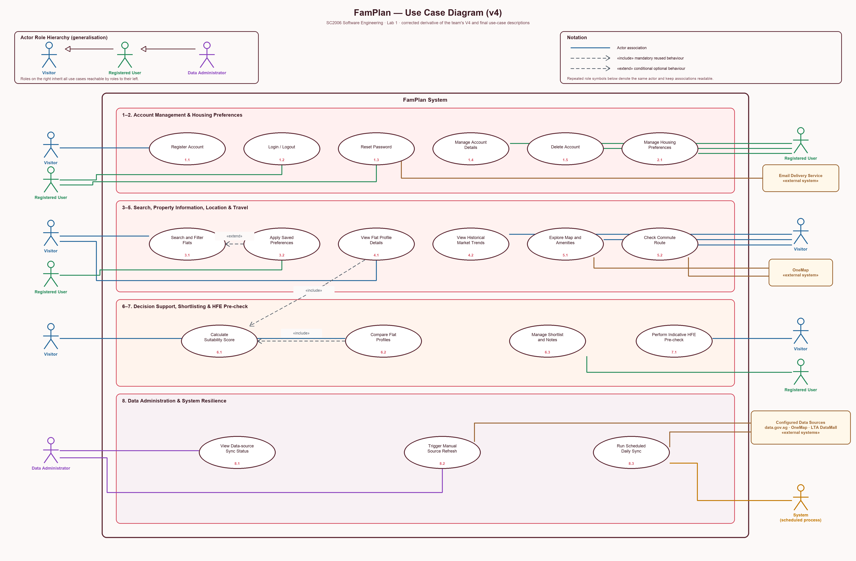

Functional Requirement Traceability
FR ID | Use Case | Coverage Note
FR-ACC-01 | 1.1 | Covered by the named use case and represented by one of the 19 diagram use cases.
FR-ACC-02 | 1.2 | Covered by the named use case and represented by one of the 19 diagram use cases.
FR-ACC-03 | 1.2 | Covered by the named use case and represented by one of the 19 diagram use cases.
FR-ACC-04 | 1.3 | Covered by the named use case and represented by one of the 19 diagram use cases.
FR-ACC-05 | 1.4 | Covered by the named use case and represented by one of the 19 diagram use cases.
FR-ACC-06 | 1.5 | Covered by the named use case and represented by one of the 19 diagram use cases.
FR-PREF-01 | 2.1 | Covered by the named use case and represented by one of the 19 diagram use cases.
FR-PREF-02 | 2.1 | Covered by the named use case and represented by one of the 19 diagram use cases.
FR-PREF-03 | 2.1 | Covered by the named use case and represented by one of the 19 diagram use cases.
FR-PREF-04 | 2.1 | Covered by the named use case and represented by one of the 19 diagram use cases.
FR-PREF-05 | 2.1 | Covered by the named use case and represented by one of the 19 diagram use cases.
FR-PREF-06 | 2.1 | Covered by the named use case and represented by one of the 19 diagram use cases.
FR-SRCH-01 | 3.1 | Covered by the named use case and represented by one of the 19 diagram use cases.
FR-SRCH-02 | 3.1 | Covered by the named use case and represented by one of the 19 diagram use cases.
FR-SRCH-03 | 3.2 | Covered by the named use case and represented by one of the 19 diagram use cases.
FR-SRCH-04 | 3.1 | Covered by the named use case and represented by one of the 19 diagram use cases.
FR-SRCH-05 | 3.1 | Covered by the named use case and represented by one of the 19 diagram use cases.
FR-SRCH-06 | 3.1 | Covered by the named use case and represented by one of the 19 diagram use cases.
FR-MKT-01 | 4.1 | Covered by the named use case and represented by one of the 19 diagram use cases.
FR-MKT-02 | 4.2 | Covered by the named use case and represented by one of the 19 diagram use cases.
FR-MKT-03 | 4.2 | Covered by the named use case and represented by one of the 19 diagram use cases.
FR-MKT-04 | 4.2 | Covered by the named use case and represented by one of the 19 diagram use cases.
FR-MKT-05 | 4.2 | Covered by the named use case and represented by one of the 19 diagram use cases.
FR-MKT-06 | 4.2 | Covered by the named use case and represented by one of the 19 diagram use cases.
FR-MKT-07 | 4.2 | Covered by the named use case and represented by one of the 19 diagram use cases.
FR-MKT-08 | 4.2 | Covered by the named use case and represented by one of the 19 diagram use cases.
FR-LOC-01 | 5.1 | Covered by the named use case and represented by one of the 19 diagram use cases.
FR-LOC-02 | 5.1 | Covered by the named use case and represented by one of the 19 diagram use cases.
FR-LOC-03 | 5.1 | Covered by the named use case and represented by one of the 19 diagram use cases.
FR-LOC-04 | 5.1 | Covered by the named use case and represented by one of the 19 diagram use cases.
FR-LOC-05 | 5.2 | Covered by the named use case and represented by one of the 19 diagram use cases.
FR-LOC-06 | 5.2 | Covered by the named use case and represented by one of the 19 diagram use cases.
FR-LOC-07 | 5.1, 5.2 | Covered by the named use case and represented by one of the 19 diagram use cases.
FR-DEC-01 | 6.1 | Covered by the named use case and represented by one of the 19 diagram use cases.
FR-DEC-02 | 6.1 | Covered by the named use case and represented by one of the 19 diagram use cases.
FR-DEC-03 | 6.1 | Covered by the named use case and represented by one of the 19 diagram use cases.
FR-DEC-04 | 6.2 | Covered by the named use case and represented by one of the 19 diagram use cases.
FR-DEC-05 | 6.3 | Covered by the named use case and represented by one of the 19 diagram use cases.
FR-DEC-06 | 6.3 | Covered by the named use case and represented by one of the 19 diagram use cases.
FR-DEC-07 | 6.3 | Covered by the named use case and represented by one of the 19 diagram use cases.
FR-HFE-01 | 7.1 | Covered by the named use case and represented by one of the 19 diagram use cases.
FR-HFE-02 | 7.1 | Covered by the named use case and represented by one of the 19 diagram use cases.
FR-HFE-03 | 7.1 | Covered by the named use case and represented by one of the 19 diagram use cases.
FR-HFE-04 | 7.1 | Covered by the named use case and represented by one of the 19 diagram use cases.
FR-HFE-05 | 7.1 | Covered by the named use case and represented by one of the 19 diagram use cases.
FR-HFE-06 | 7.1 | Covered by the named use case and represented by one of the 19 diagram use cases.
FR-HFE-07 | 7.1 | Covered by the named use case and represented by one of the 19 diagram use cases.
FR-HFE-08 | 7.1 | Covered by the named use case and represented by one of the 19 diagram use cases.
FR-HFE-09 | 7.1 | Covered by the named use case and represented by one of the 19 diagram use cases.
FR-HFE-10 | 7.1 | Covered by the named use case and represented by one of the 19 diagram use cases.
FR-ADM-01 | 8.1, 8.2 | Covered by the named use case and represented by one of the 19 diagram use cases.
FR-ADM-02 | 8.1 | Covered by the named use case and represented by one of the 19 diagram use cases.
FR-ADM-03 | 8.2 | Covered by the named use case and represented by one of the 19 diagram use cases.
FR-ADM-04 | 8.3 | Covered by the named use case and represented by one of the 19 diagram use cases.
FR-ADM-05 | 8.1 | Covered by the named use case and represented by one of the 19 diagram use cases.
FR-RES-01 | 8.3 | Covered by the named use case and represented by one of the 19 diagram use cases.
FR-RES-02 | Cross-cutting | Cross-cutting resilience behaviour verified across dependent and unaffected workflows.
FR-RES-03 | Cross-cutting | Cross-cutting resilience behaviour verified across dependent and unaffected workflows.

Non-functional Requirement Binding
NFR Group | Primary Binding
NFR-PERF and NFR-SCALE | Search UC-3.1, scoring UC-6.1, comparison UC-6.2, and representative concurrent workflows.
NFR-USAB and NFR-ACC | All validation-bearing and core user workflows, especially UC-1.x, UC-3.1, UC-4.x, UC-6.x, and UC-7.1.
NFR-COMP | All responsive web pages and core workflows.
NFR-REL | Locally backed functions, external-provider isolation, and synchronisation UC-8.x.
NFR-DATA | All externally sourced output in UC-4.x, UC-5.x, UC-7.1, and UC-8.x.
NFR-SEC | Authentication UC-1.2, password reset UC-1.3, administration UC-8.1/8.2, and all user-controlled input.
NFR-PRIV | Registration UC-1.1, deletion UC-1.5, preferences UC-2.1, shortlist UC-6.3, and HFE UC-7.1.
NFR-MAINT | Scoring, ruleset, data-source, and transformation modules supporting UC-4.x through UC-8.x.
NFR-TRANS | Suitability score UC-6.1 and indicative guidance UC-7.1.
Appendix C User Interface Mockups
These ten Lab 1 mockups illustrate the intended interaction flow and were used to refine the requirements. They are not implementation screenshots. Text and figures shown in the mockups are illustrative; the numbered requirements govern final behaviour.
Figure C1 Sign in and registration
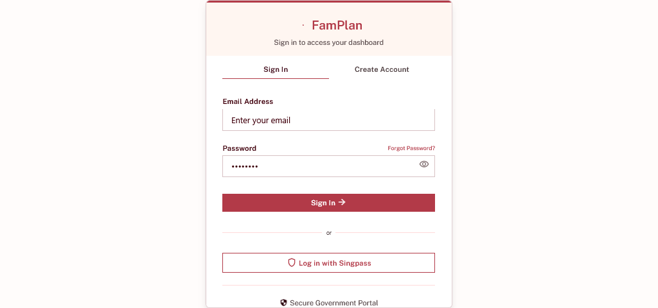
Requirements represented: UC-1.1 to UC-1.3; FR-ACC-01 to FR-ACC-04

Figure C2 Search and explore HDB resale profiles
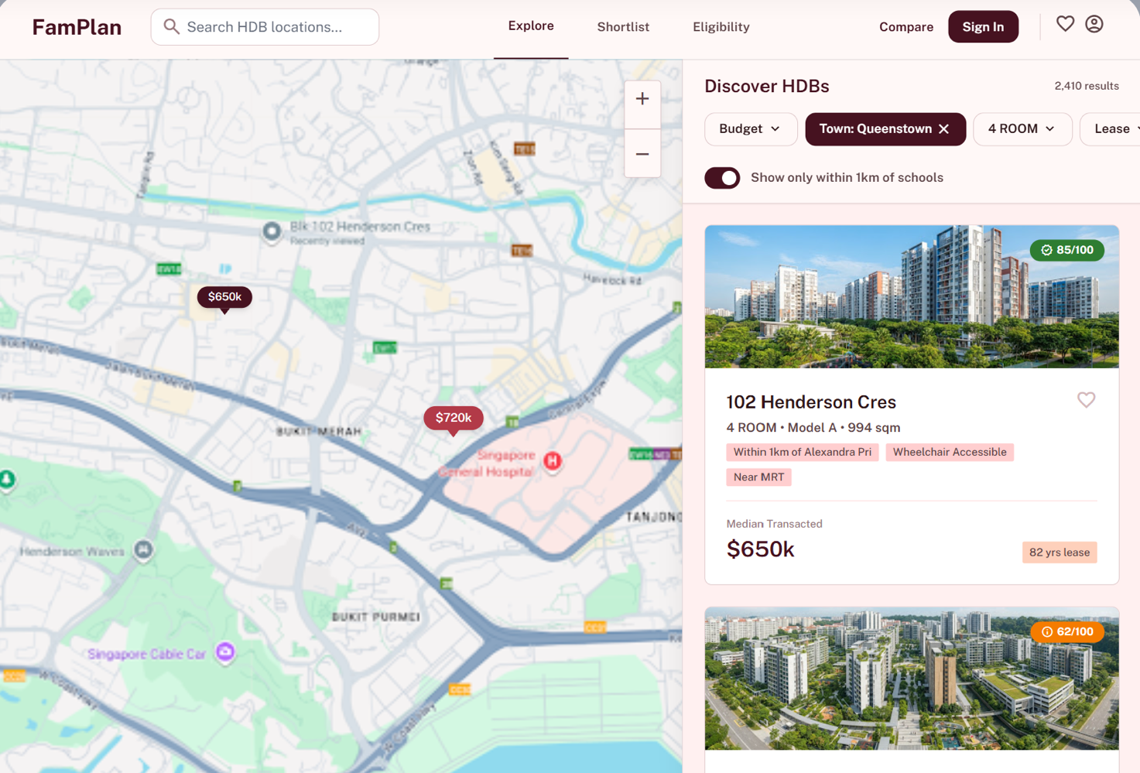
Requirements represented: UC-3.1; FR-SRCH-01 to FR-SRCH-06

Figure C3 Advanced search and saved preferences
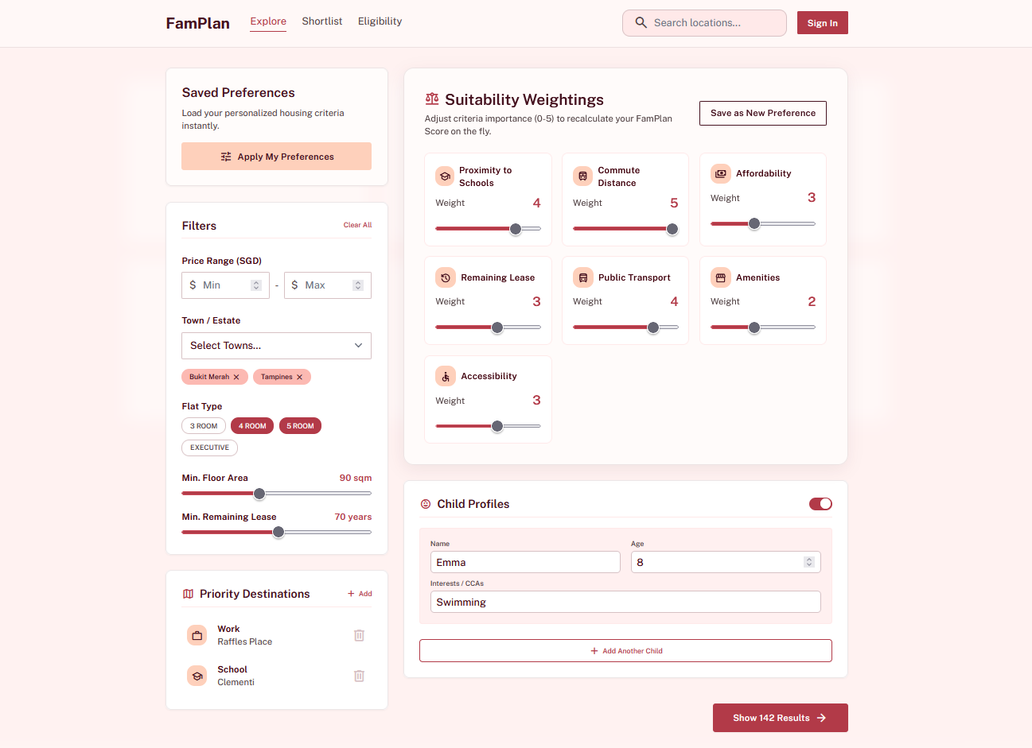
Requirements represented: UC-2.1 and UC-3.2; FR-PREF-01 to FR-PREF-06 and FR-SRCH-03

Figure C4 Property profile and market evidence
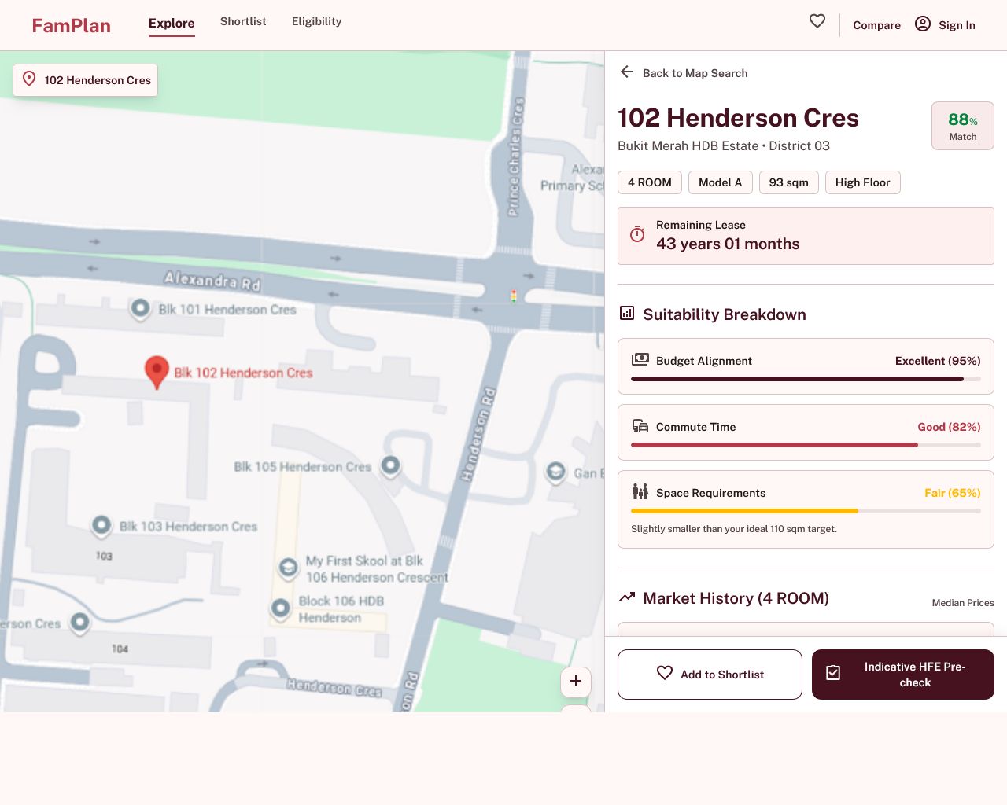
Requirements represented: UC-4.1, UC-4.2 and UC-6.1; FR-MKT-01 to FR-MKT-08 and FR-DEC-01 to FR-DEC-03

Figure C5 School and family amenity highlights
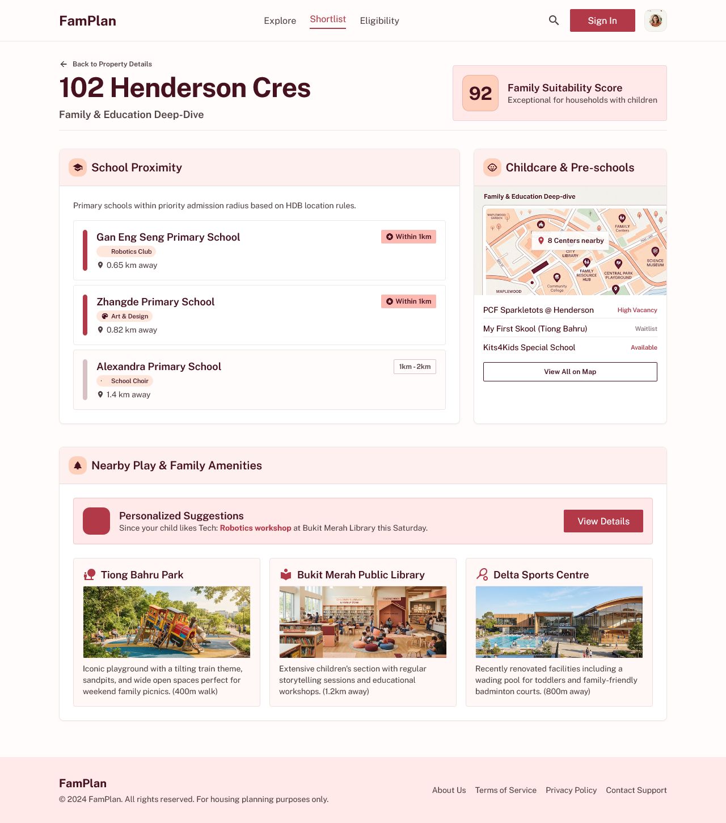
Requirements represented: UC-5.1; FR-LOC-01 to FR-LOC-04

Figure C6 Commute route details
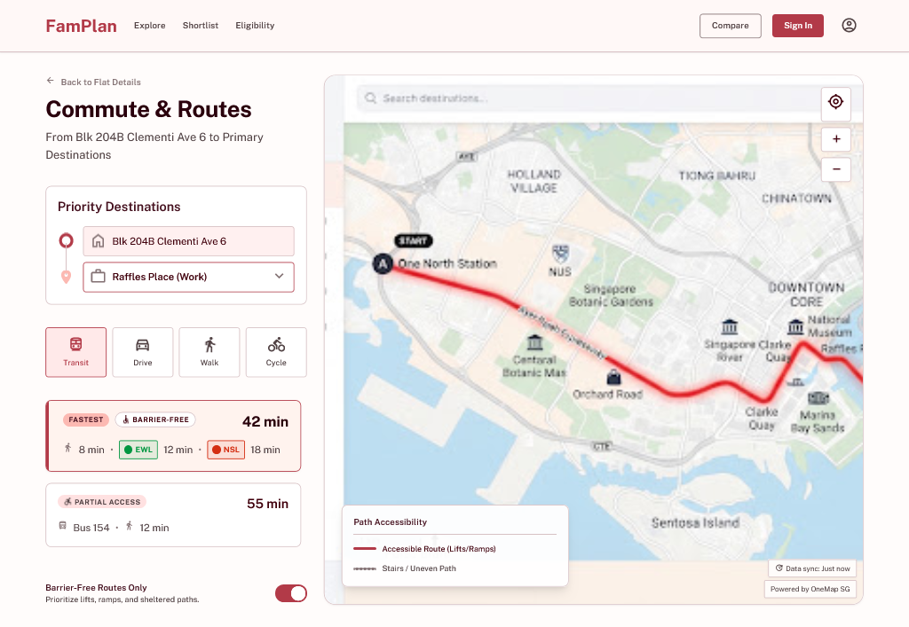
Requirements represented: UC-5.2; FR-LOC-05 to FR-LOC-07

Figure C7 Profile comparison and shortlist
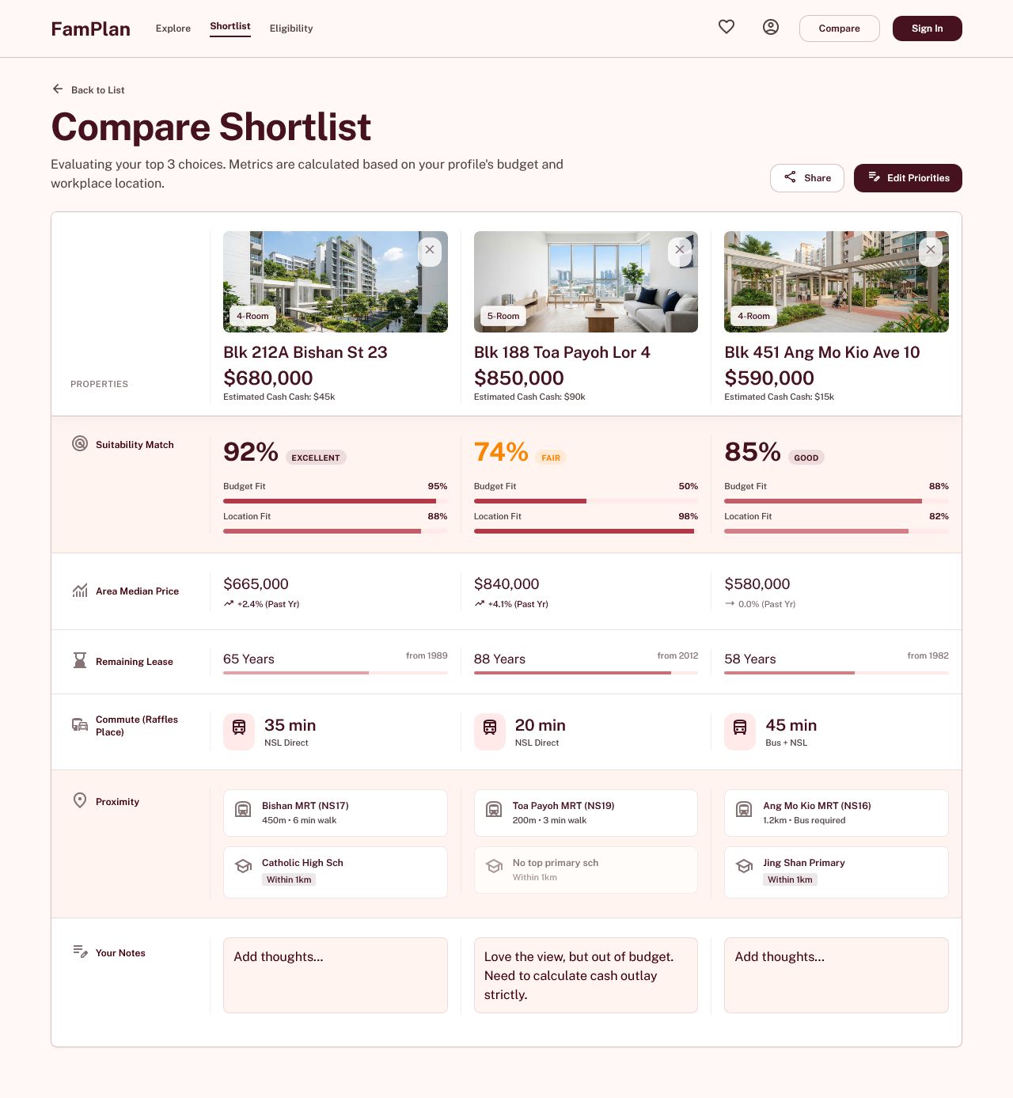
Requirements represented: UC-6.2 and UC-6.3; FR-DEC-04 to FR-DEC-07

Figure C8 Illustrative financial-planning concept
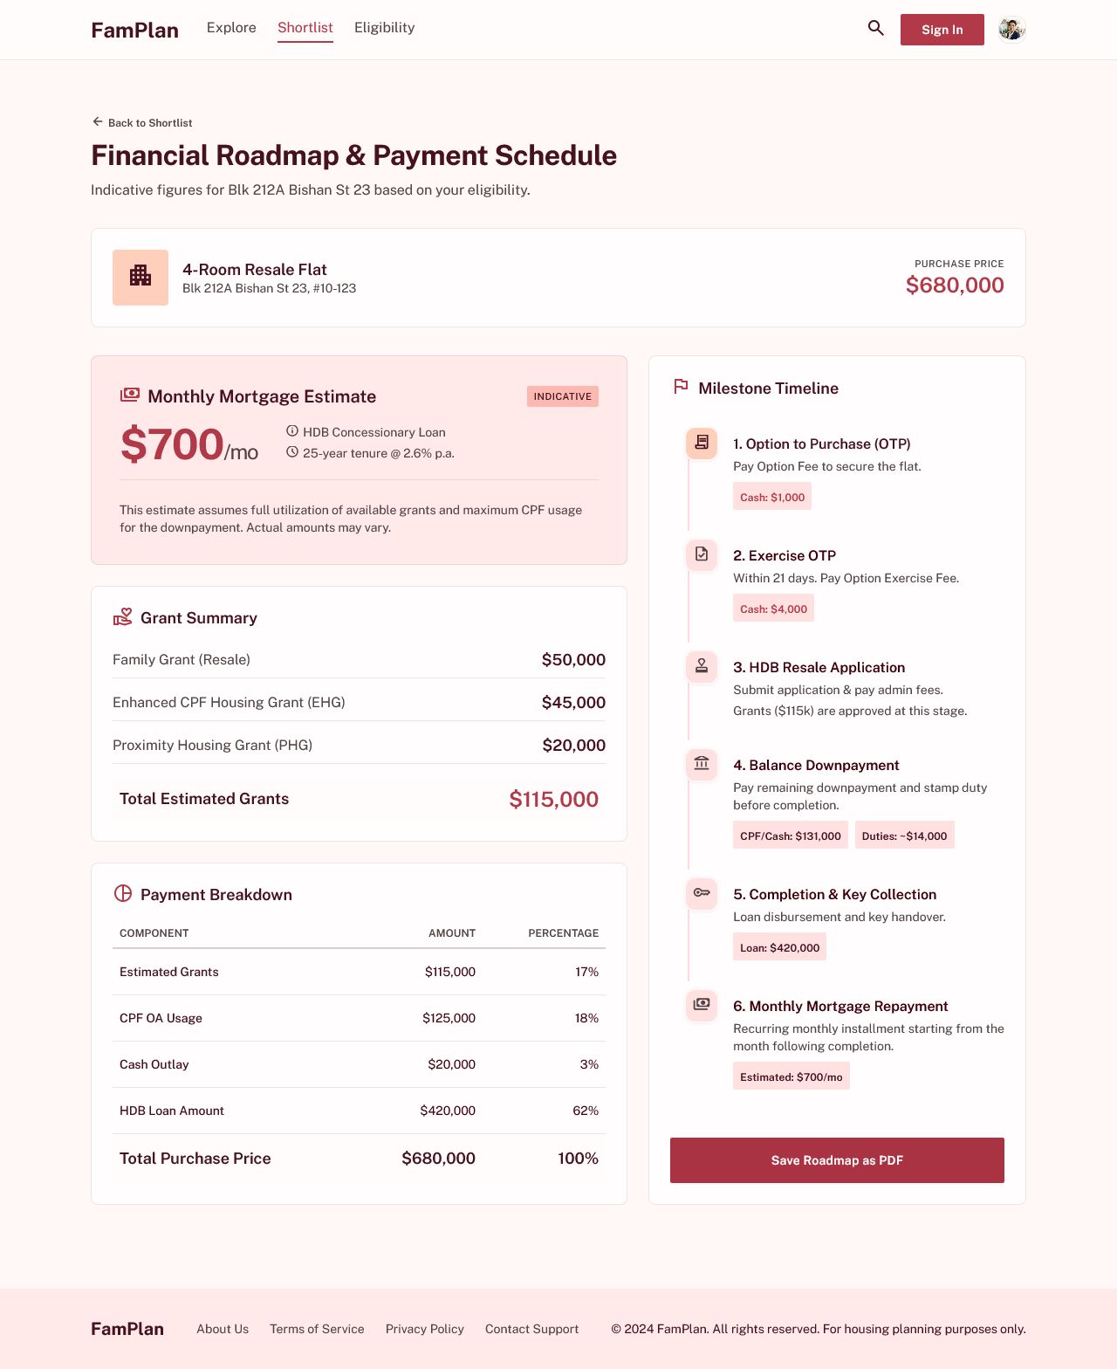
Requirements represented: Supporting affordability context only; official loan amounts and payment schedules remain out of scope

Figure C9 Indicative HFE pre-check
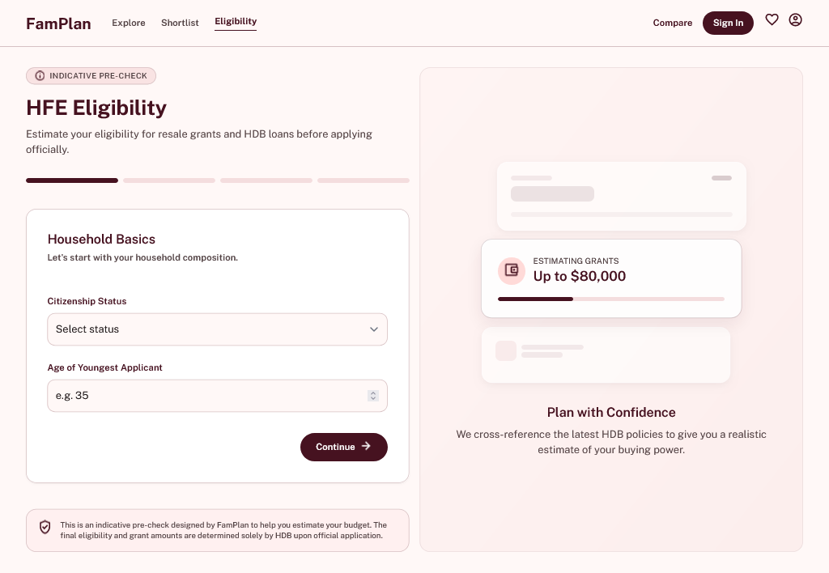
Requirements represented: UC-7.1; FR-HFE-01 to FR-HFE-10

Figure C10 Data-source synchronisation dashboard
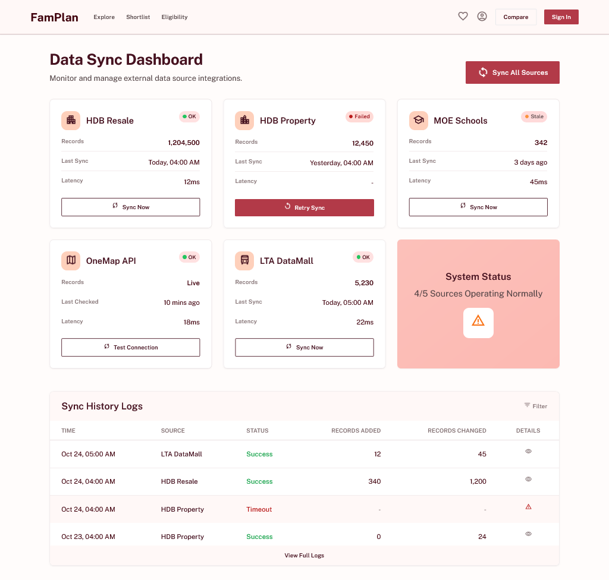
Requirements represented: UC-8.1 to UC-8.3; FR-ADM-01 to FR-ADM-05 and FR-RES-01

