Test Cases and Testing Results
for
FamPlan
Version 1.1 – Lab 5 Update
Prepared by Banana Five-O
NTU SC2006 Software Engineering
31 October 2026
Work product | Author | Username
Test cases, test code and testing results | POLOYAPOY RON JOSHUA ABES (Apollo) | POLO0002
Test cases, test code and testing results | LIM RUI XIAN EDWARD | ELIM095
Test cases, test code and testing results | LE VIET HOANG ANH (Raphael) | HOANGANH003
Test cases, test code and testing results | ATHENA LIM HUI RU (LIN HUIRU) | ALIM102
Test cases, test code and testing results | MUHAMMAD ILHAM BIN IRWAN | MUHA0313

Version | Date | Description
1.0 | 21 October 2026 | Black-box and white-box test cases with execution results for Lab 4 §3.2
1.1 | 31 October 2026 | Added tests for travel modes and multiple commute destinations (Section 4.2) and a local load test (Section 4.3); re-ran all suites

Contents
1. Introduction 3
1.1 Purpose and scope 3
1.2 Test environment 3
2. Black-box Testing: ScoringController 3
2.1 Class under test 3
2.2 Equivalence classes 4
2.3 Boundary values 4
2.4 Test cases and results 5
2.5 Minimising the number of test cases 6
3. White-box Testing: Basis Path Testing 7
3.1 WB1: ScoringController.calculateScore() 7
3.2 WB2: dedupeFacilities() 9
3.3 Checking that the tests can fail 11
4. Test Execution Summary 11
4.1 Additional tests for NFR-MAINT-02 11
4.2 Additional tests for travel modes and multiple commute destinations 12
4.3 Local load test (NFR-SCALE-02) 13
5. Traceability: Requirements to Tests 13

1. Introduction

1.1 Purpose and scope
This document records the test cases and testing results required by Lab 4 §3.2. It covers:
- Black-box testing (§3.2.1) of one important control class, ScoringController, using equivalence class partitioning and boundary value analysis.
- White-box testing (§3.2.2) of two methods with complex application logic, calculateScore() and dedupeFacilities(), using basis path testing.
- Execution of every test case and the recorded results (§3.2.4), plus additional tests and branch coverage evidence for NFR-MAINT-02.
The techniques follow Tutorial 8 (equivalence class and boundary value testing) and Tutorial 9 (control flow testing). Every requirement ID refers to FamPlan SRS v1.6.

1.2 Test environment
Item | Value
Code under test | prototype/server and prototype/client on main
Test framework | Vitest 5.0.2 with V8 coverage. v1.0 run: Node.js 22.14.0, Windows 11. v1.1 re-run: Node.js 26.5.0, macOS
Database (DB-backed suites only) | PostgreSQL 16, database famplan_test
Test files | server/test/scoring.blackbox.test.ts (black-box)  server/test/whitebox.test.ts (white-box)  server/test/sources.test.ts, server/test/service.test.ts (NFR-MAINT-02 coverage)
Run all tests | cd prototype/server && npx vitest run
Coverage report | cd prototype/server && npx vitest run --coverage
Execution date | 21 October 2026; re-run 31 October 2026
All test cases are automated. Each test is named with the test case ID used in this document, so every row in the result tables maps to one test in the code. Expected outputs were calculated by hand from the scoring rules in SRS §6 and SCORING_CONFIG (famplan-score-v1.0) before the tests were run. They still pass under famplan-score-v1.2.

2. Black-box Testing: ScoringController

2.1 Class under test
ScoringController (server/src/scoring/score.ts, SRS Table 9.5.2) calculates the Family Suitability Score. It was chosen because it holds the core application logic the client relies on (FR-DEC-01 to FR-DEC-03), and the SRS states its rules as numeric ranges. That makes it well suited to equivalence class and boundary value testing.
Its public operation is calculateScore(evidence, weights, …). It turns each criterion’s raw value into a normalised value from 0 to 1 using one of three rule types, weights the criteria, and returns a total from 0 to 100. A total ending in exactly .5 rounds upward.
Rule type | Criteria | Normalised value
nearest (distance) | groceries, healthcare (150 m – 1200 m)  public transport (250 m – 1500 m) | 1 at or below best; 0 at or beyond worst; linear between
count | childcare (target 30), schools (6), green spaces (8), accessibility (12) | count ÷ target, capped at 1
minutes | commute (20 min – 75 min) | 1 at or below best; 0 at or beyond worst; linear between
Testing approach. One representative criterion is tested for each rule type: groceries for distance, childcare for count, and commute for minutes. Within a test only the criterion under test carries weight, so the total equals its normalised value × 100. That isolates one input variable at a time (the single-fault assumption).
Invalid inputs. While designing the invalid classes, we found that before Lab 4 calculateScore() did not reject invalid weights or measurements itself. It relied on the API schema. A guard, assertValidScoringInput(), was therefore added. It collects every invalid field and throws one ScoringInputError that names each criterion, so the control class enforces its own input domain.

2.2 Equivalence classes
Input variable | Class | Condition | Valid? | Expected behaviour
Distance d (groceries) | EC-D1 | d < 0 or not a number | Invalid | ScoringInputError
 | EC-D2 | 0 ≤ d ≤ 150 | Valid | normalised = 1
 | EC-D3 | 150 < d < 1200 | Valid | normalised = (1200 − d) ÷ 1050
 | EC-D4 | d ≥ 1200 | Valid | normalised = 0
Count c (childcare) | EC-C1 | c < 0 | Invalid | ScoringInputError
 | EC-C2 | c not a whole number | Invalid | ScoringInputError
 | EC-C3 | 0 ≤ c < 30 | Valid | normalised = c ÷ 30
 | EC-C4 | c ≥ 30 | Valid | normalised = 1
Minutes m (commute) | EC-M1 | m < 0 | Invalid | ScoringInputError
 | EC-M2 | 0 ≤ m ≤ 20 | Valid | normalised = 1
 | EC-M3 | 20 < m < 75 | Valid | normalised = (75 − m) ÷ 55
 | EC-M4 | m ≥ 75 | Valid | normalised = 0
Weight w (FR-PREF-05) | EC-W1 | w < 0 | Invalid | ScoringInputError
 | EC-W2 | w ∈ {0, 1, 2, 3, 4, 5} | Valid | used as the criterion weight
 | EC-W3 | w > 5 | Invalid | ScoringInputError
 | EC-W4 | w not a whole number | Invalid | ScoringInputError
 | EC-W5 | weight missing for a criterion | Invalid | ScoringInputError
Data availability (FR-DEC-03) | EC-A1 | every criterion has data | Valid | standard explanation
 | EC-A2 | a weighted criterion has no data | Valid | excluded; weight redistributed
 | EC-A3 | no criterion has data | Valid | total 0 with explanation
 | EC-A4 | data present but every weight 0 | Valid | equal weighting fallback
Fraction f of unrounded total (FR-DEC-02) | EC-R1 | f < 0.5 | Valid | round down
 | EC-R2 | f = 0.5 | Valid | round up
 | EC-R3 | f > 0.5 | Valid | round up

2.3 Boundary values
Each boundary is tested just below, on, and just above it (robust boundary value analysis). Integer steps are used for distance (1 m), count (1) and minutes (1 min).
Variable | Boundary | Values tested | Test cases
Distance d | lower bound 0 | −1, 0 | BB-D1, BB-D2
 | best = 150 m | 149, 150, 151 | BB-D3 – BB-D5
 | worst = 1200 m | 1199, 1200, 1201 | BB-D7 – BB-D9
Count c | lower bound 0 | −1, 0, 1 | BB-C1 – BB-C3
 | target = 30 | 29, 30, 31 | BB-C5 – BB-C7
Minutes m | lower bound 0 | −1 | BB-M1
 | best = 20 min | 19, 20, 21 | BB-M2 – BB-M4
 | worst = 75 min | 74, 75, 76 | BB-M6 – BB-M8
Weight w | minimum 0 | −1, 0, 1 | BB-W1 – BB-W3
 | maximum 5 | 4, 5, 6 | BB-W4 – BB-W6
Rounding | .5 | 8.33, 12.5, 16.67 | BB-R1 – BB-R3

2.4 Test cases and results
Inputs not listed are held at their nominal value (every criterion normalises to 0.5). In the D, C, M and R groups only the criterion under test is weighted (weight 5). In the W group, childcare = 30 (normalised 1) and schools = 0 (normalised 0) with schools weight 5, so the total is w ÷ (w + 5) × 100. Values in brackets are the unrounded totals.
ID | Test input | Class / boundary | Expected output | Actual output | Result
BB-D1 | groceries = −1 m | EC-D1; BV below 0 | ScoringInputError | ScoringInputError thrown | Pass
BB-D2 | groceries = 0 m | EC-D2; BV 0 | total 100 | total 100 | Pass
BB-D3 | groceries = 149 m | EC-D2; BV 150−1 | total 100 | total 100 | Pass
BB-D4 | groceries = 150 m | EC-D2; BV 150 | total 100 | total 100 | Pass
BB-D5 | groceries = 151 m | EC-D3; BV 150+1 | total 100; normalised 0.999048 | total 100; normalised 0.999048 | Pass
BB-D6 | groceries = 675 m | EC-D3; nominal | total 50 | total 50 | Pass
BB-D7 | groceries = 1199 m | EC-D3; BV 1200−1 | total 0; normalised 0.000952 | total 0; normalised 0.000952 | Pass
BB-D8 | groceries = 1200 m | EC-D4; BV 1200 | total 0 | total 0 | Pass
BB-D9 | groceries = 1201 m | EC-D4; BV 1200+1 | total 0 | total 0 | Pass
BB-D10 | groceries = NaN | EC-D1 (not a number) | ScoringInputError | ScoringInputError thrown | Pass
BB-C1 | childcare = −1 | EC-C1; BV below 0 | ScoringInputError | ScoringInputError thrown | Pass
BB-C2 | childcare = 0 | EC-C3; BV 0 | total 0 | total 0 | Pass
BB-C3 | childcare = 1 | EC-C3; BV 0+1 | total 3 (3.33) | total 3 (3.33) | Pass
BB-C4 | childcare = 15 | EC-C3; nominal | total 50 | total 50 | Pass
BB-C5 | childcare = 29 | EC-C3; BV 30−1 | total 97 (96.67) | total 97 (96.67) | Pass
BB-C6 | childcare = 30 | EC-C4; BV 30 | total 100 | total 100 | Pass
BB-C7 | childcare = 31 | EC-C4; BV 30+1 | total 100 | total 100 | Pass
BB-C8 | childcare = 2.5 | EC-C2 | ScoringInputError | ScoringInputError thrown | Pass
BB-M1 | commute = −1 min | EC-M1; BV below 0 | ScoringInputError | ScoringInputError thrown | Pass
BB-M2 | commute = 19 min | EC-M2; BV 20−1 | total 100 | total 100 | Pass
BB-M3 | commute = 20 min | EC-M2; BV 20 | total 100 | total 100 | Pass
BB-M4 | commute = 21 min | EC-M3; BV 20+1 | total 98 (98.18) | total 98 (98.18) | Pass
BB-M5 | commute = 47.5 min | EC-M3; nominal | total 50 | total 50 | Pass
BB-M6 | commute = 74 min | EC-M3; BV 75−1 | total 2 (1.82) | total 2 (1.82) | Pass
BB-M7 | commute = 75 min | EC-M4; BV 75 | total 0 | total 0 | Pass
BB-M8 | commute = 76 min | EC-M4; BV 75+1 | total 0 | total 0 | Pass
BB-W1 | childcare weight = −1 | EC-W1; BV 0−1 | ScoringInputError | ScoringInputError thrown | Pass
BB-W2 | childcare weight = 0 | EC-W2; BV 0 | total 0 | total 0 | Pass
BB-W3 | childcare weight = 1 | EC-W2; BV 0+1 | total 17 (16.67) | total 17 (16.67) | Pass
BB-W4 | childcare weight = 4 | EC-W2; BV 5−1 | total 44 (44.44) | total 44 (44.44) | Pass
BB-W5 | childcare weight = 5 | EC-W2; BV 5 | total 50 | total 50 | Pass
BB-W6 | childcare weight = 6 | EC-W3; BV 5+1 | ScoringInputError | ScoringInputError thrown | Pass
BB-W7 | childcare weight = 2.5 | EC-W4 | ScoringInputError | ScoringInputError thrown | Pass
BB-W8 | schools weight omitted | EC-W5 | ScoringInputError | ScoringInputError thrown | Pass
BB-E1 | childcare weight 6, schools weight 2.5, groceries −1 m | EC-W3 + EC-W4 + EC-D1 together | One ScoringInputError naming childcare, schools and groceries | One ScoringInputError naming childcare, schools and groceries | Pass
BB-A1 | all criteria at nominal (0.5), all weights 3 | EC-A1 | total 50; standard explanation | total 50; standard explanation | Pass
BB-A2 | childcare 30, commute missing; weights childcare 5, commute 5 | EC-A2 | total 100; commute marked missing; “redistributed” note | total 100; commute marked missing; “redistributed” note | Pass
BB-A3 | no criterion has data; childcare weight 3 | EC-A3 | total 0; “No criterion has sufficient data” note | total 0; “No criterion has sufficient data” note | Pass
BB-A4 | childcare 30, others nominal; all weights 0 | EC-A4 | total 56 (56.25); “weighted equally” note | total 56 (56.25); “weighted equally” note | Pass
BB-R1 | accessibility = 1 bus stop (only weighted) | EC-R1 (8.33) | total 8 | total 8 | Pass
BB-R2 | green spaces = 1 park (only weighted) | EC-R2 (exactly 12.5) | total 13 | total 13 | Pass
BB-R3 | accessibility = 2 bus stops (only weighted) | EC-R3 (16.67) | total 17 | total 17 | Pass

2.5 Minimising the number of test cases
- Single-fault assumption: each invalid class has its own test with every other input valid, so a failure points to one cause. BB-E1 is the one exception. It combines three invalid inputs on purpose, to check that every field error is reported together.
- Valid classes for different criteria are not combined. The rule types are independent, so one representative criterion per rule type covers the logic shared by the criteria of that type.
- Each nominal test (BB-D6, BB-C4, BB-M5) also serves as the equivalence class representative for its linear class, so no separate class test is needed.
- In total, 42 test cases cover 24 equivalence classes and 11 boundaries. A full combinatorial design over 8 criteria and their weights would need thousands of cases.

3. White-box Testing: Basis Path Testing
Control flow graphs follow the Tutorial 9 conventions. A compound condition such as a && b is one decision node. Library calls whose callbacks contain no decisions (filter, reduce) are treated as single process nodes. map and find are treated as loops because their callbacks contain decisions. Cyclomatic complexity is calculated as V(G) = E − N + 2 and checked against V(G) = P + 1, where P is the number of decision nodes.

3.1 WB1: ScoringController.calculateScore()
calculateScore() (server/src/scoring/score.ts, lines 68–137) applies the missing-data and all-zero-weight rules and builds the itemised breakdown (FR-DEC-01 to FR-DEC-03, NFR-TRANS-01).
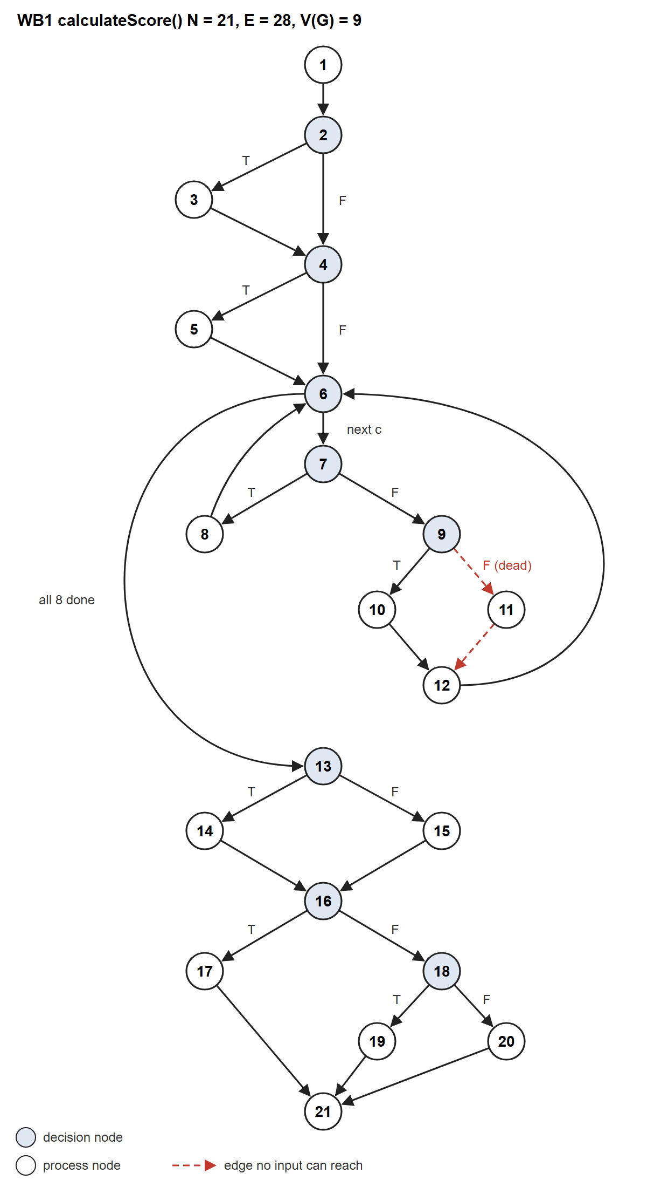
Figure 1. Control flow graph of calculateScore(). Node numbers refer to the table below.
Node | Lines | Statement / decision
1 | 75–79 | assertValidScoringInput(); available = criteria with data; weightSum = Σ weights of available; effective = weights; notes = []
2 | 81 | available.length > 0 && weightSum === 0 ?
3 | 82–84 | equal-weight fallback: effective = 1 per available criterion; weightSum = available.length; add fallback note
4 | 86–88 | missing, missingWeighted computed; missingWeighted.length > 0 ?
5 | 88 | add missing-data note
6 | 90 | CRITERIA.map: another criterion c? (always 8 iterations)
7 | 91–93 | ev.value === null ?
8 | 94–105 | return missing entry (effectiveWeight 0, contribution 0)
9 | 107–108 | n = normalise(rule, value); weightSum > 0 ?
10 | 108 | share = effective[c] ÷ weightSum
11 | 108 | share = 0
12 | 109–119 | return entry with contribution = share × n × 100
13 | 122–124 | unrounded = Σ contributions; available.length === 0 ?
14 | 124 | total = 0
15 | 124 | total = roundHalfUp(unrounded)
16 | 130 | available.length === 0 ?
17 | 131 | weightTreatment = “No criterion has sufficient data …”
18 | 132 | notes.length > 0 ?
19 | 133 | weightTreatment = notes joined
20 | 134 | weightTreatment = standard explanation
21 | 123–136 | return FamilyScoreDto

Cyclomatic complexity: V(G) = E − N + 2 = 28 − 21 + 2 = 9, and V(G) = P + 1 = 8 + 1 = 9 (decision nodes 2, 4, 6, 7, 9, 13, 16, 18). The basis set therefore has 9 linearly independent paths. They were derived with the baseline method: start from a typical path, then flip one decision at a time.
Path | Node sequence | Derived by | Feasibility | Test
P1 | 1-2-4-6-(7-9-10-12-6)×8-13-15-16-18-20-21 | Baseline | Feasible | WB1-P1
P2 | 1-2-3-4-6-(7-9-10-12-6)×8-13-15-16-18-19-21 | Node 2 → T | Feasible | WB1-P2
P3 | 1-2-4-5-6-…-(7-8-6)-…-13-15-16-18-19-21 | Node 4 → T | Feasible | WB1-P3
P4 | 1-2-4-6-…-(7-8-6)-…-13-15-16-18-20-21 | Node 7 → T | Feasible | WB1-P4
P5 | 1-2-4-5-6-(7-8-6)×8-13-14-16-17-21 | Node 13 → T | Feasible | WB1-P5
P6 | 1-2-4-6-13-… | Node 6 → exit at once | Infeasible | —
P7 | …-7-9-11-12-6-… | Node 9 → F | Infeasible | —
P8 | …-13-15-16-17-21 | Node 16 → T alone | Infeasible | —
P9 | …-13-14-16-18-… | Node 16 → F alone | Infeasible | —
(7-9-10-12-6) is one loop iteration for a criterion with data; (7-8-6) is one iteration for a criterion without data.
Why four paths are infeasible:
- P6: CRITERIA always has 8 entries, so the loop at node 6 can never exit before its first iteration.
- P7: node 9 is reached only for a criterion with data, so available.length ≥ 1. The guard ensures every weight is ≥ 0, so weightSum ≥ 0, and if weightSum is 0, node 3 sets it to available.length ≥ 1. weightSum > 0 is therefore always true, and the else branch (node 11) is dead code. The coverage report confirms it: line 108 has the only unreachable branch in calculateScore().
- P8 and P9: nodes 13 and 16 test the same condition (available.length === 0) and nothing changes in between, so the true branch of one cannot be paired with the false branch of the other.
Test cases and results:
ID | Test input | Expected output | Actual output | Result
WB1-P1 | all 8 criteria at nominal (0.5); all weights 3 | total 50; weightTreatment = standard explanation | total 50; weightTreatment = standard explanation | Pass
WB1-P2 | all 8 criteria at nominal; all weights 0 | total 50; each effectiveWeight 12.5; “weighted equally” note | total 50; each effectiveWeight 12.5; “weighted equally” note | Pass
WB1-P3 | childcare 30, commute missing; weights childcare 5, commute 5 | total 100; commute missing with contribution 0; “redistributed” note | total 100; commute missing with contribution 0; “redistributed” note | Pass
WB1-P4 | childcare 30, schools 0, commute missing; weights childcare 5, schools 5 | total 50; commute missing; standard explanation (no note) | total 50; commute missing; standard explanation (no note) | Pass
WB1-P5 | no criterion has data; childcare weight 3 | total 0; unroundedTotal 0; every entry missing; “No criterion …” explanation | total 0; unroundedTotal 0; every entry missing; “No criterion …” explanation | Pass
Statement and branch coverage. All 20 reachable nodes and all 26 reachable edges are covered by just three of these tests: WB1-P2, WB1-P4 and WB1-P5. Node 11 and its two edges cannot be reached by any input. The remaining basis paths add the independent-path assurance that basis path testing requires.

3.2 WB2: dedupeFacilities()
dedupeFacilities() (server/src/neighbourhoods/dedupe.ts, lines 31–48) is used by NeighbourhoodIndex to merge facility records from several data sources (NFR-DATA-04). Two records are the same facility when they share a category, their normalised names match, and they are no more than 60 m apart.
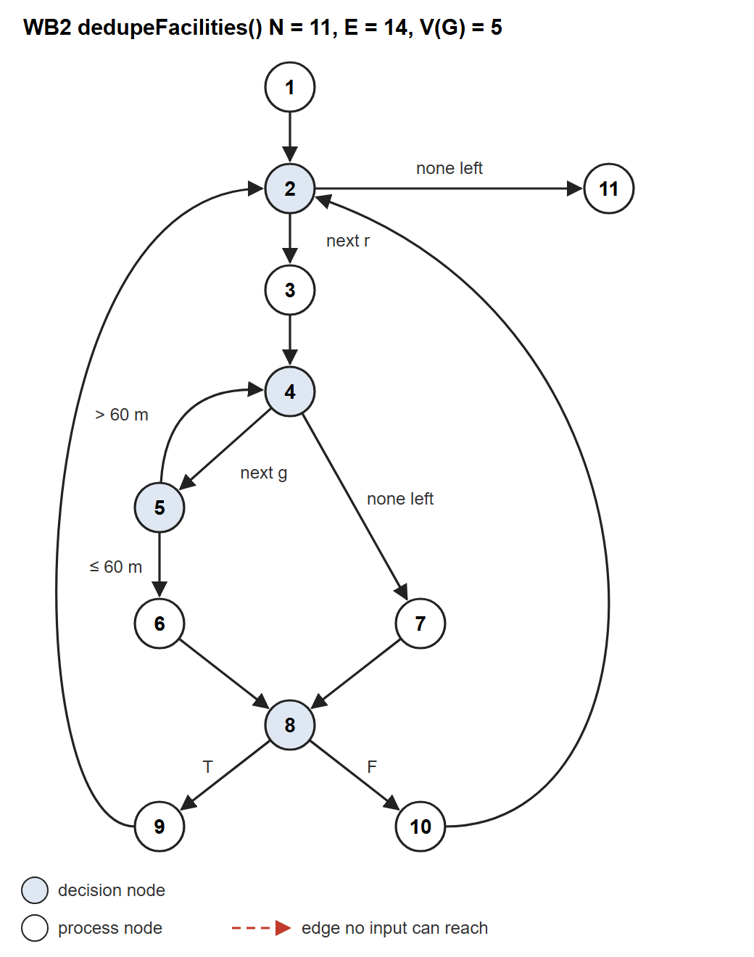
Figure 2. Control flow graph of dedupeFacilities(). Node numbers refer to the table below.
Node | Lines | Statement / decision
1 | 32–34 | sorted = records ordered by category, sourceId, id; buckets = new Map(); groups = []
2 | 35 | for (r of sorted): another record r?
3 | 36–37 | key = category | normaliseName(name); candidates = buckets.get(key) ?? []
4 | 38 | candidates.find: another candidate group g?
5 | 38 | haversineM(g[0], r) ≤ DEDUPE_DISTANCE_M (60 m) ?
6 | 38 | match = g
7 | 38 | match = undefined
8 | 39 | if (match)
9 | 39 | match.push(r)
10 | 41–44 | g = [r]; candidates.push(g); buckets.set(key, candidates); groups.push(g)
11 | 47 | return groups

Cyclomatic complexity: V(G) = E − N + 2 = 14 − 11 + 2 = 5, and V(G) = P + 1 = 4 + 1 = 5 (decision nodes 2, 4, 5, 8).
Path | Node sequence | Derived by | Feasibility | Test
P1 | 1-2-11 | Baseline (loop skipped) | Feasible | WB2-P1
P2 | 1-2-3-4-7-8-10-2-11 | Node 2 → enter loop | Feasible | WB2-P2
P3 | 1-2-3-4-7-8-10-2-3-4-5-6-8-9-2-11 | Node 4 → next g; node 5 → ≤ 60 m | Feasible | WB2-P3
P4 | 1-2-3-4-7-8-10-2-3-4-5-4-7-8-10-2-11 | Node 5 → > 60 m | Feasible | WB2-P4
P5 | …-4-5-6-8-10-… | Node 8 → F after a match | Infeasible | —
P5 is infeasible: node 6 sets match to a non-empty group, so the decision at node 8 is always true after node 6 and always false after node 7.
Test cases and results:
ID | Test input | Expected output | Actual output | Result
WB2-P1 | records = [ ] | [ ] (no groups) | [ ] (no groups) | Pass
WB2-P2 | one supermarket A “Sheng Siong” at 1.3500, 103.8 | [[A]] | [[A]] | Pass
WB2-P3 | A “Sheng Siong Pte Ltd” at 1.3500 (src-a); B “SHENG SIONG” at 1.3502 (src-b), ≈ 22 m apart | [[A, B]] (one facility) | [[A, B]] (one facility) | Pass
WB2-P4 | A and B both “Sheng Siong”, at 1.3500 and 1.3550, ≈ 556 m apart | [[A], [B]] (two facilities) | [[A], [B]] (two facilities) | Pass
Statement and branch coverage. WB2-P3 alone executes all 11 nodes (100% statement coverage). WB2-P3 and WB2-P4 together traverse all 14 edges (100% branch coverage). The coordinates were chosen far from the 60 m threshold (about 22 m and 556 m) so each test checks one path, not the threshold itself.

3.3 Checking that the tests can fail
Basis path tests written for existing code pass the first time they are run. To show they can detect faults, three deliberate faults were introduced one at a time and the white-box tests were run against each:
Fault introduced | Tests that failed
Line 81: weightSum === 0 changed to weightSum !== 0 | WB1-P1, WB1-P2, WB1-P3, WB1-P4
Line 88: missingWeighted.length > 0 changed to ≥ 0 | WB1-P1, WB1-P4
dedupe.ts line 38: ≤ DEDUPE_DISTANCE_M changed to > | WB2-P3, WB2-P4
Every fault was detected, and the original code was restored afterwards.

4. Test Execution Summary
The full server suite was run on 21 October 2026: 170 of 170 tests passed and none failed. That includes the 42 black-box and 9 white-box test cases in this document, the additional NFR-MAINT-02 tests in Section 4.1, and the existing API, synchronisation and SaaS tests.
Re-run on 31 October 2026 after the commute change, using macOS, Node.js 26.5.0 and an isolated database: 255 of 255 server tests and 28 of 28 client tests passed and none failed. Scoring configuration is now famplan-score-v1.2. The hand-calculated black-box and white-box cases above are unchanged because calculateScore() still receives one commute value for each neighbourhood. The black-box and white-box files now run 52 tests, one more than the 51 cases listed.

4.1 Additional tests for NFR-MAINT-02
NFR-MAINT-02 requires at least 80% branch coverage for family scoring, proximity aggregation, facility deduplication and external-data transformation. The first coverage run showed that two of these were below target, so two more test files were added:
Test file | Module | Tests | What is checked | Branches before → after
sources.test.ts | synchronisation/sources.ts (external-data transformation) | 13 | Each of the 9 source adapters with a small sample of the provider payload: field mapping, title-casing, category classification, skipping invalid, repeated or out-of-area rows, schema errors and coverage notes. Network calls are replaced with fixed payloads. | 0% → 96.8%
service.test.ts | neighbourhoods/service.ts (proximity aggregation) | 29 | Name matching with spelling tolerance, address search (including a failed address search), the area, stage, count, distance and commute filters at their boundaries, sorting, pagination, and amenity availability states (available, no match, incomplete, unavailable). | 60.5% → 93.0%
Coverage results. The 80% target is now enforced in server/vitest.config.ts (branch threshold 80, per file), so the coverage command fails if any NFR-MAINT-02 module drops below the target. The table shows the coverage measured on 31 October 2026.
Module (NFR-MAINT-02) | Statements | Branches | ≥ 80% branches
Family scoring: scoring/score.ts | 100% (53/53) | 95.23% (40/42) | Met
Proximity aggregation: neighbourhoods/service.ts | 97.88% (139/142) | 93.03% (147/158) | Met
Facility deduplication: neighbourhoods/dedupe.ts | 100% (19/19) | 100% (7/7) | Met
External-data transformation: synchronisation/sources.ts | 98.07% (153/156) | 94.4% (152/161) | Met
External-data validation: synchronisation/validate.ts | 100% (45/45) | 92.5% (37/40) | Met
Findings:
- Dead code at score.ts line 108: the weightSum > 0 check can never be false (path P7). It can be removed in a later refactor without changing behaviour.
- score.ts line 82: the false branch of available.includes(c) inside the equal-weight fallback is reachable (every weight 0 and some criterion missing), but it is not in the basis set, because that callback is modelled as one process node. A follow-up test is recommended.
- service.ts lines 179–180 place neighbourhoods without a sort value last. With real data this branch cannot be reached: the nearest-facility distance has no radius limit, so either every neighbourhood has a value or none does. The rule is kept as a safeguard for FR-DISC-05.
- The MOE schools adapter passes the “Nearby MRT” text through in capitals while other fields are title-cased. This is a minor display inconsistency, not a defect.
- Black-box analysis led to a design improvement: ScoringController now rejects invalid weights and measurements itself instead of relying only on the API schema.

4.2 Additional tests for travel modes and multiple commute destinations
FR-PREF-03 now stores a travel mode for each of up to three priority destinations, and the commute criterion uses the average estimated time across all of them. Equivalence classes: number of destinations (0 means no commute evidence; 1 to 3 are valid; 4 is invalid) and travel mode (pt, walk, drive and cycle are valid; anything else is invalid). Boundary values tested: 0, 1, 3 and 4 destinations. Fixture zones lie on a north-south line, which makes the expected ranking calculable by hand.
ID | Test input | Expected output | Actual output | Result
CM-1 | Sort by commute with Work only, then with Work, School and Gym | First result moves from TVSZ01 to TVSZ11 | TVSZ01, then TVSZ11 | Pass
CM-2 | Same destinations, with commute as the only weighted criterion | Top score moves from TVSZ01 to TVSZ11 | TVSZ01, then TVSZ11 | Pass
CM-3 | Work by public transport and School by car | Both trips listed; average is the rounded mean; breakdown names both | As expected | Pass
CM-4 | One destination in each of pt, drive, cycle and walk | Minutes: drive < pt < cycle < walk; contribution of drive exceeds walk | As expected | Pass
CM-5 | Work and School with maximum commute 20, then 35 minutes | No zones at 20; 12 zones at 35; far zone LVSZ01 excluded | As expected | Pass
CM-6 | Save three destinations: drive, walk, and one with no mode | Saved modes drive, walk, pt | As expected | Pass
CM-7 | Save a destination with mode teleport | HTTP 400; field error on destinations.0.mode | As expected | Pass
CM-8 | Commute sort with no destination; malformed list; unknown mode; point outside Singapore; four destinations | HTTP 400 with field guidance for each | As expected | Pass
CM-9 | Profile and comparison with two destinations | Breakdown shows the average and names both destinations | As expected | Pass
CM-C1 – CM-C3 | Client scoring request with two, then zero destinations | Every destination sent with its mode; parameter omitted when empty; names listed | As expected | Pass
CM-C4 – CM-C5 | Change a travel mode on the preferences page and save | Saved request carries each mode; the page says every destination counts | As expected | Pass
Tests are in server/test/service.test.ts, server/test/api.test.ts and client/test/commute-preferences.test.tsx, named with these IDs.

4.3 Local load test (NFR-SCALE-02)
Run on 31 October 2026 with npm run loadtest -w server against one production-mode Node.js server on a 10-core Mac, with the load generator on the same machine. Each simulated user repeats a random read request (search, filtered search, profile, facilities or comparison) and then pauses for the think time shown. The local data has 12,107 facility records and 170 family neighbourhoods.
Simulated users | p95 / p99 response time | Requests (per second) | Failed | Think time
100 | 77 ms / 106 ms | 2,907 (95/s) | 0 | 1 s
1,000 | 1,290 ms / 1,346 ms | 18,873 (615/s) | 0 | 1 s
1,000 | 299 ms / 1,954 ms | 13,952 (438/s) | 0 | 2 s
Limits of this evidence: the workload is read-only, the data is below the 100,000 records named in NFR-PERF-01, and the server is local rather than the Vercel deployment. It does not by itself satisfy NFR-SCALE-02 or show how the live site behaves under the same load.

5. Traceability: Requirements to Tests
Requirement | Design class | Implementation | Test cases
FR-PREF-05 integer weights 0–5, field errors | ScoringController | score.ts: assertValidScoringInput() | BB-W1 – BB-W8, BB-E1
FR-DEC-01 score from weights and normalisation rules | ScoringController | score.ts: calculateScore(), normalise(); config.ts | BB-D1 – BB-D10, BB-C1 – BB-C8, BB-M1 – BB-M8, WB1-P1
FR-DEC-02 itemised contributions; exact .5 rounds up | ScoringController | score.ts: roundHalfUp(), calculateScore() | BB-R1 – BB-R3, WB1-P2
FR-DEC-03 missing data disclosed, weight redistributed | ScoringController | score.ts: calculateScore() | BB-A1 – BB-A4, WB1-P3 – WB1-P5
NFR-DATA-04 duplicate facilities not counted twice | NeighbourhoodIndex | dedupe.ts: dedupeFacilities() | WB2-P1 – WB2-P4
FR-DISC-01, FR-DISC-02, FR-DISC-05 search, filters and sorting | DiscoveryController | service.ts: searchNeighbourhoods(), nameMatches() | service.test.ts
FR-NBH-03, FR-NBH-06, FR-NBH-07, FR-NBH-10 nearby facilities and availability | NeighbourhoodController | service.ts: amenitySummaries(), facilitiesNear() | service.test.ts
NFR-MAINT-01 isolated source adapters | PublicDataSourceBoundary adapters | sources.ts: SOURCES[].fetch() | sources.test.ts
NFR-MAINT-02 ≥ 80% branch coverage | ScoringController, DiscoveryController, NeighbourhoodIndex, DataSyncController | scoring/, service.ts, dedupe.ts, sources.ts, validate.ts | Coverage report (Section 4.1)
FR-PREF-03 travel mode per destination; commute across all destinations | PreferenceController, NeighbourhoodIndex | schemas.ts: destinationSchema, destinationsParam; store.ts: commuteLegs(), commuteMinutes(), evidence() | CM-1 – CM-9, CM-C1 – CM-C5
NFR-SCALE-02 concurrent users (partial, local evidence) | All read controllers | scripts/loadtest.ts | Section 4.3

