Software Requirements Specification
for
FamPlan
Version 1.7 - Lab 5 Final Revision
Prepared by Banana Five-O
NTU SC2006 Software Engineering
4 November 2026
Table of Contents
Table of Contents ii
Revision History iii
1. Introduction 1
1.1 Purpose 1
1.2 Document Conventions 1
1.3 Intended Audience and Reading Suggestions 1
1.4 Product Scope 1
1.5 References 2
1.6 Team Contributions and AI Use 2
2. Overall Description 3
2.1 Product Perspective 3
2.2 Product Functions 3
2.3 User Classes and Characteristics 3
2.4 Operating Environment 4
2.5 Constraints Assumptions and Dependencies 4
3. External Interface Requirements 4
3.1 User Interfaces 4
3.2 Hardware Interfaces 14
3.3 Software Interfaces 14
3.4 Communications Interfaces 15
4. Functional Requirements 15
4.1 Account Management 15
4.2 Family and Neighbourhood Preferences 15
4.3 Neighbourhood Discovery 16
4.4 Family Amenities and Neighbourhood Information 17
4.5 Map and Travel 17
4.6 Family Decision Support 18
4.7 Automatic Data Synchronisation and Resilience 19
5. Nonfunctional Requirements 19
5.1 Performance Requirements 19
5.2 Scalability Requirements 20
5.3 Usability Requirements 20
5.4 Accessibility Requirements 20
5.5 Compatibility Requirements 20
5.6 Reliability Requirements 21
5.7 Recoverability Requirements 21
5.8 Fault isolation Requirements 21
5.9 Data provenance Requirements 21
5.10 Data freshness Requirements 21
5.11 Reproducibility Requirements 21
5.12 Data quality Requirements 22
5.13 Transport security Requirements 22
5.14 Credential security Requirements 22
5.15 Authorisation Requirements 22
5.16 Authentication security Requirements 22
5.17 Input security Requirements 23
5.18 Privacy Requirements 23
5.19 Data minimisation Requirements 23
5.20 Maintainability Requirements 23
5.21 Testability Requirements 23
5.22 Transparency Requirements 23
5.23 Responsible guidance Requirements 24
5.24 Business Rules 24
6. Data Dictionary 24
7. Use Case Model 26
7.1 Use Case Diagram 26
7.2 Actors 27
7.3 Use Case Catalogue 28
7.4 Functional Requirement Traceability 28
7.5 Use Case Descriptions 30
7.5.1 UC-1.1 Register Account 31
7.5.2 UC-1.2 Login and Logout 32
7.5.3 UC-1.3 Reset Password 33
7.5.4 UC-1.4 Manage Account Details 34
7.5.5 UC-1.5 Delete Account 35
7.5.6 UC-2.1 Manage Family Preferences 36
7.5.7 UC-3.1 Search Neighbourhoods 37
7.5.8 UC-3.2 Apply Saved Preferences 38
7.5.9 UC-4.1 View Neighbourhood Profile 39
7.5.10 UC-4.2 Explore Family Amenities 40
7.5.11 UC-5.1 View Map and Nearby Places 41
7.5.12 UC-5.2 Check Commute Route 42
7.5.13 UC-6.1 Calculate Family Suitability Score 43
7.5.14 UC-6.2 Compare Neighbourhoods 44
7.5.15 UC-6.3 Manage Shortlist and Notes 45
7.5.16 UC-7.1 Monitor Automatic Data Synchronisation 46
8. Technology Stack Recommendation 46
8.1 Architecture Boundary 47
8.2 System Architecture 48
9. Class Diagram 50
9.1 Entity Model 50
9.2 Boundary and Control Subsystems 52
9.3 Robustness View 53
9.4 Design Layer 56
9.5 Design-to-Code Traceability 57
10. Dialog Map 60

Revision History
Name | Date | Reason For Changes | Version
Banana Five-O | 8 September 2026 | Initial SRS for Lab 1 submission | 1.0
Banana Five-O | 12 September 2026 | Revised SRS for family-neighbourhood scope | 1.1
Banana Five-O | 5 October 2026 | Revised SRS for Lab 3 submission | 1.2
Banana Five-O | 16 October 2026 | Design refinement: 9.4 design layer, 9.5 traceability | 1.5
Banana Five-O | 31 October 2026 | Lab 5 final revision: travel modes, multi-destination commute scoring, exact address search, enlarged architecture figure, updated class diagrams and dialog map, equal team contributions | 1.6
Banana Five-O | 4 November 2026 | Use case diagram, actors and 16 use case descriptions added to Section 7; UI mockups replaced by screenshots of the current build (3.1) | 1.7

Introduction

Purpose
This Software Requirements Specification defines FamPlan as a family-neighbourhood decision-support web application. It helps couples and households planning for children compare Singapore neighbourhoods using nearby childcare, kindergartens, primary and secondary schools, supermarkets, healthcare, green spaces, public transport, commute estimates, and accessibility. The product focuses exclusively on family-neighbourhood discovery and comparison. This revision records 49 functional requirements, 29 measurable non-functional requirements, a tabular data dictionary, a 16-use-case model with its diagram and full use case descriptions, traceability, screenshots of the current user interface, and a simple technology recommendation.

Document Conventions
Functional requirements use shall and have unique FR identifiers. Non-functional requirements use must or must not and have unique NFR identifiers. Must and Should are priority classifications. Visitor is the base public actor. Registered User inherits Visitor behaviour, and Data Administrator inherits Registered User behaviour. Automatic data synchronisation is internal system behaviour; administrators monitor its status and do not manually start updates.

Intended Audience and Reading Suggestions
The document is intended for the project team, teaching staff, developers, testers, and future maintainers. Sections 1 and 2 define the problem and scope, Section 3 records interfaces, including screenshots of the current build, Sections 4 and 5 are the testable requirement baseline, Section 6 defines shared domain terms, Section 7 gives the use case model (diagram, actors, catalogue, requirement traceability and use case descriptions), and Section 8 proposes a deliberately small implementation stack.

Product Scope
FamPlan helps a household answer a focused question: which neighbourhood best supports the family's planned life stages and daily needs? Users search neighbourhoods, inspect family-relevant facilities and travel information, adjust transparent weights, compare alternatives, and save a shortlist. The score is an explainable comparison aid rather than an instruction or guarantee. FamPlan is not a property marketplace, valuation or transaction service, school-admission predictor, live childcare-vacancy service, medical adviser, or guarantee that one area suits every family.

References
Reference | Purpose
SC2006 Lab 1 Manual | Defines requirements, data dictionary, initial use-case model, and UI-mockup deliverables.
SC2006 Project Description | Requires meaningful use of authorised real-world data and clear user value.
FamPlan SRS Lab 1 | Previous baseline from which the family-neighbourhood revision was derived.
Configured public datasets | Planned sources for schools, early-childhood services, supermarkets, healthcare, parks, public transport, maps, and routing; exact endpoints and licences must be confirmed before implementation.

Team Contributions and AI Use
Member | Username | Team Leader | Lab Contributions
POLOYAPOY RON JOSHUA ABES (Apollo) | POLO0002 | Yes | Equal share of all labs: requirements, data dictionary, use case model, UI mockups, dialog map, class diagrams, implementation and testing.  Star feature: Serverless architecture and load testing.
LIM RUI XIAN EDWARD | ELIM095 | No | Equal share of all labs: requirements, data dictionary, use case model, UI mockups, dialog map, class diagrams, implementation and testing.  Star feature: Self-refreshing data pipeline from 9 public sources.
LE VIET HOANG ANH (Raphael) | HOANGANH003 | No | Equal share of all labs: requirements, data dictionary, use case model, UI mockups, dialog map, class diagrams, implementation and testing.  Star feature: Family preferences and multi-destination commute scoring.
ATHENA LIM HUI RU (LIN HUIRU) | ALIM102 | No | Equal share of all labs: requirements, data dictionary, use case model, UI mockups, dialog map, class diagrams, implementation and testing.  Star feature: Explainable family score, comparison and shortlist.
MUHAMMAD ILHAM BIN IRWAN | MUHA0313 | No | Equal share of all labs: requirements, data dictionary, use case model, UI mockups, dialog map, class diagrams, implementation and testing.  Star feature: Exact address search, radius and live routes.

AI-use disclosure: OpenAI Codex assisted with consolidating team-authored artifacts, consistency editing, and populating the supplied Word templates; the team reviewed and accepts responsibility for the final content.

Overall Description

Product Perspective
Family-related location information is distributed across separate government and public services. FamPlan consolidates authorised records into neighbourhood profiles and applies transparent, user-controlled criteria. It stores only account, preference, shortlist, note, and synchronisation metadata required by the documented functions. Public source data is synchronised automatically and validated before a new local snapshot becomes active.

Product Functions
• Manage registration, authentication, password reset, display-name changes, and account deletion.
• Store family stages, preferred areas, commute destinations with travel modes, amenity thresholds, and criterion weights.
• Search and filter neighbourhoods by town, exact address or postal code, rather than property listings.
• Show childcare, education, groceries, healthcare, green spaces, transport, and accessibility evidence.
• Show interactive maps, distances, routes, and commute times with source and retrieval information.
• Calculate explainable family suitability scores and compare two to four neighbourhoods.
• Maintain a ten-neighbourhood shortlist with optional 500-character private notes.
• Synchronise configured public data automatically and let administrators monitor status and history.

User Classes and Characteristics
User Class | Characteristics and Permissions
Visitor | Can search and inspect neighbourhoods, family amenities, maps, routes, scores, and comparisons. Cannot save personal state.
Registered User | Inherits Visitor functions and can save family preferences, shortlist up to ten neighbourhoods, and maintain private notes.
Data Administrator | Inherits Registered User functions and can view automatic data-source status and synchronisation history. Does not manually trigger synchronisation.
Configured Public Data Source | External supporting system supplying authorised neighbourhood, facility, transport, map, or route information.

Operating Environment
FamPlan is a responsive browser-based application accessed from modern desktop and mobile browsers. A server-side application maintains accounts, preferences, cached public data, scoring logic, and automatic synchronisation. The system requires network access for current maps, routes, and source updates, while validated cached neighbourhood information remains available during supported provider outages.

Constraints Assumptions and Dependencies
ID | Assumption or Constraint | Consequence or Control
C-1 | Only authorised public APIs or downloadable datasets may be used. | Confirm licences, quotas, schemas, and update frequencies before implementation.
C-2 | A neighbourhood needs a documented reference point or boundary basis. | Show the basis and avoid implying that every resident is equally close to each facility.
C-3 | Facility proximity does not imply admission, eligibility, vacancy, or service quality. | Display the limitation wherever education or childcare evidence is used.
C-4 | Family preferences use stages and priorities, not children's names, birth dates, applications, or medical information. | Apply data minimisation in forms, storage, analytics, and logs.
C-5 | Configured sources can differ in coverage and freshness. | Show category-level source, date, missing-data, and stale-data states.
C-6 | Automatic source synchronisation runs at least every 24 hours. | Administrators monitor outcomes; failed candidates never replace the last validated snapshot.
A-1 | OneMap or an equivalent authorised provider supports mapping, geocoding, and routing. | If coverage is unavailable, only dependent functions show an unavailable state.
A-2 | School, early-childhood, retail, healthcare, recreation, and transport sources expose sufficient location data or addresses that can be geocoded. | Unsupported categories must be revised explicitly rather than populated with invented data.

External Interface Requirements

User Interfaces
The interface provides labelled search and preference controls, accessible category filters, a neighbourhood summary, a map with a non-map alternative, facility lists, source and date labels, score explanations, comparison, shortlist, account pages, and an administrator status page. Education and childcare results state that proximity does not guarantee admission or availability. All screens must use the family-neighbourhood vocabulary defined in Section 6.
The screens below are captured from the current FamPlan build (repository main branch, local deployment, 4 November 2026) and replace the Lab 1 mockups. Each caption lists the use cases the screen realises; the screen-to-screen navigation is shown in the dialog map (Section 10).
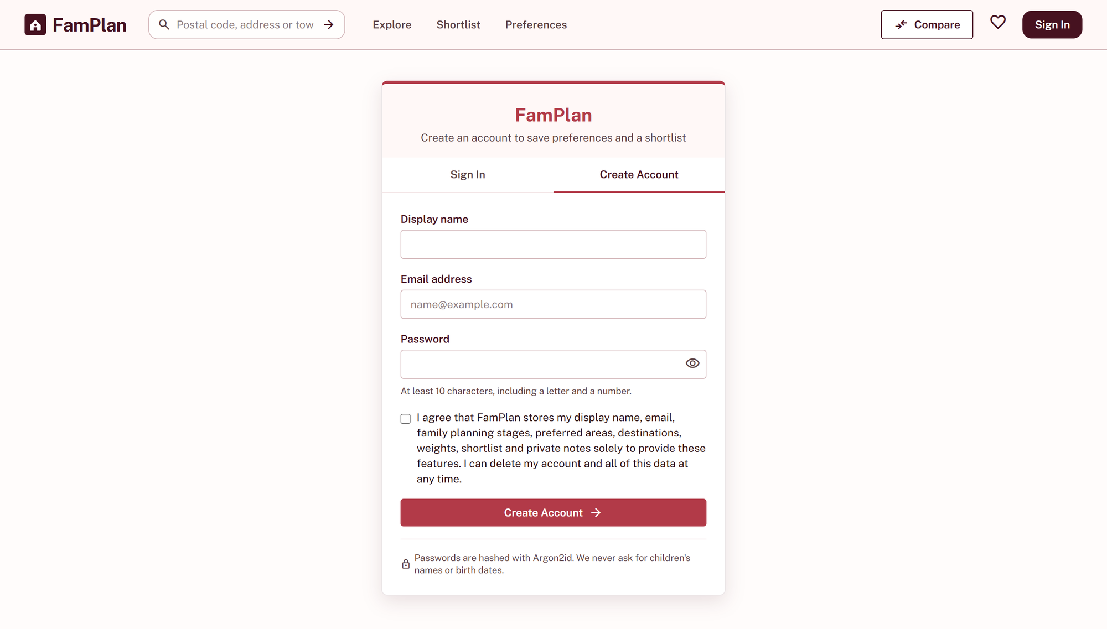
Figure 3.1. Sign in and Create Account (UC-1.1, UC-1.2). Account creation with the data-use consent statement; the Sign In tab uses the same card.
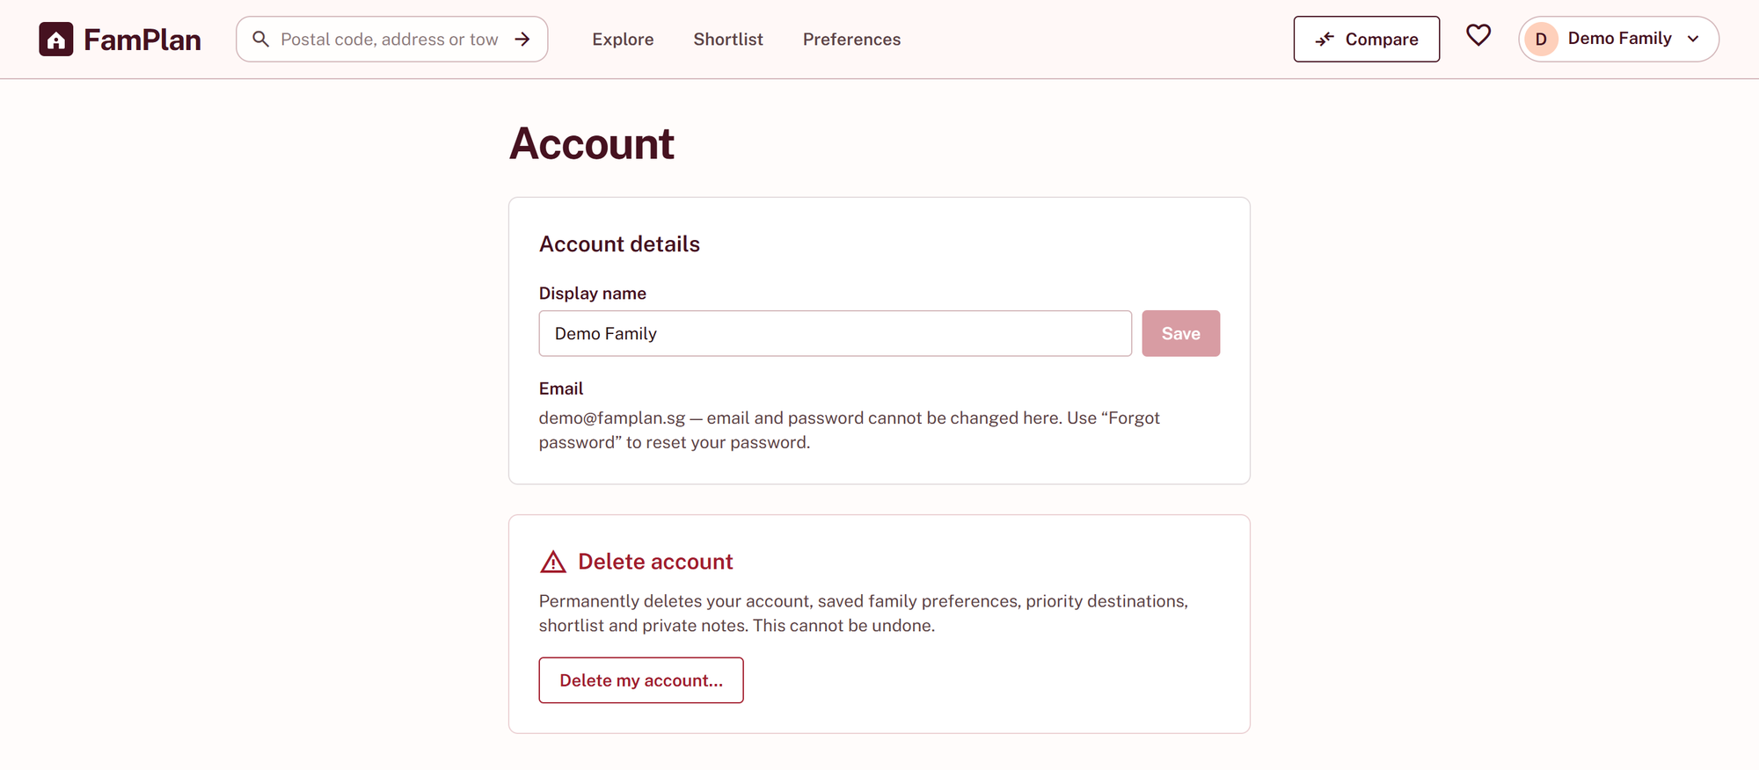
Figure 3.2. Account settings (UC-1.4, UC-1.5). Display-name change (email is read-only) and the account deletion entry point.
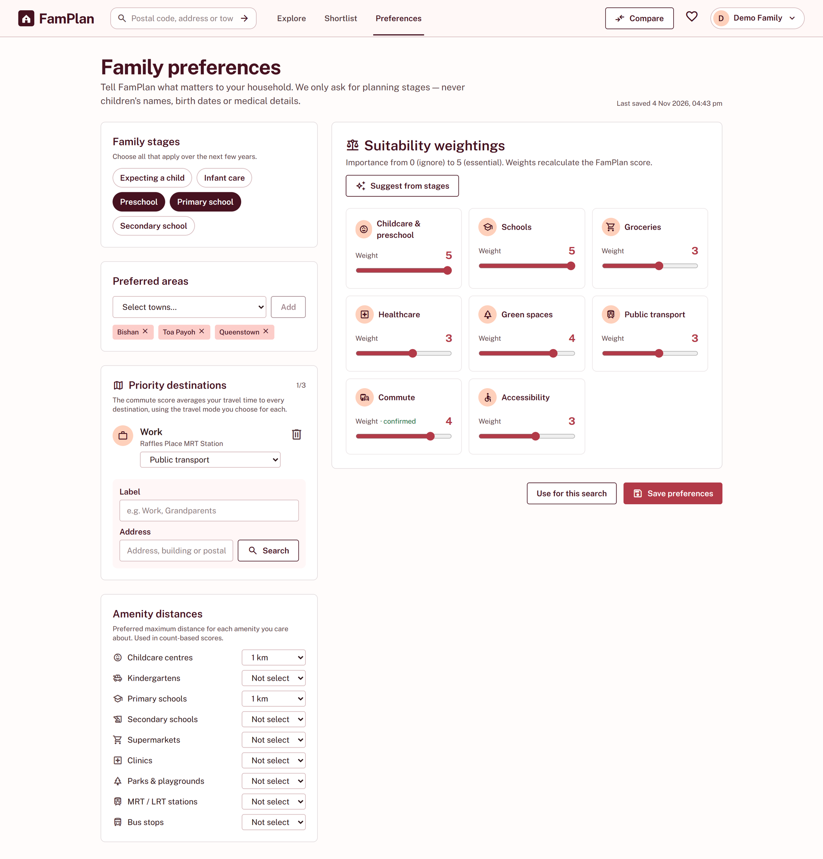
Figure 3.3. Family preferences (UC-2.1). Family stages, preferred areas, up to three priority destinations each with a travel mode, amenity distances and the eight criterion weights.
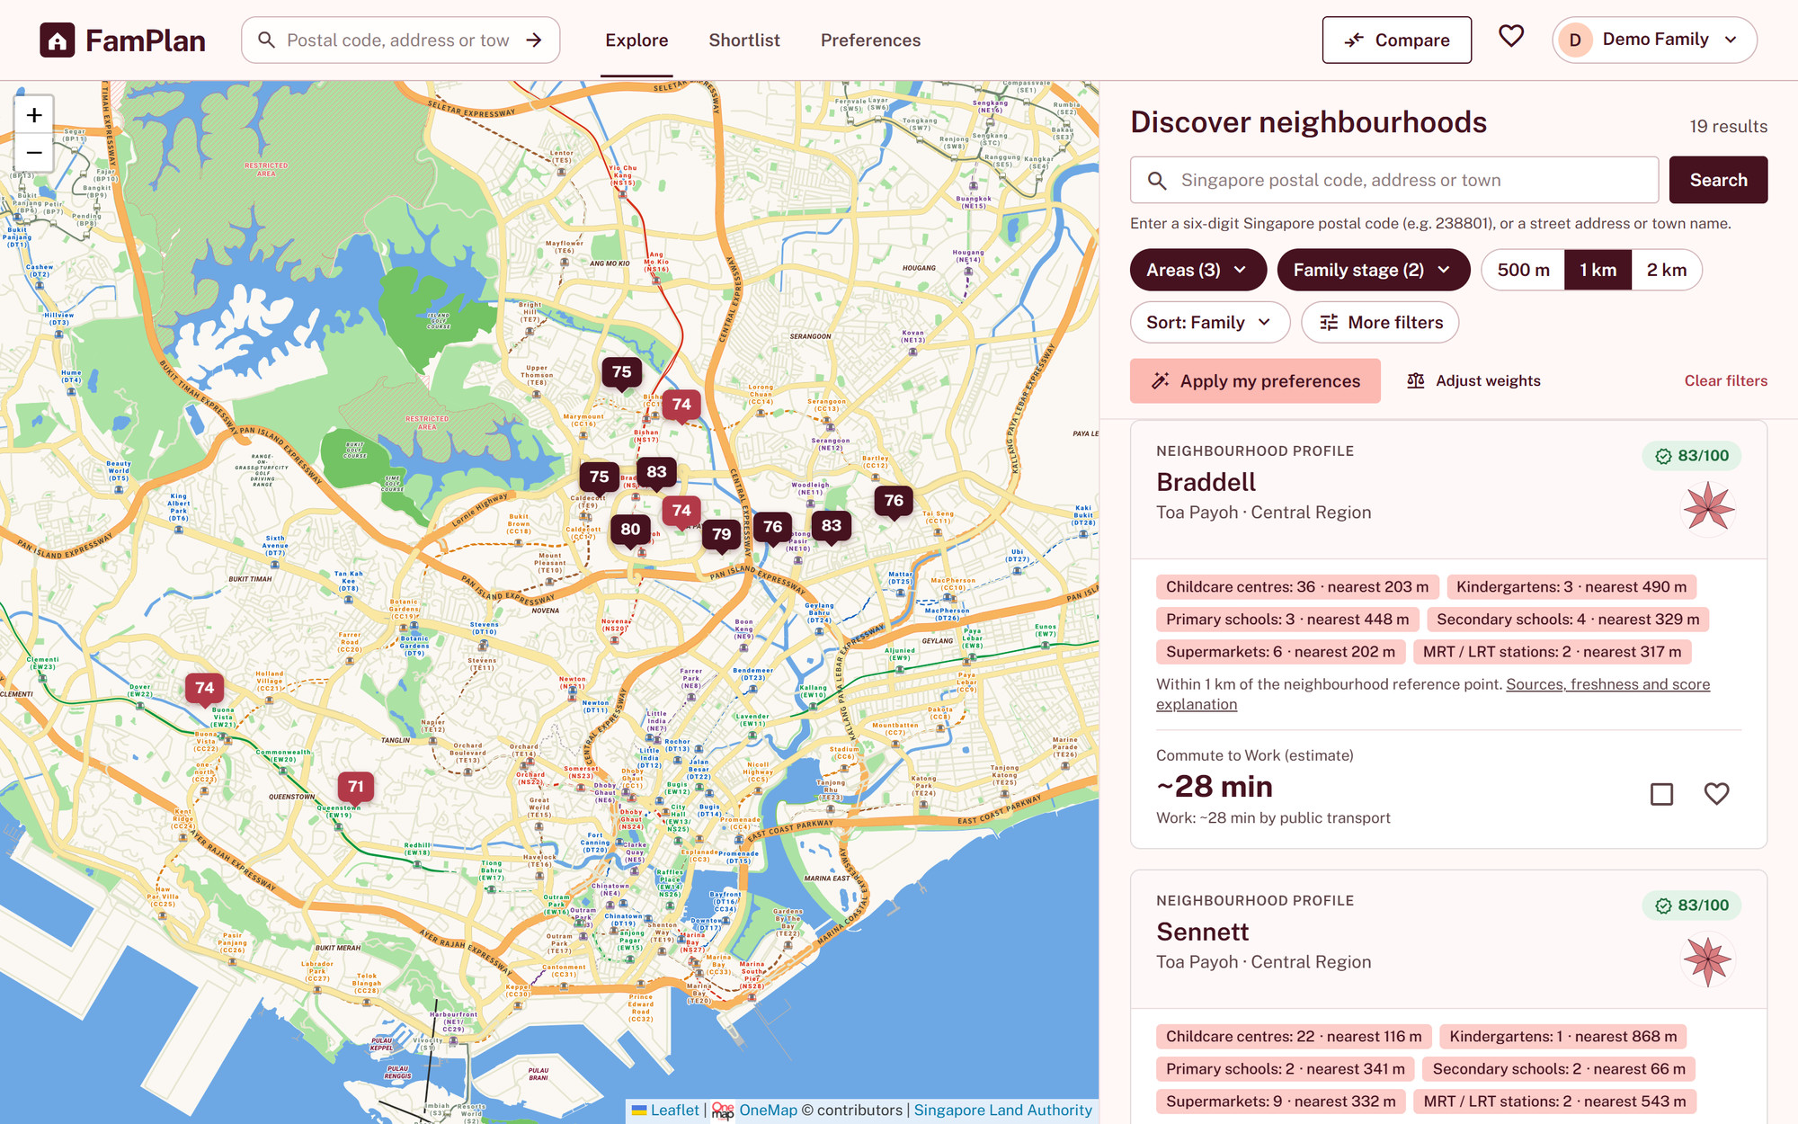
Figure 3.4. Discover neighbourhoods (UC-3.1, UC-3.2). Search, filters and sort, with saved preferences applied. Each result is labelled as a neighbourhood profile and shows its score, amenity counts and commute estimate.
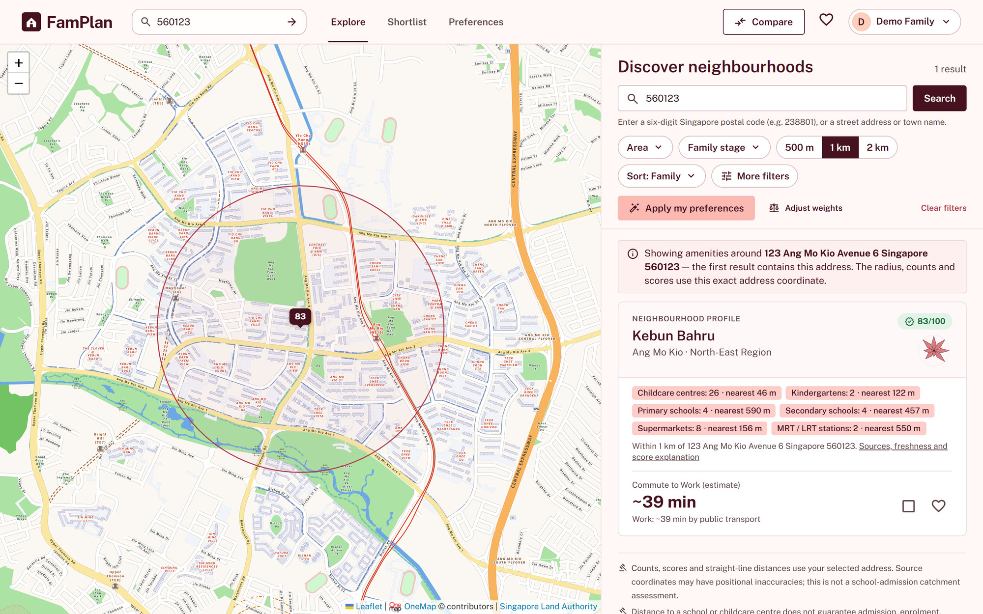
Figure 3.5. Exact address search (UC-3.1 (FR-DISC-07)). A postal code resolved to one exact address; the radius, counts and scores are measured from that coordinate.
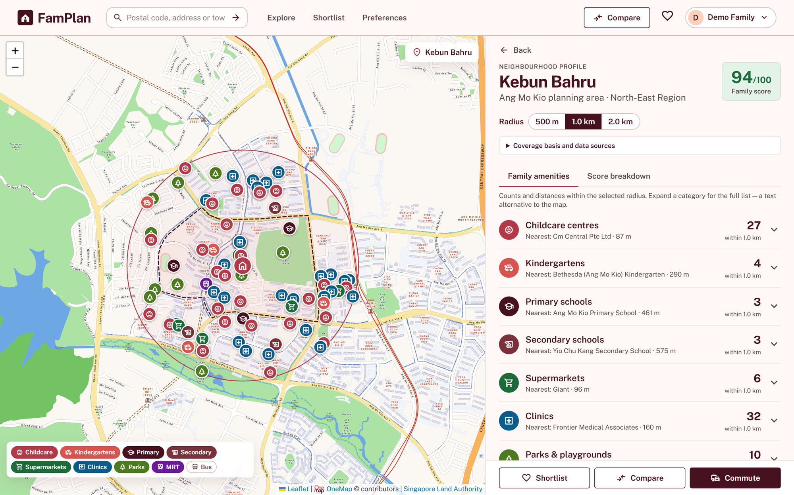
Figure 3.6. Neighbourhood profile: family amenities and map (UC-4.1, UC-4.2, UC-5.1). Family score, radius selector, per-category counts with the nearest facility, and the categorised map with layer toggles.
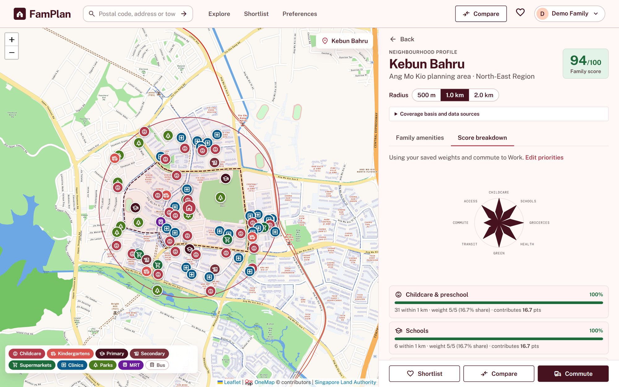
Figure 3.7. Neighbourhood profile: score breakdown (UC-4.1, UC-6.1). Itemised criterion breakdown showing evidence, weight, share and contribution to the total.
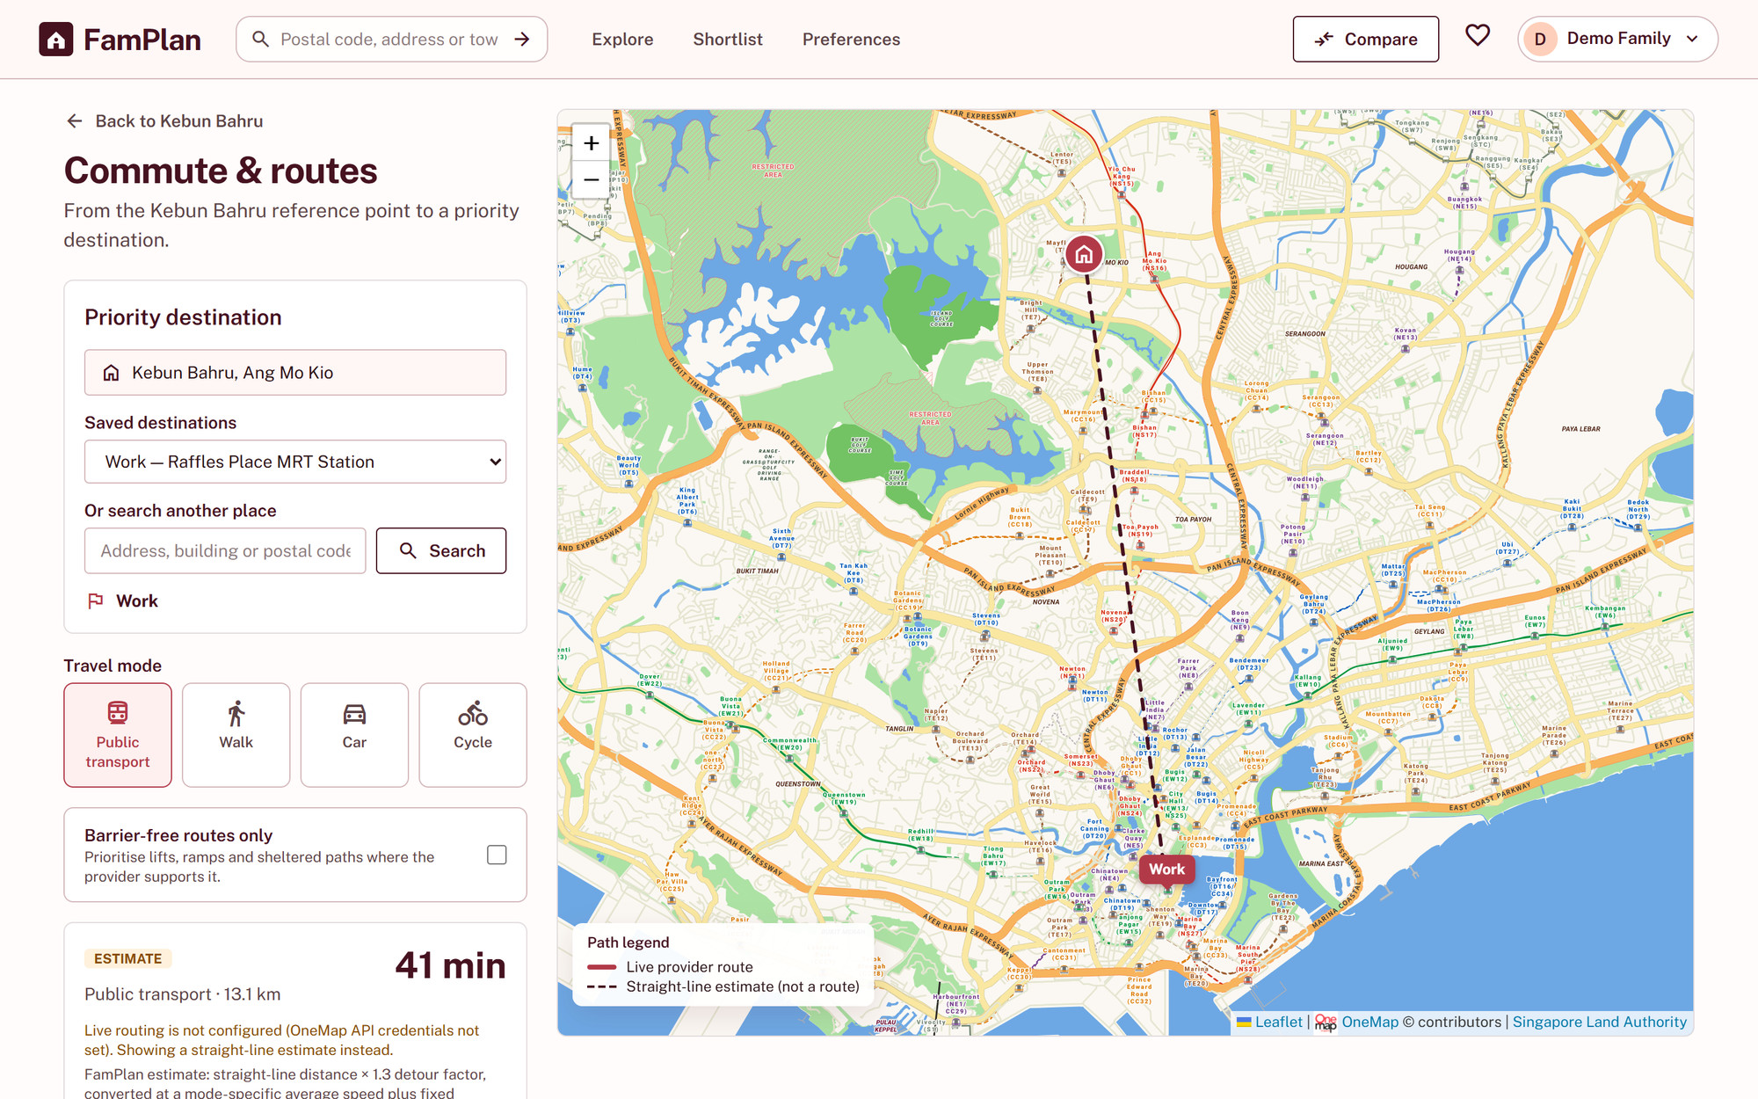
Figure 3.8. Commute and routes (UC-5.2). Saved or searched destination, travel mode, barrier-free option, and the route estimate with its provider. This local build has no OneMap credentials, so it shows the labelled straight-line estimate.
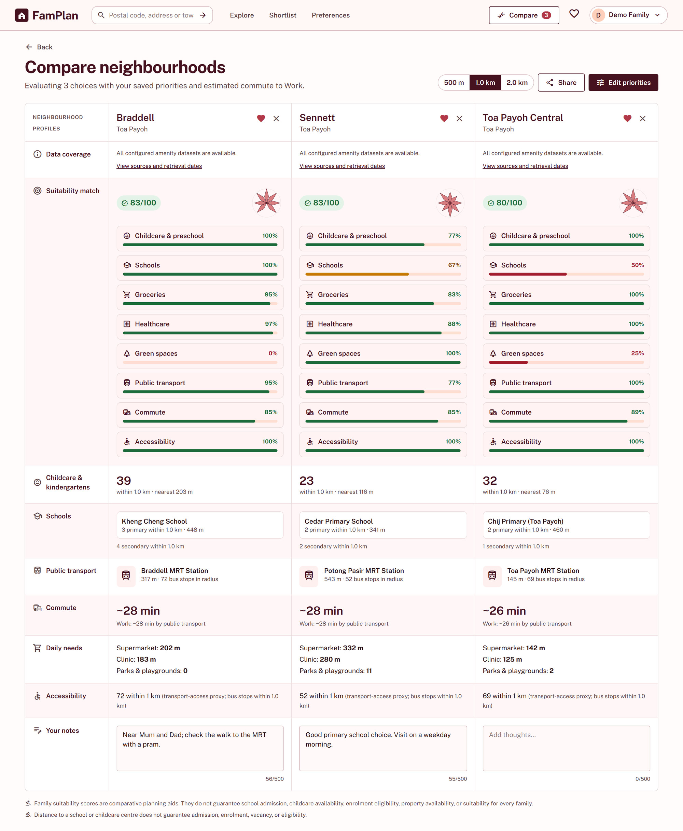
Figure 3.9. Compare neighbourhoods (UC-6.2, UC-6.1). Two to four neighbourhoods side by side with the same weights and radius: score breakdown, amenities, transport, commute, daily needs and accessibility.
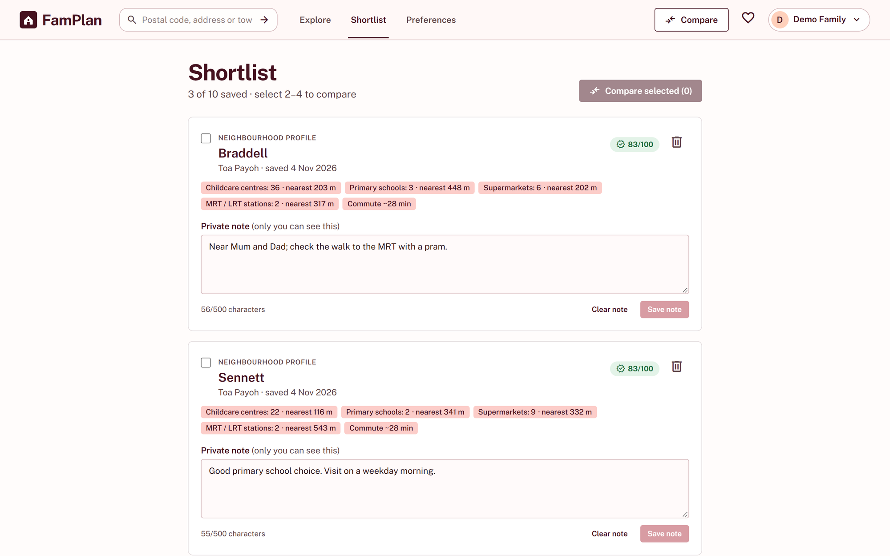
Figure 3.10. Shortlist and private notes (UC-6.3). Saved neighbourhoods (up to ten) with private notes of up to 500 characters and selection for comparison.
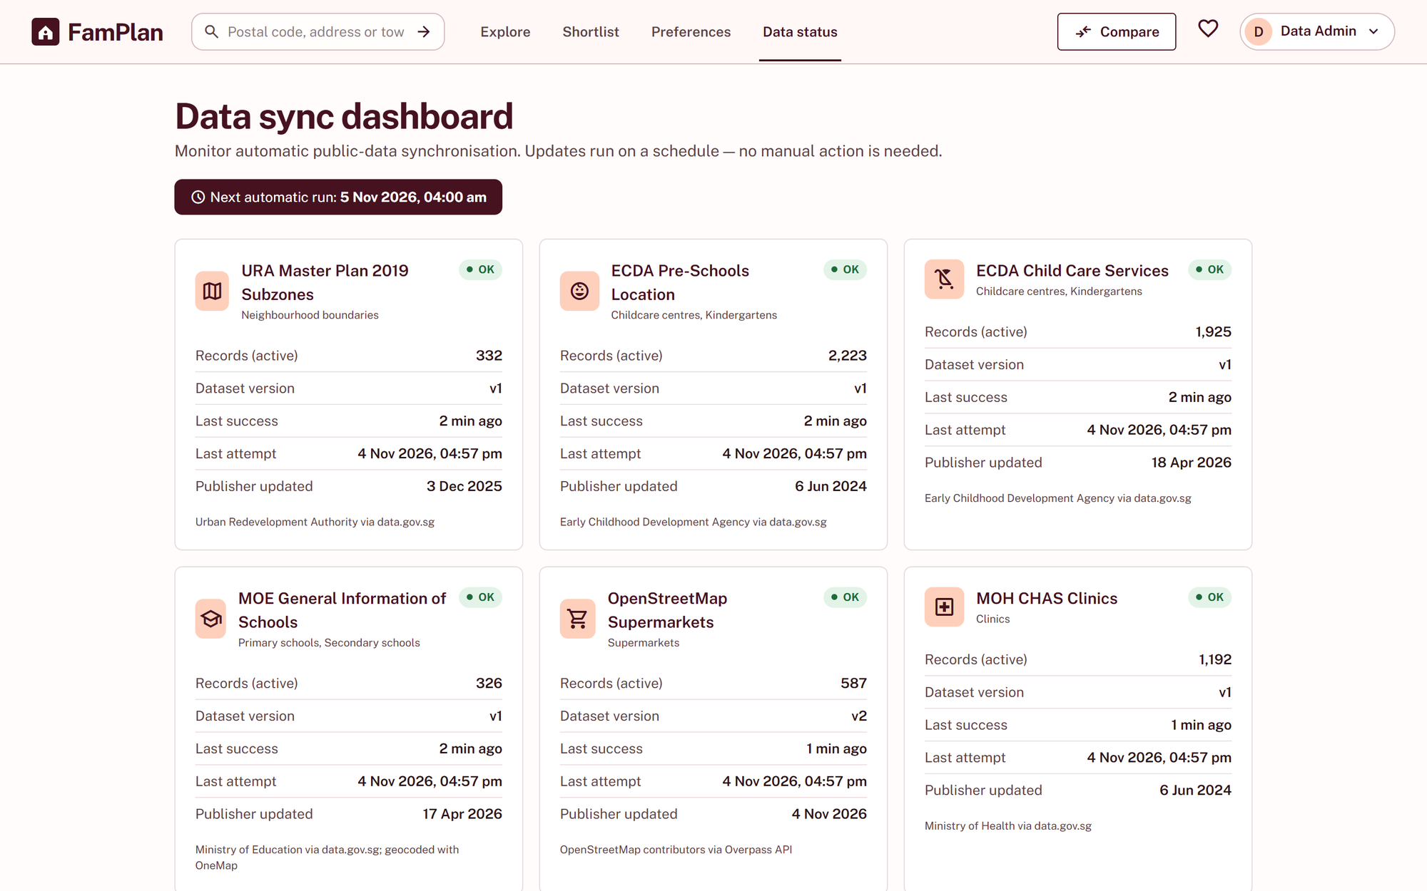
Figure 3.11. Data sync dashboard (UC-7.1). Administrator-only view of each source's status, record count, dataset version and latest successful and attempted synchronisation.

Hardware Interfaces
No specialised hardware is required. Users interact through a browser using a keyboard, pointer, or touch input. The application does not require device sensors or a native mobile application.

Software Interfaces
Interface | Planned Information | Use and Failure Behaviour
MOE or data.gov.sg education datasets | Primary and secondary school names, types, addresses, and published metadata | Supports school proximity; does not predict admission.
ECDA or authorised early-childhood dataset | Childcare and kindergarten locations and categories | Supports early-childhood proximity; does not claim live vacancy.
Authorised retail and healthcare datasets | Supermarket and clinic locations | Supports essential-service proximity with category-level unavailable states.
OneMap | Geocoding, map display, routing, and supported place themes | Supports maps and commute functions; outage does not disable locally cached neighbourhood data.
LTA DataMall | Public-transport stop or station information | Supplements transport accessibility evidence.
Email Delivery Service | Password-reset message delivery | Supports UC-1.3 and must not reveal whether an address is registered.

Communications Interfaces
Client-server and external-service traffic uses HTTPS with TLS 1.2 or newer. Requests use validated parameters and provider-specific timeouts and rate limits. Automatic data synchronisation is initiated by the server schedule at least every 24 hours; administrators do not manually trigger it. Password reset is the only email interface in scope.

Functional Requirements
The following 49 atomic functional requirements define the family-neighbourhood product. Each requirement identifies an actor, input, required output, and minimum verification evidence.

Account Management
Create and manage accounts, authentication, display names, and account deletion.
ID Priority Actor | Atomic Requirement | Input and Required Output | Verification
FR-ACC-01  Must  Visitor | The system shall create a user account after receiving valid registration details and consent to the stated data use. | Input: Display name, email, password, consent  Output: Account confirmation or field-specific errors | Submit valid, duplicate-email, weak-password, malformed-email, and missing-consent cases.
FR-ACC-02  Must  Registered User | The system shall authenticate a Registered User with valid credentials. | Input: Email and password  Output: Authenticated session or generic failure | Test valid, invalid, unknown, locked, and expired-session cases without revealing account existence.
FR-ACC-03  Must  Registered User | The system shall end the current authenticated session when the user logs out. | Input: Logout action  Output: Invalidated session and public-page redirect | Log out and verify that the previous session token cannot access a protected function.
FR-ACC-04  Should  Registered User | The system shall support password reset through a time-limited, single-use link sent to the registered email address. | Input: Email address and new password  Output: Generic confirmation and completed reset or expiry error | Test registered and unknown emails, expired and reused links, and password-policy boundaries.
FR-ACC-05  Must  Registered User | The system shall allow a Registered User to update the display name stored on the account. | Input: New display name  Output: Updated display name or validation error | Update the display name and verify that email and credentials cannot be changed through this function.
FR-ACC-06  Must  Registered User | The system shall delete the user's account, saved preferences, shortlist, and private notes after explicit confirmation. | Input: Confirmed deletion request  Output: Deletion acknowledgement and ended session | Confirm and cancel deletion, then verify that removed data is no longer retrievable within the stated period.

Family and Neighbourhood Preferences
Store family stages, preferred areas, destinations, amenity thresholds, and criterion weights.
ID Priority Actor | Atomic Requirement | Input and Required Output | Verification
FR-PREF-01  Must  Registered User | The system shall store the household's selected family-planning stages, including expecting a child, infant care, preschool, primary school, and secondary school. | Input: One or more family stages  Output: Saved family-stage preferences | Save every supported stage alone and in combination; reject unknown values.
FR-PREF-02  Must  Registered User | The system shall store preferred towns or planning areas for neighbourhood discovery. | Input: Selected towns or planning areas  Output: Saved area preferences | Save, remove, duplicate, and unknown area selections.
FR-PREF-03  Must  Registered User | The system shall store up to three priority destinations, each with a travel mode, and shall use all of them for commute scoring and comparison. | Input: Destination labels, addresses and travel modes  Output: Saved and geocoded destinations or field errors | Test zero through four destinations, duplicates, unresolved addresses, and every travel mode.
FR-PREF-04  Must  Registered User | The system shall store selected family amenity categories and a preferred maximum distance for each selected category. | Input: Amenity categories and distance thresholds  Output: Saved amenity preferences | Test all supported categories and distances below, on, and above allowed boundaries.
FR-PREF-05 Must Registered User | The system shall store an integer importance weight from 0 to 5 for childcare, schools, groceries, healthcare, green spaces, public transport, commute, and accessibility. | Input: Eight criterion weights  Output: Saved weights or field errors | Test -1, 0, 5, 6, non-integer, partial, and all-zero weight sets.
FR-PREF-06 Must Registered User | The system shall retrieve and update the user's saved family and neighbourhood preferences. | Input: Authenticated preference request  Output: Current or updated preference profile | Save preferences, sign out, sign in, retrieve them, update them, and confirm ownership isolation.
FR-PREF-07 Should Registered User | The system shall offer editable starting weights based on the selected family-planning stages without overwriting choices already confirmed by the user. | Input: Family stages and preset action  Output: Editable suggested weights | Apply each preset, edit it, and verify that a later stage change does not overwrite confirmed values without consent.

Neighbourhood Discovery
Search, filter, label, sort, and validate neighbourhood profiles.
ID Priority Actor | Atomic Requirement | Input and Required Output | Verification
FR-DISC-01  Must  Visitor | The system shall search neighbourhoods by town, planning area, estate name, or address. | Input: Search text or selected area  Output: Matching neighbourhood profiles | Test known and unknown towns, areas, estates, addresses, spelling variants, and empty search.
FR-DISC-02  Must  Visitor | The system shall filter neighbourhood results by family stage, amenity category, minimum facility count, maximum nearest-facility distance, and commute-time threshold. | Input: Filter values  Output: Filtered neighbourhood profiles | Test each filter independently, in valid combinations, and at every numeric boundary.
FR-DISC-03  Must  Registered User | The system shall apply saved family and neighbourhood preferences to the current search. | Input: Apply-preferences action  Output: Populated filters and refreshed results | Test complete, partial, empty, and outdated preference profiles without silently changing saved values.
FR-DISC-04  Must  Visitor | The system shall identify every result as a neighbourhood profile rather than a live property listing or guarantee of service availability. | Input: Search results  Output: Visible neighbourhood-profile and limitation labels | Inspect every result layout, empty state, comparison, shortlist, and shared view.
FR-DISC-05  Must  Visitor | The system shall sort neighbourhood results by family suitability score, nearest selected amenity, commute time, or overall amenity coverage when the selected value is available. | Input: Sort choice  Output: Ordered results with unavailable values placed last | Verify ascending and descending order, ties, missing values, and stable pagination.
FR-DISC-06  Must  Visitor | The system shall reject invalid or contradictory discovery criteria before executing a search. | Input: Submitted search and filter criteria  Output: Field-specific correction guidance | Test negative counts, unsupported distances, invalid destinations, contradictory thresholds, and unexpected types.
FR-DISC-07  Must  Visitor | The system shall resolve a postal code, street address or place name to one exact location, ask the user to choose when several places match, and calculate the radius, counts, score evidence and routes from that location's coordinate. | Input: Postal code, address or place name, and a chosen match when several exist  Output: Results based on the exact location, a list of matches, or a no-match message | Test leading-zero postal codes, ambiguous places, no match, provider failure, and radius boundaries from the selected coordinate.

Family Amenities and Neighbourhood Information
Present family-relevant facilities, proximity measures, counts, sources, and limitations.
ID Priority Actor | Atomic Requirement | Input and Required Output | Verification
FR-NBH-01  Must  Visitor | The system shall display a selected neighbourhood's name, town or planning area, map location, and the boundary or coverage basis used for its analysis. | Input: Selected neighbourhood  Output: Neighbourhood summary and coverage explanation | Open a known profile and verify all fields, source metadata, and missing-boundary handling.
FR-NBH-02 Must Visitor | The system shall retrieve nearby childcare centres, kindergartens, primary schools, secondary schools, supermarkets, clinics, parks or playgrounds, MRT stations, and bus stops for a selected neighbourhood. | Input: Neighbourhood and amenity category  Output: Categorised nearby facilities or category-specific unavailable state | Use fixtures containing every category, no matches, duplicate records, and a failed provider.
FR-NBH-03 Must Visitor | The system shall allow nearby-facility results to be limited to a 500 m, 1 km, or 2 km radius. | Input: Selected radius  Output: Facilities within the radius | Test places immediately inside, exactly on, and immediately outside every radius.
FR-NBH-04 Must Visitor | The system shall display the calculated distance from the neighbourhood reference point to each nearby facility and state the calculation basis. | Input: Neighbourhood and facility coordinates  Output: Distance, unit, and basis | Compare displayed values with known coordinate fixtures and documented rounding.
FR-NBH-05 Must Visitor | The system shall display the number of matched facilities in each supported family amenity category for the selected radius. | Input: Categorised nearby-facility results  Output: Per-category counts | Verify zero, one, many, boundary, and duplicate-source cases.
FR-NBH-06 Must Visitor | The system shall identify the nearest matched facility in each selected category when at least one match is available. | Input: Categorised facility distances  Output: Nearest facility and distance or no-match state | Test ties, no matches, missing coordinates, and deterministic ordering.
FR-NBH-07 Must Visitor | The system shall display each facility's name, category, address where available, and source. | Input: Selected facility  Output: Facility details with explicit unavailable fields | Inspect every category with complete and incomplete source records.
FR-NBH-08 Must Visitor | The system shall display the provider and applicable update or retrieval time for neighbourhood and facility information. | Input: External response metadata  Output: Visible provenance information | Inspect fresh, cached, merged, and unavailable results.
FR-NBH-09 Must Visitor | The system shall distinguish no matched facility, incomplete category coverage, stale cached information, and source unavailability instead of presenting a misleading zero. | Input: Data availability and freshness state  Output: Explicit category-level status | Simulate each state and verify that unaffected categories remain visible.
FR-NBH-10 Must Visitor | The system shall state that distance to a school or childcare centre does not guarantee admission, enrolment, vacancy, or eligibility. | Input: Education or childcare output  Output: Visible limitation statement | Inspect neighbourhood, comparison, shortlist, and shared result views.

Map and Travel
Show neighbourhood maps, nearby places, routes, travel times, and supported accessibility coverage.
ID Priority Actor | Atomic Requirement | Input and Required Output | Verification
FR-TRV-01  Must  Visitor | The system shall display the selected neighbourhood and matched facilities on an interactive map with distinguishable category markers. | Input: Neighbourhood and nearby facilities  Output: Interactive categorised map | Test marker categories, keyboard access, overlapping points, and missing coordinates.
FR-TRV-02  Must  Visitor | The system shall request a route and estimated travel time from the selected neighbourhood to a chosen priority destination. | Input: Origin, destination, and travel mode  Output: Route, distance, duration, or unavailable state | Test valid, invalid, timeout, no-route, and unresolved-destination cases.
FR-TRV-03  Must  Visitor | The system shall support the travel modes made available by the authorised routing provider and clearly reject unsupported modes. | Input: Travel-mode selection  Output: Supported route or explanatory rejection | Test every configured and unsupported mode against controlled responses.
FR-TRV-04  Should  Visitor | When barrier-free routing is requested, the system shall show a barrier-free route where the authorised provider supplies one or state that coverage is unavailable. | Input: Origin, destination, barrier-free option  Output: Accessible route or coverage limitation | Test supported, unsupported, and partially covered route fixtures.
FR-TRV-05 Must Visitor | The system shall display the provider and retrieval time for route information. | Input: Routing response metadata  Output: Visible provider and retrieval time | Inspect successful, cached, and unavailable route states.

Family Decision Support
Calculate transparent family suitability scores, compare neighbourhoods, and manage a shortlist.
ID Priority Actor | Atomic Requirement | Input and Required Output | Verification
FR-DEC-01  Must  Visitor | The system shall calculate a family suitability score for each neighbourhood using the selected criterion weights and disclosed normalisation rules. | Input: Neighbourhood evidence and criterion weights  Output: Total score on a 0 to 100 scale | Compare representative and boundary results with independently calculated fixtures.
FR-DEC-02  Must  Visitor | The system shall display each criterion's value, normalised value, weight, and contribution so the contributions reconcile with a total rounded to the nearest whole number, with an exact 0.5 rounded upward. | Input: Score calculation  Output: Itemised explanation and total | Recalculate typical, boundary, all-zero, and exact-0.5 cases.
FR-DEC-03  Must  Visitor | The system shall identify every criterion lacking sufficient data and disclose how its weight was treated in the score. | Input: Neighbourhood with missing criterion data  Output: Missing-data label and adjusted-weight explanation | Remove each criterion in turn and verify the disclosed rule and resulting total.
FR-DEC-04  Must  Visitor | The system shall compare between two and four selected neighbourhoods in a common view. | Input: Two to four neighbourhood selections  Output: Side-by-side family amenity, commute, accessibility, and score information | Test zero through five selections, duplicates, removal, and missing values.
FR-DEC-05  Must  Registered User | The system shall add a selected neighbourhood to the Registered User's shortlist, up to a maximum of ten neighbourhoods, without creating a duplicate entry. | Input: Add-to-shortlist action  Output: Persisted entry, already-saved state, or capacity explanation | Add through the tenth entry, attempt an eleventh, add a duplicate, and verify persistence after sign-in.
FR-DEC-06  Must  Registered User | The system shall remove a selected neighbourhood from the user's shortlist. | Input: Remove action  Output: Updated shortlist and confirmation | Remove existing and non-existing entries and verify persistent state.
FR-DEC-07  Should  Registered User | The system shall allow a private text note of up to 500 characters to be created, edited, and cleared for each shortlisted neighbourhood. | Input: Shortlisted neighbourhood and note text  Output: Persisted note or validation error | Test create, update, clear, 499-, 500-, and 501-character values, unsafe markup, and cross-account access.

Automatic Data Synchronisation and Resilience
Automatically update configured public data, let administrators monitor outcomes, and preserve validated data after failures.
ID Priority Actor | Atomic Requirement | Input and Required Output | Verification
FR-ADM-01  Must  Data Administrator | The system shall require an authenticated administrator role before displaying data-source monitoring functions. | Input: Authenticated session and monitoring request  Output: Monitoring page or access denial | Test anonymous, ordinary-user, expired-admin, and active-admin sessions at UI and API levels.
FR-ADM-02  Must  Data Administrator | The system shall display each configured source's latest successful synchronisation time, latest attempted synchronisation time, record count, and current status. | Input: Administration-page request  Output: Source-status summary | Compare the view with controlled successful, failed, never-run, and delayed states.
FR-ADM-03 Must System | The system shall automatically check and synchronise each configured public data source at least once every 24 hours without requiring an administrator to start the process. | Input: Configured schedule and source metadata  Output: Recorded check, synchronisation outcome, and active dataset decision | Advance a test clock across the boundary and verify that no manual action is required.
FR-ADM-04 Must Data Administrator | The system shall display synchronisation history containing source, start time, end time, outcome, records added or changed, and a sanitised error summary. | Input: Source and optional date filter  Output: Reverse-chronological synchronisation history | Generate successes and failures and verify fields, ordering, filtering, and absence of secrets.
FR-RES-01 Must System | The system shall preserve the last validated local dataset when an automatic synchronisation fails validation or cannot complete. | Input: Failed synchronisation  Output: Previous active dataset and recorded failure | Query before and after injected download, schema, and validation failures.
FR-RES-02 Must System | The system shall isolate an external map, route, or facility-service failure so account, shortlist, and locally cached neighbourhood functions remain usable. | Input: Simulated dependency failure  Output: Controlled unavailable state for affected features | Disable each dependency and execute every named unaffected workflow.
FR-RES-03 Must Visitor | The system shall show the age of cached external information and a stale-data warning when the configured freshness threshold is exceeded. | Input: Cached-result metadata  Output: Data age and applicable stale warning | Test values immediately below, on, and above the configured threshold.

Nonfunctional Requirements
The following 29 measurable requirements constrain performance, scalability, usability, accessibility, compatibility, reliability, data quality, security, privacy, maintainability, testability, and transparency.

Performance Requirements
ID and Priority | Measurable Requirement | Verification
NFR-PERF-01  Must | The 95th-percentile server response time for neighbourhood search and filtering must not exceed 2 seconds during a 15-minute test with 100 concurrent simulated users against at least 100,000 facility and neighbourhood records, excluding live external API calls. | Load-test report containing dataset size, concurrency, request count, errors, and percentile timings.
NFR-PERF-02  Must | The 95th-percentile response time for locally calculated family scores and neighbourhood comparisons must not exceed 3 seconds under the NFR-PERF-01 workload. | Load-test representative two-, three-, and four-neighbourhood comparisons.
NFR-PERF-03  Should | The 95th-percentile end-to-end response time for a live route request must not exceed 5 seconds while the provider is within documented normal operating conditions. | Timed integration tests that distinguish provider time from local processing and include controlled timeouts.

Scalability Requirements
ID and Priority | Measurable Requirement | Verification
NFR-SCALE-01  Must | The deployed application must store, index, and query at least 100,000 neighbourhood, facility, transport, and provenance records without violating NFR-PERF-01 or NFR-PERF-02. | Seed the required volume, record indexes, and execute the performance tests.
NFR-SCALE-02  Must | The deployed application must support at least 100 concurrent active users performing representative search, profile, map, score, comparison, shortlist, and cached-route workflows without violating applicable performance targets. | Mixed-workload load test with response and error statistics by operation.

Usability Requirements
ID and Priority | Measurable Requirement | Verification
NFR-USAB-01  Should | At least 80% of first-time representative users in a moderated test of at least 10 participants must search for a neighbourhood, select two results, and open their comparison within 3 minutes without facilitator assistance. | Anonymised usability protocol, observations, timings, completion rate, and issues.
NFR-USAB-02  Must | Every rejected user input must identify the affected field or action and state how the user can correct it; a generic error code alone is insufficient. | UI and API acceptance tests covering every documented validation error.

Accessibility Requirements
ID and Priority | Measurable Requirement | Verification
NFR-ACC-01  Must | The account, preference, search, neighbourhood, map, comparison, shortlist, and administration workflows must conform to WCAG 2.1 Level AA. | Automated accessibility scan plus manual checks for labels, headings, contrast, errors, zoom, maps, and screen-reader output.
NFR-ACC-02  Must | Every interactive function in the core workflows must be operable using only a keyboard and must expose a visible focus indicator. | Manual keyboard traversal using a documented checklist with no pointer input.

Compatibility Requirements
ID and Priority | Measurable Requirement | Verification
NFR-COMP-01  Must | Core pages must remain usable from 360 px to 1440 px viewport widths without horizontal scrolling of the primary page content. | Screenshot or browser-test evidence at boundary and intermediate widths.
NFR-COMP-02  Should | Core workflows must operate on the latest two stable versions available at test time of Chrome, Safari, Firefox, and Edge. | Compatibility matrix recording browser versions and pass or fail results.

Reliability Requirements
ID and Priority | Measurable Requirement | Verification
NFR-REL-01  Must | At least 99% of core requests must complete successfully during a continuous one-hour representative-load test, excluding requests whose sole failure is an injected or confirmed external-provider outage. | One-hour report with request totals, failure classification, and evidence for exclusions.

Recoverability Requirements
ID and Priority | Measurable Requirement | Verification
NFR-REL-02  Must | Following an application restart, locally stored account, preference, search, profile, shortlist, administration, and cached-neighbourhood functions must become operational within 5 minutes without manual reconstruction of persistent data. | Timed restart-and-recovery exercise followed by integrity and smoke tests.

Fault isolation Requirements
ID and Priority | Measurable Requirement | Verification
NFR-REL-03 Must | Failure of one external dependency must not prevent use of unrelated functions backed by validated local data. | Dependency-failure matrix showing affected and unaffected workflows.

Data provenance Requirements
ID and Priority | Measurable Requirement | Verification
NFR-DATA-01  Must | Every neighbourhood, facility, transport, route, and family-score output must display or link to its source and applicable update or retrieval date. | Automated presence checks plus manual inspection of every output and error state.

Data freshness Requirements
ID and Priority | Measurable Requirement | Verification
NFR-DATA-02  Must | Locally cached neighbourhood and facility data older than 31 complete days must be visibly marked as stale until a newer validated dataset becomes active. | Set test-data ages to 30, 31, and 32 complete days and verify boundary behaviour.

Reproducibility Requirements
ID and Priority | Measurable Requirement | Verification
NFR-DATA-03  Must | Identical neighbourhood inputs, user weights, scoring-configuration version, and dataset versions must produce identical family scores and comparison results. | Repeat deterministic fixture tests across process restarts.

Data quality Requirements
ID and Priority | Measurable Requirement | Verification
NFR-DATA-04  Must | Facility records merged from multiple sources must be normalised by supported category and must not be counted twice when they represent the same named facility at the same location. | Use exact, near-duplicate, renamed, and distinct co-located facility fixtures and inspect counts.

Transport security Requirements
ID and Priority | Measurable Requirement | Verification
NFR-SEC-01  Must | Every production client-server connection must use HTTPS with TLS 1.2 or newer, and plain HTTP must redirect to HTTPS without accepting credentials. | Protocol scan, redirect test, and attempted authentication over plain HTTP.

Credential security Requirements
ID and Priority | Measurable Requirement | Verification
NFR-SEC-02  Must | Passwords must be stored only as salted hashes using a current approved password-hashing algorithm and must never appear in application logs. | Inspect schema and configuration; scan logs after registration, login, failure, and reset tests.

Authorisation Requirements
ID and Priority | Measurable Requirement | Verification
NFR-SEC-03  Must | A non-administrator must be unable to read data-source monitoring functions even when directly calling their endpoints. | Role-based access-control tests at both UI and API levels.

Authentication security Requirements
ID and Priority | Measurable Requirement | Verification
NFR-SEC-04  Must | An account must be locked from password authentication for 15 minutes after five consecutive failed login attempts; a successful login before the threshold must reset the counter. | Test attempts 1-6, successful reset, and 14-, 15-, and 16-minute boundaries.

Input security Requirements
ID and Priority | Measurable Requirement | Verification
NFR-SEC-05  Must | All user-controlled input must be allow-list or structurally validated before use in a query, calculation, stored note, map request, or external-service request. | Security tests for injection, unsafe markup, malformed coordinates, invalid ranges, and unexpected types.

Privacy Requirements
ID and Priority | Measurable Requirement | Verification
NFR-PRIV-01  Must | Account details, saved family preferences, shortlists, and notes must become irretrievable through the application within 24 hours after confirmed account deletion. | Delete a seeded account and test UI, API, and authorised data-store lookup at the deadline.

Data minimisation Requirements
ID and Priority | Measurable Requirement | Verification
NFR-PRIV-02  Must | Registration and family preferences must not require exact dates of birth, children's names, school applications, medical information, or other personal information unnecessary for the documented functions. | Compare required fields with the approved data dictionary and submit all workflows without excluded fields.

Maintainability Requirements
ID and Priority | Measurable Requirement | Verification
NFR-MAINT-01  Must | Data-source endpoints, freshness thresholds, amenity categories, scoring criteria, and normalisation constants must be maintained as versioned configuration or isolated modules so one category can be updated without changing unrelated workflow code. | Code review plus tests that replace one configuration category while unaffected workflows still pass.

Testability Requirements
ID and Priority | Measurable Requirement | Verification
NFR-MAINT-02 Should | Automated tests must achieve at least 80% branch coverage for family scoring, proximity aggregation, facility deduplication, and external-data transformation modules. | Coverage report generated by the project's documented test command.

Transparency Requirements
ID and Priority | Measurable Requirement | Verification
NFR-TRANS-01  Must | Every family suitability score must expose criterion values, weights, contributions, dataset versions, and missing-data treatment needed to reproduce it subject to documented rounding. | Recalculate representative outputs independently from the displayed explanation.

Responsible guidance Requirements
ID and Priority | Measurable Requirement | Verification
NFR-TRANS-02  Must | The user interface must state that neighbourhood scores are comparative planning aids and do not guarantee school admission, childcare availability, enrolment eligibility, property availability, or suitability for every family. | Review every score, comparison, shortlist, and shareable output for the limitation statement.

Business Rules
Rule | Value | Requirements
Neighbourhood comparison | 2 to 4 neighbourhoods | FR-DEC-04
Shortlist capacity | Maximum 10 neighbourhoods per Registered User | FR-DEC-05
Private note length | 0 to 500 characters | FR-DEC-07
Proximity radii | 500 m, 1 km, or 2 km | FR-NBH-03
Criterion weights | Integer 0 to 5 | FR-PREF-05
Score rounding | Nearest whole number; exact 0.5 rounds upward | FR-DEC-02
Automatic synchronisation | At least once every 24 hours; system initiated | FR-ADM-03
Editable account detail | Display name | FR-ACC-05
Commute time | Average across all destinations, each by its travel mode | FR-PREF-03; FR-DEC-01

Data Dictionary
The table defines the shared terms used by the requirements, use cases, implementation, and future tests. Examples are illustrative; the attributes and constraints are the baseline.
Term | Definition | Key Attributes | Relationships and Constraints
User Account | Registered person's identity in FamPlan. | id; display_name; email; consent_given_at; status | Owns one preference profile and zero or more shortlist entries; display name is the editable general account field.
Password Credential | Stored proof of a password, never the password itself. | account_id; salted_hash; algorithm; parameters | Belongs to one User Account; never logged.
Session | Current authenticated login. | token; account_id; created_at; expires_at; invalidated_at | Belongs to one User Account; invalidated immediately on logout.
Password Reset Token | Time-limited, single-use credential for account recovery. | token; account_id; expires_at; used_at | Belongs to one User Account; delivery must not reveal whether an email exists.
Administrator Role | Privilege permitting data-source monitoring. | account_id; granted_at | At most one per User Account; enforced at UI and API levels.
Family Preference Profile | Saved settings used to personalise neighbourhood discovery. | account_id; family_stages; preferred_areas; amenity_thresholds; criterion_weights | At most one per Registered User; applied to a Search Query.
Family Stage | Planning stage relevant to nearby services. | enum: expecting_child; infant_care; preschool; primary_school; secondary_school | One or more values may be selected; no names or dates of birth are required.
Amenity Category | Supported type of family-relevant place. | childcare; kindergarten; primary_school; secondary_school; supermarket; clinic; park_playground; mrt; bus_stop | Classifies Facility records and links preferences to score criteria.
Criterion Weight | User importance assigned to a scoring criterion. | criterion; integer weight 0 to 5 | Part of a Family Preference Profile; all-zero input uses the documented fallback.
Search Query | Request-scoped neighbourhood search and filters. | search_text; area; stages; categories; counts; distances; commute threshold; sort | May be populated from saved preferences; invalid combinations are rejected before execution.
Neighbourhood Profile | Comparable representation of a town, planning area, estate, or documented coverage zone. | id; name; town; planning_area; reference_point; boundary_basis | Has many Facility Matches, routes, score breakdowns, and shortlist references; it is not a property listing.
Geolocation | Latitude and longitude pair. | latitude; longitude; source | Attached to neighbourhoods, facilities, and destinations.
Selected Location | Exact address chosen as the origin of a search. | address; latitude; longitude; postal_code | Request-scoped. Replaces the neighbourhood reference point for radius, counts, score evidence and routes.
Facility | Childcare, education, retail, healthcare, recreation, or transport place. | id; name; category; address; geolocation; source_id; source_updated_at | May appear in many neighbourhood-radius results; duplicates are resolved by the documented matching rule.
Proximity Radius | Boundary used when retrieving nearby facilities. | metres: 500; 1000; 2000 | Bounds Facility Matches for one neighbourhood query.
Facility Match | Facility located within a selected radius of a neighbourhood reference point. | neighbourhood_id; facility_id; distance_m; distance_basis | Joins one Neighbourhood Profile to one Facility for a specific calculation.
Amenity Summary | Per-category neighbourhood aggregation. | category; matched_count; nearest_facility_id; nearest_distance_m; availability_state | Computed from Facility Matches and used by scoring and comparison.
Priority Destination | Saved place and travel mode used for commute scoring and comparison. | slot 1 to 3; label; query_text; geolocation; travel_mode | Part of a Family Preference Profile and destination of a Route Estimate.
Route Estimate | Provider response for travel from a neighbourhood to a destination. | origin; destination; mode; distance_m; duration_s; retrieved_at; state | Carries provenance and may include a barrier-free coverage flag.
Scoring Configuration | Versioned definitions and normalisation constants for family suitability. | version; effective_date; criteria; normalisation rules | Referenced by every Family Suitability Score.
Family Suitability Score | 0-100 indication of how well a neighbourhood matches selected priorities. | neighbourhood_id; configuration_version; dataset_versions; total; computed_at | Contains Criterion Score Breakdowns; comparative planning aid, not a guarantee.
Criterion Score Breakdown | One criterion's transparent contribution to a total score. | criterion; raw_value; normalised_value; weight; contribution | Part of one Family Suitability Score.
Missing Data Treatment | Explanation of how unavailable evidence affects scoring. | criterion; reason; weight_treatment | Attached to a score breakdown when a value cannot be computed.
Neighbourhood Comparison Set | Transient selection of two to four neighbourhoods. | neighbourhood_ids | Request-scoped; contains no duplicates.
Shortlist Entry | Saved neighbourhood selected by a Registered User. | account_id; neighbourhood_id; added_at | Maximum ten per account; unique by account and neighbourhood; may have one note.
Shortlist Note | Private text attached to a shortlisted neighbourhood. | shortlist_entry_id; text; updated_at | Maximum 500 characters; readable only by the owning account.
Data Source Registry | Configuration and current health of each public data source. | source_id; name; schedule; freshness_threshold; last_attempt; last_success; status | Has many Sync History Records and Validated Dataset Snapshots.
Sync History Record | Outcome of one automatic API update attempt. | source_id; start; end; outcome; records_added; records_changed; sanitised_error | Created automatically; displayed to the Data Administrator; contains no manual-trigger field.
Sync Lease | Cross-instance lock for one data source's refresh. | source_id; owner; expires_at | Prevents duplicate runs. An expired lease can be taken over after an interrupted refresh.
Validated Dataset Snapshot | Source version that passed validation and can be served. | source_id; version; validated_at; active | Only a validated snapshot becomes active; prior active data remains after failure.
Data Provenance Stamp | Source and applicable data date shown with externally derived output. | provider; source_updated_at; retrieved_at; dataset_version | Attached to neighbourhood, facility, route, and score evidence.

Use Case Model

Use Case Diagram
Figure 7.1 shows the 16 use cases inside the FamPlan system boundary, grouped as in Section 4. Registered User specialises Visitor and Data Administrator specialises Registered User, so inherited associations are not redrawn. UC-6.1 has no initiating actor because it is included by UC-4.1 and UC-6.2; UC-3.2 extends UC-3.1. Scheduled synchronisation (FR-ADM-03) is supporting system behaviour, so the administrator only monitors it (UC-7.1).
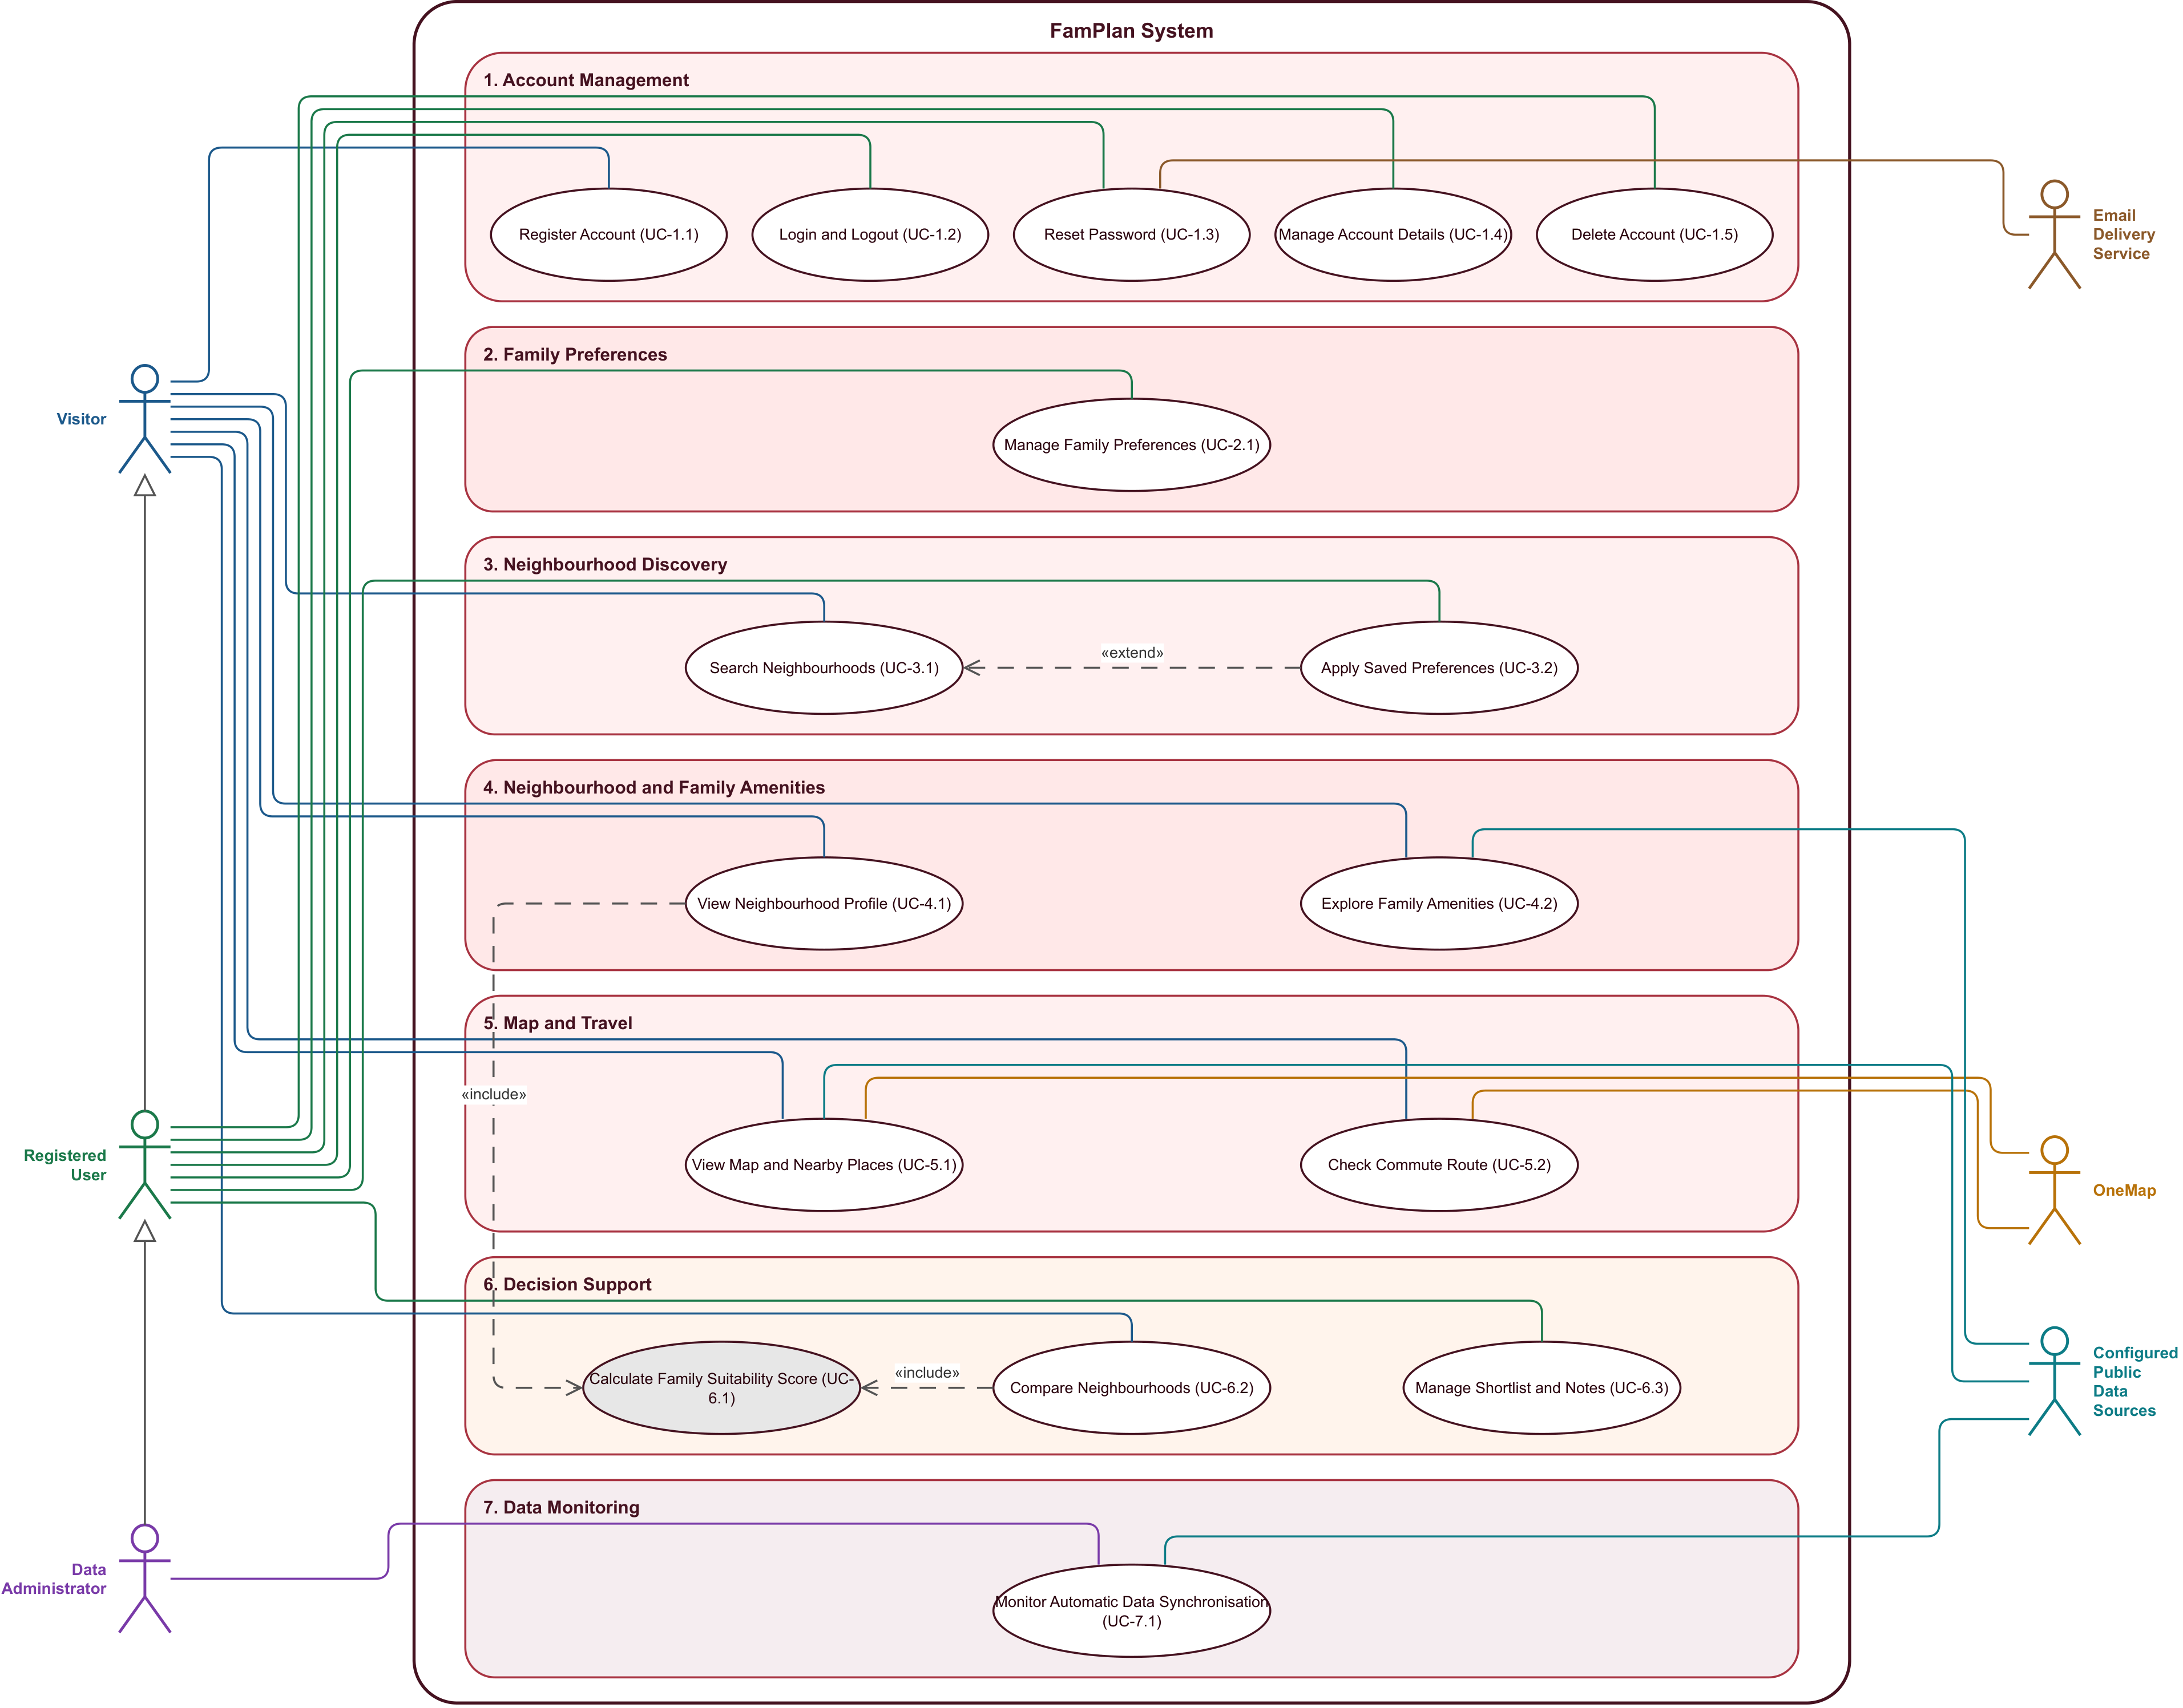
Figure 7.1. FamPlan use case diagram.

Actors
Actor | Type | Description
Visitor | Primary | Any member of the public using FamPlan without signing in.
Registered User | Primary | A signed-in household member; inherits every Visitor use case.
Data Administrator | Primary | A Registered User with the DATA_ADMINISTRATOR role; monitors automatic synchronisation only.
Email Delivery Service | Supporting | Sends password-reset emails (UC-1.3).
OneMap | Supporting | Singapore Land Authority map, address search and routing service (UC-5.1, UC-5.2).
Configured Public Data Sources | Supporting | data.gov.sg datasets (URA, ECDA, MOE, MOH, NParks, LTA) and OpenStreetMap, synchronised automatically (UC-4.2, UC-5.1, UC-7.1).

Use Case Catalogue
ID | Use Case | Actor or Supporting System | Goal | Requirements | Relationship
UC-1.1 | Register Account | Visitor | Create a personal account. | FR-ACC-01 | None
UC-1.2 | Login and Logout | Registered User | Start or end an authenticated session. | FR-ACC-02 to FR-ACC-03 | None
UC-1.3 | Reset Password | Registered User; Email Delivery Service | Recover access through a secure reset link. | FR-ACC-04 | None
UC-1.4 | Manage Account Details | Registered User | Update the account display name. | FR-ACC-05 | None
UC-1.5 | Delete Account | Registered User | Confirm deletion of the account and saved data. | FR-ACC-06 | None
UC-2.1 | Manage Family Preferences | Registered User | Save family stages, areas, amenities, destinations, and weights. | FR-PREF-01 to FR-PREF-07 | None
UC-3.1 | Search Neighbourhoods | Visitor | Find and filter neighbourhood profiles. | FR-DISC-01 to FR-DISC-02; FR-DISC-04 to FR-DISC-07 | Base use case
UC-3.2 | Apply Saved Preferences | Registered User | Populate search criteria from saved preferences. | FR-DISC-03 | Extends UC-3.1
UC-4.1 | View Neighbourhood Profile | Visitor | Inspect the selected neighbourhood and its family score. | FR-NBH-01; FR-DEC-01 to FR-DEC-03 | Includes UC-6.1
UC-4.2 | Explore Family Amenities | Visitor; Configured Public Data Sources | Review nearby childcare, schools, groceries, healthcare, recreation, and transport. | FR-NBH-02 to FR-NBH-10 | None
UC-5.1 | View Map and Nearby Places | Visitor; Configured Public Data Sources; OneMap | Explore categorised facilities and distances on a map. | FR-NBH-02 to FR-NBH-09; FR-TRV-01 | None
UC-5.2 | Check Commute Route | Visitor; OneMap | Request a route and travel estimate to a priority destination. | FR-TRV-02 to FR-TRV-05 | None
UC-6.1 | Calculate Family Suitability Score | No initiating actor | Compute an explainable neighbourhood score. | FR-DEC-01 to FR-DEC-03 | Included by UC-4.1 and UC-6.2
UC-6.2 | Compare Neighbourhoods | Visitor | Compare two to four neighbourhoods consistently. | FR-DEC-04; FR-DEC-01 to FR-DEC-03 | Includes UC-6.1
UC-6.3 | Manage Shortlist and Notes | Registered User | Save up to ten neighbourhoods and maintain private notes. | FR-DEC-05 to FR-DEC-07 | None
UC-7.1 | Monitor Automatic Data Synchronisation | Data Administrator; Configured Public Data Sources | Review status and history of automatic API updates. | FR-ADM-01 to FR-ADM-04 | Monitoring only; synchronisation is automatic

Functional Requirement Traceability
FR ID | Use Case or Binding | Coverage
FR-ACC-01 | UC-1.1 | Directly covered
FR-ACC-02 | UC-1.2 | Directly covered
FR-ACC-03 | UC-1.2 | Directly covered
FR-ACC-04 | UC-1.3 | Directly covered
FR-ACC-05 | UC-1.4 | Directly covered
FR-ACC-06 | UC-1.5 | Directly covered
FR-PREF-01 | UC-2.1 | Directly covered
FR-PREF-02 | UC-2.1 | Directly covered
FR-PREF-03 | UC-2.1 | Directly covered
FR-PREF-04 | UC-2.1 | Directly covered
FR-PREF-05 | UC-2.1 | Directly covered
FR-PREF-06 | UC-2.1 | Directly covered
FR-PREF-07 | UC-2.1 | Directly covered
FR-DISC-01 | UC-3.1 | Directly covered
FR-DISC-02 | UC-3.1 | Directly covered
FR-DISC-03 | UC-3.2 | Directly covered
FR-DISC-04 | UC-3.1 | Directly covered
FR-DISC-05 | UC-3.1 | Directly covered
FR-DISC-06 | UC-3.1 | Directly covered
FR-DISC-07 | UC-3.1 | Directly covered
FR-NBH-01 | UC-4.1 | Directly covered
FR-NBH-02 | UC-4.2, UC-5.1 | Directly covered
FR-NBH-03 | UC-4.2, UC-5.1 | Directly covered
FR-NBH-04 | UC-4.2, UC-5.1 | Directly covered
FR-NBH-05 | UC-4.2, UC-5.1 | Directly covered
FR-NBH-06 | UC-4.2, UC-5.1 | Directly covered
FR-NBH-07 | UC-4.2, UC-5.1 | Directly covered
FR-NBH-08 | UC-4.2, UC-5.1 | Directly covered
FR-NBH-09 | UC-4.2, UC-5.1 | Directly covered
FR-NBH-10 | UC-4.2, UC-5.1 | Directly covered
FR-TRV-01 | UC-5.1 | Directly covered
FR-TRV-02 | UC-5.2 | Directly covered
FR-TRV-03 | UC-5.2 | Directly covered
FR-TRV-04 | UC-5.2 | Directly covered
FR-TRV-05 | UC-5.2 | Directly covered
FR-DEC-01 | UC-6.1 | Directly covered
FR-DEC-02 | UC-6.1 | Directly covered
FR-DEC-03 | UC-6.1 | Directly covered
FR-DEC-04 | UC-6.2 | Directly covered
FR-DEC-05 | UC-6.3 | Directly covered
FR-DEC-06 | UC-6.3 | Directly covered
FR-DEC-07 | UC-6.3 | Directly covered
FR-ADM-01 | UC-7.1 | Directly covered
FR-ADM-02 | UC-7.1 | Directly covered
FR-ADM-03 | Supporting system behaviour | Supporting or cross-cutting behaviour
FR-ADM-04 | UC-7.1 | Directly covered
FR-RES-01 | Supporting system behaviour | Supporting or cross-cutting behaviour
FR-RES-02 | Cross-cutting | Supporting or cross-cutting behaviour
FR-RES-03 | Cross-cutting | Supporting or cross-cutting behaviour

Use Case Descriptions
Each use case below follows the course template. Main flows have at most seven steps; alternative flows are numbered AF-<step><letter> and branch from that main-flow step. "System" means the FamPlan application. Inherited associations are not repeated: a Registered User can also perform every Visitor use case, and a Data Administrator every Registered User use case. "Notes and Issues" names the screen and endpoint that implement each use case, for traceability to the code.

UC-1.1 Register Account
Use Case ID | UC-1.1
Use Case Name | Register Account
Actor(s) | Visitor
Description | Lets a visitor create a FamPlan account using a display name, email address and password, after explicitly consenting to the stated data use.
Preconditions | - The visitor is not signed in.
Postconditions | - Success: the account and an empty family preference profile are created, and the visitor is signed in as a Registered User.  - Failure: no account is created; field-specific errors are shown.
Priority | Must
Frequency of Use | Low (once per user)
Flow of Events | - Visitor opens the Sign in page and selects the Create account tab.  - Visitor enters a display name, email address and password.  - Visitor ticks the data-use consent statement and selects Create account.  - System validates every field, the password policy and the consent.  - System creates the account and stores only a salted Argon2id hash of the password.  - System starts an authenticated session and shows the signed-in view.
Alternative Flows | - AF-4a Email already registered: System shows "An account with this email already exists. Sign in or reset your password."; return to step 2.  - AF-4b Malformed email or password that breaks the policy: System shows a field error naming the rule; return to step 2.  - AF-4c Consent not given: System shows a consent error; return to step 3.
Exceptions | - Too many attempts or service unavailable: System shows a generic error and creates no account.
Includes / Extends | None
Requirements Traced | FR-ACC-01
Special Requirements | NFR-SEC-01 (HTTPS only); NFR-SEC-02 (salted password hash); NFR-SEC-05 (input validation); NFR-PRIV-02 (no exact dates of birth or unnecessary personal data).
Assumptions | The email address uniquely identifies an account; there is no separate email-verification step in this release.
Notes and Issues | Implemented in client/src/pages/SignIn.tsx and POST /auth/register (server/src/account/routes.ts).

UC-1.2 Login and Logout
Use Case ID | UC-1.2
Use Case Name | Login and Logout
Actor(s) | Registered User
Description | Lets a registered user start an authenticated session with email and password, and end that session.
Preconditions | - Login: the user has a registered account and is not signed in.  - Logout: the user is signed in.
Postconditions | - Login success: a session is created (12-hour lifetime) and stored in an httpOnly cookie.  - Login failure: a generic failure is shown and no session is created.  - Logout: the session is invalidated on the server and the user is returned to a public page.
Priority | Must
Frequency of Use | High (every visit)
Flow of Events | - User opens the Sign in page.  - User enters email and password and selects Sign in.  - System verifies the password against the stored hash and checks that the account is not locked.  - System creates a session, resets the failed-login counter and shows the signed-in view.  - Later, the user selects Log out.  - System invalidates the session on the server and returns the user to a public page.
Alternative Flows | - AF-3a Wrong password or unknown email: System shows the same generic failure for both, so account existence is not revealed, and increments the failed-login counter; return to step 2.  - AF-3b Fifth consecutive failure: System locks password sign-in for 15 minutes and shows the generic failure.  - AF-5a Session expired: protected pages ask the user to sign in again.
Exceptions | - Service unavailable: System shows a generic error and creates no session.
Includes / Extends | None
Requirements Traced | FR-ACC-02, FR-ACC-03
Special Requirements | NFR-SEC-01 (HTTPS only); NFR-SEC-02 (password hashing); NFR-SEC-04 (15-minute lockout after five failures).
Assumptions | Users sign in from a browser that accepts first-party cookies.
Notes and Issues | Implemented in client/src/pages/SignIn.tsx, POST /auth/login and /auth/logout, and server/src/account/sessions.ts.

UC-1.3 Reset Password
Use Case ID | UC-1.3
Use Case Name | Reset Password
Actor(s) | Registered User (primary); Email Delivery Service (supporting)
Description | Lets a user who has forgotten the password receive a time-limited, single-use reset link by email and choose a new password.
Preconditions | - The user is not signed in.
Postconditions | - Success: the new password hash is stored, the link is marked used, all existing sessions are ended and any lockout is cleared.  - Failure: the password is unchanged.
Priority | Should
Frequency of Use | Low
Flow of Events | - User selects Forgot password and enters the account email address.  - System shows the same generic confirmation whether or not the email is registered.  - If the email is registered, System asks the Email Delivery Service to send a reset link valid for 30 minutes.  - User opens the link, enters a new password and confirms it.  - System checks that the link is valid, unused and unexpired, and validates the password policy.  - System stores the new password hash, marks the link used, ends existing sessions and asks the user to sign in.
Alternative Flows | - AF-5a Link invalid, already used or expired: System shows "This reset link is invalid, already used, or expired. Request a new link."; return to step 1.  - AF-5b Password breaks the policy or the confirmation does not match: System shows a field error; return to step 4.
Exceptions | - Email delivery fails: no link arrives; the user can request a new link from step 1.
Includes / Extends | None
Requirements Traced | FR-ACC-04
Special Requirements | NFR-SEC-02 (password hashing); NFR-SEC-04 (a successful reset clears the lockout); NFR-SEC-05 (input validation).
Assumptions | The user still has access to the registered email inbox.
Notes and Issues | Implemented in client/src/pages/PasswordReset.tsx, POST /auth/forgot-password and /auth/reset-password, and server/src/account/mailer.ts.

UC-1.4 Manage Account Details
Use Case ID | UC-1.4
Use Case Name | Manage Account Details
Actor(s) | Registered User
Description | Lets a signed-in user change the display name stored on the account. Email address and password cannot be changed through this function.
Preconditions | - The user is signed in.
Postconditions | - Success: the new display name is stored and shown.  - Failure: the display name is unchanged and a field error is shown.
Priority | Must
Frequency of Use | Low
Flow of Events | - User opens Account settings.  - System shows the current display name and the read-only email address.  - User edits the display name and saves.  - System validates the new name.  - System stores it and confirms the change.
Alternative Flows | - AF-4a Name empty or longer than 60 characters: System shows a field error; return to step 3.
Exceptions | - Session expired: System asks the user to sign in again.
Includes / Extends | None
Requirements Traced | FR-ACC-05
Special Requirements | NFR-SEC-05 (input validation).
Assumptions | None.
Notes and Issues | Implemented in client/src/pages/Account.tsx and PATCH /account.

UC-1.5 Delete Account
Use Case ID | UC-1.5
Use Case Name | Delete Account
Actor(s) | Registered User
Description | Permanently deletes the account and all associated personal data after explicit confirmation.
Preconditions | - The user is signed in.
Postconditions | - Success: the account, credentials, sessions, saved preferences, priority destinations, and owned shortlist and notes are deleted; the session ends and an acknowledgement is shown.  - Cancelled: nothing changes.
Priority | Must
Frequency of Use | Very low
Flow of Events | - User opens Account settings and selects Delete account.  - System explains exactly what will be deleted and that deletion cannot be undone.  - User types DELETE to confirm and submits.  - System deletes the account and all associated personal data.  - System ends the session and shows a deletion acknowledgement on a public page.
Alternative Flows | - AF-3a User cancels: nothing is deleted.  - AF-4a Confirmation text is not DELETE: System shows "Type DELETE to confirm account deletion."; return to step 3.
Exceptions | - Service unavailable: no data is deleted; System shows a generic error.
Includes / Extends | None
Requirements Traced | FR-ACC-06
Special Requirements | NFR-PRIV-01 (deleted personal data is no longer retrievable).
Assumptions | None.
Notes and Issues | Implemented in client/src/pages/Account.tsx and DELETE /account.

UC-2.1 Manage Family Preferences
Use Case ID | UC-2.1
Use Case Name | Manage Family Preferences
Actor(s) | Registered User
Description | Lets a user save family-planning stages, preferred planning areas, up to three priority destinations each with a travel mode, amenity distance thresholds and eight criterion weights, with optional stage-based suggested weights.
Preconditions | - The user is signed in (needed to save).
Postconditions | - Success: the preference profile is saved and used by search, scoring and comparison; every saved destination contributes to the commute score using its own travel mode.  - Failure: the previously saved profile is kept and field errors are shown.
Priority | Must
Frequency of Use | Medium (at setup, then occasionally)
Flow of Events | - User opens Family preferences.  - System loads the saved profile, or defaults for a new account.  - User selects family stages and preferred planning areas.  - User adds up to three priority destinations (label and address), chooses a travel mode for each (public transport, walk, car or cycle), and sets amenity distances and the eight criterion weights (0 to 5).  - Optionally, user requests suggested weights; System fills stage-based presets without overwriting weights the user has already confirmed.  - User saves; System validates every value.  - System stores the profile and confirms the save.
Alternative Flows | - AF-1a Visitor not signed in: weights can be tried for the current session only, and System prompts the user to sign in to save.  - AF-4a A fourth destination is added: System rejects it (maximum three).  - AF-4b No travel mode chosen for a destination: System uses public transport.  - AF-6a Weight outside 0 to 5 or not a whole number, an unsupported travel mode, or an unresolved destination address: System shows a field error; return to step 4.
Exceptions | - Address search unavailable: destinations cannot be added, but the other preferences can still be saved.
Includes / Extends | Saved values are reused by UC-3.2 Apply Saved Preferences.
Requirements Traced | FR-PREF-01 to FR-PREF-07
Special Requirements | NFR-PRIV-02 (family stages only; no exact dates of birth); NFR-SEC-05 (input validation).
Assumptions | A household is represented by a single preference profile.
Notes and Issues | Implemented in client/src/pages/Preferences.tsx, GET/PUT /preferences and POST /preferences/suggest-weights. Destination address suggestions come from OneMap search through GET /geocode.

UC-3.1 Search Neighbourhoods
Use Case ID | UC-3.1
Use Case Name | Search Neighbourhoods
Actor(s) | Visitor
Description | Finds neighbourhoods by town, planning area, estate, street address or postal code, and filters and sorts the results. An address or postal code is resolved to one exact location, and distances, counts and scores are measured from that coordinate.
Preconditions | - Validated neighbourhood data has been loaded.
Postconditions | - Success: matching neighbourhood profiles are listed and plotted on the map, each labelled as a neighbourhood profile rather than a property listing.  - Failure: an empty state or field-specific correction is shown.
Priority | Must
Frequency of Use | High
Flow of Events | - Visitor opens Discover neighbourhoods.  - Visitor enters a town, estate, street address or six-digit postal code, or picks planning areas.  - Visitor optionally sets filters (family stage, amenity category, minimum facility count, facility radius, commute destination and time) and a sort order.  - System validates the criteria.  - For an address or postal code, System resolves the text to one exact location and uses its coordinate as the origin for the radius, counts, score evidence and routes.  - System searches the locally stored validated data and orders the matches by the chosen sort.  - System lists the matching neighbourhood profiles, states which origin was used, and plots them on the map.
Alternative Flows | - AF-2a Spelling variant: System still matches the intended area by approximate name matching.  - AF-3a Registered User selects Apply my preferences: UC-3.2 extends the search at this point.  - AF-4a Invalid or contradictory criteria, or a postal code with fewer than six digits: System shows field-specific correction guidance (for example "Enter all six digits of the Singapore postal code, including any leading zero."); return to step 3.  - AF-5a Several places match the address: System lists the matching addresses and asks the visitor to choose one; continue at step 6 with the chosen location.  - AF-5b No Singapore address matches: System shows "No Singapore address matches this postal code or address. Check the input and try again."; return to step 2.  - AF-7a No matches: System shows an empty state suggesting wider filters.
Exceptions | - Address search unavailable: System falls back to town and planning-area name matching where the text matches a name; otherwise it shows "Address search is temporarily unavailable. Search by town or area name instead."  - Source data older than the freshness threshold: results are still shown with a stale-data warning.
Includes / Extends | Extended by UC-3.2 (extension point: step 3, Apply my preferences).
Requirements Traced | FR-DISC-01, FR-DISC-02, FR-DISC-04 to FR-DISC-07
Special Requirements | NFR-PERF-01 (search response time); NFR-REL-03 (search reads local validated data, never live APIs); NFR-SEC-05 (input validation).
Assumptions | Neighbourhoods are planning-area subzones from the URA dataset.
Notes and Issues | Implemented in client/src/pages/Explore.tsx and GET /neighbourhoods (searchNeighbourhoods() in server/src/neighbourhoods/service.ts). Address resolution uses OneMap search through the geocode cache.

UC-3.2 Apply Saved Preferences
Use Case ID | UC-3.2
Use Case Name | Apply Saved Preferences
Actor(s) | Registered User
Description | Fills the current search criteria from the user's saved family preferences and refreshes the results.
Preconditions | - The user is signed in.  - A search is in progress (UC-3.1).
Postconditions | - Search criteria are populated and results refreshed; the saved preference values are not changed.
Priority | Must
Frequency of Use | Medium
Flow of Events | - During a search, the user selects Apply my preferences.  - System loads the saved family stages, preferred areas, amenity distances, priority destinations with their travel modes, and weights.  - System fills the search criteria with these values.  - System re-runs the search (UC-3.1 steps 4 to 7).  - System confirms that the preferences were applied without changing the saved values.
Alternative Flows | - AF-1a User not signed in: the control reads "Sign in to apply saved family preferences".  - AF-2a Profile only partly filled: System applies the saved fields and keeps the current values for the rest.  - AF-2b No saved profile: System directs the user to Family preferences (UC-2.1).
Exceptions | - None.
Includes / Extends | Extends UC-3.1.
Requirements Traced | FR-DISC-03
Special Requirements | None.
Assumptions | None.
Notes and Issues | Implemented in client/src/pages/Explore.tsx (applyMyPreferences()).

UC-4.1 View Neighbourhood Profile
Use Case ID | UC-4.1
Use Case Name | View Neighbourhood Profile
Actor(s) | Visitor
Description | Shows a selected neighbourhood's summary (name, planning area, map location and coverage basis) together with its explainable family suitability score.
Preconditions | - A neighbourhood has been selected from results, a comparison, the shortlist or a direct link.
Postconditions | - The profile and score breakdown are displayed.
Priority | Must
Frequency of Use | High
Flow of Events | - Visitor selects a neighbourhood.  - System loads it from the local validated data.  - System displays its name, planning area, map location and boundary or coverage basis.  - System calculates its family suitability score (includes UC-6.1).  - System shows the score with its criterion breakdown and the statement that the score is a comparison aid, not a guarantee.  - System shows the data sources and their update times.
Alternative Flows | - AF-2a Unknown neighbourhood: System shows "not found" with a link back to search.  - AF-4a A criterion lacks data: the score discloses how its weight was treated (see UC-6.1).
Exceptions | - Cached data older than the freshness threshold: System shows its age and a stale-data warning.
Includes / Extends | Includes UC-6.1.
Requirements Traced | FR-NBH-01; FR-DEC-01 to FR-DEC-03
Special Requirements | NFR-TRANS-01 and NFR-TRANS-02 (explainable score, limitation statement); NFR-DATA-01 (provenance on every result).
Assumptions | None.
Notes and Issues | Implemented in client/src/pages/Profile.tsx and GET /neighbourhoods/:id.

UC-4.2 Explore Family Amenities
Use Case ID | UC-4.2
Use Case Name | Explore Family Amenities
Actor(s) | Visitor (primary); Configured Public Data Sources (supporting)
Description | Lets the visitor review nearby childcare centres, kindergartens, schools, supermarkets, clinics, parks, MRT stations and bus stops within a chosen radius, with counts, nearest facilities, distances and sources.
Preconditions | - A neighbourhood profile is open (UC-4.1).
Postconditions | - Per-category facilities, counts and availability states are displayed.
Priority | Must
Frequency of Use | High
Flow of Events | - Visitor chooses a radius (500 m, 1 km or 2 km) and optionally an amenity category.  - System selects facilities within the radius from the validated datasets synchronised from the configured public data sources.  - System shows the count for each category and the nearest facility with its distance and calculation basis.  - Visitor opens a facility.  - System shows its name, category, address where available, source and update time.  - For schools and childcare, System states that proximity does not guarantee admission, enrolment, vacancy or eligibility.
Alternative Flows | - AF-2a The same facility appears in two sources: System counts it once.  - AF-3a No facility within the radius: System shows an explicit "no match" state instead of a misleading zero.  - AF-3b A category's source is unavailable, incomplete or stale: System shows that status for the category; other categories remain visible.
Exceptions | - None beyond AF-3b; data is served from the local validated store.
Includes / Extends | None
Requirements Traced | FR-NBH-02 to FR-NBH-10
Special Requirements | NFR-DATA-01 (provenance); NFR-DATA-02 (31-day freshness threshold); NFR-DATA-04 (de-duplicated facility records).
Assumptions | Distances are measured from the neighbourhood reference point (straight line).
Notes and Issues | Implemented in client/src/pages/Profile.tsx, GET /neighbourhoods/:id/facilities and server/src/neighbourhoods/dedupe.ts.

UC-5.1 View Map and Nearby Places
Use Case ID | UC-5.1
Use Case Name | View Map and Nearby Places
Actor(s) | Visitor (primary); Configured Public Data Sources and OneMap (supporting)
Description | Shows the neighbourhood and its matched facilities on an interactive map with distinguishable category markers.
Preconditions | - A neighbourhood profile is open (UC-4.1).
Postconditions | - The map shows the neighbourhood boundary, reference point and categorised facility markers.
Priority | Must
Frequency of Use | High
Flow of Events | - Visitor opens the map on the neighbourhood profile.  - System draws the OneMap base map with the neighbourhood boundary and reference point.  - System plots the matched facilities within the radius with a distinct marker for each category.  - Visitor toggles map layers or changes the radius.  - System updates the markers and counts.  - Visitor selects a marker; System shows the facility details and distance.
Alternative Flows | - AF-3a Facility without coordinates: it is listed but not plotted, with a note.  - AF-3b Overlapping markers: each remains individually selectable.
Exceptions | - Base map unavailable: the facility list and counts remain usable.
Includes / Extends | None
Requirements Traced | FR-NBH-02 to FR-NBH-09; FR-TRV-01
Special Requirements | NFR-ACC-01 (keyboard-accessible map controls); NFR-REL-03 (one dependency failing does not block others).
Assumptions | None.
Notes and Issues | Implemented in client/src/pages/Profile.tsx (map layers) and client/src/components/map.tsx.

UC-5.2 Check Commute Route
Use Case ID | UC-5.2
Use Case Name | Check Commute Route
Actor(s) | Visitor (primary); OneMap (supporting)
Description | Requests a route and travel estimate from the neighbourhood to a priority destination for a supported travel mode, optionally asking for a barrier-free route.
Preconditions | - A neighbourhood profile is open.  - A destination is chosen (saved priority destination or entered address).
Postconditions | - A route with distance, duration, provider and retrieval time is shown, or an explained unavailable state.
Priority | Must
Frequency of Use | Medium
Flow of Events | - Visitor opens Commute & routes from a neighbourhood profile.  - Visitor chooses a saved priority destination or searches another place; a saved destination preselects its saved travel mode.  - Visitor chooses a travel mode (public transport, walk, car or cycle) and optionally ticks Barrier-free routes only.  - System checks that the mode is supported by the routing provider.  - System requests the route from OneMap.  - System shows the route on the map with distance, duration, travel mode, provider and retrieval time.
Alternative Flows | - AF-3a Mode differs from the destination's saved mode: System labels the route as a preview only and states that the commute score still uses the saved mode.  - AF-4a Unsupported mode: System explains the rejection; return to step 3.  - AF-5a Barrier-free route requested: System states that step-free coverage is unavailable from the provider and advises checking lift and ramp availability with LTA or the station operator.  - AF-5b OneMap finds no route: System shows a "no route" state with a labelled straight-line estimate.
Exceptions | - OneMap unavailable, timed out or not configured: System shows a labelled straight-line estimate instead; the rest of the profile still works.
Includes / Extends | None
Requirements Traced | FR-TRV-02 to FR-TRV-05
Special Requirements | NFR-REL-03 (routing failure is isolated); NFR-DATA-01 (provider and retrieval time shown).
Assumptions | None.
Notes and Issues | Implemented in client/src/pages/Commute.tsx, GET /neighbourhoods/:id/route and server/src/travel/route.ts and onemap.ts.

UC-6.1 Calculate Family Suitability Score
Use Case ID | UC-6.1
Use Case Name | Calculate Family Suitability Score
Actor(s) | None (included behaviour)
Description | Computes an explainable 0 to 100 family suitability score from eight criteria using the user's weights and the versioned scoring configuration.
Preconditions | - Invoked by UC-4.1 or UC-6.2 with a neighbourhood and a set of weights (saved, session or default).
Postconditions | - A total score is returned with each criterion's value, normalised value, weight and contribution, any missing-data notes, and the configuration and dataset versions used.
Priority | Must
Frequency of Use | Very high (every profile and comparison)
Flow of Events | - The base use case supplies the neighbourhood and the weights.  - System gathers evidence for the eight criteria from the local validated data; the commute value is the average estimated minutes to every priority destination, each by its saved travel mode.  - System normalises each value with its criterion's rule (facility count, nearest distance or commute minutes).  - System excludes criteria that lack data and re-normalises the remaining weights.  - System computes each contribution and the total, rounding an exact 0.5 upward.  - System returns the total with the itemised breakdown and version stamps.
Alternative Flows | - AF-2a No priority destination is set: the commute criterion lacks data and is handled as in step 4.  - AF-4a All weights are zero: System weights every available criterion equally and discloses this.  - AF-4b No criterion has data: the score is shown as unavailable with an explanation.
Exceptions | - None.
Includes / Extends | Included by UC-4.1 and UC-6.2.
Requirements Traced | FR-DEC-01 to FR-DEC-03
Special Requirements | NFR-DATA-03 (identical inputs and versions reproduce the same score); NFR-TRANS-01 (itemised explanation); NFR-MAINT-01 (rules kept in versioned configuration).
Assumptions | None.
Notes and Issues | Implemented in server/src/scoring/score.ts (calculateScore()) and server/src/scoring/config.ts (SCORING_CONFIG).

UC-6.2 Compare Neighbourhoods
Use Case ID | UC-6.2
Use Case Name | Compare Neighbourhoods
Actor(s) | Visitor
Description | Compares two to four selected neighbourhoods side by side using the same weights and radius.
Preconditions | - At least two neighbourhoods have been selected for comparison.
Postconditions | - A side-by-side comparison of scores and family information is displayed.
Priority | Must
Frequency of Use | Medium
Flow of Events | - Visitor marks two to four neighbourhoods for comparison from results, profiles or the shortlist.  - Visitor opens Compare neighbourhoods.  - System validates the selection.  - System calculates each neighbourhood's score with the same weights and radius (includes UC-6.1).  - System shows them side by side: suitability match, childcare and kindergartens, schools, daily needs, public transport, accessibility and the commute estimate to each priority destination.  - Visitor changes the radius or weights; System recalculates every column consistently.
Alternative Flows | - AF-3a Fewer than two or more than four selected: System shows "Choose two to four neighbourhoods to compare."; return to step 1.  - AF-3b The same neighbourhood selected twice: System counts it once.  - AF-5a A criterion lacks data for one neighbourhood: System marks it in that column.
Exceptions | - None.
Includes / Extends | Includes UC-6.1.
Requirements Traced | FR-DEC-04; FR-DEC-01 to FR-DEC-03
Special Requirements | NFR-PERF-02 (comparison response time); NFR-TRANS-01 and NFR-TRANS-02.
Assumptions | None.
Notes and Issues | Implemented in client/src/pages/Compare.tsx and GET /compare.

UC-6.3 Manage Shortlist and Notes
Use Case ID | UC-6.3
Use Case Name | Manage Shortlist and Notes
Actor(s) | Registered User
Description | Lets a user save up to ten neighbourhoods to a shortlist, remove them, and keep a private note of up to 500 characters on each.
Preconditions | - The user is signed in.
Postconditions | - The shortlist and notes are saved and appear again after the next sign-in.
Priority | Must
Frequency of Use | Medium
Flow of Events | - User selects Add to shortlist on a neighbourhood.  - System checks for a duplicate and the ten-entry limit, then saves the entry.  - User opens Your shortlist.  - System lists the saved neighbourhoods with their current scores.  - User writes, edits or clears a private note.  - System validates and saves the note.  - User removes an entry; System deletes it and confirms.
Alternative Flows | - AF-1a Visitor not signed in: System prompts the visitor to sign in or create an account.  - AF-2a Neighbourhood already saved: System shows it as already saved and creates no duplicate.  - AF-2b An eleventh entry: System rejects it and explains the capacity limit.  - AF-6a Note longer than 500 characters: System shows a validation error and keeps the previous note.
Exceptions | - Session expired: System asks the user to sign in again; nothing is lost.
Includes / Extends | None
Requirements Traced | FR-DEC-05 to FR-DEC-07
Special Requirements | NFR-SEC-05 (notes are validated and rendered as plain text); NFR-PRIV-01 (notes are deleted with the account).
Assumptions | Notes are private to the owner.
Notes and Issues | Implemented in client/src/pages/Shortlist.tsx and the /shortlist endpoints. Entries are stored per account (ShortlistEntry, unique per account and neighbourhood).

UC-7.1 Monitor Automatic Data Synchronisation
Use Case ID | UC-7.1
Use Case Name | Monitor Automatic Data Synchronisation
Actor(s) | Data Administrator (primary); Configured Public Data Sources (supporting)
Description | Lets an administrator review the status and history of the automatic public-data synchronisation. Synchronisation itself runs automatically (FR-ADM-03); there is no manual sync action.
Preconditions | - The user is signed in with the Data Administrator role.
Postconditions | - Source status and synchronisation history are displayed; no data is changed (read-only).
Priority | Must
Frequency of Use | Low (routine check)
Flow of Events | - Administrator opens the Data sync dashboard.  - System verifies the administrator role.  - System shows each source's status, latest successful and latest attempted synchronisation, record count and freshness.  - Administrator filters the synchronisation history by source or date.  - System lists the runs newest first with start and end time, outcome, records added, changed and removed, and a sanitised error summary.
Alternative Flows | - AF-2a Signed-in user without the administrator role: System denies access (403).  - AF-2b Not signed in: System asks the user to sign in.  - AF-3a A source's latest run failed: System shows the failure while the previous validated dataset stays active.
Exceptions | - None.
Includes / Extends | None
Requirements Traced | FR-ADM-01, FR-ADM-02, FR-ADM-04 (background: FR-ADM-03, FR-RES-01)
Special Requirements | NFR-SEC-03 (role check at UI and API level); error summaries contain no secrets.
Assumptions | Synchronisation runs daily at 04:00 Singapore time (SYNC_CRON) and at start-up when a source is due.
Notes and Issues | Implemented in client/src/pages/Admin.tsx, GET /admin/sources and GET /admin/history (server/src/synchronisation/routes.ts).

Technology Stack Recommendation
This is a deliberately small recommendation rather than a binding requirement. It keeps the project understandable for the team and supports the client-server, mapping, scoring, persistence, testing, and automatic synchronisation work already required.
Layer | Recommendation | Reason
Frontend | React with TypeScript and Vite | One responsive browser interface with reusable components and strong typing.
Backend | Node.js with Express and TypeScript | Simple REST API and one language across client and server.
Database | PostgreSQL with Prisma | Relational data, geolocation fields, constraints, migrations, and straightforward querying.
Maps and routes | Leaflet with authorised OneMap services | Lightweight interactive maps without introducing a separate native application.
Automatic data sync | Vercel Cron in production; node-cron on a long-running server | Calls configured APIs at least daily, validates data, and records outcomes without an administrator trigger.
Testing | Vitest, Supertest, and Playwright | Covers calculation units, API behaviour, and a small number of end-to-end workflows.
Local setup and deployment | GitHub, Vercel and Neon PostgreSQL | Keeps development reproducible without microservices, Kubernetes, or extra infrastructure.

Architecture Boundary
Use one frontend, one backend, and one PostgreSQL database. Keep data-source adapters and scoring logic as modules inside the backend rather than separate services. The scheduled job calls the same validation and activation modules used by the application. Do not introduce microservices, message queues, machine learning, a native mobile application, or a separate administrator backend for the first release.

System Architecture
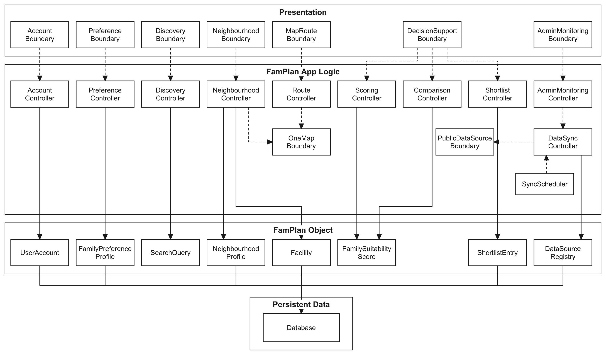
Layered architecture: dashed arrows are calls and dependencies; solid arrows show the entity each controller reads or updates; persistent entities are stored in PostgreSQL. Deployment: the React client is served by Vercel; Express runs as serverless Node.js functions in Singapore (sin1); Prisma connects to hosted PostgreSQL; one Vercel Cron job refreshes each of the 9 public data sources daily. Local development runs the same Express app as one long-running server with node-cron.

Presentation Layer
This layer is responsible for user interaction and view rendering inside the user's web browser, implemented as a TypeScript Single-Page Application using React and Vite. The boundary components capture user inputs, enforce form formatting, and delegate actions to backend REST API endpoints.
This layer consists of:
1. AccountBoundary: Presents registration, login, logout, display name updates, and password reset forms. Captures credentials and displays operation outcomes to users.
2. PreferenceBoundary: Captures family life stages, preferred planning areas, priority commute destinations with travel modes, and 0–5 criterion importance weights.
3. DiscoveryBoundary: Captures neighbourhood search queries and filter options (amenity distances, counts, and commute limits). Presents filterable and sortable result cards.
4. NeighbourhoodBoundary: Displays neighbourhood summary profiles, amenity counts by category, and availability states.
5. MapRouteBoundary: Renders an interactive Leaflet map marking categorized facilities, proximity radii (500 m, 1 km, 2 km), and travel route estimates.
6. DecisionSupportBoundary: Presents suitability score breakdowns, captures comparison selections (2 to 4 neighbourhoods), and displays the user's shortlisted neighbourhoods and private notes.
7. AdminMonitoringBoundary: Displays the automated synchronisation dashboard showing data source health, record counts, execution timestamps, and sync logs.
App Logic Layer
This layer contains all controller classes and external adapter boundaries executing on the Node.js / Express backend, as serverless functions in production. It coordinates business rules, processes data transformations, and encapsulates third-party integrations.
This layer consists of:
1. AccountController: Enforces password hashing using Argon2id, verifies session tokens, enforces login lockout policies (15 minutes after 5 failures), and manages account deletion lifecycles.
2. PreferenceController: Evaluates family planning stages, supplies stage-based weight presets, and manages persistent user preference profiles.
3. DiscoveryController: Validates search query bounds and executes spatial and attribute filters over cached neighbourhood datasets.
4. NeighbourhoodController: Aggregates nearby facilities within requested radius buffers and compiles the amenity summary for neighbourhood profiles.
5. RouteController: Validates transit modes and calculates commute estimates between neighbourhood reference points and priority destinations.
6. ScoringController: Implements the deterministic scoring engine, normalizes 8 criterion values, applies missing-data policies, and computes the rounded 0–100 suitability score.
7. ComparisonController: Validates that 2 to 4 neighbourhoods are selected and compiles side-by-side metric evaluations.
8. ShortlistController: Enforces the 10-entry shortlist capacity limit per user and validates private text notes up to 500 characters.
9. AdminMonitoringController: Enforces administrator role authorization and retrieves data source health and synchronisation audit logs.
10. DataSyncController: Fetches datasets from external endpoints, validates dataset schemas against checksums, creates provenance stamps, and persists validated snapshots.
11. SyncScheduler: Runs scheduled data synchronisation at least once every 24 hours without human intervention. It uses node-cron on a long-running server and one Vercel Cron job per source in the serverless production deployment.
12. OneMapBoundary: External adapter interfacing with the Singapore OneMap REST API for address geocoding, reverse geocoding, and transit routing.
13. PublicDataSourceBoundary: External adapter encapsulating public data providers (ECDA childcare, MOE schools, URA subzones, LTA DataMall) to insulate domain logic against schema changes.
App Object Layer
This layer consists of the core domain entity classes depicted in the architecture diagram:
1. UserAccount: Represents a registered user identity and encapsulates account status, timestamps, and role privileges.
2. FamilyPreferenceProfile: Stores user-configured family planning stages, preferred planning areas, and amenity distance criteria.
3. SearchQuery: Encapsulates transient request criteria, location text, and active filter thresholds during neighbourhood discovery.
4. NeighbourhoodProfile: Represents a comparable planning zone with name, planning area, reference point coordinates, and boundary basis.
5. Facility: Represents an individual school, clinic, preschool, supermarket, park, or transport station with geocoordinates and source metadata.
6. FamilySuitabilityScore: Encapsulates the overall 0–100 score, calculation configuration version, and contributing criterion breakdowns.
7. ShortlistEntry: Represents a saved neighbourhood pinned to a user account, supporting an optional private note.
8. DataSourceRegistry: Maintains configuration, freshness thresholds, and operational health status for each public data source.
Persistent Data Layer
This layer contains the database that will store all of the entities. In FamPlan, this is implemented using a PostgreSQL relational database to reliably manage and persist application data.

Class Diagram
If the images are unclear, please refer to the raw files uploaded together with this document.

Entity Model
Domain data model defining 26 entity classes, attributes, relationships, and 11 enumerations implemented via Prisma/PostgreSQL. Each entity is tagged with its persistence decision ({persistent}, {transient}, ...); GeocodeCache is a design-only persistent class.
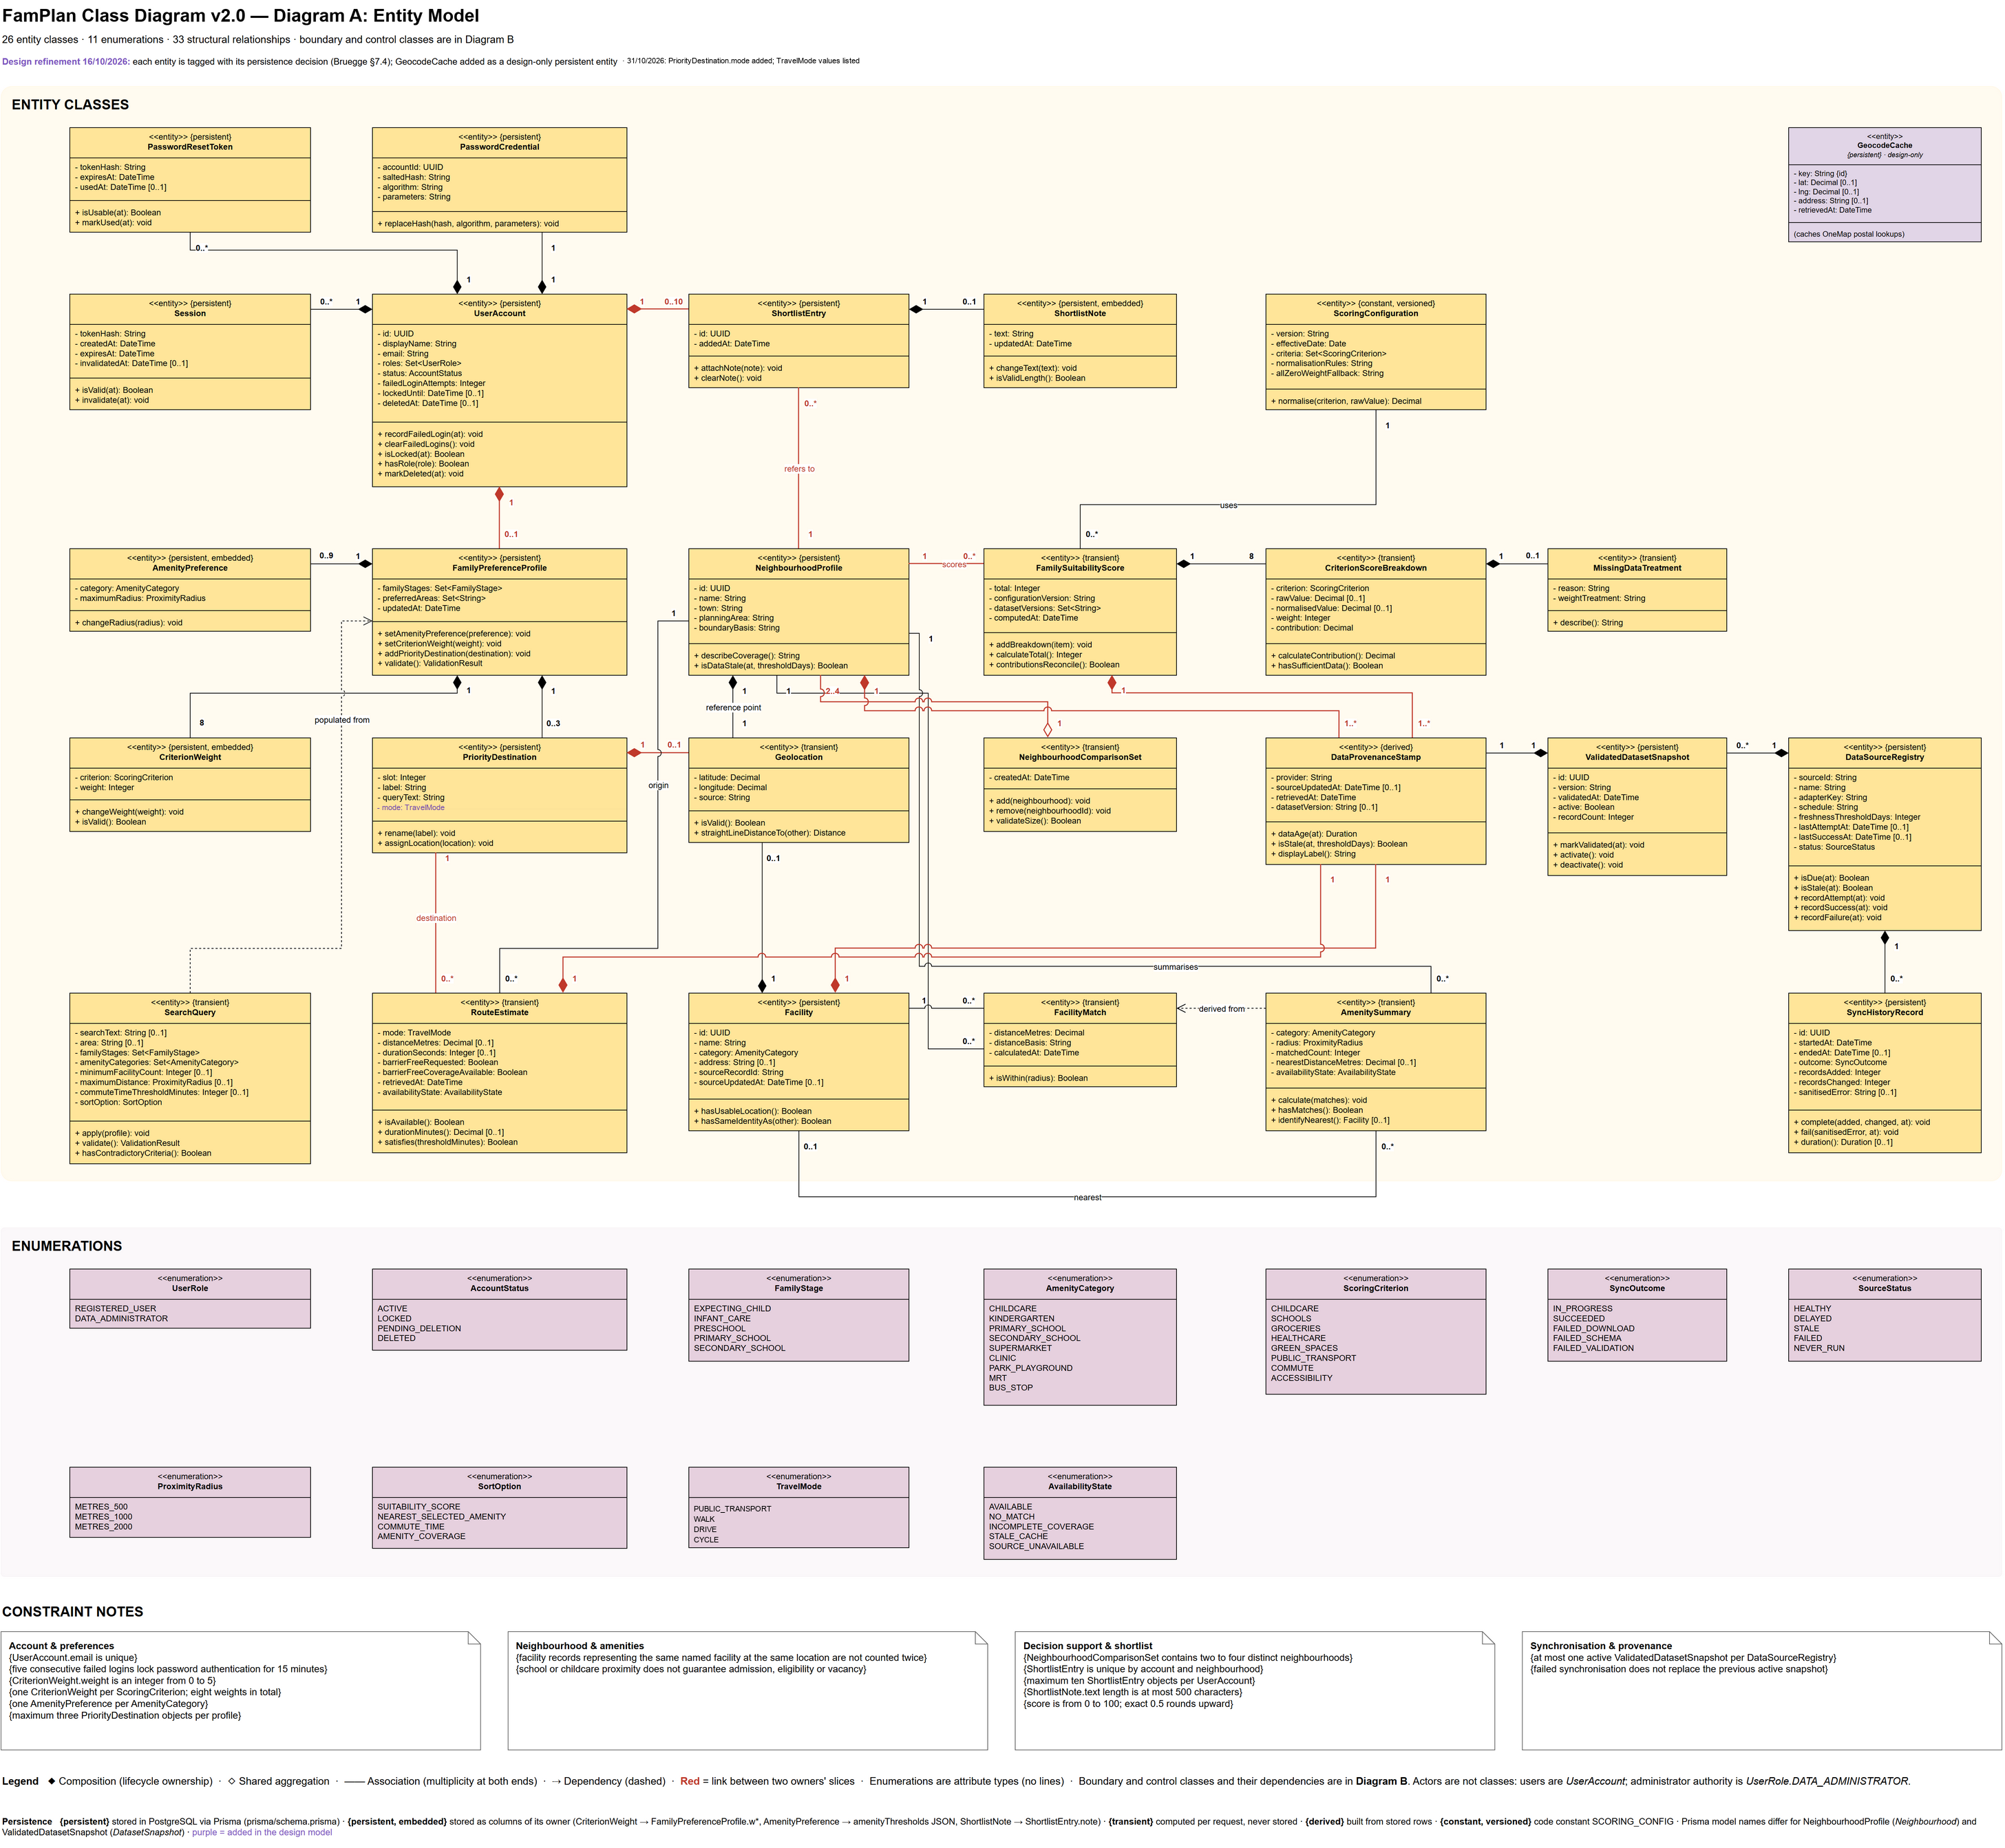

Boundary and Control Subsystems
Structural view mapping UI boundaries to controllers across the 5 functional subsystems.

Robustness View
BCE analysis view illustrating communication between actors, external services, boundaries, controls and entity stores.
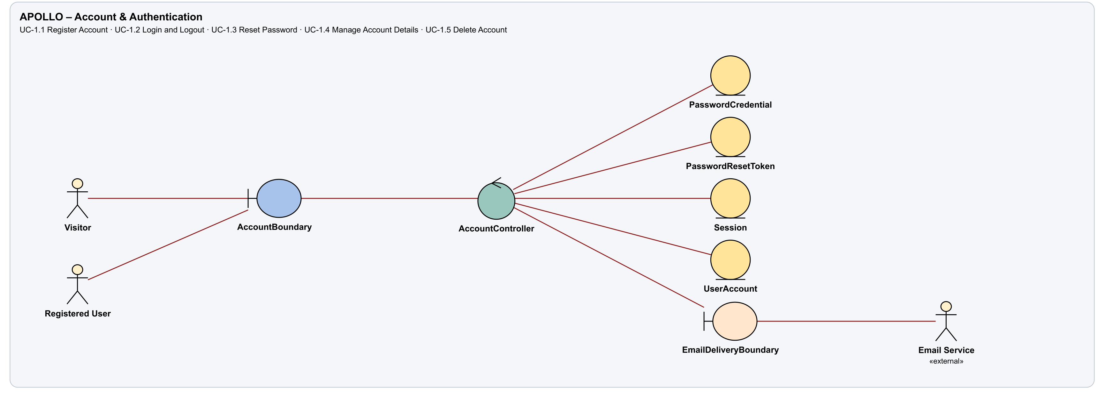
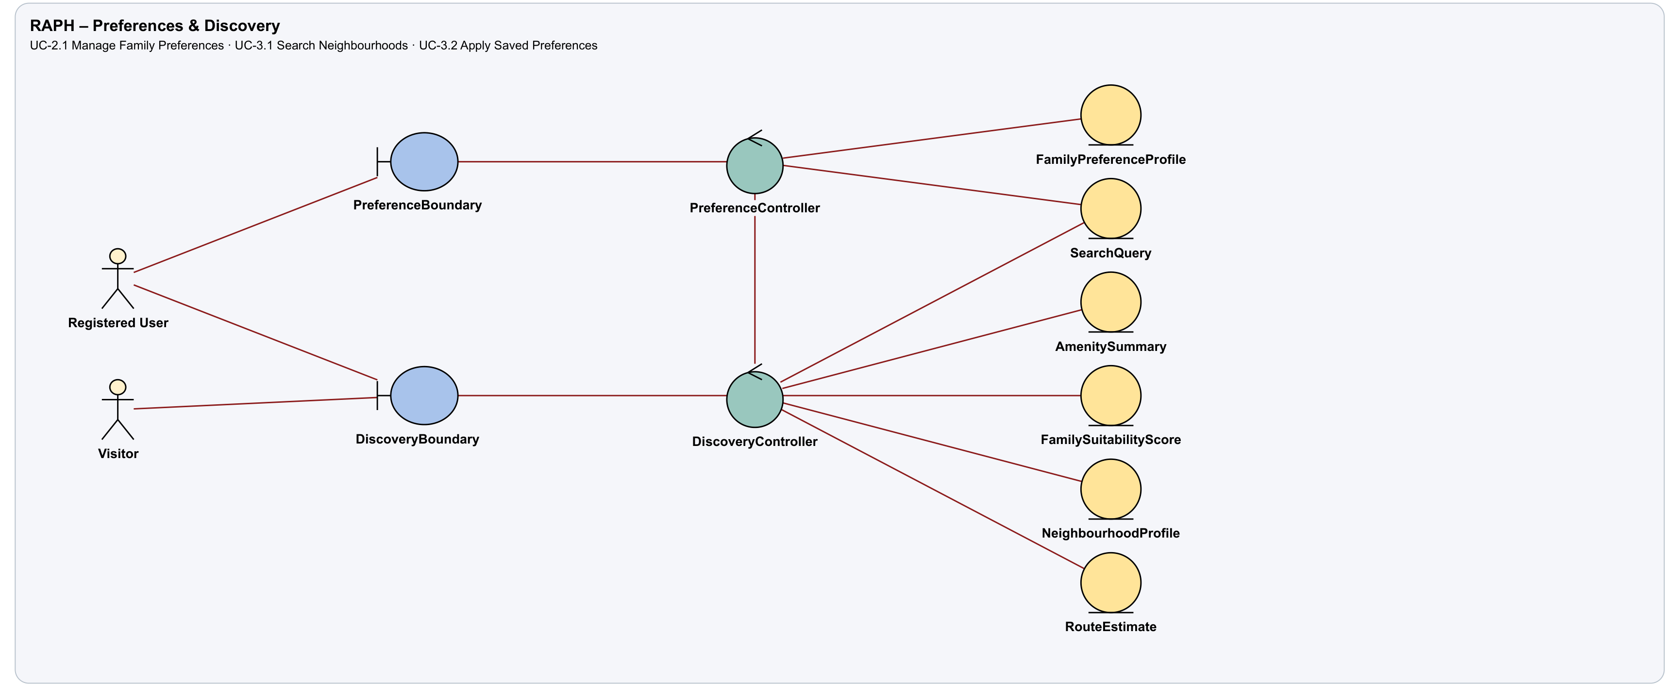
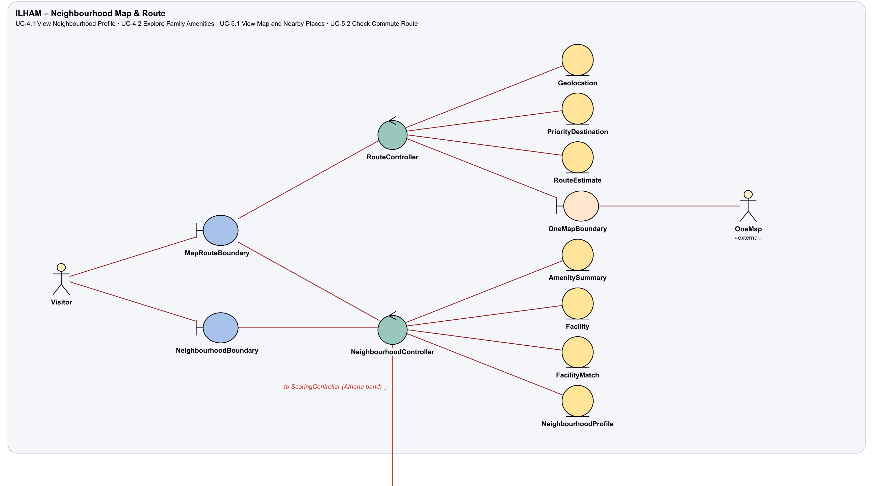
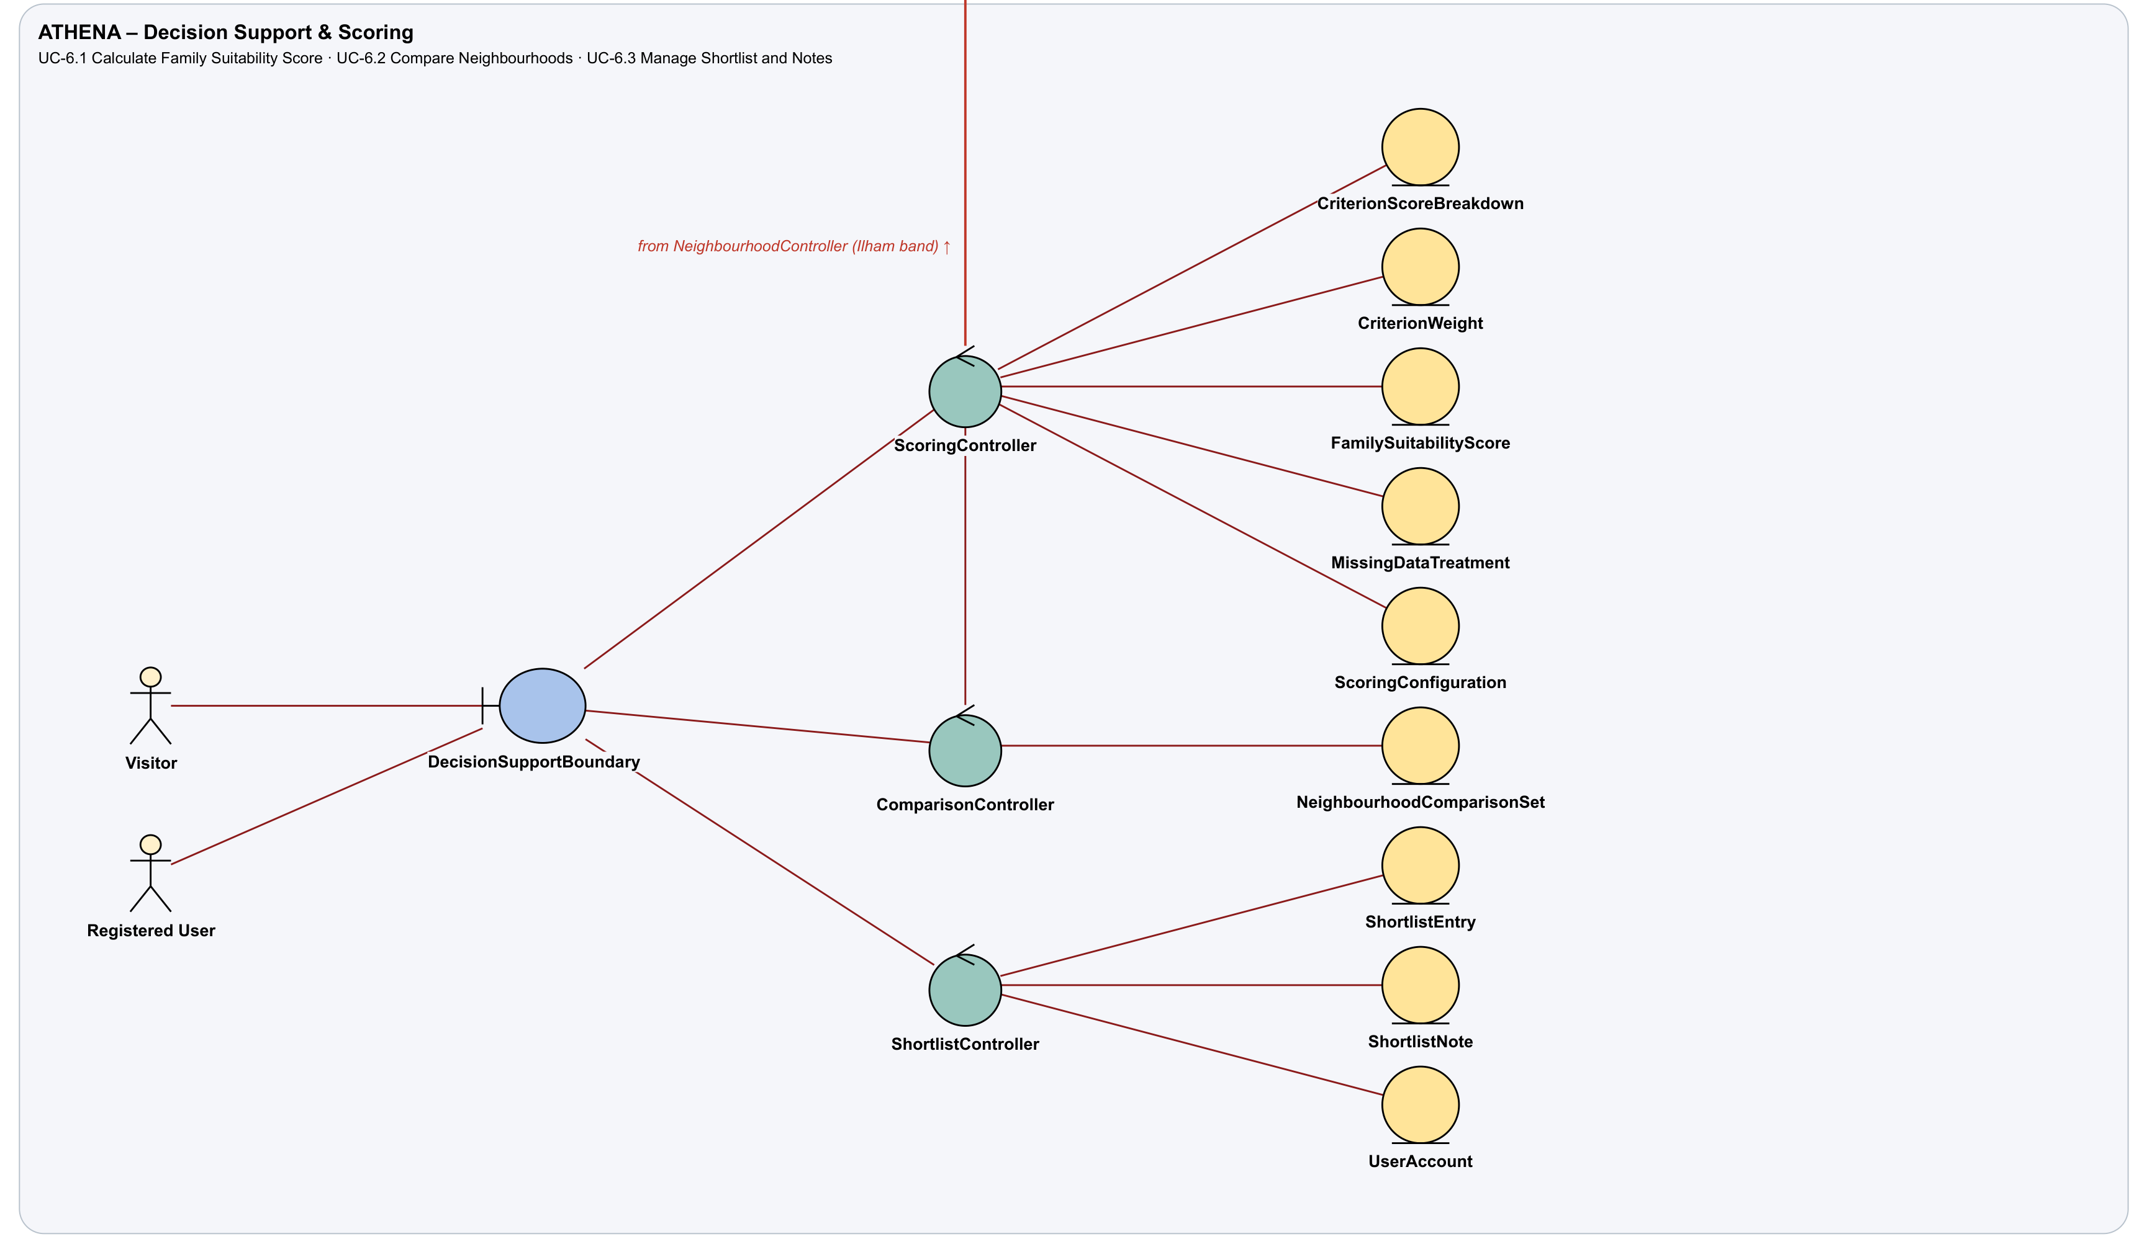
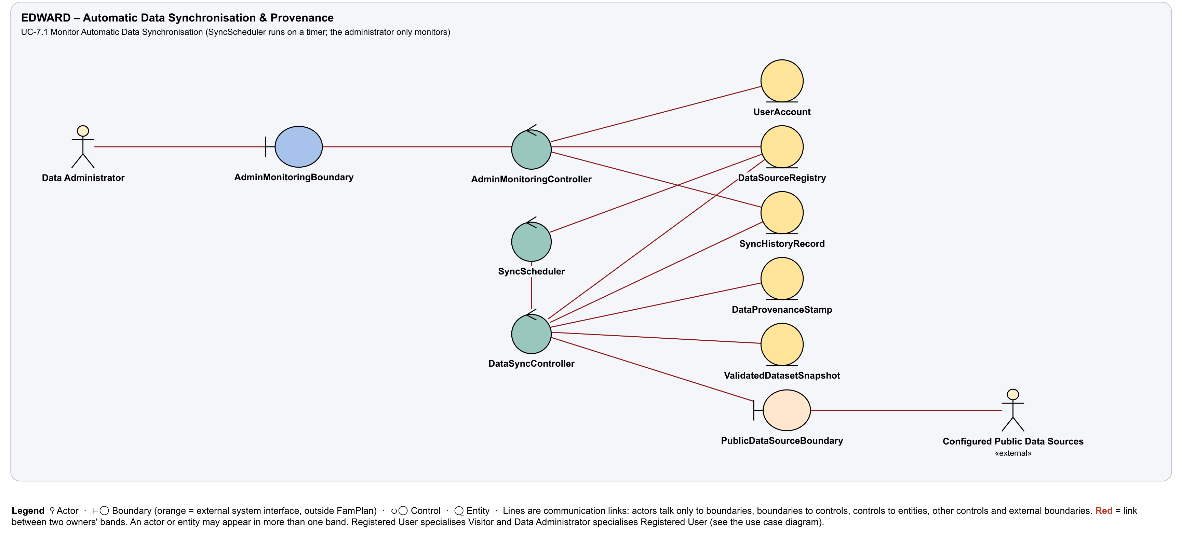

Design Layer
Design-level classes added when refining the analysis model (Lab 3): a start-up class, container classes, persistence, access control and design-pattern roles. Grey dashed boxes are classes drawn in Sections 9.1 and 9.2; file paths are relative to prototype/server/src.
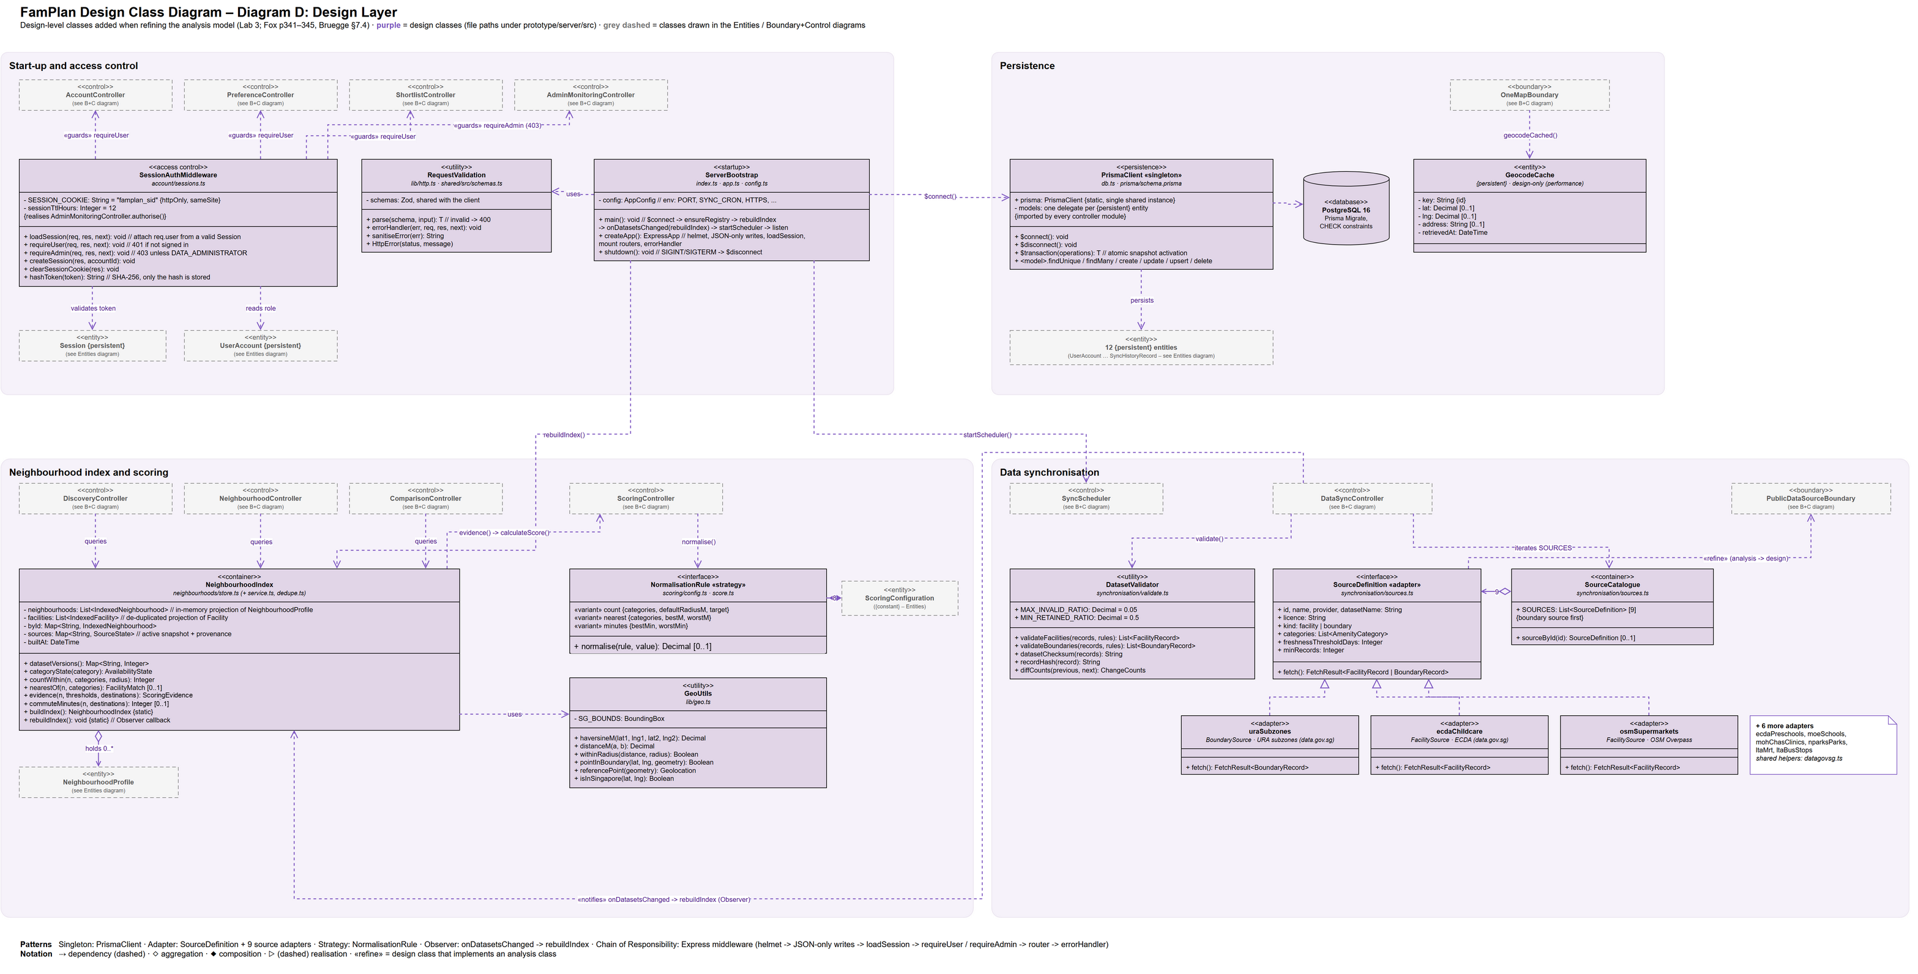
Diagram E below shows the modules added after Lab 3: serverless entry points, cron coordination with a database lease, the Overpass failover adapter and postal code handling. The commercial billing and workspace modules were removed when the project narrowed to personal family planning, so they are not modelled.
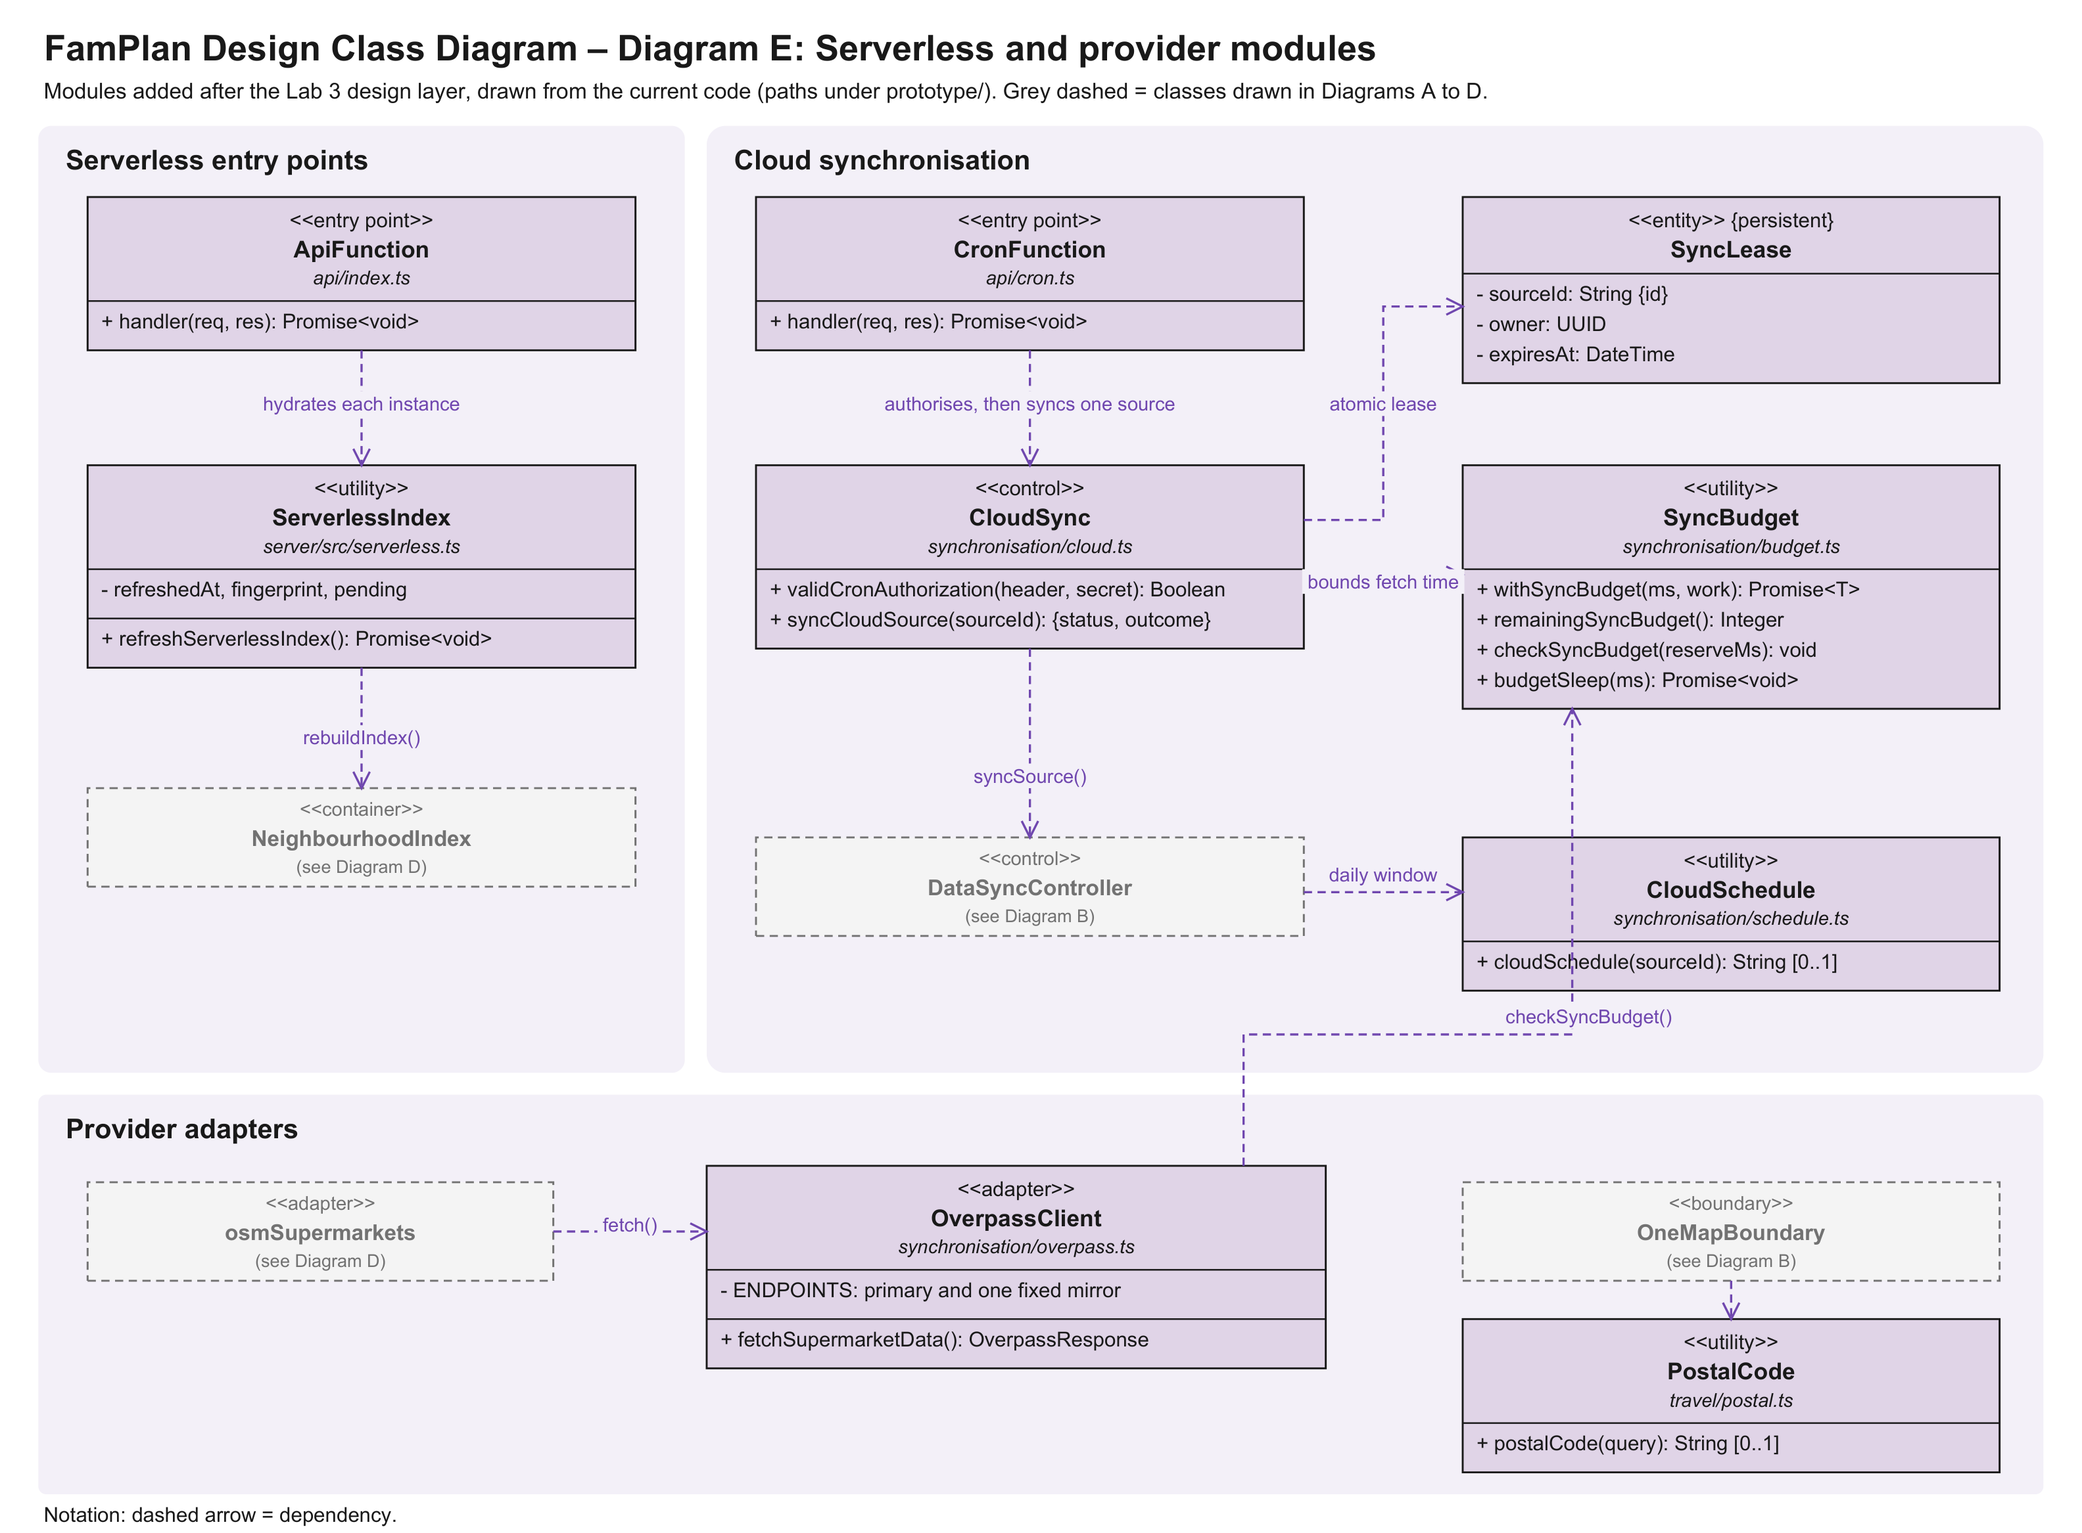

Design-to-Code Traceability
The prototype backend is organised by feature module (prototype/server/src/<feature>/) rather than by layer. Inside each module, routes.ts is the HTTP boundary, the service and logic files hold the control logic, and the Prisma models in prisma/schema.prisma hold the entities. The tables below map each design class in Sections 9.1, 9.2 and 9.4 to the code that implements it; paths are relative to prototype/ unless shown as server/src-relative.
Table 9.5.1 Boundary classes
Design class | Implemented in
AccountBoundary | client/src/pages/SignIn.tsx, PasswordReset.tsx, Account.tsx
PreferenceBoundary | client/src/pages/Preferences.tsx
DiscoveryBoundary | client/src/pages/Explore.tsx
NeighbourhoodBoundary | client/src/pages/Profile.tsx
MapRouteBoundary | client/src/pages/Commute.tsx, components/map.tsx
DecisionSupportBoundary | client/src/pages/Compare.tsx, Shortlist.tsx, components/ ScoreBreakdown.tsx
AdminMonitoringBoundary | client/src/pages/Admin.tsx
EmailDeliveryBoundary | server/src/account/mailer.ts – sendMail()
OneMapBoundary | server/src/travel/onemap.ts – searchAddress(), geocodeCached(), onemapRoute()
PublicDataSourceBoundary | server/src/synchronisation/sources.ts, datagovsg.ts (SourceDefinition adapters)
(all UI boundaries to server) | client/src/lib/api.ts – api<T>(path) over JSON/HTTPS

Table 9.5.2 Control classes
Design class | Module (server/src/) | Key functions / endpoints
AccountController | account/routes.ts, passwords.ts | POST /auth/register, /auth/login, /auth/logout, /auth/forgot-password, /auth/reset-password; PATCH, DELETE / account; Argon2id hashPassword()
PreferenceController | preferences/routes.ts, presets.ts | GET, PUT /preferences; POST /preferences/suggest-weights; suggestWeights()
DiscoveryController | neighbourhoods/ service.ts, routes.ts | GET /neighbourhoods – searchNeighbourhoods(), nameMatches()
NeighbourhoodController | neighbourhoods/ service.ts, routes.ts | GET /neighbourhoods/:id, /:id/facilities – neighbourhoodDetail(), amenitySummaries(), facilitiesNear()
RouteController | travel/route.ts, neighbourhoods/ routes.ts | GET /neighbourhoods/:id/route – routeEstimate(); GET / geocode
ComparisonController | neighbourhoods/ routes.ts | GET /compare (compareQuerySchema: 2–4 ids) – summarise() per item
ScoringController | scoring/score.ts, config.ts | calculateScore(evidence, weights, datasetVersions, config, now), normalise(), roundHalfUp()
ShortlistController | shortlist/routes.ts | GET, POST /shortlist; DELETE /shortlist/:id; PUT / shortlist/:id/note
AdminMonitoringController | synchronisation/ routes.ts | GET /admin/sources, /admin/history, /admin/metrics (behind requireAdmin)
SyncScheduler | synchronisation/ scheduler.ts | startScheduler() (node-cron, SYNC_CRON), nextRunAt(); api/cron.ts (Vercel Cron in production)
DataSyncController | synchronisation/ pipeline.ts, validate.ts | syncAll(), syncSource(), ensureRegistry(), onDatasetsChanged()
CloudSync | synchronisation/  cloud.ts, budget.ts,  schedule.ts | validCronAuthorization(), syncCloudSource(), withSyncBudget(), cloudSchedule()
OverpassClient | synchronisation/  overpass.ts | fetchSupermarketData()
PostalCode | travel/postal.ts | postalCode()
ApiFunction, CronFunction | serverless.ts; prototype/  api/index.ts, api/cron.ts | handler(), refreshServerlessIndex()

Table 9.5.3 Entity classes and persistence decisions
Design class | Decision | Stored as
UserAccount, PasswordCredential, Session, PasswordResetToken | {persistent} | Prisma models of the same name
FamilyPreferenceProfile, PriorityDestination | {persistent} | Prisma models of the same name
CriterionWeight, AmenityPreference | {persistent, embedded} | FamilyPreferenceProfile.w* columns; amenityThresholds (JSON)
NeighbourhoodProfile | {persistent} | Prisma model Neighbourhood
Facility | {persistent} | Prisma model Facility (one set per dataset snapshot)
ShortlistEntry, ShortlistNote | {persistent} / {persistent, embedded} | ShortlistEntry; the note is ShortlistEntry.note (max 500 characters)
DataSourceRegistry, SyncHistoryRecord | {persistent} | Prisma models of the same name
ValidatedDatasetSnapshot | {persistent} | Prisma model DatasetSnapshot
GeocodeCache (design only) | {persistent} | Prisma model GeocodeCache (cached OneMap postal lookups)
DataProvenanceStamp | {derived} | Built in NeighbourhoodIndex from DatasetSnapshot and DataSourceRegistry
ScoringConfiguration | {constant, versioned} | scoring/config.ts SCORING_CONFIG (version string)
SearchQuery, Geolocation, RouteEstimate, FacilityMatch, AmenitySummary | {transient} | Shared DTOs and Zod schemas in shared/src
FamilySuitabilityScore, CriterionScoreBreakdown, MissingDataTreatment, NeighbourhoodComparisonSet | {transient} | Computed per request (calculateScore(), / compare)

Table 9.5.4 Design-layer classes (Section 9.4)
Design class | Role (Lab 3 heuristic) | Implemented in (server/src/)
ServerBootstrap | Start-up class | index.ts, app.ts, config.ts
SessionAuthMiddleware | Access control | account/sessions.ts – loadSession, requireUser, requireAdmin
PrismaClient «singleton» | Persistent data | db.ts, prisma/schema.prisma
NeighbourhoodIndex | Container class | neighbourhoods/store.ts
SourceCatalogue | Container class | synchronisation/sources.ts – SOURCES
SourceDefinition «adapter» + 9 adapters | Adapter pattern | synchronisation/sources.ts, datagovsg.ts
NormalisationRule «strategy» | Strategy pattern | scoring/config.ts, score.ts
DatasetValidator | Utility | synchronisation/validate.ts
RequestValidation | Utility (input validation, errors) | lib/http.ts, shared/src/schemas.ts
GeoUtils | Utility | lib/geo.ts

Dialog Map
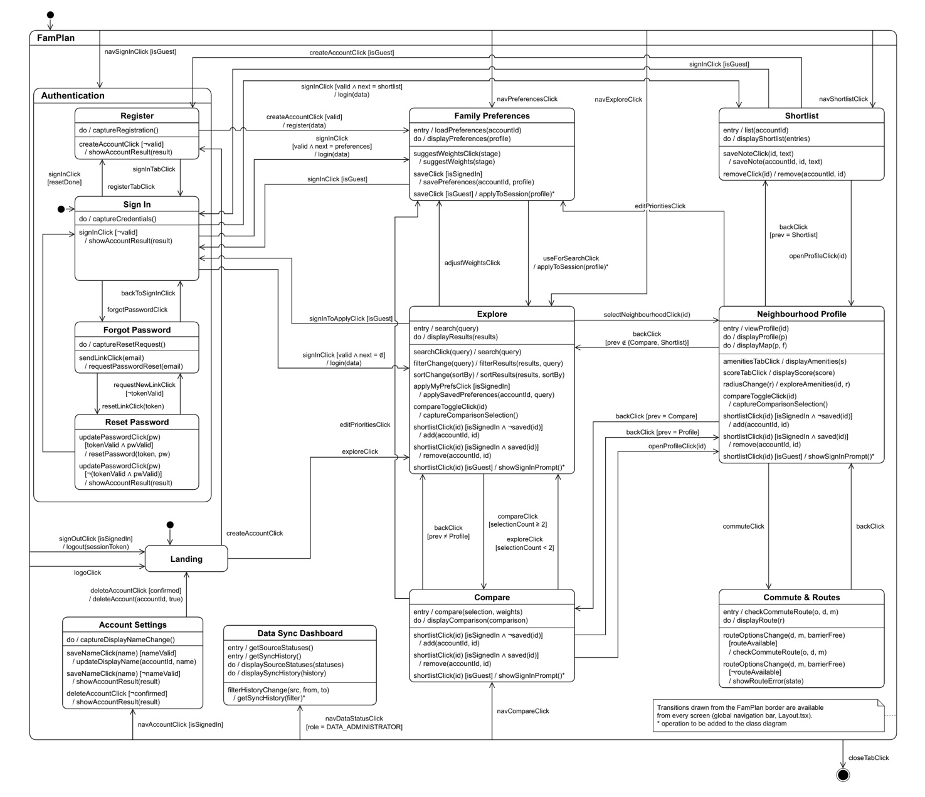
The screens above match the application's routes. The exact-address search flow adds the transitions below, and travel modes are saved through the existing Family Preferences saveClick.
State | Trigger | Result
Any screen | quickSearchClick(query) | Opens Explore and runs search(query).
Explore | searchClick(query) [one place matches] | search(query, place): counts and scores use that exact coordinate.
Explore | searchClick(query) [several places match] | showLocationChoices(places), and no result is chosen automatically.
Explore | chooseLocationClick(place) | search(query, place)
Explore | selectNeighbourhoodClick(id, origin) | Neighbourhood Profile opens using the selected address and radius.
Neighbourhood Profile | commuteClick(origin) | Commute & Routes starts its route from the same address.

