UNIVERSITY INSTITUTE OF COMPUTING

PROJECT REPORT
ON
Hospital Emergency Queue

Program Name: BCA(Hons)(Data Science)
Subject Name/Code: 25CAH-153

Submitted by: Submitted to:
Name: Sumit Chauhan Name: Mr Kaushlendra Tiwari
UID: 25BCD10093 Designation: Assistant Professor
Section: 25BCD-2(B)

Project Report: Hospital Emergency Queue
CHAPTER 1: INTRODUCTION
1.1 Identification of Need / Issue
In hospitals, emergency patients must be treated based on severity, not arrival time. Traditional queue systems fail in critical situations, leading to delays in treatment.
1.2 Identification of Problem
Normal FIFO queues treat patients in order of arrival, which can risk lives when critical patients are delayed.
1.3 Identification of Tasks
- Design a priority-based system
- Implement Min-Heap using C
- Insert and remove patients efficiently
- Display queue status
1.4 Timeline
- Week 1: Problem understanding
- Week 2: Design & algorithm
- Week 3: Coding
- Week 4: Testing & report
1.5 Organization of Report
This report covers problem analysis, design, implementation, and results of the emergency queue system.

CHAPTER 2: LITERATURE REVIEW / BACKGROUND STUDY
2.1 Timeline of Problem
Emergency prioritization has been used in healthcare systems for decades, especially in ICU and trauma care.
2.2 Existing Solutions
- Manual triage system
- Simple queue systems
- Computer-based scheduling
2.3 Bibliometric Analysis
Most research focuses on improving healthcare efficiency using algorithms like priority queues and scheduling.
2.4 Review Summary
Existing systems lack automation or efficiency in dynamic conditions.
2.5 Problem Definition
Design a system that always treats the most critical patient first using data structures.
2.6 Goals/Objectives
- Implement priority queue using heap
- Ensure fast insertion and deletion
- Improve emergency response time

CHAPTER 3: DESIGN FLOW / PROCESS
3.1 Features Selection
- Priority-based treatment
- Fast operations (O(log n))
- Simple user interface
3.2 Design Constraints
- Limited memory
- Fixed maximum patients
- Real-time performance
3.3 Analysis
Min-Heap is chosen because it gives the minimum severity patient quickly.
3.4 Design Flow
- Input patient data
- Insert into heap
- Heapify
- Extract minimum
- Display result
3.5 Design Selection
Min-Heap is selected over other structures due to efficiency.
3.6 Methodology
- Use array-based heap
- Implement heapify operations
- Test with sample data

CHAPTER 4: RESULTS ANALYSIS AND VALIDATION
4.1 Implementation
The system is implemented using C programming language and uses a Min-Heap based Priority Queue to manage emergency patients efficiently.

4.1.1 Program Code:-
#include <stdio.h>
#include <string.h>

#define MAX 100

// Patient structure
struct Patient {
char name[50];
int severity;
int arrivalTime;
};

// Min Heap structure
struct MinHeap {
struct Patient data[MAX];
int size;
};

int timeCounter = 0;

// Swap function
void swap(struct Patient *a, struct Patient *b) {
struct Patient temp = *a;
*a = *b;
*b = temp;
}

// Initialize heap
void initHeap(struct MinHeap *h) {
h->size = 0;
}

// Compare priority
int isHigherPriority(struct Patient a, struct Patient b) {
if (a.severity < b.severity)
return 1;
if (a.severity == b.severity && a.arrivalTime < b.arrivalTime)
return 1;
return 0;
}

// Heapify Up
void heapifyUp(struct MinHeap *h, int index) {
while (index > 0) {
int parent = (index - 1) / 2;

if (isHigherPriority(h->data[index], h->data[parent])) {
swap(&h->data[index], &h->data[parent]);
index = parent;
} else {
break;
}
}
}

// Heapify Down
void heapifyDown(struct MinHeap *h, int index) {
int left, right, smallest;

while (1) {
left = 2 * index + 1;
right = 2 * index + 2;
smallest = index;

if (left < h->size &&
isHigherPriority(h->data[left], h->data[smallest])) {
smallest = left;
}

if (right < h->size &&
isHigherPriority(h->data[right], h->data[smallest])) {
smallest = right;
}

if (smallest != index) {
swap(&h->data[index], &h->data[smallest]);
index = smallest;
} else {
break;
}
}
}

// Add patient
void enqueue(struct MinHeap *h) {
if (h->size == MAX) {
printf("Queue is full!\n");
return;
}

struct Patient p;

printf("Enter Patient Name: ");
scanf("%s", p.name);

printf("Enter Severity (1 = Critical, 10 = Normal): ");
scanf("%d", &p.severity);

p.arrivalTime = timeCounter++;

h->data[h->size] = p;
heapifyUp(h, h->size);
h->size++;

printf("Patient added successfully!\n");
}

// Treat patient
void dequeue(struct MinHeap *h) {
if (h->size == 0) {
printf("No patients in queue!\n");
return;
}

struct Patient root = h->data[0];
h->data[0] = h->data[h->size - 1];
h->size--;

heapifyDown(h, 0);

printf("\nTreating Patient:\n");
printf("Name: %s | Severity: %d\n", root.name, root.severity);
}

// View next patient
void peek(struct MinHeap *h) {
if (h->size == 0) {
printf("Queue is empty!\n");
return;
}

printf("\nNext Patient:\n");
printf("Name: %s | Severity: %d\n",
h->data[0].name, h->data[0].severity);
}

// Display queue
void display(struct MinHeap *h) {
if (h->size == 0) {
printf("Queue is empty!\n");
return;
}

printf("\nCurrent Queue:\n");
for (int i = 0; i < h->size; i++) {
printf("%s (Severity: %d)\n",
h->data[i].name,
h->data[i].severity);
}
}

// Main function
int main() {
struct MinHeap heap;
initHeap(&heap);

int choice;

while (1) {
printf("\n--- Hospital Emergency System ---\n");
printf("1. Add Patient\n");
printf("2. Treat Patient\n");
printf("3. View Next Patient\n");
printf("4. Display All Patients\n");
printf("5. Exit\n");
printf("Enter choice: ");
scanf("%d", &choice);

switch (choice) {
case 1:
enqueue(&heap);
break;
case 2:
dequeue(&heap);
break;
case 3:
peek(&heap);
break;
case 4:
display(&heap);
break;
case 5:
printf("Exiting...\n");
return 0;
default:
printf("Invalid choice!\n");
}
}
}
4.1.2 Screenshot:
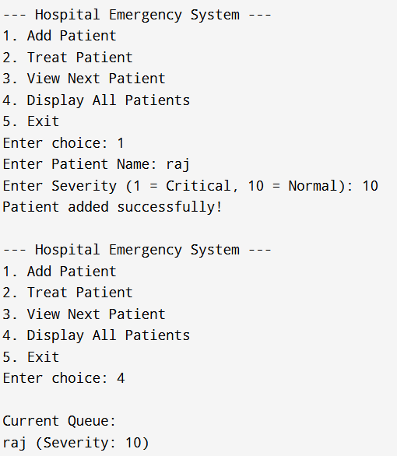-

CHAPTER 5: CONCLUSION AND FUTURE WORK
5.1 Conclusion
The system successfully prioritizes patients using a Min-Heap, ensuring efficient and correct emergency handling.
5.2 Future Work
- Add GUI interface
- Integrate with hospital database
- Add real-time monitoring
- Include multiple priority factors (age, condition, etc.)

REFERENCES
Github:-

2. Design Checklist
✔ Problem defined
✔ Algorithm implemented
✔ Tested successfully

USER MANUAL
- Run the program
- Enter patient details
- View queue
- Treat patients in order

