Samuel Brownley – 31691379

ICT373 – Software Architectures

Assignment 2

Contents

Title 2

Requirements/Specification 2

User Guide 3

Sructure/Design 6

UML 6

Class Description 7

Limitations 7

Testing 8

# Title

Title: Family Tree Fun

Author: Samuel Brownley – 31691379

Date: 22/05/2017

Files:

* Address.java
* Assignment2.java
* FMember.java
* Ftree.java
* GUI.java

Purpose: Allows users to create a family tree and view the direct family member of those people.

# Requirements/Specification

This program is to allow users to record information about a family tree. Users are able to add and edit family members, create member with specific relationships and save and load the family trees.

Assumptions:

* The family will only save when the “Save Family” button is clicked. Any changes made since the last save will not be available if the program is closed or another family is created/loaded

# User Guide

The current families are located in the following location:

* Assignment2/family

There are currently 3 families in this folder for testing.

**How to use:**

At start up, users will be presented with the following window.

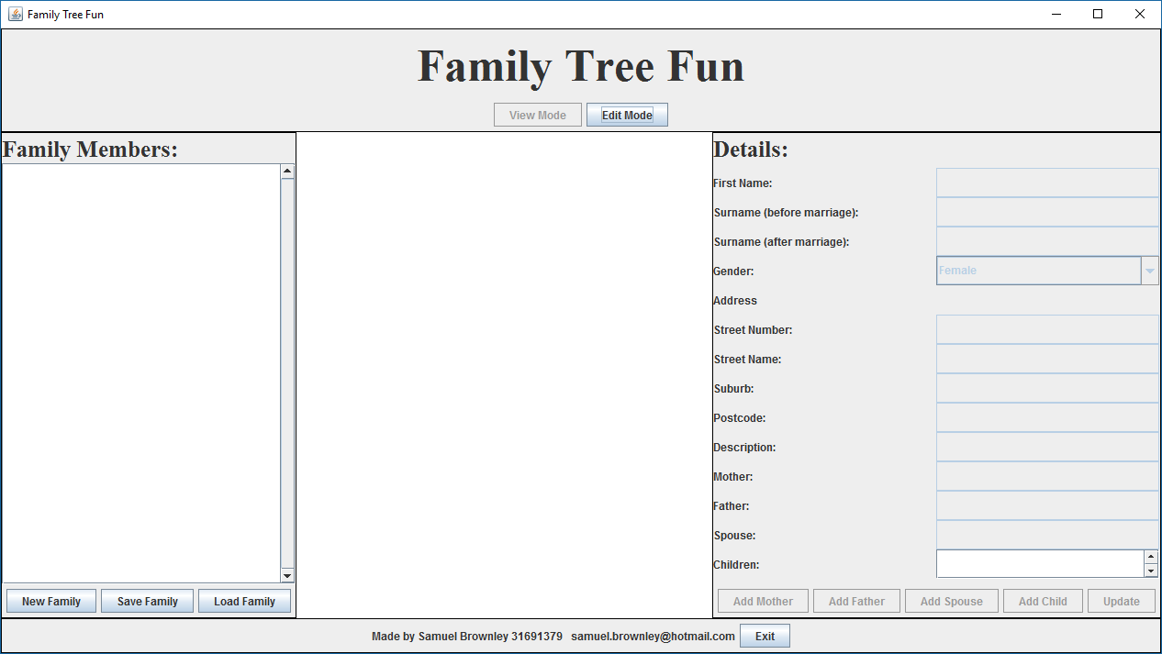

The window users are presented upon start up.

At the top, the user is able to switch between “View Mode” and “Edit Mode”. In “View Mode”, the user is only able to view the details of the family and also save, load and create families. In “Edit Mode”, The user will be able to alter the details of the selected family member but changing their details and also adding family members.

To the left is the area that will list all the members of the active family. Each member can be selected to display their direct relatives and their details.

The center will contain the list of direct family members when one has been selected from the “Family Members” list.

The right has all the details of the selected family member. These details can be altered in “Edit Mode” and in addition, family members can be added as direct relatives to the selected family member.

The bottom of the window contains the author details and the button used to exit the application.

From this window, users are able to either create a new family by clicking “New Family” or load an already existing family by clicking “Load Family”.

When creating a new family, a window will appear to enter the details of the first person of the family.

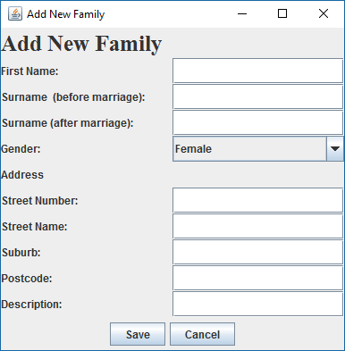

The window used to create family member of both new and previous created families.

All the fields must be completed except for “Surname (after marriage)” and once these have been entered, click “Save”. The family tree will now be populated with this person. Their details will be displayed in the Details area and they will be the only member in the center area.

When loading a family, a file selector will appear. Simply choose a file with the extension “.ftree” and the tree will be populated with the data for the family.

Once a family has been created/loaded, the user is able to edit the family by changing to edit mode. This will enable to the Details section and allow alterations to be made. To alter the current family member, simply edit the text fields available and click “Update”.

To add a new family member, click one of the other buttons in the Details section. The buttons will create a new family as either a mother, father, spouse or child in that order from left to right. When one of these buttons is clicked a pop-up similar to that of creating a new family will appear. Simply enter the details of the new family member and click “Save”. That family member will now be added to the list of the family members and also to the family tree of the selected member.

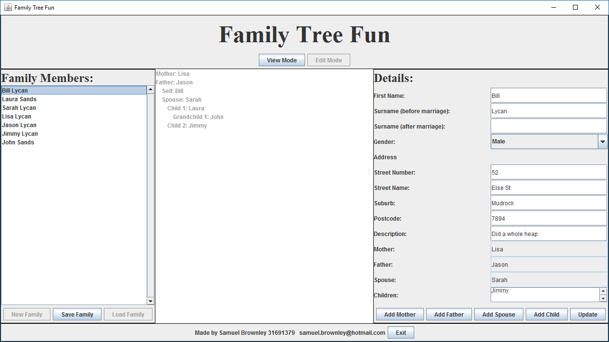

An example family.

To save the family, simply click “Save” in the left of the window. A pop-up will appear, allowing the user to enter a new family name or keep the current name. Once saved, the user will be able to load that family at another time.

When all is done, simply click the “Exit” button at the bottom or the red cross at the top right to exit the application.

# Sructure/Design

## UML



## Class Description

**Address.java**

Defines the Address class. Contains the details to be stored about the address of each family member. These details are street number, street name, suburb and postcode.

**Assignment2.java**

Creates a GUI object

**FMember.java**

Defines the Fmember class. This contains the details of the family member and each of the direct family members of the person. These are the main objects that are users will be creating and manipulating.

**Ftree.java**

Defines the Ftree class. Contains a list a of FMembers and allows the user to add different tyes of family members to the family tree.

**GUI.java**

Defines the GUI class for the project. The GUI in the interface users will be interacting with.

# Limitations

Relationships when adding family members: though not required by the assignment, when a user adds a family member it not reflected anywhere else except for the member it was added to. An example of this: when a user adds a mother to an already existing member, the mother shows up in the mother section of that already existing member. The already existing member does not show up as a child of the mother. I feel this would be simple enough to implement and it would reduce the need to enter in a persons details more than once.

Relationships after adding: once a family member has been added, there is no way to change the relationship between the people.

Issues when loading families: if I load a family that has less members than the currently loaded family, an errors sometimes occurs where the list is still populated but the previous family’s members.

# Testing

|  |  |  |  |
| --- | --- | --- | --- |
| **Case** | **Expected Outcome** | **Actual Outcome** | **Proof** |
| Click “Exit” | Closes application | Closes application |  |
| **Adding a new family** |  |  |  |
| Click “New Family” | Add New Family window appears | Add New Family window appears |  |
| Click “Save” without input.  This message will occur unless all data except for Surname (after marriage).  The same error will occur for each of the following:   * Add New Mother * Add New Father * Add New Spouse * Add New Child | Error message to input all data | Error message to input all data |  |
| Click “Save” with correct input   |  |  | | --- | --- | | **Input** | **Value** | | First Name | Bill | | Surname (before marriage) | Harpy | | Surname (after marriage) |  | | Gender | M | | Street Number | 12 | | Street Name | Hope St | | Suburb | Murdoch | | Postcode | 6554 | | Description | Has done some things | | Family member added to new family and displays family | Family member added to new family and displays family |  |
| **Saving a family** |  |  |  |
| Click “Save Family” with family to save | Open svae dialog | Open svae dialog |  |
| Click “OK” in save dialog – no input | Error message validating name | Error message validating name |  |
| Click “OK” in save dialog   |  |  | | --- | --- | | **Input** | **Value** | | Family name | Harpy | | Family is saved to familes folder is project | Family is saved to familes folder is project |  |
| **Load family** |  |  |  |
| Click “Load Family” | File Chooser window pops up to select family | File Chooser window pops up to select family |  |
| Open .ftree file – Lycan.ftree | File is loaded, populating appropriate fields in the tree | File is loaded, populating appropriate fields in the tree |  |
| Open non .ftree file – manifest.mf | Error message saying a problem occurred when loading the file | Error message saying a problem occurred when loading the file |  |
| **Change Modes** |  |  |  |
| Click “Edit Mode” | The details panel becomes editable. New Family and Load Family are disabled | The details panel becomes editable. New Family and Load Family are disabled |  |
| Click “View Mode” | Details panel is no longer editable. New Family and Load Family are enabled |  |  |
| Click “Update”   |  |  | | --- | --- | | **Input** | **Value** | | First Name | Harry | | Description | Has done some things. Even more things have been done | | Fields are updated | Fields are updated. As Description is a text field and not text area, the details panel is extended to fit the text |  |

|  |  |  |  |
| --- | --- | --- | --- |
| **Add Family Member** |  |  |  |
| Click “Add Mother” | Open Add New Mother Window | Open Add New Mother Window |  |
| Click “Save” in Add New Mother window   |  |  | | --- | --- | | **Input** | **Value** | | First Name | Sarah | | Surname (before marriage) | Halls | | Surname (after marriage) | Harpy | | Gender | F | | Street Number | 12 | | Street Name | Some Place | | Suburb | Mudrock | | Postcode | 1345 | | Description | Some things have been done | | Adds new mother to family tree and updates Mother field in details panel | Adds new mother to family tree and updates Mother field in details panel |  |
| Click “Add Father” | Open Add New Father Window | Open Add New Father Window |  |
| Click “Save” in Add New Father window   |  |  | | --- | --- | | **Input** | **Value** | | First Name | Bill | | Surname (before marriage) | Harpy | | Surname (after marriage) |  | | Gender | M | | Street Number | 12 | | Street Name | Some Place | | Suburb | Mudrock | | Postcode | 1345 | | Description | Has also done some things | | Adds new father to family tree and updates Father field in details panel | Adds new father to family tree and updates Father field in details panel |  |
| Click “Add Spouse” | Open Add New Spouse Window | Open Add New Spouse Window |  |
| Click “Save” in Add New Spouse window   |  |  | | --- | --- | | **Input** | **Value** | | First Name | Linda | | Surname (before marriage) | Carpet | | Surname (after marriage) | Harpy | | Gender | F | | Street Number | 12 | | Street Name | Hope St | | Suburb | Murdoch | | Postcode | 6554 | | Description | Many more things than any other have been done | | Adds new spouse to family tree and updates Spouse field in details panel | Adds new spouse to family tree and updates Spouse field in details panel |  |
| Click “Add Child” | Open Add New Child Window | Open Add New Child Window |  |
| Click “Save” in Add New Child window   |  |  | | --- | --- | | **Input** | **Value** | | First Name | Jill | | Surname (before marriage) | Harpy | | Surname (after marriage) | Kendell | | Gender | F | | Street Number | 45 | | Street Name | Elsewhere Rd | | Suburb | Mandurah | | Postcode | 6123 | | Description | Did some things when she was young but not so much anymore | | Adds new child to family tree and updates Children field in details panel | Adds new child to family tree and updates Children field in details panel |  |
| Select diffent name in the Family Members list – Bill Harpy | Details panel updates to show Bills details, center panels updates to show direct relationships | Details panel updates to show Bills details, center panels updates to show direct relationships. As relationships are not 2 directional, tree only shows self. See limitations. |  |