Appendix

Broadband "Travelling Wave" Dipole

Based on a design by Dr. R.J.F. Guertier and G.E. Collyer, (1974 address) Antenna Engineering Australia (Pty) Ltd., Melbourne

Quote from "Amateur Radio" - journal of the Wireless Institute of Australia - April 1974 edition:
"The authors presented a paper on this antenna at the recent IREE convention held in August 1973, in Melbourne. Further details are given in the Convention Digest which contains a two-page synopsis of all the papers presented. This digest is available from the offices of the IREE . . . Enquiries may be made by . . . writing to the IREE Melbourne Branch at 191 Royal Parade, Parkville, 3052."

Original Design:
"A dipole can be modified by inserting resistive loading networks so as to produce standing waves between the feedpoint and the networks. The authors have, by adjustment of the networks and the dipole sections, developed a travelling wave dipole whose VSWR is less than 2:1 from 3 to 15 MHz and does not exceed 2.6 to 1 from 2.3 to at least 30 MHz."
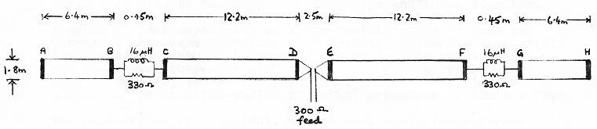
(A, B, C, D, E, F, G, H are 25mm dia. aluminium tubes.)
". . . neither the value of the 330 ohm resistors nor that of the shunt inductors was very critical. The shunt inductor has a small effect on SWR at the lower frequency end. However, reduction of the resistance to 150 ohms caused the SWR to fluctuate considerably with frequency. The taper sections were required to reduce shunt capacity between the spreaders D and E. reducing the length of this section produced an increase in SWR."
Elsewhere, (the ARRL Antenna Handbook), the resistors are specified as 2-5 watts rating for up to 500 watts pep. It is also recommended that the aerial should be at a height of at least 40ft (13m).
Several versions of this aerial were constructed, with varying degrees of success. The principal problem was high VSWR in the 5 to 8 MHz region. In an attempt to experiment with the shunt inductance, ferrite rod was inserted into the conduit upon which the coil was wound. It was found to be possible to adjust for low SWR at various places between 3 and 9 MHz, but clearly this would be a critical procedure in the field, and in any case, the problem was solved in a different way.

Modified Design:
An additional wire was run down the centre of the "tramlines". This dramatically reduced the fluctuations in SWR and virtually eliminated any critical adjustments. The height of the aerial seemed to have no effect upon its matching, although of course performance was changed slightly.
Details of the construction of the aerial are given in the diagram. A 5:2 matching transformer was wound on a standard 50mm toroid as shown.

Low-Cost Broadband Travelling Wave Dipole - constructional details
(Please note that this diagram has been redrawn at 90 degrees from original for easier viewing in a web browser)
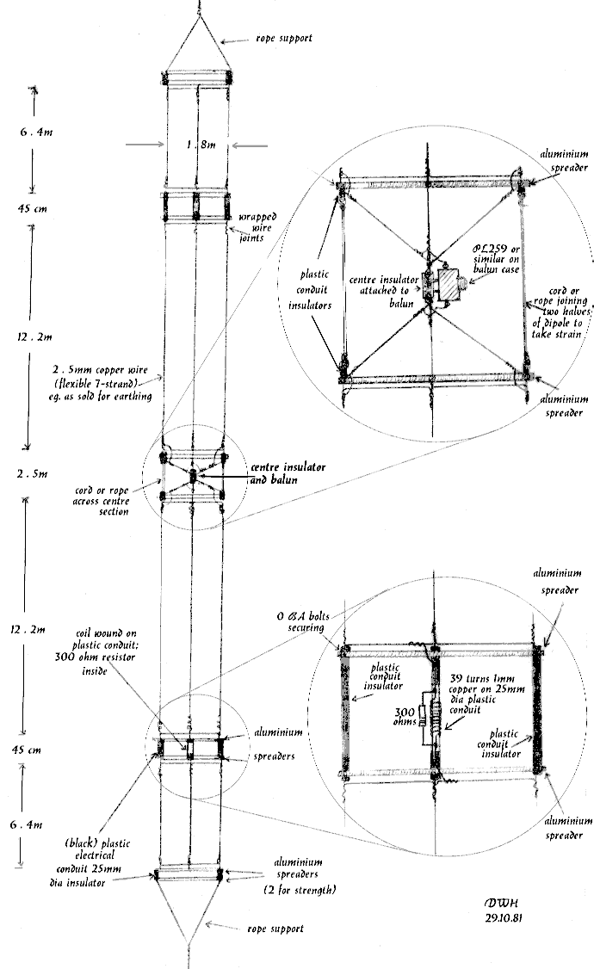
Broadband dipole - constructional details
With the exception of the toroid, all materials were obtained locally. Approximately 100m of 7-strand, 2.5mm overall dia. copper wire was used, as sold for earthing in domestic installations. It was found convenient not to use the PVC insulated type, which simplified the wire-wrapping. Cheap, black plastic 25mm electrical conduit was used as a coil former and to make the insulators. The aluminium spreaders were very simply made, using decorative aluminium strip approximately 25mm wide and about 10mm thick, formed as a half-"U" and sold for fronting formica table-tops and the like. Ordinary 0-BA bolts were used to hold the various strips and tubes together.
Because of past experience of ultra-violet damage to rope and plastics, some care was taken to select the appropriate materials. Black conduit was used because of its resistance to UV, and the aerial was suspended with ordinatry fibre rope rather than nylon. However, it appears that fishing stores may be also be a good source of ultra-violet resistant polyester or similar rope.
The performance of a typical, unadjusted, aerial/transformer combination, with approximately 25m of 50 ohm coaxial feeder, is shown in the diagram. The aerial was suspended at about 40 feet.

Measured Performance
Wideband Dipole, VSWR against frequency
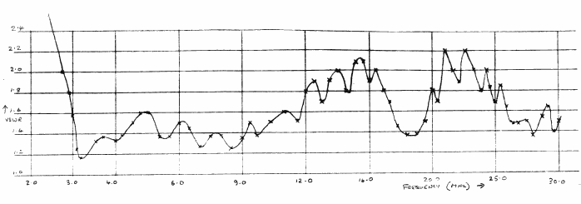

Constructional Details
5:2 Broadband transformer
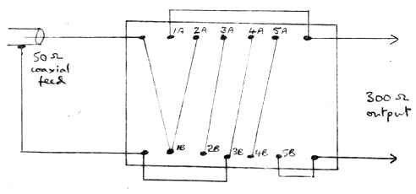
5:2 wideband transformer wiring diagram
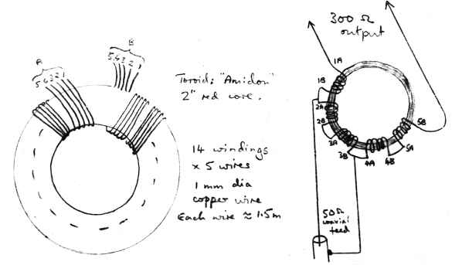
Toroid connections

