**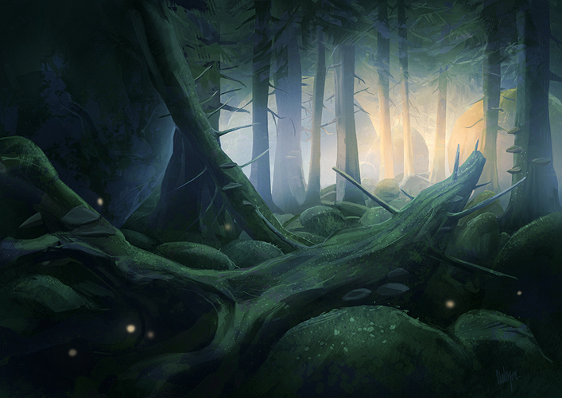**

**GENERATIONS**

Game Design Document

January 28th 2012

**Revision History**

|  |  |  |
| --- | --- | --- |
| **Version** | **Date** | **Comments** |
| V1.0 | January 28th 2012 | Created file and main template |
|  |  |  |

Table of contents

Introduction 1

Story 1

Synopsis 1

Narrative Tools 2

Setting 2

Unity (City) 2

The Spiral Bridge 3

The Interplanetary Trades and Commerce Tower 3

The Milky Way 3

Eruption (Planet) 3

Game structure 3

Gameplay loop 5

Primary gameplay 6

Combat 6

Melee 6

Wrist Implant 6

Stun 6

Shooting 6

Pistol (Shock Pistol) 6

Assault Rifle (Red Shark) 7

Shotgun (Neutralizer) 7

Crossbow (Wirebow) 7

Puzzle 8

Wrist Implant 8

Hacking Ray 8

Mind Hacking 8

Shock Pistol 8

Red Shark 8

Neutralizer 9

Wirebow 9

Traversal 9

Walk 9

Run 9

Crouch 9

Jump 9

Skywalking 9

Secondary gameplay 10

Terminal Hacking 10

Exotic gameplay 10

Hover-car 10

The basic controls 10

Control philosophy 11

Control layout 11

Left stick 12

Right Stick 12

Directional pad 13

Up 13

Down 13

Left and Right 13

A button 13

B button 14

X button 14

Y button 14

Left trigger 15

Left bumper 15

Right trigger 15

Right bumper 16

Start button 16

Back button 16

NPCs 16

Philosophy 16

Enemies 17

Red Cobra 17

Agent 17

Special Agent 18

Brute 18

Operative 18

General 18

Mech 18

Security Mech 19

Armored Security Mech 19

Security Turret 19

Assassin 20

Behemoth 20

Ghosts 20

Slashers 20

Binders 21

Screamers 21

Bosses 21

Super Brute 21

White Cloak 21

Security AI 21

Red Cobra 21

Citizen 22

Ingredients 22

Philosophy 22

Interactive objects 22

Shock lamp 22

Magnetic gear 23

Magnetic Switch 23

Water leak 23

Gas leak 23

Gas container 24

Water tank 24

Energy source 24

Terminals 24

Skywalk path 24

Obstacles 25

Electrical currents 25

Hot steam 25

Strong steam 25

Fire 26

Blizzard 26

Absolute Zero 26

Character progression 27

Health system 27

Medi-packs 27

Health Needles 27

Intelligence pick-ups 28

Weapon intel 28

Background intel 28

Story intel 28

Weapons 28

Wrist Implant 28

Shock Pistol 29

Red Shark 29

Neutralizer 30

Wirebow 30

Save system 30

Autosave 31

Difficulty 31

Easy 31

Normal 31

Hard 31

User interface 32

HUD 32

Menus 32

Title Screen 32

Main Menu 32

New Game / Continue 32

Mission Select 32

Leaderboards 33

Achievements 33

Help & Options 33

Exit Game 33

Missions outline 33

# Introduction

Generations is a title intended for the PC and Mac platform. The game is a third person puzzle platformer, where the player must combine the skills and powers of three characters acting on their own timeline, each influencing the environment of the next. The game observes the changing setting of three generations, as a preceding generation’s changes impacts the world of As the player advances through the game, he or she will be rewarded skill points to spend on special abilities, and will be encouraged to select a character class in order to become more efficient in a field of their liking. The game follows the story of a commercial spy, answering the multiple requests of his employer, hoping in the end to gain access to his former home and the family he or she left behind.

The game is a single player experience featuring a vast open galaxy for the player to explore. The main story advances through the completion of various missions. The game aspires to offer the player an experience nearing or surpassing that of a game like *Mass Effect*

# Story

## Synopsis

## Narrative Tools

# Setting

## Unity (City)

### The Spiral Bridge

### The Interplanetary Trades and Commerce Tower

## The Milky Way

## Eruption (Planet)

# Game structure

# Gameplay loop

# Primary gameplay

## Combat

### Melee

### Shooting

### Cleric

### Engineer

## Traversal

### Walk

By pressing the left stick forward, the player can move forward at a normal pace. The spy never gets tired when using this type of navigation.

### Run

Running is evidently faster than walking, but it also drains on the spy’s energy. After a short time, the stamina is back to normal, and he or she can run again.

### Cover

# Secondary gameplay

## Terminal Hacking

A contextual action when Howard approaches an important terminal that can be interacted with. Terminals advance the story because Howard has to extract information from them, but they also let him advance in the level by opening doors. A simple push of a button is needed to interact with a terminal.

# Exotic gameplay

## Shuttle

# The basic controls

## Control philosophy

Intended to remind the familiar control layout of other popular shooters. The learning curve for the layout is meant to be quick and easy. Triggers and bumpers are separated as follows: investigation and analysis on the *left*, and shooting and action on the *right*. This is meant to ensure that players are not confused and press the wrong button expecting their desired action.

## Control layout

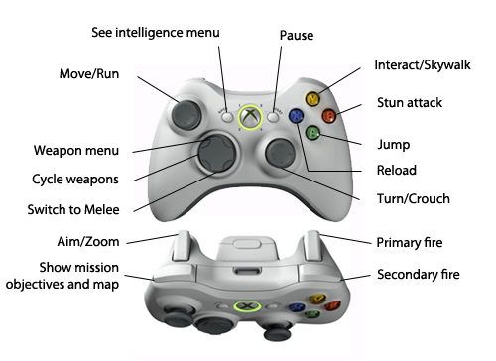

## Left stick

|  |  |  |  |
| --- | --- | --- | --- |
|  | Up | Left/Right | Down |
| Xbox360_Stick_Left.png | Walk forward | Side walks to the left or right. | Walks backwards |
| Press |
| Xbox360_Stick_Leftclick.png | Click once to run, while holding up/walking forward. The character will stop running if the player releases the left stick. |  |  |
| Click |

## Right Stick

|  |  |
| --- | --- |
|  | In any direction |
| Xbox360_Stick_Right.png | Turns the camera/character in the desired direction  Select a weapon in the weapon selection menu |
| Press |
| Xbox360_Stick_Rightclick.png | Toggle Crouch |
| Click |

## Directional pad

### Up

|  |  |
| --- | --- |
| dpad_up.png | Shows the weapon selection menu |
| Hold |

### Down

|  |  |
| --- | --- |
| dpad_up.png | Switches to Melee mode |
| Press |

### Left and Right

|  |  |
| --- | --- |
| dpad_up.pngdpad_right.png | Cycle between the four weapons (pistol, assault rifle, shotgun, crossbow)  From Melee mode, switches to the pistol, then resumes cycling between the four weapons. |
| Press |

## A button

|  |  |
| --- | --- |
| Xbox360_Button_A.png | Jump  *Not while skywalking* |
| Press |

## B button

|  |  |
| --- | --- |
| Xbox360_Button_A.png | Stun attack |
| Press |

## X button

|  |  |
| --- | --- |
| Xbox360_Button_A.png | Reload weapon |
| Press |

## Y button

|  |  |
| --- | --- |
| Xbox360_Button_A.png | Interact with objects  *Open doors, skywalk etc.* |
| Press |

## Left trigger

|  |  |
| --- | --- |
| Xbox360_Button_A.png | Aim/Zoom |
| Hold |

## Left bumper

|  |  |
| --- | --- |
| Xbox360_Button_A.png | Shows mission objectives and mini-map for 5 seconds |
| Press |
| Xbox360_Button_A.png | Shows mission objectives and mini-map for as long as it is held |
| Hold |

## Right trigger

|  |  |
| --- | --- |
| Xbox360_Button_A.png | Primary fire |
| Press/Hold |

## Right bumper

|  |  |
| --- | --- |
| Xbox360_Button_A.png | Secondary fire |
| Press/Hold |

## Start button

|  |  |
| --- | --- |
| Xbox360_Button_A.png | Pauses the game |
| Press |

## Back button

|  |  |
| --- | --- |
| Xbox360_Button_A.png | Opens the Intel menu |
| Press |

# NPCs

## Philosophy

None of the NPCs found in the game can ever be trusted. Whenever the player meets a Mech or a humanoid, it’s always highly likely that this is a future enemy or one that will become an enemy once approached. Because Red Cobra can syndicate just about any civilian on the spot, the player never knows if an encountered civilian will stay friendly.

## Enemies

### Red Cobra

Red Cobra agents are proficient with all sorts of weapons, and can been seen all around the city, from the lower to the high sections. They are found in high numbers in Red Cobra headquarters. They represent the basic enemy, with balanced health and damage resistance, but they get smarter the more important their title is.

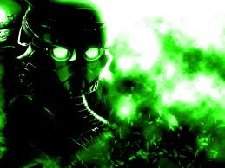

#### Agent

The first encountered agent. Has basic resistance and can use the pistol or the assault rifle. These enemies cannot wear any special armor and will never come to attack Howard while using shields or any other special tool. They are easily killed and pose no threat to the experienced player. Citizens who are syndicated on the spot become agents.

|  |  |  |  |
| --- | --- | --- | --- |
| **Agent** | **HP** | **Weapon** | **Behavior** |
|  | 60 | Pistol,  Assault Rifle | Stays in plain view and attacks the player. Mostly stationary. |

#### Special Agent

Special agents are upgraded and much smarter agents. They always use weapons that will force them to go up and personal with the player, like the assault rifle and the shotgun. They also usually wear magnetized armor and use their protection to slowly pressure the player. They are the main general threat when the player fights Red Cobra.

|  |  |  |  |
| --- | --- | --- | --- |
| **Special Agent** | **HP** | **Weapon** | **Behavior** |
|  | 100 | Assault Rifle, Shotgun | Finds cover when under attack, slowly advances towards the player. |
| **Protection** |
| Magnetic Armor |

#### Brute

Heavy, bulky agents with low intelligence. They always fight with their bare fists and quickly advance on the player to force them out of cover. They are strong and tough, and at all times, the player will want to stay away and fight them from a distance. They represent a huge menace, but they can be dealt with by using ruse and the environment. Being the big idiots that they are, the Brutes can be easily flanked. They speed up when they see the player, but when the player is out of sight, they slow down and clumsily look around. One can therefore attack them from the back and use environmental hazards to dispatch them.

#### Operative

Operatives are a great hindrance. They typically use crossbows to snipe the player from a distance. But they can also wield the upgraded shotgun: the Neutralizer. When using the Neutralizer, they shut down the building lights and go in hiding to use their crossbow again. They can also install traps when using the upgraded crossbow: the Wirebow.

#### General

The general is the ultimate Red Cobra fighter. He can use the Shock Pistol’s discharge function, the Red Shark’s explosive bullets and the shotgun, without its upgrade. They wield all three weapons, and so they can switch from one to the other during combat.

### Mech

Mechs are the default tools used to enforce security. While they are still used by Red Cobra and Coldfly as protection measures, there are still very few of their kind in the city. They can be found in abandoned buildings, and especially in the countryside, where they wander aimlessly. They represent the toughest enemy type, and contrary to Red Cobra agents, different Mechs also feature different key abilities. They can be sta tionary or straightforward in their attacks, but regardless, they show less intelligence than the Red Cobra agents.

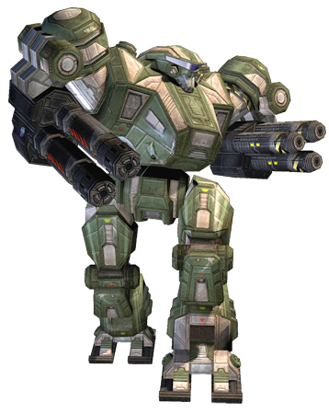

#### Security Mech

The Security Mech is the default Mech enemy. It’s a humanoid-looking robot, but unlike the Red Cobra agents, it’s not smart and does not use strategy. The Security Mechs will advance towards the player at a faster pace than the Special Agents. They only use pistols.

#### Armored Security Mech

The Armored Security Mech is a slow, bulky version of the Security Mech. It uses miniguns and imposes a lot of pressure on the player, but its heavy weapons also waste a lot of its energy. It will typically take a couple of seconds to recover before starting to fire again. Some Armored Security Mechs are protected by body shields that need to be taken down using the Wrist Implant before actually dealing damage to them.

|  |  |  |  |
| --- | --- | --- | --- |
| **Special Agent** | **HP** | **Weapon** | **Behavior** |
|  | 400 | Minigun | Slowly advances towards player and shoots down cover. |
| **Protection** |
| Magnetic Shield |

#### Security Turret

Security Turrets are stationary and unintelligent. They however use an implanted minigun, and will attack the player on sight with excellent precision. If the player somehow disappears, they will retract in idle position and wait until the player is visible again. They are deadly and powerful, but suffer from their lack of movement.

#### Assassin

Assassins are fast Mechs that like to attack the player in close range. They are jumpy enemies that stick to walls and the ceiling. They will jump out of range of the player and attempt to move to his back. After 3 to 5 attempts to flank the player, they will jump in and attack with their attached blades, and jump out of reach again.

#### Behemoth

The Behemoth is the biggest Mech in the game. It is deadly, tough and powerful. The Behemoth attacks using homing rocket launchers. One cannot destroy a behemoth by merely shooting until it’s down: the player must approach the behemoth slowly and safely by taking cover between the rocket waves, and take down it’s protections before beginning to chip away at its main health points.

### Ghosts

Ghosts are actually technology glitches, aggressive visions from Howard’s past that come to haunt him. They are at first seen during the Mind Hack sequences while in dystopic view, but are soon found in the normal view, attacking Howard in his last efforts to bring down Red Cobra. Ghosts are typically weak, as one single punch can bring them down (or just a few bullets), but they have very specif ic behaviors and abilities, and can be a real hassle to deal with, especially when in numbers.

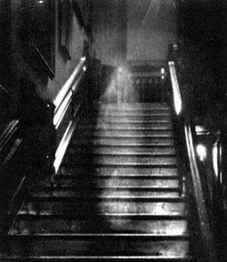

#### Slashers

Slashers are dead Red Cobra agents and syndicated civilians who jump out from their sleepy states or from pure ether to attack the player by slashing with their ghost limbs. They are easily dispatched with one punch, but come in greater numbers with each new encounter. While the punch is effective, it’s a bit too slow to deal with numbers, forcing the player to use his less effective weapons in certain situations.

#### Binders

Binders are isolated Red Cobra operatives who run up to the player and restrain his movements, leaving him open to other ghost attacks. To defeat them, it is best to attack with the fist, but they also automatically defeated as the player breaks free from their hold. A player frees himself by tapping the Stun button when shown on screen.

#### Screamers

Screamers are Brutes or Generals who stand away from the player and scream at him, causing him to walk slower. When first receiving the scream, the player steps back due to the pressure, and while all attacks are just as fast and effective, the walking speed is reduced until the scream no longer reaches the player (behind a cover), or until the Screamer is dead. Two punches are required to beat them (or two EMP blasts), and no other weapon affects them. They cannot scream through cover.

### Bosses

Bosses are, all in all, hyper versions of an enemy type. They are only encountered once, and once destroyed/killed, are never seen again. They are however exciting encounters that give a whole new challenge to the player.

#### Super Brute

The Super Brute is the first Boss encountered in the game. It is a large, much bulkier version of the Red Cobra Brute, and its moves are much more lethal to the player. Killing the Super Brute requires of the player to understand the patterns of the enemy and use the interactive elements found in the environment to his advantage.

#### White Cloak

The White Cloak actually represents Howard’s ex-wife. After being murdered with their kids by the Red Cobra Agents, following Howard’s conversion to an agent, she turned into a gigantic vengeful ghost that watches over Howard’s past home. The White Cloak typically looks female, mixed with the insane face of a witch. Killing the White Cloak requires of the player to move around the boss area to dodge the many deadly swipes of the White Cloak’s arms attacking the surrounding structures.

#### Security AI

The Security AI is the great computer working for Red Cobra. It is also the command center of all mechs in the game. The Security AI attacks by releasing on Howard its army of Mechs and by using harmful technology through the use of its multiple screens. The player must learn the patterns and survive the many tests of the Security AI in order to win.

#### Red Cobra

Red Cobra is actually the Master of the corporation. It is strong, and like the player, will use many weapons to fight, switching between its own versions of the Shock Pistol, the Red Shark, the Neutralizer, the Wirebow and the Wrist Implant. It is also protected by many types of shields and armor. The player must use all his tools to fight this last enemy. Through the battle, the player and the Red Cobra leader are forced to fight in the Utopia and Dystopia, and their implants clash.

## Citizen

Citizens are always neutral to the player. They live their utopic dream and talk nonsense, but never pose any threat. That, is however not always true.

Some citizens will quickly get syndicated upon player approach, and will start to attack him. They are always unarmed, and therefore defenseless, but can pose a real threat if attacking in numbers.

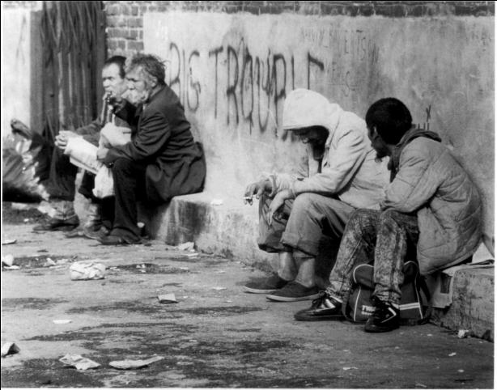

# Ingredients

## Philosophy

The different elements found in the world have two uses, they either damage the player, or they can be used to interact with the world or damage nearby enemies. They are separated in two categories: interactive objects, and obstacles.

## Interactive objects

### Shock lamp

A city lamp found in some alleys and generally all the main streets. Some can be found in different shapes inside buildings, but regardless, they all have one thing in common. The player can use the discharge function from the Shock Pistol on the Shock lamp, which will cause it to shoot out electricity, damaging nearby enemies.

### Magnetic gear

A gear that comes in many sizes. Can be manipulated with the Shock Pistol’s discharge function, opening doors and moving mechanisms in linear directions.

### Magnetic Switch

A prop stuck in a narrow path imbedded in the wall. It can be dragged along the path using the Shock Pistol, and usually needs to be moved to the end of its path to unlock doors or activate mechanisms. Comes in many sizes. One such prop is found to be gigantic, and to be moved, requires many energy sources, demanding the use of the Wirebow’s secondary function to set up an electricity path.

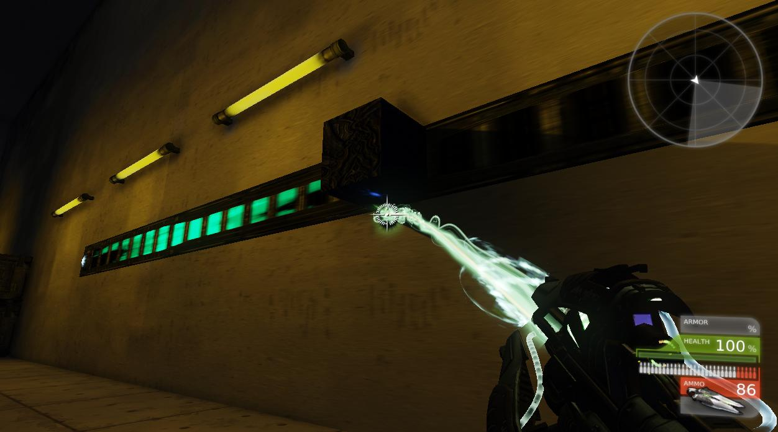

### Water leak

Leaking water can be shocked, causing damage to enemies standing in it, but also to the player. If the water was shocked while connected to a mechanism, the mechanism would also receive the energy blast.

### Gas leak

Gas leaks work just the same as water. The only difference is that it requires fire to be active. Gas on fire causes damage, but it’s also used to spread fire to specific locations, burning down wood or causing attached mechanisms to blow up.

### Gas container

A container of gas. If shot, it explodes on impact. It also occasionally leaves a gas leak behind for the player to use.

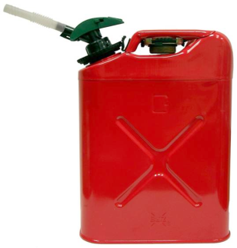

### Water tank

Water tanks will drop water when shot, leaving a water leak.

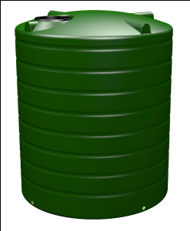

### Energy source

A source of electric energy, found inside certain mechanisms or in big generators. They cannot be turned off by the Electromagnetic impulse blast, and serve only as their name suggests: energy sources. By shooting a receptor rod in the source, the energy can be transferred if the receptor rod is connected to another by the use of a wire.

### Terminals

Terminals can be hacked using the Wrist implant. They usually open doors or turn on or off mechanisms in a level.

### Skywalk path

The skywalk path allows the player and enemies to walk on walls. There are sometimes many paths on a single wall. If the player uses the wrist implant and punches a path, he will break the energy supply and deactivate that path temporarily. This will mean that enemies standing on it will plummet to their death. The player can also die if he is standing on the path, so one must carefully aim the paths they are not standing on. Enemies will also learn to do this trick, so the player must pay close attention to enemy movements when skywalking.

## Obstacles

### Electrical currents

Electrical currents will shoot out of loose wires and active dischargers. Those currents will sometime be followed by a short delay before another current is shot, while other times, they will be active full time. The player will either have to jump over, crouch under, wait for an opening or turn off the electricity in some fashion. They are a common obstacle, sometime found in a level where they won’t especially block a path or force an action, but also bug the player. When electrical currents shoot on water, anyone, player or enemies, will receive a great load of damage while standing in the affected water.

### Hot steam

Hot steam shoots out of pipes. It damages the player or enemy in the way, and demands platforming skills and anticipation to avoid.

### Strong steam

Strong steam also shoots out of pipes. It is not damaging in any way, but affects human enemies or the player in a different way. Any humanoid standing in the path of the strong steam is sent flying in the direction the steam is shooting. This can actually knock anyone off a platform, causing death, or simply a puzzle fail. The only way to avoid a strong steam is anticipation.

### Fire

Fire can be shot out of pipes, but also comes from enemy weapons or already burning props. On touch, fire damages, but also has other puzzle uses. If fire touches a gas leak, this gas will start burning and damage anyone standing in it. Wood is also subject to burning, so when fire is moved through gas leaks or by dropping wood on it, it can spread to other features of the environment, such as electronics, in some cases causing elements to explode. Some burning objects will also create a fire wall of sort, blocking the player’s path.

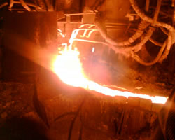

### Blizzard

Found only in Mission 7 and 8 (The Frozen River, Howard), blizzards are events that occur at specific points during a level. When active, the player must find a shelter, lest he die in the cold. Blizzards will eventually toggle off, allowing the player to move onwards. They basically force the player to enter structures and not go outside, directing the path of the player.

### Absolute Zero

Found only in Mission 7 (The Frozen River), Absolute Zero is a line of severe cold temperature advancing on the player. On touch, it damages the player a lot, and three strikes are enough to kill him. The player recognizes the advancing cold by seeing thick ice spread on the floor and walls. When this event starts, the player’s goal is to run away from the Absolute Zero line of cold. The tension rises and the gameplay demands quick reflexes and rapid interpretation of puzzles.

# Character progression

## Health system

The player is equipped with a magnetic shield, in the same way that some Mechs do. Unlike theirs however, bullets can deplete his shield. When the shield is gone, the player starts to lose health points. The shield will, if left alone, slowly recover until reaching 100%.

Health points can be restored through the use of Medi-packs and health needles.

### Medi-packs

Medi-packs are uncommon and usually found in secret areas, lockers or other locations the player wouldn’t necessarily look first. They are also found in places where they are vital to a player’s survival, following a tough boss battle or before a tough boss battle for example. They restore 50% of a player’s max health. They cannot be taken and moved from their location for a later use. The player uses them on spot.

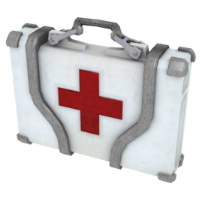

### Health Needles

Health needles are typically dropped by Red Cobra enemies or found in evident locations. They restore 10% of the player’s total health and are used as they are picked up, without any animation required. They cannot be stored.

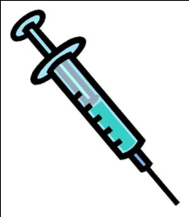

## Intelligence pick-ups

Intelligence pick-ups are extras the player can find throughout the levels of the game. While they are not part of the core Gameplay, their importance is such that they influence the ending of the game. If the player finds all intel during the game, he gets the best ending. Getting less intel leads to good, bad, and worse endings.

### Weapon intel

Weapon intel will provide the player with information regarding the weapon they’ve just recently found. This intel can provide the player with helpful hints on how to best use the weapons, and in what situation.

### Background intel

Background intel tells the story of the city of New London and the player’s surroundings (for example: a restaurant).

### Story intel

Story intel provides the player with information regarding Coldfly, Red Cobra, and specific information that could help Howard restore lost memories.

# Weapons

## Wrist Implant

|  |  |  |  |  |
| --- | --- | --- | --- | --- |
| **ONE MELEE HIT** | | | | |
| Enemy type | Damage | Hit reaction | | Cooldown |
| Human | *50 HP* | If standing | If lying on the ground | *2 secs.* |
| Target is sent flying for a distance of *6 feet* unless it hits an obstacle | Target slides away for a distance of *4 feet* unless it hits an obstacle |
| Mech | *40 HP* | Target is stunned for *2 secs.* | |
| Ghost | *Instant Kill* |  | |
| Shield | *Destroyed* |

|  |  |  |
| --- | --- | --- |
| **STUN** | Damage | *0 HP* |
| Added Effect | Enemy is stunned for *2 secs.* |
| Cooldown | *1 sec.* |

* Stun only works if the enemy is human. (No mechs or ghosts)
* Stun can also be performed while using any other weapon.

## Shock Pistol

|  |  |  |  |
| --- | --- | --- | --- |
| **ONE PISTOL SHOT** | | | |
| Enemy type | Damage | Added effect | Cooldown/Fire rate |
| Human | 20 HP | Enemies stagger for 0.3 sec. | 0.5 sec. |
| Mech | 15 HP |  |
| Ghost | 10 HP |

|  |  |  |  |
| --- | --- | --- | --- |
| **ONE DISCHARGE** | | | |
| Enemy type | Damage | Added effect | Cooldown/Fire rate |
| Human | 2 HP | Enemies are paralyzed for 1 sec. | Continuous until energy reaches 0%. |
| Mech | 1 HP |  |
| Ghost | No damage |

## Red Shark

|  |  |  |  |
| --- | --- | --- | --- |
| **ONE RED SHARK BULLET** | | | |
| Enemy type | Damage | Added effect | Cooldown/Fire rate |
| Human | 10 HP |  | 0.1 sec. |
| Mech | 8 HP |
| Ghost | 5 HP |

|  |  |  |  |
| --- | --- | --- | --- |
| **ONE EXPLOSIVE BULLET** | | | |
| Enemy type | Damage | Added effect | Cooldown/Fire rate |
| Human | 40 HP | Enemies are thrown to the ground 4 meters away. | 0.1 sec. Fires all 15 bullets automatically. Damage is reduced by 10 HP for every meter away an enemy is from the explosion |
| Mech | 30 HP | Mechs are thrown to the ground 2 meters away. |
| Ghost | *No damage* |  |

## Neutralizer

|  |  |  |  |
| --- | --- | --- | --- |
| **ONE SLUG** | | | |
| Enemy type | Damage | Added effect | Cooldown/Fire rate |
| Human | 40 HP | Enemies stagger for 0.5 sec. | 2 secs. Damage is reduced by 10 HP for every meter away the enemy is standing. |
| Mech | 30 HP |  |
| Ghost | 30 HP |

|  |  |  |  |
| --- | --- | --- | --- |
| **ONE EMP BLAST** | | | |
| Enemy type | Damage | Added effect | Cooldown/Fire rate |
| Human |  | Enemies stagger for 3 secs. | 15 secs. |
| Mech |
| Ghost | *Instant kill* |  |

## Wirebow

|  |  |  |  |
| --- | --- | --- | --- |
| **ONE ROD** | | | |
| Enemy type | Damage | Added effect | Cooldown/Fire rate |
| Human | 40 HP | Enemies stagger for 1 sec. | 2 secs. Damage is doubled for a shot to the head. |
| Mech | 30 HP |  |
| Ghost |  |

|  |  |  |  |
| --- | --- | --- | --- |
| **CONTACT WITH TRIPWIRE** | | | |
| Enemy type | Damage | Added effect | Cooldown/Fire rate |
| Human | 30 HP | Enemies are paralyzed for 1 sec. | N/A |
| Mech | 20 HP |  |
| Ghost | *Instant kill* |

# Save system

## Autosave

The game saves automatically upon meeting certain conditions.

* The game saves every time a player reaches a checkpoint.
  + When a player dies, he is brought back to the last checkpoint crossed. Completion time and overall score is returned to the state it was upon first crossing the checkpoint. The death penalty is counted at the end on the results screen.
  + If the player exits the level and comes back, he will have to start over from the beginning.
* The game saves every time a player finishes a level. This occurs after closing the results screen.
* The game saves every time a player leaves the “Options” menu, whether on the main menu or pause menu.

# Difficulty

## Easy

This is as the name suggests, the easiest difficulty setting. On this difficulty, enemies behave normally and do not recover if left alone.

## Normal

On normal difficulty, enemies have an added barrier to take down before the player can deplete their health. This barrier recharges if left alone. It is an added protection that even applies to enemies that already have a protection like shields, magnetic armors and fields.

## Hard

Now all **Red Cobra** enemies have recharging health. To take them down, the player must pressure them for as long as they are alive, otherwise he would be letting them recover. All **Mechs** have double the health, but it does not recover. **Ghosts** now are twice as fast.

# User interface

The user interface is intended to be as minimal as possible, so that players are the least disconnected from the game experience. Score is not shown until the result screen.

## HUD

The heads-up display shows all permanent data on the bottom left of the screen. The elements are stacked. They are, from top to bottom:

* Current weapon’s ammunition (if the weapon is already upgraded, the secondary function is shown on the right of the primary function)
* Player shields
* Player health

When the player calls the weapon selection menu, a compass rose type of menu appears, with five selections to choose from. For as long as the directional pad up button is held, the menu will stay on screen. It will disappear if the player lets go. The player can choose the weapons of his choice with the right stick.

## Menus

### Title Screen

The title screen is the first screen seen by the player. Pressing START will lead the player to the Main menu.

### Main Menu

The main menu lists the available option menus of the game. Leaving Gameplay through the pause menu will lead back here.

### New Game / Continue

New Game will make the player start the game anew, erasing all previously gained data and removing access to previously completed levels. Once a new game is started, the Continue options is available, and allows the player to start the game from where he left off.

### Mission Select

Missions in the Mission select menu will unlock as the player progresses through the story. All missions can eventually be accessed here and replayed to gain a better score or to find all intel files. Player an early level will not erase score or extras gained in a later level.

### Leaderboards

The Leaderboards will show the player’s current rank for his overall score, and for the score gained for a single mission. The player can compare his score with friends or the whole of the leaderboards.

### Achievements

The achievements option will open the basic Xbox 360 Achievements menu.

### Help & Options

Help & Options will provide the player with all required information on how to play the game, and also allow him to change the difficulty or change sound and graphic settings.

### Exit Game

The Exit Game options will ask the player if he or she wants to quit the game. Upon confirmation, the player will be brought back to the Xbox 360 dashboard.

# Missions outline

**Mission 1: Smoked**

The player plays the role of one of the agents. After a quick shooting tutorial, the situation turns to chaos. The player’s teammates die, killed in an explosion. As the player slowly makes his way out of the burning debris, Coldfly agents, whom we understand are the player’s contractor’s main rival, capture him.

The player character’s body is apparently tempered with, shocked, in what looks like cruel torture. Technology is removed from the body, and other technology is implemented. The player character is then transported to a hovercar, and the Coldfly agents escape with him on board. During their escape, they are chased by the player’s contractor, who then proceeds to shoot the hovercar down. The hovercar crashes down to the lowest point of the city, in a dark alley.

**Mission 2: Out in the Blue**

Waking up, the nameless agent receives communication from a Coldfly agent: Nathalia. While not trusting her, he is forced to listen to her advice as his survival depends on it. He learns that Red Cobra has decided he was a nuisance, and is now out to get him. During his escape, he sees with his own eyes the true color of the world and its controlled inhabitants. Innocent civilians are syndicated on spot and attack him, forcing him to defend himself. He gains his first tool, and learns to use his new implant in his wrist to analyse the environment and hack the neck chip of an agent. Controlling the Red Cobra agent and seeing his point of view, the nameless agent understands that he too was forced to see a false vision of the world, and was controlled that way. During the Mind Hack, he also sees glitches, flashes of ghosts, and has yet to understand what they are.

Escaping out of an office, the nameless agent enters an abandoned hovercar. Before he does anything, he intends to follow his last steps and find out about the real world, and about himself. He speeds off to the location of the first mission.

**Mission 3: Unknown**

Arriving at the base of the tower he infiltrated in mission 1, the nameless agent makes his way up to the top using the broken elevators. He also meets dead Red Cobra agents, killed in his last mission, brought back to life using their implanted technology. The nameless agent finally reaches the computer room at the top floor.

The nameless agent searches the database for any information he can find. Nathalia tells him what was done to him when he was captured, but also what was done to him before he became syndicated. The agent finds his name: Howard Watts. Deciding he won’t find out about his past life by whining about it, Howard decides to help Coldfly by infiltrating a Red Cobra control center, thinking the action will probably put his mind in the right place and allow for deeper thinking.

**Mission 4: The Empty City**

The city is populated, but it is also quite silent. All inhabitants are living their lives through a false vision or reality, and as such, look like zombies wandering around pointless locations, thinking they are absolutely different than what they really are. To get where he wants to go discretely, Howard must hack a civilian’s chip and open doorways for himself. He finally enters the base.

Howard enters the base stealthily. Transition from the restaurant to the base using a secret elevator.

**Mission 5: Into the Dream**

Inside the control center of Red Cobra, Howard hacks an agent to open his way inside the main labs and computer rooms. This section works as a long reconnaissance walk. As he regains his own control, Howard breaks in and fights through the guards, finally reaching the big computer room.

Howard obtains the data required by Coldfly. He sends it to them, but is quickly caught by the sensors of heavy armored mechs and the toughest Red Cobra pawns.

**Mission 6: Deadly Fireworks**

Through the flames and explosions, Howard escapes the Red Cobra base, pursued by the deadliest agents and robots. After a tense escape, Howard battles a powerful monstrous enemy on a sky platform.

Despite being the winner, Howard is sent off from the platform by the strong wind, and drops on snowy frozen river. There he lies, unconscious.

**Mission 7: The Frozen River**

Howard wakes up and walks the long frozen river, freezing due to the strong winds. There, he has his first illusions that are not related to mind hacks. He follows his visions and fights off the enemies on his path. He sees an abandoned ship, but finally is lead to land once again.

The ghosts lead him to what seems to be broken down houses in an environment that is much less techno savvy.

**Mission 8: Howard**

The visions become stronger. Some come from the dystopia, and attack Howard, some seem to come from the utopia, and drive the story forward. Howard reaches the end of his long walk, and finally understands his visions. He had a life in utopia before, but he realizes that was taken from him when he was formed an agent. His family was killed, and changed from a false view to another. Motivated to bring down Red Cobra, Howard answers to Nathalia’s pleas and goes to the Coldfly command center.

Howard is motivated to bring down Red Cobra. He finds a vehicle and sets off to Coldfly’s command center, its location provided by Nathalia.

**Mission 9: Invasion**

As Howard arrives, he finds the base has been invaded by Red Cobra. Breaking his way through, he saves Nathalia, whom he encounters for the first time now.

Armed with the best tools and weapons, Howard leaves to take down the strong tower of Red Cobra, the center piece of the organization.

**Mission 10: Skyscrapers I**

Through a car chase, Howard makes his way to the great tower of Red Cobra. He fights off his pursuers and pays close attention to the towering buildings on his way, which could easily take him down with just a moment’s inattention.

Howard arrives at the tower. He lands on the wall, and using skywalk, walks his way up, as the hovercar cannot go any higher.

**Mission 11: Skyscrapers II**

Howard fights a load of enemies on his way up. To his surprise, some blocks of the tower start to move. He must also pay close attention to the sparks shot down from the top.

Howard enters the tower, he is close to the top, but cannot go higher due to obstacles he cannot cross. He makes his entrance.

**Mission 12: The King’s Tower**

Howard fights his way up the remaining floors, which are all circular and heavily protected. There, he meets the mastermind. At the end of a complicated boss fight, Howard approaches the main computers.

Nathalia informs Howard that to take down Red Cobra, a strong signal could be sent from the tower, breaking all communications and deactivating the neck chips of the civilians and agents. It is risky, and could take Howard down with it, since his chip was programmed differently. Being an intruder to the signal, it would destroy it along with Howard. Howard decides to give it a go regardless.

**Mission 13: Signal**

Through a final hovercar escape, Howard flees the signal of the great tower. He must reach the country side before the wave hits him, because the wave only affects the area of the city.

Depending on the player’s obtained collectibles, the end cutscene shows a bad ending, a neutral ending, a good ending and a great one. The first explains that the signal was not strong enough and lacked too much data to be effective. The Red Cobra annihilated Coldfly, and Howard’s fate is unknown. In the neutral ending, Howard sends a signal too strong that kills all life within the city. Nathalia dies, but so does Red Cobra. Howard leaves to repair his mistakes and turn the survivors to the reality. In the good ending, Red Cobra loses, and Howard and Nathalia win. The future looks bright, but it’s unclear if Coldfly will use it’s newfound power correctly or not. The great ending shows part of the good ending, and finishes with the city being renovated by the people.