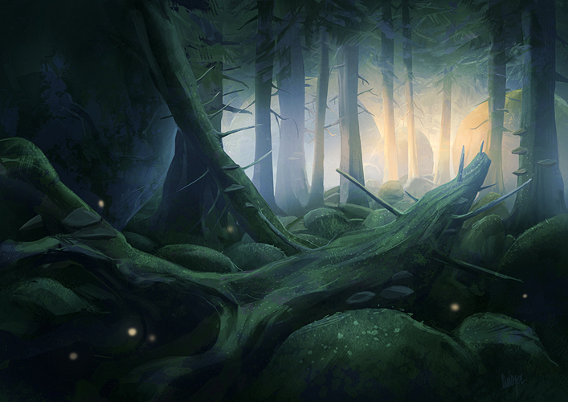

**GENERATIONS**

Game Design Document

January 28th 2012

**Revision History**

|  |  |  |
| --- | --- | --- |
| **Version** | **Date** | **Comments** |
| V1.0 | January 28th 2012 | Created file and main template |
| V2.0 | January 28th 2012 | Created Synopsis and main gameplay |

Table of contents

Introduction 1

Story 1

Synopsis 1

Narrative Tools 1

Setting 2

The Forest 2

Game structure 2

Primary gameplay 2

Puzzle 2

Generation Switch 2

Plant Trees 3

Chop Trees 3

Pick up seeds 3

Traversal 3

Run 3

Jump 3

The basic controls 3

Control philosophy 3

Control layout 4

Ingredients 4

Philosophy 4

Interactive objects 4

Obstacles 4

Save system 4

Autosave 4

User interface 4

HUD 5

Menus 5

# Introduction

Generations is a title intended for the PC and Mac platform. The game is a third person puzzle platformer, where the player must modify the environment by planting special seeds that grow through generations. The game observes the story of a clan member and his descendants as they try to reach milestones set by their founding fathers, using plants to modify the environment that will allow the next generation (when grown) to reach previously inaccessible platforms.

The game is a single player experience featuring 6 puzzle levels, each picturing the adventures of a generation. The game aspires to offer the artistic experience brought by games such as *Grow* and *Braid*.

# Story

## Synopsis

Each generation, a member of a Celtic tribe is chosen to depart on a quest to find the legendary milestones left by the clan’s founding fathers. It is said that these stones hold great wisdoms, but also that a great secret lies deep within the tribe’s sacred forest.

As the last surviving chosen of the tribe (the last generation) leaves the final puzzle, he finds a special seed and plants it. The tree grows live with him and reaches a fantastic size. The sun sets and tree lights up, the tip of its branches glowing blue and emitting a weird mist. Finally, the former generations who helped the final character reach the sacred seed within the forest (character look alikes), appear, serenely saluting the main character, seeing their efforts were not in vain.

## Narrative Tools

The game’s storyline is told through the opening and ending cutscenes. The player’s progress through the game serves to explain how each generation helped the next move onward towards the final goal.

# Setting

## The Forest

Full of vibrant vegetation, the forest is the main setting of the puzzles the clan members must complete. Trees are dominant, but some rare berries can also be found, making the forest a colorful environment.

# Game structure

|  |  |  |  |  |
| --- | --- | --- | --- | --- |
| **Nom** | **Description** | **Générations** | **Assets** | **Difficulté** |
| Level 1 |  |  |  | Facile |
| Level 2 |  |  |  | Facile |
| Level 3 |  |  |  | Moyen |
| Level 4 |  |  |  | Moyen |
| Level 5 |  |  |  | Difficile |
| Level 6 |  |  |  | Difficile |

# Primary gameplay

## Puzzle

Puzzle solving in the game is explored through the planting of trees and the platforms they spawn when advancing a stage forward in their life cycle. Trees can be grown, but also cut down, providing the player needs the resources they provide…

### Generation Switch

The Generation button allows the player to move forward in the timeline, controlling the next generation clan member to experience the puzzle at hand.

### Plant Trees

In order to grow trees that will eventually grow leaves and flowers, seeds must be planted on fertile soil (clearly identified) by brown earth.

### Chop Trees

Trees can also be chopped down. By using the tribe’s axe, the character can bring down the tree and build bridges. Chopped trees also provide one seed for the player to use.

### Pick up seeds

Seed management is also a section of the puzzle solving. The character starts with a limited amount of seeds, and can pick up more during a puzzle by picking up seeds that are left alone or chopping existing trees.

## Traversal

### Run

By pressing the left and right arrow, the character can run left and right in the level. The level scrolls, following the player’s jogging.

### Jump

By pressing the jump button, the character hops from the ground to reach platforms above.

# The basic controls

## Control philosophy

## Control layout

# Ingredients

## Philosophy

## Interactive objects

## Obstacles

# Save system

## Autosave

The game saves automatically upon meeting certain conditions.

* The game saves every time a player completes a puzzle.
* The game saves every time a player leaves the “Options” menu, whether on the main menu or pause menu.

# User interface

The user interface is intended to be as minimal as possible, so that players are the least disconnected from the game experience. Score is not shown until the result screen.

## HUD

## Menus