**Arrival Phases**

|  |  |
| --- | --- |
| 00sec – 30sec | 1 user/sec |
| 30sec – 60sec | 2 users/sec |
| 60sec – 90sec | 4 users/sec |
| 90sec – 120sec | 8 users/sec |
| 120sec – 150sec | 16 users/sec |

**Sessions**

|  |  |
| --- | --- |
| Session 1 | Visit home page. Perform search. Visit a random result. |
| Session 2 | Visit home page. Create a new stream. Post 3 text messages. Upload 1 file. |
| Session 3 | Visit home page. Visit a random recent stream. Stay for 3 polls. |

**SP m3.medium**

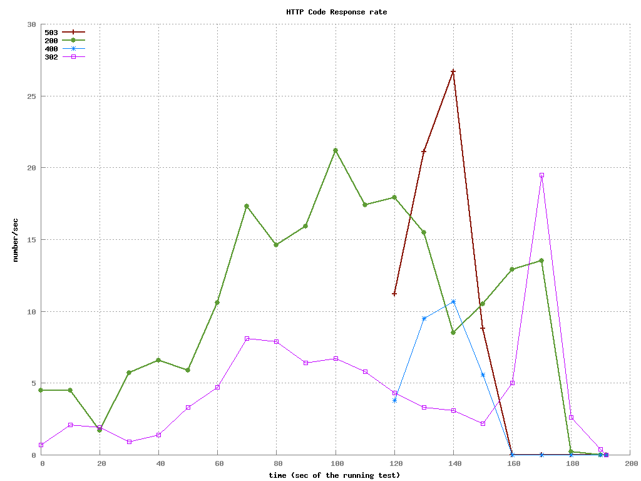

**SP m3.large**

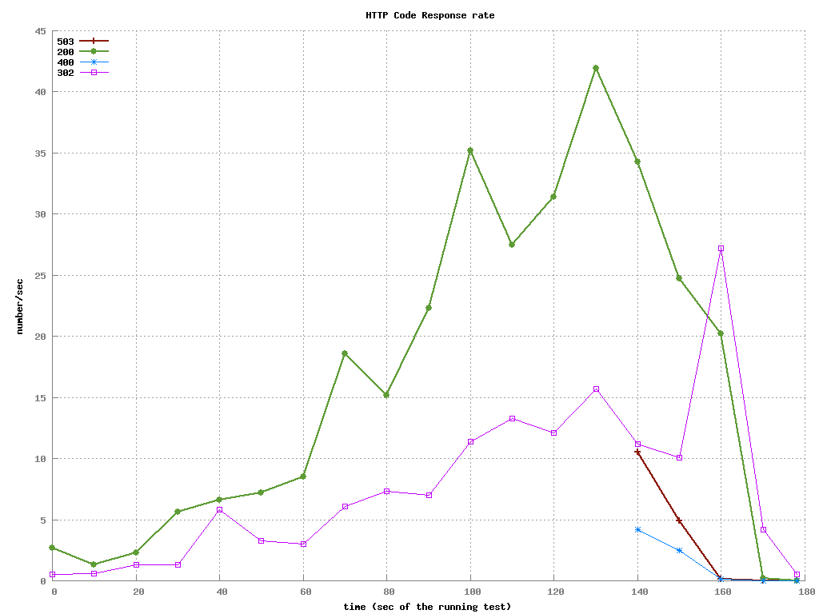

**SP m3.xlarge**

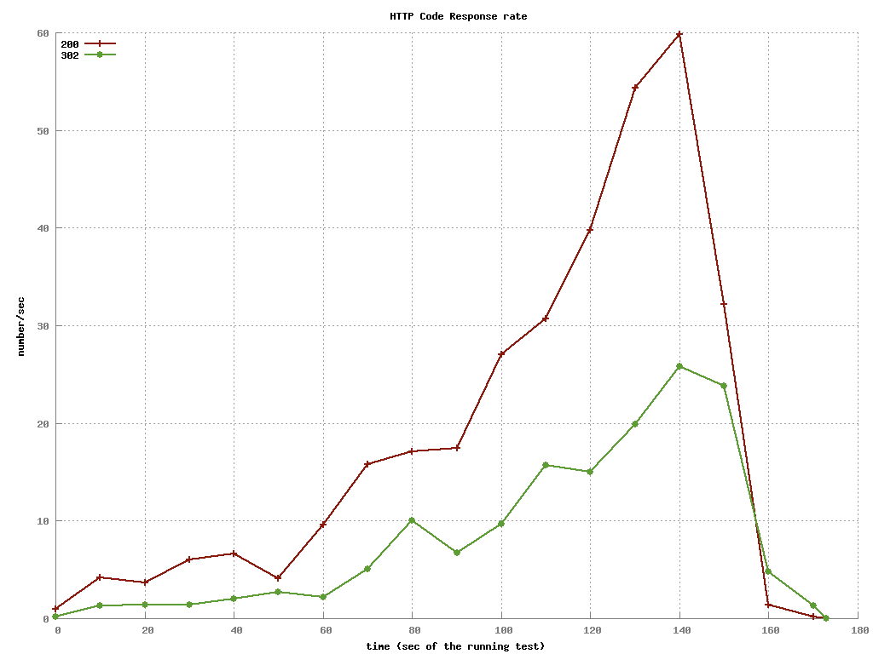

**Combined request times**

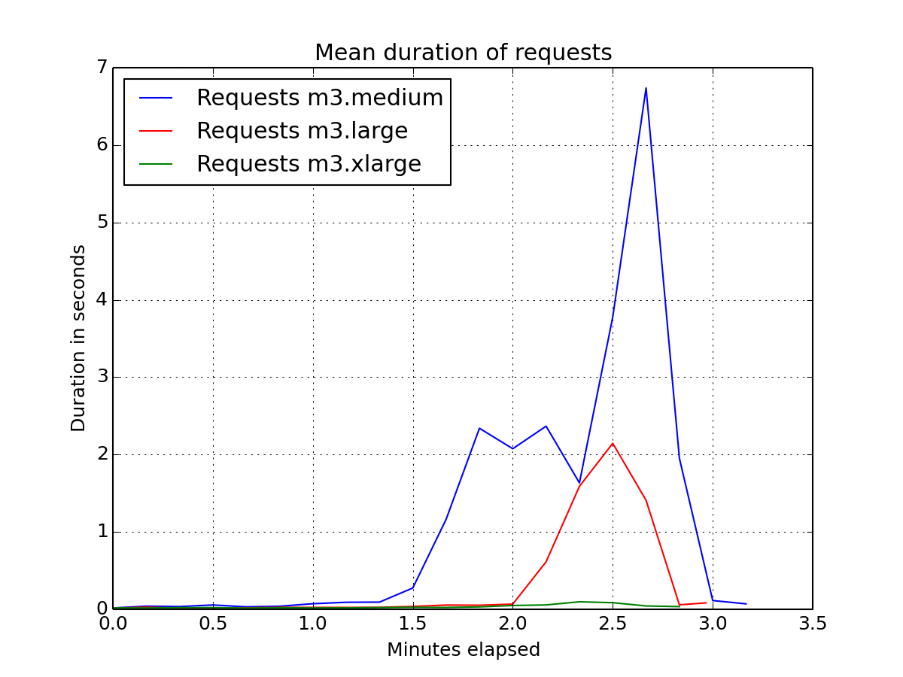

**MP 1xm3.medium**

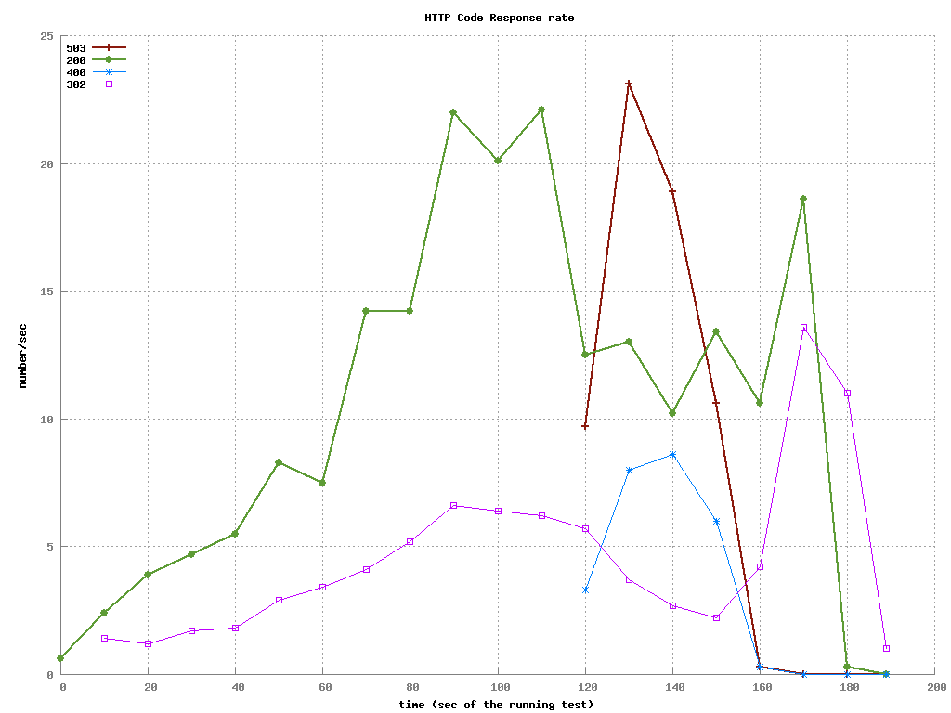

**MP 2xm3.medium**

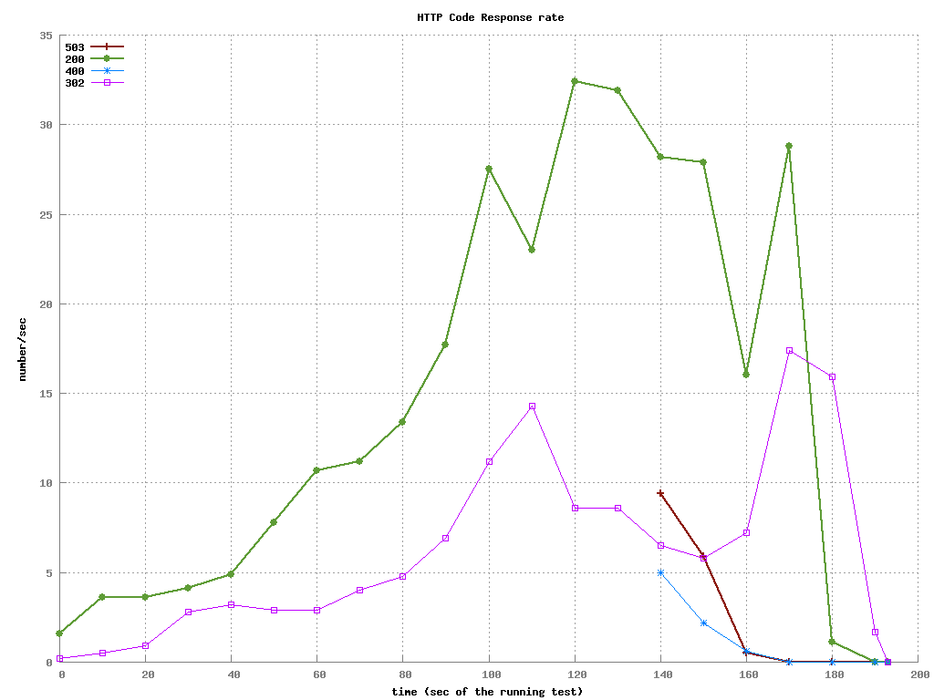

**MP 3xm3.medium**

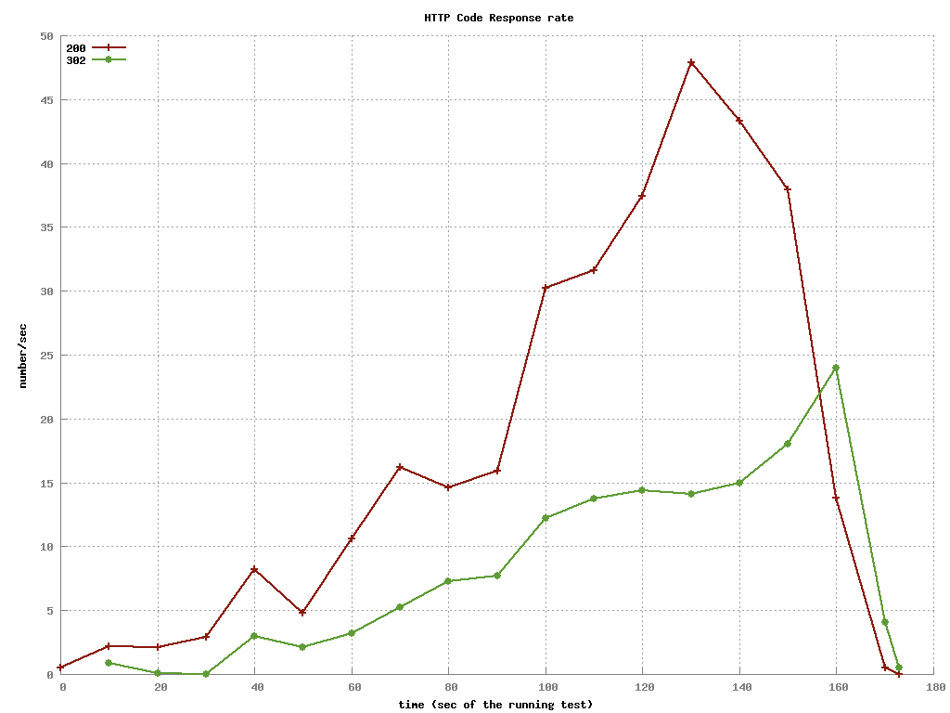

**Combined request times**

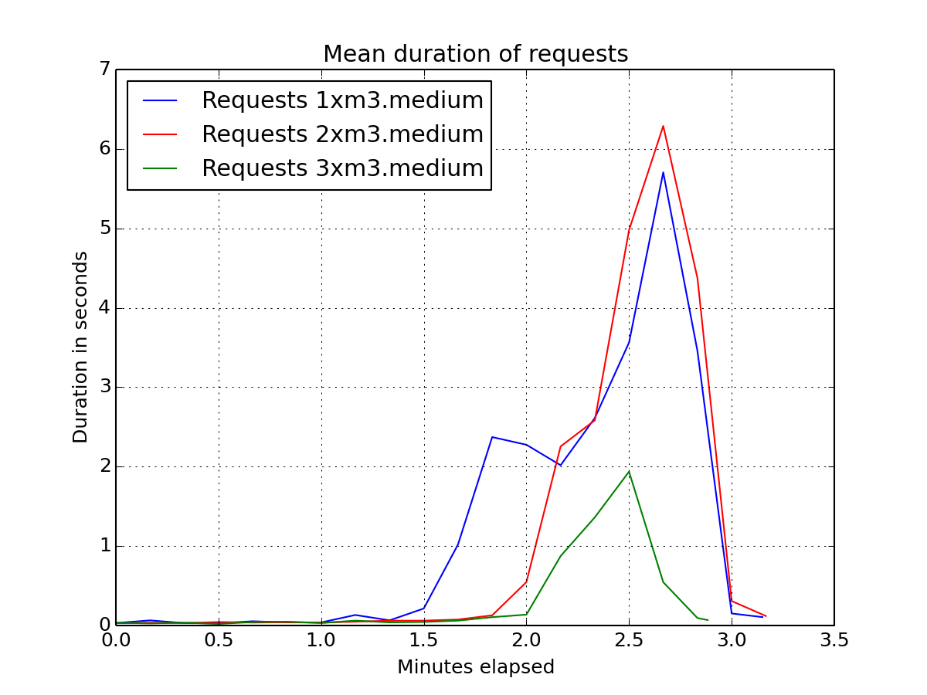

**Conclusion:**

SP m3.xlarge performs better than MP 3xm3.medium

**Request times with Caching**

