All insights, we summed up in “diabetes map” in order to get an overview, how the typical process of diabetes looks like. We found out, that the course of peoples change is very complex and there is no typical way of changing.

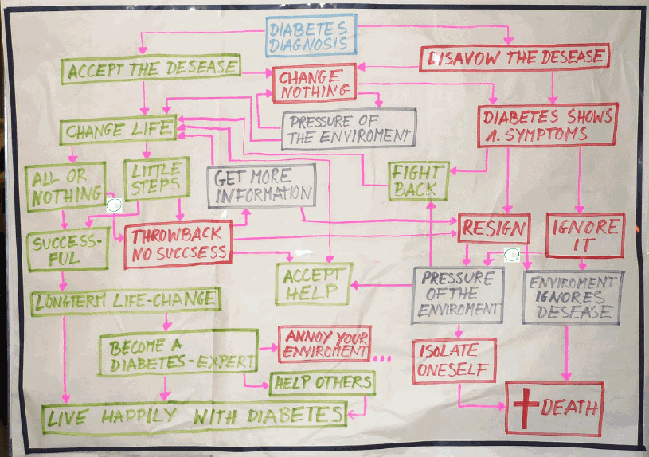
As one perspective of this diabetes process, we analyzed the motivation level over the time. We want to define, at which point the motivation level is near the bottom and backstrokes are often.

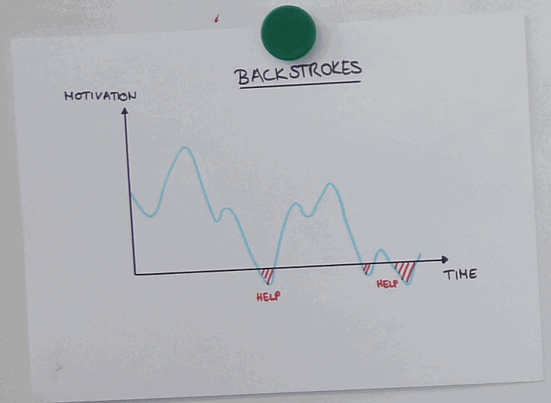
Building on this, we came up with our Persona “Carola”, which we used in the ideation process to find solutions.
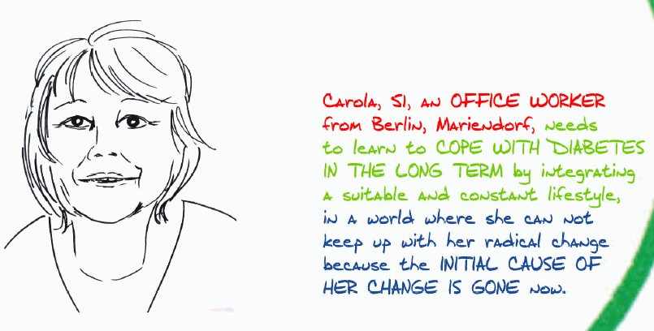
As a second perspective, we analyzed, who is involved in the life of a diabetic, and we found out, that the surrounding of a diabetic has a huge impact on the process of the disease and the life style change.
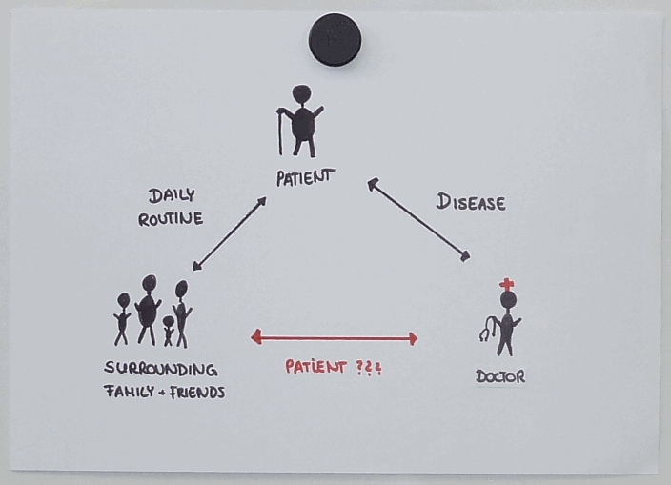
We used this finding to create our second persona “Hermann”.
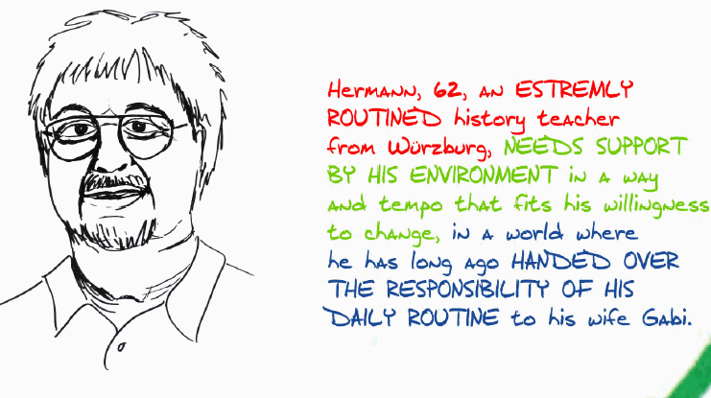
To be more concrete we want to find out, how much time a diabetic passes with for the process of the disease important stakeholder, and compare this time budget with a desired budget.
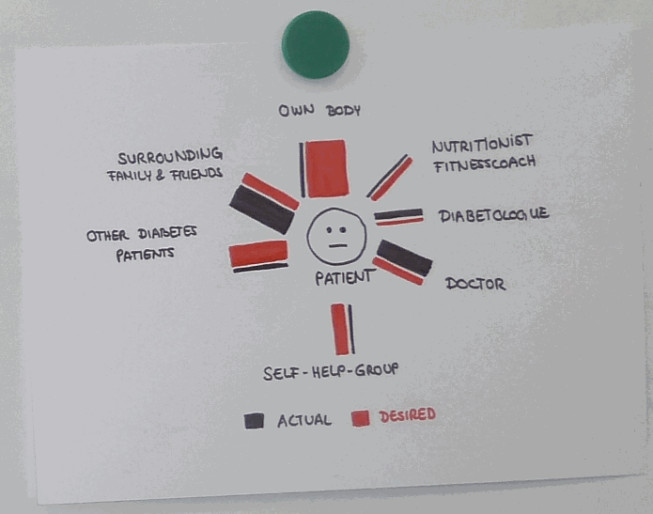
As we want to help as many people as possible, we were looking for similarities in the people’s life and their habits.
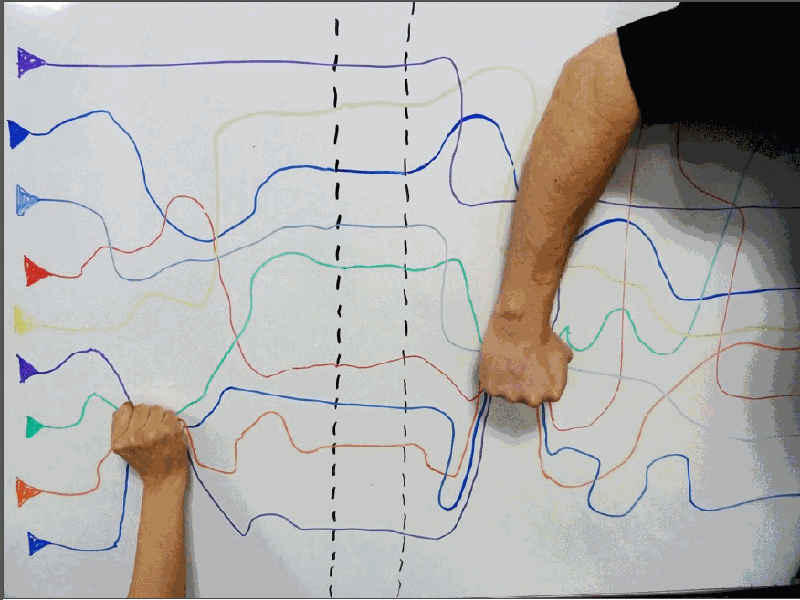
We found out, that the similarity in all diabetic life were nor their habits, neither their needs, the big similarity was just their feeling right after been diagnosed.
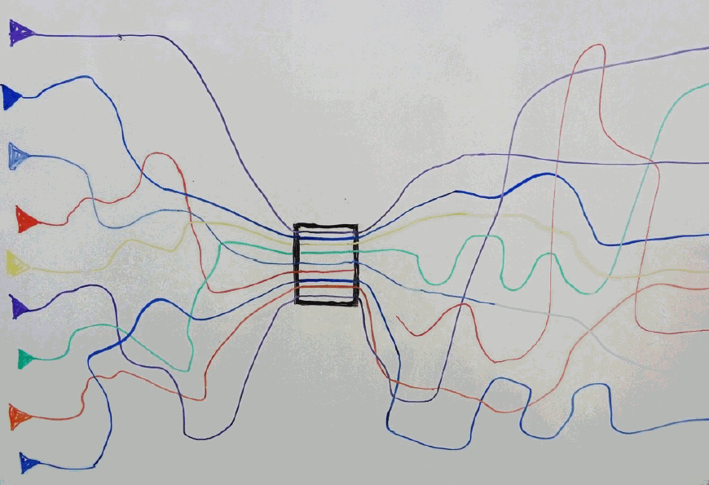

Right after the diagnoses, you
- Feel alone
- are scared of loosing life quality
- are confused
- Are full of questions

Additional Text:
Diabetes type 2 requires a completely change of life style in order to avoid long-term problems. The crucial point is, that diabetes doesn’t hurt, so there is no direct feedback to bad habits and inadequate life style. People need a tangible added value, if they have to change.
Therefore, people are not motivated to change their life. As a second crucial point, there is no target to reach after a change of life style, no point, where you can return to your old bad habits.
We need to support every diabetic on their individual path of changing their life style. In order to avoid irreparable damage of health, the change of life style has to be at an early stage of the disease, preferentially direct after being diagnosed.

ODT ODT ODT ODT ODT ODT ODT ODT ODT ODT ODT ODT ODT ODT ODT ODT ODT
ODT
ODT

