Couch Puzzle : Interactive room planning on the go

|  |
| --- |
| **Dominic Bräunlein, Tom Bocklisch, Tom Herold, Norman Rzepka** |
| Hasso Plattner Institute Prof.-Dr.-Helmert-Str. 2-3  14482 Potsdam, Germany |
| { dominic.braeunlein, tom.bocklisch, tom.herold, norman.rzepka }@hp.i.uni-potsdam.de |

# ABSTRACT

Couch Puzzle is a system intended to assist interior designers. We propose a solution that lets you create a digital representation of your living room and helps you arranging furniture within it. Our system profits from well-known gestures and adheres to iOS standards to provide familiarity to the user.

# INTRODUCTION

When going to a furniture store, people have a hard time judging dimensions. We found this to be especially true when talking to random shoppers at an Ikea furniture store in Berlin. All our interviewees claimed that they had not measured their living rooms before looking for a new couch or table. While some told us they were confident that they would manage to somehow cram a new piece into their home, others were having second thoughts and wished they had taken precautions.

In this paper, we present a system that features all the tasks necessary in order to have an interior-designing suite on the go. We will show that interior design is not a domain exclusively for big desktop environments but can be done on mobile devices, too.

During our contextual inquiry we learned from Alen – an interior designer from Berlin – that every room design starts with acquiring a precise blueprint of a room. The preferred method is to laser measure it yourself. André – an office designer from Potsdam – made us aware of industry standard tools, that provides the users with a great number of realistic furniture models and rely heavily on different editing modes. He went on to arrange these in a room, stressing to look out for doors and windows.

Both agreed that they spend most of the time arranging objects. Thus, our prototype will focus on this task in detail.



Figure 1: Our interviewees: André (left) and Alen (right)

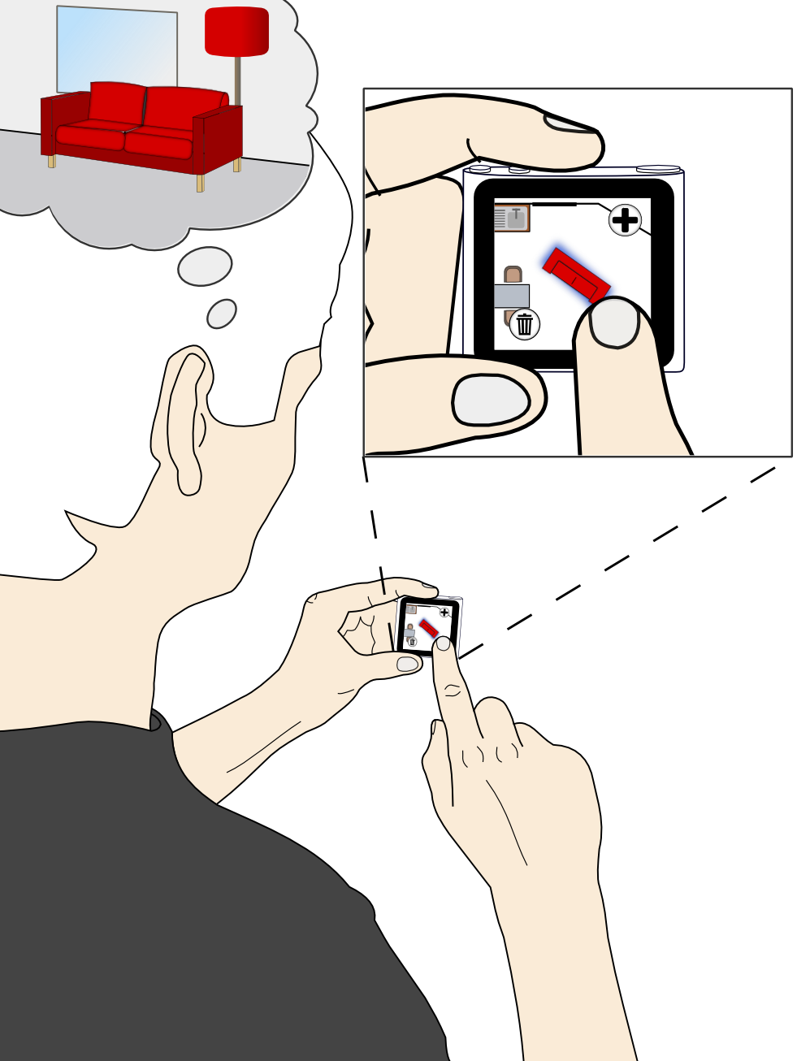

Figure 2: An interior designer has an idea about a room concept. Couch puzzle helps him.

# Device

Our solution features a iPod nano 6th Generation from Apple. We added a laser range sensor to the device for precise measurement of the room. The sensor works by casting a laser ray in a specific angle onto a wall. Using the camera the offset of the ray's reflection is captured and used to calculate the distance.

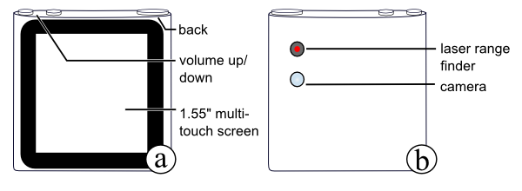

Figure 3: (a) Front side of an iPod Nano. (b) The back features a laser range finder with the required camera module.

# Walkthrough

For Alen, a typical interior design process starts with measuring a room, creating a digital blueprint out of the dimensions and placing objects into the room before taking some high-quality renderings of the scene.

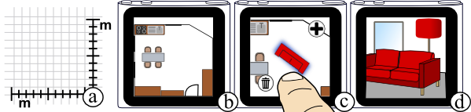

Figure 4: Task overview. (a) First, Alen measures a room by hand relying on laser measuring tools. (b) He builds a CAD[1] model of the room by tracing every single wall. Additionally he adds wall-features like doors and windows. (c) Alen selects a new piece of furniture from a catalogue and adds it to the scene. He moves it around until it feels right to him. (d) Finally, he positions a camera in 3D space and adds props to the scene to make it more alive. The resulting renderings are important for his clients.

Adding new pieces of furniture to a room, adjusting their properties and placing them is the most important task. Hence, we focus on this task in detail.

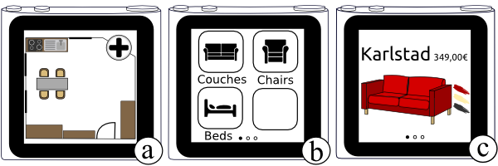

Figure 5: (a) Alen is presented with a previously created blueprint of a room. (b) He taps the menu button and a catalogue of different furniture categories is invoked. (c) To chose a new piece of furniture Alen selects a category by tapping on it. He browses the selection by flicking through the image catalogue. Besides the furniture item, additional information about the price and the available color pallet is displayed. In accordance with the iOS style guidelines we use page indicators to increase the discoverability of this action. [1]

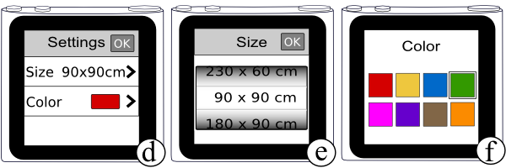

Figure 6: After Alen picked a piece of furniture he can adjust various options for his selection. (d) A list view displays the available parameters and provides links to the submenus for each property. For every option a default value is displayed. Alen can quickly finish the selection by clicking the OK button to accepts the defaults or make a refinement by pressing on a list item. (e) He can change the height and width by flicking through the item picker. (f) Alen modifies colors by pressing on one of the options from a limited color palette.

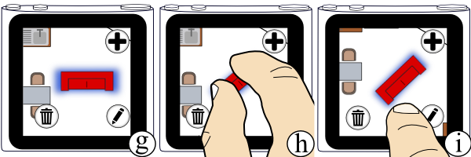

Figure 7: (g) After selecting and configuring a piece of furniture it is placed in the room and highlighted as the currently active object. (h) Alen is now able to rotate the selection by performing a two-finger rotation gesture. (i) Finally, he can drag and move the couch to the desired location next to the wall.

# Design

**On small devices 3D is less usable**

Early on we had to decide on how to display a room. From our interviews we knew that professionals relied on a mix of 2D top down drawings and 3D preview. We came up with three different 3D visualizations that were up for consideration. The first one provides a static panorama-like view of the scene with a camera placed in the middle of the room facing one wall (c). Swiping left or right rotates it by 45°, showing corners and the other walls. The second approach featured a similar design but had cameras set up in the upper corners of the room hence providing a bigger overview. It is similar to a bird’s view (b). The third solution introduced a free moving 3D camera, but this idea was quickly abandoned because it is very hard to interact with.

After considering the complexity of 3D navigation in industry standard tools, like Autodesk Maya or the Ikea Kitchen Planner [1], we found that 3D – though visually superior – was not feasible for a small mobile device. User interviews supported this decision. That is why we settled on a 2D top-down view instead (a).

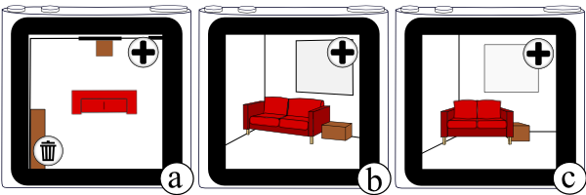

Figure 8: (a) 2D top down view, (b) Bird’s eye view, (c) Panorama view

**Users expect gestures instead of buttons**

Our first design iteration featured a rather conservative approach with buttons to move, rotate and delete the selected piece of furniture (a). During our first presentation we were encouraged by our peers to rely on well-known gestures instead. Consequently we reworked the furniture handling to use standard gestures like drag and drop to move objects and a two-finger rotation gesture (b). We decided to keep the *remove functionality* as a dedicated button in order to avoid accidental deletions. We quickly realized moving the couch via drag and drop completely obscured the user’s view. This is referred to as the *fat finger problem* as formerly defined by Vogel at al. [3] To address these disadvantages we placed the couch in the center of the screen and dragging gestures move the background layer to avoid occlusion. (c)

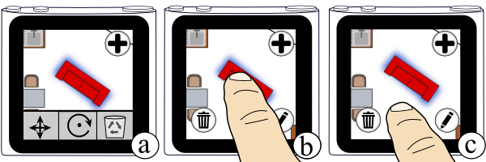

Figure 9: (a) A toolbar with buttons was replaced (b) with an interface relying on gestures instead hence providing more screen space. (c) The final version lets the user move the background instead of the couch thus eliminating the fat finger problem.

**Users lose the orientation when rotating the room**

At first, users needed to rotate the room instead of the selected piece of furniture. This design follows the same principles as the one chosen for moving furniture. During user testing two of our testers claimed that they had trouble orienting themselves after rotating the room. Therefore, we decided to rotate the piece of furniture instead. Although the first design seems more consistent then the solution we propose, the second design sticks to the rotation behavior known from other applications.

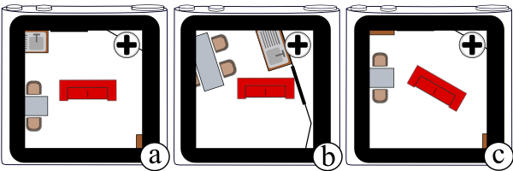

Figure 10: (a) The room (b) can be rotated using a two-finger rotation gesture to rotate the background. During rotation users tend to lose the orientation. (c) Therefore, the final version lets the user rotate the furniture itself.

**Laser range finders provide precise room measuring**

Our interviews revealed that the precision of the initial room measuring is important for an accurate digital reconstruction of the room. We were told that margins in single number centimeter range had to be met. Hence, many interior designers go so far to measure every project again to ensure quality—even if they received a blueprint from an architect.

We assessed several options for a mobile measuring solution. (a) Using manual input allowed us to acquire the needed precision. Our design featured various input methods. First we tried using native iOS number pickers but had to realize that user repeatedly overshot the desired numbers when using flicking gestures. (b) Our second approach featured regular text input by means of a numpad. However, we observed that users found it tedious to input every measurement by hand, especially for complex architectures. (c) Attaching a small laser range finder to the back of a device is our third proposal. Laser measurement tools provide enough accuracy for the task and the approach reflects what professional interior designers actually do. Adding a range finder requires a hardware prototype, which we haven’t built in this project.

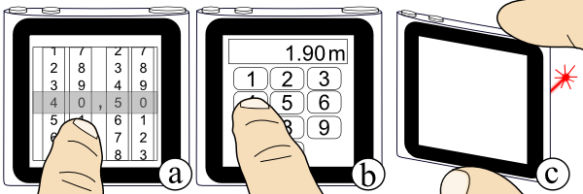

Figure 11: (a) Number picker. (b) Numpad. (c) Instead, we use the same tool as professionals and rely on precise laser range measuring.

**Displaying actions based on contextual awareness**

Following the lead of the industry tools we encountered during our contextual inquiry, we initially put buttons for deleting, editing and adding objects all on the screen at once. With this approach, we not only wasted space, but also found that we confused three out of four users when nothing happened, even though they clicked on delete or edit without selecting anything. Consequently, it is only necessary to make these actions available when a user has an active selection. (a) Our second design used replaced the button for adding new objects with the editing mode, because the user is focused on the current selection and only wants actions associated with it. (b) Finally, we settled for keeping the edit and add buttons separately in order to not mode anyone in. Regardless of the fact that there is an active selection, a user should have the opportunity to always add new objects to the scene.

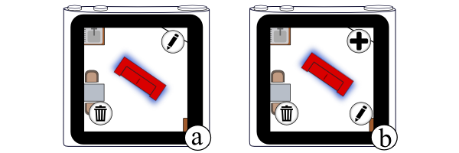

Figure 12: (a) A piece of furniture is selected and the button for adding objects is replaced with an editing mode icon. (b) The final version gives users the opportunity to always add new furniture regardless whether they selected anything in the first place.

**Using schematic textures instead of wireframes**

Our original design featured abstract black and white wireframes for every object in the room. Objects were hard to distinguish from each other and almost beyond recognition when zoomed in too far. Additionally, during user testing we learned that users prefer a more direct representation to imagine the room in all its details. The simple graphical representation also directly conflicted with our goal to provide an accurate and pleasing preview of a room. We solved this challenge by using schematic colored textures for all objects, hence making them easier to recognize and associate meanings with them. Users now have a better sense of their new room's look and know whether the added piece fits visually.

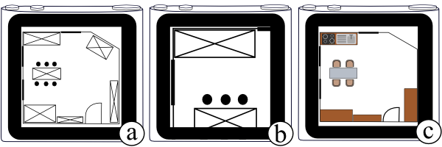

Figure 13: (a) Initially, all objects had wireframe texture applied to them. (b) When zoomed in, a lot of contextual information is lost. (c) The final version has fully colored textures.

**Users associate information elements as action elements**

During user testing we discovered that some testers tried to click on the circles next to the couch selection which represent the available color palette for this model. (a) Our primary screen featured round buttons with a distinctive black gradient towards the edge to provide a 3D effect commonly associated with buttons. To eliminate confusion we replaced the circles with strokes of a paintbrush to stress the right metaphor. (b)

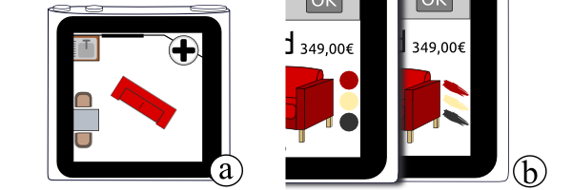

Figure 14: (a) Our main screen uses round buttons, which led users to believe they could click the color pallet. (b) Next to the couch selection menu we showed the available colors for a couch as circles. Displaying paintbrush strokes instead emphasized the color pallet metaphor better.

**<Two-way flicking area>**

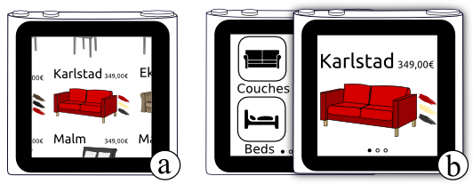

Figure 15: (a)

# Conclusion

In general, we wanted to provide a system with a rich feature set and still very discoverable interface. By relying on well-known gestures and adhering to iOS user-interface standards we feel confident that we achieved this goal.

In the process we learned that room tracing and object placement are the two most common tasks executed by interior designers. In this paper we outline a few possible options to tackle these challenges.

Interior designers profit a lot from precise input data. We approached this challenge by fitting a mini laser ranger finder unit into our device.

In the future the system could be expanded by a 3D rendering component to provide realistic previews. Both, professional designers and casual users, could benefit from that.

# REFERENCES

1. iOS Human Interface Guidelines: iOS UI Element Usage Guidelines, section *Page Indicator*, p. 122. http://developer.apple.com/library/ios/ documentation/UserExperience/Conceptual/ MobileHIG/MobileHIG.pdf
2. Ikea Kitchen Planner.  
   http://www.ikea.com/ms/en_AA/rooms_ideas/splashplanners.html
3. Vogel, D. and Baudisch, P. Shift: A Technique for Operating PenBased Interfaces Using Touch. Proc. CHI ’07, 657-666.

1. CAD = Computer-aided design