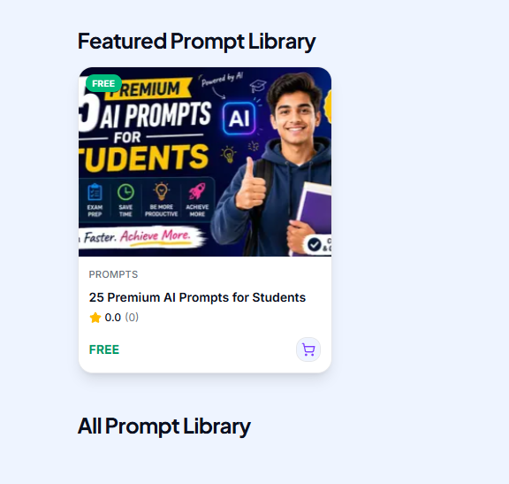
The picture is not cropping properly. I need this to be properly done.

Here three images are coming from media in product editor I don’t need multiple images. Until it’s needed. For that sort of product I will be using preview feature.

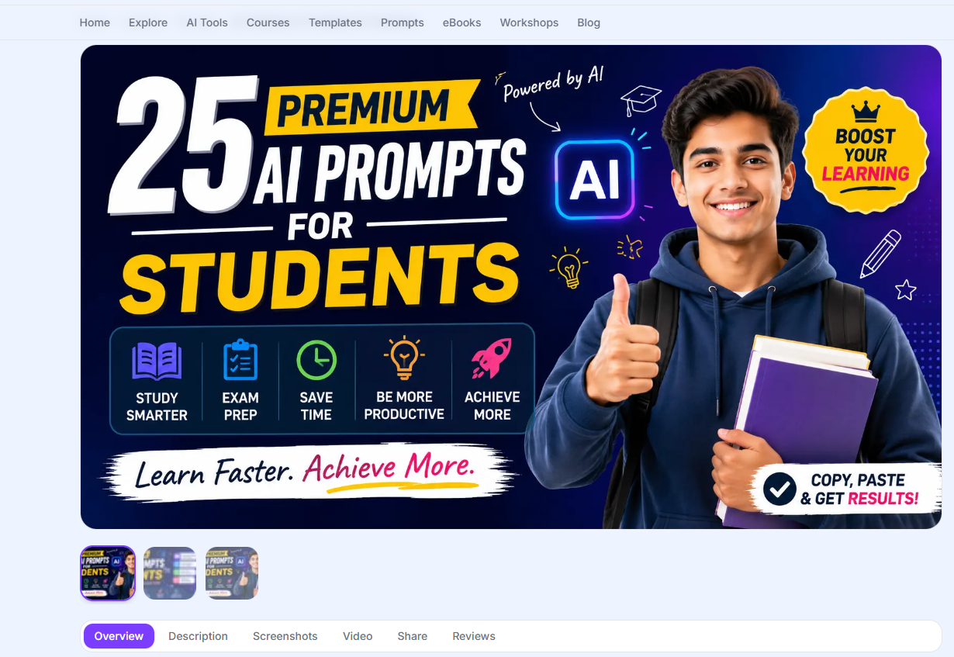

Also in product editor don’t know why I have product type and category both because of this on website though this is prompt liabrary it’s not coming as . because of that it’s not flowing properly. So remove the product type.

Check media section and then actual site and see all image size are properly aligned so if I put any image it will be cropped properly. It’s fine to have small image on computer.

Also when I shared from below it’s lagged very much not even allowed to share from whats app. And no favicon came. I don’t need to put favicon every product , it will take my website favicon and I add when needed.
I want you to thourouly audit all admin panel features again and main impotant product editor so don’t left any small issue.

