Heart Disease Model Optimization and Ethical Evaluation
Subba Taniparti, Harini Mamidala, Christian Gaston, and Bellary Naveen Vishal
Department of Computer and Information Sciences, University of the Cumberlands
PhDAI 733-A02: Python Application for Data Analytics in AI
Dr. Karriem Perry
October 16, 2026

Heart Disease Model Optimization and Ethical Evaluation

Problem, Dataset, and Model Recap
This project evaluates a Python classification prototype for identifying existing coronary artery disease in a historical Cleveland referral cohort. It does not predict future cardiovascular events or diagnose acute myocardial infarction. The proposed application is a clinician-reviewed worklist after cardiac investigations, prioritizing completed cases for review. Patients, clinicians, and service managers would be affected by missed cases, unnecessary review, and limited review capacity. The results support further research, rather than clinical deployment.
The analysis uses a mirrored CSV derived from the UCI Heart Disease dataset (Janosi et al., 1989). One exact duplicate was removed, leaving 302 records and 13 predictors. The original UCI outcome distinguishes absence from levels of disease; the mirrored file contains a binary target, which the project reverses as disease = 1 − target. The resulting positive class represents disease presence. Overall prevalence is 45.7%; subgroup prevalence is 25.0% for sex = 0 and 55.3% for sex = 1. These observations motivated stratified evaluation and subgroup auditing, but do not establish why subgroup errors differ.
The mirror contains no pandas-recognized missing values, although this does not establish the completeness of the original source records or the meaning of exceptional category codes. Five categorical variables were dummy encoded, expanding the input to 22 features. Five continuous variables were standardized within a ColumnTransformer and model pipeline. Encoding used pd.get_dummies before splitting, whereas scaling was fitted within training folds. A stronger implementation would fit categorical encoding within the pipeline as well. Predictors include vessel count measured by fluoroscopy and thallium stress-test results, so this feature set is unsuitable for early screening before specialized investigations.

Hyperparameter Tuning
Regularized logistic regression and random forest were compared using scikit-learn (Pedregosa et al., 2011). Logistic regression provides a compact linear classifier; random forest tests whether nonlinear relationships improve discrimination. GridSearchCV optimized ROC-AUC using five stratified inner folds. Logistic regression searched C values of 0.01, 0.1, 1, 10, and 100. Random forest searched 100 or 300 trees, maximum depths of 3, 5, or unlimited, and minimum leaf sizes of 1, 3, or 5, totaling 18 combinations. Five stratified outer folds evaluated the tuning procedures (scikit-learn developers, n.d.-b).
Table 1
Nested and Non-Nested Model Discrimination
Model | Nested AUC | Fold SD | Non-nested AUC
Logistic regression | .9102 | .0431 | .9169
Random forest | .8858 | .0388 | .9008
Note. Nested AUC is the mean area under the ROC curve across five outer folds. Fold SD is the standard deviation across those folds and is not a confidence interval. Non-nested AUC is the best inner-loop score obtained on the full dataset.
As Table 1 shows, logistic regression had the higher mean nested ROC-AUC. Differences from non-nested scores are consistent with selection optimism, but this comparison does not establish that search-space size caused the difference. Nested evaluation used all 302 records, including the original test patients, so the subsequent test result is not an independent confirmation of model selection. The final training-set search selected C = 1.

Final Model Evaluation
The original stratified 75/25 split used random seed 42, producing 226 training records and 76 test records, including 35 disease cases. At threshold .50, the logistic model produced 28 true positives, 35 true negatives, seven false negatives, and six false positives. ROC-AUC was .9261. Table 2 compares the default threshold with an exploratory lower threshold; supporting plots appear in the appendix.
Table 2
Performance at Default and Exploratory Thresholds
Measure | Default .50 | Exploratory .16
Accuracy | .829 | .789
Precision | .824 | .686
Recall | .800 | 1.000
F1 | .812 | .814
Specificity | .854 | .610
Missed cases | 7 | 0
False alarms | 6 | 16
Flagged patients | 34 of 76 | 51 of 76
Note. Values come from the 76-patient test partition. Flagged patients are those predicted positive at the stated threshold. The .16 threshold was selected using test outcomes and is therefore exploratory.
The Brier score was .1105. A five-bin quantile calibration plot showed absolute differences between predicted and observed frequencies of approximately .036 to .085 (Figure A1). With about 15 patients per bin, this is preliminary calibration evidence. A constant prediction using test prevalence yields an illustrative Brier score of .2484; it is a descriptive benchmark rather than a fitted baseline. Neither a low Brier score nor the plot establishes reliable individual clinical probabilities.
The notebook searched thresholds from .05 to .95 in increments of .01, minimizing C × false negatives + false positives. Equal costs selected .57, with seven missed cases and three false alarms. Assumed missed-case costs of two or more times false-alarm costs selected .16. Compared with .50, this detected seven additional disease cases while adding ten false alarms and 17 review requests (Figure A2). F1 changed little, illustrating why error counts and workload matter alongside summary metrics.
These thresholds were selected and evaluated using the same test outcomes and must remain exploratory (scikit-learn developers, n.d.-c). Zero observed misses among 35 cases does not guarantee zero future misses. ROC-AUC is unchanged by threshold adjustment. The reported fold SD describes variation across five folds, not a confidence interval; the report does not establish statistically significant superiority or provide independently validated uncertainty intervals.

Ethical Considerations
At .50, recall was .714 for sex = 0 and .821 for sex = 1. Lowering only the sex = 0 threshold to .30 raised recall to .857, recovering one of seven subgroup disease cases while adding one false alarm. Across 30 overlapping resampled splits, retrospectively chosen thresholds averaged .336 (SD = .157), ranging from .05 to .50. The rule selected the highest searched threshold achieving recall at least as high as sex = 1 recall, rather than exact equality (Figure A3). Because each threshold used its split’s test labels, this is an instability analysis, not independent validation of a fairness remedy.
Sex is included both as a predictor and as an auditing attribute. Removing it would not by itself establish fairness, and retaining it requires an explicit justification and subgroup monitoring (Rajkomar et al., 2018). Sex-specific troponin studies illustrate that identifying more patients does not automatically improve treatment or outcomes; they do not validate subgroup thresholds for this classifier (Lee et al., 2019). No subgroup correction is adopted here. Future evaluation should report case counts, recall, false-positive rates, and uncertainty, and examine whether flagged patients actually receive follow-up (Chen et al., 2019).
The public historical dataset does not establish consent or authorization for the proposed clinical deployment. Any future local patient data should have restricted access, encrypted storage, defined retention, and identifiers separated from model inputs. Institutional governance should determine permissible use. Population imbalance, historical care practices, and absent demographic information limit the scope of the fairness audit.

Real-World Application
A feasible workflow begins after required cardiac investigations are complete. Clinical staff verify the inputs, the model assigns a score, and an authorized clinician reviews the resulting worklist alongside ordinary clinical information. The score would prioritize review rather than replace diagnosis, discharge decisions, or existing care pathways. The intended benefit is more consistent review prioritization under capacity constraints; the project has not demonstrated improved outcomes, reduced costs, or faster treatment.
The operating threshold must reflect the consequences of delayed review, unnecessary review, and available capacity. In this sample, lowering the threshold increased the flagged proportion from 44.7% to 67.1%. The assumed cost ratios are scenarios rather than preferences elicited from clinicians or patients. Service managers would need to assess whether this workload is feasible and whether prioritization actually improves care.
Development should first correct implementation errors and separate selection from evaluation. Preprocessing, model comparison, calibration adjustments if needed, and threshold selection should occur within development data. The locked workflow then needs evaluation on an independent contemporary cohort. A silent evaluation could compare proposed priorities with current practice before influencing care. A later pilot would require institutional approval, clinician training, clear escalation procedures, and monitoring of calibration, missed cases, false alarms, subgroup performance, and population change.
The notebook’s coefficient table originally assigned input dataframe labels to the transformed coefficient vector. ColumnTransformer emits the scaled continuous columns before the passthrough remainder, so seven of 22 labels were displaced, and the value reported as maximum heart rate was in fact the coefficient for sex. Labels are now taken from the fitted transformer’s get_feature_names_out method (scikit-learn developers, n.d.-a). With correct labels, maximum heart rate carries a coefficient of −.345, consistent with its negative marginal association, and the previously reported sign reversal does not exist. Correctly labeled coefficients represent conditional associations rather than causal effects. Explanations shown to clinicians must identify the input measurements, uncertainty, and limits of the model.

Final Thoughts and Conclusion
Logistic regression remained the stronger candidate by mean nested ROC-AUC. Threshold exploration showed how similar F1 scores can conceal different missed-case counts and review demands. Subgroup experiments showed that very small case counts produce unstable retrospective threshold adjustments. These findings support reporting discrimination, calibration, error counts, workload, and uncertainty together.
The main limitations are the small historical cohort, full-cohort model comparison before the later test evaluation, and test-selected thresholds. The coefficient-labeling error found during review has been corrected. The next steps are to fit all preprocessing within development folds, select thresholds without test outcomes, and validate the locked procedure independently. The contribution is an evaluated research prototype and a concrete account of what remains necessary before clinical use.

Teamwork and Documentation
Group 8 coordinated through WhatsApp, developed analysis in shared Google Colab notebooks, and synchronized artifacts to GitHub. Christian Gaston led the problem recap, application discussion, and assembly; Subba Taniparti led tuning and evaluation metrics; Harini Mamidala contributed evaluation figures and the conclusion; Bellary Naveen Vishal led ethics and team documentation. The decision log records contributions because synchronized commits do not capture all individual authorship.
The repository records the nested-evaluation and threshold-selection caveats. The coefficient-labeling error was found during drafting and corrected in the notebook, which was then rerun; every other stored output was unchanged by the correction, so the figures and metrics reported here are unaffected. Reproducibility also requires recording Python and package versions, pinning the dataset source, identifying the final commit, and documenting figure regeneration. The final report should accompany the executed notebook as the authoritative Part 2 submission.

References
Chen, I. Y., Szolovits, P., & Ghassemi, M. (2019). Can AI help reduce disparities in general medical and mental health care? AMA Journal of Ethics, 21(2), E167–E179. https://doi.org/10.1001/amajethics.2019.167
Janosi, A., Steinbrunn, W., Pfisterer, M., & Detrano, R. (1989). Heart disease [Data set]. UCI Machine Learning Repository. https://doi.org/10.24432/C52P4X
Lee, K. K., Ferry, A. V., Anand, A., Strachan, F. E., Chapman, A. R., Kimenai, D. M., Meex, S. J. R., Berry, C., Findlay, I., Reid, A., Cruickshank, A., Gray, A., Collinson, P. O., Apple, F. S., McAllister, D. A., Maguire, D., Fox, K. A. A., Newby, D. E., Tuck, C., . . . Mills, N. L. (2019). Sex-specific thresholds of high-sensitivity troponin in patients with suspected acute coronary syndrome. Journal of the American College of Cardiology, 74(16), 2032–2043. https://doi.org/10.1016/j.jacc.2019.07.082
Pedregosa, F., Varoquaux, G., Gramfort, A., Michel, V., Thirion, B., Grisel, O., Blondel, M., Prettenhofer, P., Weiss, R., Dubourg, V., Vanderplas, J., Passos, A., Cournapeau, D., Brucher, M., Perrot, M., & Duchesnay, É. (2011). Scikit-learn: Machine learning in Python. Journal of Machine Learning Research, 12, 2825–2830. https://jmlr.org/papers/v12/pedregosa11a.html
Rajkomar, A., Hardt, M., Howell, M. D., Corrado, G., & Chin, M. H. (2018). Ensuring fairness in machine learning to advance health equity. Annals of Internal Medicine, 169(12), 866–872. https://doi.org/10.7326/M18-1990
scikit-learn developers. (n.d.-a). ColumnTransformer. scikit-learn. https://scikit-learn.org/stable/modules/generated/sklearn.compose.ColumnTransformer.html
scikit-learn developers. (n.d.-b). Nested versus non-nested cross-validation. scikit-learn. https://scikit-learn.org/stable/auto_examples/model_selection/plot_nested_cross_validation_iris.html
scikit-learn developers. (n.d.-c). Tuning the decision threshold for class prediction. scikit-learn. https://scikit-learn.org/stable/modules/classification_threshold.html

Appendix

Evaluation Figures
Figure A1
Calibration and Predicted Disease Probabilities
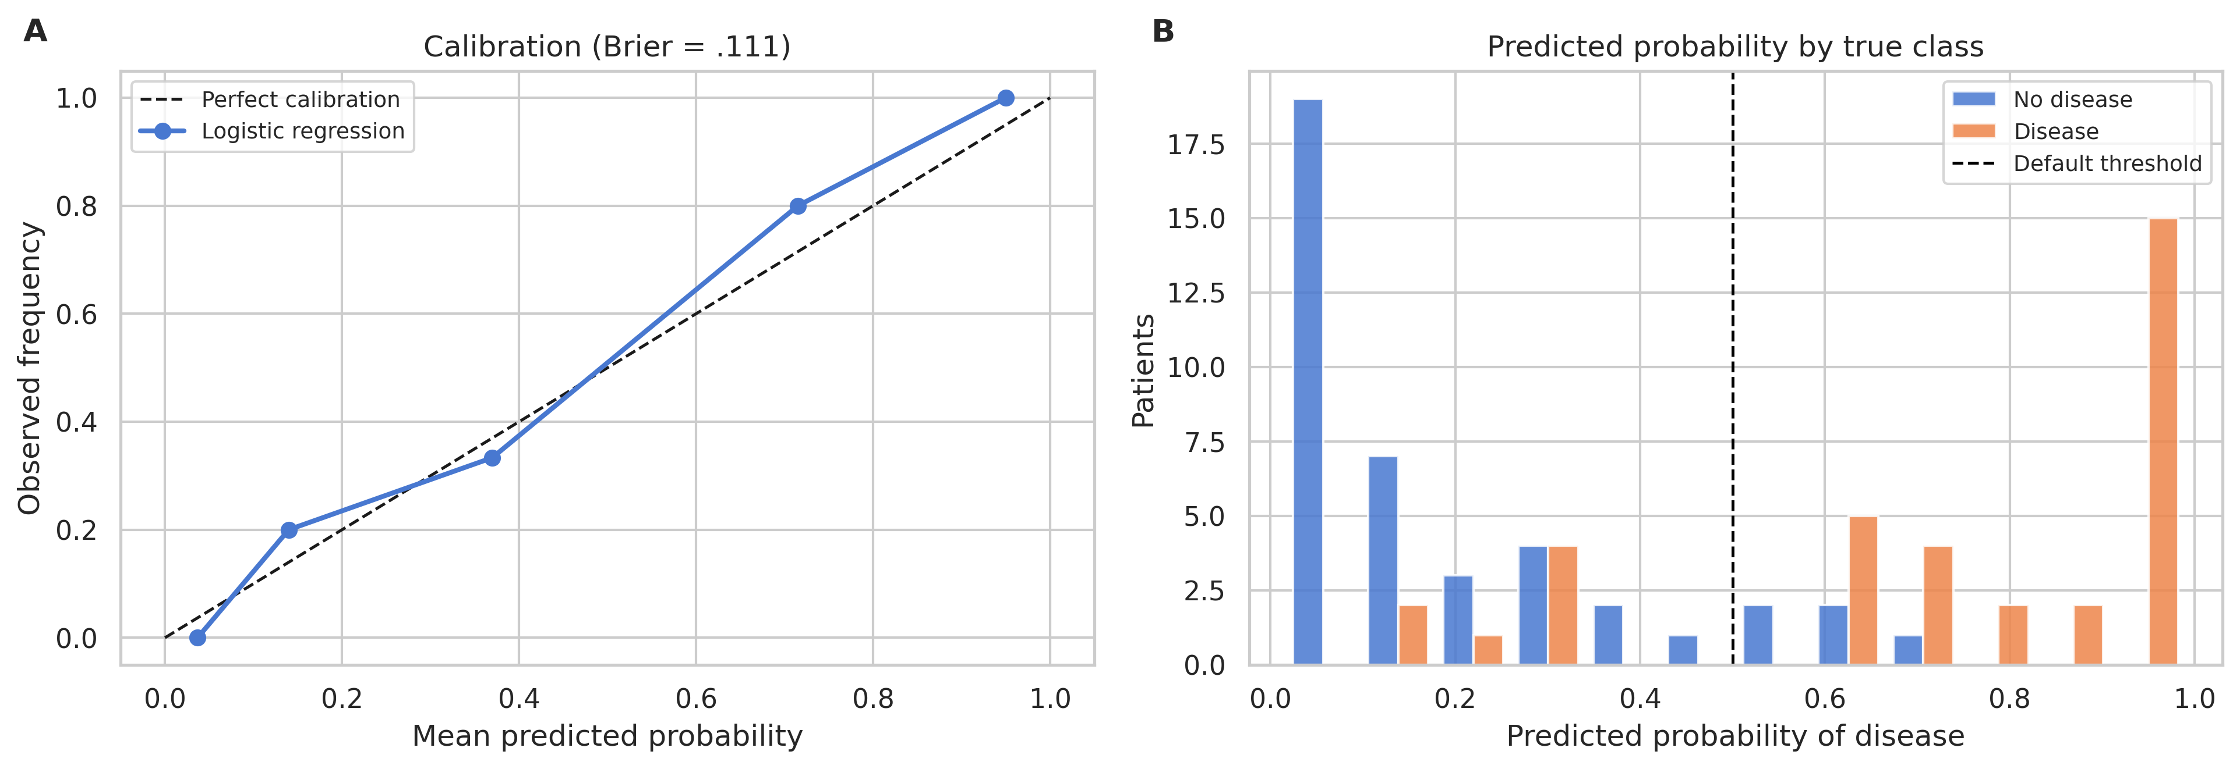
Note. Five quantile bins summarize calibration in 76 test patients. Brier score = .1105. The small sample does not establish clinical calibration.

Figure A2
Confusion Matrices at Default and Exploratory Thresholds
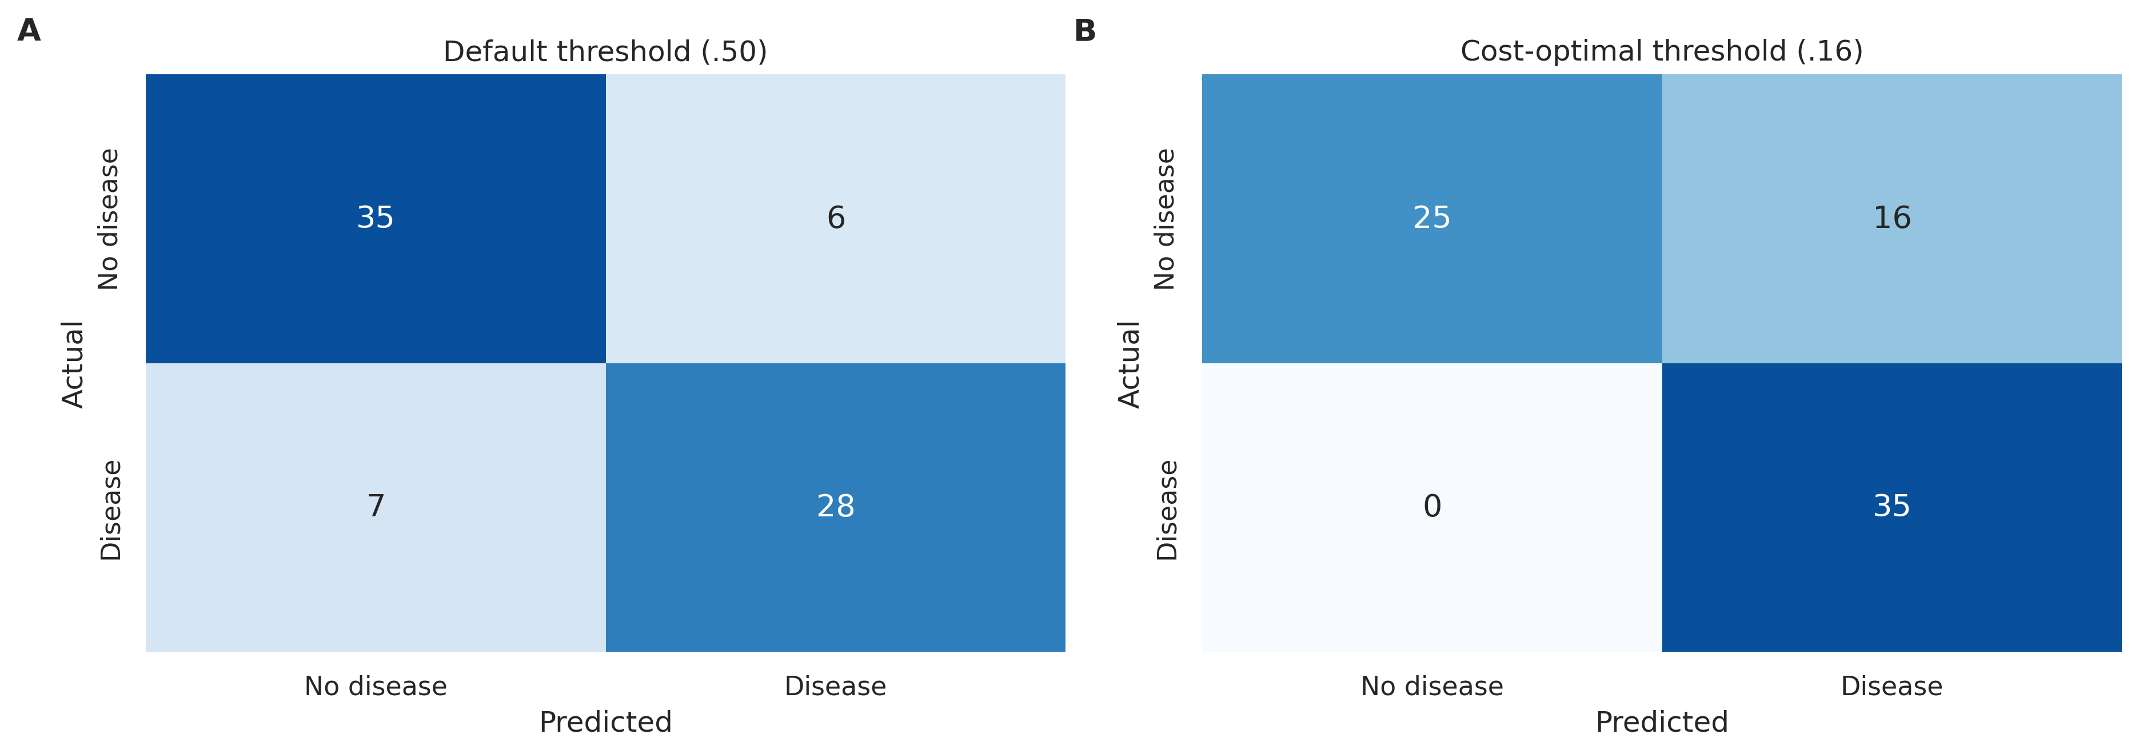
Note. The .16 threshold was selected using test outcomes. Compared with .50, it adds ten false alarms and recovers seven disease cases. These results require independent validation.

Figure A3
Retrospective Subgroup Thresholds Across Resampled Splits
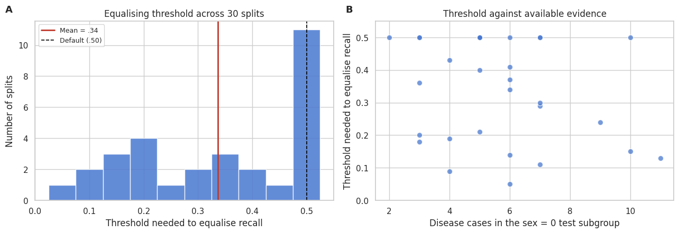
Note. Across 30 overlapping splits, thresholds achieving at least the comparison-group recall ranged from .05 to .50. Each threshold used that split’s test labels; this plot demonstrates instability rather than a validated fairness correction.

