Predicting Heart Disease Risk: A Clinical Decision-Support Prototype

Group 8: Subba Taniparti, Harini Mamidala, Christian Gaston, and Naveen Vishal
Department of Computer and Information Sciences, University of the Cumberlands
PhDAI 733-A02: Python Application for Data Analytics in AI
Dr. Karriem Perry
September 27, 2026

Predicting Heart Disease Risk: A Clinical Decision-Support Prototype
Heart disease kills more people than anything else, and catching it early changes what happens to patients. The hard part is not treatment but deciding who to send for further testing. Cardiology referrals and angiograms are expensive and invasive, so sending everyone with chest pain is not realistic, but sending too few means disease goes undetected. We built a prototype that estimates heart-disease risk from thirteen measurements a clinic already collects, using the Cleveland cohort of the UCI Heart Disease dataset (n = 302 after removing a duplicate; Janosi et al., 1989). It is meant to support triage, not to diagnose anyone. We asked three questions: do these measurements beat a naive baseline (RQ1), does a more flexible model beat a simpler one on a dataset this small (RQ2), and does the model work equally well for different patient groups (RQ3)?
Three groups have a stake in this. Clinicians need a risk score they can understand well enough to act on, and to disagree with. Patients carry the two kinds of error very unevenly: a false alarm costs them an unnecessary appointment, while a missed case can mean coronary disease goes untreated. Health systems need triage that puts limited specialist time where it matters. Because those costs are so uneven, we report recall and the confusion matrix alongside accuracy, and we treat the fairness check as seriously as the model comparison.
Dataset Exploration and Preprocessing
Validating the label encoding
The single most important thing we did was check what the target column actually means. This dataset circulates in several copies that do not agree on the convention, so instead of assuming, we tested it against what cardiology would predict. Four measurements have a clear expected direction: patients with disease reach a lower maximum heart rate, show more ST depression, have more blocked vessels on fluoroscopy, and more often get chest pain during exercise.
All four pointed the same way, and all four contradicted the usual assumption. Patients coded target = 0 had a lower maximum heart rate (139.10 vs. 158.38 bpm), more ST depression (1.59 vs. 0.59), more affected vessels (1.17 vs. 0.34), and far more exercise-induced angina (55.1% vs. 14.0%). So in this file target = 0 denotes disease and target = 1 means they do not. We defined a separate disease variable and used that throughout. Had we gone with the usual reading, every clinical conclusion here would have come out backwards, including what recall means and the whole fairness section.
Cleaning and encoding
Nothing is missing in this dataset, so there was nothing to impute. The forward-fill the hints suggest would have been wrong here anyway, since it assumes the row order means something and these records are not ordered in any clinical way. We did remove one exact duplicate, taking us from 303 to 302 patients. Left in, that patient could land in both the training and test sets and make the model look better than it is.
A second problem does not show up in summary statistics at all: five of the predictors are categories stored as numbers. Chest pain type runs 0 to 3 for four different presentations, and type 3 is not three times type 1. Because pandas sees these as numeric, calling get_dummies on the raw data encodes nothing at all and hands back the same dataframe with no warning. Converting those five to categorical first took us from 13 predictors to 22.
Scaling departs deliberately from the assignment hints, which apply StandardScaler to everything before splitting. That fits the scaler using test rows, which lets information from the test set bleed into training and makes the results look better than they are. We put the scaler inside a scikit-learn Pipeline instead (Pedregosa et al., 2011) so it only ever sees training data, and applied it to the five continuous variables only, since scaling a 0/1 indicator just muddies what it means. The team agreed on this and we logged it in the repository.
Figure 1
Class Balance and Distribution of Two Leading Predictors by Outcome
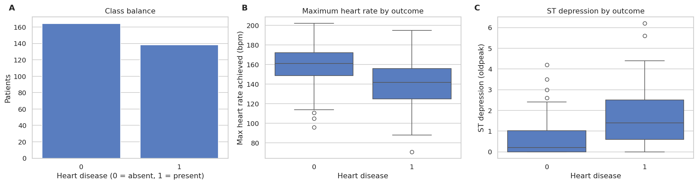
Note. Panels B and C share plot type and axis conventions, so the two predictors are directly comparable. Disease prevalence is 45.7%, balanced enough that accuracy is usable but insufficient alone given asymmetric error costs. Both predictors separate the classes in the clinically expected direction, confirming the label correction was applied correctly, while the substantial overlap signals that no single predictor suffices and a multivariate model is warranted.
Figure 2
Correlation Structure and Association of Each Predictor With Disease
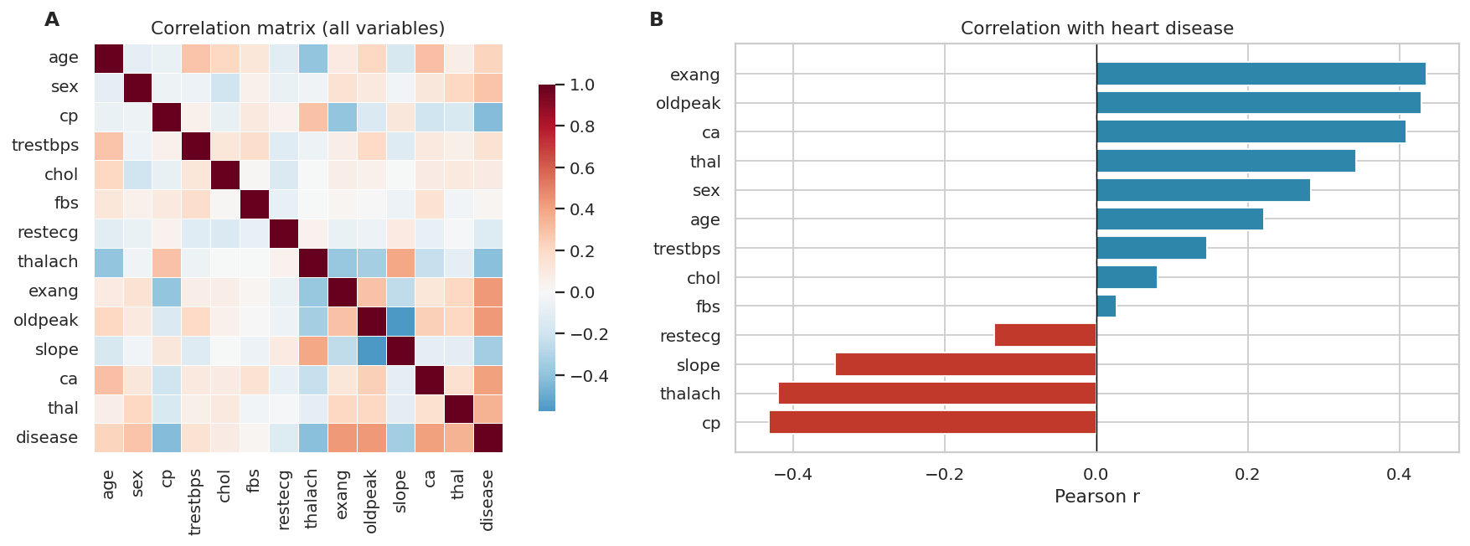
Note. Panel A shows no block of near-collinear predictors of the kind that destabilises regression coefficients, supporting retention of all thirteen. Panel B confirms every association runs in the clinically expected direction, a second independent check on the label correction. No predictor exceeds an absolute correlation of .45, so predictive performance must come from combining weak signals rather than from any dominant variable.

Initial Model Development
We compared two models against a baseline that always predicts the majority class. That baseline is not a formality: saying no disease to everyone scores 54.0% accuracy while finding nobody, so every accuracy figure below should be read against that. We picked logistic regression because it gives honest probabilities and coefficients a clinician can actually look at and argue with, which matters if anyone is going to use this. We picked random forest because cardiac risk factors interact, and ensembles pick up interactions without being told about them.
Both were tuned with grid search and five-fold cross-validation, using the training data only. We tuned on ROC-AUC rather than accuracy because it measures how well a model ranks patients across every possible cut-off. For a triage tool the cut-off should eventually be set by what the errors cost a clinic, not left at 0.5, so ranking well matters more than being right at one arbitrary threshold.
Logistic regression came out at 82.9% accuracy, .800 recall, and .926 ROC-AUC on held-out data. The random forest managed 77.6%, .714, and .867. A 76-patient test set is thin evidence, so we refit both across 30 different splits. Logistic regression won 26 of the 30, averaging 84.3% against 80.4%, so this is not one lucky split. The two models looked nearly identical in cross-validation (.911 vs. .904) but pulled apart on held-out data (.926 vs. .867), which is what it looks like when the more flexible model has memorised noise. That matches H2: with 226 training patients and 22 features, the forest has little room to use its extra flexibility well.
Figure 3
ROC Curves for Both Tuned Models on the Held-Out Test Set
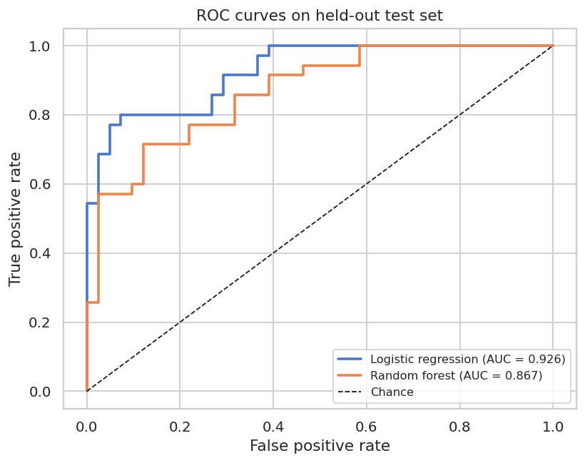
Note. The curves separate across most of the range, with logistic regression above the forest nearly everywhere. Because a triage threshold should be set by clinical cost rather than left at 0.5, this whole-range view is more decision-relevant than performance at any single cut-point.
Figure 4
Confusion Matrices for Both Tuned Models on the Held-Out Test Set
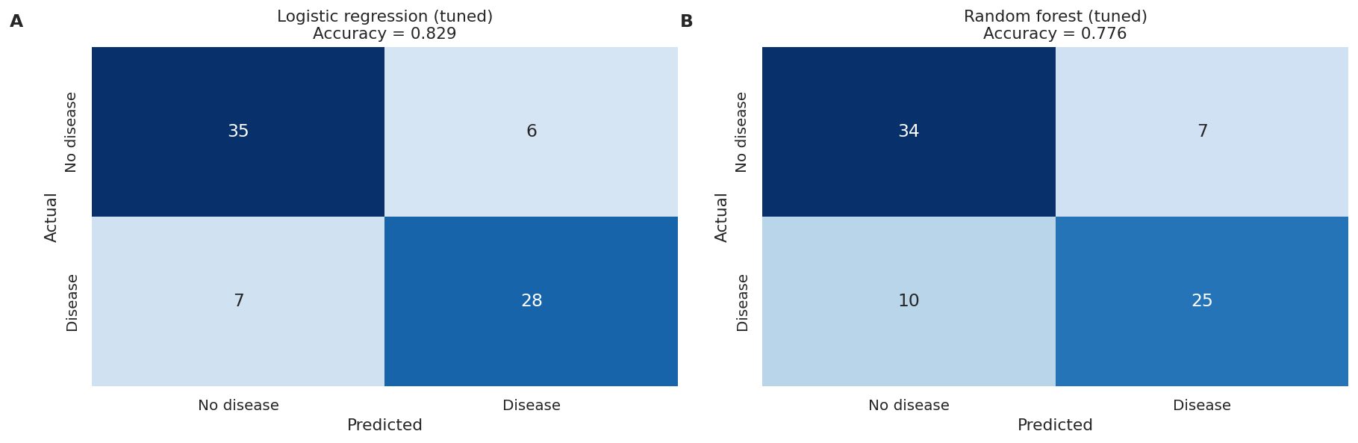
Note. Panels share layout, class ordering, and colour scale, so only the model varies. The bottom-left cell counts patients with disease classified as healthy: 7 for logistic regression against 10 for the random forest. These are not interchangeable with the 6 and 7 false alarms in the top-right cell, since a false alarm costs a consultation while a missed case may mean untreated coronary disease.
Ethics and Impact
The dataset records patient sex as a binary code, but does not document which value means which sex. We therefore report the groups as sex = 0 and sex = 1 and make no claim about which population each represents. We can show that performance differs; we cannot say for whom.
Breaking performance down by subgroup revealed something the overall numbers hide. For sex = 0 the model was more accurate (.917 vs. .788) but caught fewer actual cases (recall .714 vs. .821). Recall is what matters clinically: of the seven patients in that group who had disease, the model called two of them healthy. Judging by accuracy alone, this would have looked like the group the model handled best. The cause is prevalence rather than the sex variable itself. Only 25.0% of sex = 0 patients have disease, against 55.3% of sex = 1. When disease is rare in a group, a model scores well simply by leaning toward "no disease", and that same lean is what causes it to miss real cases. With just 96 patients in that group, roughly 24 of them with disease, there is also not much for the model to learn from. This is also why dropping sex from the inputs would not fix anything: the prevalence gap would remain, the other clinical variables still track sex, and we would lose the only means of spotting the problem.
We want to be careful about how strongly to state this. Across 30 splits, recall for sex = 0 was lower in 19, higher in 10, and tied in one, averaging a gap of -0.090 with a standard deviation of 0.184. The direction holds more often than not, but the spread is wide because each split leaves only about seven disease cases in that group. We therefore treat this as a real signal worth investigating, not a proven bias — seven cases cannot support a stronger claim. If this tool were deployed as it stands, it would under-refer sex = 0 patients while its high accuracy on that group suggested it was doing well. That is the practical case for building subgroup checks into model selection rather than running them at the end, if at all.
Figure 5
Subgroup Recall by Model and Stability of the Recall Gap Across 30 Splits
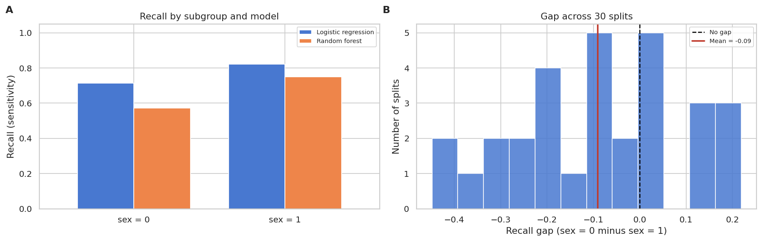
Note. Panel A shows both models detect disease less reliably for sex = 0 despite that subgroup's higher accuracy. Panel B shows the gap is directionally consistent but noisy: lower recall for sex = 0 in 19 of 30 splits, with a standard deviation of 0.184 reflecting roughly seven disease cases per subgroup per split. The width of this distribution is itself the finding — it is why we report a signal rather than a confirmed disparity.
Limitations
With 302 patients and only 76 in the test set, every number here carries real uncertainty, which is why we leaned on 30 splits instead of testing significance on one. The subgroup analysis is the weakest part: sex = 0 has about 24 disease cases in total and roughly seven per split, enough to spot a big gap but not to measure a moderate one. The data comes from one hospital in 1989, so it should not be assumed to carry over to patients or practice today. Our hyperparameter grids are coarse, though the model ranking held across all 30 splits, so a finer search probably would not flip it. Everything here is prediction, not cause: none of it says that changing a measurement would change a patient's outcome.

Team Collaboration Process
[TO BE COMPLETED BY THE TEAM BEFORE SUBMISSION]
References
Janosi, A., Steinbrunn, W., Pfisterer, M., & Detrano, R. (1989). Heart disease [Data set]. UCI Machine Learning Repository. https://doi.org/10.24432/C52P4X
Pedregosa, F., Varoquaux, G., Gramfort, A., Michel, V., Thirion, B., Grisel, O., … Duchesnay, E. (2011). Scikit-learn: Machine learning in Python. Journal of Machine Learning Research, 12, 2825-2830.

