Predicting Heart Disease Risk: A Clinical Decision-Support Prototype

Group 8: Subba Taniparti, Harini Mamidala, Christian Gaston, and Bellary Naveen Vishal
Department of Computer and Information Sciences, University of the Cumberlands
PhDAI 733-A02: Python Application for Data Analytics in AI
Dr. Karriem Perry
September 27, 2026

Predicting Heart Disease Risk: A Clinical Decision-Support Prototype
Heart disease kills more people than anything else, and catching it early changes outcomes. The hard part is not treatment but deciding who to send for further testing: referrals and angiograms are expensive and invasive, so sending everyone with chest pain is unrealistic, while sending too few lets disease go undetected. We built a prototype estimating heart-disease risk from thirteen measurements a clinic already collects, using the Cleveland cohort of the UCI Heart Disease dataset (n = 302 after removing a duplicate; Janosi et al., 1989). We ask whether these measurements beat a naive baseline (RQ1), whether a flexible model beats a simpler one at this sample size (RQ2), and whether the model works equally well across patient sex (RQ3).
Two of the predictors constrain where this can sit in a clinical pathway. Fluoroscopy vessel count requires angiography, and the thalassemia scan requires nuclear perfusion imaging, so the model cannot screen undiagnosed patients. It operates on results already available once a cardiac workup is complete, which makes it a prioritisation aid for review and follow-up among patients who have been investigated, not a front-door triage tool. Deployment would be a ranked worklist inside an existing health record, showing a risk tier beside the values producing it, with a clinician who can always overrule it. Because a false alarm costs an appointment while a missed case can mean untreated disease, we report recall and the confusion matrix rather than leading with accuracy.
Dataset Exploration and Preprocessing
The most important thing we did was check what the target column means. This dataset circulates in copies that disagree on the convention, so we tested it against cardiology rather than assuming. Patients with disease should show a lower maximum heart rate, more ST depression, more blocked vessels, and more exercise-induced angina. All four markers pointed the same way and all four contradicted the usual reading: patients coded target = 0 had lower maximum heart rate (139.10 vs. 158.38 bpm), more ST depression (1.59 vs. 0.59), more affected vessels (1.17 vs. 0.34), and far more exercise angina (55.1% vs. 14.0%). In this file target = 0 means disease. Had we accepted the usual reading, every clinical conclusion here would have come out backwards, including the fairness finding. We defined a separate disease variable accordingly; 138 patients (45.7%) have disease.
Nothing is missing, so there was nothing to impute; the forward-fill the hints suggest assumes row order carries meaning, which it does not here. One exact duplicate was removed (303 to 302 patients), since a repeated patient could otherwise land in both training and test sets. Cholesterol reaches 564 mg/dL and resting pressure 200 mm Hg, but four patients exceed 400 mg/dL and five sit at or above 180, so these are plausible referral-population patients rather than errors. Trimming them would discard exactly the high-risk cases the tool exists to surface, so we kept them and let scaling limit their leverage.
A second problem is invisible in summary statistics: five predictors are categories stored as numbers. Chest pain type runs 0 to 3 for four presentations, and type 3 is not three times type 1. Because pandas sees them as numeric, get_dummies on the raw data encodes nothing and returns the same dataframe without warning. Casting those five to categorical first took us from 13 predictors to 22 features. Finally, the hints scale before splitting, which lets test-set statistics bleed into training; we put the scaler inside a scikit-learn Pipeline (Pedregosa et al., 2011) so it only ever sees training folds, applied to the five continuous variables alone. Figure A1 shows the resulting class balance and the two strongest predictors.

Initial Model Development
We compared logistic regression and random forest against a majority-class baseline, all inside identical pipelines. The baseline matters: predicting no disease for everyone scores 54.0% while finding nobody. Logistic regression was chosen for coefficients a clinician can inspect and argue with; random forest for interactions it can capture unprompted. Both were tuned by grid search with five-fold stratified cross-validation on training data only, optimising ROC-AUC because a triage threshold should eventually reflect what errors cost a clinic rather than stay at 0.5.
Logistic regression reached 82.9% accuracy, .800 recall, and .926 ROC-AUC; the forest managed 77.6%, .714, and .867. Because 76 test patients is thin evidence, we refit both across 30 splits: logistic regression won 26 of 30, averaging 84.3% against 80.4%. The two were nearly tied in cross-validation (.911 vs. .904) but separated on held-out data, which is what it looks like when the flexible model has memorised noise — with 226 training patients and 22 features, the forest has little room to use its flexibility well. Figure A2 shows both confusion matrices; logistic regression missed 7 disease cases against the forest's 10.
Ethics and Impact
A triage tool changes who gets seen and who waits, so the ethical weight sits in its errors rather than its accuracy. The first obligation is documentary. Because this dataset circulates in copies that disagree on the target convention, and the canonical repository record (Janosi et al., 1989) uses the opposite one to the file we used, a reader who downloads from that source and runs our code unchanged would build a model that ranks healthy patients as urgent and sends patients with disease home. We therefore name the exact file rather than the dataset: the CSV used here was retrieved on 23 September 2026 from https://raw.githubusercontent.com/sharmaroshan/Heart-UCI-Dataset/master/heart.csv, and its polarity was verified against clinical markers before modelling. In a clinical context reproducibility is a safety property, not a formality.
Disaggregating by sex exposed what aggregate numbers conceal. For the sex = 0 subgroup, which the coding and prevalence figures indicate is female, the model was more accurate (.917 vs. .788) yet detected fewer true cases (recall .714 vs. .821); of seven patients in that subgroup with disease, two were classified as healthy. The mechanism is prevalence rather than the sex variable: 25.0% of sex = 0 patients have disease against 55.3% of sex = 1, and when a condition is less common in a group a model scores well there by leaning negative, which is the same lean that misses cases. This result is uncomfortable because it is not novel. Coronary disease in women has been documented as under-recognised and undertreated for decades (Mosca et al., 2011), and a model trained on records generated inside that environment inherits the pattern rather than correcting it, which is the general lesson that health algorithms reproduce whatever the historical data rewarded (Obermeyer et al., 2019). Our estimate is also fragile: across 30 splits the gap favoured sex = 1 in 19, with a standard deviation of 0.184. That spread reflects how little data sits behind the sex = 0 estimate: a test split leaves about six disease cases in that subgroup against roughly 29 for sex = 1. We therefore describe a signal warranting investigation on a larger and more current cohort rather than a demonstrated disparity (Figure A3).
We retained the sex variable deliberately. Removing it would not close the prevalence gap, several retained predictors correlate with sex, and the model would continue behaving differently across groups while we lost the ability to measure it — fairness through unawareness fails for exactly this reason, since auditing subgroup performance requires keeping the attribute available for evaluation (Rajkomar et al., 2018). Deleting it would have produced a cleaner-looking paper and a less safe tool. Accordingly this prototype is a prioritisation aid, not a diagnostic instrument: no patient should receive or be denied testing on its output alone. The cohort is 302 patients from a single 1989 referral population who did not consent to training a deployed clinical system. A screening version usable before a workup would have to be retrained on non-invasive predictors alone and would likely perform worse, since two of the strongest features here come from imaging. Any real use would require local validation, a threshold chosen against the cost of a missed case rather than left at 0.5, subgroup monitoring after deployment rather than only before it, and a documented route for clinicians to flag the tool when it is wrong (Chen et al., 2019).
Team Collaboration Process
Group 8 formed September 22 via Blackboard, moved to WhatsApp for daily coordination, and worked from a shared GitHub repository with separate per-member notebooks to avoid merge conflicts. Work was divided across the eight rubric criteria rather than the four sections, since roughly a third of the marks sit in criteria the section list never names: Christian Gaston took problem framing and synthesis, Harini Mamidala dataset exploration and preprocessing, Subba Taniparti the modelling pipeline and validation design, and Bellary Naveen Vishal the dataset comparison and fairness audit.
The most useful thing that happened was a mistake caught in review. Two drafts disagreed about what the target column meant, and reconciling them exposed the inverted label convention — one draft had already been written on the wrong assumption. No individual caught this; the disagreement between two independent write-ups did. Coordination was not frictionless either: one member was unreachable for two days and a fourth joined on September 23, costing about a day of uncertainty about scope. In Part 2 we would lock roles within the first day and run cross-review earlier, since that is what caught the error that mattered most.

References
Chen, I. Y., Szolovits, P., & Ghassemi, M. (2019). Can AI help reduce disparities in general medical and mental health care? AMA Journal of Ethics, 21(2), E167-E179. https://doi.org/10.1001/amajethics.2019.167
Janosi, A., Steinbrunn, W., Pfisterer, M., & Detrano, R. (1989). Heart disease [Data set]. UCI Machine Learning Repository. https://doi.org/10.24432/C52P4X
Mosca, L., Barrett-Connor, E., & Wenger, N. K. (2011). Sex/gender differences in cardiovascular disease prevention: What a difference a decade makes. Circulation, 124(19), 2145-2154. https://doi.org/10.1161/CIRCULATIONAHA.110.968792
Obermeyer, Z., Powers, B., Vogeli, C., & Mullainathan, S. (2019). Dissecting racial bias in an algorithm used to manage the health of populations. Science, 366(6464), 447-453. https://doi.org/10.1126/science.aax2342
Pedregosa, F., Varoquaux, G., Gramfort, A., Michel, V., Thirion, B., Grisel, O., … Duchesnay, E. (2011). Scikit-learn: Machine learning in Python. Journal of Machine Learning Research, 12, 2825-2830.
Rajkomar, A., Hardt, M., Howell, M. D., Corrado, G., & Chin, M. H. (2018). Ensuring fairness in machine learning to advance health equity. Annals of Internal Medicine, 169(12), 866-872. https://doi.org/10.7326/M18-1990

Appendix A
Supporting Figures
Figure A1
Class Balance and Distribution of Two Leading Predictors by Outcome
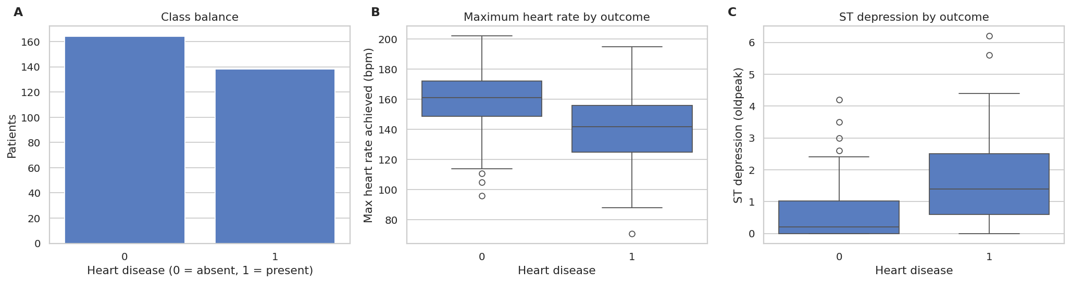
Note. Panels B and C share plot type and axis conventions, so the predictors are directly comparable. Disease prevalence is 45.7%. Both predictors separate the classes in the clinically expected direction, confirming the label correction was applied correctly, while the substantial overlap shows no single predictor suffices.
Figure A2
Confusion Matrices for Both Tuned Models on the Held-Out Test Set
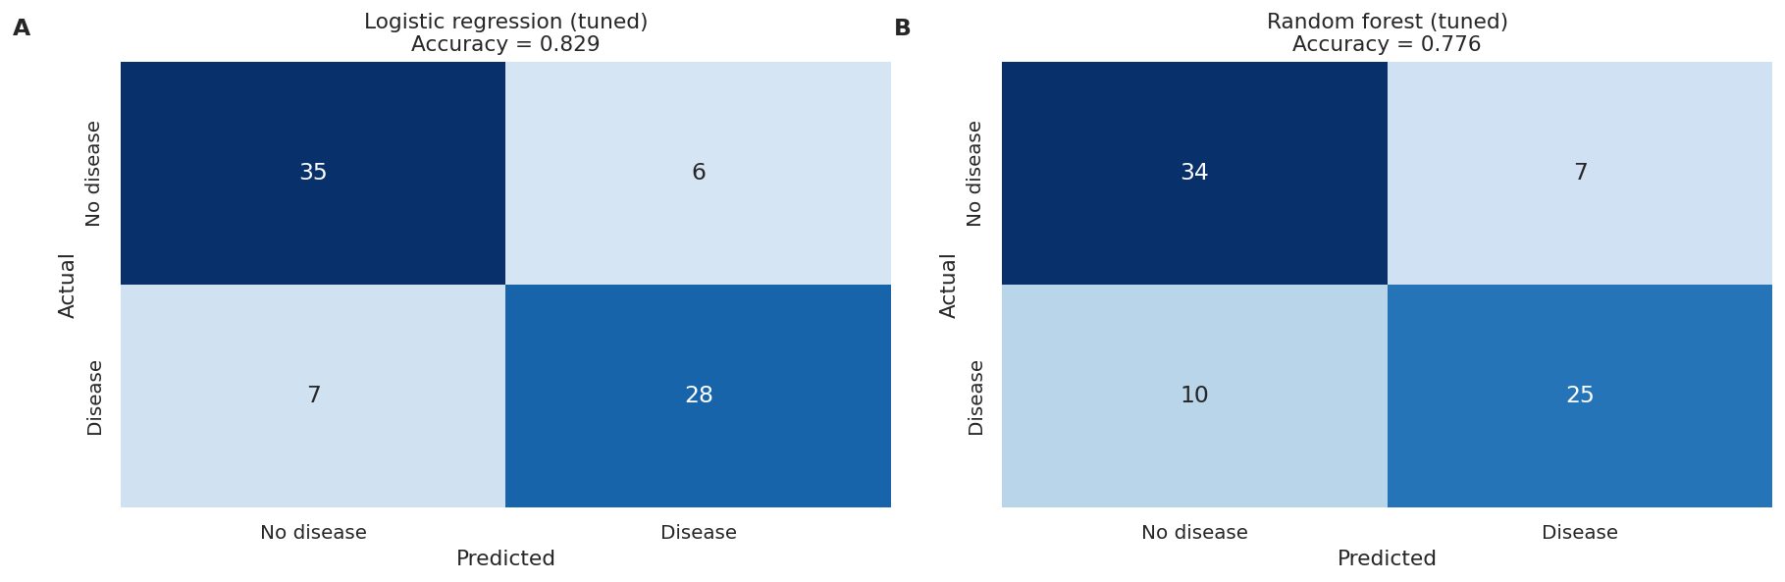
Note. Panels share layout, class ordering, and colour scale, so only the model varies. The bottom-left cell counts patients with disease classified as healthy: 7 for logistic regression against 10 for the random forest. These are not interchangeable with the 6 and 7 false alarms, since a false alarm costs a consultation while a missed case may mean untreated coronary disease.
Figure A3
Subgroup Recall by Model and Stability of the Recall Gap Across 30 Splits
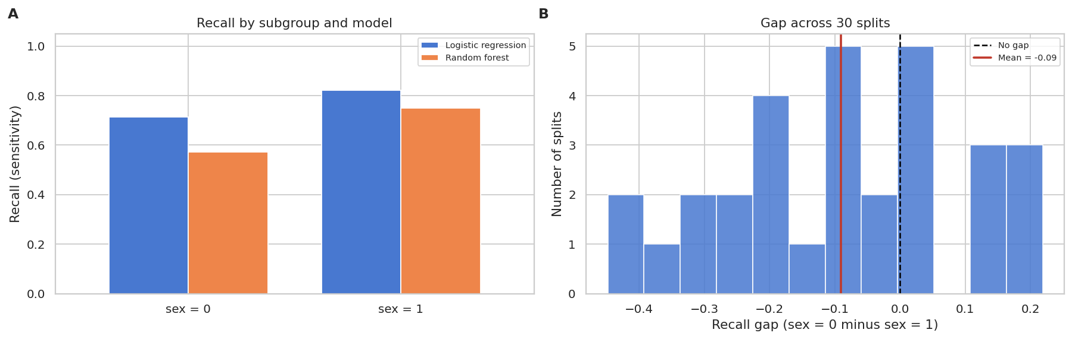
Note. Panel A shows both models detect disease less reliably for sex = 0 despite that subgroup's higher accuracy. Panel B shows the gap is directionally consistent but noisy, with a standard deviation of 0.184. The spread reflects how thin the sex = 0 estimate is: a test split leaves about six disease cases in that subgroup against roughly 29 for sex = 1. That width is itself the finding, and is why we report a signal rather than a confirmed disparity.

