- General Information
- Purpose
The purpose of this document is to define the end-to-end solution design for the implementation of an OISA product with license consumption and flexible usage tracking. This product allows customers to purchase a fixed number of licenses (Ex:50 licenses) valid for a specified period (2 years), and consume them across different time intervals.

The system would support consumption-based revenue recognition, integrating real-time usage data from the assessment platform(EPS). If the school's consumption exceeds the purchased quantity, then a new interface should call the bapi and create a new sales order by replicating the existing order details and sending it to Aria and EPS and trigger revenue recognition accordingly. This document outlines the process flow, system design, integration touchpoints, and configuration required in SAP S/4HANA SD, MM, TAX and Revenue Accounting and Reporting (RAR) modules to support this requirement

- Business Requirement
In the current OUP business, there are several interfaces running between the SAP S/4 HANA system and third-party systems like ARIA, ORB via Camel.

The requirement is to modify existing interfaces of Create/Manage/Cancel/Pause/Unpause and sales offering and build a new interface to manage consumption between S/4 and EPS. The data flow between S4 HANA and ARIA is to be done via integration layer (CAMEL) where mapped fields are modified and mapped (new interface)appropriately for data flow, besides adding a few integration rules to meet the S4 HANA system requirement.

When a subscription contract is created/modified/cancelled/paused/unpaused in the ARIA system, it instantaneously sends back the response of the subscription with the ARIA contract ID and other details. This is an inbound interface, i.e. from ARIA to SAP and is covered under Acknowledgement.

- Expected Business Benefit
- Improved Revenue Accuracy,
- Scalable billing and revenue model.
- Real-time integration and automation

- Definitions and Acronyms
Sl. No. | Acronyms | Description
1. | ISBN / Material / Product | International Standard Book Number
2. | S/4 | SAP S/4 HANA system
3. | CAMEL | Apache camel middleware
4. | IDOC | Intermediate document
5. | ARIA | Subscription Management System (Third-Party System)
6 | EPS | Platform

- Assumptions, Dependencies & Constraints
- Assumptions:
- All mapping and posting to the correct source/target is done in Camel.
- Existing output is utilised to trigger Idocs for outbound.
- The existing interface is used for Create/Manage/Cancel/Pause,
- A New Interface would be created for Consumption between Camel and S/4

- Dependencies:
- Material master data to be Created/Loaded in S/4 HANA.
- Customer Master data to be Created/uploaded in S/4 HANA.

- Constraints:
- Interface requirements must be agreed with and fit to O2C operational cycles.

- Solution Design
- Basic Configuration
- MM:
- Define MARA/ZZ1_MEDIATYPE_PRD (Media type) - as Onix Code list 150: LA: (digital product licence delivery unspecified), to be utilized as part of reporting and tax calculation and integrations.
- Define MVKE/MVGR5 (Subs output) - (ISA) to define platform of product. Utilized for integrations
- Define (T604) Commodity code and associated tariff code to be utilized for tax calculations
- Define MVKE/KTGRM (Account assignment category) for material to be used for accounting determination
- Define MVKE/MTPOS (General Item Cat) (ZSUE) for item category determination .

- O2C:
- Define TVAPT/ PSTYN (Item category) (ZTBE) to differentiate from subscription but allow for integration to ARIA and allow for the change to billing plan
- Define Item category determination (allows license product types (Gen item cat ZSUE and specific order types to populate O2C item cat ZTBE)
- Set up T184/VKOA (Revenue recognition) to datamine the item category for OISA EPS consumption
- Define new text ID(Consumption) (new text item level field to capture individual consumption integration details
- Define new field (Additional data B tab- line item) to capture Total consumption- to be utilized in reporting as well as in the consumption integration for available quantity to rev rec against. Field needs to update the change log
- Define new field (additional data B tab- line item) to capture Total Cancelled amount: to be utilized in reporting as well as in the consumption integration for available quantity to rev rec against. Field needs to update the change log

- Additional mappings:

- Add a new media type to the existing mapping to global next
- Add a new media type to the existing mappings to IPM

- S/4 Development
- Define a new text ID for Consumption, and capture the consumption details date-wise for each consumption integration sent from EPS. If available licenses, -once the BAPI posts the quantity to revenue, it should also update the text under consumption date-wise (Shown like below) and then update the consumption cumulative quantity in the Consumption field. see below for further details on the BAPI
- We need to create 2 new fields at line item level in the Additional data b tab to capture total amount data. to achieve this we need to modify the standard program SAPMV45A, this will only be active for the line items with item category ZTBE:
- “Consumption Quantity” to capture the total consumed quantity. This needs to total the consumption line amounts from the individual integrations. Each consumption integration will add a text line to the new text ID (Consumption) and add to the value of the consumption quantity field – additional data b tab
- “Cancelled Amount” to capture total consumed quantity. This needs to tally any quantity credit raised for the line item. The field should update from the ZCR created with reference and in the case of multiple ZCRs should tally the cancelled total and add to the cancelled quantity field – additional data b tab
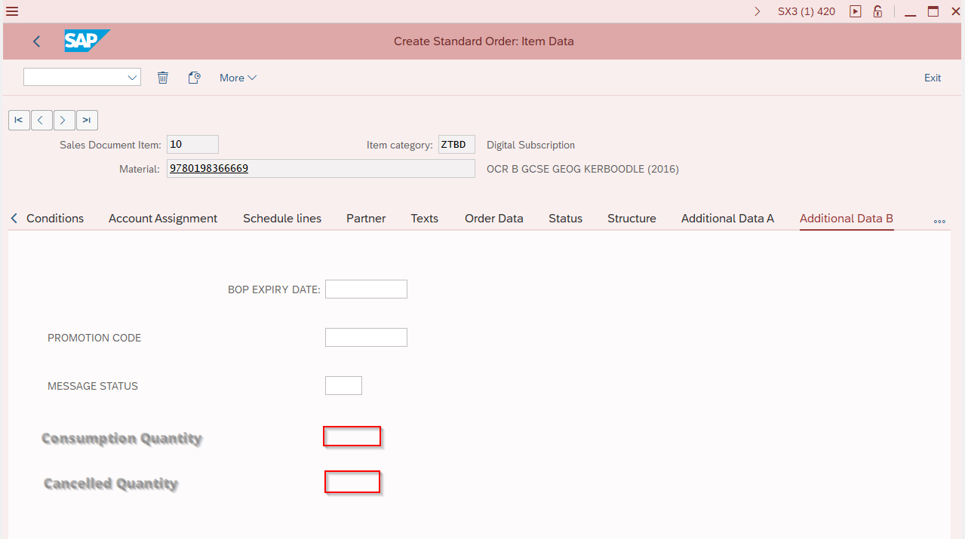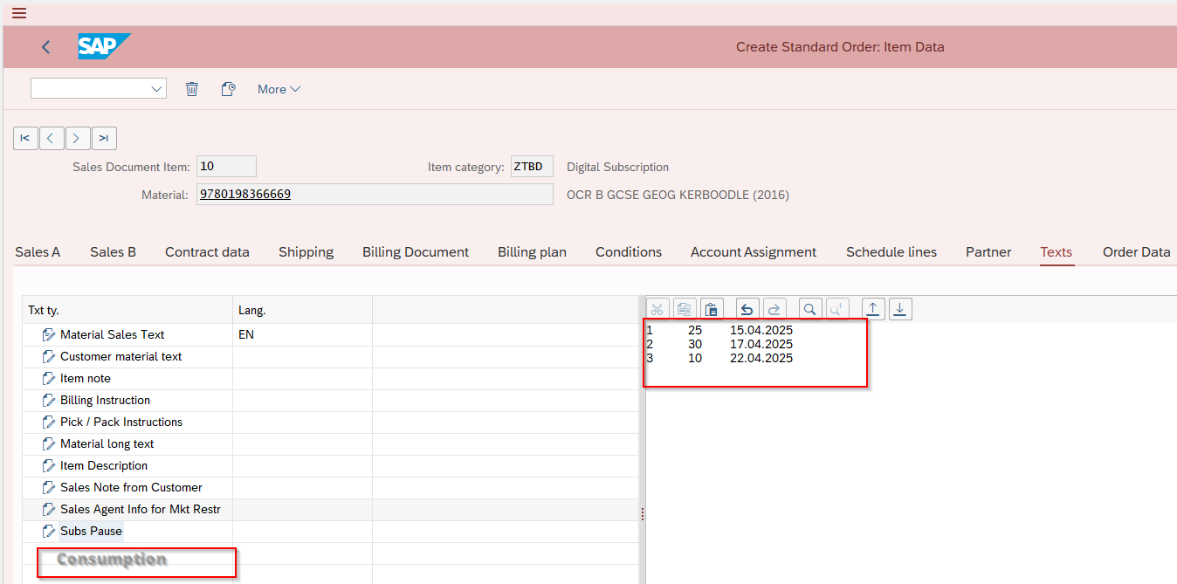

- Development required to standard BAPI:
- BAPI_ACC_DOCUMENT_CHECK àWhen Camel calls this, check the 2 new fields in Additional data B tab (consumed quantity and cancelled quantity) against the order quantity to determine available licenses. It should then check those available licenses agains the newly integrated consumption amount.
- If available quantity is greater than the consumption amount the full consumption amount will be posted rev rec by calling BAPI_ACC_DOCUMENT_POST and update the consumption text field with a new line and update the Additional data b field ‘consumed quantity with the new cumulative quantity
NOTE: Currently, for subs, RAR is considering the acceptance date in order while posting it in to RAR from differing revenue. This needs to be restricted for ZTBE items, and it should always be posted with the above-stated BAPI.
- If the available quantity is less than the consumption amount. It will post to what is available and for the remaining consumed will call the BAPI_SALESORDER_CREATEFROMDATA2 to create a new order copying from the exising order- copying all header details and details of the corresponding line item with the over consumed amount populating as the quantity. This new order should do the following:
- Update the VBKD/BSTKD (customer reference) field with the original order number followed by 00 and line item (can this be used for for identifying a consumed quantity order for EPS?)
- Updating quantity amount with over consumed amount.
- Sales Order Maintenace app (cancellations)
- The Sales Order Maintenance app is currently used for the cancellation of KMATs in S4. Currently the app only recognizes item categories ZTBC and ZTBD. We will need to add the new item category of ZTBE to this selection. In addition, the app will need to recognize a ZTBE and display the available quantity (sold quantity-consumed and previously cancelled quantity) for cancellation. This quantity field can then be amended by customer services to allow for:
- Full cancellation (total ordered quantity cancelled): Camel to send Cancel Call to ARIA
- Not invoiced: with 0 consumption: apply rejection reason and cancellation date: send idoc to camel
- Invoiced(unpaid) with 0 consumption: reverse invoice, apply rejection and cancellation date: send idoc to camel
- Invoiced(paid) with 0 consumption: Raise a ZCR with rejection reason and cancellation date on ZCR and apply cancellation date to sales order line. Send idoc to camel
- Invoiced (paid or unpaid) with >0 consumption (good will cancellation): Available for cancellation amount on APP amened to full order quantity, Raise a ZCR with rejection reason and cancellation date on ZCR and apply cancellation date to sales order line. send idoc to Camel
- Partial Cancellation (partial quantity cancellation) Camel to send Manage call to ARIA
- Not invoiced: where cancel qty < available qty: amend quantity on sales order line, trigger idoc to Camel
- Invoiced (unpaid): where cancel qty < available qty: raise ZCR with reference to sales order line for cancelled quantity copying ARIA ID but with no rejection reason or cancellation date: trigger idoc to Camel
- Invoiced (paid): where cancel qty < available qty: raise ZCR with reference to sales order line for cancelled quantity copying ARIA ID but with no rejection reason or cancellation date: trigger idoc to Camel
- Dunning Pause/Unpause Program: ZOTCR_AR_PAUSE_UNPAUSE) needs to ensure that ZTBE item catagories are updated based on dunning levels +21 days (BRF).
- Job ZGL_OTC_3_D_SPIRIT_MTR need to investigate what if anything needs doing to the Spirit and MTR programs to exclude from subs files but include in sales files.
- Cancellation (INT-92)
Gap 1008àThe SO Maintenance App will be used for both full and partial cancellations (see above. The app will need to differentiate between a full and partial cancellation. Applying a rejection reason and cancellation date to a full cancellation only.
Camel can then identify those idocs with a rejection reason and cancellation date as Cancel Calls to ARIA

INT-92àWhen CS fully cancel the sales order line item, the cancellation process will be executed in the S4 HANA system, and then the details shared with the ARIA system through the integration layer CAMEL system.
INT should consider Item category ZTBE items
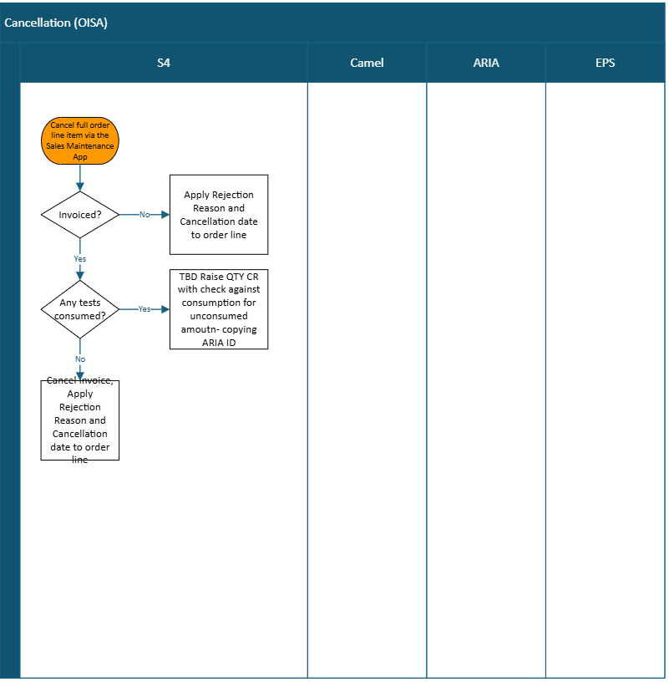

- Pause/Unpause (INT-90, 91)
INT should consider Item category ZTBE line items. S4 Hana runs the pause/unpause program (ZOTCR_AR_PAUSE_UNPAUSE) daily. This program checks for if the line item is open and part of dunning. It then applies an appropriate pause text and dunning level to the line item. This will create an idoc to camel which then sends a pause call to ARIA.
The program also checks for if the dunned line item has been cleared and if so updates the line item with appropriate text and removes dunning level. This will create an idoc to camel which then sends a Unpause call to ARIA.
NOTE: if a line item is in Pause and then cancelled, Cancel call should be sent (Cancel trumps pause)

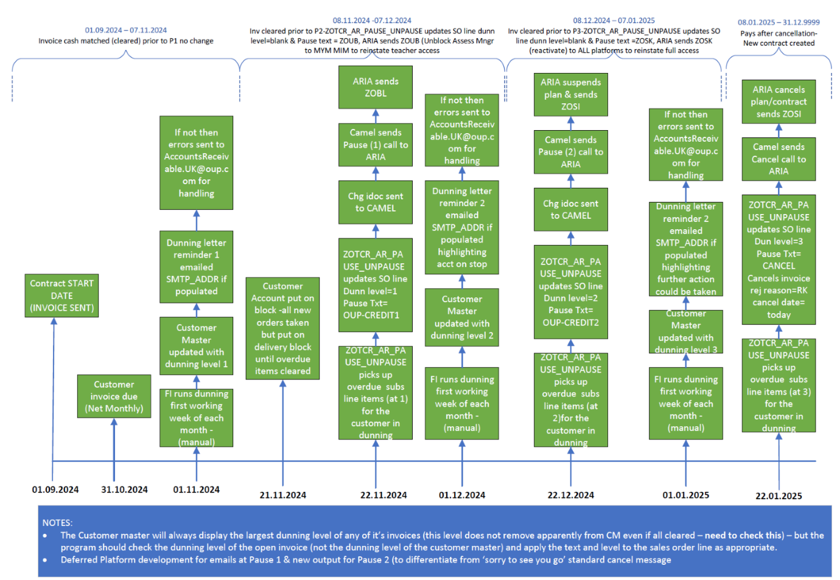

- Consumption (INT-XX)
Camel fetches the file from the EPS. File contains:
- Sales Order Number
- Date
- Quantity
- ISBN
- Line Item
Middleware queries based on data in the EPS file to find the corresponding original sales order.
- Camel Check Revenue Recognition details by calling SAP BAPI BAPI_ACC_DOCUMENT_CHECK
and checks the filed Consumption in sales order addition data B, how much quantity has already been revenue recognised.
Compare File Quantity vs Available Recognisable Quantity
- If file quantity ≤ available recognizable quantity:
- Camel calls SAP BAPI BAPI_ACC_DOCUMENT_POST to post revenue.
- If file quantity > available recognizable quantity:
- Camel calls SAP BAPI BAPI_SALESORDER_CREATEFROMDATA2 to create a new order with a copy of the existing order details for the excess quantity. And this new order is sent to Aria and EPS.
- Once the Aria confirms and the billing block is removed, Camel will repeat the check + post-revenue steps above for this new order.
- If there are two orders — for example, one placed in August 2024 for 50 units with 10 units remaining, and another placed in September 2024 for 50 units — the following year, when the school consumes the tests, the consumption follows a chronological sequence from the oldest to the newest order. We assume that EPS also sends the consumption data grouped by order per line enabling the Camel middleware to process the data order-wise and post it to SAP accordingly.

