Design, Development, and Implementation OF A Cross Platform Mobile Application Using the MEAN Software Stack

A Senior Project Submitted to the
Department of Computer Systems Engineering Technology
of the School of Engineering, Technology, and Management at the Oregon Institute of Technology
in partial fulfillment of the requirements for the Degree of
Bachelor of Science

Christopher Jay Meyer

© March 2016

Senior Project Approval Page

The senior project of Christopher Jay Meyer for the Bachelor of Science degree was accepted by the evaluation committee and the Department of Computer Systems Engineering Technology at the Oregon Institute of Technology.

COMMITTEE APPROVALS:

____________________________________________________________
Jay Bockelman, Wilsonville Program Director (Oregon Institute of Technology)

____________________________________________________________
Reviewer 2 (Oregon Institute of Technology)

____________________________________________________________
Reviewer 3

____________________________________________________________
Reviewer 4

abstract
This report describes the design and implementation of a cross platform mobile application that is implemented using the MEAN JavaScript software stack, and is built using the Phonegap framework. The application for this project is a proof of concept that attempts to tackle the major issues and side effects that come with using these tools.
The MEAN software stack consists of four major open source technologies: MongoDB (NoSQL database that is not relational), ExpressJS (A server side MVC framework for NodeJS), Angular (A client side MVC JavaScript framework), and NodeJS (An open-source cross-platform run time environment). All technologies are leveraged through JavaScript.
The problems dealt with in the proof of concept application are as follows:
- Animations in HTML5 Canvas on Android webView run slowly (8fps).
- Solution: Use CSS transitions for animations instead of Canvas.
- Result: Animations in the Android webView are still "choppy" on certain Android devices. When using the application on a browser or an iOS device, the animations are extremely smooth, running at about 60fps.
- Reduce image rendering time on the client.
- Solution: Off load rendering of maps to the server.
- Result: The server draws a new map in roughly 3 seconds. This time could be decreased with hardware improvements on the server.
- Support as many platforms as possible webView, and browser.
- Solution: Implement a client that handles events from a mobile webView and browsers on Windows, OSX, iOS, and Android.
- Result: Client supports webView and all major browsers for all devices that were accessible to test during implementation (Android, iOS, OSX, and Windows).
acknowledgements

I’d like to acknowledge the OIT staff for all their help and support in making this project possible. Honorable mention goes to Michael Hoffman, Sherry Yang, Peter Myers, Jay Bockelman, and Carl Love.

List of Acronyms

MEAN MongoDB, ExpressJS, AngularJS, NodeJS
NoSQL References a non-relational database
REST Representational State Transfer
Security by Obscurity Method of JavaScript security (Compact and strip down script to be difficult to read)
Summary Table of Contents

Chapter 1 Introduction 9
Chapter 2 Background 11
Chapter 3 Functional Description 14
Chapter 4 Detailed Description 17
Chapter 5 Test Results & Validation 27
Chapter 6 Economic and IP Analysis 31
Chapter 7 Summary 32

Table of Contents

Chapter 1 Introduction 8
Overview 8
Product Description 8
Summary 9
Chapter 2 Background 10
Overview 10
Background Information 11
State of the Art 11
Summary 12
Chapter 3 Functional Description 13
Overview 13
Functional Description 13
Block Diagram 14
Summary 15
Chapter 4 Detailed Description 16
Overview 16
Detailed Description 17
Summary 25
Chapter 5 Test Results & Validation 26
Overview 26
Test Plan 26
Test Results 27
Discussion 28
Summary 29
Chapter 6 Economic and IP Analysis 30
Overview 30
Intellectual Property Analysis 30
Summary 30
Chapter 7 Summary 31
Overview 31
Project Summary 31
Future Direction 32
Concluding Remarks 33

Introduction

Overview

This section will briefly discuss the overall description of the project. The end product of this project is nothing more than a proof of concept for cross platform mobile development and some of the common issues related to it.

This application attempts to solve multiple problems related to development of cross platform mobile applications that utilize the device web view:

- Animations in HTML5 Canvas on Android 4.4.2 webView run slowly (8fps).
- Reduce image rendering time on the client.
- Target as many platforms as possible with this technology.

The application itself is nothing more than a means to show proof of concept. There are many applications that use the same architecture as this project, so there is little need to compare them from an architectural perspective.

What makes this application stand apart from most “games” using this architecture is that it does not use the HTML5 canvas element at all; rather it uses CSS transitions for animation which allows for a higher FPS than it would be using Canvas.

The map images are rendered on the server at call time, so all maps are generated dynamically from definitions in the MongoDB database. This method eliminates the need to use the canvas element for 2D rendering on the client. A JSON map definition object is also sent to the client so it can calculate the purpose of various tiles on the map.

Product Description

This project has been implemented completely in web languages using the MEAN stack and the Phonegap build framework. It is a small social network game where a user can create an account with an avatar and navigate a small tile based map. The extent of the features in the application is the user may edit their account, create a custom profile, and chat with other users in real time.

The project itself is an attempt to leverage this architecture and create a useable product, and to solve some widespread issues that to these mobile development frameworks such as Phonegap. A social networking game was chosen because it offered the potential for a well-rounded feature set that would present all the problems in cross platform mobile development this project targets. One of the core problems is the HTML5 canvas element within Android 4.4.2 webView.

Due to low fps rate on Android, it was decided to attempt to create a mini game engine that is completely event driven with server side rendering, and animations done on client with a combination of JavaScript and CSS transitions. The solution gave reasonable result (15-20 fps). The performance of this solution varies between different devices. When tested on a Samsung Galaxy 3 7inch tablet running 4.4.2, the fps rate was closer to 10 fps. While running on an LG Optimus running the same OS gave closer to 15 – 20.

Summary

Cross platform development for mobile devices is highly valuable since developers only have to maintain one code base, instead of one for each platform. Since this single code base is written completely in web languages (primarily JavaScript) for both the client, server, and database; it is easier for developers to work on multiple aspects of the application. Since JavaScript is so popular, and is well supported it would be easy to find new capable developers to work on the project as well.

There is also value in the solution implemented concerning Canvas in Android webView. It doesn’t leverage the canvas element at all, which would allow for older browsers to run the engine, and as a mobile application will have better performance on more platforms that implement a web view. While there are still issues with the engine, it is believed that with more work and focus, the engine to could be improved to a point where it would run at acceptable speed on all platforms.

Overall, the MEAN architecture used in this project has potential for many real world applications. However, it is suggested that this framework be avoided if there is sensitive business logic that must be in the client. In this case extra steps would have to be taken during implementation to protect sensitive code.

Background

Overview

Mobile applications are very popular right now. Many organizations want their software on as many platforms as possible. The Phonegap build framework is a valid option when either client code doesn’t need to be secured (i.e. not in JavaScript), or the client can be implemented as a thin client.

The Phonegap build framework takes the client web application source code and builds an Android, and an Xcode iOS application project, which is then built for each platform. At its core, this framework simply takes web code and creates platform specific project files which can then be built into their respective applications. The framework also allows for access to device features (camera, file system, accelerometer …) through JavaScript libraries the framework makes available.

While there are methods to secure JavaScript such as “security by obscurity”, it is argued that this form of security is similar to putting your house key inside a fake rock by your front door. People would have hard time finding it, but they could if they looked hard enough. It’s this security hole in JavaScript applications that makes Phonegap a poor choice for applications that require sensitive code on the client side.

Cross platform mobile development using a web view has been around for quite some time, as most mobile operating systems come with some kind of browser sandbox window. Other methods include moving as much logic over to C or C++ libraries which most all platforms can run, then have platform dependent wrappers to those libraries.

Background Information

This project exclusively uses web languages throughout the entire application (client, server, and database). It’s done this way for a few reasons:
- Portability
  - The code base can run on any mobile device with a web view and all major browsers: IE, Chrome, Firefox, and Safari.
- Ease of Use
  - While web development comes with its own set of challenges. JavaScript as a language is fairly easy to learn, and can be run on any operating system that is supported by a major browser.
- Find a work around for the Canvas element issue
  - The issue with Canvas on Android webView has been a on and off again issue for Chromium and Phonegap for quite some time now. Web languages were chosen because it presented the opportunity to find different solutions for the mentioned bug in Android.
- Reliability
  - While there are many cross platform mobile frameworks, Phonegap is the most popular, and has a higher number of resources for learning this framework. Since Phonegap uses web view exclusively, web languages must be used.

Web languages can be an ideal solution when a developer needs to run on as many platforms as possible, and code security isn’t an issue. When JavaScript is used on the front and back-end of the application it allows developers to work in different areas of the application without too much trouble, meaning they don’t have to shift between the caveats of different languages as often.

State of the Art

There are many different frameworks that allow for cross platform mobile development, most of which use web languages to implement them. There are a few exceptions to the rule. One of which is Xamarin, which allows the developer to create their application in C# and .Net, but it can be expensive since you need to purchase a license. MoSync allows for development in web languages and C++, but this project is poorly maintained. QT Mobile is a valid choice as well, though you are limited to the QT framework when using it, and commercial licenses can be expensive.

While there have been advancements in this technology, it has yet to be perfected to the point developers can implement it with business sensitive logic in the client. There are also challenges in keeping the framework aligned, with mobile operating system updates. It’s this lack of alignment that can make reliability of a framework “spotty”.

In short, there is much improvement needed across all of these frameworks. There is a definite need to have compiled libraries where business logic can be secured and be able to link those libraries to JavaScript without the need to create custom wrappers for each platform. If this technology was available to users of these frameworks, then web views would be a valid path for all applications.

Summary

This project is an attempt to implement a complete cross platform mobile application completely in web languages. This architecture was chosen because it met the requirements for the Phonegap framework, which is currently the most popular and well supported framework available for this type of development. There are added bonuses for using these languages as well. It allows the ability to find a work around for the Android webView bug related to Canvas, the language allows the developer to present their application of the most platforms, and it allows developers to easily work in different parts of the system without the added complication of working in a different language.

Currently, these frameworks are used in production for many popular applications, but there is still a lot of room for improvement.

The ideal framework that would allow all applications to take this path would be to have a mechanism in the framework that would allow JavaScript to communicate with C or C++ libraries without the need to maintain a wrapper for each platform. Rather the wrapper would be created dynamically by the framework.

Functional Description

Overview

This section will give a functional description of the application from two perspectives. It will describe the functionality of the application itself, and it will also describe the build process as it applies to the unique platforms that are within the scope of the project.

At the application level this is a simple n tier web application. There is a client which handles displays and user input, an app server which manages user input and allows for real time interaction between users, and there is a database that allows for persistent storage for all users.

Functional Description

To use the application a user must be using either a web browser on a PC or mobile device, or a built application for iOS or Android. The application is designed to be as cross platform as possible. It is intended to run on many other platforms that Phonegap supports, but limitations on access to devices and time to test took these out of scope for the project.

When a user has the application loaded into a browser or mobile device. The application will make a series of web service calls to the NodeJS app server which will perform various tasks, such as generate maps, create map definition objects, validate credentials, and pass messages to other users who are using the same map.

The interface between the application and the server is through JSON. The server itself is stateless, so there is no need for connection with server via web socket. The server is implemented using a REST architecture, so that is can be easily duplicated under heavy load.

The server connects to the external MongoDB server to store a get data. The database is leveraged as place to store persistent information, and allow for multiple users to communicate with each other in seemingly real time. For the application to be real time, the server needs to be accessible on the internet. Otherwise multiple users can utilize the system on a LAN.

The overall architecture of the system is fairly generic and simple. It has a client, app server, and database. The client communicates with an app server via HTTP requests and the app server stores persistent data on an external database server. This architecture was chosen for speed of implementation to permit development focus on the problems targeted for this project.

Block Diagram

The following diagram illustrates the high level architecture of the application and how the user would interact with it. Essentially the user would log into the system with a mobile device or a web browser and have the ability to setup their own account and chat with other users on the system, while being able to navigate their avatar over a series of maps. The maps are setup such that they are expandable on the server, so users will never reach a limit of space to explore.

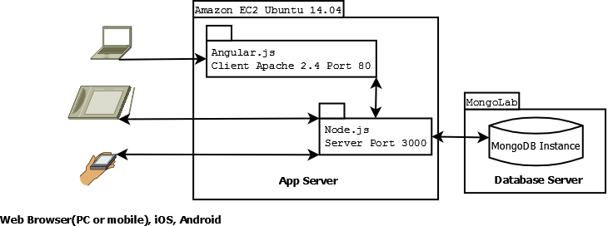
Figure 1: High Level
If the user accesses the application via a web browser, it will connect to an Apache server hosted on the cloud. From that point, the application will communicate with the app server being hosted on NodeJS. When accessed as a mobile application, the mobile app will communicate to the NodeJS server directly.

Under the current set of features implemented for this application, a user interacts with the system is to send messages to one another, and view user profiles. The user feature is limited due to the nature of the application being a proof of concept rather than a complete app. The focus of this project is based on it's architecture and build system.

Summary

This is an n tier architecture. This simple architecture was chosen for ease of use, and flexibility for client implementation. The app server and database are hosted separately on Amazon AWS, and MongoLab.

This architecture requires the user have access to a web browser on PC or mobile, or the packaged application for an iOS or Android device. The application is most useful when multiple users are logged into the system, otherwise there are no interactions to have with the system, other than updating and viewing user profiles.

The feature set of this application is limited due to the nature of the project being a proof of concept rather than a complete app. The limited feature set allowed the project to focus on supporting as many devices and screen sizes as possible, which is one of the main goals of this project. While there are functional aspects to this project, it is not core to the focus of it.

Detailed Description

Overview

The application has completely been implemented in web languages. It utilizes an MVC architecture on both the client and server. The client uses the Angular1 framework, and the server uses ExpressJS. This architecture is ideal, because it allows for maintaining code that is separated by role.

Angular1 on the client uses only a single view in the main game area. There was little need for separate views in the design of the same since it only serves as proof of concept. The most interesting facet of the client is that it does it's animation with CSS transitions rather than Canvas (which is something of a standard for HTML5 game development). Rather than redraw the all elements in a constant loop. The CSS transitions are event driven, where draws only need to occur when the user executes a move. This also applies to map requests and user status updates.

The ExpressJS server is a simple RESTful API that Maintains a persistent model all users and manages which users get specific messages. The server recognizes the user’s current state in the request and returns information that the user needs. Their needs are based on what map tile they are currently on. So if a user is on map tile (0,0). Then they will only see users who are on the same map tile, and will only see messages that have been generated on that map tile.

The database is NoSQL, which means it's not relational and it uses JavaScript as a query language rather than SQL. There are four collections in the Mongo database. They hold information about users, messages, maps, and map tiles. Each collection stores multiple JSON documents. Each document holds information about a single item. For instance, a user who is stored in the 'Users' collection, is considered to be a single document.
The Phonegap build framework takes the client web application source code and builds an Android, and an Xcode iOS application project, which is then built for each platform. At it's core, this framework simply takes web code and creates platform specific project files which can then be built into their respective applications. The framework also allows for access to device features (camera, file system, accelerometer …) through JavaScript libraries the framework makes available.

The current deployment scheme for the application is manual, meaning it is installed via a file manager and it not publicly available for download. The application is available for download, but is password protected and can only be accessed if the maintainer of website provides the URL and credentials.

Detailed Description

Client
The client uses the AngularJS 1 framework. The client is broken down into three main sections: View, Controller, and Services. The view has three components: Map, Options Menu, and Log in Modal. The view is set to monitor specific events from the user to begin execution of various tasks.

On the map area, there are two types of touch events (single and double tap). On a single tap, if the event is on a sprite, the profile for that account displays in the profile pane on the right (Illustration 1).

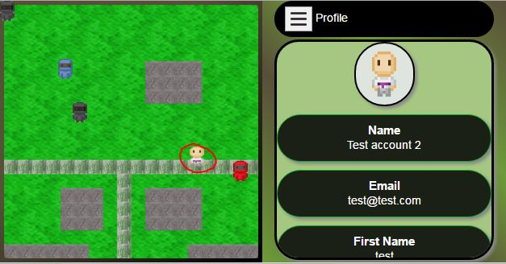Illustration 1: Single Touch Event
Between touch events a timer is triggered. The touches are considered to be a double tap if the touches are within a half a second of each other. While there are Angular methods that handle double clicks. There are no methods that handle both single touches and double touches. To work around this, and maintain functionality across browsers and mobile devices, and custom event handler had to be implemented to avoid having multiple types of click and touch events. This way, there is only one single click event that triggers different methods based on how often it's triggered.

The maps on the client are dynamic, but not rendered locally. At call time the server renders the map image and sends it to the client as a blob. The client only renders the motion of the sprites, and updates the sprite objects based on their actions (messages sent, map changes, etc.).

The client is designed to run on Android and iOS devices. The issue that comes with game development using this type of web based framework is that, developers tend to need the HTML5 canvas element to properly run a game loop, and render graphics. In Android KitKat 4.4.2, there was a bug where canvas would run at roughly 5-8 frames per second.

When a double click or tap event is triggered. The client executes the sprites move method. The CSS transition works as such:

- Get event coordinates by CSS top and left.
- Calculate the top and left deltas between the current position and the destination.
- Every 30ms transition the sprite image closer to it's destination.

During this cycle, the client evaluates the map tiles the sprite is currently touching and heading towards to look for tile objects that block or generate a new map. This CSS approach to animation over Canvas improved performance to 10 – 15 frames per second. The range is applied here due to difference in performance for various Android devices. There were some similar issues with devices when the user would try to send chat messages.

Sending chat messages without the aid of sockets was somewhat challenging. In this case there is a timeout loop the main controller executes to poll the server for new messages. One bug that has surfaced in the client is that occasionally on some devices, chat messages will not come through properly. The fix for this is to move the sprite and eventually, the message comes through.

Overall the client is fairly thin. Most rules and business logic are performed on the server. This allows administration of the application in a single place and avoids unnecessary client releases and updates.
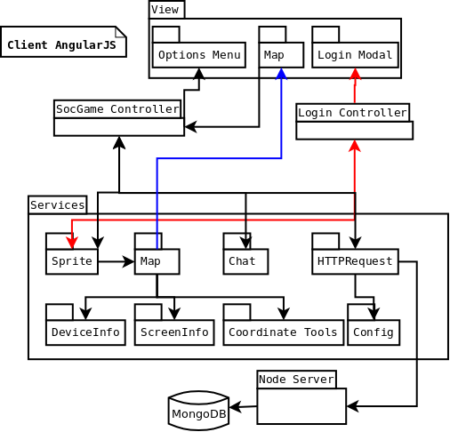Figure 2 - Angular Client
Server
The client gets information about users, maps, and messages through a RESTful API that is hosted by a NodeJS web server. The server is implemented in NodeJS. The application framework is ExpressJS, which uses an MVC architectural pattern. The framework consists of three main components: Routes, Controllers, and Models. Each route is assigned per topic, meaning one route is for user API calls, and there is another assigned to maps, and so on. Each route has a subset of routes that define different API methods. For instance, the user controller, and a Create, Update, and Get method. All of these methods return data in json format.

There is exactly one controller for each route. Each controller handles all the business logic for each method. Some route methods share methods in the controller.

All the methods in the user and message API are basic getters and setters. There is some special logic applied to the map getter method that allows images to rendered server side, and sent to the client and blob.

The server uses UTC date stamps recorded in each document to determine the currency of each request. For instance, when a client makes a request to see how many new messages are available, it passes up the UTC date of the last time it checked for messages. If the server has any new messages after that date, and the client passes up matching map coordinates, then it sends those messages to the client.

When the client requests a map; it requests it with the maps 'i, j’ coordinates and screen resolution. The server will then look up the json definition for the map and build a flattened tile image of the map. It does this using the following steps:

- Get json definition from database
- Get background image
- Loop through each tile object and get the image data for the tile
- Using the tile 'x, y' coordinates place the tile in the proper location
- Flatten and re-size the image to the appropriate screen resolution
- Return the image data as a base 64 encoded blob

While this increases server load significantly, it reduces rendering time on the client and eliminates the need for canvas elements. This might not be an optimal situation for a production application, but this could be solved with a simple caching scheme on the server, since maps only need to be rendered when they've been changed.

The server is setup such that it can be easily duplicated on the cloud under heavy loads. This is because it's stateless and does not need to maintain a persistent connection with the client to maintain a real time interface with other users.

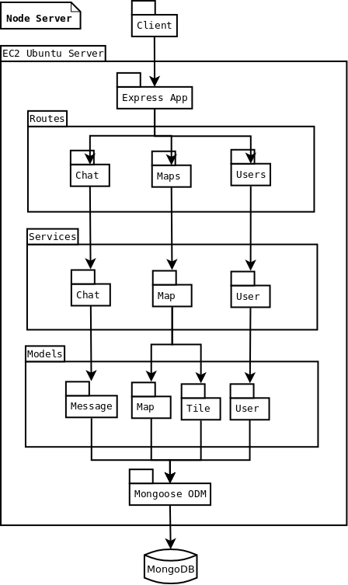Figure 3 - Node Server

Database

The database is hosted on a MongoLab server. It has four collections to maintain persistent data: Map, User, Message, and Tile. Each collection holds a series of documents that define an object. For instance the User collection holds a document for each user (Figure 4). The document for a specific user holds all the information the system has about that specific user. The same applies for the message collection. Each document in the message collection holds all the information needed to define a single message sent by a user.

The user collection has a document for each user. Most data about the user is not sensitive information, there are only two sensitive pieces: email address, and password.

Email addresses are shown through the user profile display. However, passwords are only stored on the server as hashes. When a user creates an account and the server has been called to store this new account in the database, it uses a Node library called bCrypt that uses a salt and key to hash the password a developer defined number of times. This application hashes the password ten times before it's stored to the database. From that point on, the server only compares password hashes for each subsequent log in.

Maps are handled differently. Typically in a non-relational document oriented database, redundant information is acceptable when it's static. However, maps can be changed and altered as needed by an administrator. Therefore tile definitions are maintained in a separate collection. This reduces maintenance when maps need to change. The drawback to this method is that it requires an extra query at every call to get that data. This cost is negligible in this scenario since the tile collection only has four documents in it. If the tile definitions were to get to be 100 documents or more, then a different approach should be taken.

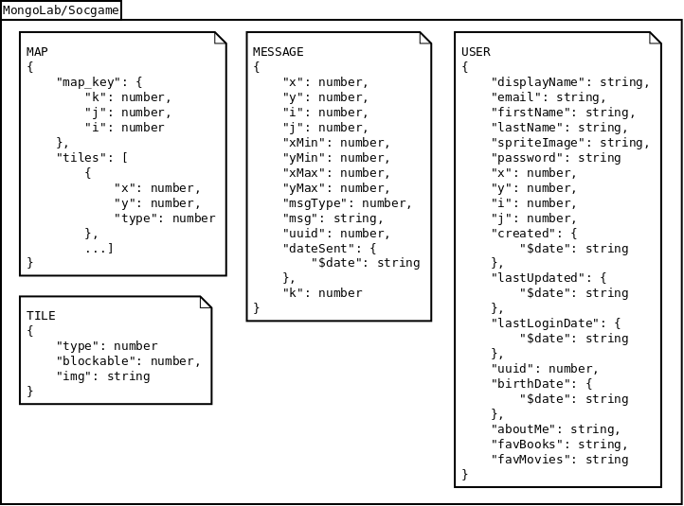Figure 4 - Mongo Database

Build and Deployment

The client is completely implemented in web languages, and uses the Phonegap framework to create platform specific project folders that can be built into applications for their platform. The application itself is kept in common directory that all platform project folder feed from. So all platforms share the same code base.

When Phonegap is called to create or update a project folder it takes the code from the common folder and populates it into the section specified for that platform project file. It then reads in a common configuration file that defines application setting that may or may not be platform specific. For instance, it is possible to hide the status bar for Android applications, and display it on iOS.

Once the project folders have been created or updated. The user can then use either Phonegap to build the application package, or use more direct methods.

In this project, Android applications were built using Phonegap, while iOS applications were built directly in Xcode. This allowed for more control over project configuration over what's available in the Phonegap configuration file.

After the mobile applications packages have been built, they are ready for deployment.

The mobile applications are installed to devices directly from the development machine to the device. Since this application is a proof of concept, there is no reason to deploy it to the public facing application distribution sites. The original web code however, can be directly deployed to the development server on the cloud.

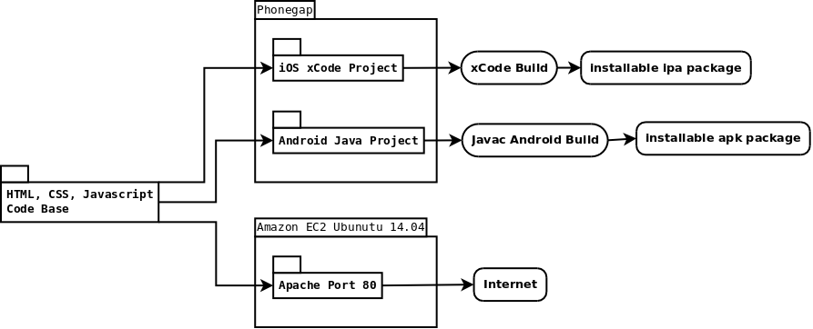Figure 5 - Build and Deployment

Summary

This project has been completely implemented in web languages using JavaScript MVC frameworks. The client utilizes AngularJS and has three different fragments under a single view. The server uses ExpressJS and has three routes to handle user, map, and message requests. The database has four collections that persist data for users, maps, tiles, and messages.

The client handles the unique task of providing a user interface, and running animations in CSS rather than using HTML5 Canvas elements. It does this by only being triggered by touch or click events, rather than using a standard game loop.
Image rendering is offloaded to the server when the client needs to display new maps. Offloading this work to server eliminates the need to the canvas element on the client. Since maps are not intended to be static, the client would have to draw those images at every call.

The database maintains records for all users, maps, and messages. While it is not a relational database, there are some relational methods being used to map tile types to tile definitions for maps.

The build process uses Phonegap to share common web code among all platform specific project folders and configures them using a common file that all project folders use. After the projects are built into installable packages, they are deployed as needed. The common web code can be deployed to any HTTP server to host the application for major browsers.

Test Results & Validation

Overview

In terms of functionality goals for this project, one of the main ones was device support. The testing process was iterative. After each bug fix or feature implementation there were a series of tests performed to validate the functionality of the application within various screen sizes and environments. There were two core tools used during development, the Phonegap developer tool and the Chrome developer tools. After successful development testing of a specific feature or bug fix, a series of devices and browser configurations were tested:

Configurations to Test
- iOS iPhone6 (webView application)
- Android 4.4.2 Samsung Galaxy 3 tablet 7” (web View application)
- Android 4.4.2 LG Optimus 4.6” (web View application)
- iOS iPhone6 (Safari browser)
- Android 4.4.2 Samsung Galaxy 3 tablet 7” (Chrome browser)
- Android 4.4.2 LG Optimus 4.6” (Chrome browser)
- OSX (Safari browser)
- PC (Chrome browser)
- PC (Firefox browser)

As each fix or feature was validated and pushed to source control. The bug or feature was considered resolved.

Test Plan

Top down testing was used for this project. As code was added or changed in the project, the application was tested using the Node Live-Server, Phonegap Desktop application, and the built in developer tools that are included with Google Chrome. The following iterative test steps were taken as development took place in the application.

- Setup test environment.
  - Enable Live-Server – Hosts web code as localhost
  - Run Phonegap Desktop – Host web as code as Phonegap application on mobile devices.
  - Access web code hosted on Live-Server through evergreen browser (Chrome or Firefox).
- Implement fix/feature
  - Test functionality in Chrome on PC
    - Repeat for each in Configurations to Test on success.
    - On failure go to step 2 and add correction to code.
- Push to remote source control.
- Go to next feature / bug fix at step 2.

Since target of this project is about finding solutions to cross platform mobile development and problems associated with it, testing at the device level was sufficient. In the case of the bug related to the HTML5 canvas element and Android 4.4.2, some performance testing occurred.

There is a use case for this project where the animation scheme implemented should outperform the low fps found when using canvas in Android 4.4.2. The baseline for successful test would be a fps greater than 5.

Test Results

Each test performed was a pass overall. There are some known remaining bugs in the application.

- Occasionally chat messages can get dropped if user is not moving.
- Android soft keyboard can hide the active text field.
- Background can be movable in iOS web view.
- Status bar hides some game area in iOS web view.

Some chat messages will get dropped in the application and it seems to occur when a user is idle for too long. If the user moves around the map some, then messages will come through.

The keyboard in Android will hide the active text field. This occurs because of the CSS configuration in the application. To fix this bug would most likely require a redesign of the application UI.

In iOS the background can be moveable if the status bar appears. While the status bar is displayed that background of the application can be moved slightly. It is likely this could be fixed along with bug 2.

The status bar in iOS also seems to make the top portion of the application unusable. A work around for this bug was implemented, but it still needs to be fixed.

Some of these bugs are a minor inconvenience for the user. These bugs were put into the project backlog, because increasing support for more platforms was a higher priority.

The results for CSS performance vs. Canvas element performance in Android 4.4.2 webView were reasonably successful. Depending on the device, the CSS transition performance was closer to 10-15 fps.

After the CSS animation scheme was implemented, there was some difficulty in acquiring a reliable method for getting fps in CSS on the mobile device itself. An alternative method for gather this metric was found. The frame rate would be judged visually using a web tool a measurement.

https://frames-per-second.appspot.com/

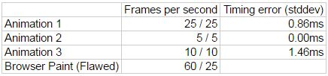Table 1 - FPS metrics

Discussion

All of the core requirements for this project were validated in testing overall. The main focus of this project is within the implementation and validity of using this type of framework and build process, so testing was only utilized to validate how many platforms this project could target with the resources available, and to determine the validity of a CSS based animation framework.

Overall, the framework proved to perform better than HTML5 Canvas. Though at 10 fps, there is some optimization that needs to happen before this could become a valid solution for production environments.

Summary

Testing this application was geared towards determining how many platforms and environments could support this application. It also targeted the validity of CSS based animation framework as a work around for browsers and web views that could not support HTML5 canvas properly.

There are some minor bugs in the application that remain, they would be inconvenient to the user, but would not prohibit them from using the application. These bugs were put in the project backlog to favor testing as many platform configurations as possible. The application has been tested and can support all platform listed in the “Configurations to Test” list.

Economic and IP Analysis

Overview

There are no issues with intellectual property conflicts in this project. All tools and frameworks are open source and free to use. The only original process used in this application is the CSS animation framework. To the best of the author's knowledge, there is not another like framework available.

Intellectual Property Analysis

All the frameworks and tools used in this project are open source. All intellectual property belongs to their owners. There is only one element in this project where the author of this project (Chris Meyer) might be able to claim as intellectual property.

The CSS animation framework created in this project is original to best of the author's knowledge. The author has not been able to find another game framework for the web that is completely CSS and JavaScript based.

Summary

This project only uses open source software tools and frameworks. There is no issue with intellectual property. There is one patentable element to this project which is the CSS animation framework.

Summary

Overview

The application created is only a proof of concept. The project is intended to be a learning experience, and to evaluate the usefulness of a web based cross platform mobile application.

The project was implemented using the MEAN stack. Which also leveraged the Phonegap framework to create installable mobile application packages. It uses the AngularJS framework for the front-end, and Node ExpressJS framework for the server. The database is a document oriented NoSQL MongoDB.

There are no plans to move forward with this application. Since it was an exercise in learning and evaluation of development methods, it will likely be shelved. Only elements of this application will be leveraged in the future, such as server side image rendering, and CSS based animation frameworks.

While the design and frameworks are valid for production applications. It it believed by the author that developers who need better protection for their business logic, to move those elements of the code into native libraries, calling them from JavaScript using a native wrapper.

Project Summary

This project is a cross platform mobile application that has been completely implemented using web languages and Phonegap as a build framework. It utilizes a back-end app server implemented in NodeJS, and a database created with MongoDB. The goal of this project is to validate the use of development method in a production environment.

There are many goals that were set during the design phase. One was intended to solve the issue of the HTML5 canvas element bug related to Android 4.4.2 web view. The CSS solution implemented was technically successful, but requires optimization before it would be a valid solution in a production environment.

The application itself is only a proof of concept, to validate the usefulness of this framework. Other goals of this project included eliminating the need for sockets to make a more scalable system. This was also a successful aspect of the project. A chat mechanism was implemented that only interacts with a RESTful API Node server.

The last project goal was to offload image rendering to the server, as opposed to the client. This improved the overall performance of the client, but increased load time for new maps. This goal was met. All requests for maps are handled on the server and drawn at call time.

The Phonegap framework was used to build packaged mobile applications. It proved to be a reliable framework, for the features that were implemented in this project. The framework was used to build ipa and apk packages for iOS and Android respectfully.

The application is not being distributed in any way. It is available on an Amazon EC2 server, but access to the application download as an apk, or web application is by invitation only. These restrictions are in place to protect the web server from being abused during the development of this project.

Future Direction

This project was intended to be a learning experience, and not to produce a production application. While there are no plans to move forward with this application, the new skills and methods taken from it will be when the opportunity presents itself. There are many socially oriented games on the market today, and are meeting the needs of the public far better than this application ever could.

The elements of this project that would be useful in other situations are the use of the MEAN stack and the Phonegap build framework, along with the ability to render images on a server dynamically. The other element would be the CSS animation framework that was laid out in this project.

The CSS framework is still a valid workaround. While there have been many iterations and releases of the Android operating system. Many devices will not be updated past 4.4.2. The KitKat version of Android still holds the largest amount of users who have this bug in their device.

Version | Codename | API | Distribution
2.2 | Froyo | 8 | 0.1%
2.3.3 - 2.3.7 | Gingerbread | 10 | 2.6%
4.0.3 - 4.0.4 | Ice Cream Sandwich | 15 | 2.2%
4.1.x | Jelly Bean | 16 | 7.8%
4.2.x | Jelly Bean | 17 | 10.5%
4.3 | Jelly Bean | 18 | 3.0%
4.4 | KitKat | 19 | 33.4%
5.0 | Lollipop | 21 | 16.4%
5.1 | Lollipop | 22 | 19.4%
6.0 | Marshmallow | 23 | 4.6%
Table 2 – Taken from the Android Developers Dashboard

Concluding Remarks

This application has proved itself to be a valid method for cross-platform mobile development. However, due to the exposed nature of web code, it should only be applied to systems where a thing client would be acceptable, or sensitive business logic would not have to reside on the client.

This idea could be utilized on a client and protect their business logic better if extra steps were taken to create their own JavaScript functions in the native wrapper to use native code for sensitive cases.

The server was designed to be a RESTful API for the client. The most complex tasks it performed were related to dynamically generating map images for clients at call time. This would prove to be useful for many applications where data to render images could be better protected on the server, and not leaked to the client.

This project proved to be a great learning experience in the software development cycle using agile methodologies. It allowed exercise in problem solving and restraint from trying to implement too many features which leads to scope creep. The goals of this project were met and implemented using responsible software practices. The methods and skills that were utilized during this project will be valuable for years to come.

References

“Dashboards,” Android Developers. [Online]. Available at: http://developer.android.com/about/dashboards/index.html#2015. [Accessed: 05-Aug-2015].

“HTML enhanced for web apps!,” AngularJS. [Online]. Available at: https://angularjs.org/. [Accessed: 03-Jan-2016].

“Compare frames per second: which looks better?,” Compare frames per second: which looks better? [Online]. Available at: https://frames-per-second.appspot.com/. [Accessed: 11-March-2016].

“Express - Node.js web application framework,” Express - Node.js web application framework. [Online]. Available at: http://expressjs.com/. [Accessed: 05-Aug-2016].

“Issue 315111 - chromium - Bad performance in SimpleSpinner software canvas example - Monorail,” Issue 315111 - chromium - Bad performance in SimpleSpinner software canvas example - Monorail. [Online]. Available at: https://bugs.chromium.org/p/chromium/issues/detail?id=315111. [Accessed: 05-Aug-2016].

“MongoDB 3.2,” MongoDB for GIANT Ideas. [Online]. Available at: https://www.mongodb.org/. [Accessed: 05-Aug-2016].

“Node.js,” Node.js. [Online]. Available at: https://nodejs.org/en/. [Accessed: 05-Aug-2016].

“Adobe PhoneGap,” PhoneGap. [Online]. Available at: http://phonegap.com/. [Accessed: 05-Aug-2016].

