# Bloque de preguntas: electric_en_components

1. What is the component of the image?

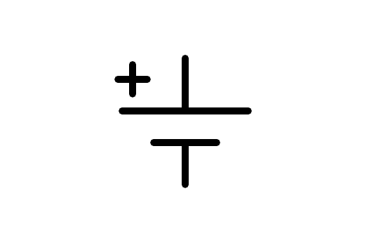

a) Altern current source

b) Battery

c) Motor

d) Toma de Ground

1. What is the component of the image?

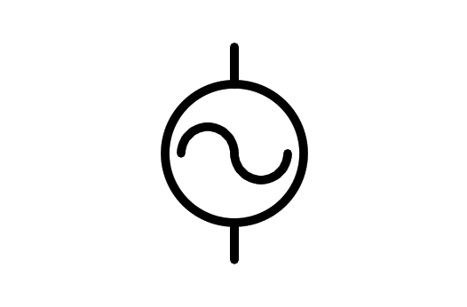

a) Light Bulb

b) Altern current source

c) Battery o Battery

d) Electric Motor

1. What is the component of the image?

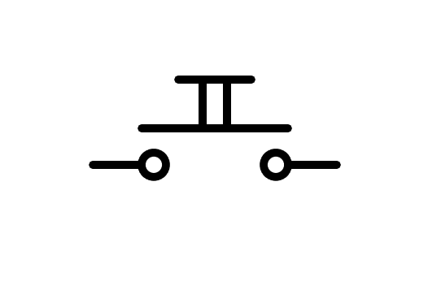

a) Spot Switch n.o.

b) Switch n.o.

c) Button n.o.

d) Battery

1. What is the component of the image?

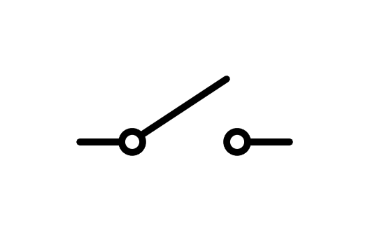

a) Botón

b) Button

c) Switch

d) Spot Switch

1. What is the component of the image?

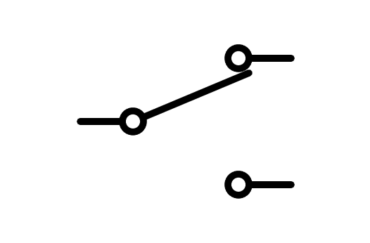

a) Spot Switch

b) Switch

c) Fuse

d) Button

1. What is the component of the image?

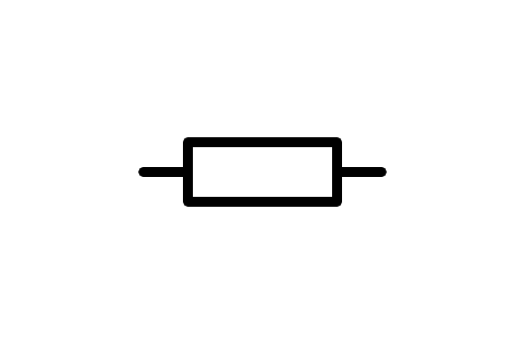

a) Resistor

b) Switch

c) Light Bulb

d) Battery

1. What is the component of the image?



a) Battery

b) Resistor

c) Switch

d) Light Bulb

1. What is the component of the image?

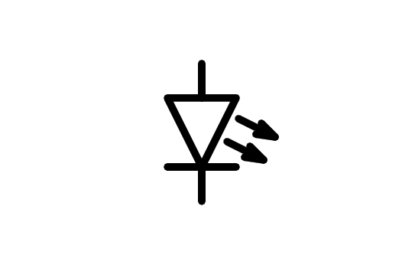

a) Motor

b) Light Bulb

c) Speaker

d) LED Diode

1. What is the component of the image?

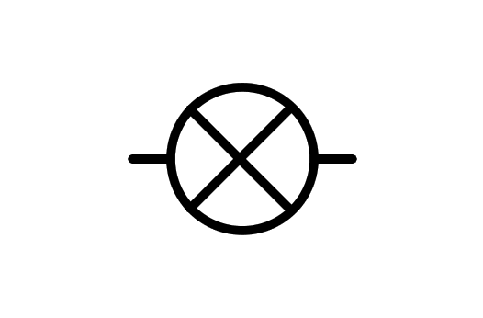

a) Light Bulb

b) Motor

c) X component

d) LED Diode

1. What is the component of the image?

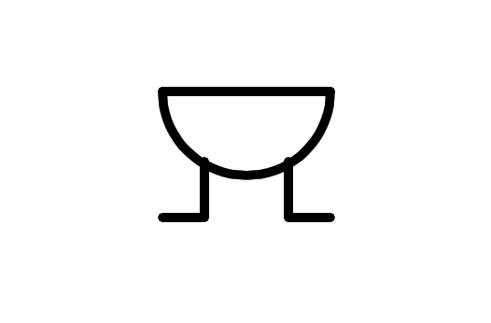

a) Motor

b) Altern current source

c) Buzzer

d) Speaker

1. What is the component of the image?

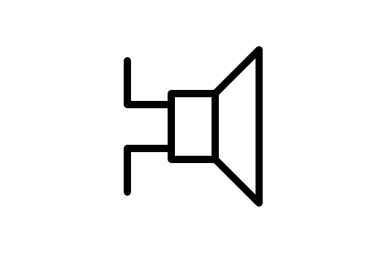

a) Direct current source

b) Speaker

c) Altern current source

d) Buzzer

1. What is the component of the image?

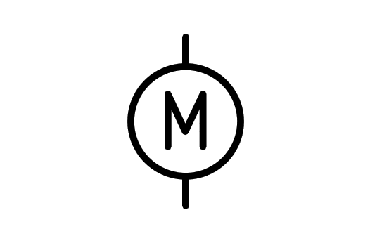

a) Wattmeter

b) Light Bulb

c) Buzzer

d) Motor

1. What is the component of the image?

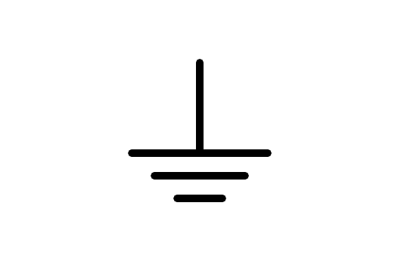

a) Battery

b) Receiver

c) Ground

d) Antenna

1. What is the component of the image?

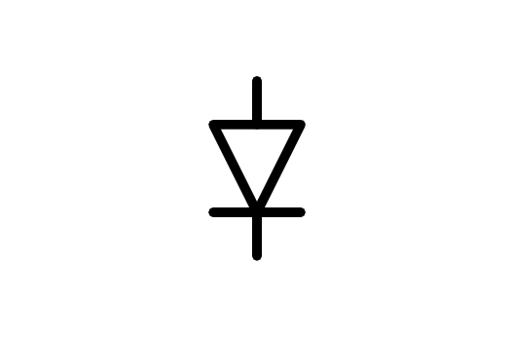

a) Transistor

b) LED Diode

c) Diode

d) Battery

1. What is the component of the image?

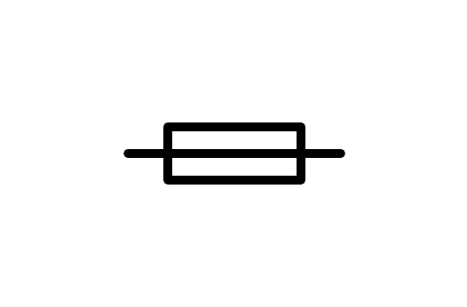

a) Resistor

b) Fuse

c) Relay

d) Generator

1. What is the component of the image?

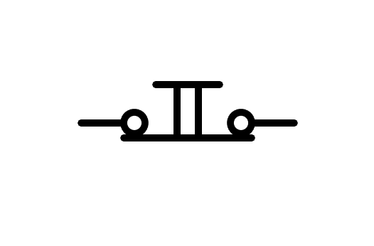

a) Button n.c.

b) Distributor

c) Battery

d) Switch n.c.

1. What is the component of the image?

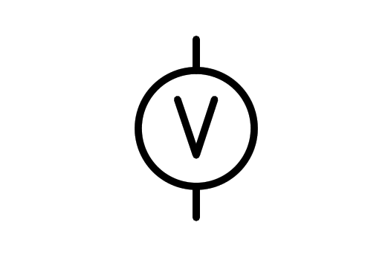

a) Power source

b) Voltmeter

c) Light Bulb

d) Battery

1. What is the component of the image?

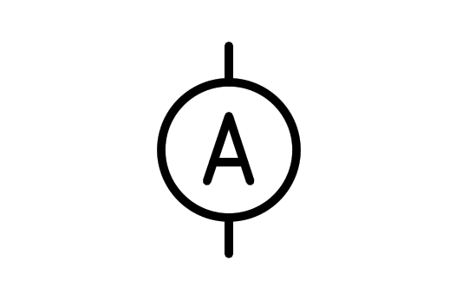

a) Ammeter

b) Battery

c) Aluminum

d) Current source

1. What is the component of the image?

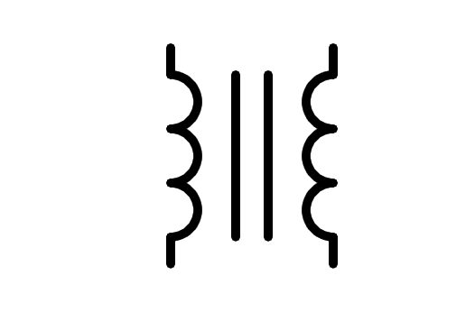

a) Transistor

b) Double conductor

c) Coil

d) Transformer

1. What is the component of the image?

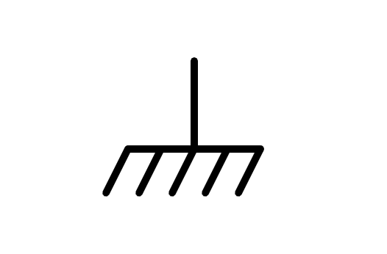

a) Mass

b) Battery

c) Ground

d) Brush

1. What is the component of the image?

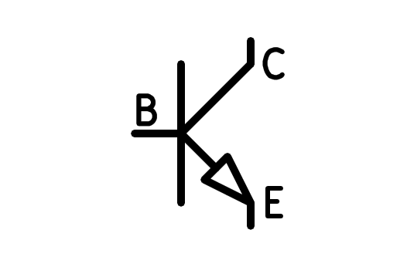

a) NPN Transistor

b) PNP Transformer

c) PNP Transistor

d) NPN Transformer

1. What is the component of the image?

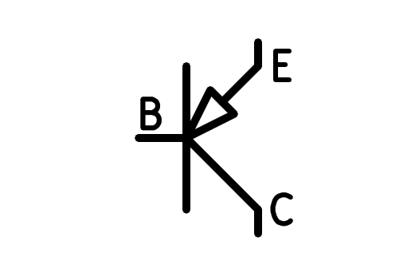

a) NPN Transistor

b) NPN Transformer

c) PNP Transformer

d) PNP Transistor

1. What is the component of the image?

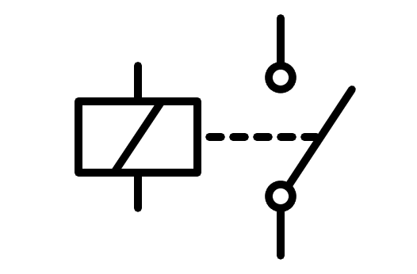

a) Coil

b) Relay

c) Double Switch

d) Double Button

1. What is the component of the image?

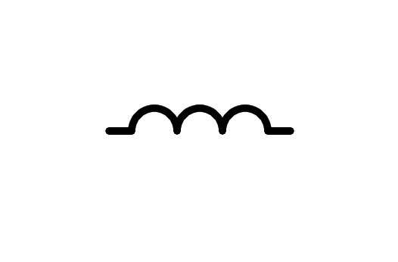

a) Round Button

b) Coil

c) Fingers

d) Cable

1. What is the component of the image?

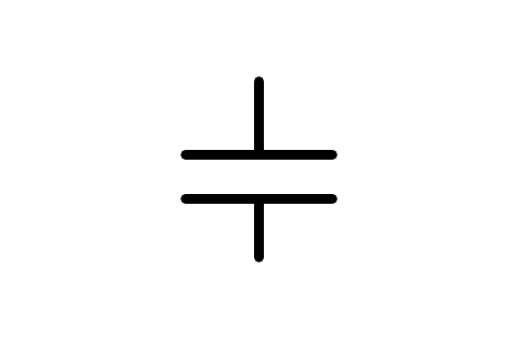

a) Battery

b) Small Battery

c) Capacitor

d) Congregator

1. What is the component of the image?

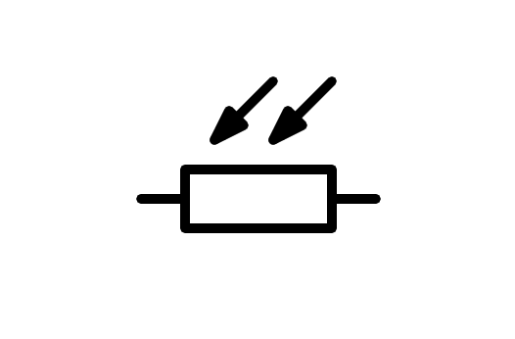

a) LDR Resistor

b) Variable Resistor

c) Resistor

d) NTC Resistor

1. What is the component of the image?

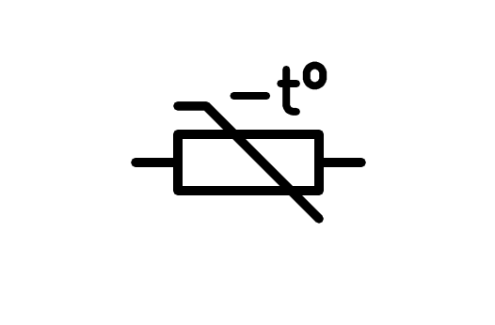

a) NTC Resistor

b) Variable Resistor

c) LDR Resistor

d) Resistor

1. What is the component of the image?

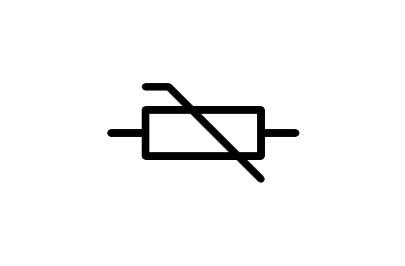

a) LDR Resistor

b) Variable Resistor

c) NTC Resistor

d) Resistor

1. What is the component of the image?

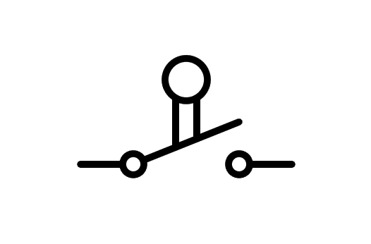

a) Switch

b) Button

c) Limit Switch

d) Button n.o.

1. What is the component of the image?

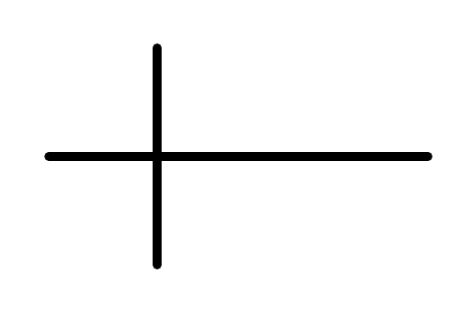

a) Crossover wire not connected

b) Connected wire

c) Cross

d) Crossover wire connected

1. What is the component of the image?

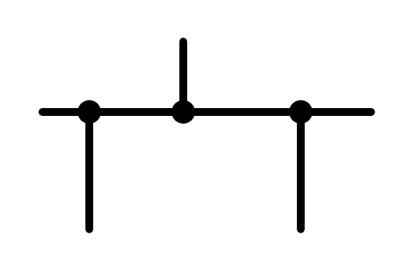

a) Connected and unconnected wire

b) Connected wire

c) Unconnected wire

d) Mass

1. What is the component of the image?

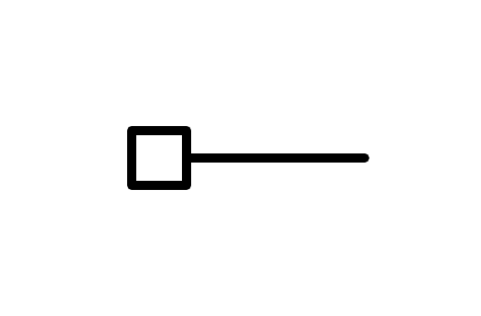

a) Ground

b) Mass

c) Connector

d) Squared

1. What is the component of the image?

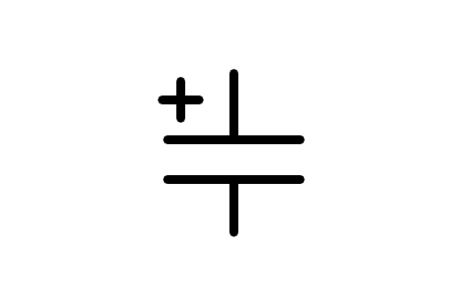

a) Polarized Capacitor

b) Battery

c) Capacitor

d) Small Battery