# Bloque de preguntas: electric_en_series_parallel

1. How is the following circuit connected?

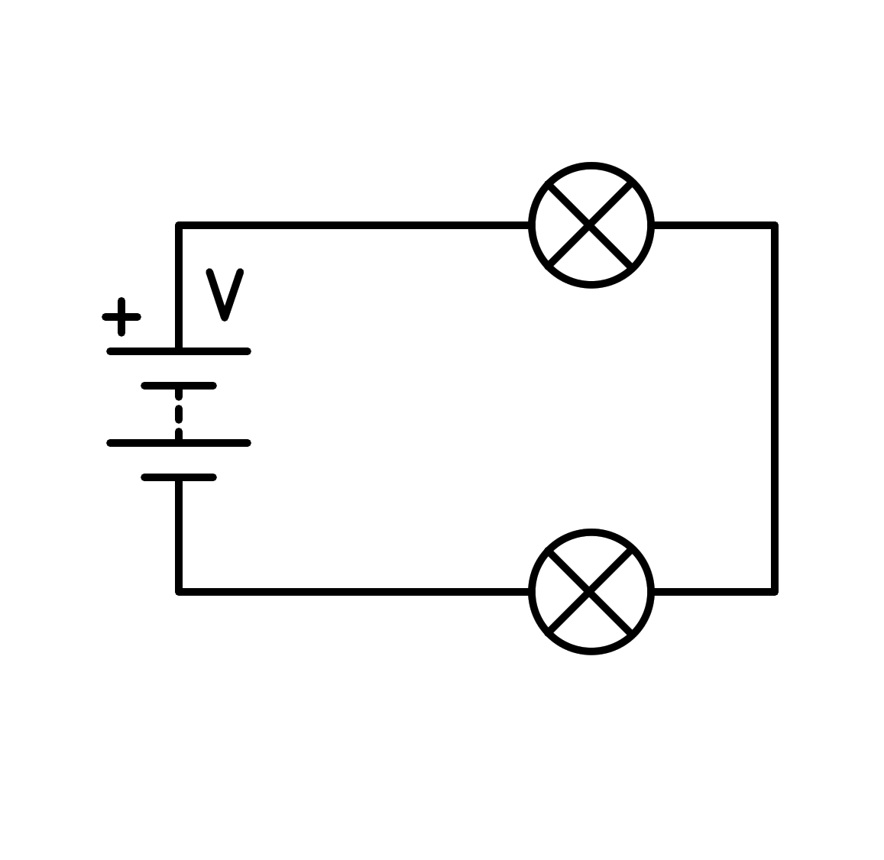

a) Sort circuit in the battery

b) In series

c) In parallel

d) Sort circuit in the light bulb

1. How is the following circuit connected?

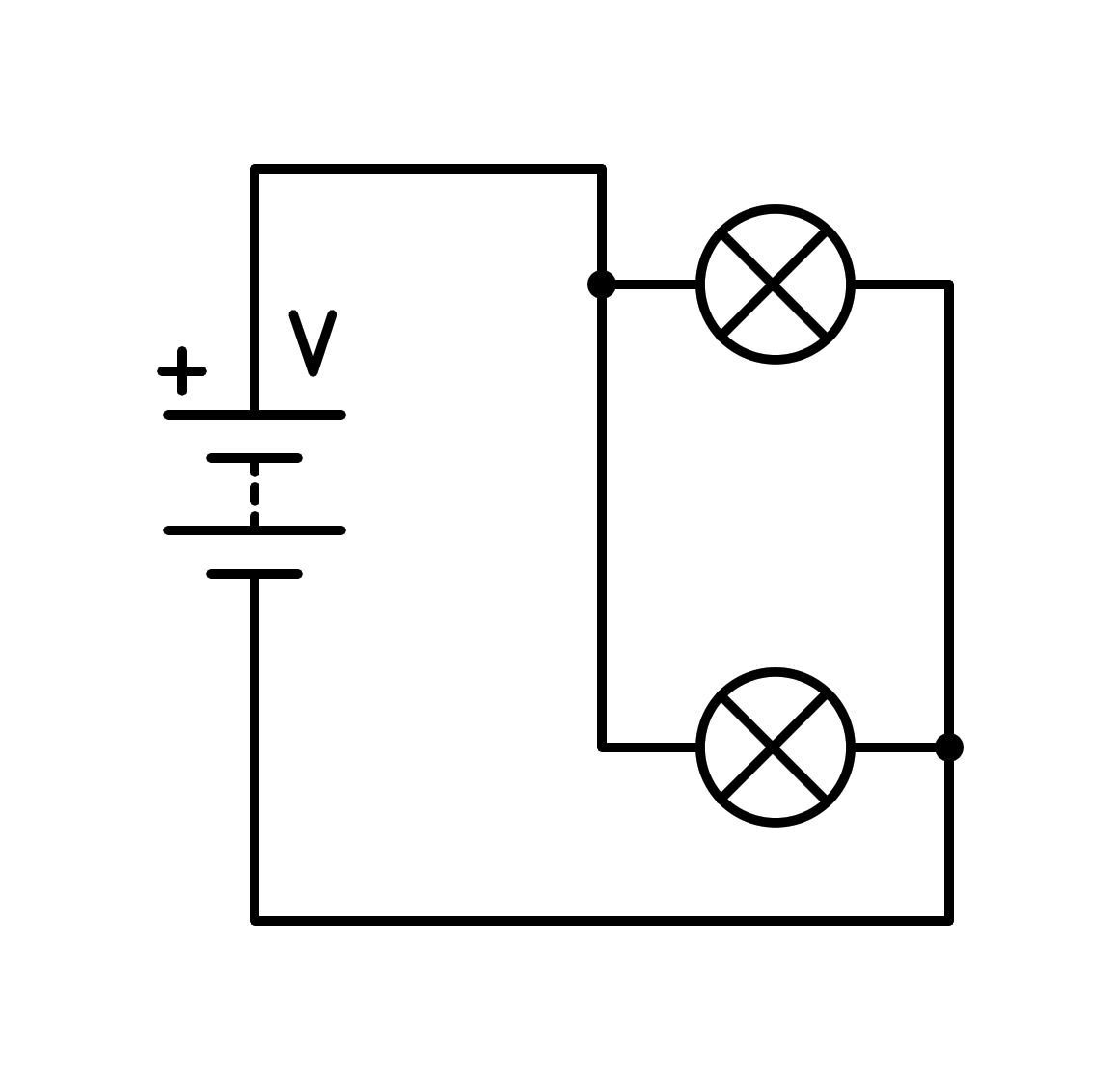

a) In series

b) Sort circuit in the light bulb

c) In parallel

d) Sort circuit in the battery

1. How is the following circuit connected?

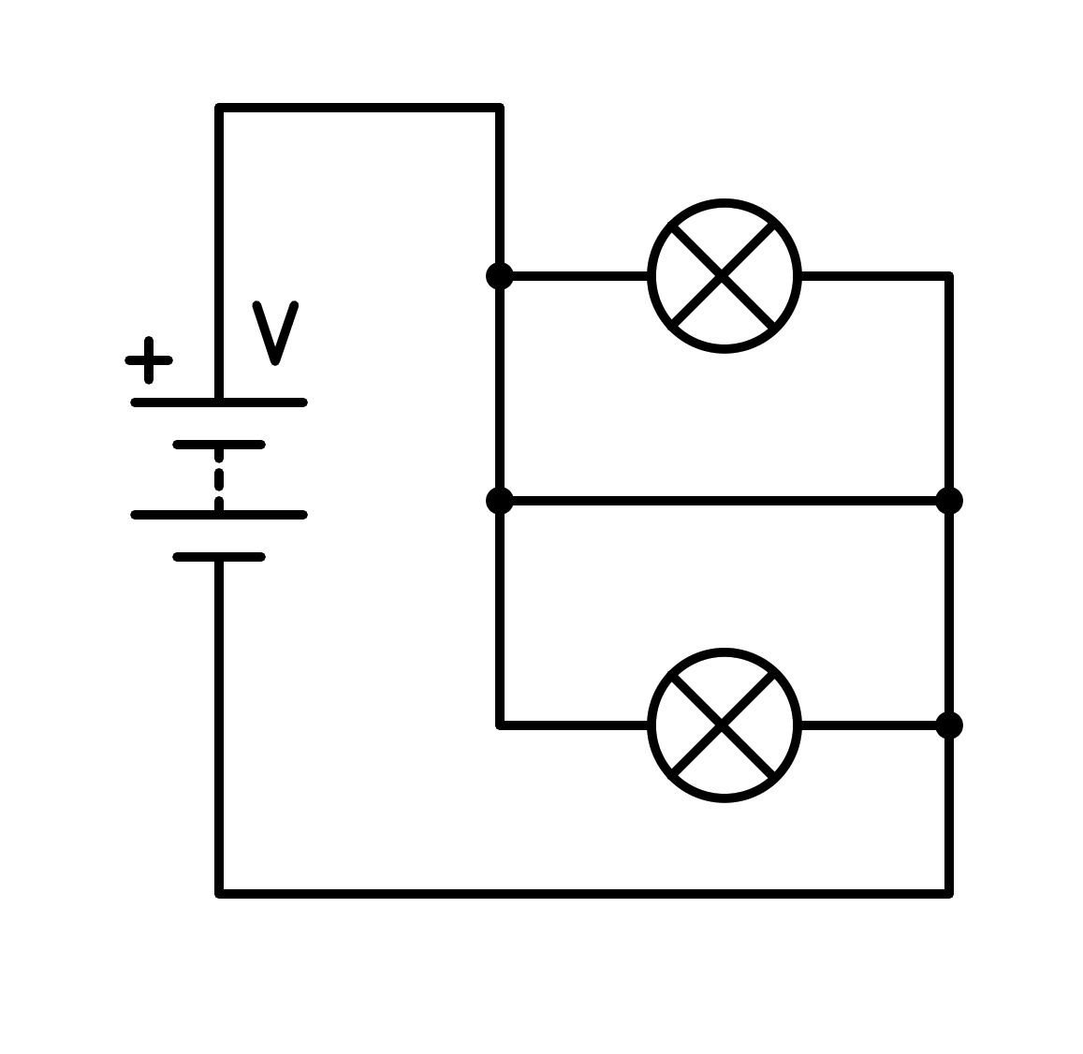

a) Sort circuit in the light bulb

b) In series

c) Sort circuit in the battery

d) In parallel

1. How is the following circuit connected?

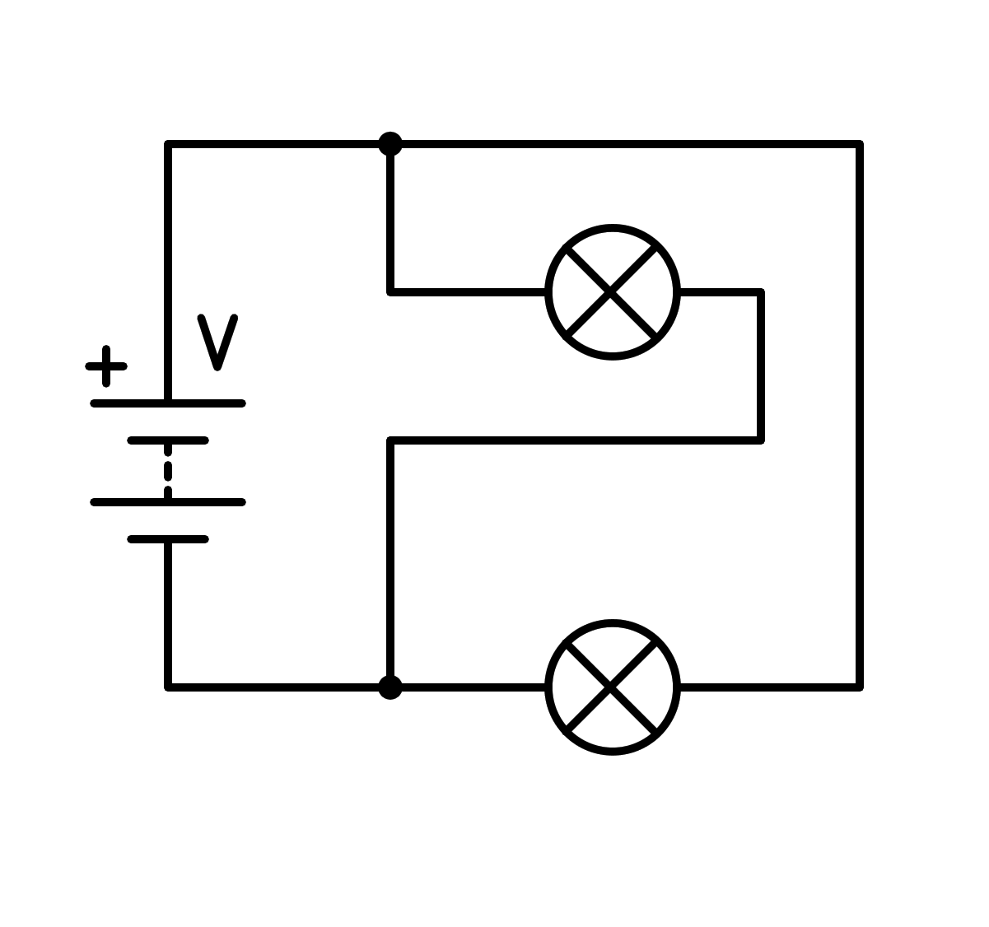

a) In series

b) Sort circuit in the light bulb

c) In parallel

d) Sort circuit in the battery

1. How is the following circuit connected?

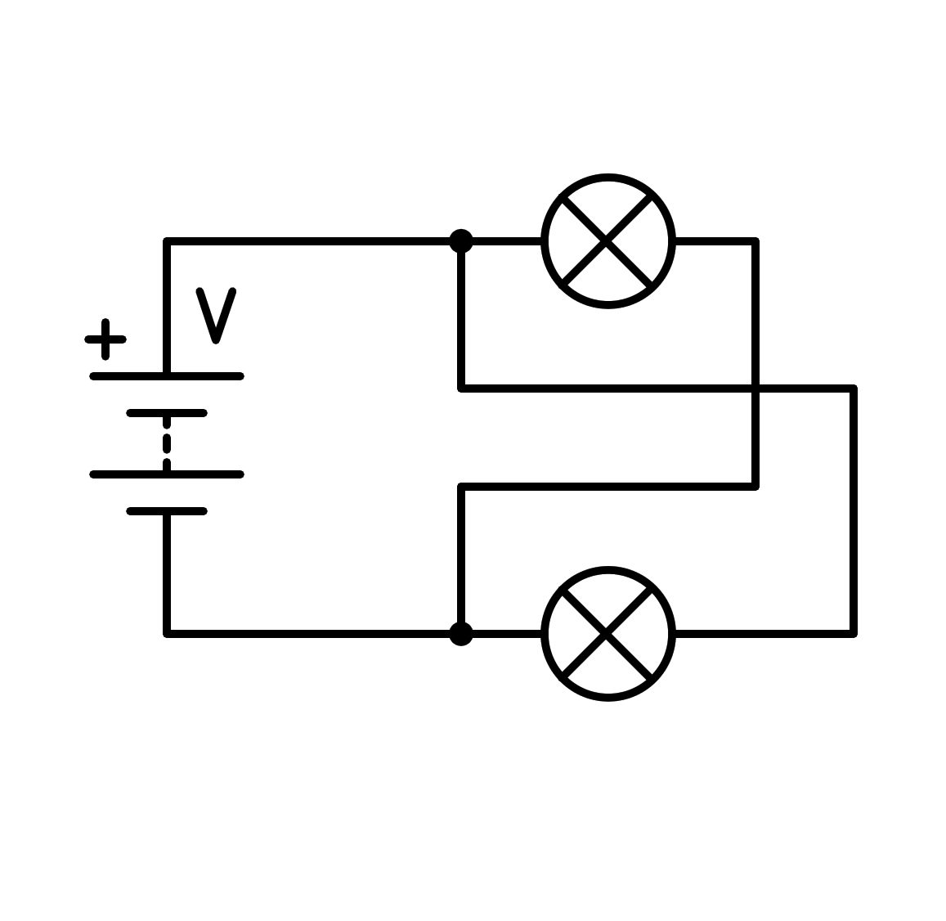

a) In series

b) Sort circuit in the battery

c) Sort circuit in the light bulb

d) In parallel

1. How is the following circuit connected?

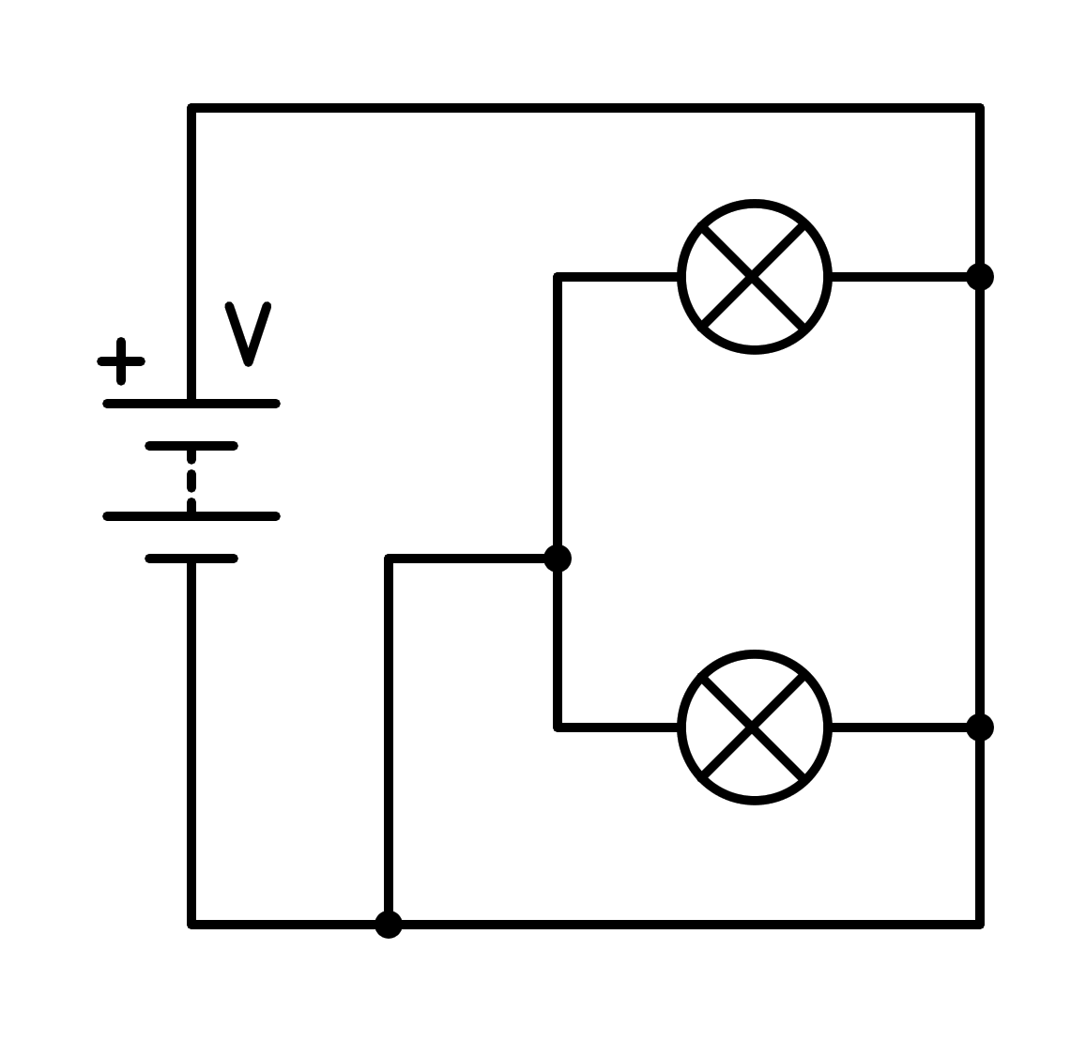

a) Sort circuit in the light bulb

b) In parallel

c) Sort circuit in the battery

d) In series

1. How is the following circuit connected?

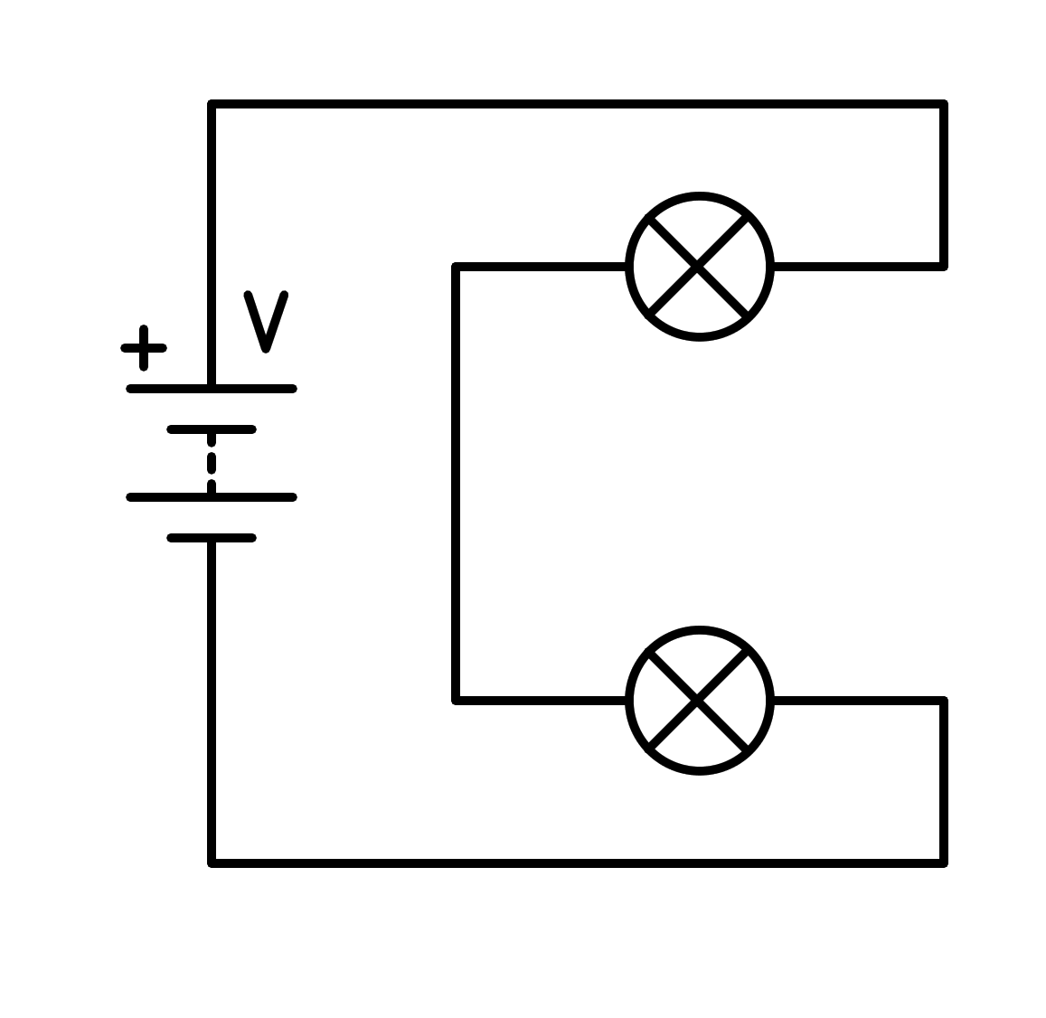

a) In parallel

b) Sort circuit in the light bulb

c) Sort circuit in the battery

d) In series

1. How is the following circuit connected?

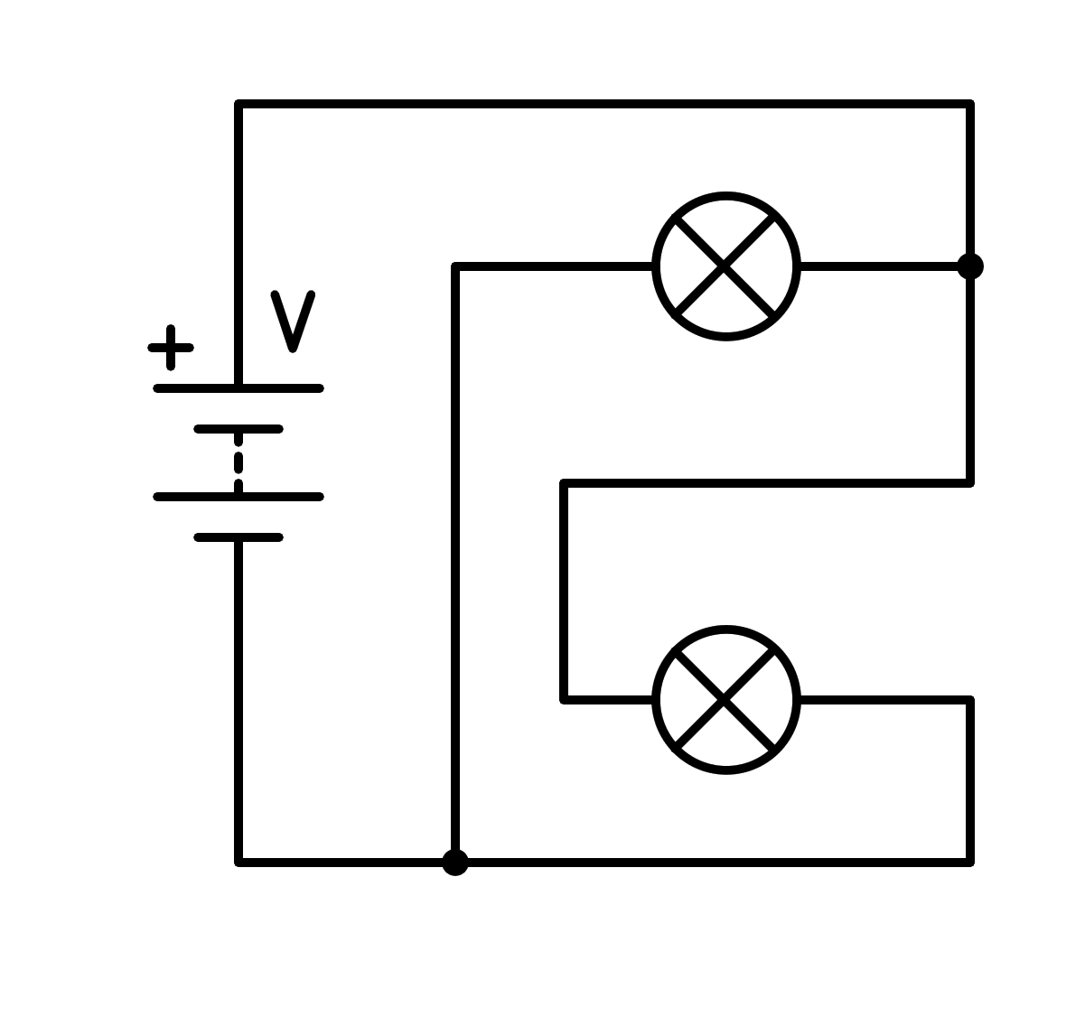

a) In series

b) Sort circuit in the battery

c) Sort circuit in the light bulb

d) In parallel

1. How is the following circuit connected?

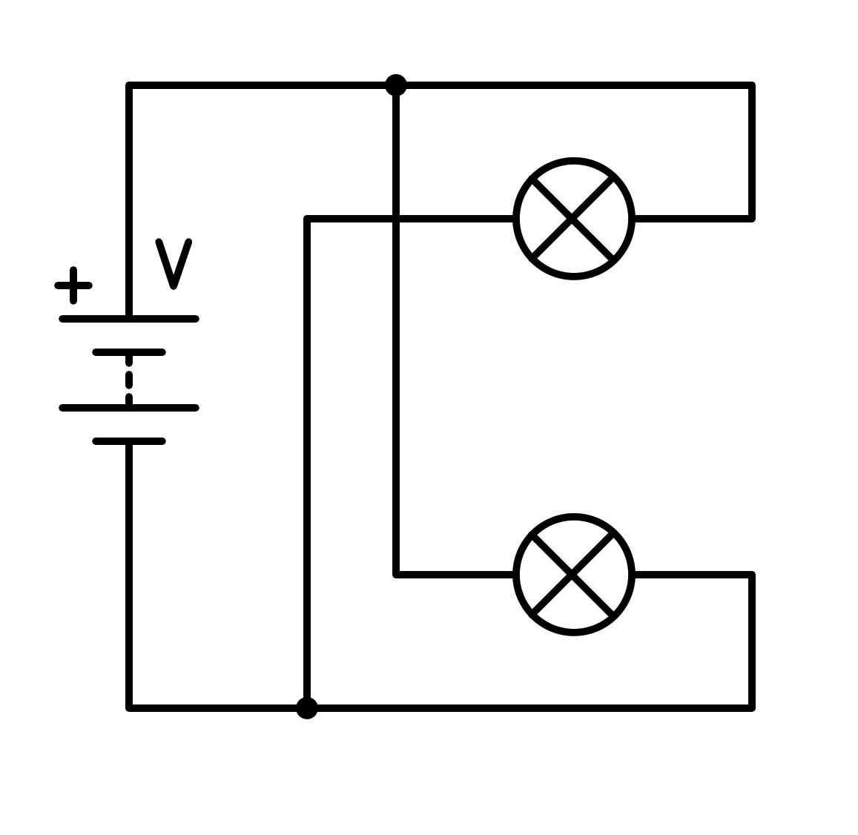

a) In series

b) In parallel

c) Sort circuit in the light bulb

d) Sort circuit in the battery

1. How is the following circuit connected?

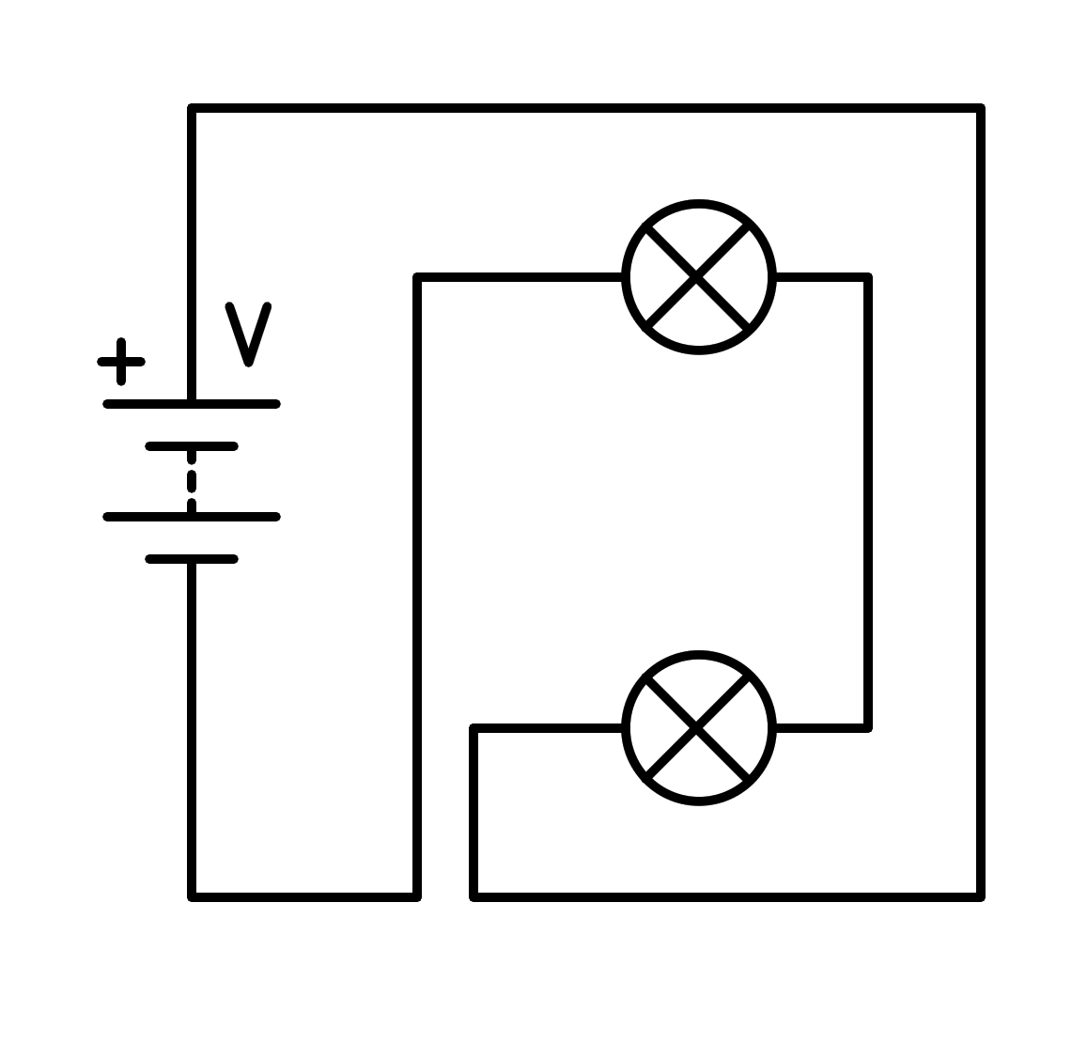

a) Sort circuit in the light bulb

b) Sort circuit in the battery

c) In parallel

d) In series

1. How is the following circuit connected?

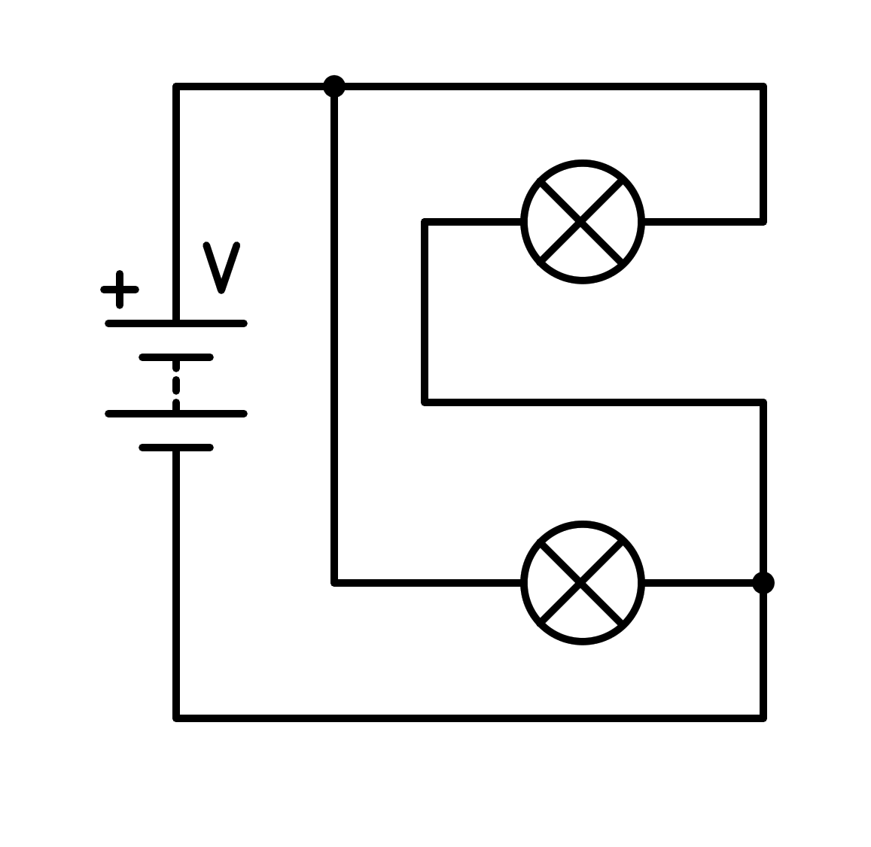

a) In series

b) Sort circuit in the light bulb

c) Sort circuit in the battery

d) In parallel

1. How is the following circuit connected?

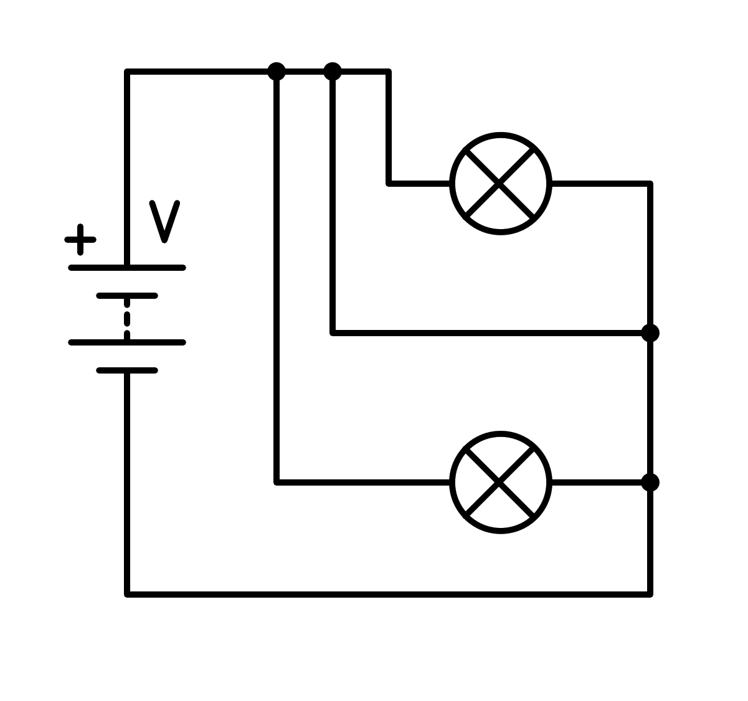

a) In series

b) Sort circuit in the light bulb

c) Sort circuit in the battery

d) In parallel

1. How is the following circuit connected?

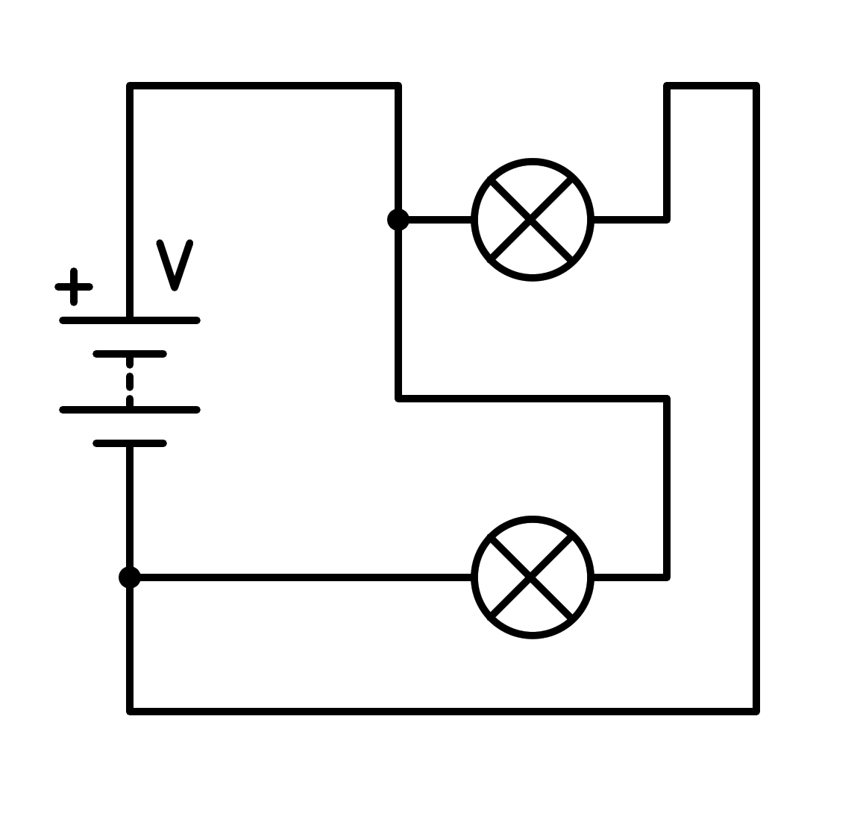

a) Sort circuit in the battery

b) Sort circuit in the light bulb

c) In parallel

d) In series

1. How is the following circuit connected?

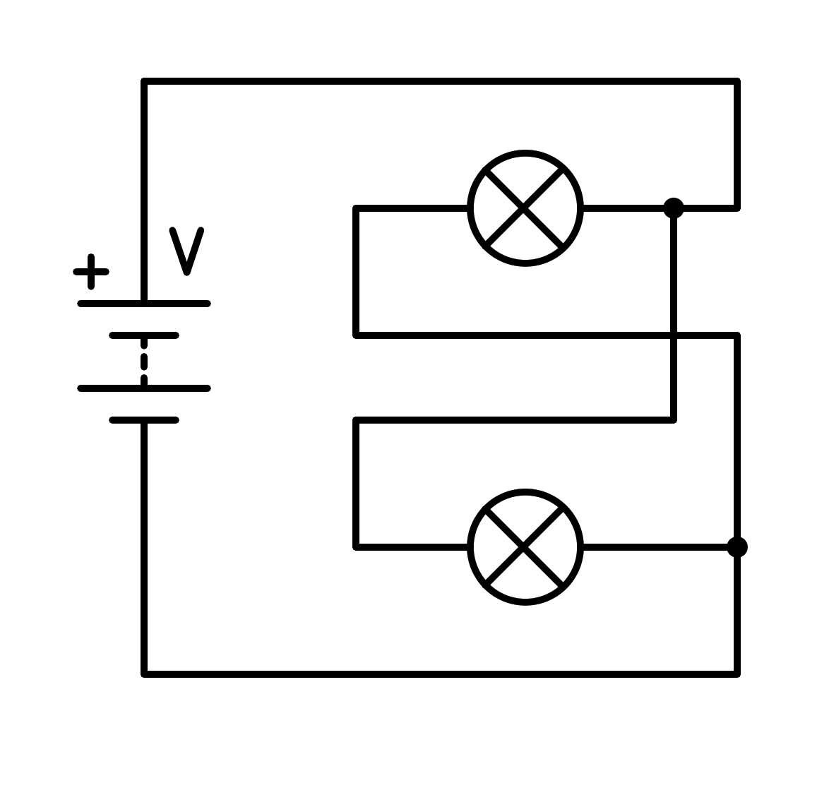

a) Sort circuit in the battery

b) In parallel

c) Sort circuit in the light bulb

d) In series

1. How is the following circuit connected?

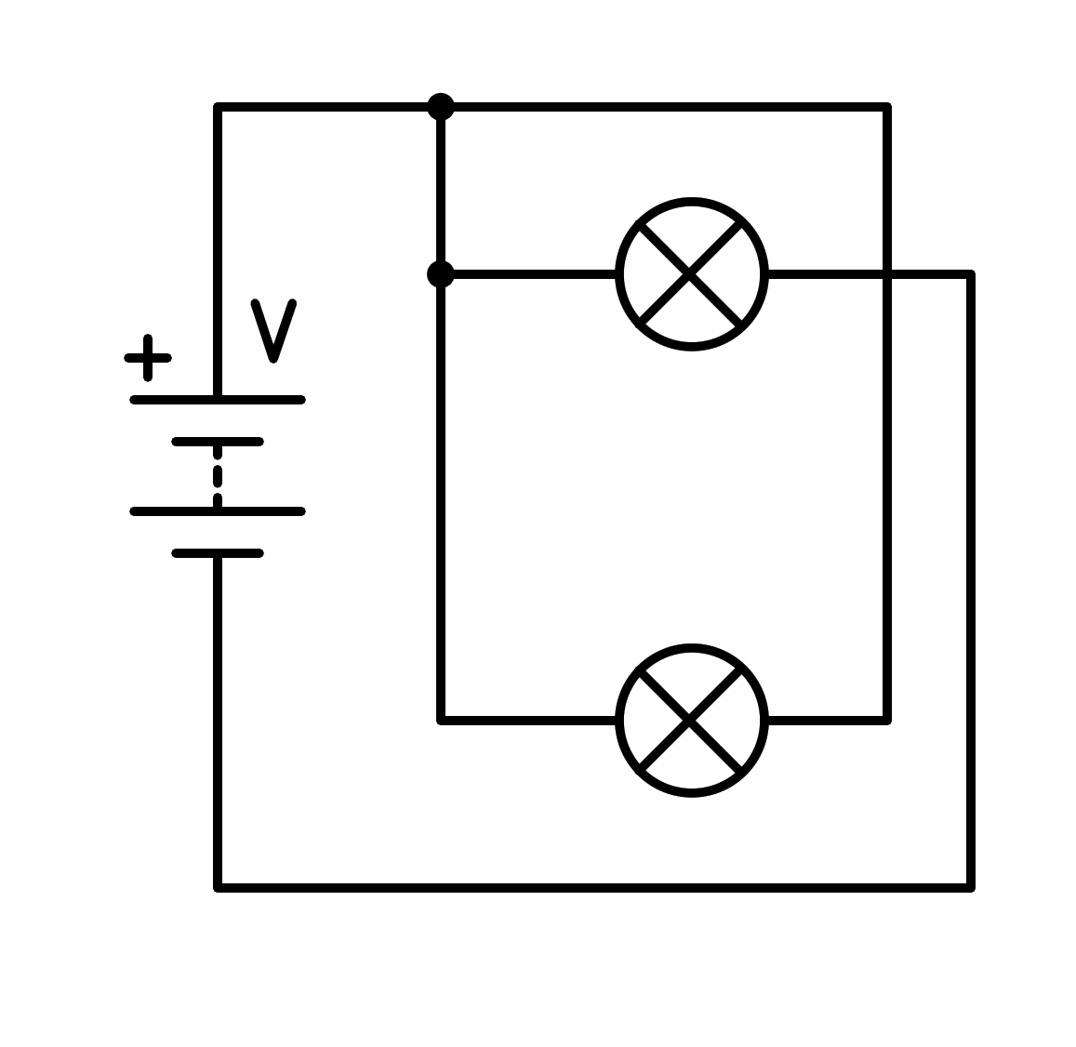

a) Sort circuit in the light bulb

b) In parallel

c) Sort circuit in the battery

d) In series

1. How is the following circuit connected?

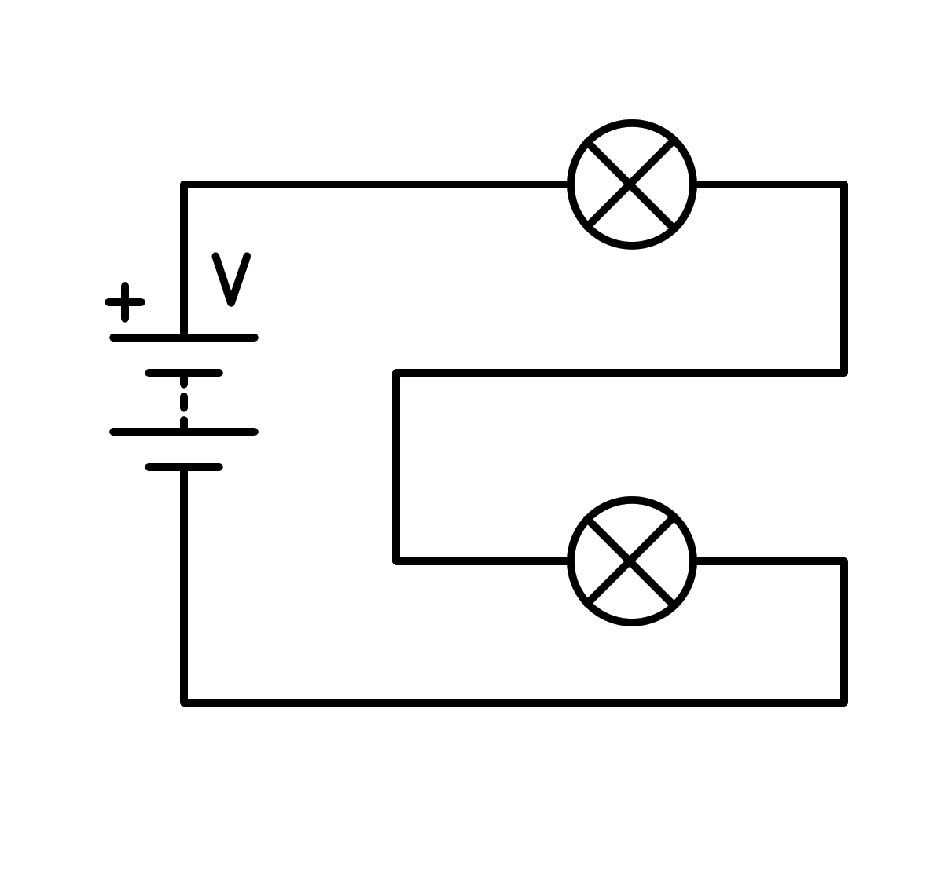

a) In parallel

b) Sort circuit in the light bulb

c) Sort circuit in the battery

d) In series

1. How is the following circuit connected?

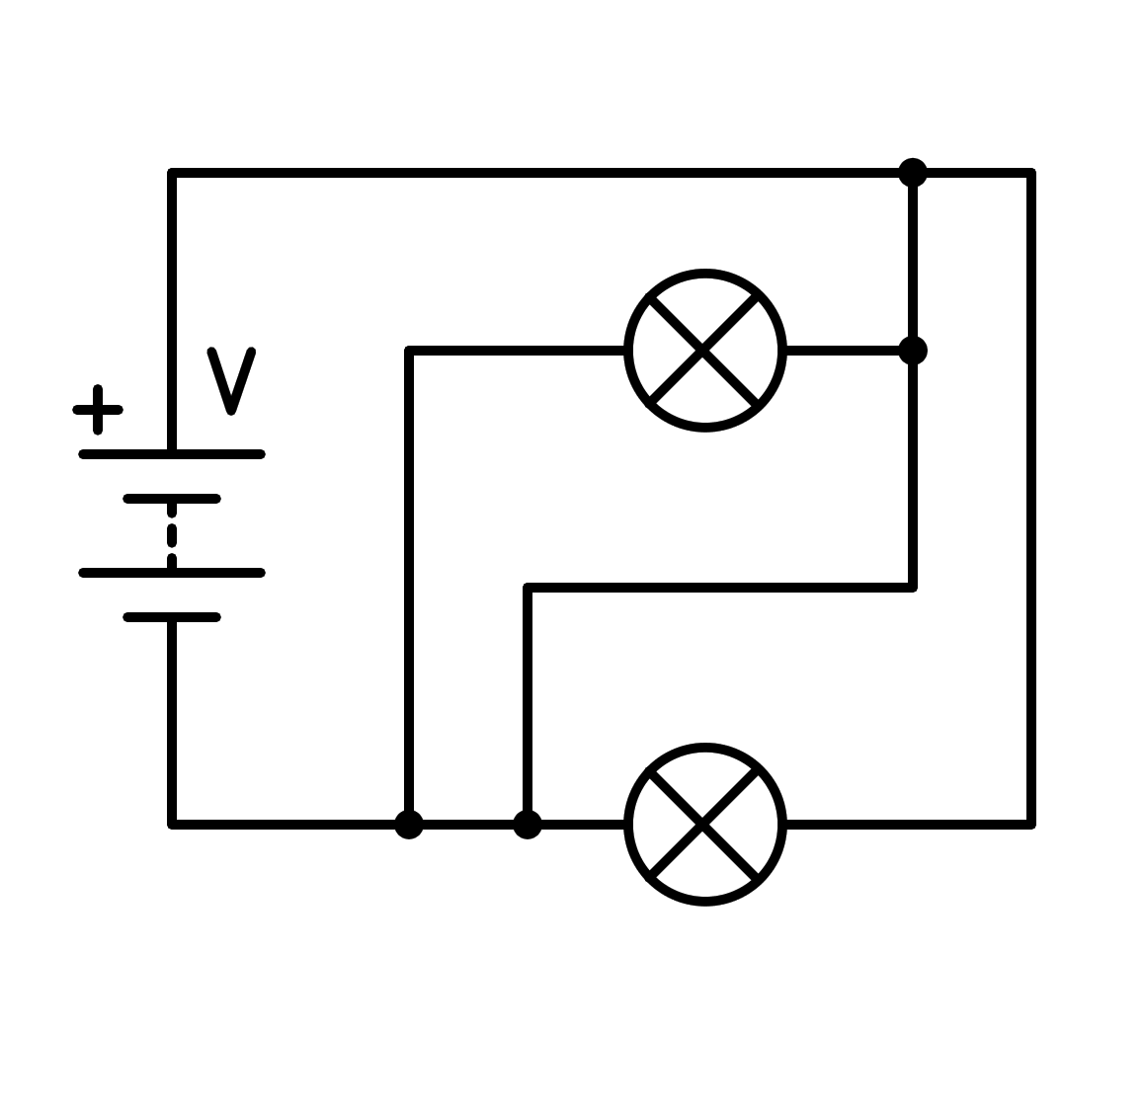

a) In parallel

b) Sort circuit in the battery

c) In series

d) Sort circuit in the light bulb

1. How is the following circuit connected?

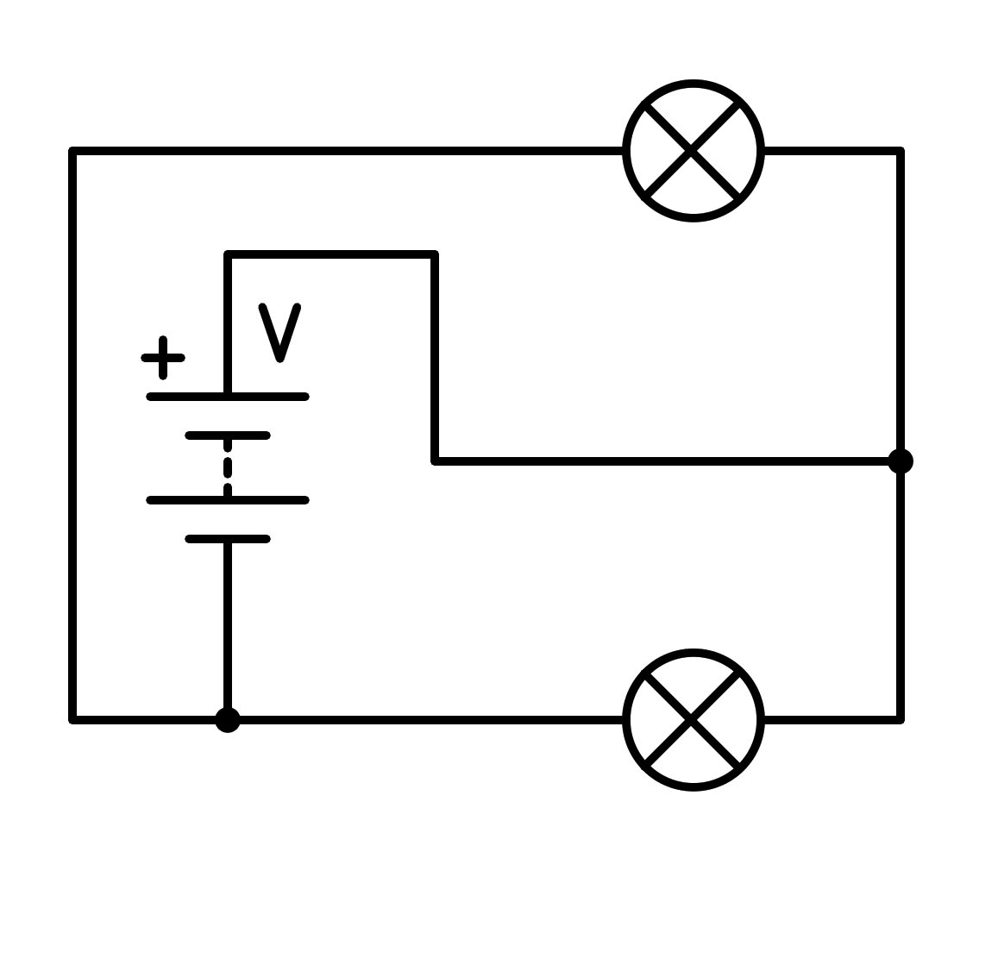

a) Sort circuit in the battery

b) In series

c) In parallel

d) Sort circuit in the light bulb

1. How is the following circuit connected?

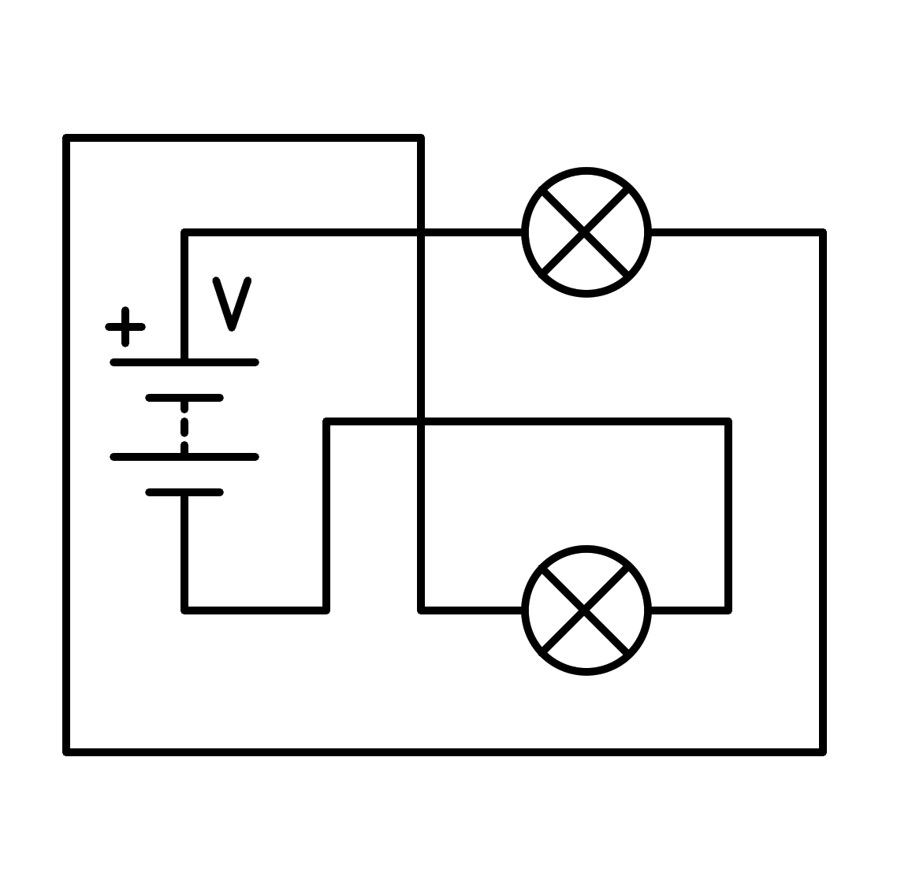

a) In parallel

b) In series

c) Sort circuit in the light bulb

d) Sort circuit in the battery

1. How is the following circuit connected?

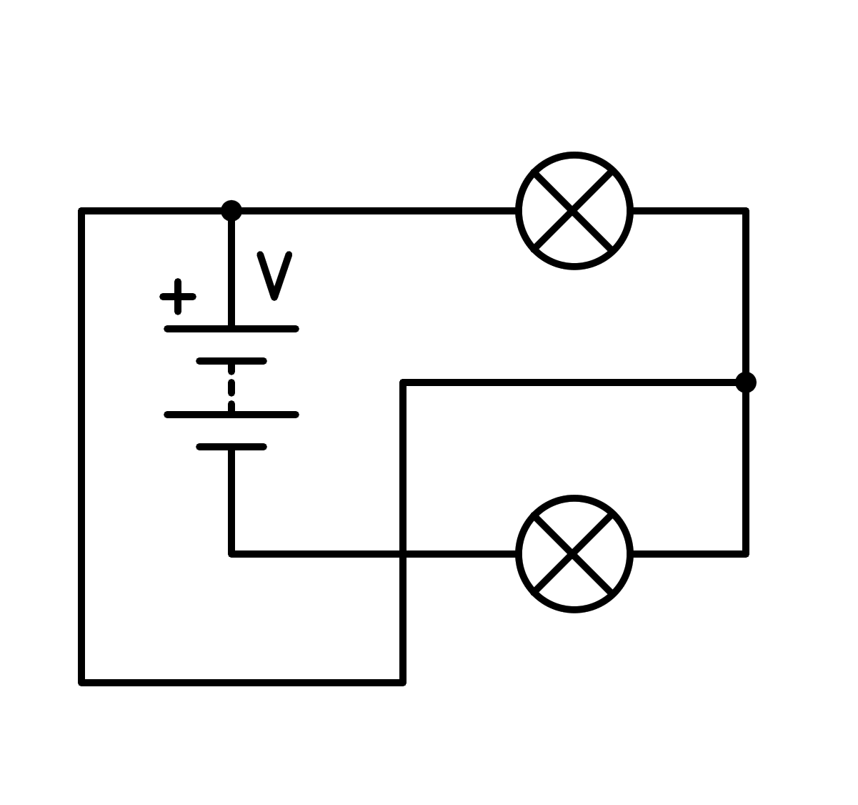

a) In series

b) Sort circuit in the battery

c) In parallel

d) Sort circuit in the light bulb

1. How is the following circuit connected?

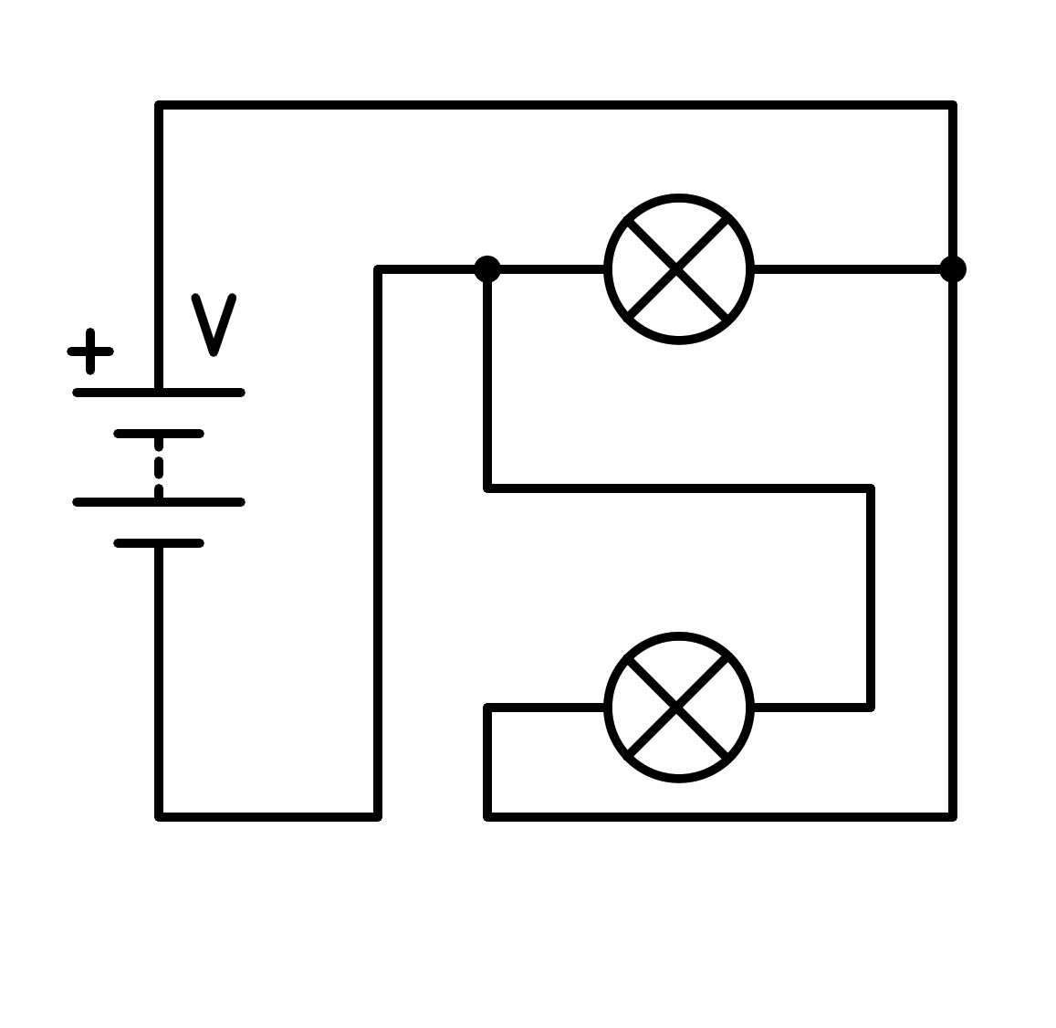

a) Sort circuit in the light bulb

b) In series

c) In parallel

d) Sort circuit in the battery

1. How is the following circuit connected?

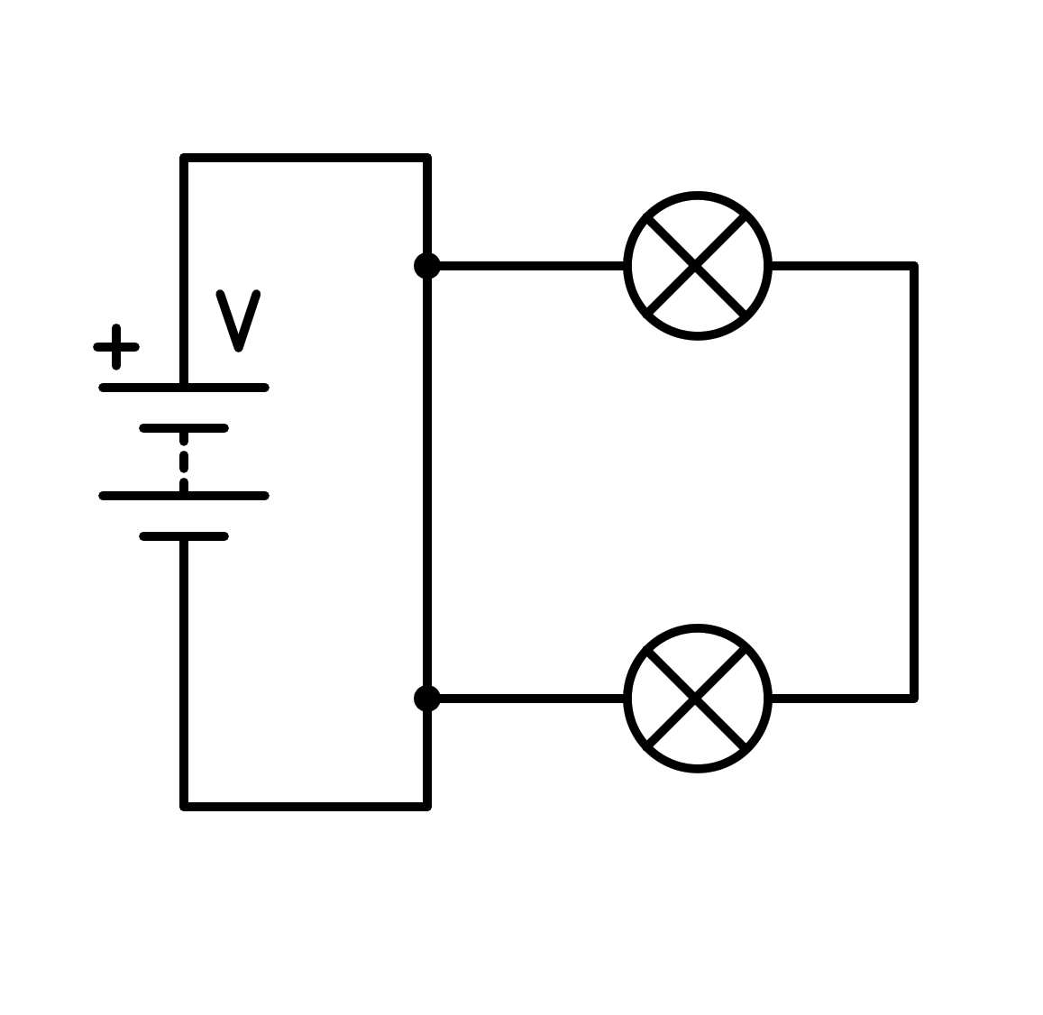

a) In series

b) Sort circuit in the battery

c) Sort circuit in the light bulb

d) In parallel

1. How is the following circuit connected?

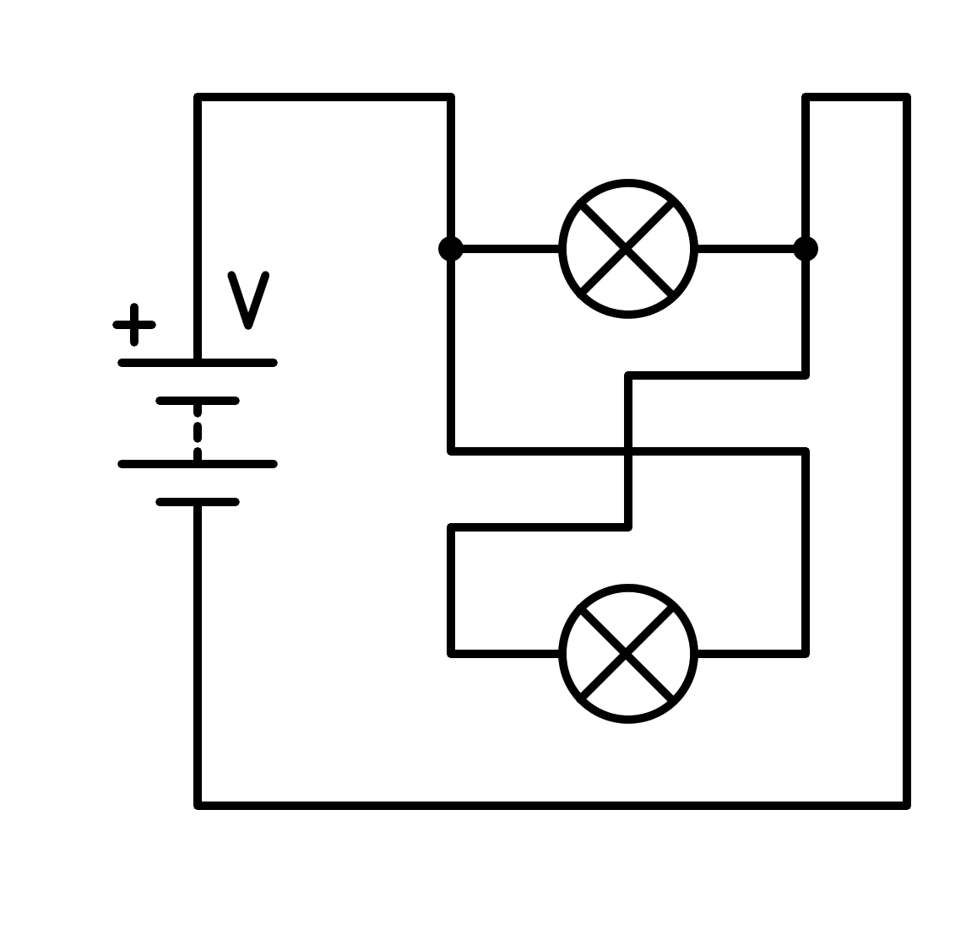

a) In series

b) Sort circuit in the battery

c) Sort circuit in the light bulb

d) In parallel

1. How is the following circuit connected?

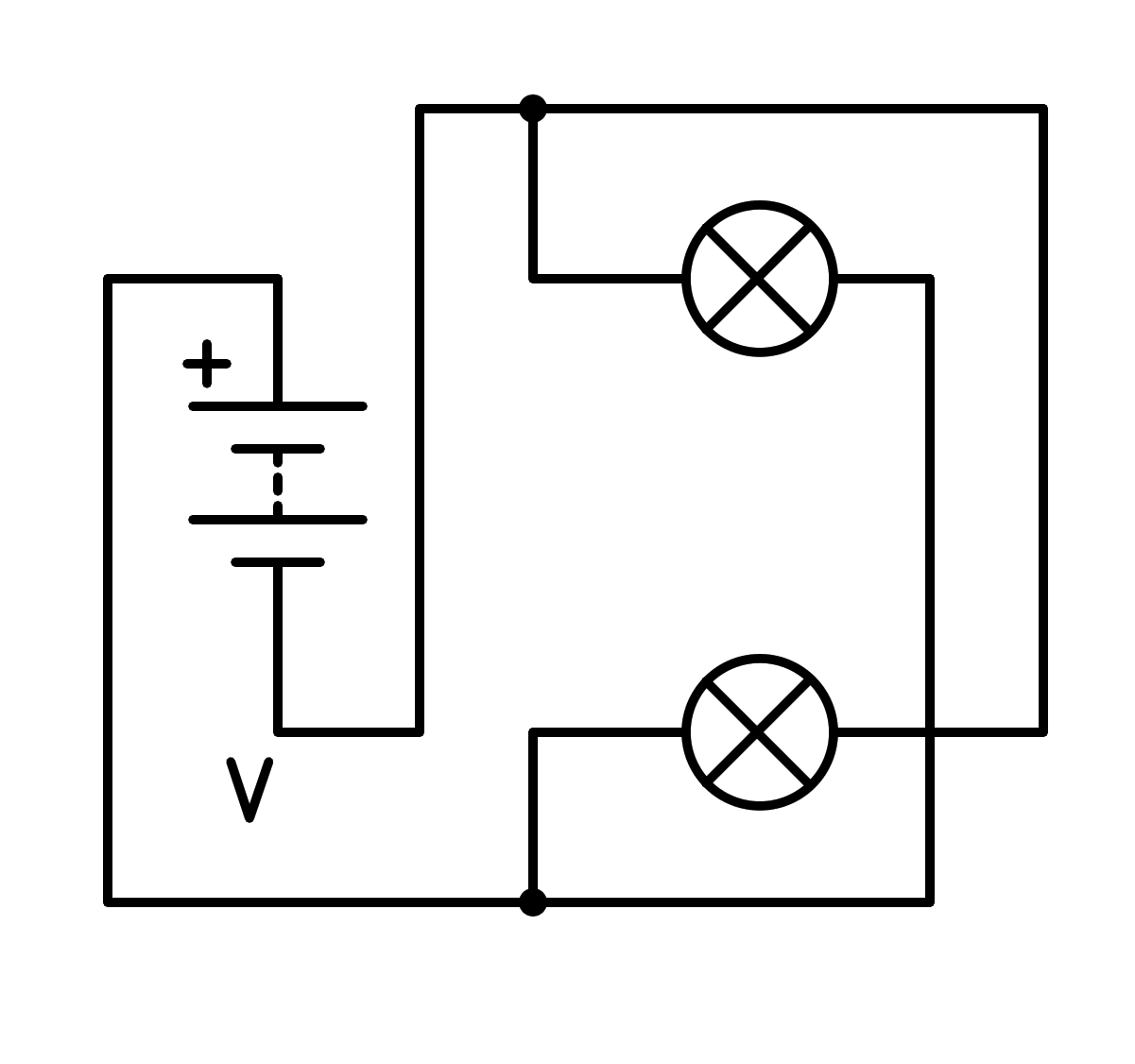

a) Sort circuit in the light bulb

b) In series

c) Sort circuit in the battery

d) In parallel

1. How is the following circuit connected?

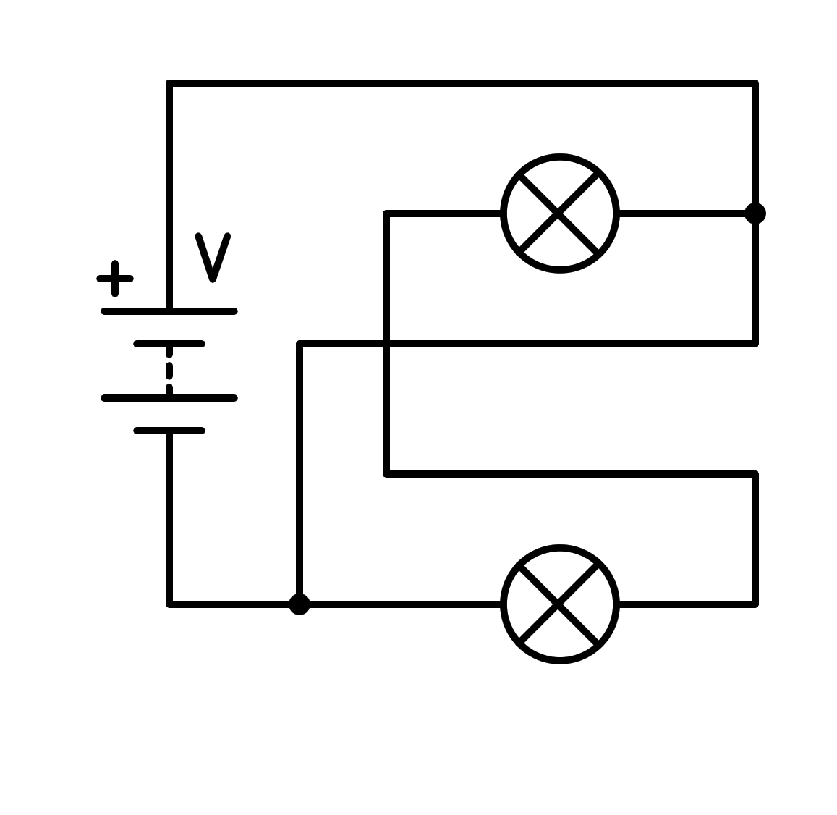

a) In parallel

b) In series

c) Sort circuit in the battery

d) Sort circuit in the light bulb

1. How is the following circuit connected?

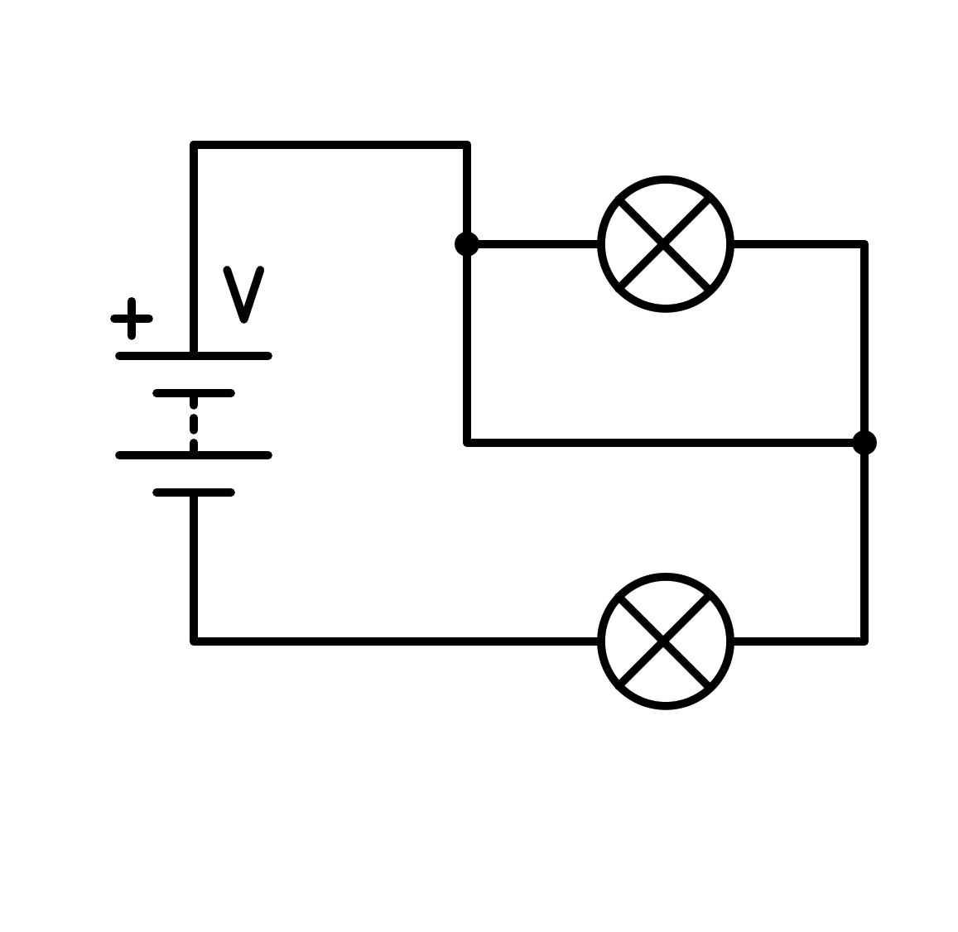

a) In series

b) Sort circuit in the battery

c) In parallel

d) Sort circuit in the light bulb

1. How is the following circuit connected?

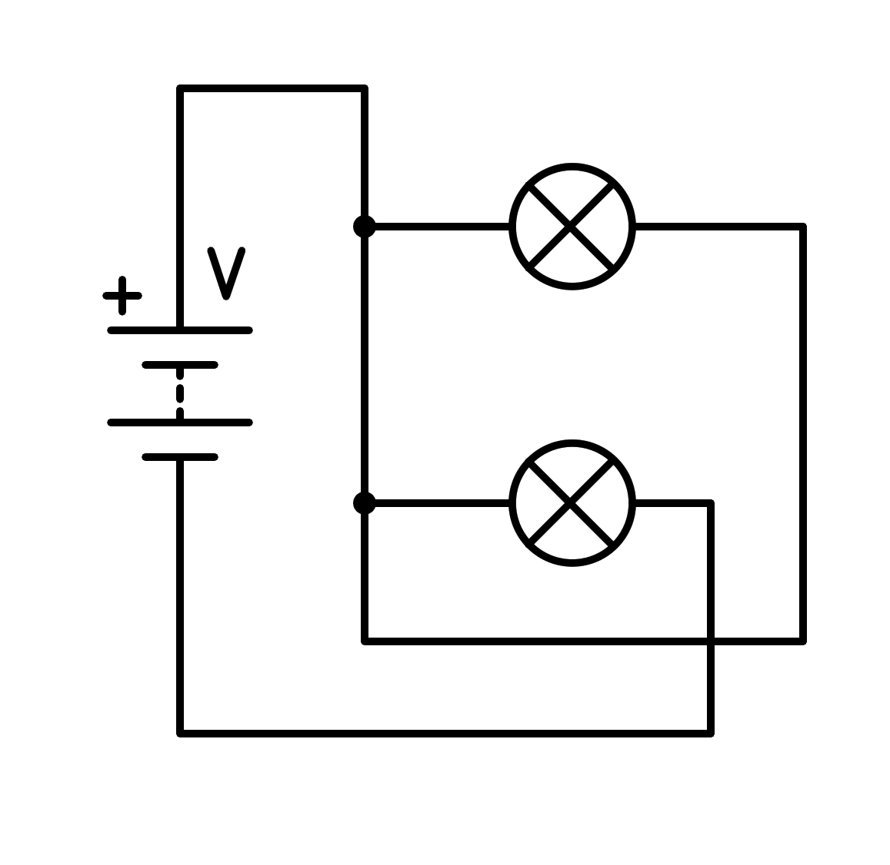

a) In series

b) Sort circuit in the light bulb

c) Sort circuit in the battery

d) In parallel

1. How is the following circuit connected?

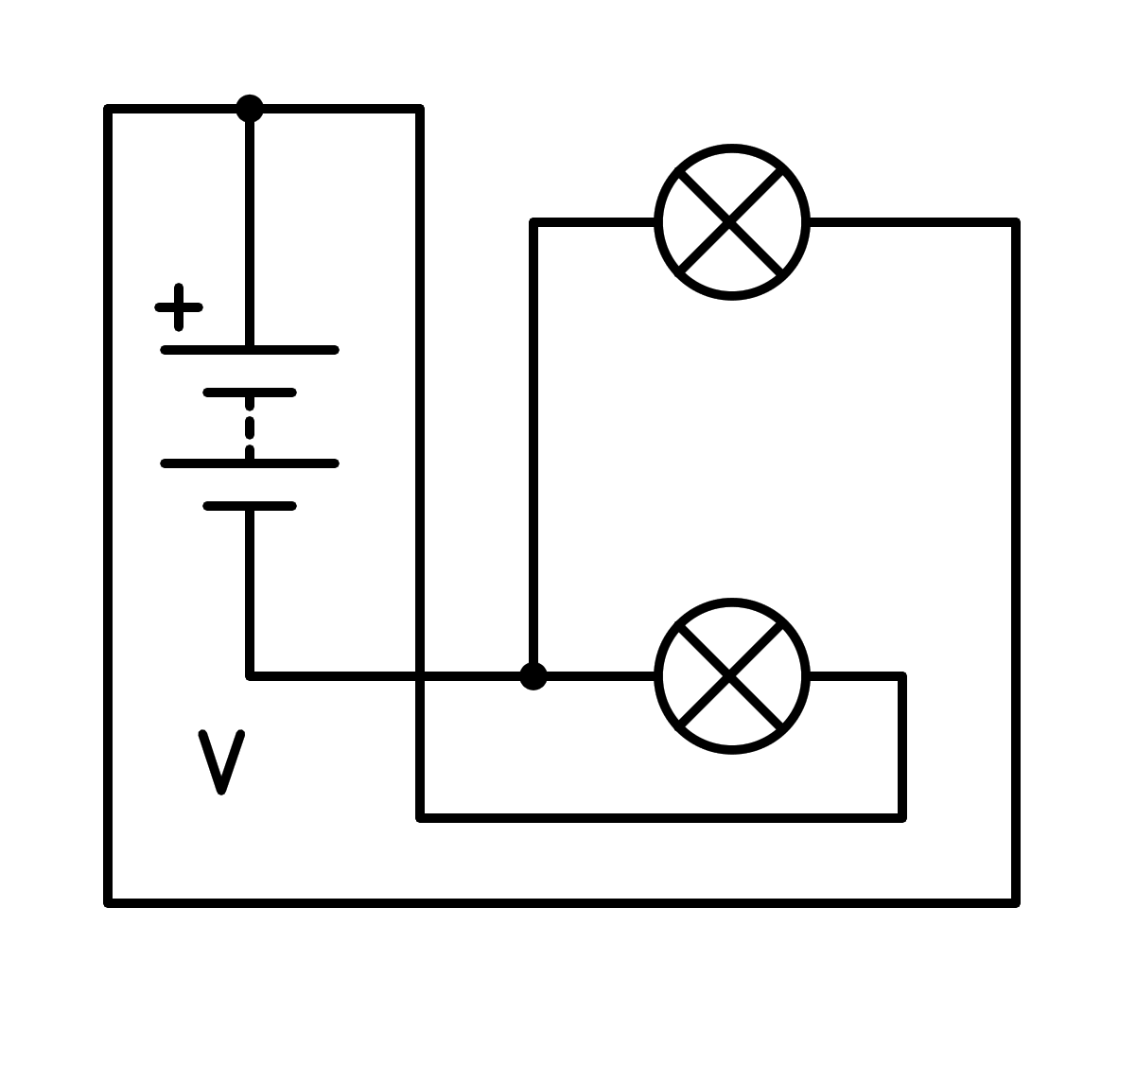

a) In parallel

b) Sort circuit in the light bulb

c) In series

d) Sort circuit in the battery

1. How is the following circuit connected?

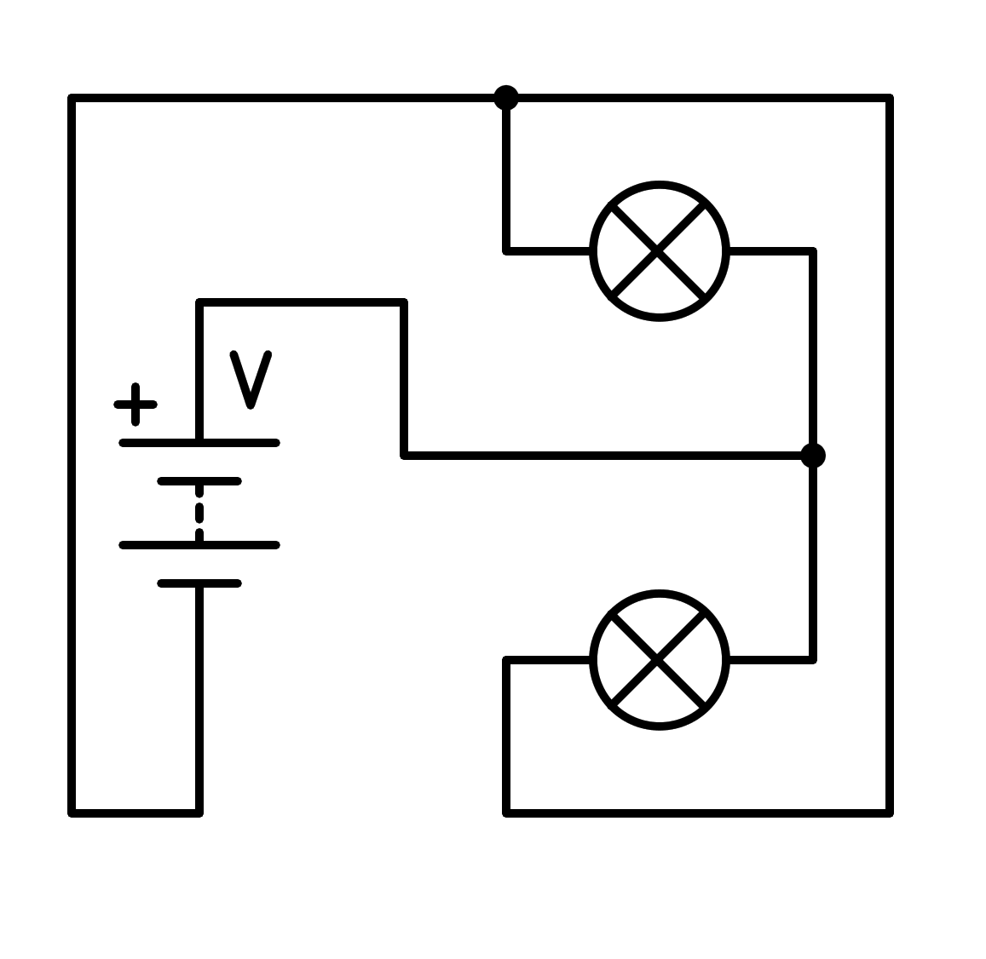

a) Sort circuit in the battery

b) Sort circuit in the light bulb

c) In parallel

d) In series

1. How is the following circuit connected?

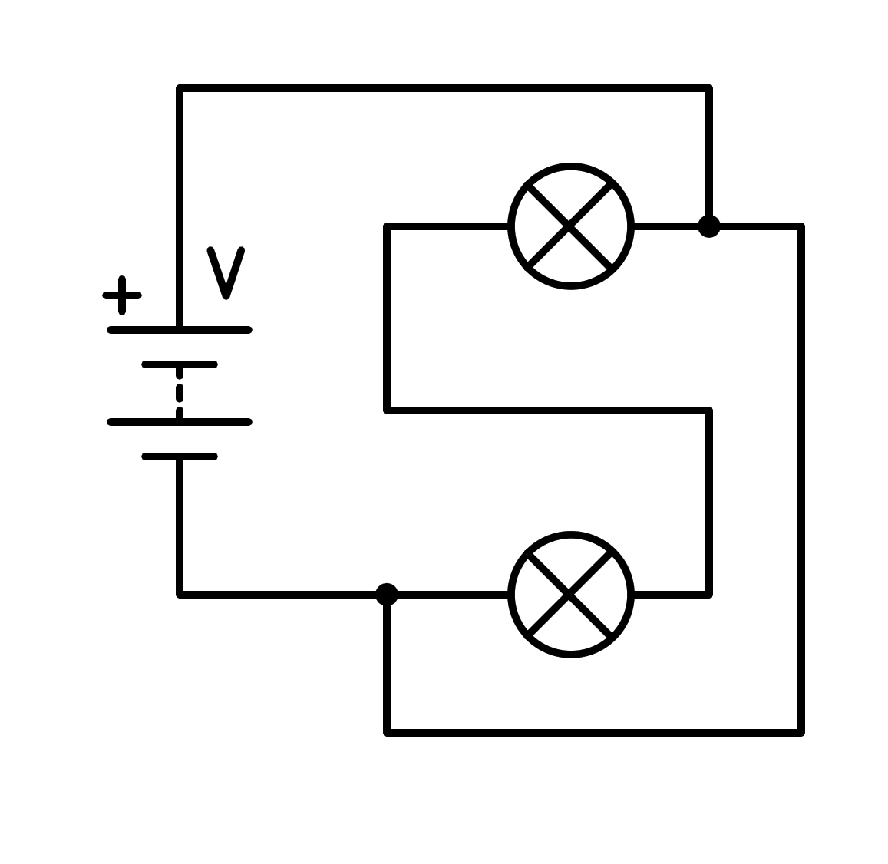

a) Sort circuit in the light bulb

b) Sort circuit in the battery

c) In parallel

d) In series

1. How is the following circuit connected?

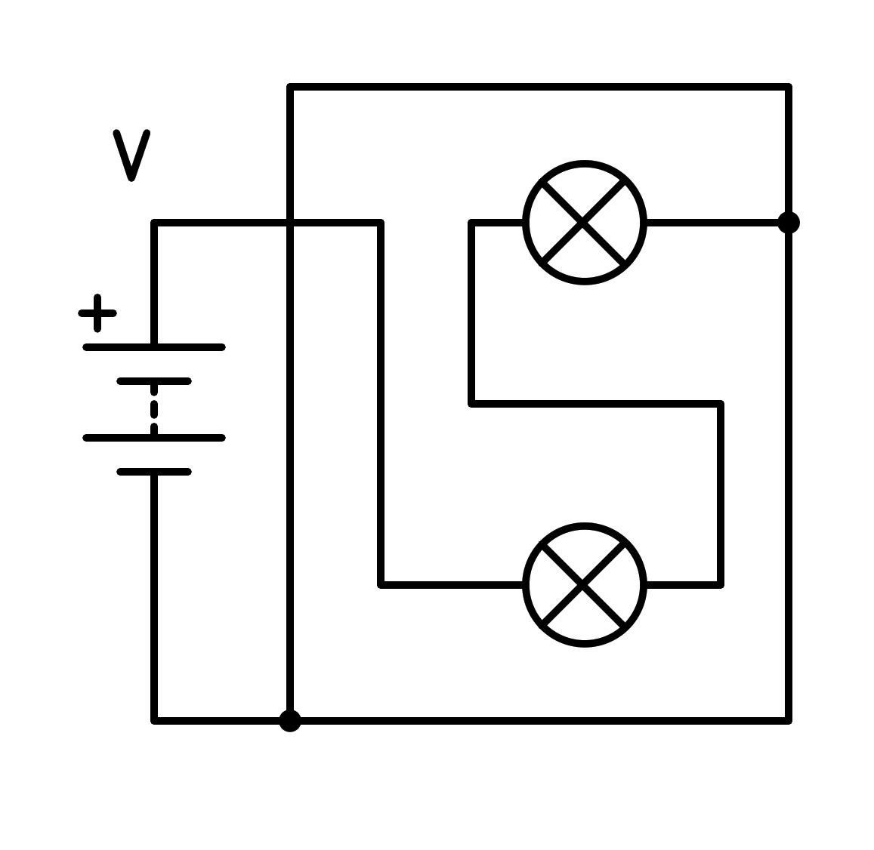

a) In series

b) In parallel

c) Sort circuit in the light bulb

d) Sort circuit in the battery

1. How is the following circuit connected?

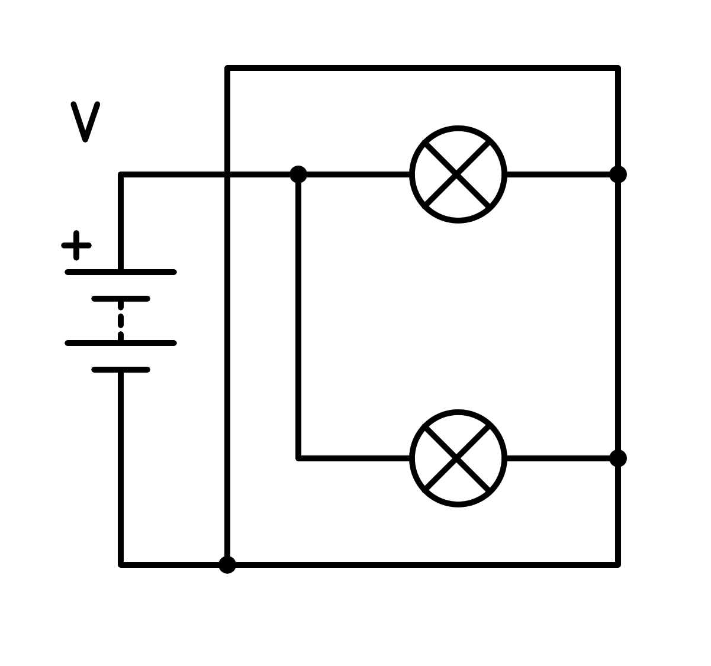

a) Sort circuit in the light bulb

b) In series

c) In parallel

d) Sort circuit in the battery

1. How is the following circuit connected?

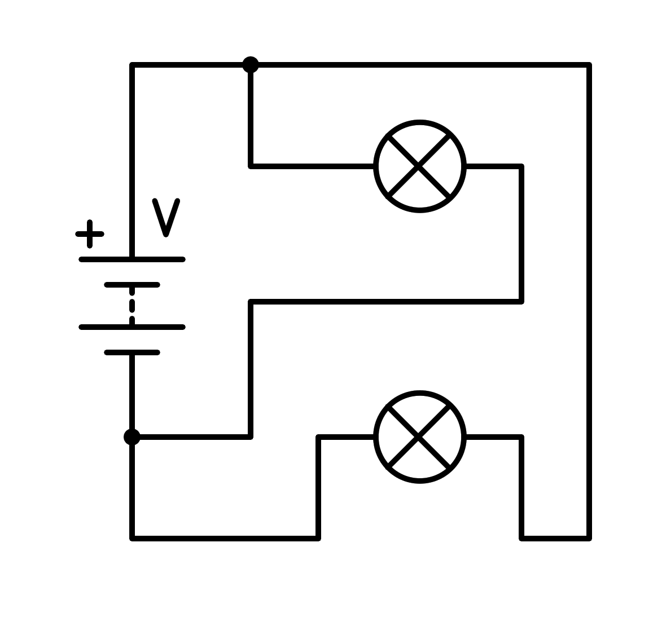

a) In parallel

b) Sort circuit in the battery

c) Sort circuit in the light bulb

d) In series

1. How is the following circuit connected?

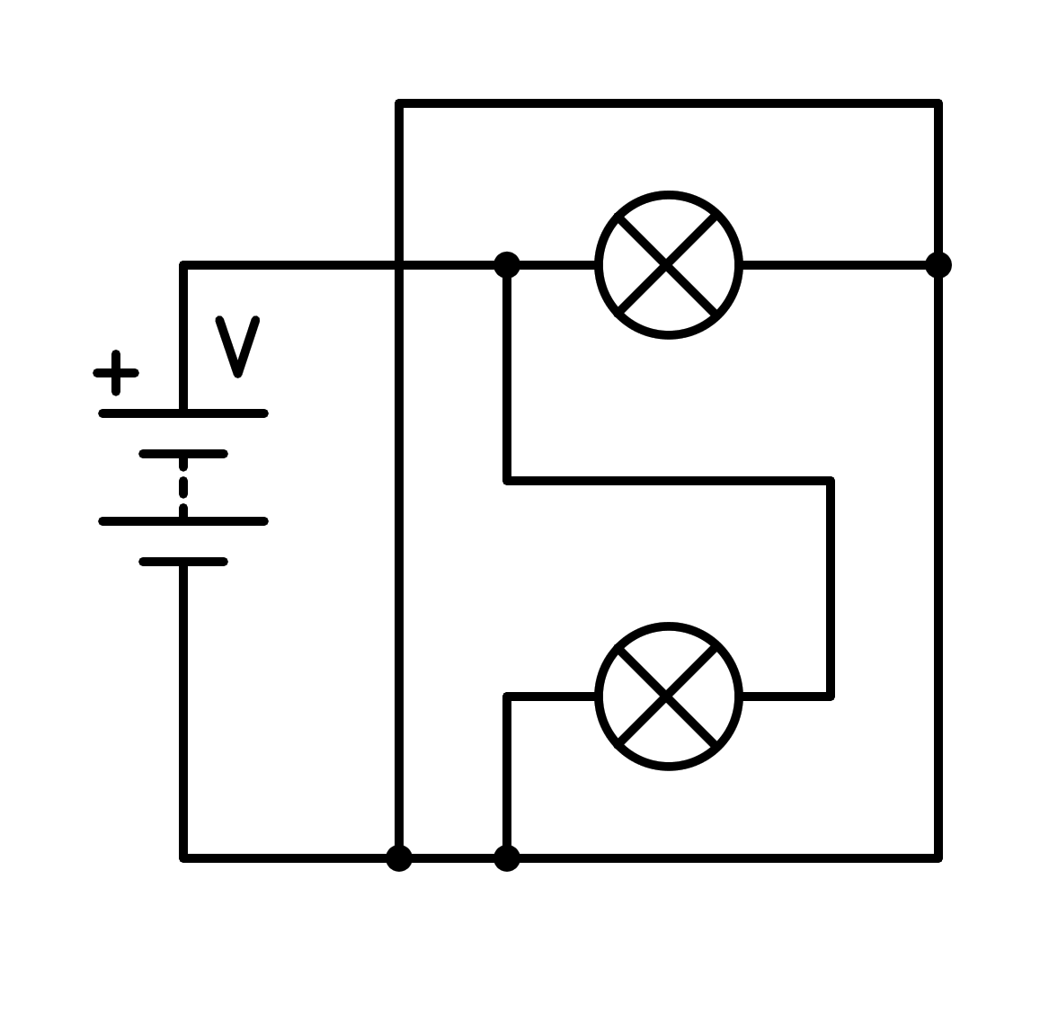

a) Sort circuit in the battery

b) In parallel

c) Sort circuit in the light bulb

d) In series

1. How is the following circuit connected?

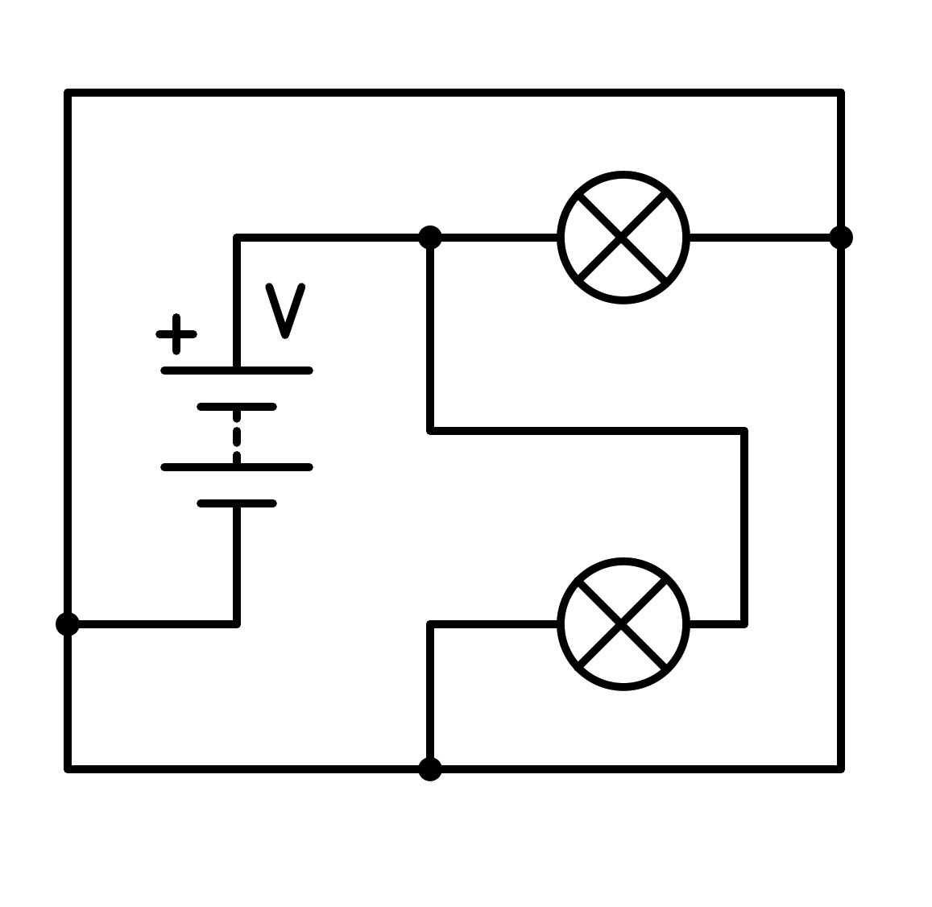

a) Sort circuit in the light bulb

b) In parallel

c) In series

d) Sort circuit in the battery

1. How is the following circuit connected?

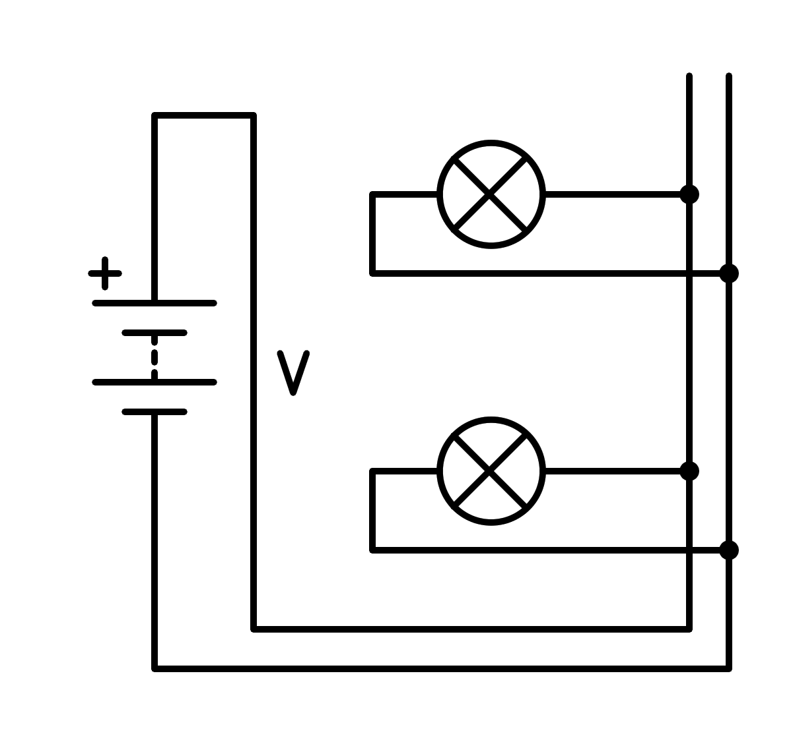

a) In series

b) In parallel

c) Sort circuit in the light bulb

d) Sort circuit in the battery

1. How is the following circuit connected?

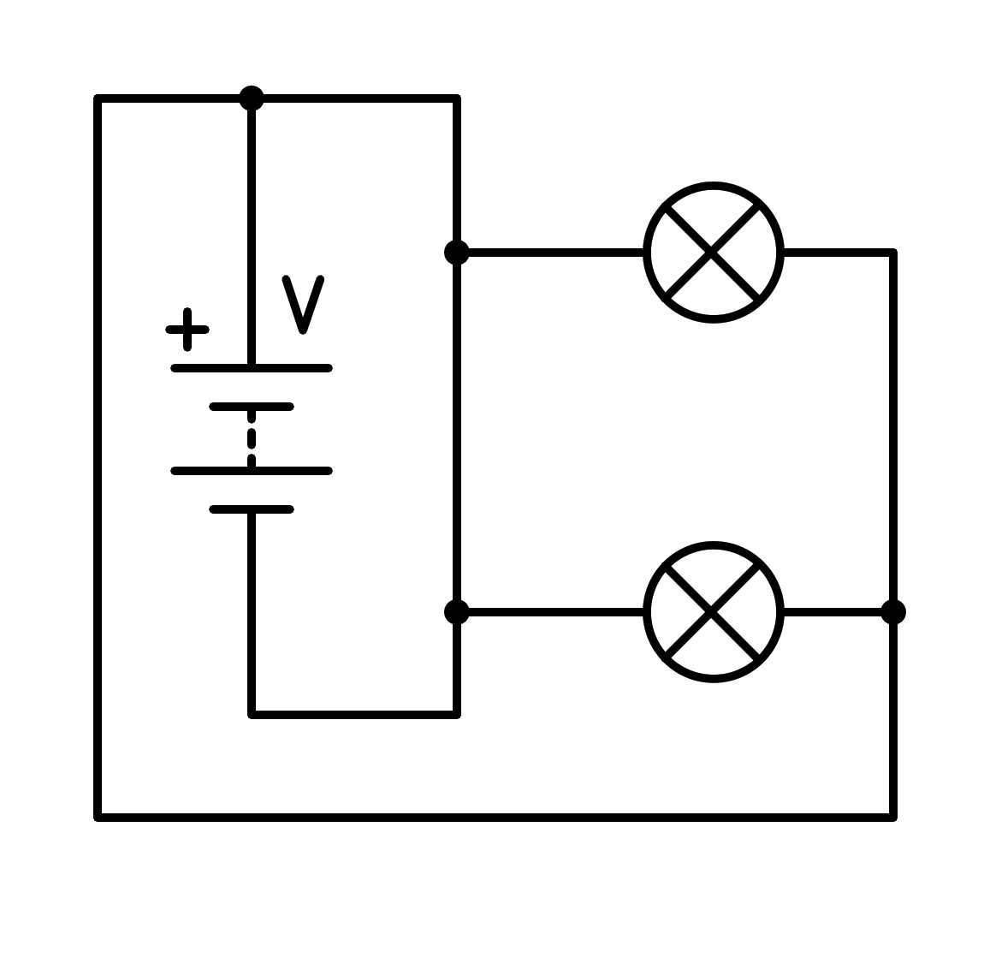

a) In series

b) Sort circuit in the light bulb

c) Sort circuit in the battery

d) In parallel

1. How is the following circuit connected?

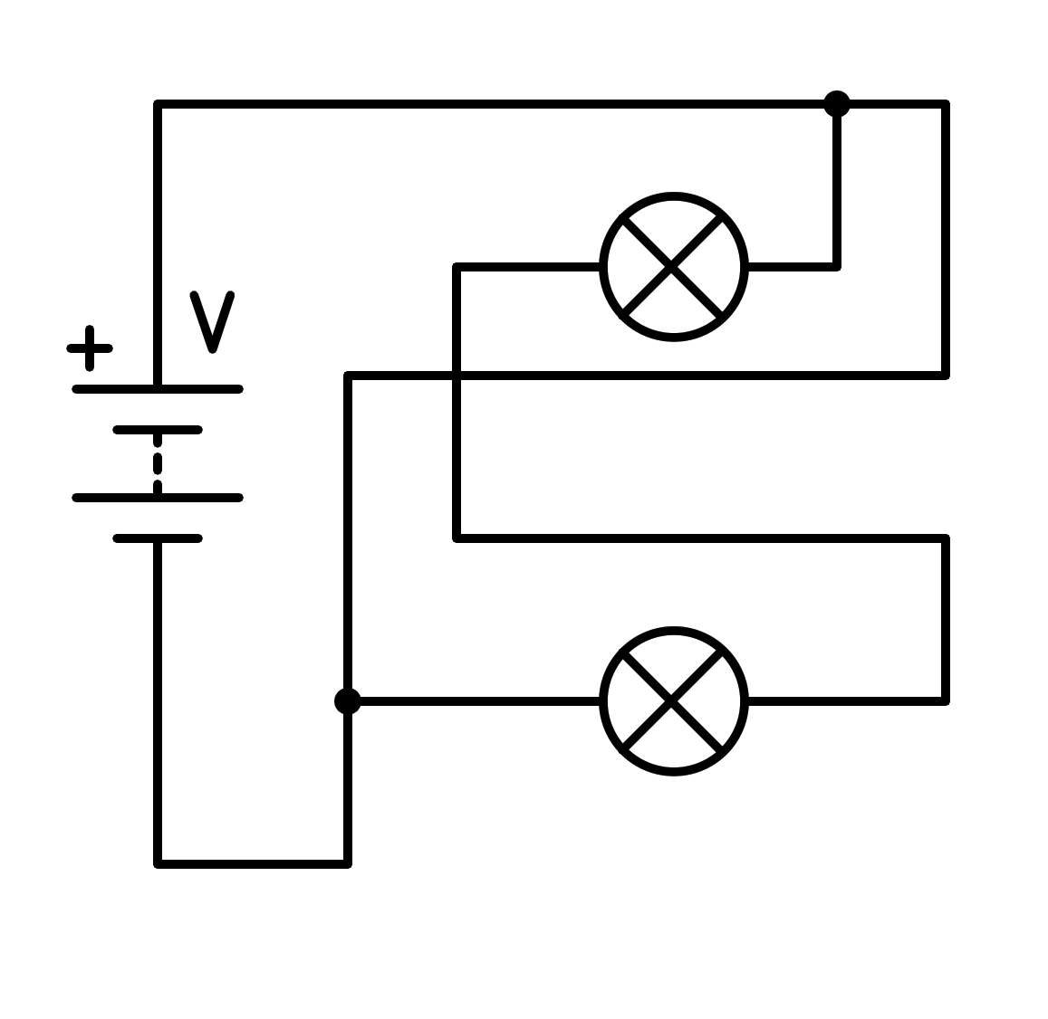

a) In parallel

b) Sort circuit in the battery

c) In series

d) Sort circuit in the light bulb

1. How is the following circuit connected?

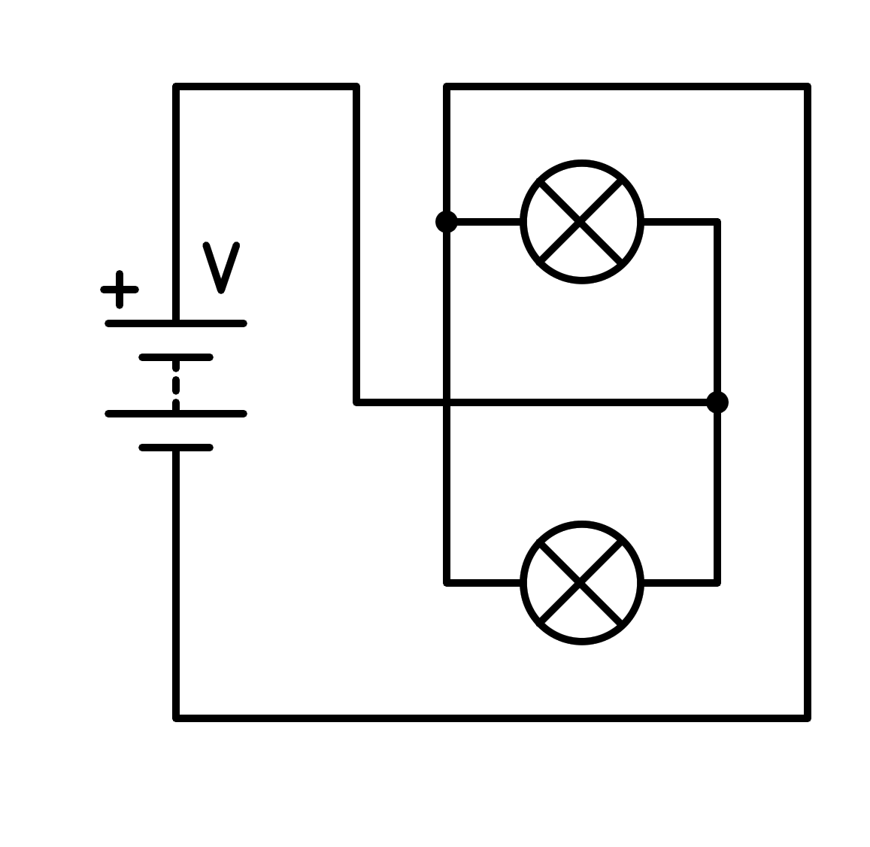

a) Sort circuit in the battery

b) Sort circuit in the light bulb

c) In parallel

d) In series

1. How is the following circuit connected?

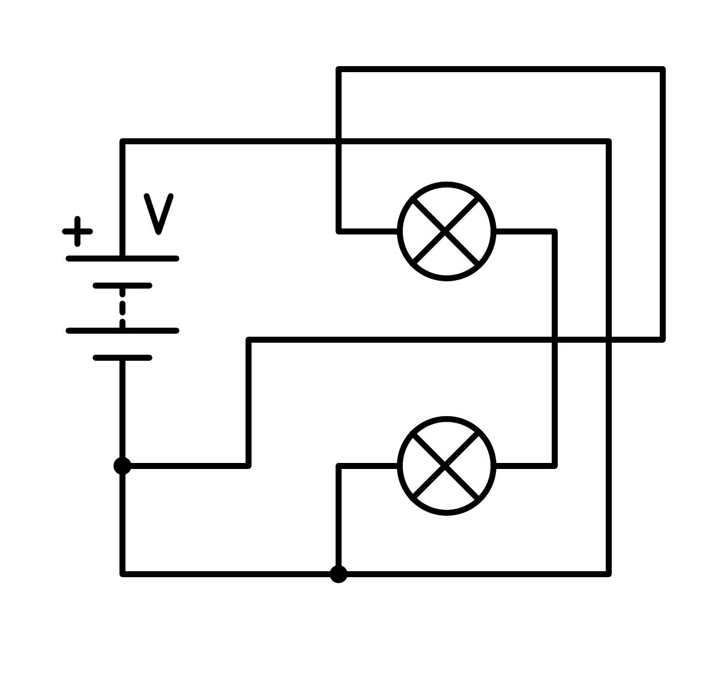

a) In series

b) In parallel

c) Sort circuit in the battery

d) Sort circuit in the light bulb