Kazakh-British Technical University
Data collection and preparation

STUDENTS' INDEPENDENT STUDY (SIS) №1
Apartment market report

Full Name: Bekmurzin Alim
ID: 23B031254

2026
Kazakhstan Apartment Market: Scraping, Cleaning and Price Analysis
Data collection and analysis project report | Source: krisha.kz listings

Github link: https://github.com/scamlumamontov/krisha.kz_eda

1. Approach
Collection. Listing IDs were taken from the krisha.kz home page, then each ad page was fetched with requests and parsed with BeautifulSoup (CSS selectors plus regular expressions on the page source). For every ad the scraper extracts price, city, latitude/longitude, bathrooms, ceiling height, renovation state, building type, year, floor, total floors and area. A second request to the site’s live-views endpoint returns the view count (page views + phone views) and price(some of them are stored only in API’s). Ads with missing price, location or coordinates are skipped, and rows are appended to dirty_data.csv.
Cleaning. Text fields were lower-cased and normalised against fixed lists (e.g. “требует ремонта”, “свежий ремонт”; brick / monolithic / panel / other). Price and area were coerced to numeric, the “показать на карте” suffix was stripped from city names, and unknown states or types received a default code. Categories were encoded as integers (17 cities, 5 states, 4 building types). Columns were dropped (id, lat, lon, raw price) or created: dist (Haversine distance in km from the listing to its city centre, taken from a median-coordinate table) and cur_price_m (asking price ÷ area). In the analysis notebook rows with missing values (mostly missing area) were removed, leaving 5,304 listings.
Merging. The listings table was joined with a second source, city_centers.csv (median latitude/longitude per city), on the city key. This produced the distance-to-centre feature and the common key used for per-city comparison. A column rec_price_m (the site’s recommended price per m²) is carried along as a benchmark.

2. Results: descriptive statistics
Variable | Mean | Median | Std | Min | Max
rec_price_m (KZT/m²) | 684,296 | 670,390 | 141,618 | 174,130 | 997,820
area (m²) | 43.2 | 43 | 36.6 | 1 | 300
year built | 2014.7 | 2022 | 15.6 | 1945 | 2027
max_floor | 10.1 | 9 | 4.6 | 1 | 41
dist to centre (km) | 5.75 | 4.75 | 23.1 | 0.03 | 966.7
cur_price_m (KZT/m²) | 5.29 M | 866,667 | 10.1 M | 6,024 | 136 M
Table 1. Descriptive statistics for the cleaned dataset (n = 5,304).
Typical flats are around 43 m², built in the 2010s–2020s (median 2022), in buildings of about 9 floors, and roughly 4.7 km from the city centre. Most listings have one bathroom (mean 1.16) and are in the “draft finish” state (code 3). Monolithic buildings are the most common type (median type code 2). The recommended price per m² has a median of about 670 thousand KZT, while views are strongly right-skewed (median 173, maximum 27,384).
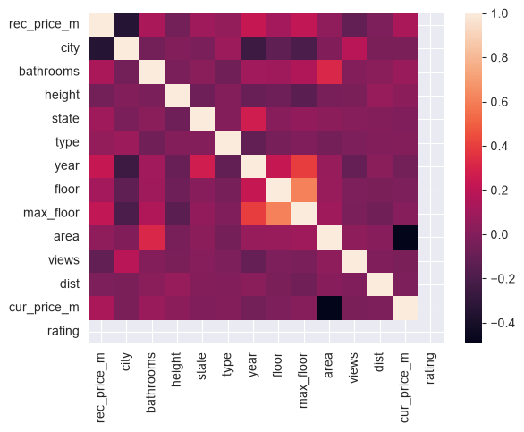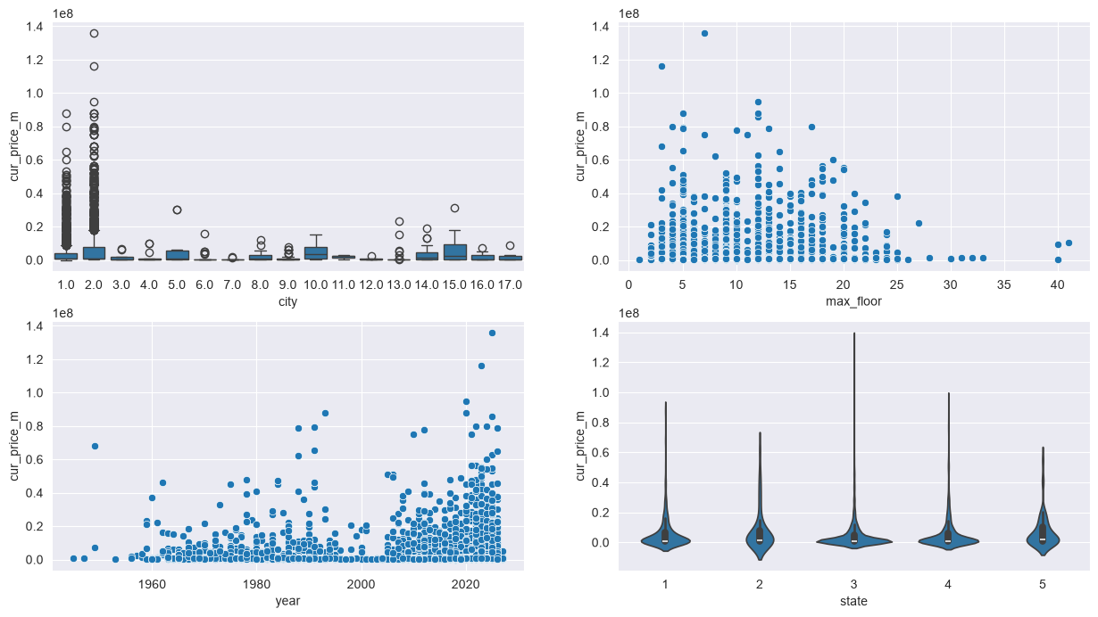
Figure 1 (left). Correlation heatmap of all numeric features. Figure 2 (right). Asking price per m² by city, max floor, build year and renovation state.
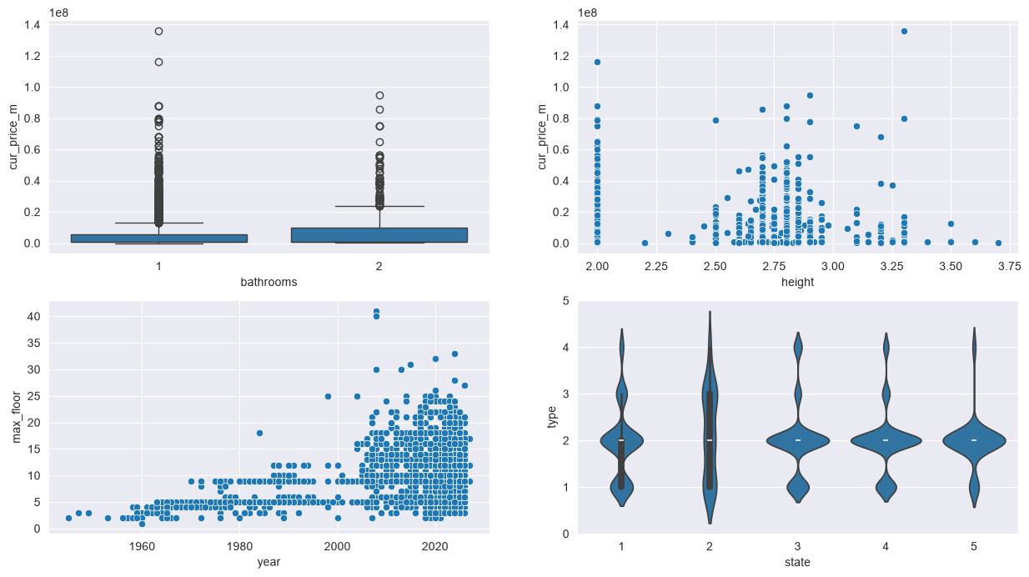
Figure 3. Price per m² vs bathrooms and ceiling height; build year vs building height; renovation state vs building type.

3. Key insights
- City is the strongest driver of the recommended price. rec_price_m has the largest negative correlation with the city code (about −0.4 on the heatmap). Because the codes start with Astana (1) and Almaty (2), this means the two largest cities are the most expensive; the box plots show these two also have by far the widest spread and most outliers.
- Newer and taller buildings are pricier. Build year and max floor show modest positive correlations with rec_price_m (roughly +0.2 to +0.25). Year and max floor are also correlated with each other (about +0.4): high-rise construction is a post-2005 phenomenon (Figure 3, bottom left).
- Renovation state and bathrooms matter a little. Better-finished flats and flats with two bathrooms lean slightly higher in price, but the effects are weak compared with location. Ceiling height and distance to centre show almost no linear relationship with price.
- Strongest relationship is mechanical. area and cur_price_m correlate at about −0.5 because the latter is price divided by area: small parsed areas inflate the ratio.

4. Limitations and next steps
Data quality. cur_price_m has a mean of 5.3 M and a maximum of 136 M KZT/m², far above any realistic price, and 25% of listings have an area of 6 m² or less. This points to parsing errors in the area field (the regex can pick up a room count or another “м²” value) and to the “dist” maximum of 967 km caused by listings mapped to the wrong city. Duplicates were also visible in the cleaned sample (same flat repeated with changing view counts). The scraper additionally sampled only a small set of listings from the home page, and the rating column is a constant 0 placeholder.
Next steps. Drop duplicate IDs, validate area against price (e.g. area ≥ 15 m², price per m² within a plausible range), clip distance outliers, scrape category pages (respecting robots.txt and with delays) for a more representative sample, and then fit a regression model of price on city, year, floors, state and distance using the cleaned data. Correlations above are read off the heatmap and are approximate.

