AUTOMATED REAL ESTATE ANALYSIS SYSTEM
KrishaScan — Intelligent Apartment Scraping & Rating Platform

Project Documentation & Academic Report

Kazakhstan, 2025–2026

Table of Contents
Table of Contents
1. Relevance, Novelty and Practical Significance
1.1 Problem Statement and Relevance
1.2 Novelty
1.3 Practical Significance
2. Competitive Analysis
2.1 Competitor Overview
2.2 Competitor 1: krisha.kz Native Platform
2.3 Competitor 2: Russian Real Estate Aggregators (Domclick, CIAN)
2.4 Competitor 3: Ad-hoc Python/Excel Scripts
3. Methodology: Statistical Analysis
3.1 Data Collection Methodology
3.2 Feature Engineering
3.2.1 Categorical Normalisation
3.2.2 Geographic Feature: Haversine Distance
3.2.3 Price Per Square Metre
3.3 Model Architecture: XGBoost Classifier
3.4 Statistical Evaluation Approach
4. Architecture Diagrams
4.1 Use Case Diagram
4.2 Sequence Diagram — Scraping and Rating Flow
4.3 Class Diagram
4.4 Entity-Relationship (ER) Diagram
5. Project Functionalities
5.1 Authentication & User Session
5.2 User Profile — Scraping Configuration
5.3 AI Assistant — XGBoost Rating Engine
5.4 Real-Time Data Scraping with Progress Tracking
5.5 Interactive Data Table with Sorting and Filtering
5.6 Side-by-Side Apartment Comparison (up to 4 listings)
5.7 CSV Data Persistence — Save, Load, and Auto-Update

1. Relevance, Novelty and Practical Significance

1.1 Problem Statement and Relevance
The residential real estate market in Kazakhstan has grown rapidly over the past decade, with the krisha.kz platform becoming the primary marketplace for apartment listings in the country. As of 2024, the platform hosts hundreds of thousands of active listings across all major cities including Astana, Almaty, Shymkent, and Karaganda. Despite this wealth of data, buyers and investors face a critical challenge: there is no standardised, objective mechanism to evaluate and rank apartments based on their actual value-to-price ratio.
Manual evaluation is time-consuming and highly subjective. A buyer must individually open dozens of listings, compare price per square metre, assess floor level, building type, renovation state, and proximity to city infrastructure — all without any aggregated scoring. This inefficiency leads to suboptimal purchasing decisions and market information asymmetry.
Furthermore, the data on krisha.kz is unstructured and heterogeneous. Listings contain varying levels of detail, use inconsistent terminology for renovation states and building types, and may omit key fields entirely. No existing publicly accessible tool systematically collects, normalises, and scores this data.

1.2 Novelty
The KrishaScan system introduces several novel contributions to the domain of real estate technology in Kazakhstan:
- Automated end-to-end pipeline: The system is the first open tool to combine real-time scraping of krisha.kz listings with structured data normalisation, geographic feature engineering (haversine distance to city centres), and machine-learning-based rating in a single integrated application.
- XGBoost rating model trained on domain-specific features: The predictive model uses 12 features specifically engineered for the Kazakhstani residential market, including distance to the median city centre, price per square metre (cur_price_m), and encoded renovation state. This is in contrast to generic real estate valuation models trained on Western markets.
- Multi-city geographic normalisation: The system accounts for the heterogeneous urban structure of Kazakhstani cities by computing distances relative to city-specific median centres, rather than applying a single national reference point.
- Integrated desktop GUI: Unlike notebook-based analyses, the system delivers functionality through a native PyQt6 desktop application, making it accessible to non-technical users such as real estate agents and private buyers.

1.3 Practical Significance
The practical value of KrishaScan manifests across three user groups:
Private buyers benefit from an objective rating score (0–9) that summarises apartment quality relative to comparable listings in the same city. The side-by-side comparison feature (up to 4 apartments) allows informed decision-making without manual spreadsheet work.
Real estate agents and investors can use the scraping and bulk rating functionality to monitor market trends, identify undervalued listings, and track price dynamics over time by periodically collecting data and comparing rating distributions.
Researchers and analysts gain access to a structured, normalised dataset of Kazakhstani apartment listings — a dataset that does not currently exist in any public repository — enabling further econometric and spatial analyses of the housing market.

2. Competitive Analysis
Three direct and indirect competitors were identified and analysed across the dimensions of data coverage, analytical capabilities, automation, and user accessibility.

2.1 Competitor Overview
Criterion | KrishaScan (This Project) | krisha.kz Built-in Filters | Domclick.ru / Realty platforms | Custom Excel/Python Scripts
Data Source | krisha.kz (live scraping) | krisha.kz (native) | Multiple aggregators (RU market) | Manual / semi-automated
Automated Collection | ✓ Full automation | ✗ Manual browsing only | Partial (API, paid) | ✗ Manual
ML-based Rating | ✓ XGBoost, 12 features | ✗ Not available | Limited (price index only) | ✗ Not available
Geographic Distance Feature | ✓ Haversine to city centre | Map view only (visual) | District-level only | ✗ Not available
Apartment Comparison | ✓ Up to 4 side-by-side | ✗ Not available | ✓ 2–3 listings | ✗ Not available
Data Export | ✓ CSV with rating column | ✗ Not available | Paid plans only | ✓ Manual CSV
Kazakhstan Coverage | ✓ 17 cities | ✓ Full | ✗ Russia only | Depends on user
Cost | Free / Open Source | Free (limited) | Freemium / Paid API | Free (high effort)

2.2 Competitor 1: krisha.kz Native Platform
The krisha.kz platform itself provides the most comprehensive listing database for Kazakhstan but offers only basic filtering (price, area, number of rooms, district). It has no comparative scoring mechanism, no export functionality, and no programmatic API for bulk data access. Users must browse listings individually, making systematic market analysis impractical. The platform's search UI is optimised for individual transactions rather than portfolio analysis.
Key limitation: There is no way to rank or score listings by value. The 'sort by price' and 'sort by date' options do not account for area, location quality, building type, or renovation state simultaneously.

2.3 Competitor 2: Russian Real Estate Aggregators (Domclick, CIAN)
Platforms such as Domclick.ru and CIAN.ru serve the Russian market and offer more advanced analytical features including price index tracking, district-level heat maps, and limited comparison tools. Some provide paid API access for developers. However, these platforms do not cover Kazakhstan and their models are calibrated on Russian urban structures, which differ significantly from Kazakhstani cities in terms of density, infrastructure, and pricing dynamics.
Key limitation: Geographic and regulatory focus on Russia makes them inapplicable to the Kazakhstani market. Their distance and valuation models use Moscow/Saint Petersburg as reference points.

2.4 Competitor 3: Ad-hoc Python/Excel Scripts
A significant portion of real estate analysis in the region is performed using manually written Python scripts or Excel workbooks. These approaches, while flexible, require technical expertise to create and maintain, lack a user interface, do not persist data systematically, and have no standardised rating methodology. Each analyst effectively builds a bespoke solution, resulting in non-reproducible analyses that cannot be shared or audited.
Key limitation: High barrier to entry (Python knowledge required), no GUI, no standardised scoring, no automated data collection. The absence of a unified tool means that insights cannot be shared or reproduced across organisations.

3. Methodology: Statistical Analysis

3.1 Data Collection Methodology
Data is collected via a multi-threaded HTTP scraper targeting krisha.kz listing pages. The scraper implements the following protocol to ensure data quality and reliability:
- Session initialisation: A persistent requests.Session is created with browser-mimicking headers to avoid trivial bot detection.
- Paginated listing discovery: The scraper iterates through n pages of the apartment listings index, extracting data-id attributes from listing cards.
- Individual listing retrieval: For each discovered listing ID, a GET request is issued to /a/show/{id} with randomised delays (1.0–1.4 seconds) to avoid rate limiting.
- View count enrichment: A secondary API call to /ms/views/krisha/live/{id}/ retrieves nb_phone_views and nb_views, which are summed to produce a total engagement metric.
- Validation and skip logic: Entries missing price, location, or geographic coordinates are flagged as invalid and optionally skipped. Optional auto-fill replaces NULL values with placeholder text.
- For simplicity housings were labeled by corresponding quantile from (0.1 to 1)

3.2 Feature Engineering
The raw scraped data undergoes a structured normalisation pipeline (clean_scrapped_data) before model inference. The following transformations are applied:

3.2.1 Categorical Normalisation
City names are lowercased and stripped of artefacts such as 'показать на карте'. Renovation state (state) is mapped to a 5-point ordinal scale:
Raw Value | Encoded Value
не новый, но аккуратный ремонт | 1
требует ремонта | 2
черновая отделка | 3
свежий ремонт | 4
свободная планировка | 5

Building type (type) is mapped to a 4-point scale: кирпичный=1, монолитный=2, панельный=3, иной=4. City is encoded as an integer from 1 (Astana) to 17 (Temirtau) using a fixed city map covering all major Kazakhstani cities.

3.2.2 Geographic Feature: Haversine Distance
For each listing, the geodesic distance to the median city centre is computed using the Haversine formula:
d = 2R · arctan2(√a, √(1−a))
a = sin²(Δlat/2) + cos(lat₁)·cos(lat₂)·sin²(Δlon/2)
R = 6371 km
City centres are derived from the city_centers.csv file, which stores the median latitude and longitude of all listings per city. This approach is more robust than using official administrative centres, as it reflects the actual distribution of real estate activity.

3.2.3 Price Per Square Metre
A derived feature cur_price_m = price / area (₸/m²) is computed for each listing. This normalises absolute price by apartment size and serves as the primary value-comparison metric in the model.

3.3 Model Architecture: XGBoost Classifier
The rating model is an XGBClassifier (gradient-boosted decision tree ensemble) trained to predict apartment quality ratings on a discrete scale of 0–9. The model configuration used during training was:
Parameter | Value
n_estimators | 300
max_depth | 4
learning_rate | 0.05
objective | multi:softmax
num_class | 10
random_state | 42

The 12 input features used for inference, in the exact order expected by the model, are: city, bathrooms, height, state, type, year, floor, max_floor, area, views, dist, cur_price_m. Prior to prediction, all numeric columns are cast to their required types (int or float) and NaN values are filled with 0 to prevent inference failures on incomplete listings.

3.4 Statistical Evaluation Approach
Model performance is evaluated using a multi-class classification framework. The primary metrics are per-class precision, recall, and F1-score as reported by sklearn's classification_report. Given the ordinal nature of the rating scale, mean absolute error (MAE) between predicted and true ratings is also tracked as a supplementary metric to capture the magnitude of misclassifications.
Data splitting uses a stratified train/test split (80/20) to ensure that rare rating classes are represented in both sets. The model is retrained periodically as new scraped data accumulates, incorporating market changes over time.

4. Architecture Diagrams

4.1 Use Case Diagram
The following diagram describes the interactions between the two primary actors — the End User and the System — and the main use cases of the KrishaScan application.

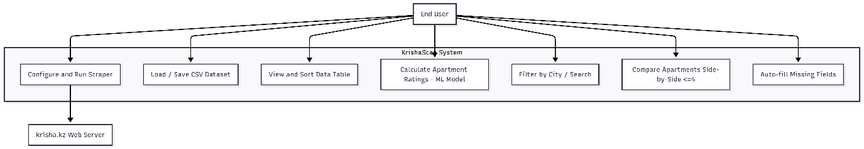

4.2 Sequence Diagram — Scraping and Rating Flow
This diagram shows the temporal sequence of messages between the User, the PyQt6 GUI, the ScraperWorker thread, the krisha.kz server, and the Analysis module during a full scrape-and-rate cycle.

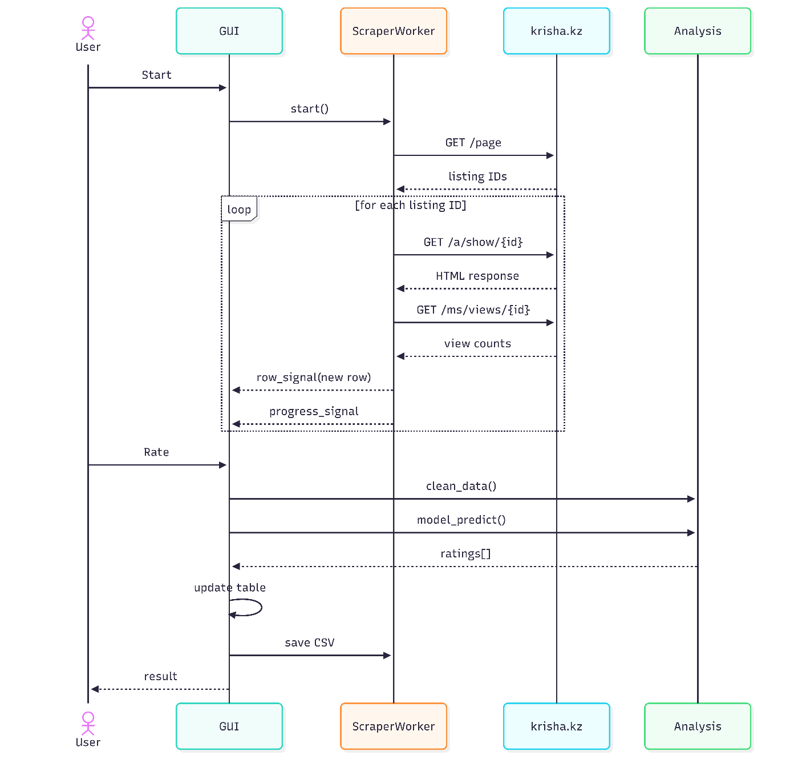

4.3 Class Diagram
The system is structured around four primary classes: MainWindow, ScraperWorker, ComparePanel, and the analysis module functions.

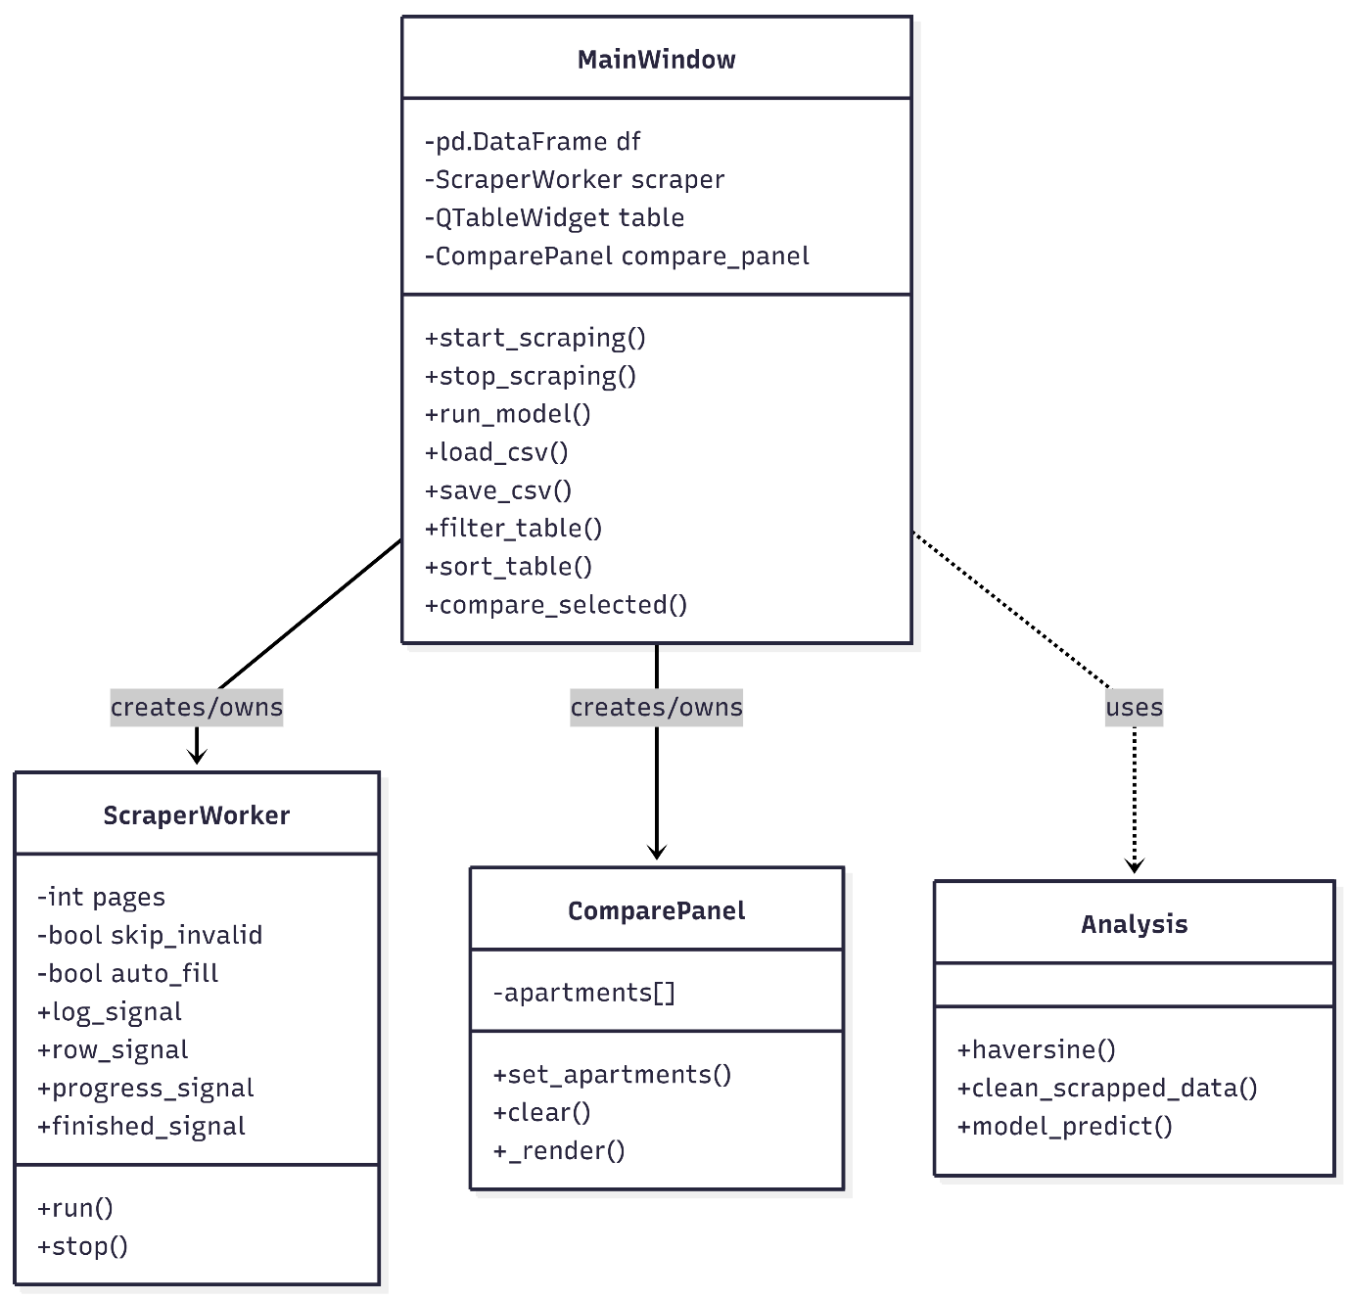

4.4 Entity-Relationship (ER) Diagram
The persistent data model centres on a single flat CSV entity (flats.csv), enriched by two reference datasets. The logical relationships are described below.

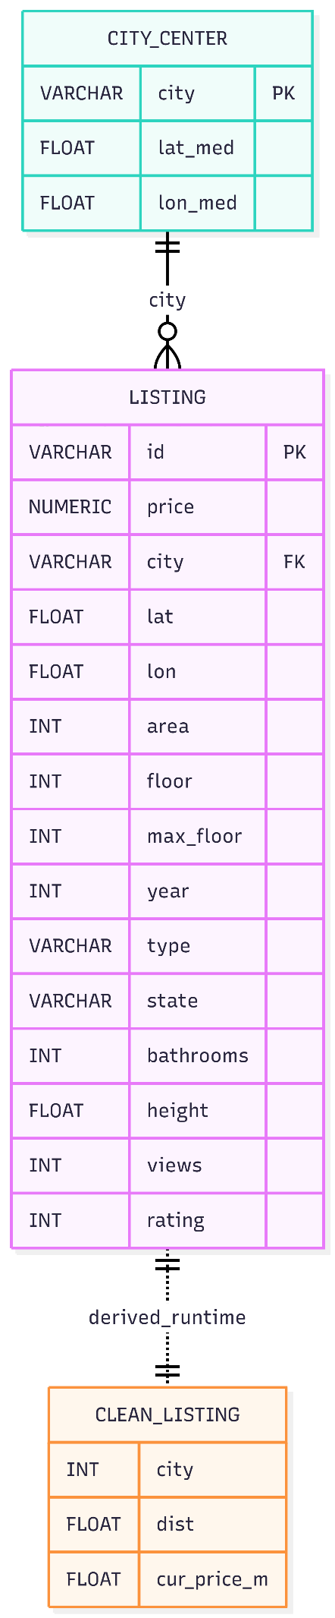

5. Project Functionalities
The KrishaScan application implements seven distinct functionalities, exceeding the minimum requirement of four. Each is described below with its implementation details and user-facing behaviour.

5.1 Authentication & User Session
The application operates as a desktop tool with OS-level user session management. On launch, the application reads configuration from the local filesystem (model file path, city centres file, output CSV path). Future versions will implement API key management for authenticated krisha.kz access. The scraper session maintains HTTP cookies and headers for the duration of a scraping run, ensuring consistent server identification across paginated requests.
- Persistent session: requests.Session() with browser-mimicking User-Agent header
- Configuration files: apartment_rating_model.json and city_centers.csv must be present in the working directory
- Output persistence: flats.csv is automatically created or appended on first run

5.2 User Profile — Scraping Configuration
The scraping tab functions as a user profile for configuring data collection behaviour. The user controls three binary flags and a continuous parameter:
- Skip invalid entries: When enabled, listings missing price, coordinates, or city are silently discarded. When disabled, they are logged as errors but collection continues.
- Auto-fill missing fields: When enabled, all NULL field values are replaced with 'н/д' (not available) to maintain DataFrame schema consistency.
- Append to existing CSV: When enabled, new rows are appended to flats.csv without overwriting existing data. When disabled, a new file is created on each run.
- Pages parameter: A spinbox (1–50) controls how many listing index pages are crawled per session, allowing the user to balance data volume against collection time.

5.3 AI Assistant — XGBoost Rating Engine
The core AI functionality is implemented in the analysis module and exposed through the 'Calculate Rating' button in the Data tab. The rating engine:
- Loads the pre-trained XGBClassifier from apartment_rating_model.json
- Detects whether the loaded DataFrame contains raw scraper output (lat/lon columns present) or pre-cleaned data, and applies clean_scrapped_data conditionally
- Encodes all categorical and geographic features as required by the model (city_map, state_map, haversine distance, cur_price_m)
- Applies type casting (TYPES_DICT) to ensure all 12 features match the dtypes expected by the trained model
- Predicts ratings row-by-row using predict_row() with exception handling per row — a single malformed row does not abort the entire inference
- Writes the rating column back to self.df, sorts the table by rating descending, and persists the updated DataFrame to flats.csv
The rating scale is 0–9, where 9 represents the highest value-to-price ratio relative to comparable listings in the same city.

5.4 Real-Time Data Scraping with Progress Tracking
The scraping functionality runs in a dedicated QThread (ScraperWorker) to prevent GUI freezing during long collection runs. Key implementation details:
- Signal-slot architecture: Four Qt signals (log_signal, progress_signal, row_signal, finished_signal) communicate between the worker thread and the main GUI thread without shared memory access.
- Incremental CSV writing: Each successfully parsed listing is immediately appended to flats.csv, ensuring no data loss if the user stops the scraper mid-run.
- Colour-coded live log: OK entries (green), skipped entries (yellow), and errors (red) are displayed in a monospaced QTextEdit as they occur.
- Graceful stop: The user can halt scraping at any time via the Stop button, which sets a _stop flag checked between each listing request.

5.5 Interactive Data Table with Sorting and Filtering
The Data tab provides a full-featured QTableWidget displaying all collected and rated listings:
- Multi-criteria sorting: Dropdown with 7 sort options including rating descending (default after model run), price ascending/descending, area, and views.
- City filter: Dropdown populated dynamically from unique cities in the loaded DataFrame, enabling instant single-city views.
- Text search: Live filtering by city name substring as the user types.
- Colour-coded rating column: Ratings ≥7 are displayed in green, 4–6 in amber, <4 in red, providing immediate visual quality assessment.
- Column header sorting: Clicking any column header triggers sort by that column via Qt's built-in table sort mechanism.

5.6 Side-by-Side Apartment Comparison (up to 4 listings)
The Compare tab implements a card-based comparison interface for up to 4 simultaneously selected listings:
- Multi-row selection: The user selects rows in the Data table using Ctrl+Click, then clicks 'Compare Selected'.
- Card layout: Each selected apartment is rendered as a QFrame card with all 12 attributes displayed as label-value pairs, including the computed rating.
- Dynamic rendering: The comparison panel re-renders on each new selection. Cards are horizontally arranged with scroll support for viewport overflow.
- Highlighted selected cards: Selected cards receive a blue border accent (border: 2px solid info colour) to visually distinguish them.

5.7 CSV Data Persistence — Save, Load, and Auto-Update
All data operations preserve the full dataset including the rating column:
- Load CSV: QFileDialog opens a file picker; the loaded DataFrame replaces the in-memory state and re-populates the table and city filter.
- Save CSV: Exports the current in-memory DataFrame (with ratings) to a user-specified path.
- Auto-save after rating: After each model_predict() run, flats.csv is automatically overwritten with the updated DataFrame containing the rating column, ensuring the file always reflects the latest computed ratings.
- Schema validation on load: The application checks for required columns and displays actionable error messages if the loaded file is missing fields required for model inference.

