Hadoop Framework
A wide variety of techniques and technologies has been developed and adapted to aggregate, manipulate, analyze, and visualize big data. These techniques and technologies draw from several fields including statistics, computer science, applied mathematics, and economics. This means that an organization that intends to derive value from big data has to adopt a flexible, multidisciplinary approach.
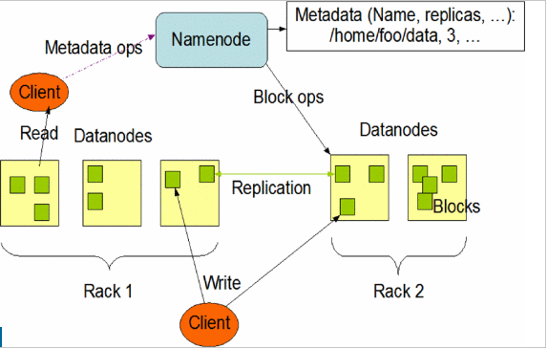
The system architecture comprises of hadoop architecture, hadoop multi-node cluster setup, setup of HDFS and implementation of Map Reduce programming work to solve the data intensive problem. As show in figure, an HDFS cluster consists of a single NameNode, a master server that manages the file system namespace and regulates access to files by clients. In addition, there are a number of DataNodes, usually one per node in the cluster, which manages storage attached to the nodes that they run on. HDFS exposes a file system namespace and allows user data to be stored in files. Internally, a file is split into one or more blocks and these blocks are stored in a set of DataNode. NameNode determines the mapping of blocks to Datanodes.
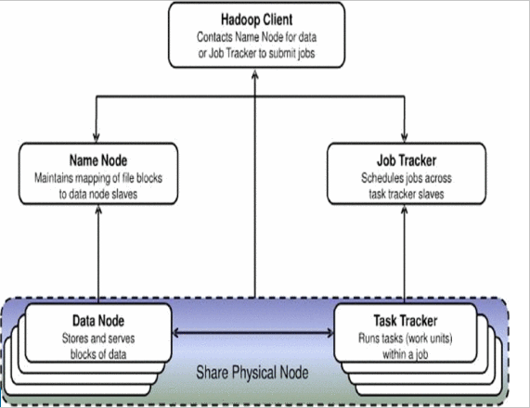
Fig: Hadoop high-level architecture

A TaskTracker is a node in the cluster that accepts tasks - Map, Reduce and Shuffle operations - from a JobTracker. The master node consists of a JobTracker, TaskTracker, NameNode, and DataNode. A slave or worker node acts as both a DataNode and TaskTracker. In a larger cluster, the HDFS is managed through a dedicated NameNode server to host the file system index, and a secondary NameNode that can generate snapshots of the name node's memory structures, thus preventing file system corruption and reducing loss of data.

Spark Architecture
Apache Spark is a powerful unified analytics engine for large-scale distributed data processing and machine learning. On top of the Spark core data processing engine are libraries for SQL, machine learning, graph computation, and stream processing. These libraries can be used together in many stages in modern data pipelines and allow for code reuse across batch, interactive, and streaming applications. Spark is useful for ETL processing, analytics and machine learning workloads, and for batch and interactive processing of SQL queries, machines learning inferences, and artificial intelligence applications.

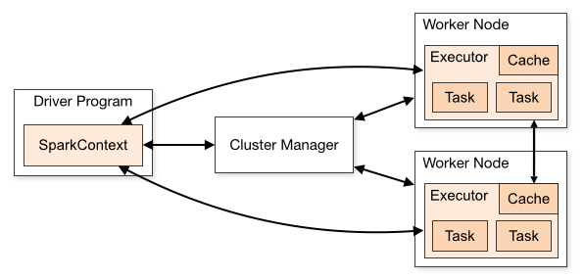
Fig: Spark Architecture

