Nate Matsunaga and Rick Sullivan

Dr. Fang

Senior Design

7 November 2014

Schematics and Diagrams

**Architectural Diagram:**

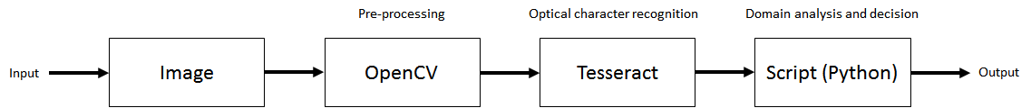

**Activity Diagrams:**

Pre-processing:

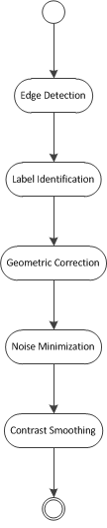

Post-processing:

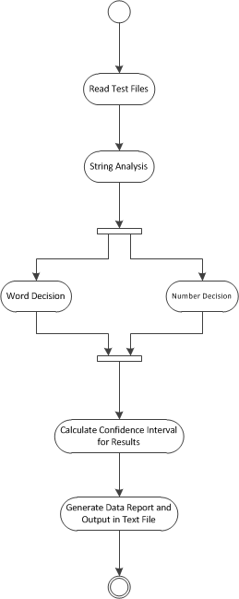

**Use Case Diagram:**

