**How to build with CMake, OpenCV, and Visual Studio 2015**

1. Clone repository from <https://github.com/scanavan/ExpressionAnalysis.git> using TortoiseGit.
2. You will need to change the file CMakeLists.txt that you will get when you complete step 1. This file is located under ExpressionAnalysis/DataPreProcessing. You will need the entire path of wherever you cloned the directory (e.g. on my machine the path is D:\Research\DeepLearning\ExpressionAnalysis.). On lines 10 and 11, change the path to match where you have OpenCV installed for the lib and include directories.
3. Open CMake and set the directories for source and build. Both directories are where the file CMakeLists.txt is located. 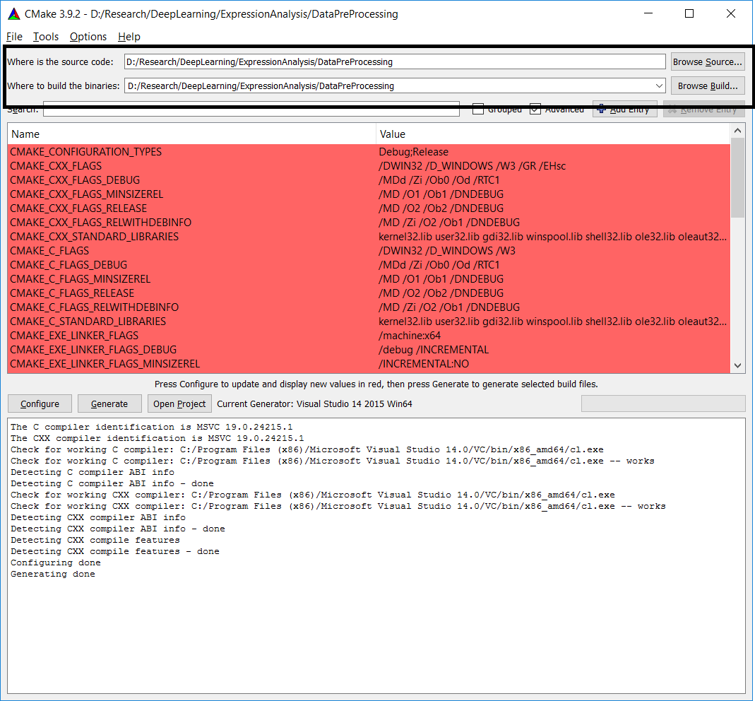
4. Once you have selected the directories, click on the configure button. If you have the paths correctly set in CMakeLists.txt, you will see “Configuring done” as shown above.
5. Once, you see configuring done, click the generate button, it will then say “Generating done” as above.
6. Go into the DataPreprocessing directory, you will see new files as below. Open DataPreProcessing.sln. This will open Visual Studio will all the files you created.

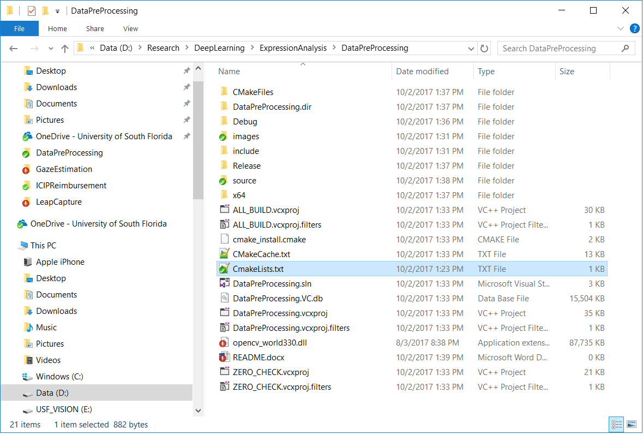

1. Select release build instead of debug as below.

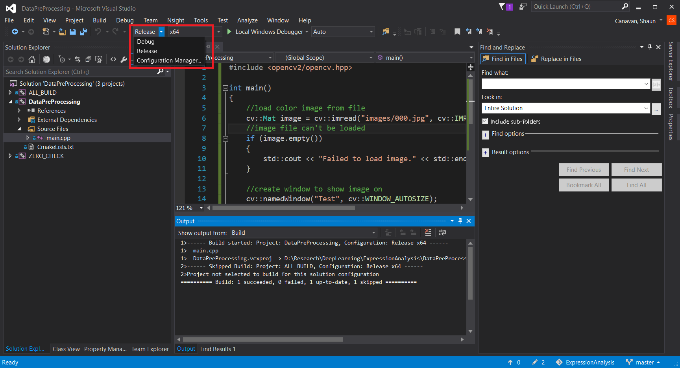

1. Right click on the project and select “Set as startup project” as seen below.

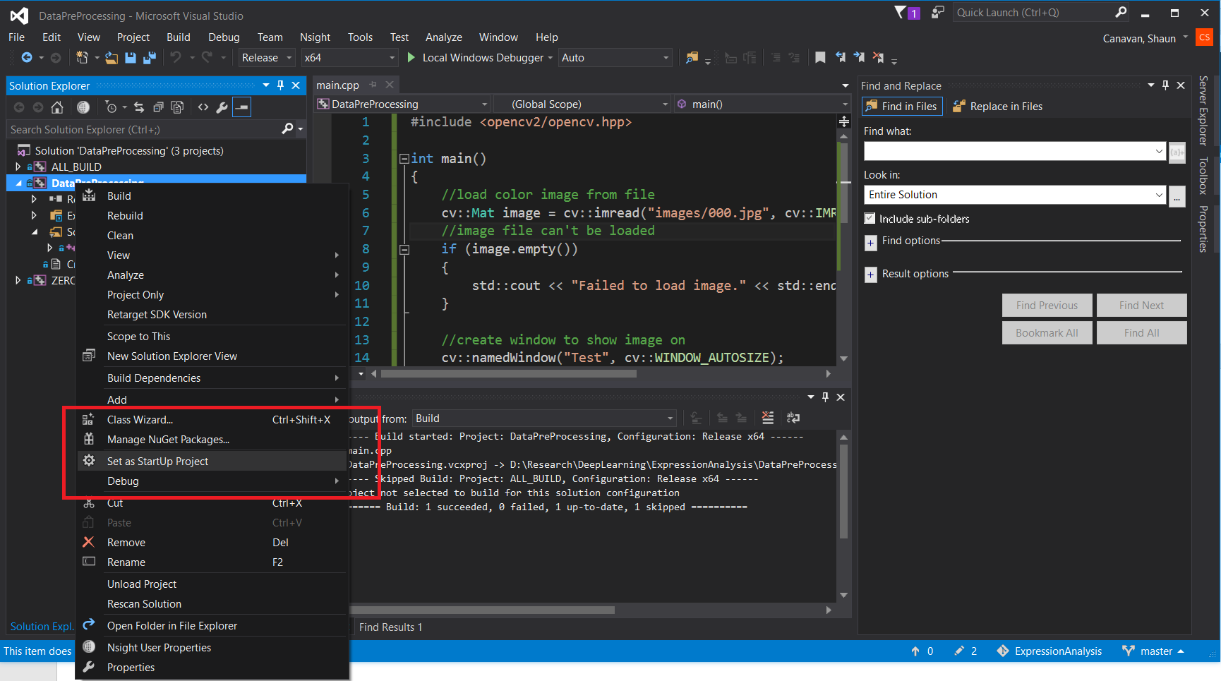

1. Select Debug->Start without debugging as seen below. This will build it and run if it is correct. If it works successfully you will see an image from our data display on the screen. You can press any button while the image is the focus to exit.

