NCS Datasheet編輯說明

Rev 3.0
December, 2024

Prepared By | Reviewed By | Approved By

Revision History
Revision |  | Date | Release Notes
From | To
 | V1.0 | 2019/11/28 | Initial version
 | V1.1 | 2019/12/05 | 更新範例說明
 | V1.2 | 2019/12/9 | 更新照相說明
 | V1.3 | 2019/12/11 | 更新擴充卡規格說明與eNews 說明
 | V1.4 | 2019/12/12 | 增加LAN module slot 拍照說明與修改wording
 | V1.5 | 2019/12/18 | 增加LAN module slot 可裝Lan module 型號的圖示說明
 | V1.6 | 2020/03/09 | 增加Product Positioning Check List; 增加LAN module拍照說明;
 | V1.7 | 2020/04/09 | 增加 LAN module ordering information description 說明
 | V1.8 | 2020/04/14 | 增加MCU by pass LAN module, main features 註明為MCU Based
 | V1.9 | 2020/07/22 | 增加LAN Module Datasheet rule
 | V2.0 | 2020/11/24 | 1.增加說明Optional部份統一註明方式  2.增加TPM2.0 (on Board) or TPM2.0 module編寫位置區別  3.增加Power規格說明  4.增加互斥option的編寫說明  5.增加M.2 device 規格說明
 | V2.1 | 2020/12/1 | Update LAN Module Datasheet rule
 | V2.2 | 2021/01/29 | Update LAN module list table
 | V2.2 | 2022/03/10 | 文字注意事項
 | V2.3 | 2023/04/10 | Note about LAN module table is added
 | V2.4 | 2023/06/08 | Updated datasheet example to newer model
 | V2.5 | 2024/05/07 | Updated wording about memory and storage description; Product positioning page updated; Datasheet example changed to NSA 1170
 | V3.0 | 2024/11/15 | 規格需參閱10_Specification Table  \\10.1.1.99\NCS_marketing\1_Support Pack\標準品相關資訊\Specification Table_241204.xlsx | 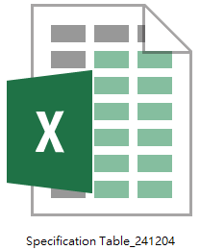

Product Positioning

Check Box |  | Model:  DNA/NSA XXXX | Cyber Security Solutions
□ | ■
□ |  | Desktop | Soc Based Appliance
□ |  | Desktop | X86 Based Appliance
□ |  | Rackmount | Soc Based Appliance
□ |  | Rackmount | X86 Based Entry Level Appliance
□ |  | Rackmount | X86 Based Mainstream Appliance
□ |  | Rackmount | X86 Based Performance Appliance
□ |  | LAN Module
□ |  | Expansion Card
Check Box |  | Model:  DTA/TCA/NSA XXXX | Edge & Cloud Solutions
□ | ■
□ |  |  | uCPE/Edge Appliance
□ |  |  | SD-WAN Appliance
□ |  |  | Datacenter Appliance
Check Box |  | Model:  PNSA XXXX/iNAS | Network Peripheral Solutions
□ | ■
□ |  |  | NVR Solutions
□ |  |  | Storage
Check Box |  | Model:  ISA XXXX | OT Security Solutions
□ | ■
□

NCS Datasheet 編輯說明
- 注意事項
- 每一個獨立料號都有獨立的datasheet ，不同料號規格的主要差異的地方，在產品Main feature 或 Overview 的說明裡面可以說明，例如 Support redundant PSU, support 4 Lan modules, QAT, IPMI…,etc。
- 照片一律外拍，共四個角度，正面，背面，左上45度正面，右上45度正面，照片的擺法，統一是用型號(料號)建BOM規格的最大組合，BOM規格是指外觀上料號的BOM有建的照片就要有，比方說有4xUSB，照片上就要有4個USB，BOM沒建的就不需要有。最大規格是指型號(料號)如果有支援LAN module 或是天線這些外觀上看得到組建，就都要組裝上去拍照。放在Datasheet上的一律是正面照一張，背面照一張。
- LAN Module 拍照統一上TRAY. 傾斜角度由行銷部門統一跟外拍的攝影工作室定義.
- Datasheet規格說明的部分，若系統BOM沒建，但是屬於設計上有只改BOM或是選QVL的零組件就會有的(像是LCM，IPMI module…ect) ，書寫時統一在規格後備註(optional)
- Datasheet填寫時請務必核對實際BOM list的正確性與一致性, 寫eNEWS 的時候, 請參考DATASHEET, 不參考PSD。
- Optional 統一描述為(Optional)
- 各種option的寫法，若因為規格上可能會互斥，另需要在datasheet page 2 以matrix table 來呈現
- Check CPU max. memory speed and capacity, it should not be lower than selected memory speed and capacity. (example: CPU max. memory speed is 2400, capacity – 64GB selected memory speed should be equal or lower than 2400 and max. capacity equal or lower 64GB)
- Memory in Main Features:
2 x DDR4 ECC SO-DIMM slots, up to XXGB – per whole system
Memory in Detailed Spec:
2 x DDR4 2400 ECC SO-DIMM slots, up to XXGB per slot – max memory per slot
- If module/card is included into BOM, make sure to add module/card wording; if not included – make sire to add “slot”
- Add “SATA” before SSD and after Key M

- 格式
型號Model | 型號描述:  寫法是: ”產品類別””CPU””功能”  範例一  2U Rackmount Performance Appliance w/ Dual Intel® Xeon® Scalable Processor and 8 x LAN Module Slot  範例二  1U Rackmount uCPE w/ Intel® Xeon® D Processor, 8 x 1GbE Copper, 4 x 10GbE Fiber Port, and 2 x LAN Module Slot
ISS ICON 或其他重要行銷目的ICON (如果有要強調)
產品正面圖  機種若有LAN module slot, 則照片上要插滿LAN modules，插卡組態則由PLM依產品特性來定義，PLM須提供類似如下的說明給PJM拍照  NSA7141 Slot1 Slot2 Slot3 Slot4  2U/LAN module NI140C NQ120F NC 220Q28M  1U/LAN module # # #  Notes 共四張照片：正面，背面，左上45度正面，右上45度正面。 | 產品背面圖
產品特徵ICON(如果有要強調)
Main Feature 8-10
必寫項目(基本功能)  - CPU世代/規格或Socket 規格  - 2 X DDR4 2400/2666 UDIMM, non-ECC, unbuffered, up to 32GB, 16GB per DIMM  - Storage規格  - 固定LAN port 數量/規格  - 其他(依產品線定位的基本功能) | 特徵項目(產品特色與重大成本項目)  - LAN module 支援數量  - IPMI 遠端管理功能  - QAT 硬體加速功能  - 單電源或雙電源  - 其他(依產品線定位的特徵功能)
產品Overview
請根據產品線的特色描寫內容，比方說Security 跟uCPE的應用不同，內容就應該不同
因每個獨立料號有獨立的datasheet ，不同型號規格的主要差異的地方，需在這裡說明，例如 support redundant PSU, support 4 Lan modules…etc
Specification
Mainboard
- CPU socket 的規格以及支援CPU的世代(比方說Skylake and Kabylake)
- 若是SOC 則要寫上標準品料號上 onboard 的CPU世代與型號
  - 比方說 Skylake-D D-2123IT
  - QAT支援與否
- PCH資訊(如果有PCH，需要寫上型號，比方說C621)
  - QAT支援與否
- 其他主板On board的功能像是
  - IPMI
  - TPM
  - Dual BIOS…etc
PS: Onboard指直接打件上去的，若模組則寫在後面Interface Internal
Memory
寫Memory規格上限，一律以up to 容量 結尾, 如果有兩條需特別註明每條的個別容量
2 X DDR4 2400/2666 UDIMM non-ECC slot, unbuffered, up to 32GB, 16GB per DIMM
Storage
規格尺寸要寫清楚，像是M.2 Key B 2280; 2.5” internal SSD/HDD, 2.5” hot swappable SDD/HDD…
Interface external
不開蓋就可以存取/使用的介面，像是LED/Button,USB, LAN port, Console, LAN module slot, PCIe slot, Fixed or Swappable FAN,LCM,Antenna…基本上外觀看得到，有功能的就要寫。
Interface internal
要開蓋才可以存取的擴充介面，像是minicard, PCIe card slot, M.2 slot, TPM module pin head, RunBMC…等等，相關尺寸規格要寫清楚，像是”PCIe x8 slot support FHHL PCIe card”，除非擴充槽可支援全高全長的卡, 否則有限制擴充卡尺寸的, 請一律加註說明清楚。
- 不含前述已經提到的DDR跟Storage，如果是Shared的介面(比方說minicard同時可做mSATA or 其他擴充，就需要備註，比方說shared with mSATA，或是備註訊號，比方說minicard (PCIex1 and USB2.0x1), M.2 2280 B key(PCIex2, SATAx1)或是就擇一功能定位來寫。
- 含標準的介面(minicard, M.2, PCIe card)或是新漢已經有可搭配的模組的介面(像是TPM module, RUN BMC)
- 不含不建議客戶自己使用的介面，像是USB pin head, UART pin head,…這部分大多是非標準的規格，建議讓客戶詢問依個案回復。
- TPM 2.0 or TPM 2.0 module , 這些不同的設計要區別出來，TPM2.0 module 要放在Interface Internal
- M.2 2242/2280會誤以為兩個都可以裝，但實際上是不行的(螺絲孔位會干涉)，寫一種就好。
Power
1．Power 成本佔比很高，如果料號有Single 或Redundant 的差異 ，瓦數等規格要寫清楚
2．Power 的規格要統一寫法，且要清楚，例如是1 x power inlet 要改成1 x AC power inlet之類
Dimension and Weight
與材積運費相關的規格，如
- 系統尺寸
- 包材尺寸(一律寫包材外徑)
- 不含包材重量
- 含包材重量
Environment
- Temperature:
- Ambient with air flow: 0°C ~ 40°C
- Storage temperature: -20°C ~ 70°C
- Relative humidity: 0% ~ 90% (non-condensing)
- Ambient with air flow: -5°C to 55°C
PS:如果有特殊加強的規格，像是IP保護等級，防塵，雷擊，防震，寬溫…等等，可以補充說明
Certification
- CE
- FCC Class A
Ordering information
System
型號，料號以及型號的描述，描述要能辨別不同型號的差異，比方說CPU規格，LAN module 數量，Redundant PSU…等等重大差異，同一系列機種的datasheet必須要能從描述裡看出不同料號的主要差異點，且不能含BOM沒建的功能。
範例:
NSA 3180A (P/N: 10S00318000X0 )
1U w/ Intel® Coffee Lake Processor, 8 x 1GbE ports, 1 x LAN module slot, single PSU

NSA 3180HA (P/N: 10S00318001X0)
1U w/ Intel® Coffee Lake Processor, 8 x 1GbE ports, 1 x LAN module slot, dual PSU

if LAN module configuration is fixed, please also fill in table below with the following information about corresponding LAN modules that can be adapted by the system

LAN module
型號，料號以及型號的描述，描述要能辨別不同型號的差異，比方說LAN Chipset的規格，LAN connect 的差異。
範例:
Model | P/N | Controller | Speed | I/O ports | PCIe | Bypass | Location slot

- 範例

NSA 1170 | 1U Rackmount Cyber Security Appliance w/ Intel Atom® P5300 Processor, 8 x 1GbE RJ45 and 8 x 10GbE SFP+ Ports
PRODUCT PHOTOS and icons

Main Features
- Intel Atom® P5322 processor SoC, BGA type  - 2 x DDR4 ECC SO-DIMM, up to 64GB, 32GB per DIMM  - 1 x M.2 Key M 2242 SATA slot  - 1 x RJ45 management port | - 8 x 1GbE RJ45 port  - 8 x 10GbE SFP+ port  - 2 x 2.5” SATA ?.0 SSD slot, up to ??GB/TB (optional)  - Supports Intel® QAT
Product Overview
1U network security appliance NSA 1170 helps small and medium enterprises build a securely connected workplace. Based on Intel Atom® P5300 processor series, it features excellent performance per watt and server-grade Ethernet connectivity through eight 1GbE copper and eight 10GbE fiber ports. Embedded Intel® QuickAssist Technology provides security and compression acceleration capabilities to improve performance and efficiency across the enterprise network.
Specification
Mainboard
- Intel Atom® processor P5322 SoC, BGA type, 8 cores w/ QAT
Memory
- 2 x DDR4 ECC SO-DIMM, up to 64GB, 32GB per DIMM
Storage
- 1 x M.2 Key M 2242 SATA slot
- 2 x 2.5” SATA ?.0 SSD slot, up to ??GB/TB (optional)
Interface External
- 8 x 1GbE RJ45 ports
- 8 x 10GbE SFP+ ports
- 1 x RJ45 console port
- 1 x RJ45 management port
- 3 x USB 3.0
- Buttons: Power & Reset
- LEDs: Status/MGMT/SYS/PWR1/PWR2/SSD
- 1 x Ground screw
Interface internal
- 1 x M.2 Key M 2242 SATA slot
- 1 x TPM 2.0 module (optional)
- 2 x 2.5” SATA SSD (optional)
Power
- 2 x Slim type 150W AC + AC PSU (default)
- 2 x Slim type 150W DC + DC PSU (optional)
Dimension and Weight
- Chassis dimension: 438 mm (W) x 300 mm (D) x 44 mm (H)
- Carton dimension: 575 mm (W) x 412 mm (D) x 237 mm (H)
- Without packing: 5.3 kg
- With packing: 9.3 kg
Environment
- Temperature:
- Ambient with air flow: 0°C ~ 40°C
- Storage temperature: -20°C ~ 70°C
- Relative humidity: 0%~95% (non-condensing)
Certification
- CE
- FCC Class B
Order information
- NSA 1170 (P/N: 10S00117000X0)
Intel Atom® processor P5322, BGA type, 8 cores, 2 x SO-DIMM DDR4 3200 ECC memory slots, 8 x 1GbE RJ45 and 8 x 10GbE SFP+ ports

For products with fixed LAN module configuration

For optimal performance, the below configuration of LAN modules is recommended.
Model | P/N | Controller | Interface | Port Number | Bypass/ Segment | Expansion Slot | Speed | Location Slot
NI 180C | 2BQ000ODS13X1 | i350AM4 x 2 | 2 x PCIe x4 | 8 x RJ45 | None | None | 1 GbE | 3, 4
NI 184CX1 | 2BQ000ODS14X1 | i350AM4 x 2 | 2 x PCIe x4 | 8 x RJ45 | 4 | None | 1 GbE | 3, 4
NX 140F | 2BQ000ODS11X1 | XL710-BM1 | PCIe x8 | 4 x SFP+ | None | None | 10 GbE | 1, 2
NX 142FX1 | 2BQ000ODS15X1 | XL710-BM1 | PCIe x8 | 4 x LC | 2 | None | 10 GbE | 1, 2
NX 142FX1-LR | 2BQ000ODS16X1 | XL710-BM1 | PCIe x8 | 4 x LC | 2 | None | 10 GbE | 1, 2
NV 120F | 2BQ000ODS17X1 | XXV710-AM2 | PCIe x8 | 2 x SFP28 | None | None | 25 GbE | 1, 2

To check the availability of other compatible LAN modules, please contact your responsible NEXCOM account manager or fill in the online inquiry form.

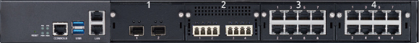

LAN module datasheet rule

Dimension 部份: 需要有LAN TRAY 和PCBA，多增加一個Dimension Drawing (如下圖)

右上角要寫上歸屬的速度, 例如 : intel 40G Fiber LAN module , 而非以major chip

NC 120FMS4 | - Mellanox LAN controller ConnectX®-5 (or Intel® Ethernet Controller E810 Series)  - With 2 x 100GbE Fiber ports
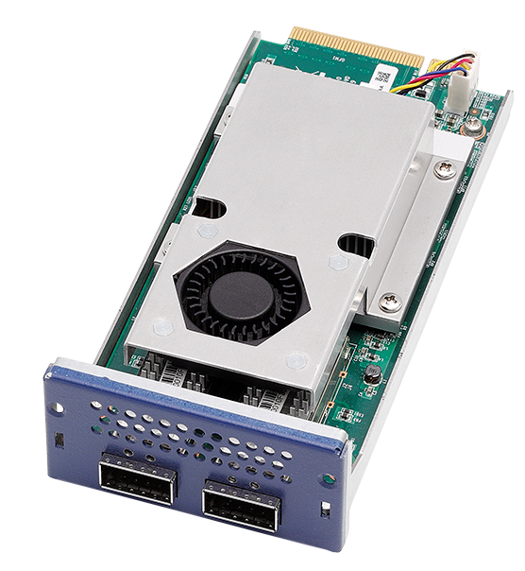
Main Feature
- Mellanox ConnectX®-5 (MT28808A0-FCCF-EV)  - 2 x QSFP28 ports | - PCIe Gen4 x16  - Supports 100GbE
LAN Features

Module | Controller | Bypass | Link Speed | Media Type | I/O ports
NC 120FMS4 | MT28808A0-FCCF-EV | None | 100G | Fiber | 2 QSFP28

Interface External
- 2 x QSFP28 ports
Dimension and Weight
- PCBA dimension: 71.3mm (W) x 165.5mm (D) x 28.1mm (H)
- PCBA with LAN tray dimension: 78.35mm (W) x 170mm (D) x 40mm (H)
- Packaging dimension: 175mm (W) x 255mm (D) x 62mm (H)
- Without packaging weight: 365g
- With packaging weight: 505g
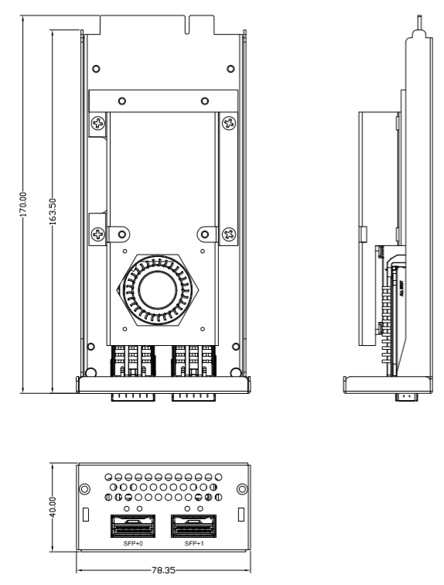 ※機構圖請提供DXF與PDF檔
Environment
- Temperature:
- - Ambient with air flow: 0°C~40°C
- Storage temperature: -20°C~60°C
- Relative humidity: 10%~90% (non-condensing)
Certification

Order information
NC 120FMS4 (P/N: 10S30012000X0)
Mellanox MT28808A0-FCCF-EV, 2 x 100GbE QSFP28 ports

