**BLG 335E Assignment 2**

**Report**

a)

T(n) = T(n-1) + Θ(n)

for the worst case : Θ (n) + Θ (n - 1) + Θ (n - 2) + ... + Θ (1)

Algorithm does all operation for 1 to n number for reverse order data set.

= k=1 ∑k k=n => k^2

=Θ(n^2)

for the best case : Recurrence for quicksort is

T(n) ≤ 2T(n/2) + Θ(n)

By Master metod:

a = 2 , b = 2 ; f(n) = Θ(n)

T(n) = Θ(n lgn)

b)

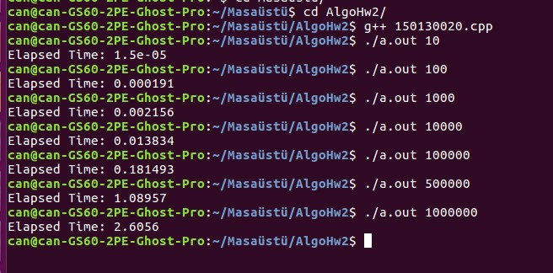

For 10 data execs time(s):

9e-06 , 4e-06, 7e-06, 15e-06, 11e-06, 8e-06,8e-06 ,11e-06,10e-06,11e-06

Avarage = 8.6e-06

For 100 data execs time(s):

0.000148, 0.000241, 0.000174, 0.000212, 0.000191, 0.000214, 0.000128, 0.000216, 0.000239, 0.000212

Avarage = 0.000197

For 1000 data execs time(s):

0.002026, 0.002707,0.003407,0.002954,0.002718,0.002732,0.002714, 0.003385, 0.002707, 0.001162

Avarage = 0.002651

For 10000 data execs time(s):

0.014043, 0.013894, 0.013926, 0.013757, 0.013709, 0.014297, 0.014248, 0.014088, 0.013935,

0.013693

Avarage = 0.013959

For 100000 data execs:

0.180827, 0.180866, 0.180516, 0.180978, 0.181065, 0.180309, 0.18065, 0.180515, 0.180757, 0.180878

Avarage = 0.164447

For 500000 data execs time(s):

1.07953, 1.08082, 1.07978, 1.07972, 1.07906, 1.07894, 1.0797, 1.07802, 1.07791, 1.10243

Avarage = 1,08159

For 1000000 data execs time(s):

2.74013, 2.52632, 2.51653, 2.52159, 2.526, 2.52278, 2.52444, 2.5395, 2.52625

Avarage = 2,29435

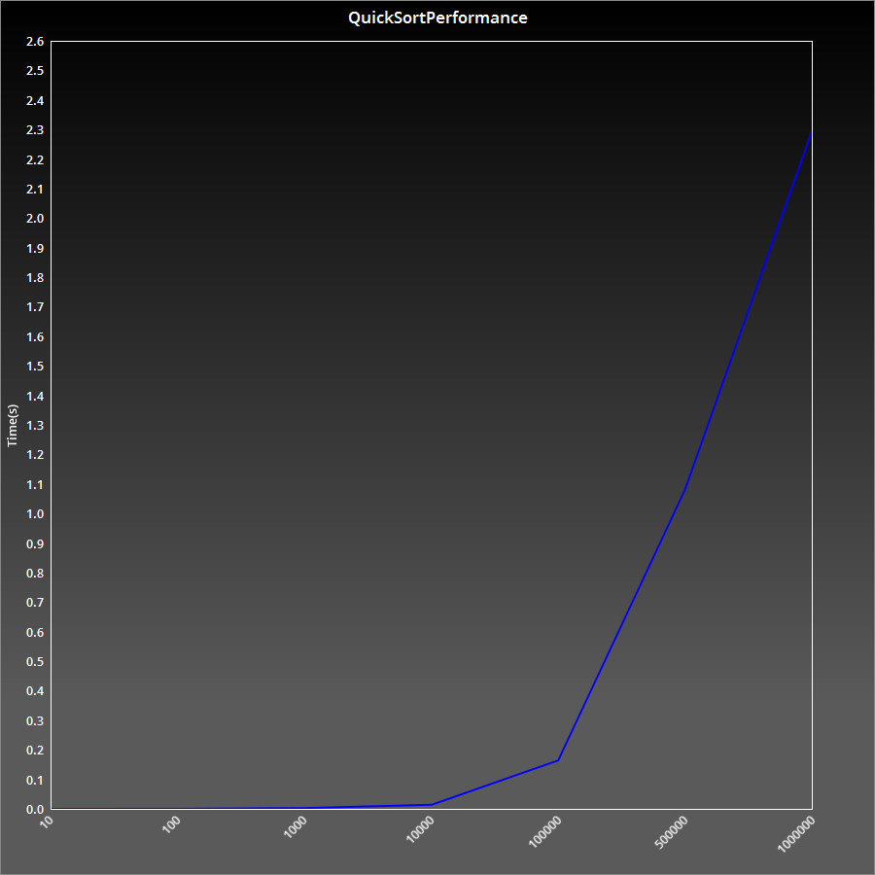

5

c)

For 10 data execs for WorstCaseTxt time(s):

1.6e-05, 1.7e-05, 1.6e-05, 1.7e-05, 1.7e-05, 1.5e-05, 1.5e-05, 8e-06, 1.3e-05, 1.7e-05

Avarage = 1.5e-05

For 100 data execs for WorstCaseTxt time(s):

0.000979, 0.000531, 0.000802, 0.000834, 0.000967, 0.00107, 0.000796, 0.000958, 0.001086, 0.000983

Avarage = 0.0009006

For 1000 data execs for WorstCaseTxt time(s):

0.025008, 0.026691, 0.027267, 0.031854, 0.032009, 0.029946, 0.027404, 0.031073, 0.031498, 0.029767

Avarage =0.0292517

For 10000 data execs for WorstCaseTxt time(s):

2.79377, 2.39083, 2.42953, 2.42648, 2.39006, 2.58809, 2.39243, 2.50016, 2.38626, 2.39128

Avarage = 2.46888

For 100000 data execs for WorstCaseTxt time(s):

277.331, 261.569, 280.809, 259.885, 267.493, 265.725, 272,137, 284.655, 278.978, 269.413

Avarage = 271,799

For 500000 data execs for WorstCaseTxt time(s):

~75min

for 1M data set it takes too much time and terminal is down twice,so that i cant measure it.

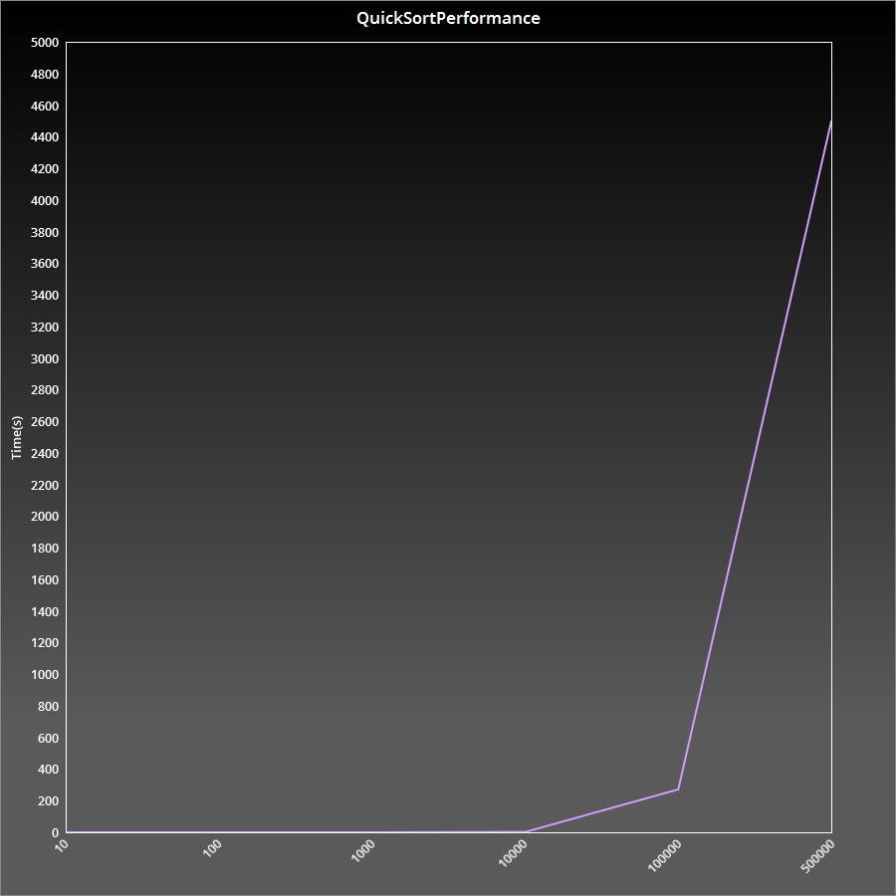The quicksort algorithm is good for main data on this homework. Program sort the list very quickly and stabily. However the algorithm speed is down for the reverse order data set file, because the pivot of the partition moves through whole array. Therefore it takes more time. We can solve this problem the selecting pivot randomly. So that randomizing quicksort can handle the reverse order problem, and It makes the Big O notation close to avarage case.