SaTScan Tutorial #1

Purely Spatial Poisson Scan Statistic for Cancer Incidence

# 1. Introduction

Thomas Talbot and Sanjaya Kumar

New York State Department of Health

Martin Kulldorff

Harvard Medical School

November, 2014

v1.0

This is a step-by-step tutorial for the SaTScan™ software. SaTScan is a free software that analyzes spatial, temporal and space-time data using the spatial, temporal, or space-time scan statistics. It is designed to detect spatial or space-time disease clusters, and to determine if they are statistically significant. The software may also be used for similar problems in other fields such as archeology, criminology, demography, ecology, geography or zoology. A wide list of published application areas can be found in the SaTScan bibliography: <http://www.satscan.org/references.html>

This tutorial is meant to serve as a quick start guide. It is intended for self-learning, but it can also be used in a classroom setting. We recommend using it as a complement to the SaTScan User Guide and to the various scientific publications describing the statistical methods. The only pre-requisite knowledge is a basic understanding of statistics and epidemiology.

In this first SaTScan tutorial, we will use the purely spatial scan statistic to analyze the geographical distribution of breast cancer incidence in New York State, USA, in order to determine if there are any geographical clusters of breast cancer incidence. That is, we will determine if there are any geographical areas with more breast cancer cases than would be expected if the risk of breast cancer was evenly distributed across the State.

The tutorial is written for SaTScan version 9.4 for Windows. The software tabs for subsequent versions may be slightly different than the screen shots shown in this tutorial, but they will be almost the same and there should not be a problem using the tutorial for subsequent versions. You can also use this tutorial if you use SaTScan for Linux or the Mac, except that some of the file handeling steps will have to be adapted to those operating systems.

# 2. New York State Breast Cancer Incidence Data

The data for this tutorial consists of female breast cancer incidence in New York State, for the years 2005 to 2009. The data comes from the New York State Cancer Registry, which is a part of the New York State Department of Health. It can be downloaded from the <https://health.data.ny.gov/d/cw3n-fkji?category=Health&view_name=Cancer-Mapping-Data-2005-2009> website. In addition to the downloadable data, an interactive map of the data can be viewed on the NYSDOH web site.

*Geographical Resolution:* The data are provided at the level of the census block group. Block groups are relatively homogeneous statistical units and are the smallest unit for which sample-based data are tabulated by the United States Census Bureau’s American Community Survey (United States Census Bureau, 2014). In order to protect patient confidentiality, a block group needs to have a minimum of 6 tumors diagnosed among males and females separately. Block groups not meeting this threshold were merged with neighboring block groups. This resulted in a reduction in the number of block groups.

*Expected Counts:* The expected counts were calculated using the indirect standardization method, adjusted for 5-year age groups up to 85+, using the 2010 census counts for New York State. In exchange for such fine geographic detail, other aspects of the data had to be omitted to ensure patient confidentiality. Accordingly, there is no information on the age, race, ethnicity, or any other demographic characteristics of the cases.

*Socio-economic Status:* Along with New York State Cancer data, two separate files containing socioeconomic status (SES) data fields and block group crosswalk are also provided. Each of these files contains a common field, DOHREGION, which can be used for linking the cancer data with these files for further analysis. The SES file includes block group level information by sex and race, ethnicity, average household size, number of occupied and vacant housing units, number of persons above and below the poverty line, median household income, and number of persons with and without a high school education. The population counts included in this file are from the 2010 United States Census and the socioeconomic data is from the 2006-2010 American Community Survey.

More information about the New York State Cancer Registry and breast cancer can be found at the <http://www.health.ny.gov/statistics/cancer/registry/> and <http://www.health.ny.gov/diseases/cancer/breast/> websites, respectively.

*Links to Original Data Sources:*

|  |  |
| --- | --- |
| Data Source | |
| Cancer Data | <https://apps.nyhealth.gov/METRIX/main.action>  <https://health.data.ny.gov/d/cw3n-fkji?category=Health&view_name=Cancer-Mapping-Data-2005-2009> |
| Population Data | <http://www2.census.gov/census_2010/04-Summary_File_1/> |
| SES Data | <http://www.census.gov/acs/www/about_the_survey/american_community_survey_and_2010_census/> |

*Link to the Data Set for this Tutorial:* The data required for this tutorial can be found on the SatScan website, at <http://www.satscan.org/datasets.html>. The name of the file is ‘NYSCancer_Region.dbf’. Please download this file to your computer before you proceed to the next step.

**Data Directories**:

SaTScan Input Files: ***InputFiles*** directory (NYSDOH Cancer Data). Data is available in txt, csv, kmz, shp and MapInfo formats in the ***Data*** directory

SaTScan Output Files: ***OuputFiles*** directory

Data Dictionary: ***InputFiles*** directory (Data_Dictionary_SatScan_Training.xls)

Socio-demographic Data: ***InputFiles*** directory

Geographical Data: ***InputFiles*** directory

*File required for tutorial*: \sample_data\InputFiles\NYSCancer_Region.dbf

# 3. SaTScan Software Download and Installation

To download the free SaTScan software, please go to [www.satscan.org](http://www.satscan.org). Select “download”, and follow the instructions. In order to obtain the download password, you need to register, providing your name, email address, affiliation and country.

The SaTScan software is able to depict detected clusters on Google Earth. For this feature to work, you need to install Google Earth on your computer. To download, go to <http://www.google.com/earth/index.html>, and follow the instructions. This is an optional step, and you can run SaTScan perfectly well without Google Earth.

# 4. Launching the SaTScan Software

Launch the SaTScan software by using one of the following three methods. Your set-up may vary slightly on your compter.

Click on the SaTScan shortcut on desktop

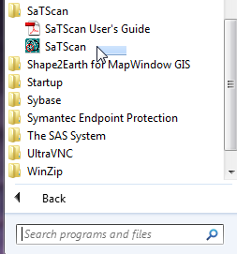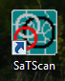

Click on Start >SaTScan >SaTScan

Browse to the SaTScan directory and click on SaTScan.exe

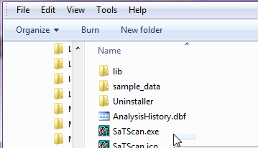

As the next step, select “Create New Session” from the Start Window.

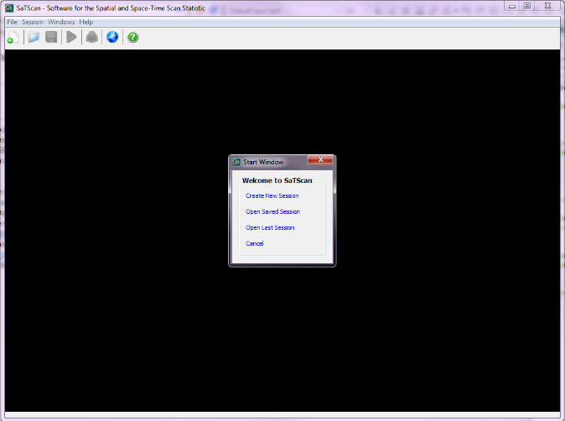 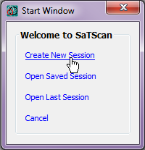

You should now see the input data tab, and you are ready to specify the anaylis you want to run. The SaTScan software has three main tabs for specifying the input data, analysis parameters and output formats respectively. We will go over each in turn. Each of the three main tabs also have a set of advanced tabs to define less used software options.

# 5. Input Data Tab

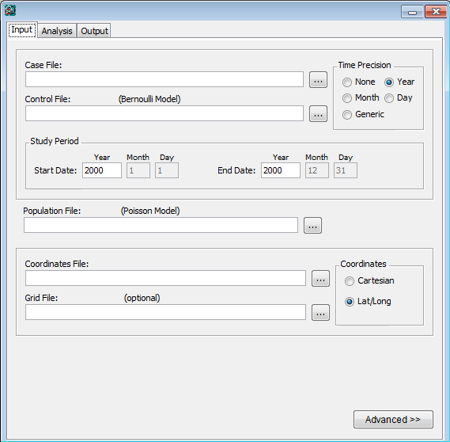

**Three separate input data files are required:**

Case file (*.cas), Population file (*.pop)

Coordinates file (*.geo)

The first of the three main tabs is used to specify the input data. For a Poisson model, which we will be using, three input files are required: for the breast cancer incident cases, for the background population at risk and for the geographical information. The three files are linked through a location ID, which represents the name or code for some geographical entety such as a state, province, county, postal code area, census tract or dwelling. In the New York State data, the locations used are different Department of Health Regions (DOHREGION), with each one represented by a set of twelve integers.

**5.1 Input Tab:** Case File (*.cas)

If the Case File is in the SaTScan input file format (see User Guide), it is enough to specfy its name in the Case File text box. In our case, we do not have the breast cancer cases in such a format, so we will instead use the SaTScan Import Wizard.

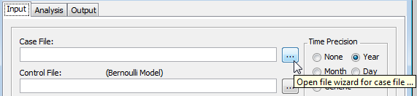

**Click on the** **button** to import the case data using the SaTScan file wizard.

**Select** NYS_Cancer_region.dbf file as the case file.

The SaTScan import wizard can read several common file formats including *.csv, *.xlsx, *.xls, *.dbf, *.txt and *.shp We are using a *.dbf file.

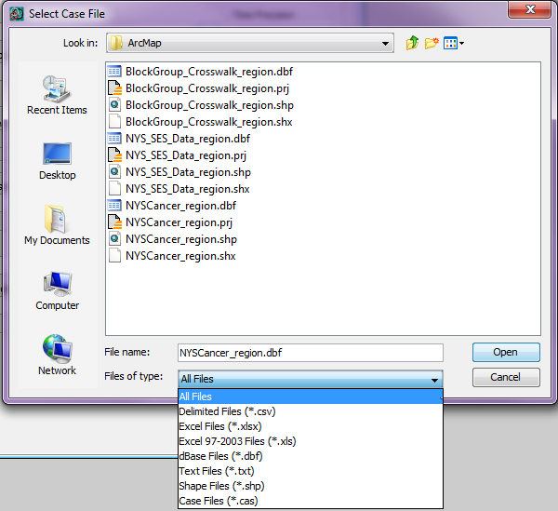

**Open** the file NYS_Cancer_region.dbf

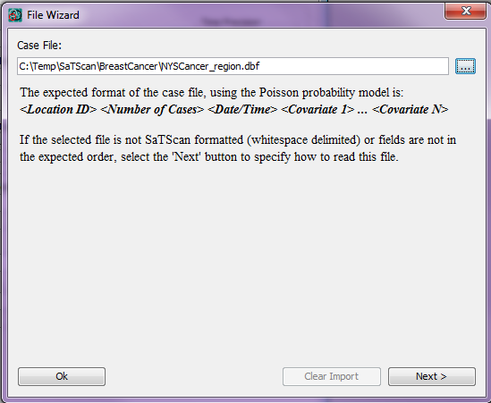

**Click Next**

Once the import file has been selected, you must assign columns to each of the required SaTScan variables. For the case file, we first need to specify the column for the location ID, which in our case is DOHREGION. Click on the word “unassigned” that is to the right of the Location ID variable name, and then select DOHREGION. The next step is to repeat the same procedure for the number of cases. Since we are interested in breast cancer, we select OBREAST. The O in OBREAT stands for the Observed number of breast cancer cases. After finishing this tutorial, you can reapeat the analysis for a different cancer site such as bladder, bone or brain cancer. As a third step, assign YEAR as the date/time. For a purely spatial analysis, this step is optional.

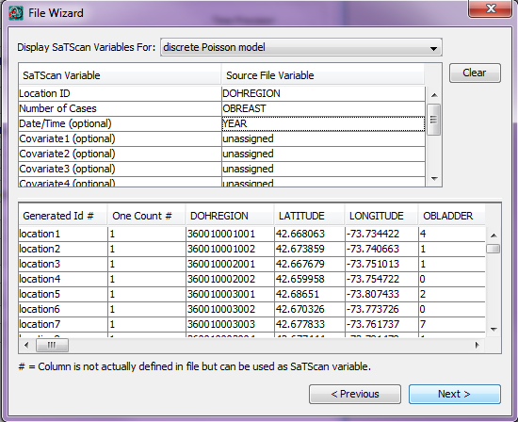

**Assign** Column names for the location ID, the Number of Cases, and for Date/Time as shown on the left.

After assigning all the variables, click on next. You are now asked to specify the file name and the directory in which you want to save the case file. You do not have to, but if you want to, you can change the name of the case input file, to something that is easier to remember.

For this tutorial, we susggeat that you do not change the directory, but do change the file name to NYS_BreastCancer.cas. This file is in the SaTScan case file format, with the extention *.cas. It is automatically assigned as the case file for the current analysis.

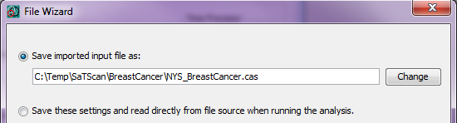

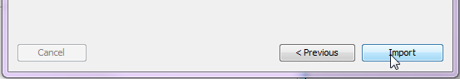

**Click on “Change” button and browse to** directory for breast cancer data

**Click Open**

**Click “Import”**

# **5.2** **Population Data**

Once you are done with the case file, repeat the same process using the population data to create the population file. For population, you want to select the EBREAST variable, which is the expected number of breast cancer cases, adjusted for age.

**Population Data (*.pop)**:

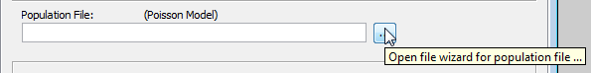

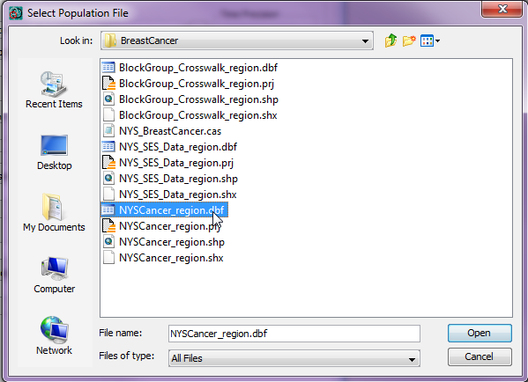

**Open**  the file NYS_Cancer_region.dbf

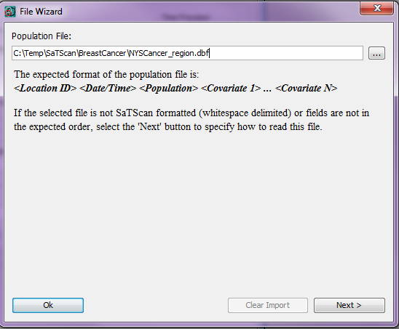

Click **Next** on this file Wizard screen to import population data file.

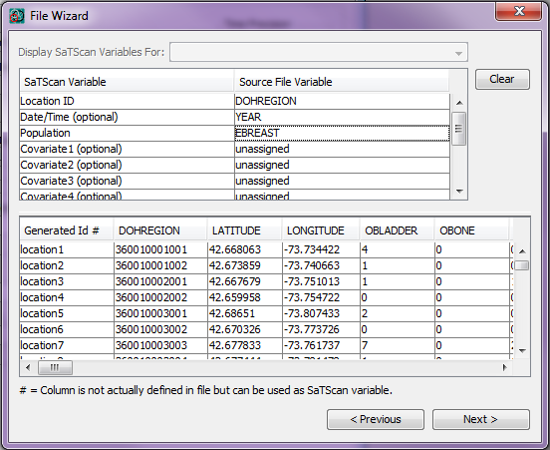

ASSIGN column names for the location ID, for Date/Time and for the Population as shown on the left.

The numbers in the population file can be either expected counts, like we have, or raw population numbers. If we had the latter, SaTScan can automatically do the age adjustment. This is done by providing SaTScan with case and population numbers stratified by age, and assigning the age variable as covariate 1 in both the case and population files. Since our expected counts are already adjusted for age, we do not have to worry about that. Instead, just click next to save the population file.

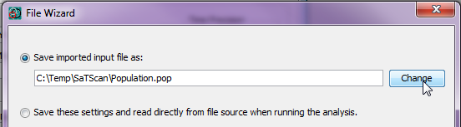

Click on **Change** and change the file name from Population.pop to NYS_BreastCancer.pop

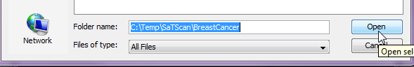

Click **Open** and type the file name (NYS_BreastCancer.pop) and then click **import**.

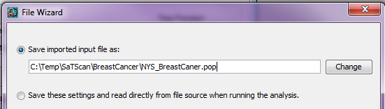

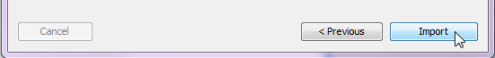



# 5.3 Geographical Data

We cannot do a spatial analysis without information about the spatial location of the cancer cases and the population. Using the same location IDs as for the cases and the population, we have to specify the geographical coordinates for each location ID. That is done using the coordinates file.

**Coordinates File (*.geo)**:

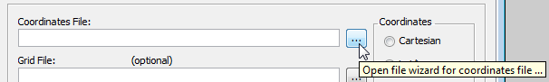

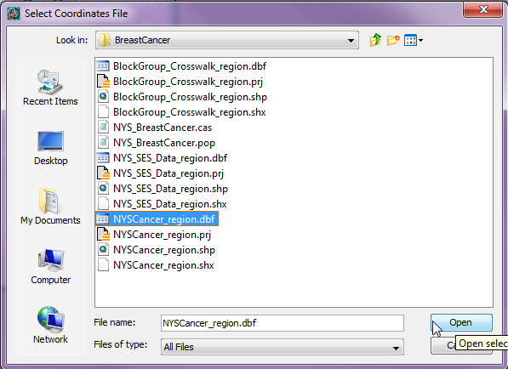

**Open** the fileNYS_Cancer_region.dbf file

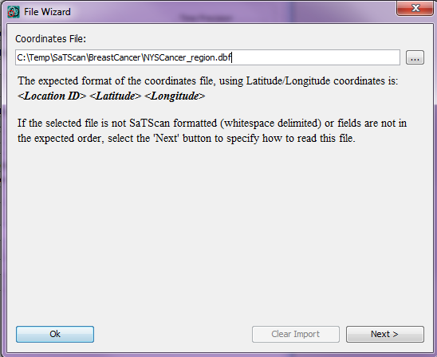

Click **Next** to go to the next step in the Import File Wizard

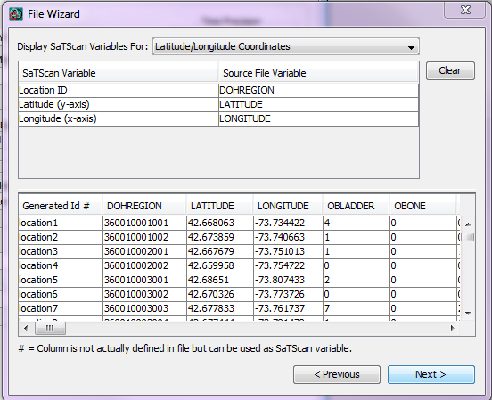

Click **Next**

Make selections for SaTScan variables using the dropdown list under the Source File Variable column. You will need to make a selection for each SaTScan Variable as shown.

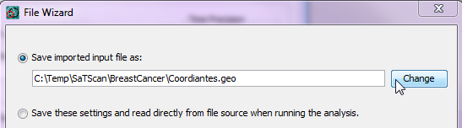

Click on **Change** and change the file name from Coordinates.pop to NYS_BreastCancer.geo

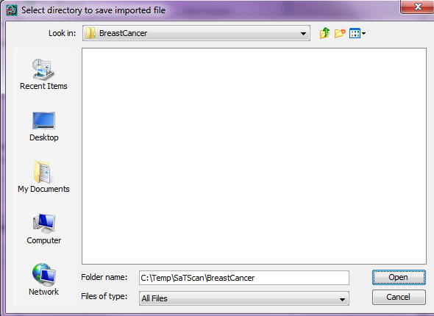

Click **Open**

Click **Open** and type the file name (NYS_BreastCancer.geo) and then click **import**.

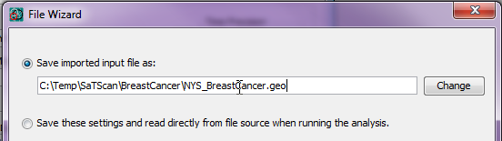

Click **Change** and select file location and file name for coordinate file

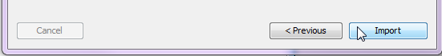

Click **Import**

# 5.4 Information About the Input Data

After specifying the names of the input files, it is neccesary to specify some information about the input data. This is also done on the main input tab.

**Time Precision (input tab)**

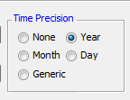

The first piece of information to specify is the precision of the times specified in the case file. If there are no times in the case file, “none” is selected. Using integer values, generic is used for times not specified using calendar dates. In the New York cancer data that we imported, time is given as the year of the incident diagnosis, and hence we select “Year”. In a purely spatial analysis, this temporal information is optional, but, SaTscan needs to know if it is in the case file in order to read that file correctly.

**Study Period (input tab)**

The next step is to define the study period. This is the time period for which we have collected breast cancer cases. In this tutorial we only have data from 2009, so we select 2009 as both the start and end date. This information is important even in a purely spatial analysis, in order for the expected counts of the clusters to be correctly calculated.

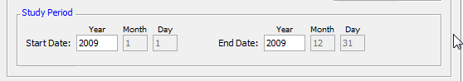

**Coordinates (input tab)**

In SaTScan, the geographical locations can either be specified as latitude and longitude, or, as Cartesian coordinates, which is the regular x,y-coordinate system taught on high school. For the New York cancer data, we have latitude and longitude coordinates. It is important to make the correct selection, since otherwise, the intended circles will not be circles. Note that, when latitude/longitude is used, SaTScan draws perfect circles on the surface of the earth, and no map projection is used.

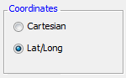

# 5.5 Final Check of Input Tab

You should now be done with the input tab, but before moving on to the next tab, it is a good idea to double check all the entries to make sure they are right. To do so, you can compare your input tab with the one below.

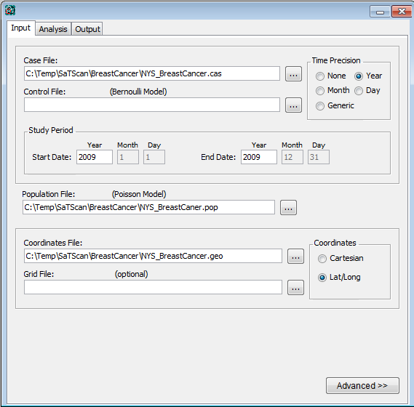

# 6. SaTScan Analysis Parameter Settings

After providing SaTScan with the data needed to run an analysis, the next step is to tell SaTScan the type of analysis to perfrom. This is done on the Analysis Tab.

***Analysis Tab***:

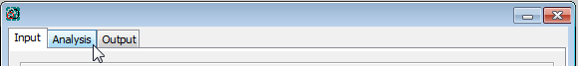

The first choice is to decide whether to do the *analysis* using a purely spatial, a purely temporal or a space-time scan statistic. We are not inetrested in time, so we will do a purely spatial analysis.

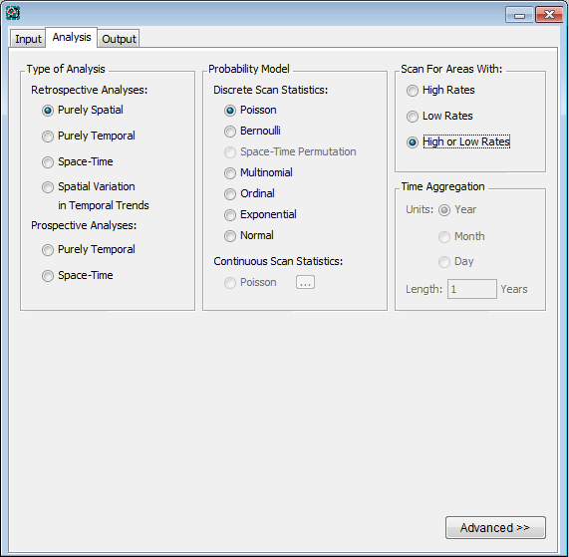

Make the selectionsselection as shown in the window.

Next, it is necessary to choose the *probability model*. We have count data, where there is a background population from which the cases arise, and where under the null hypothesis, the cases of breast cancer are independent of each other. For such data, it is suitable to use the Poisson probability model.

Scan statistics are typically used to detect clusters of cases; that is, areas with a larger number of cases than would be expected by chance. This indicates areas where there may be a higher risk for the disease. Sometimes it is also of interest to look for areas with fewer cases than expected, where the risk of the disease is lower. In our case, let’s say that we are interested in areas of either high and low risk. We then select to scan for areas with high or low rates.

The last option on the Analysis Tab is for *Time Agagregation*, but that is only relevant for purely temporal and space-time analyses. Since we are doing a purely spatial analaysis, this option is greyed out, and we simply ignore it.

If we wanted to, we could now be done with the Analysis Tab and move on to the Output Tab, but we will instead go to the advanced tabs. This is reached by clicking on “Advanced” in the bottom right corner of the Analysis Tab. See the blue box below.

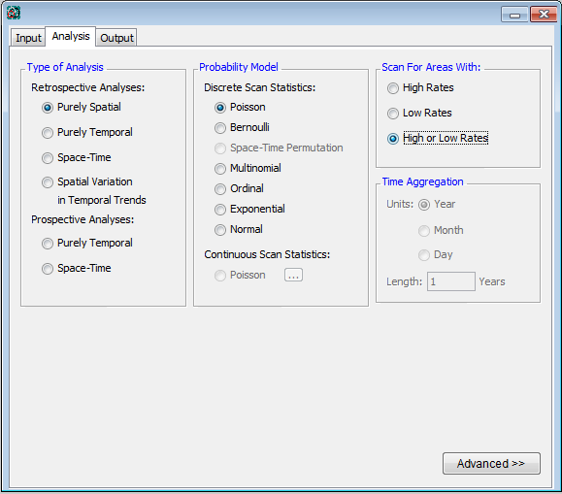

Click **Advanced**

The first of the six advanced analysis tabs is called ‘Spatial Windows’, which is the one we want. The default in SaTScan is to look for clusters covering up to half the population at risk, or to be more precise, half of the total expected counts. In New York State, that can be a very large area, containing almost the whole state except New York City. To avoid the detection of such large clusters, one can set a smaller maxima on the cluster size. We will pick a maximum of 25% of the population at risk, and this is specified on the top of the ‘Spatial Windows’ tab.

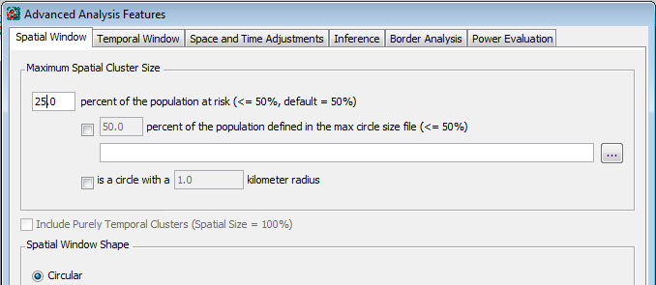

Change cluster size to 25

Change cluster size to 25

Note that, it is not appropriate to try different values of this maxima, running multiple SaTScan analyses. Instead, pick the largest number that you could concievable be interested in, and SaTScan will look for any cluster of that size or smaller, adjusting for the multiple testing.

While we are on the advanced analaysis tabs, please go to the fourth one, which is called ‘Inference’. One important parameter there is the number of Monte Carlo replications. This should be at least 999 when running an actual analysis, although it can be set to 0 or 9 for a trial run. A larger number is always better on statistical grounds, as it will increase the statistical power of the analysis. Above 999, the increase in power is very marginal. The drawback of a larger number is that the analysis takes a longer time to run. A good rule of thumb is to use 999 for large data sets that are computer intensive to run, while using 9,999 or 99,999 for smaller data sets that are quick to run. Since we have a fairly large data set, and we want this tutorial to work on both slow and fast computers, we will pick 999. Feel free to experiment with other numbers as well.

As a side note, the reason that the number of Monte Carlo replications always end 999, is so that the random data sets plus the one real data set is a multiple of one thousand. This ensures that the Monte carlo based p-values have a finite number of decimals, such as 0.021 or 0.001, and that there are no p-values with an infinite number of decimals, such as 0.021729560302171…..

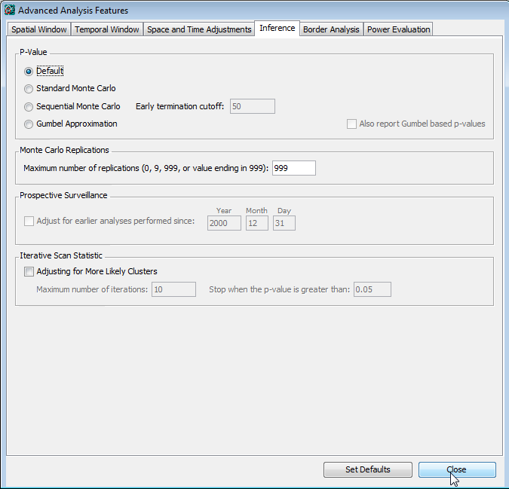

Click **Close**

Clickon **Inference tab.**

Check the **maximum number of replications.**

Once all the advanced parameter setting have been specified, click on ‘Close’ in the bottom right corner. If you click on ‘Set Default’, SaTScan will erase your choosen setting and return them to the default values.

# 7. Specifying SaTScan Output Options

SaTScan gives several options to view and save the results of the of the scan sttaistic analysis. You will need to make these selections before you execute the SaTScan session. Click on the **Output** tab to view and select one or more options.

# Output Tab:

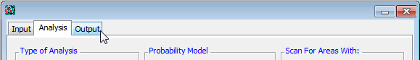

Clickon **Outptut Tab**

There are three sections on the main output tab for text, geographical and column output format.

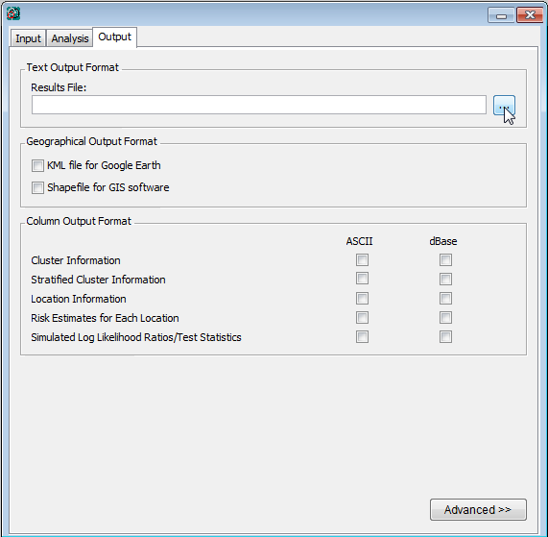

Click on the icon to modify/select the location of SaTScan output file. The file will be saved as a text file and will have several important sections including a summary of the data, locaction IDs of each location included in each cluster, coordinates and radius of each cluster, population, number of cases, number of expected cases, relative risk and p-value for each cluster detected.

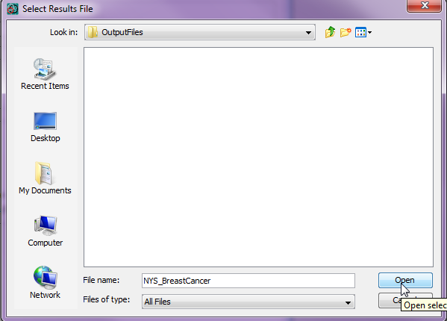

**Browse** to the folder location where you want to save the text output file.

**Enter** file name and click **open**

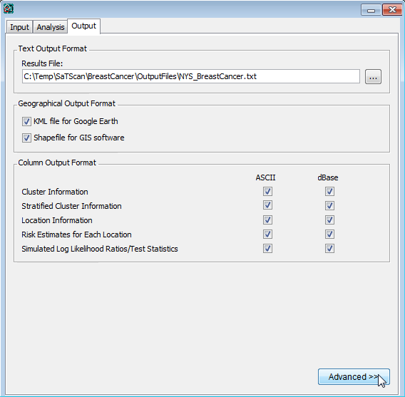

Make a selection to see the output file (clusters) in Google Earth and/or to provide a shape file that can be imported into a GIS software.

Make selections to save additional output files separately in one or more formats. You can but do not need to select both formats. The

ASCII files can be opened in Excel or other spreadsheet software.

Click **Advanced>>** to make additional selections

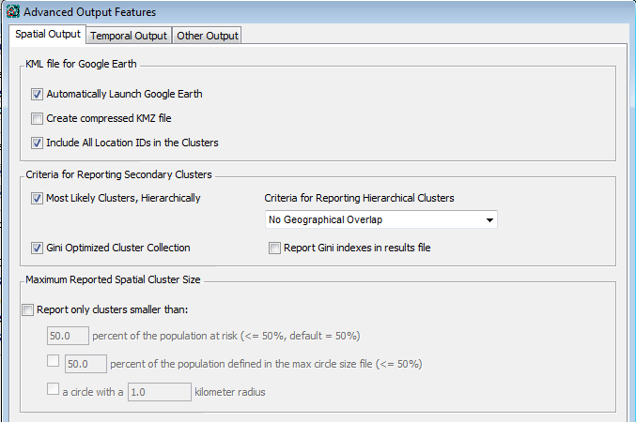

For secondary clusters, select hierarchical reporting of most likely clusters, deselecting the Gini optimized cluster collection.

If you have Google Earth installed on your computer, select “Automatically Launce Google Earth”.

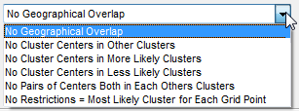

SaTScan will typically find multiple overlapping clusters, some of which are almost identical to each other. In SaTScan there are options to report a different number of these overlapping clusters based on different criteria. For this tutorial, select ‘No Geographical Overlap’, which is the most restrictive choice. With this option, a secondary cluster will only be reported if it does not overlap with a more likely and previously reported cluster.

For the purpose of this tutorial, make selections as shown in screen below.

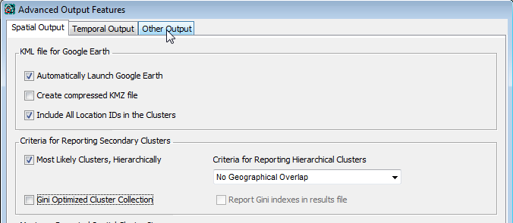

After making the selections, click on the ‘**Other Output**” tab on top of the **Advances Output Features**.



After making the selections, click on the ‘**Other Output**” tab on top of the **Advances Output Features**.

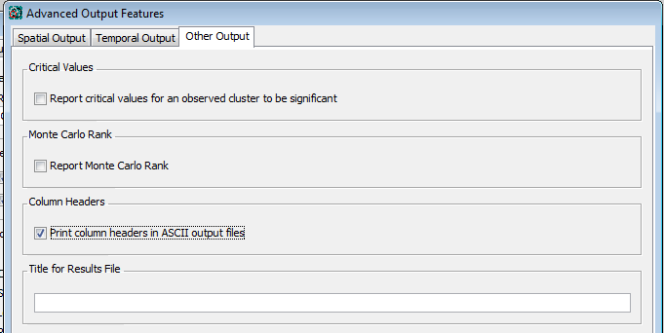

Select the column headers option as shown if you selected the ASCII output files.

**Click Close**



After you have made all the selections on the output tabs, you are ready to run a SaTScan analysis.

# 8. Running SaTScan

Once all the SaTScan parameters have been selected on the various tabs, it is time to run the program. This can be done in either of two ways. From the menu, first select ‘Session’ and then ‘Execute’.

From Menu: Session > Execute

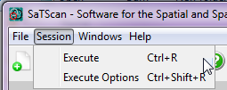

Alternatively, and much faster, just click on the button with the green triangle.

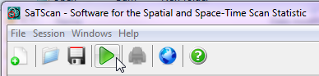

Once the SaTScan analysis is running, you will see a window that shows the progress being made. There is nothing in this window that you need to write down or memorize. After the analysis is done, this window will show the text based results file. You will be able to scroll through this window to see all the results, as well as the paraneter settings you used. These are the same results that are also saved in the file that you specified in section 7.

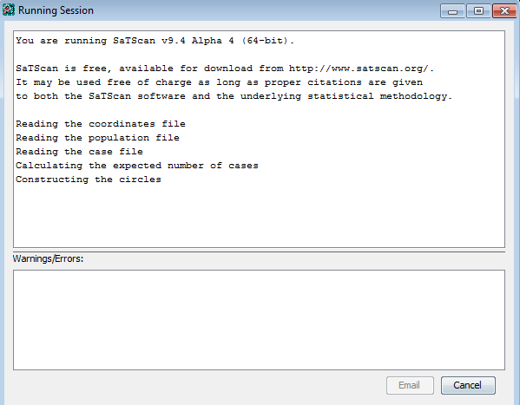

Sometimes SaTScan produces warnings or error. The most common errors are problems with the input files, such as a location ID that is present in the case file but missing in the geographical coordinates file. The descriptions of the warnings and errors are meant to help finding any problems that may exist in the input data. In this tutorial, you should not get any warnings or errors if you have done everything accordining to the tutorial instructions.

# 9. Reading and Intepreting the Results

The SaTScan software provides the output result in various formats, some of which are optional. The main text-based results file will automatically open once the calculations are complete:

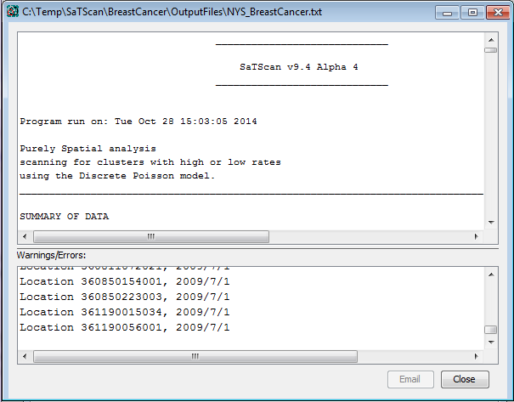

The first thing to do is to check for any warnings or errors. These are designed to help the user find any data problems that may exist in the input files as well as unintended parameter settings.

At the end of the main results file, there is a list of the parameter settings used for the analysis. For example, it states how many Mionte Carlo replications were used. In this way, you can always go back and check the parameters you used for a particular analysis. At the very end, there is also information about when the SaTsCan program was run, and how long it took to run it.

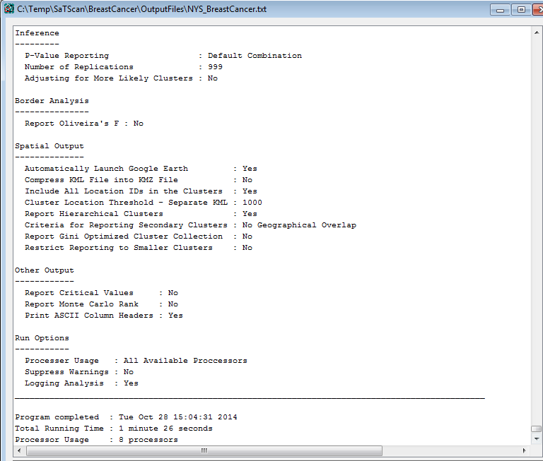

The list of parameter settings also includes the names of the optional results files that you requested, if any. These optional files contains the results in column and row format, for easy incorporation and further analysis using GIS and other software products.

# Final output files:

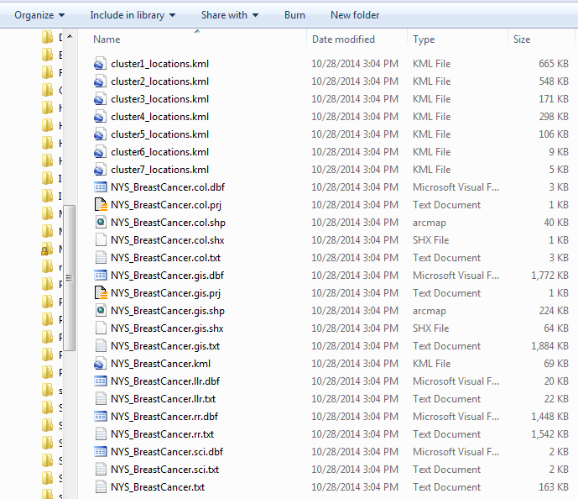

In order to depict the detected clusters on a map, SaTScan produces an optional geographical shapefile and/or a KML file. SaTScan will automatically open the KML file if you have Google Earth installed on your computer:

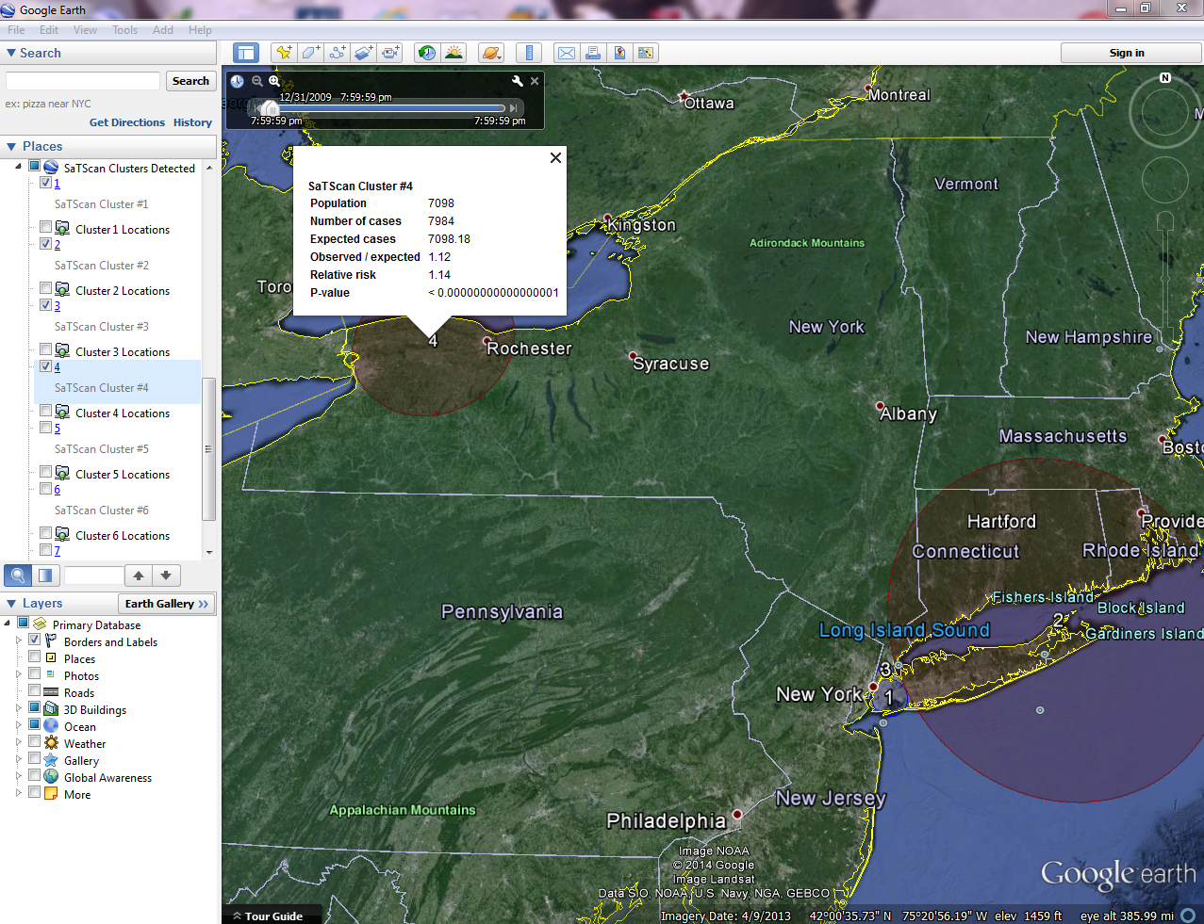

# 10. Some Common Questions

*How can I read the *cas, *.pop and *.geo files?*

You will need to associate the *.cas, *.pop and *.geo files to the **Notepad** program.

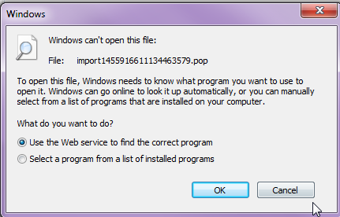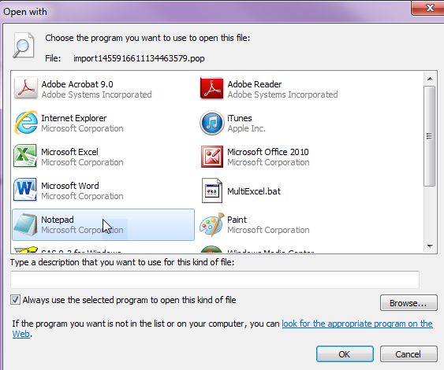

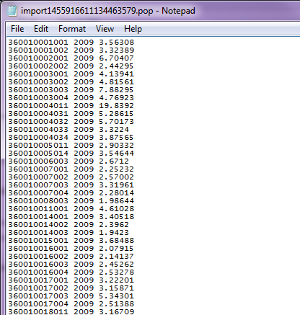

*Does SaTScan utilize all the processors on my computer for optimal speed?*

Yes, SaTScan uses a paralell computing algorithm for the most computer intensive part of the claculations. You can control the processing speed by selecting the number of processors to use for the SaTScan analysis:

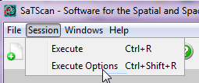

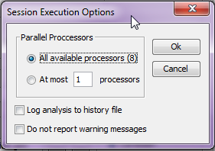

*How can I save my parameter settings?*

To save time when you run the same program next time, you can save the current SaTScan session with all its parameter settings, by clicking on “File” and then “Save Session” or “Save Session As”:

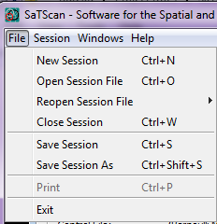

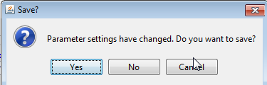

EXITing the program without saving the session will prompt you to save the parameter settings, which is same as saving the session.

*How can I open a saved session?*

When you start SaTScan, you will be asked if you want to open an already saved session.

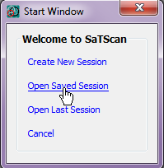

To Open you last session,click on “Open Saved Session” on the Start Window.

Alternatively, you can select “File” followed by “Open Session File” or “Reopen Session File”.

*Can SaTScan create kml and shp output files if my input files are in a Cartesian coordinate system?*

No, SaTScan must have latitude and longitude coordinates in the input file in order to create shp and kml files.

*Can SaTScan test for non-circular shaped clusters?*

Yes, if the coordinate system is Cartesian, it is possible to use ellipses instead of circles. This is an advanced option on the Windows Tab.

# 11. References and Further Reading

This is the first in a series of SaTScan tutorials. Subsequent tutorials cover space-time scan statistics; different probability models and different types of diseases.

We also strongly recommend using the SaTScan User Guide. The User Guide is automatically downloaded together with the software, and can be found as a pdf file in the SaTScan directory. It can also be downloaded directly from the SaTScan web site: <http://www.satscan.org/techdoc.html>.

For scientific publications describing the Poisson based purely spatial scan statistic, we recommend:

#### General Statistical Theory, Poisson Probability Model

Kulldorff M. A spatial scan statistic. Communications in Statistics: Theory and Methods, 1997; 26:1481-1496. [[online](http://www.satscan.org/papers/k-cstm1997.pdf)]

*Application to Breast Cancer Data with Covariate Adjustments*

Kulldorff M, Feuer EJ, Miller BA, Freedman LS. Breast cancer in northeastern United States: A geographical analysis. American Journal of Epidemiology, 146:161-170, 1997. [[online](http://www.satscan.org/papers/k-aje1997.pdf)]

Sheehan TJ, DeChello LM, Kulldorff M, Gregorio DI, Gershman S, Mroszczyk M. The geographic distribution of breast cancer incidence in Massachusetts 1988-1997, adjusted for covariates. International Journal of Health Geographics, 2004, 3:17. [[online](http://www.ij-healthgeographics.com/content/3/1/17)]

Additional references of both a methodological and applied nature can be found in the SaTScan User Guide: <http://www.satscan.org/techdoc.html>.

*Please contact the authors with any comments, questions or suggestions:*

Thomas Talbot; New York State Department of Health

[Thomas.Talbot@health.ny.gov](mailto:Thomas.Talbot@health.ny.gov)

Sanjaya Kumar; New York State Department of Health

[Sanjaya.Kumar@health.ny.gov](mailto:Sanjaya.Kumar@health.ny.gov)

Martin Kulldorff; Harvard Medical School

[martin_kulldorff@hms.harvard.edu](mailto:martin_kulldorff@hms.harvard.edu)

**NOTES**

--------------------------------------------------------------------------------------------------------------------------------------------------------------------------------------------------------------------------------------------------------------------------------------------------------------------------------------------------------------------------------------------------------------------------------------------------------------------------------------------------------------------------------------------------------------------------------------------------------------------------------------------------------------------------------------------------------------------------------------------------------------------------------------------------------------------------------------------------------------------------------------------------------------------------------------------------------------------------------------------------------------------------------------------------------------------------------------------------------------------------------------------------------------------------------------------------------------------------------------------------------------------------------------------------------------------------------------------------------------------------------------------------------------------------------------------------------------------------------------------------------------------------------------------------------------------------------------------------------------------------------------------------------------------------------------------------------------------------------------------------------------------------------------------------------------------------------------------------------------------------------------------------------------------------------------------------------------------------------------------------------------------------------------------------------------------------------------------------------------------------------------------------------------------------------------------------------------------------------------------------------------------------------------------------------------------------------------------------------------------------------------------------------------------------------------------------------------------------------------------------------------------------------------------------------------------------------------------------------------------------------------------------------------------------------------------------------------------------------------------------------------------------------------------------------------------------------------------------------------------------------------------------------------------------------------------------------------------------------------------------------------------------------------------------------------------------------------------------------------------------------------------------------------------------------------------------------------------------------------------------------------------------------------------------------------------------------------------------------------------------------------------------------------------------------------------------------------------------------------------------------------------------------------------------------------------------------------------------------------------------------------------------------------------------------------------------------------------------------------------------------------------------------------------------------------------------------------------------------------------------------------------------------------------------------------------------------------------------------------------------------------------------------------------------------------------------------------------------------------------------------------------------------------------------------------------------------------------------------------------------------------------------------------------------------------------------------------------------------------------------------------------------------------------------------------------------------------------------------------------------------------------------------------------------------------------------------------------------------------------------------------------------------------------------------------------------------------------------------------------------------------------------------------------------------------------------------