**CS435/535 Computer Graphics  
Spring 2019**Project #3

Hierarchical Modeling

**Due: Feb. 25 by 11:59 pm**

**Problem**: Use WebGL to model a 3D text display that can read a paragraph embedded in the html file (like the vertex or fragment shader) and display the paragraph word by word in a 3D font. The following figure illustrates such a device. Both the base and the display are rectangles, and they are connected by a cylinder. The base and the cylinder are fixed. The display can be tilted up or down using the UP and DOWN buttons, and it can be turned left or right using the LEFT and RIGHT buttons.

For simplicity, the device can display one word at a time in capital letters only. So any lower case letters shall be converted into the upper case ones, and any punctuation marks shall be dropped. Words shall be displayed automatically at certain speed, say, one word per second. It is assumed the longest word in the paragraph has a length of 12.

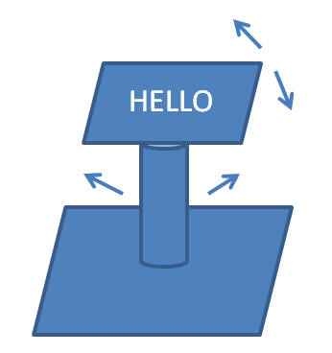

Create a directory called *project3* under your cs435 or cs435 home directory. Move into that directory, and create two files: *modeling.html* and *modeling.js* to complete this project.

**Hints:** You can build a 3D font from a 2D font. In 2D, a dot-matrix font is a very basic font. (Please see <http://www.dafont.com/dot-matrix.font> for an example.) If you use a cylinder to represent a dot, you will have a 3D font. Also it is frequent to use a 16-segment display to display letters in 2D. (Please see <http://en.wikipedia.org/wiki/Sixteen-segment_display> for an example.) If you use a cylinder to represent a segment, you will have a 3D font.

**Submission Requirements:**

* Make sure the *project3* directory contain the two files: *modeling.html* and *modeling.js*.(Here we assume the *Common* directory is located in the same directory as the *project3* directory, and you do not need to submit the *Common* directory.)
* The title of *modeling.html* should contain your name, CS435 (or CS535), Project #3.
* The *modeling.js* file should contain the following information at the beginning: CS435 (or CS535), Project #3, your name, a description of the program. Add other necessary comments whenever a part of the code is not obvious.
* Compress the *project3* directory into *project3.zip* and submit the compressed file as an attachment on Blackboard.