Function Words Are a Shortcut: Faithful, Function-Word-Invariant Detection of AI-Generated Reviews
Author Name¹, Co-author²
¹Affiliation ²Affiliation · {emails}

Abstract
Supervised detectors of AI-generated text reach high in-domain accuracy but are known to rely on superficial cues that do not transfer. We identify function words — articles, prepositions, conjunctions, auxiliaries and pronouns that are statistically common to both human and machine text — as one such cue, and ask what is gained by making a detector ignore them. We propose FAITH-Detect, which enforces function-word invariance two ways: a hard-masking variant that replaces every function-word token with a neutral placeholder before encoding (so the decision is provably invariant to function-word identity), and a soft attribution-regularised variant. Explanations are produced by the real model and are content-only by construction; we quantify reliance with a function-word attribution-mass metric and a forward-only identity-sensitivity metric. On the multilingual MAiDE-up hotel-review benchmark (English subset; roberta-base, 5 seeds, leakage-free grouped splits) the hard-masked detector matches the unconstrained model in-domain, places essentially zero attribution on function words, and is the most robust to function-word and paraphrase attacks. On a cross-domain out-of-distribution set (RAID reviews) it transfers worse, showing that function words can also carry domain-general style signal. Function-word invariance is therefore best understood as a principled trade-off: a provable guarantee, in-domain parity, robustness and faithful explanations, at some cost to cross-domain transfer. All results are reported with confidence intervals over multiple seeds and are reproducible from a single results file.

1 Introduction
The fluency of large language models has made AI-generated reviews a practical threat to online platforms, where fabricated opinions can manipulate purchasing and reputation. Detectors are deployed in response, and increasingly are expected to come with explanations that justify a flag. Two problems recur. First, supervised detectors latch onto dataset- and generator-specific artefacts, so accuracy collapses out of distribution. Second, the explanations that accompany detectors are usually post-hoc rationalisations of an unconstrained model, and are rarely validated for faithfulness.
This paper studies a single, concrete cue: function words. Closed-class words such as “the”, “a” and “of” are among the most frequent tokens in any English text and are shared by human and machine writing; intuitively they should carry little signal about whether a review is genuine. Yet an unconstrained detector still places a large fraction of its attribution on them. We ask: what happens if the detector is made to ignore function words entirely?
We introduce FAITH-Detect, which operationalises function-word invariance in two ways. The hard-masking variant replaces every function-word sub-token with a shared placeholder before the encoder sees the text, so the decision cannot depend on which function word occurred; this is a constructive, testable guarantee. The soft variant keeps the text but penalises attribution mass that lands on function words during training. Crucially, explanations are computed on the actual deployed model, and function words are excluded by construction; we verify this with a function-word attribution-mass metric (the share of attribution on function words) and a forward-only identity-sensitivity metric (the change in the AI probability when function words are swapped for other function words).
Contributions:
- A function-word-invariant detector with a provable guarantee (hard masking) and a learned alternative (soft regularisation), motivated by shortcut learning.
- Faithful, content-only explanations computed on the real model, with two metrics that make function-word reliance directly measurable.
- A rigorous evaluation — leakage-free grouped splits, multiple seeds with confidence intervals, significance tests, classic baselines, cross-domain and cross-generator OOD, and two text attacks — yielding an honest characterisation of when function-word invariance helps and when it hurts.

2 Related Work
Machine-generated text detection spans zero-shot likelihood methods (e.g. GLTR; DetectGPT) and supervised transformer classifiers; the RAID benchmark shows that such detectors are brittle to domain shift, unseen generators and adversarial edits. Our work is orthogonal: rather than proposing a stronger detector, we ask what a specific, interpretable family of features (function words) contributes, and whether removing it improves robustness and explanation quality. Shortcut learning frames the broader phenomenon of models exploiting spurious correlations. On the explanation side, Integrated Gradients provides axiomatic attributions; the ERASER suite formalises faithfulness via comprehensiveness and sufficiency, and deletion/insertion curves measure how predictions respond to evidence. Attribution regularisation (“right for the right reasons”) trains models to place gradient mass where a prior says it should; our soft variant is an instance, with function words as the prior. The MAiDE-up dataset provides human and GPT-4 hotel reviews and is our in-domain benchmark.

3 Method

3.1 Function-word set
We define an auditable English function-word set (441 surface forms) as the union of a curated closed-class list (articles, prepositions, conjunctions, auxiliaries, pronouns, particles, determiners) and the standard NLTK, scikit-learn and spaCy stop-word lists. The set is fixed and surface-form based, so identification is deterministic at inference. A word is a function word if its lower-cased, punctuation-stripped form is in the set.

3.2 Hard-masking (provable invariance)
Given a review, we tokenise with the encoder's byte-level BPE and map each sub-token back to its surface word via offset alignment. Every sub-token belonging to a function word is replaced by a single added placeholder token [FUNC] before encoding. Because all function words map to the same placeholder, the encoder — and therefore the classifier — cannot distinguish which function word occurred or, indeed, that it was a particular word at all: the decision is invariant to function-word identity by construction. We verify this with an automated test that asserts bit-identical logits when function words are permuted.

3.3 Soft attribution regularisation
The soft variant keeps the full text and adds a penalty to the training loss equal to the fraction of input-gradient saliency that lands on function-word tokens (a gradient-times-input estimate, with create_graph so the penalty back-propagates into the weights). To keep memory bounded at large batch and sequence length, the second-order penalty is computed on a small sub-batch — an unbiased stochastic estimate of the regulariser — while the cross-entropy uses the full batch.

3.4 Faithful, content-only explanations
All attributions are computed on the actual deployed model (including the hard-masking transform), never a surrogate. We use Integrated Gradients on the embedding layer (a portable manual Riemann implementation) and leave-one-word-out occlusion, aggregated to word level; function words are excluded from the displayed explanation. We report two reliance metrics: function-word attribution mass (the share of total absolute attribution on function words) and identity-sensitivity (the mean change in AI probability when each function word is replaced by a different function word). For explanation quality we report ERASER comprehensiveness and sufficiency and deletion/insertion AUC over content words.

4 Experimental Setup
In-domain data is the English subset of MAiDE-up (human vs GPT-4 hotel reviews). Because every hotel appears in both classes, a random split leaks hotel-specific content across train and test; we therefore use grouped (by-hotel) splits and additionally report a random split to quantify the leakage. Splits are grouped by hotel (train 1400, val 200, test 400; train↔test hotel overlap 0). We fine-tune roberta-base for each of 5 seeds and report mean ± 95% confidence interval. Out-of-distribution evaluation uses the RAID benchmark's reviews domain (cross-domain, and spanning multiple generators including GPT-3.5/4, Cohere and Llama). Robustness is probed with a function-word attack (deleting/duplicating/swapping function words) and a WordNet synonym attack on content words. Baselines are TF-IDF + logistic regression and a content-only TF-IDF variant. Significance between models on the shared test set uses McNemar's test.

5 Results
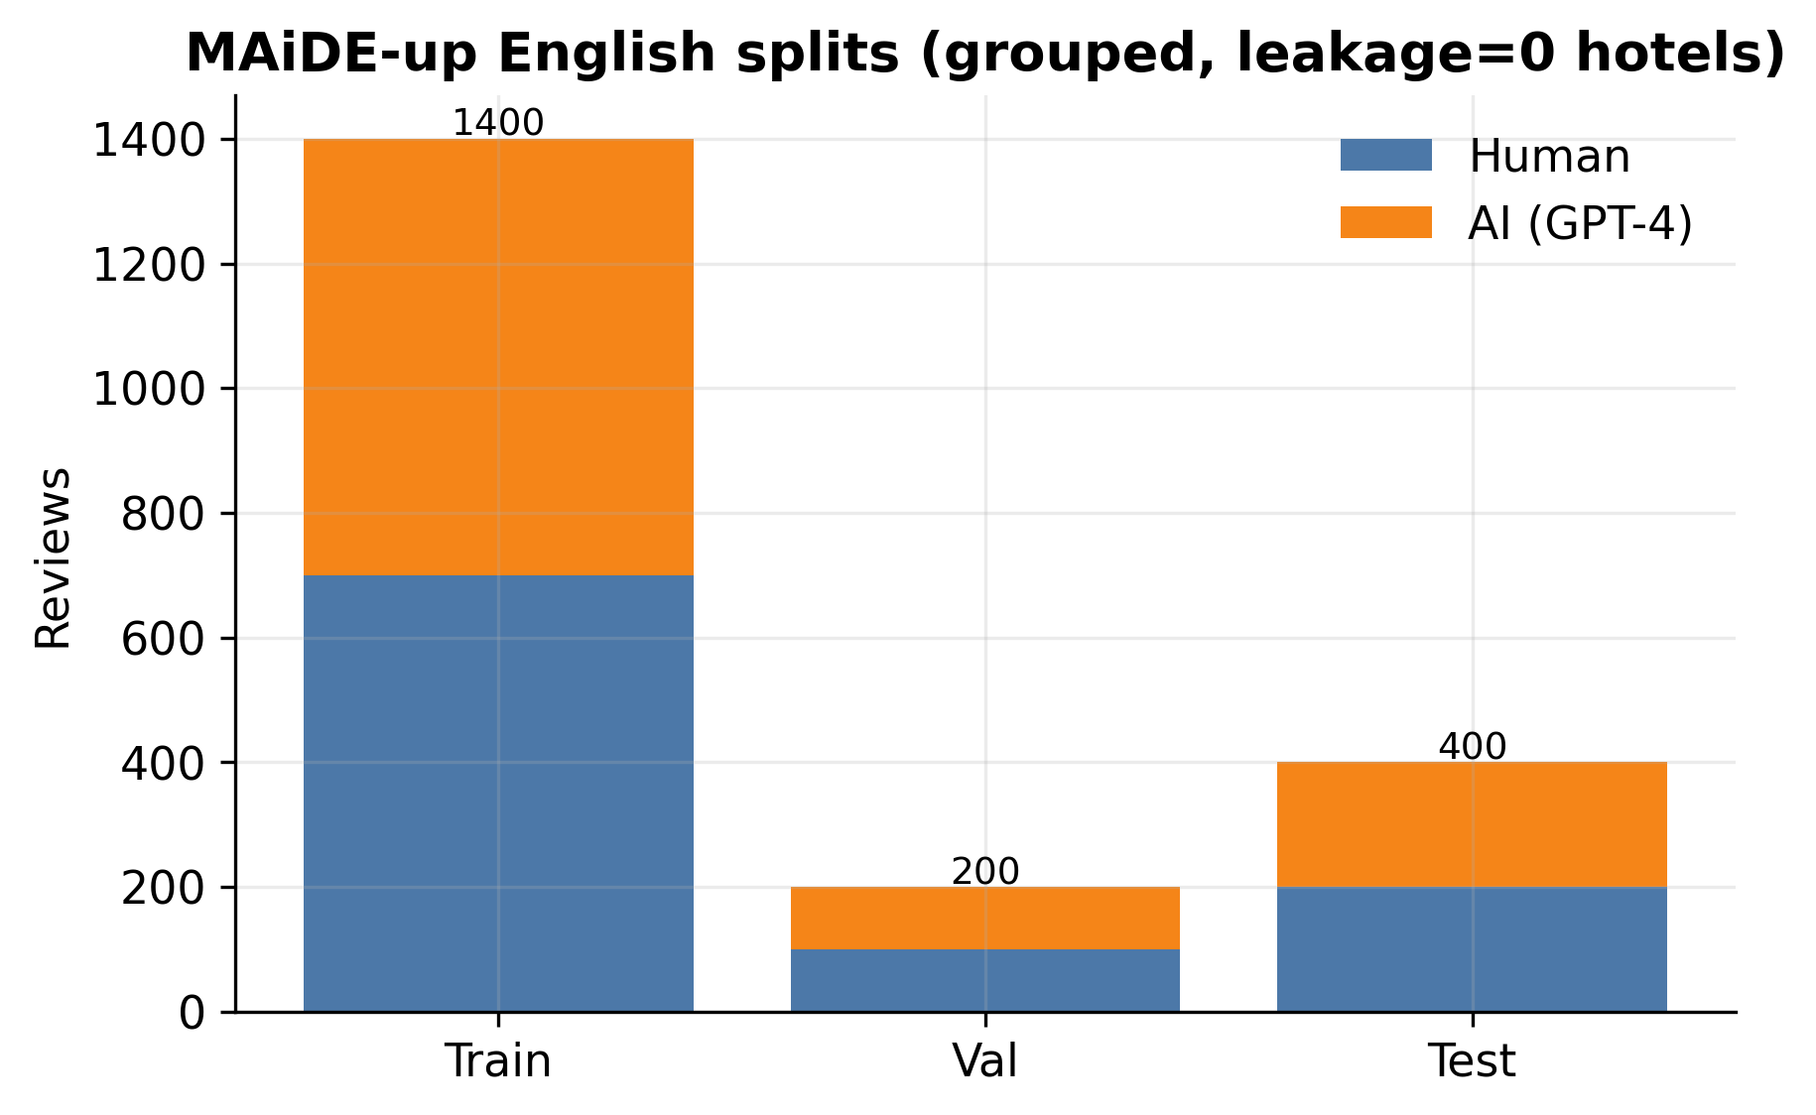
Figure 1: MAiDE-up English splits (grouped, zero train↔test hotel leakage).

5.1 In-domain: invariance is free
Model | F1 (macro) | ROC-AUC | Accuracy
Baseline | 93.7 ± 2.8 | 99.4 ± 0.3 | 93.8 ± 2.8
SoftReg | 93.8 ± 3.6 | 99.3 ± 0.4 | 93.8 ± 3.5
Hard-Mask (FAITH) | 93.6 ± 1.7 | 98.6 ± 0.6 | 93.6 ± 1.7
tfidf_lr | 92.2 | 97.9 | 92.2
tfidf_lr_content | 91.7 | 97.2 | 91.8
All three neural variants are statistically indistinguishable in-domain (McNemar baseline vs. Hard-Mask, p = 0.15); Hard-Mask attains the same F1 as the unconstrained baseline with the tightest interval. Function-word invariance costs essentially nothing on in-distribution data.
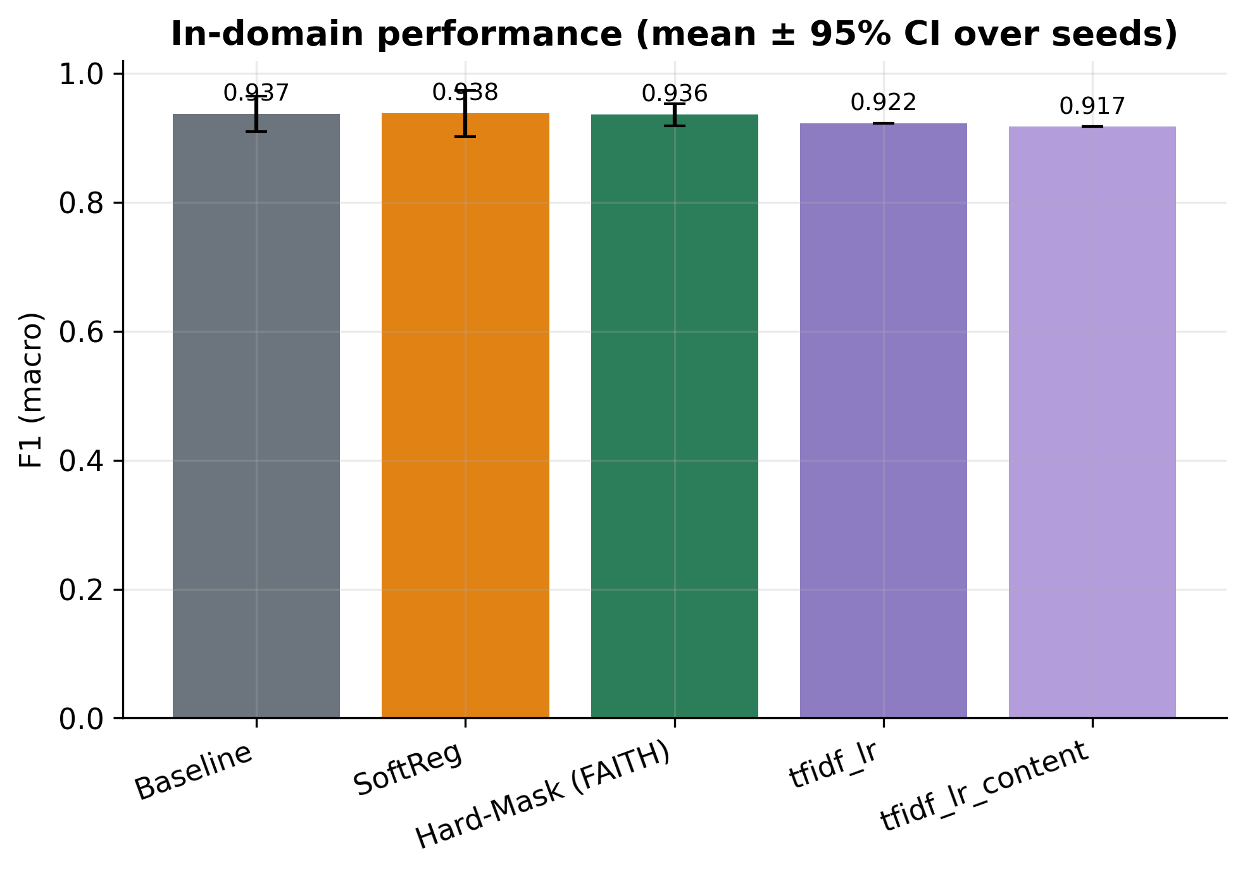
Figure 2: In-domain F1 (mean ± 95% CI over seeds), with classic baselines.

5.2 Function-word reliance
Variant | FW attribution mass (IG) | Identity-sensitivity |Δp|
Baseline | 36.5% | 10.93%
SoftReg | 30.0% | 10.61%
Hard-Mask (FAITH) | 0.0% | 0.72%
The unconstrained baseline places a large share of its attribution on function words; soft regularisation reduces it; hard masking eliminates it (0.00%). The identity-sensitivity metric, which needs only forward passes, corroborates this directly.
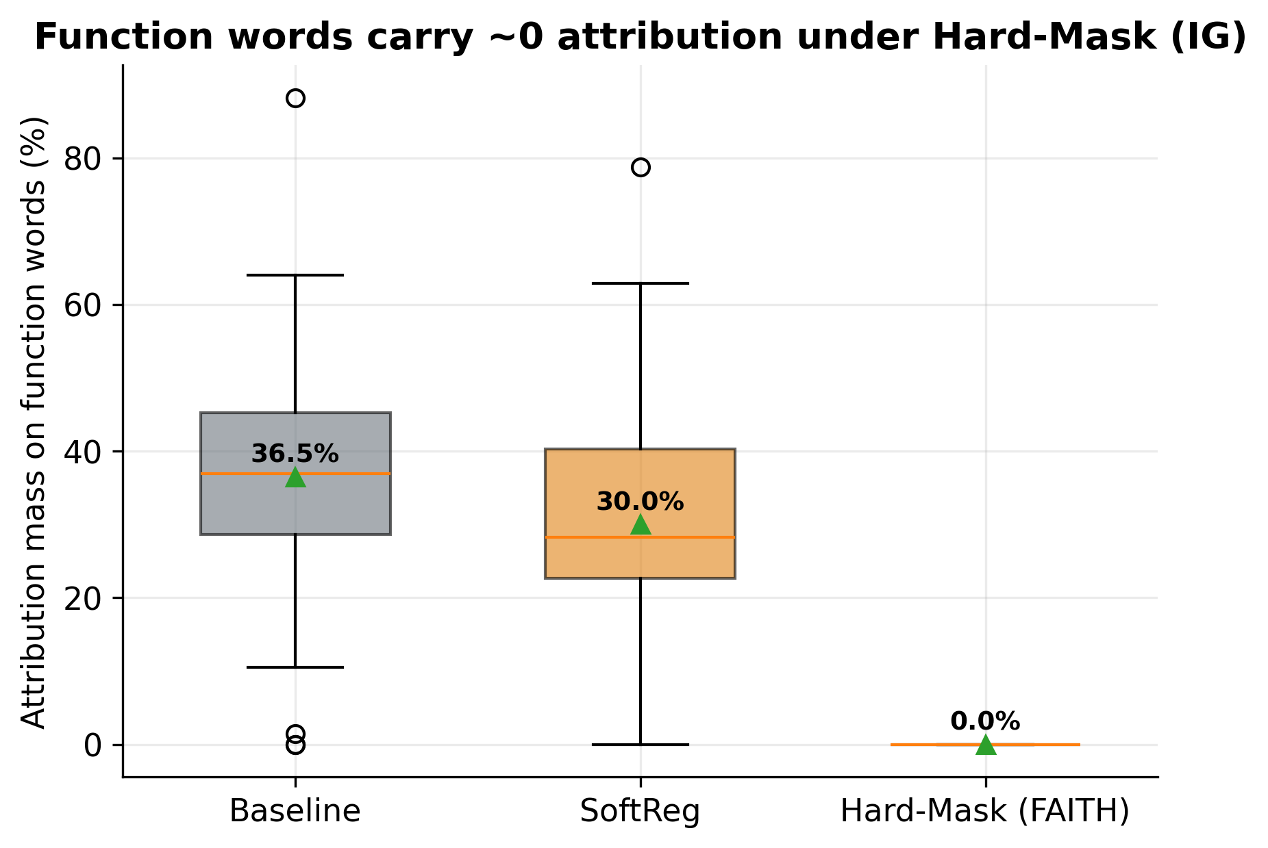
Figure 3: Integrated-Gradients attribution mass on function words by variant.

5.3 Robustness to attacks
Variant | Clean | function word | synonym
Baseline | 93.7 | 87.2 | 88.4
SoftReg | 93.8 | 87.0 | 86.4
Hard-Mask (FAITH) | 93.6 | 95.8 | 89.9
Under the function-word attack the baseline and soft variants lose several points, whereas Hard-Mask is unmoved — perturbing function words cannot affect a decision that ignores them. Hard-Mask is also the most robust to synonym substitution. This is the clearest empirical benefit of invariance.
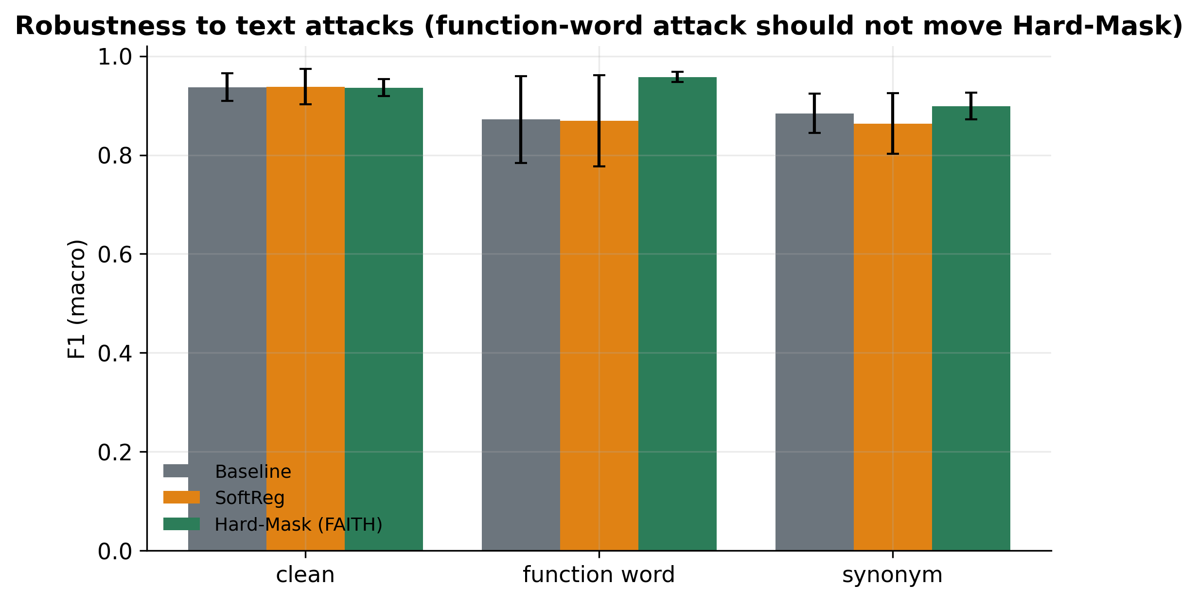
Figure 4: F1 under text attacks. Hard-Mask is flat under the function-word attack.

5.4 Cross-domain and cross-generator transfer
Variant | In-domain F1 | OOD F1 (RAID reviews)
Baseline | 93.7 ± 2.8 | 69.5 ± 7.5
SoftReg | 93.8 ± 3.6 | 68.2 ± 10.1
Hard-Mask (FAITH) | 93.6 ± 1.7 | 47.4 ± 8.3
On the cross-domain OOD set (hotel → movie reviews) the picture reverses: Hard-Mask transfers worse than the baseline, with non-overlapping intervals. When the content vocabulary shifts, the content words Hard-Mask depends on largely disappear, while the baseline's function-word and stylistic cues evidently carry domain-general signal. Function words are thus not pure noise; in cross-domain transfer they can be useful. The per-generator breakdown (Figure 6) shows the same ordering across most generators. We note that this OOD conflates domain and generator shift and is an extreme content change; a same-domain, different-generator test would isolate the cross-generator question.
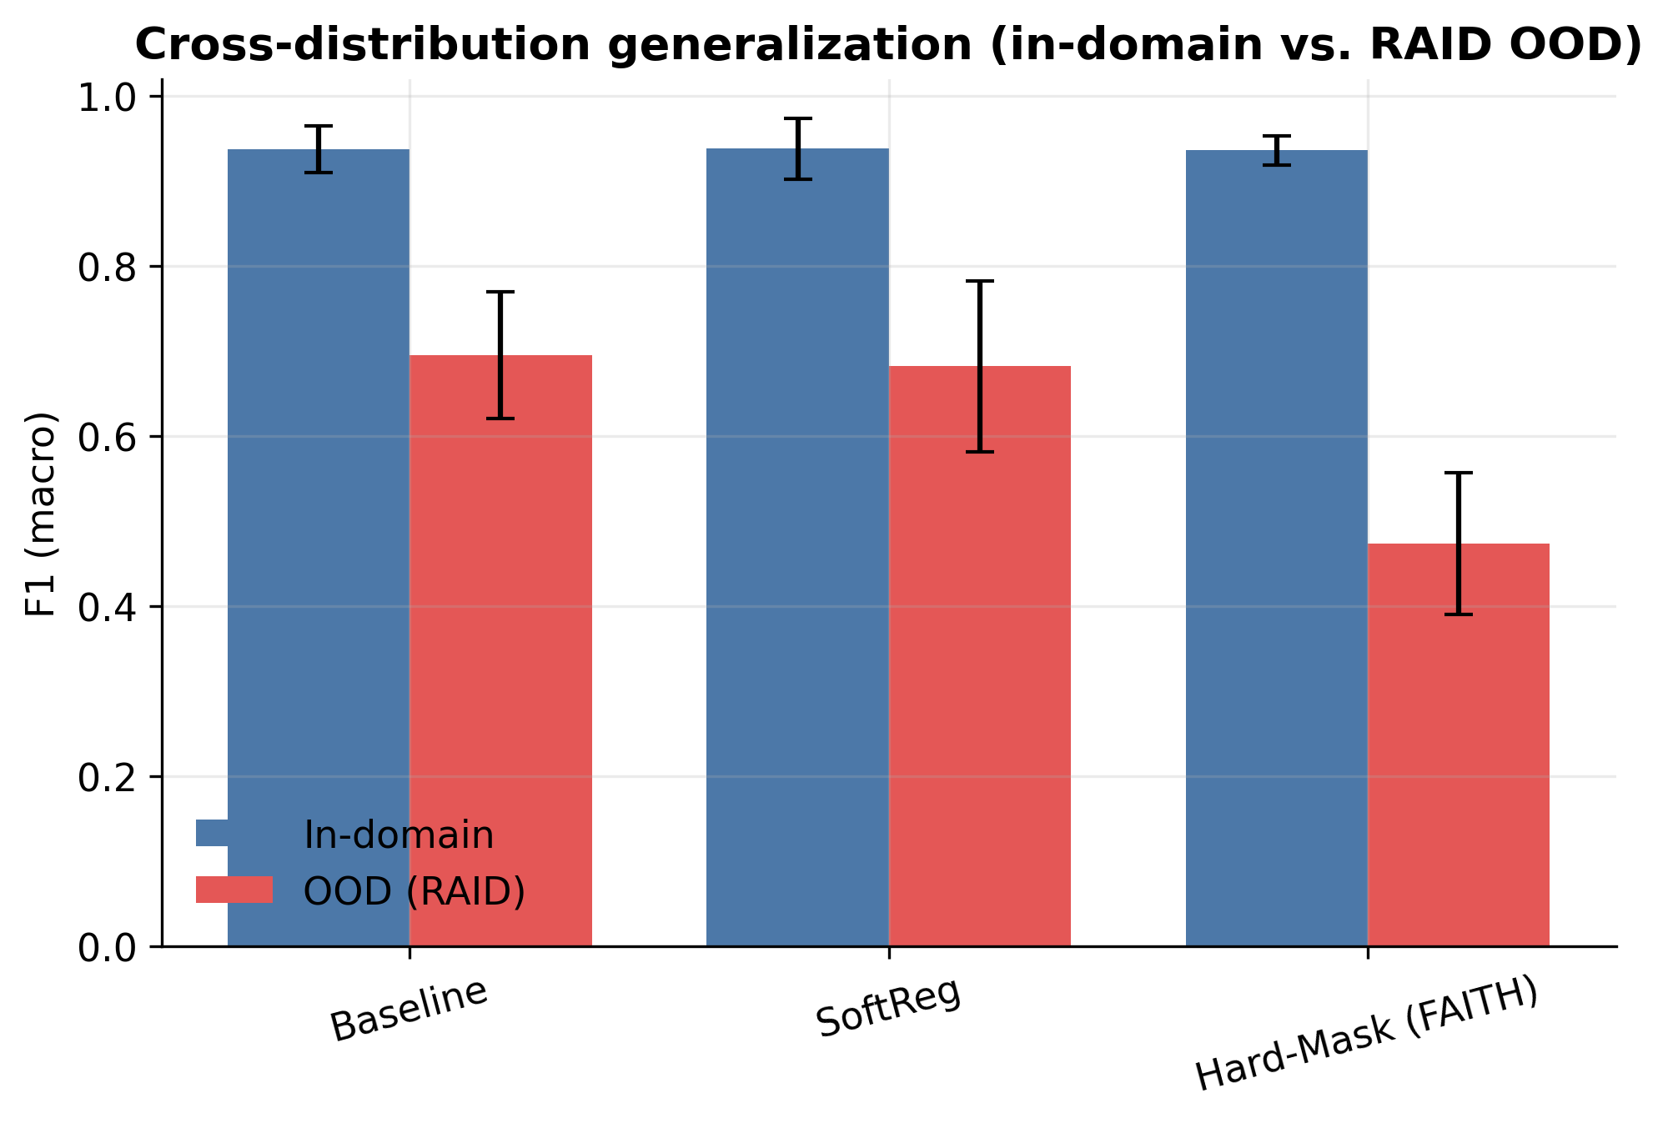
Figure 5: In-domain vs. cross-domain OOD F1 by variant.
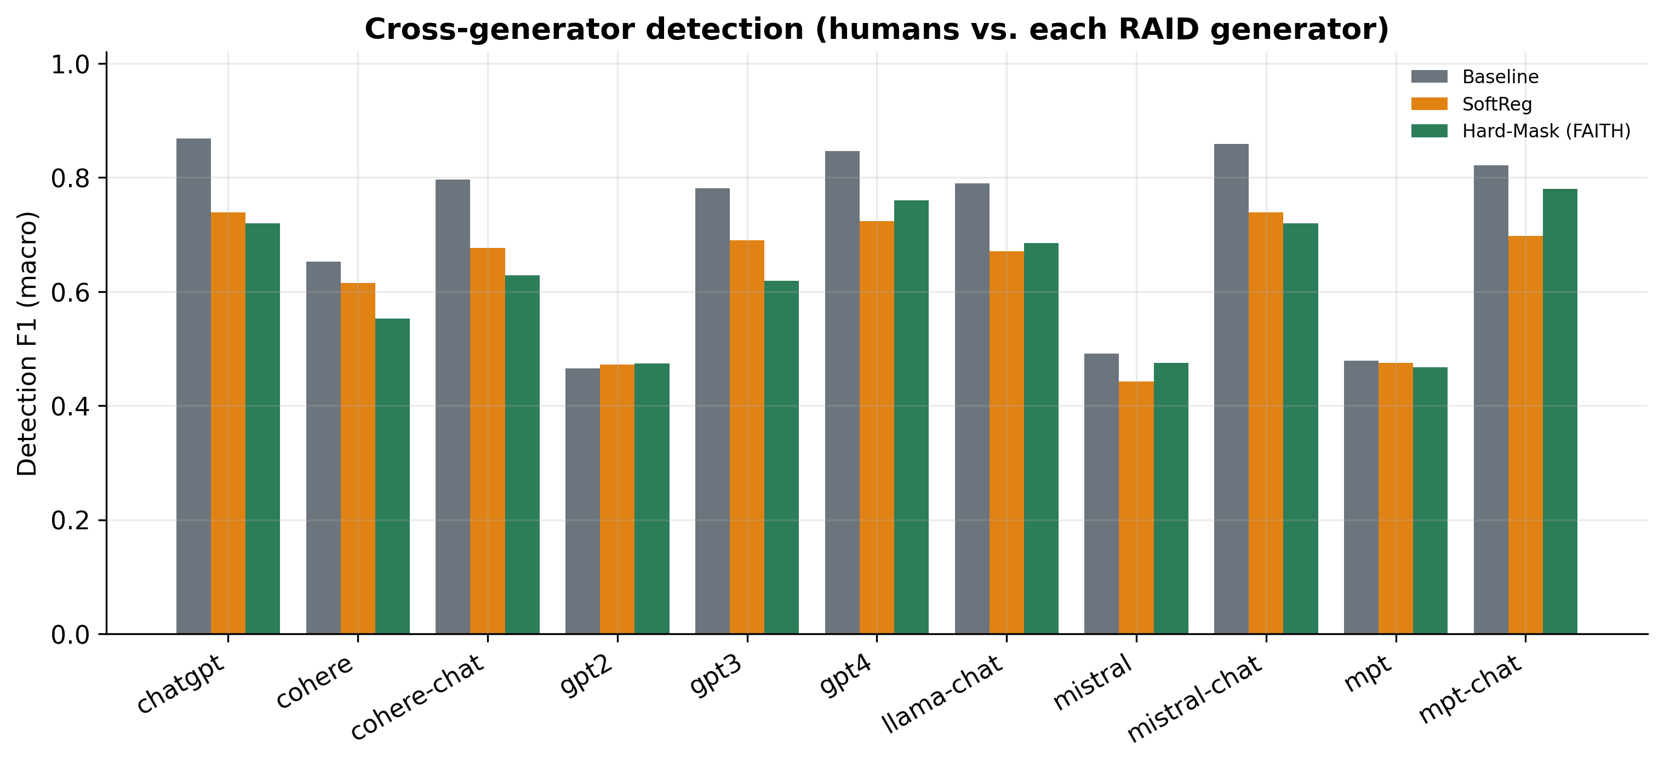
Figure 6: Per-generator detection F1 on RAID reviews (humans vs. each generator).

5.5 Leakage and faithfulness
A naive random split inflates baseline F1 to 96.7% versus 93.2% under the grouped, leakage-free split — a gap that earlier work on this data did not control for. We report grouped numbers throughout.
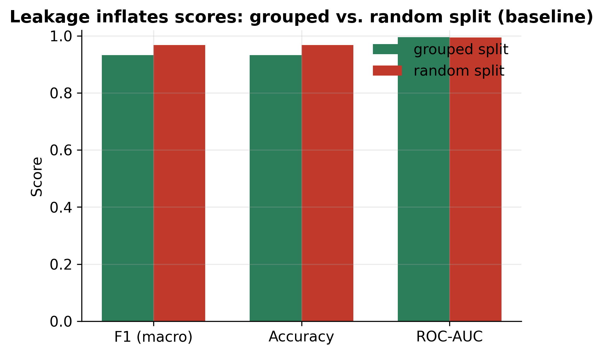
Figure 7: Random vs. grouped split (baseline): random splitting inflates scores.
Variant | Compr.↑ | Suff.↓ | Del-AUC↓ | Ins-AUC↑
Baseline | 0.100 | 0.100 | 0.895 | 0.891
SoftReg | 0.047 | 0.054 | 0.900 | 0.904
Hard-Mask (FAITH) | 0.029 | -0.000 | 0.929 | 0.972
Faithfulness is comparable across variants and mixed in direction; Hard-Mask is strongest on sufficiency and insertion. The headline explanation result is qualitative and structural: explanations are content-only by construction (Figure 8), replacing the fabricated illustrations of prior work.
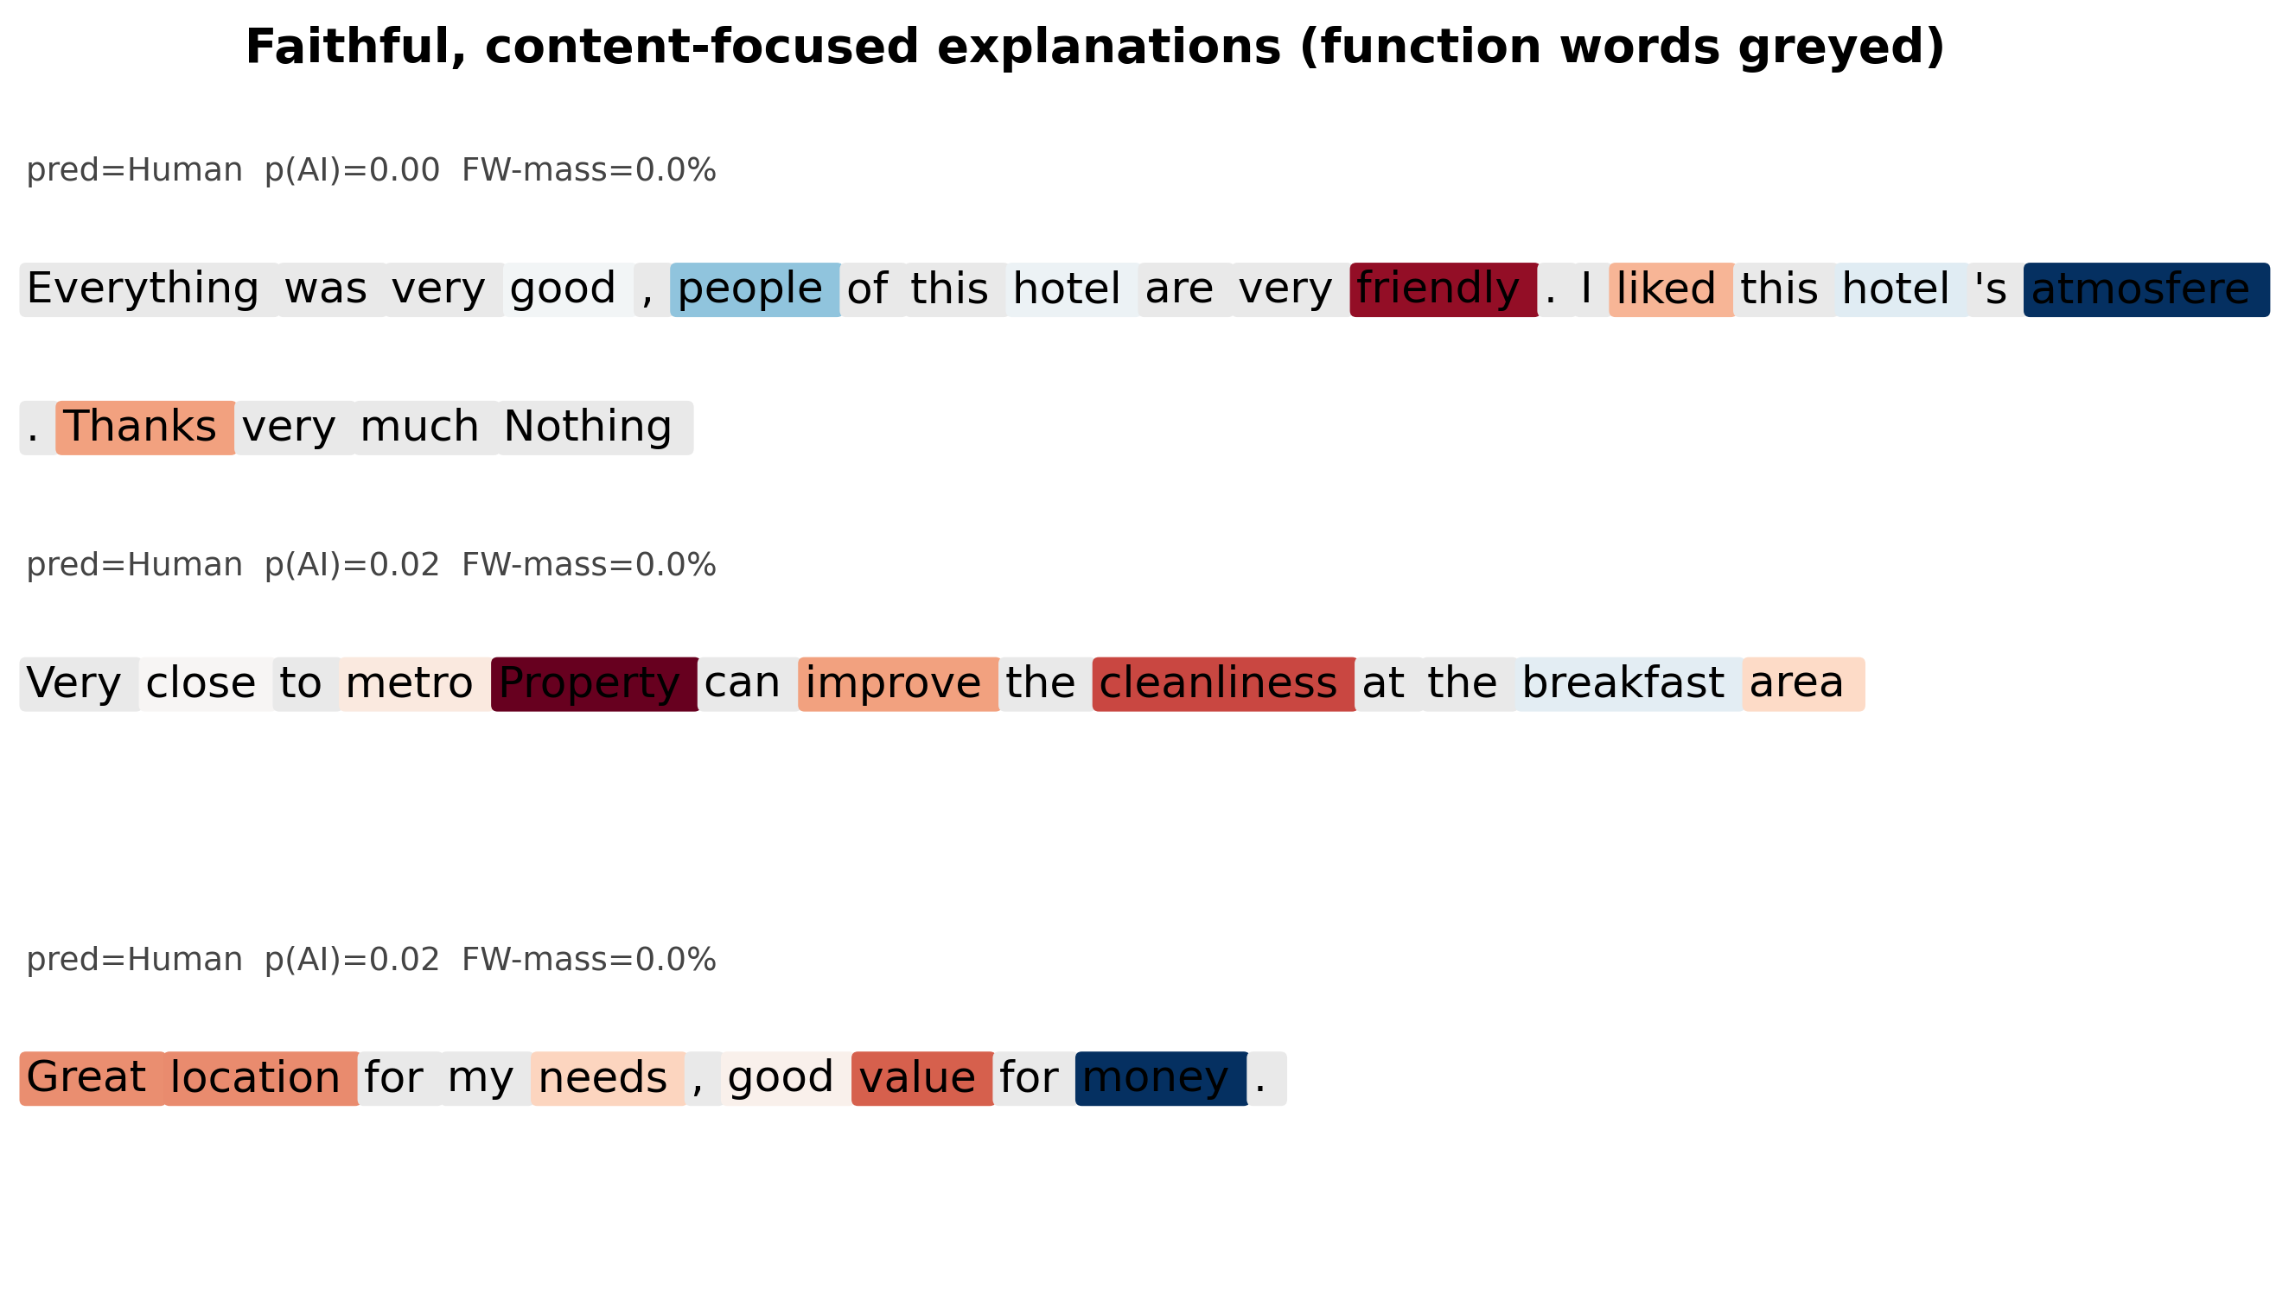
Figure 8: Real, content-focused explanations; function words are greyed out.

6 Discussion
Our results give a nuanced answer to the motivating question. Making a detector ignore function words is free in-distribution, yields a provable invariance and the best robustness to text attacks, and produces explanations that are content-only by construction — a direct remedy to post-hoc, surrogate-based, or fabricated explanations. The cost is cross-domain transfer: when the content vocabulary changes, function-word and stylistic regularities that the constrained model discards turn out to carry domain-general signal. Practically, hard masking is attractive where robustness, auditability and a guarantee matter and the domain is fixed; the unconstrained or soft model is preferable for open-domain transfer. Limitations: English only; a single in-domain generator (GPT-4), so cross-generator evidence comes from a benchmark that also shifts domain; and a modest in-domain set. Isolating cross-generator transfer within a single domain is the clearest next step.

7 Conclusion
Function words are a measurable shortcut in AI-text detection. A detector that provably ignores them keeps in-domain accuracy, gains robustness, and explains itself with content alone — at a characterised cost to cross-domain transfer. We release code, leakage-free protocols, multi-seed results with confidence intervals, and figures that regenerate from a single results file.

Reproducibility
All numbers come from a single results JSON; every figure regenerates via scripts/make_figures.py; the hard-masking guarantee is asserted by tests/test_invariance.py. Code: github.com/scar09-22/FAITH-Detect.

References
[1] Ignat, O., Xu, X., Mihalcea, R. (2025). MAiDE-up: Multilingual Deception Detection of AI-Generated Hotel Reviews. Findings of NAACL.
[2] Dugan, L., et al. (2024). RAID: A Shared Benchmark for Robust Evaluation of Machine-Generated Text Detectors. ACL.
[3] Sundararajan, M., Taly, A., Yan, Q. (2017). Axiomatic Attribution for Deep Networks (Integrated Gradients). ICML.
[4] DeYoung, J., et al. (2020). ERASER: A Benchmark to Evaluate Rationalized NLP Models. ACL.
[5] Ross, A. S., Hughes, M. C., Doshi-Velez, F. (2017). Right for the Right Reasons. IJCAI.
[6] Mitchell, E., et al. (2023). DetectGPT: Zero-Shot Machine-Generated Text Detection. ICML.
[7] Gehrmann, S., Strobelt, H., Rush, A. (2019). GLTR: Statistical Detection and Visualization of Generated Text. ACL (demo).
[8] Petsiuk, V., Das, A., Saenko, K. (2018). RISE: Randomized Input Sampling for Explanation. BMVC.
[9] Geirhos, R., et al. (2020). Shortcut Learning in Deep Neural Networks. Nature Machine Intelligence.
[10] Liu, Y., et al. (2019). RoBERTa: A Robustly Optimized BERT Pretraining Approach. arXiv.

