**Banana Ripeness Identification and Classification using Hybrid models with RESNET-50, VGG-16 and Machine Learning Techniques.**

Milan Bins Mathew1, Surya Manjunathan G2, Gokul B3, Mohana Ganesh G4

1 Vellore Institute of Technology, Chennai 600127, India.

2 Vellore Institute of Technology, Chennai 600127, India.

3 Vellore Institute of Technology, Chennai 600127, India.

4 Vellore Institute of Technology, Chennai 600127, India.

**Abstract**

Bananas are one of the most consumed fruits in the world with a very short shelf life. For any fruit or vegetable consumers consider the ripeness of the item as one of the major indicators of its price and quality. Similarly, for bananas, the quality of the fruit is strongly associated with its ripeness and is a matter of concern for consumers, producers and traders of this fruit. This is because the ripeness of a fruit is associated with its taste, texture, and edibility which is important for any food. A manual method of classifying the bananas based on their ripeness is a tedious and impractical technique. This study aims to use modern day computer vision technologies to automatically identify and classify bananas based on their ripeness. The research aims to use a hybrid model that uses deep learning models like VGG16 and ResNet50 for feature extraction and a machine learning classifier to classify the banana based on its ripeness. The bananas will be classified into 4 categories - ripe, mid-ripe, overripe and underripe. The results are compared with other machine learning classifiers and another deep learning model used for feature extraction. The results reveal that the proposed system has a better overall recognition rate than the other techniques discussed.

**Keywords:** Deep Learning, Banana Ripeness Classification, Neural Network Models, Machine Learning Techniques.

1. **Introduction**

Bananas are one of the world's most widely consumed fruits. Having been cultivated for over 10000 years, bananas are highly nutritious and are considered as an energy supplement during athletic events and sometimes even in medical emergencies. Well over 150 Million Tons of Bananas are produced each year across the globe and India leads the list with an estimated annual production of 30 Million Tons. But off these massive volumes of bananas produced yearly an estimated 1.5 Million Bananas are thrown away everyday due to mismanagement of the product leading to an unnecessary wastage. A major problem faced by the industry is the mixing up of bananas of different ripeness together. Bananas are usually harvested when fully mature but still green. This is done so as to accommodate the factors of transportation from the plantations to the market and weather. Bananas are consumed in various forms (direct, juiced, dried, powdered, processed foods etc.). Based on the final utilization of the fruit the ripeness also varies and is hence, utmost important to the food industry. Even today the commonly used technique to sort the bananas is to manually do it with humans which is done based on an experimental judgment. This is highly error prone, expensive and inefficient.

 This is the problem that we will be trying to address here. Our vision is to use a Computer Vision enabled robot to do the sorting of the bananas as they arrive at the warehouses. This enables the entire process to be more streamlined, accurate and reliable. We will be focussing on the software end of this plan now. The proposed approach is to use Pretrained Deep Learning Models VGG16 and ResNet50 for feature extraction. The models will be intialized with weights based on the ImageNet. The last fully connected layers of ResNet50 and VGG16 which act as classifiers are disabled and the output from the final block of the last convolutional layer is stored which are the extracted feature vectors. The extracted features are then fed to the machine learning classifiers like SVM, KNN, Logistic Regression, Naive Bayes to classify the bananas based on their ripeness level taken into 4 categories (ripe, unripe, overripe and mid-ripe). The performance of each Machine Learning model is compared based on metrics like accuracy, R-Squared, Mean Squared error, Mean absolute error, Precision, and we found that the VGG16+Logistic regression classifier model performed consistently with better accuracy and least error compared to other models.

1. **Dataset Description**

The images in our dataset are collected by Fayoum University for their research on banana color pigment. So, this dataset contains 350 images with 4 different class labels (ripe, unripe, overripe and mid-ripe). Each class has 90-120 images.

For implementing this project, we are considering 300 training images and 50 testing images.



This is one example of the format in which our images are stored in respective folders. Some sample images in the dataset can be seen in Figures 1, 2, 3, and 4 below.

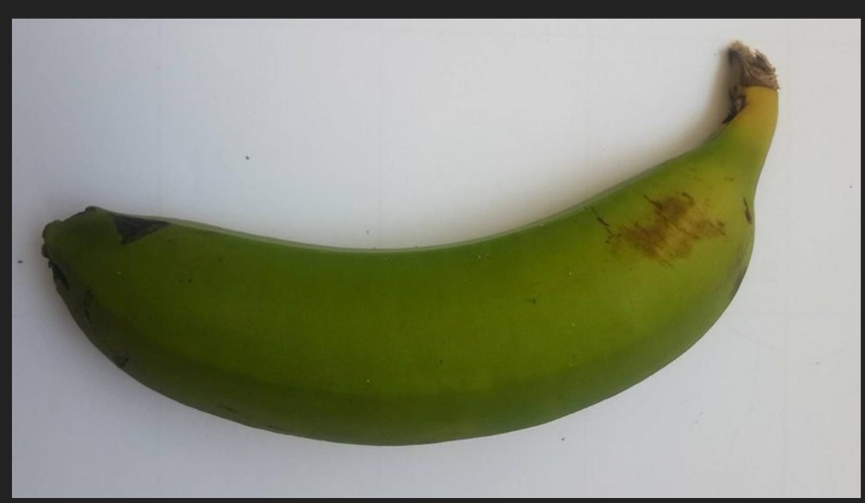

**Fig.1** Green Banana.

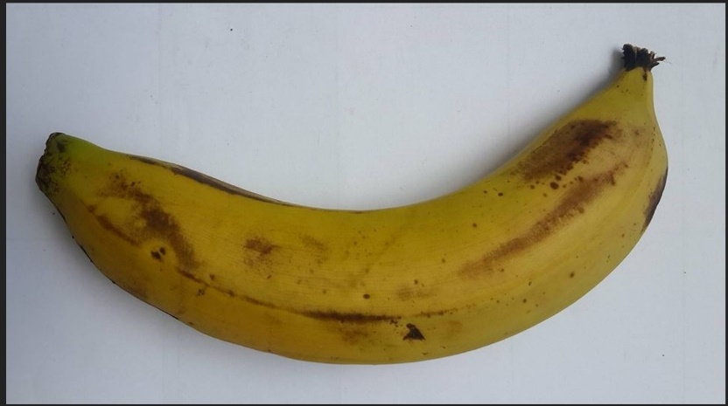

**Fig.2** Midripe Banana.

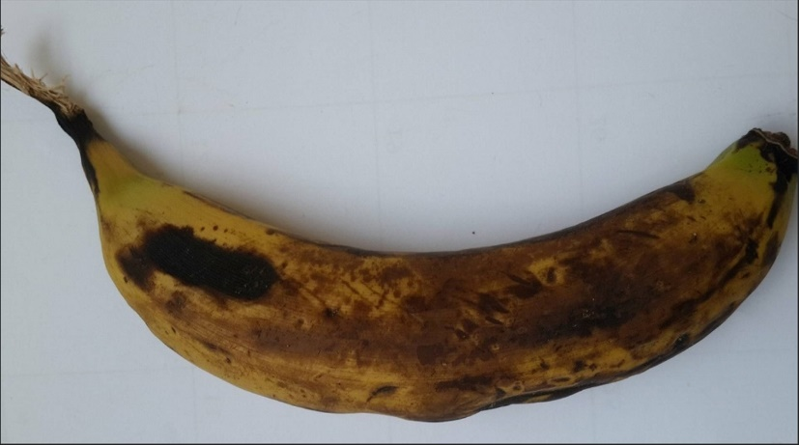

**Fig.3** Overripe Banana.

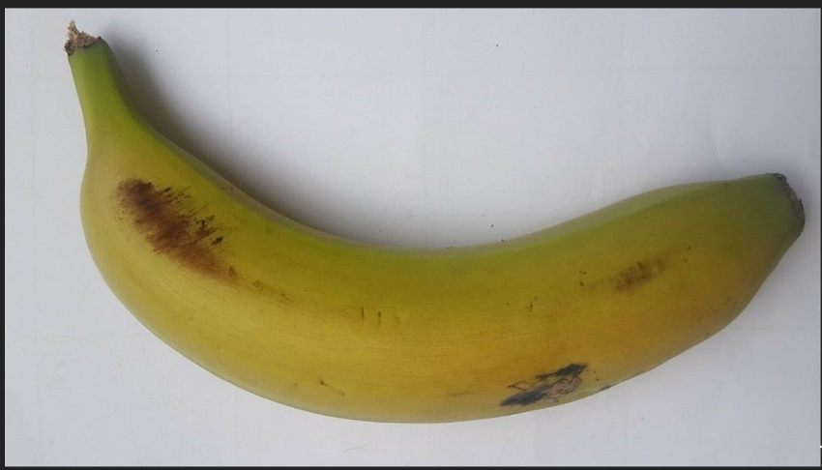

**Fig.4** Yellowish-Green Banana.

1. **Literature Survey**

Bananas are rich in potassium Vitamins K and B6, fiber, tryptophan and amino acids [1]. Proper management of the fruit is highly essential and the problem is also seen in other fruits and vegetables as well.

 Fadilah et.al [2], proposed an Artificial Neural Network (ANN) model for classifying oil palm fruit bunches according to their ripeness. The Multi-Layer Perceptron model which is a 3-layer ANN model which was used in the study. The images are segmented using K-means clustering and the RGB segmented images are converted to HSI colour model to extract Hue values. It was reported that the proposed model had a highest accuracy of 86.67%. El-Bendary et.al [3] suggested machine learning techniques for evaluating the ripeness of maturity. The techniques used for classification were Support Vector Machine (SVM) and Linear Discriminant Analysis (LDA) and for feature extraction Principle Component Analysis (PCA) is used. They were able to classify the fruit with an accuracy of 84%. Mazen et.al [4] proposed another Artificial Neural Network model for classifying bananas based on their ripeness. The model is classified based on HSV and CIELAB characteristics, development of brown spots and Tamura texture feature. Levenberg–Marquardt backpropagation optimization algorithm is used for training the suggested artificial neural network. Sensitivity and Precision are used as performance metrics and the final results suggested that the proposed model had a correctness percentage of 97. Sidehabi et.al. [5], proposed a technique to classify passion fruit’s ripeness using K-Means Clustering and Artificial Neural Network. The fruit was to be distinguished into 3 classes namely ripe, nearly ripe and unripe stage. The proposed model first applies clustering using K-Means algorithm and then after extracting the features with RGB extraction it is then passed to the ANN that has 2 hidden layers and trained for 1000 epochs. The model attained 90% accuracy on the dataset used. Adebayo et.al [6] suggested classifying bananas based on their optical properties. The main objective of this research paper is to predict the banana quality attributes like chlorophyll, elasticity and soluble solids content(SSC) The next objective is to classify the bananas based on ripening stages into 4 classes of different colours like fully green(unripe), green with some yellow, yellow with some green and fully yellow (ripe) For banana quality attribute prediction and classification Artificial Neural Network is used.  The above-mentioned studies have achieved such high accuracies given the condition that they use additionally extracted features through different techniques and experimental setups. The study we propose has no condition and the model itself learns the parameters required from the stock images to perform the classification to enforce true Deep Learning capabilities. Hasnida Saad et.al [7] in their paper titled “Recognizing the Ripeness of Bananas using Artificial Neural Network based on Histogram Approach.”  The main objective of the study was to develop a technique to classify the ripeness of bananas into 3 categories and this was achieved through an analysis of the histogram RGB values components of the images. The dataset was composed of 60 images and achieved an accuracy of 89.2%. Zhang et.al [8] proposed a Convolutional Neural Network (CNN) model [9], one of the first to use it for the purpose of banana ripeness classification. CNN models have been used for a variety of image classification problems in various fields such as medicine [10], road safety [11], food and agriculture [12, 13] etc. The method used a four-layer model (three convolutional and one dense layer). In [14], Velezrivera et.al. used computer vision technique to classify manila mangoes during the ripening process. The used techniques that also took into account the biochemical characteristics for its classification. The color spaces applied in product classification are the standard RGB (sRGB) and CIELAB. sRGB can be obtained rapidly using computer vision systems. The percentage of correctness after classification was observed to be 90%. Santi Kumari Behera [15] proposed a model to design an automation system in the fruit Industry using machine learning and deep learning techniques like ANN, CNN, SVM and random forest with adequate concepts of image processing needed to be used to provide intelligence for the automation system to classify the fruits according to its type, variety, maturity and intactness. SVM with texture features and K-means clustering outperformed other models. K. Srinivasan [16] defined a CNN model with 11 convolutional layers to classify the bananas based on 4 ripeness levels and compare the performance with pre-trained models like ResNet and VGG16. They also performed data augmentation which is carried out to increase the dataset size and distribution. It duplicates the image by shifting, flipping, rotating, brightening and zooming in and out the training images. After evaluation it was clear that the proposed model performed well with better accuracy. Moreover, for Hass Avocados ripeness classification, Melado-Herreros et.al. [17], the authors proposed an automated classification system based on Fisher’s Linear Discriminant Analysis and K-means algorithms. The RGB colour space has been used and the proposed system applied some filters to minimize noises. Then, an image segmentation step was applied, using Fisher’s Linear Discriminant Analysis algorithm, to separate Avocado fruit from background. Finally, K-means grouping technique was employed, in order to classify Avocados into very mature avocados from mature and green avocados categories, based on pixel percentage. The proposed system achieved an accuracy of 87.85%. A system based on an artificial neural network (ANN) with image processing approach for colour recognition has been designed in [18] by Paulraj et.al., for identifying the ripeness stage of bananas. The proposed system depended on RGB color components of the captured images of bananas. It used four sets of bananas with different sizes and ripeness stages. Each image of the banana was captured in four different positions and the images were captured daily until all bananas turned to be rotten. The proposed research used a supervised Neural Network model utilizing the error back propagation model. It achieved an identification accuracy of 96%. The rest of the paper discusses our novel approach to solving this problem and is organized as follows. In Section 4, we present the details of the materials we used and our approach. Section 5 contains our experimental results and discussions. In Section 8, we provide our conclusion and vision for the future.

1. **Techniques Employed**

In our proposed work we classify the bananas based on their ripeness stages by first performing feature extraction using pre-trained neural network models and those extracted features are fed to machine learning classifiers to classify the images. Then we carry out the comparative study of performance of 2 different models for feature extraction namely Resnet, VGG16. The machine learning classifiers used in this project are KNN, Naive Bayes, Logistics regression, SVM. The proposed model can be seen in Fig.5

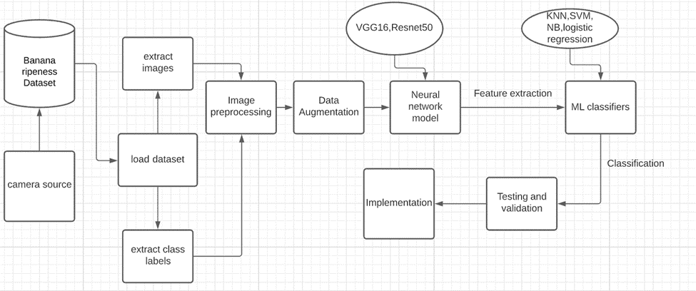

**Fig.5** Proposed Model

First, we carried out data pre-processing by extracting the image and the class labels and storing them into a data frame. The images are reshaped to (200,200) size which fits well with the ResNet50 and VGG16 model’s input layer. We convert the images to RGB format so as to visualize them easily. In data augmentation we did some operations like shearing, zooming, flipping on the images and generating images of batch size 32.

**4.1     VGG-16**

VGG-16 is a deep convolutional neural network model first proposed by Simonyan and Zisserman [19]. It was one of the major advancements since AlexNet and was better than AlexNet by replacing the large kernel-sized filters with multiple 3x3 kernel-sized filters. The architecture of VGG-16 is given in Fig.6.

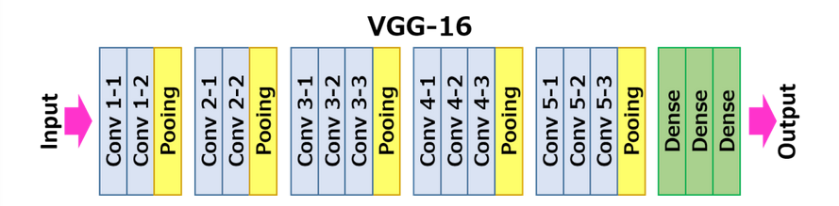

**Fig.6** VGG-16 Architecture.

**4.2     RESNET-50**

ResNet or Residual Network was first introduced by Kaiming et.al [20]. ResNet-50 is a residual network model with 50 layers. A major innovation of the ResNet-50 when compared to other models was the use of skip connection i.e., The input of the previous layers is also given as input to the consecutive layer along with the output of the predecessor. Fig.3 represents the resnet-50 architecture.

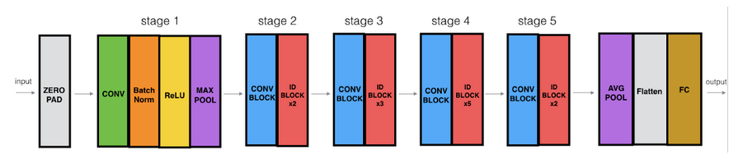

**Fig.7** ResNet-50 Model

**4.3    Naïve Bayes**

Naive Bayes (NB) is a supervised machine learning classifier based on the Bayes’ theorem with the ‘naive’ assumption that any two features are always conditionally independent. It is called naive because this is not a very practical assumption as most of the datasets do not have entirely conditionally independent features. The formula of Bayes Theorem is given in equation (1).

*Posterior = Prior * Likelihood / Evidence*         (1)

**4.4    K-Nearest Neighbor**

K-Nearest Neighbor or KNN is a supervised machine learning technique that classifies based on the number of data points of a particular category that satisfies the given ‘k’ values required. KNN is a non-parametric classifier. The distance is calculated using distance functions such as Euclidean distance, Manhattan distance, and Minkowski distance. We use Euclidean Distance for our given problem. The formula for Euclidean Distance is given in equation (2), where x and y represent the cartesian coordinates of the data points.

*d (X, Y) = $\sqrt[2]{\sum_{i=1}^{k}{{(x_{i}-y_{i})}^{2}}}$*  (2)

**4.5    Support Vector Machine**

Support Vector Machine or SVM is a very popular and commonly used ML technique that has numerous uses in the field of classification, photonics, pattern recognition etc. SVM solves problems by mapping the training examples to points in space so as to maximize the width of the gap between any two different categories. Though initially developed for binary classification, SVM can now also efficiently perform multiclass-classification. Equation (3) is the function of the Linear SVM model.

$f\left(x\right)=\sum_{i=0}^{N}{α_{i}y_{i}x_{i}^{T}}*x+β_{0}$                (3)

**4.6    Logistic Regression**

Logistic regression, despite its name, is a classification model rather than a regression model. Logistic regression is a simple and more efficient method for binary and linear classification problems. It is a classification model, which is very easy to realize and achieves very good performance with linearly separable classes. It is an extensively employed algorithm for classification in industry. The logistic regression model, like the Adaline and perceptron, is a statistical method for binary classification that can be generalized to multiclass classification. The formula used in Logistic Regression is given in Equation (4).

$\ln\left(P/{1-P}\right)= β_{0}+β_{1}x$        (4)

1. **Results**

The dataset has been split in the ratio 1:4 for validation and training respectively. This results in around 50 images for validation and 300 images for training. The results of the model have been evaluated using various performance metrics which have been given below. The evaluation is based on the validation dataset.

**5.1   Accuracy**

Accuracy is a commonly used performance metric that represents the fraction of the predictions that have been correctly classified by a model. Thus, accuracy can be mathematically represented as given in equation (5).

Accuracy = $\frac{Number of Correct Predictions}{Total Number of Predictions}$      (5)

**Table 1.** Accuracy of the Models.

|  |  |  |
| --- | --- | --- |
| Machine Learning classifiers/ Pre-Trained Neural Network models | ResNet-50 | VGG-16 |
| KNN | 85.45 | 76.3 |
| Naive Bayes | 87.27 | 80 |
| SVM | 90.9 | 87.2 |
| Logistic Regression | 89.09 | 90.9 |

**5.2   R-Squared**

R- Squared (R2) is a statistical measure that represents the proportion of the variance in a dependent variable that can be explained by the independent variable. R- It ranges between 0 and 1. The formula for computing R-Squared value is given in equation (6).

$R^{2}=1- \frac{Unexplained Variation}{Total Variation}$        (6)

**Table 2.** R-Squared score of the models.

|  |  |  |
| --- | --- | --- |
| Machine Learning classifiers/ Pre  Trained Neural Network models | ResNet-50 | VGG-16 |
| KNN | 0.34 | 0.146 |
| Naive Bayes | 0.48 | 0.326 |
| SVM | 0.68 | 0.534 |
| Logistic Regression | 0.62 | 0.731 |

**5.3    Mean Squared Error**

Mean Squared Error or MSE of an estimator measures the average of the squares of errors. That is the average squared difference between the actual values and predicted values. It can be mathematically represented as in equation (7)

$MSE= \frac{1}{n}\sum_{i=1}^{N}{{\left(y_{i}-{\hat{y}}_{i}\right)}^{2}}$                (7)

**Table 3.** Mean Squared Error of the Models.

|  |  |  |
| --- | --- | --- |
| Machine Learning classifiers/ Pre Trained Neural Network models | ResNet-50 | VGG-16 |
| KNN | 0.763 | 1 |
| Naive Bayes | 0.6 | 0.78 |
| SVM | 0.363 | 0.545 |
| Logistic Regression | 0.43 | 0.309 |

**5.4    Mean Absolute Error**

Mean Absolute Error (MAE) is defined as the average of the difference between actual values and predicted values. This prevents equal values with opposite signs from cancelling each other out. The formula for Mean Absolute Error is given in equation (8).

$MAE= \frac{\sum_{i=1}^{N}{\left|y_{i}-x_{i}\right|}}{n}$            (8)

**Table 4.** Mean Absolute Errors of the Models.

|  |  |  |
| --- | --- | --- |
| Machine Learning classifiers/ Pre Trained Neural Network models | ResNet-50 | VGG-16 |
| KNN | 0.254 | 0.454 |
| Naive Bayes | 0.272 | 0.381 |
| SVM | 0.181 | 0.254 |
| Logistic Regression | 0.218 | 0.163 |

**5.5   PRECISION**

Precision gives us information regarding the proportions of the positive identifications that were actually true. It can be represented as given in equation (9)

Precision = $\frac{True Positive}{True Positive+False Positive}$     (9)

**Table 5.** Precision of the Models.

|  |  |  |
| --- | --- | --- |
| Machine Learning classifiers/ Pre Trained Neural Network models | ResNet-50 | VGG-16 |
| KNN | 0.851 | 0.751 |
| Naive Bayes | 0.872 | 0.825 |
| SVM | 0.914 | 0.861 |
| Logistic Regression | 0.894 | 0.899 |

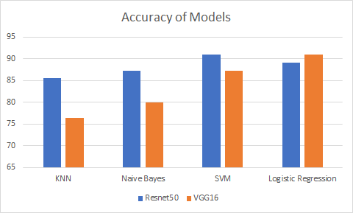

**Fig.8** Accuracy of different models.

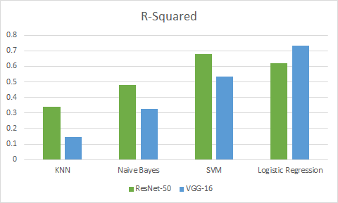

**Fig.9** R-Squared values of different models.

**5.6    Comparative Results**

We will now compare our results with some other previously done work. The comparative study will be conducted with the artificial neural network model based on histogram approach [7], the CNN model in [23] and the ANN model as proposed by Cho and Koeski [24]. The accuracy of the different models can be seen in Table.6.

**Table.6** Comparative Accuracy of Different Models.

|  |  |  |  |
| --- | --- | --- | --- |
| BanNet | ANN + Histogram [7] | CNN [23] | ANN [24] |
| 90.9% | 89.2% | 76% | 79.55% |

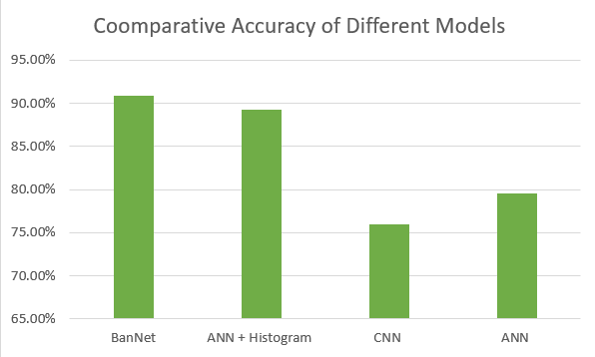

**Fig.10** Comparative Accuracy of Different Models.

From Table 1 it can be clearly seen that the accuracies of the models, ResNet + SVM and VGG + Logistic Regression, are highest with both attaining a maximum accuracy of 90.9%, we can infer this also from Figure 4 . But the R-Squared score of the VGG model is higher than that of the ResNet model as seen in Figure 5. Similarly, from Tables 3 and 4 which contain records regarding the Mean Squared Error and Mean Absolute Error respectively, we can conclude that the VGG + Logistic Regression Model has consistently outperformed all its competitor models. In the Precision table (Table 5) it is seen that the ResNet-50 + SVM model slightly performs better than other models. A graphical visualization of the comparison of all models with respect to Accuracy and R-Squared scores can be seen in Figures 4 and 5 respectively.  From our comparative study and its results as tabulated in Table 6 we can clearly see the superiority of our proposed BanNET model. The same can also be inferred from the graphical visualization of the results in Figure 6.

**5.7    Predictions**

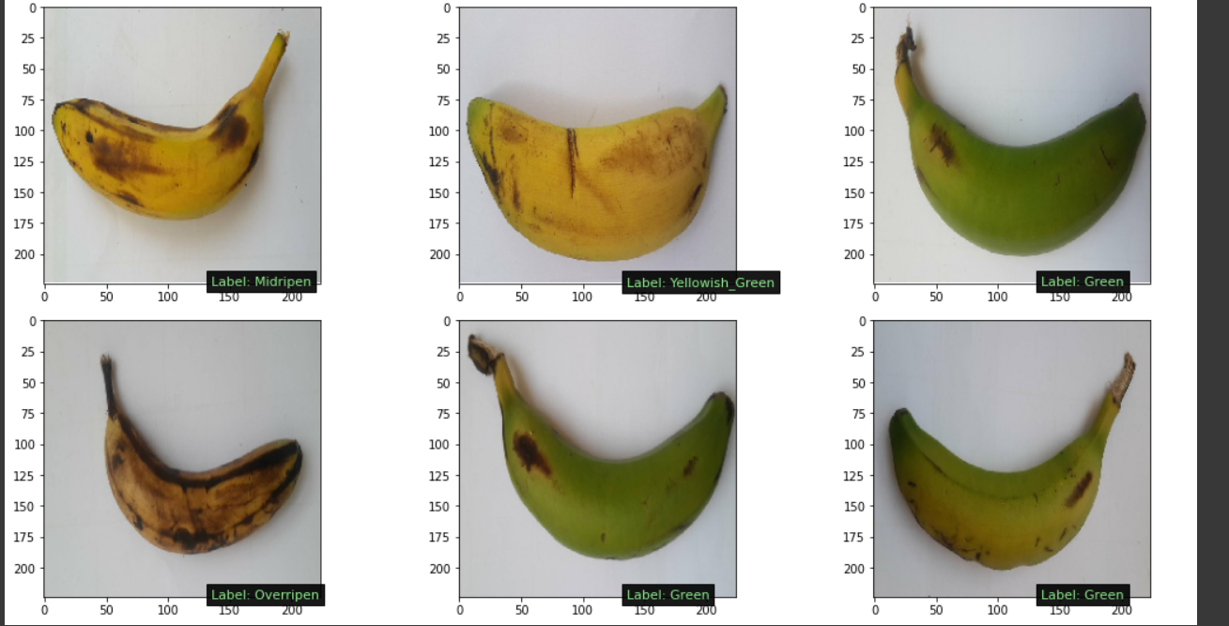

**Fig.11** Predicted Images of the Model with label.

From the Figure -11 we can infer that our proposed model classified the bananas correctly based on their ripeness stages.

1. **Compliance with Ethical Standards**

**Conflict of Interest** The authors declare no conflict of interest.

**Ethical Approval** This article does not contain any studies with human participants performed by any of the authors. This article does not contain any studies with animals performed by any of the authors. This article does not contain any studies with human participants or animals performed by any of the authors.

1. **Conclusion**

With the incredibly powerful deep learning techniques and well refined machine learning techniques hybrid models are one of the most important and dignified as one of the developing research zones. A powerful computer vision system is a key goal to truly achieving Industry 4.0 and other sustainable development goals.

We have considered two of the most powerful convolutional neural network models (Resnet-50 and the VGG-16) and machine learning models (SVM, Logistic Regression, NB, and KNN). After evaluating with different performance metrics such as MAE, R-Squared, Accuracy, Precision and MSE we can conclude with sufficient evidence that the VGG-16 combined with Logistic Regression is the ideal model for the given problem and can be explored for various other similar problems as well.

For future works, a live feed classifier that can be deployed to robot systems can be considered, so that real-time classification can be performed. Furthermore, multiple object detection and sub-classification can be explored by using short-term memory cells as well.

1. **References**

1. Sampson, H.A., Aceves, S., Bock, S., A, James, J., Jones, S., Lang, D., Nowak-Wegrzyn, A., Oppenheimer, J., Perry, T.T., 2014. *Food allergy: a practice parameter update—2014. J. Allergy Clin. Immunol. 134 (5), 1016–1025.*
2. Fadilah, Norasyikin; Saleh, Junita Mohamad; Ibrahim, Haidi; Halim, Zaini Abdul (2012). *[IEEE 2012 4th International Conference on Intelligent & Advanced Systems (ICIAS) - Kuala Lumpur, Malaysia (2012.06.12-2012.06.14)] 2012 4th International Conference on Intelligent and Advanced Systems (ICIAS2012) - Oil palm fresh fruit bunch ripeness classification using artificial neural network.*
3. El-Bendary, Nashwa; El Hariri, Esraa; Hassanien, Aboul Ella; Badr, Amr (2015). *Using machine learning techniques for evaluating tomato ripeness. Expert Systems with Applications, 42(4), 1892–1905.*
4. Mazen, Fatma M. A.; Nashat, Ahmed A.  (2019)*. Ripeness Classification of Bananas Using an Artificial Neural Network. Arabian Journal for Science and Engineering.*
5. Sidehabi, Sitti Wetenriajeng; Suyuti, Ansar; Areni, Intan Sari; Nurtanio, Ingrid (2018). *[IEEE 2018 International Conference on Information and Communications Technology (ICOIACT) - Yogyakarta, Indonesia (2018.3.6-2018.3.7)] 2018 International Conference on Information and Communications Technology (ICOIACT) - Classification on passion fruit's ripeness using K-means clustering and artificial neural network.*
6. Adebayo, Segun Emmanuel; Hashim, Norhashila; Abdan, Khalina; Hanafi, Marsyita; Mollazade, Kaveh (2016). *Prediction of quality attributes and ripeness classification of bananas using optical properties. Scientia Horticulturae.*
7. Saad, Hasnida; Ahmad Puad Ismail, ; Noriza Othman, ; Mohamad Huzaimy Jusoh, ; Nani fadzlina Naim, ; Nur Azam Ahmad, (2009). *[IEEE 2009 IEEE International Conference on Signal and Image Processing Applications - Kuala Lumpur, Malaysia (2009.11.18-2009.11.19)] 2009 IEEE International Conference on Signal and Image Processing Applications - Recognizing the ripeness of bananas using artificial neural network based on histogram approach. , (), 536–541.*
8. Zhang, Y., Lian, J., Fan, M., & Zheng, Y. (2018). *Deep indicator for fine-grained classification of banana’s ripening stages. EURASIP Journal on Image and Video Processing, 2018(1).*
9. Y LeCun, L Bottou, Y Bengio, P Haffner (1998). *Gradient-based learning applied to document recognition. Proc. IEEE. 86(11), 2278–2324.*
10. HH Vo, A Verma (2016). *IEEE International Symposium on Multimedia. New deep neural nets for fine-grained diabetic retinopathy recognition on hybrid color space (IEEE, Los Alamitos,), pp. 209–215.*
11. J Fang, Y Zhou, Y Yu, S Du (2016). *Fine-grained vehicle model recognition using a coarse-to-fine convolutional neural network architecture. IEEE Trans. Intell. Trans. Syst. PP(99), 1–11.*
12. N Sunderhauf, C Mccool, B Upcroft, P Tristan (2014)*. Fine-grained plant classification using convolutional neural networks for feature extraction. Proc. Congress Faons. 37(2), 123–30.*
13. K Yanai, Y Kawano (2015). *IEEE International Conference on Multimedia & Expo Workshops. Food image recognition using deep convolutional networks with pre-training and fine-tuning (IEEE, Los Alamitos), pp. 1–6.*
14. N Velezrivera, J Blasco, J Chanonaperez, G Calderondominguez (2013). *MDJ Pereaflores, I Arzatevazquez, S Cubero, RR Farrerarebollo, Computer vision system applied to classification of “manila” mangoes during ripening process. 7(4), 1183–1194.*
15. Karen Simonyan, Andrew Zisserman (2014). *Very Deep Convolutional Networks for Large-Scale Image Recognition. ILSVRC-2014.*
16. Kaiming He, Xiangyu Zhang, Shaoqing Ren, Jian Sun. *Deep Residual Learning for Image Recognition. Proceedings of the IEEE Conference on Computer Vision and Pattern Recognition (CVPR), 2016, pp. 770-778.*
17. S. Picek, A. Heuser, and S. Guilley, *“Template attack versus Bayes classifier,” Journal of Cryptographic Engineering, vol. 7, no. 4, pp. 343–351, 2017.*
18. A. Naik and L. Samant*, “Correlation review of classification algorithm using data mining tool: WEKA, rapidminer, tanagra, orange and knime,” Procedia Computer Science, vol. 85, pp. 662–668, 2016.*
19. U. R. Acharya, H. Fujita, S. Bhat et al.*, “Decision support system for fatty liver disease using GIST descriptors extracted from ultrasound images,” Information Fusion, vol. 29, pp. 32–39, 2016.*
20. E. K. Hashi, M. S. Uz Zaman, and M. R. Hasan, “An expert clinical decision support system to predict disease using classification techniques,” in *Proceedings of the ECCE 2017-International Conference on Electrical, Computer and Communication Engineering*, pp. 396–400, Cox’s Bazar, Bangladesh, February 2017.
21. S. Khan, R. Ullah, A. Khan, N. Wahab, M. Bilal, and M. Ahmed, *“Analysis of dengue infection based on Raman spectroscopy and support vector machine (SVM),” Biomedical Optics Express, vol. 7, no. 6, p. 2249, 2016.*
22. A. N. Arbain and B. Y. P. Balakrishnan, “A comparison of data mining algorithms for liver disease prediction on imbalanced data,” *International Journal of Data Science and Analytics*, vol. 1, no. 1, 2019.
23. C. Hari Priyanka, V. Shikha Rachel, B. Harshith and R. Moulisha, “*Color Recognition Algorithm using a Neural Network Model in Determining the Ripeness of a Banana*”, Journal of Engineering Sciences, vol.11 issue 6, June 2020.
24. Cho B.-H., & Koseki S. “Determination *of banana quality indices during the ripening process at different temperatures using smartphone images and an artificial neural network”. Scientia Horticulturae, 288, 110382, 2021.*