POLARIS: A Real-Time Telemetry and Spatial Orchestration Platform for Large-Scale Fleet and IoT Networks

Abstract
The rapid expansion of connected devices and mobility platforms has created significant challenges in monitoring and coordinating large-scale distributed fleets. Modern transportation, logistics, and IoT infrastructures generate continuous streams of telemetry data such as location updates, operational status, and sensor readings. However, most existing fleet management systems focus primarily on historical analytics and monitoring dashboards rather than real-time coordination.
This paper introduces Polaris, a real-time telemetry ingestion and spatial orchestration platform designed to process continuous device data streams and enable intelligent coordination of distributed fleets. Polaris emphasizes a streaming-first architecture capable of processing telemetry data in real time while supporting spatial analytics and decision-making mechanisms. The system aims to provide a scalable foundation for managing large networks of connected devices, including transportation fleets, logistics systems, and emerging IoT infrastructures.
By integrating telemetry streaming, spatial analytics, and dynamic coordination capabilities, Polaris demonstrates how modern distributed systems can enable real-time operational intelligence for next-generation mobility and IoT ecosystems.

1. Introduction
The emergence of connected transportation systems and Internet-of-Things (IoT) networks has significantly transformed the way organizations manage fleets of devices. From ride-hailing vehicles and logistics trucks to delivery drones and autonomous robots, modern systems increasingly rely on large numbers of distributed devices that continuously generate telemetry data.
Telemetry data typically includes:
- device location
- speed and movement patterns
- operational status
- sensor information
Organizations depend on this information to monitor operational performance, allocate resources efficiently, and respond to changing conditions.
However, many existing fleet management platforms are designed primarily for monitoring and historical analytics. These systems collect data from devices and store it for later analysis, resulting in delays between data generation and actionable insights.
In highly dynamic environments such as logistics networks and urban transportation systems, delays in decision-making can lead to inefficiencies including underutilized vehicles, service delays, and poor resource allocation.
To address these limitations, there is a growing need for systems capable of processing telemetry streams in real time while enabling intelligent coordination of distributed devices.
This project introduces Polaris, a real-time telemetry processing and spatial orchestration platform designed to support large-scale fleets and IoT networks. Polaris focuses on enabling continuous data ingestion, real-time spatial analysis, and dynamic coordination of devices across geographic regions.

2. Related Work
Several commercial platforms provide solutions for fleet tracking and telematics management.
Examples include:
- Samsara
- Geotab
- Verizon Connect
These systems provide functionalities such as:
- GPS-based fleet tracking
- driver behavior monitoring
- operational dashboards
- historical analytics
While these platforms offer valuable monitoring capabilities, they primarily focus on observability and reporting, rather than real-time orchestration.
Large ride-hailing companies such as Uber and Lyft employ sophisticated dispatch systems that allocate drivers to passenger requests using location-based algorithms. However, these systems are proprietary and tightly integrated into their internal infrastructure. They are not designed as general-purpose platforms for coordinating arbitrary fleets or IoT devices.
Recent research in distributed systems and stream-processing technologies has demonstrated the potential of real-time data processing frameworks for handling high-velocity data streams. These systems enable continuous processing pipelines capable of supporting large-scale event-driven architectures.
Polaris builds upon these ideas by integrating telemetry streaming with spatial analytics to enable dynamic coordination of distributed device networks.

3. Problem Statement
Modern fleet operations face several challenges due to the increasing scale and complexity of device networks.
3.1 Delayed Analytics
Many fleet management systems rely on batch-oriented data pipelines where telemetry data is stored before being analyzed. This approach introduces delays between data generation and operational insight.
For example, fleet managers may only discover inefficiencies such as idle vehicles or traffic congestion after significant delays.

3.2 Inefficient Fleet Coordination
Without real-time analytics, it becomes difficult to dynamically allocate vehicles or devices based on current demand conditions. This can lead to inefficient fleet utilization and increased operational costs.

3.3 Scalability Challenges
The number of connected devices continues to grow rapidly with the adoption of IoT technologies. Systems must be capable of handling telemetry streams from thousands or even millions of devices simultaneously.
Traditional analytics systems often struggle to scale to these levels while maintaining low latency.

4. Proposed System: Polaris
Polaris is designed as a real-time telemetry processing and spatial orchestration platform that enables organizations to monitor and coordinate distributed device networks efficiently.
The system provides three core capabilities:

4.1 Real-Time Telemetry Ingestion
Polaris collects telemetry data from distributed devices such as vehicles, sensors, or drones. These data streams are processed continuously as they are generated.
Examples of telemetry data include:
- GPS location updates
- velocity and movement patterns
- device health status
- sensor measurements
By processing this data in real time, the system provides up-to-date operational visibility.

4.2 Spatial Analytics
Polaris performs spatial analysis on device telemetry to understand how devices are distributed across geographic regions.
Spatial analytics enables the system to answer questions such as:
- Which vehicles are closest to a service request?
- Which regions have insufficient fleet coverage?
- Where are clusters of idle devices forming?
These insights are essential for efficient resource allocation.

4.3 Dynamic Device Coordination
Using telemetry data and spatial insights, Polaris enables dynamic coordination of fleets.
Examples of coordination mechanisms include:
- dispatching the nearest available vehicle
- redistributing idle vehicles across regions
- detecting congestion zones
- optimizing route allocation
These capabilities allow organizations to move from passive monitoring to active fleet management.

5. System Architecture
Polaris follows a distributed architecture designed to support large-scale telemetry ingestion and real-time analytics.
The system consists of several core components:
Telemetry Ingestion Layer
Responsible for collecting telemetry streams from devices and transmitting them to the processing pipeline.

Stream Processing Layer
Processes incoming telemetry data in real time and performs analytics operations such as filtering, aggregation, and event detection.

Spatial Analytics Engine
Maintains location-based indexes and computes spatial relationships between devices and geographic regions.

Coordination Engine
Uses analytics outputs to generate decisions for fleet coordination and dispatch operations.

Visualization and Monitoring Layer
Provides dashboards that display fleet status, device locations, and operational metrics in real time.

6. System Objectives
The key objectives of Polaris are:
- Design a scalable architecture capable of handling high-frequency telemetry streams.
- Enable continuous analytics for monitoring fleet behavior in real time.
- Implement spatial analysis capabilities for location-based decision-making.
- Support dynamic coordination mechanisms for fleet optimization.
- Provide a foundation for future IoT-scale orchestration platforms.

7. Potential Applications
The Polaris platform can support a wide range of applications involving distributed device networks.
Mobility Platforms
Ride-hailing and shared transportation systems can use real-time analytics to allocate vehicles efficiently.

Logistics and Delivery Networks
Companies can optimize delivery routes and fleet utilization using live telemetry insights.

Drone Fleet Management
Autonomous aerial delivery systems require real-time coordination of multiple drones.

Smart City Infrastructure
Urban environments increasingly rely on connected sensors and mobility systems that require continuous monitoring and coordination.

Autonomous Robotics
Warehouses and logistics centers may deploy fleets of autonomous robots that require centralized orchestration.

8. Expected Outcomes
The Polaris project aims to demonstrate how modern stream-processing architectures can support real-time orchestration of distributed device networks.
Expected outcomes include:
- improved operational visibility
- reduced decision-making latency
- more efficient fleet utilization
- scalable architecture for IoT-scale systems

9. Conclusion
As transportation systems, logistics networks, and IoT infrastructures continue to grow in scale and complexity, the ability to process telemetry data in real time becomes increasingly important.
Polaris proposes a real-time telemetry processing and spatial orchestration platform designed to support dynamic coordination of distributed device networks. By integrating streaming data processing with spatial analytics, the system provides a foundation for intelligent fleet management and real-time operational decision-making.
The project highlights the importance of scalable, low-latency architectures for future connected ecosystems and demonstrates how such systems can improve the efficiency and responsiveness of large-scale fleet operations.

Generalized Architecture Blueprint
Phase 1: High-Throughput Ingestion (The Pipeline)
This phase handles the massive influx of data without crashing the server.
- 1.1 Universal Telemetry Gateway: A persistent WebSocket (and extensible) connection layer that accepts generic JSON payloads from any IoT device (e.g., node_id, lat, lon, asset_class, battery_level).
- 1.2 Event Stream Buffering: Integrating Redis Streams to act as a "shock absorber." The Gateway instantly pushes incoming telemetry to Redis (XADD) and immediately acknowledges the ping, doing zero database or memory processing on the main thread.
- 1.3 Batch Consumer Workers: Background Go routines (Consumer Groups) that pull telemetry from Redis in batches (e.g., 1,000 pings at a time) to drastically reduce lock contention on the CPU.
- 1.4 Time-Series Archiving: A dedicated, low-priority background worker that reads the telemetry stream and performs bulk inserts into PostgreSQL for historical logging, saving disk I/O.
Phase 2: The Universal Spatial Engine (The Brain)
This phase tracks and filters the state of the physical world in real-time.
- 2.1 Polymorphic Asset Tracking: Upgrading the uint8 bitmask to support diverse IoT nodes. For example:
  - Ground Vehicles (Class 1)
  - Aerial Drones (Class 2)
  - Static Smart Sensors (Class 4)
- 2.2 Generic In-Memory QuadTree: Refactoring the RAM map and QuadTree to store abstract SpatialNode structs instead of just Driver profiles, allowing the system to track anything with coordinates.
- 2.3 Context-Aware Routing: A dynamic routing switch. If a dispatcher queries a ground vehicle, Polaris queries OSRM for street routes. If they query a drone, Polaris automatically calculates a 3D Euclidean "crow-flies" trajectory.

Phase 3: Spatial Analytics & State Management (The Intelligence)
This phase turns raw coordinates into actionable data.
- 3.1 Live Heatmap Aggregation: A spatial aggregator that continuously queries the QuadTree to calculate node density across different geographic bounding boxes, powering a live heatmap on the frontend (e.g., red = congested, blue = sparse).
- 3.2 Programmable Finite State Machines (FSM):
  - The Concept: A Dynamic Rules Engine.
  - The Upgrade: We will abstract the FSM so each device class has its own rules.
  - A drone's FSM: Charging to Airborne to Delivering to Returning.
  - A smart traffic light's FSM: Active to Error to Maintenance.
  - Why it matters: Polaris becomes a platform where administrators can define their own operational rules without rewriting the Go code.
  - Abstracting the trip lifecycle so different devices can have custom rules.
  - Car FSM: Idle to Dispatched to En_Route to Completed
  - Drone FSM: Charging to Airborne to Delivering to Returning
- 3.3 Spatial Alerting System: The ability to trigger server-side events if certain thresholds are met (e.g., "Alert if active drone density in Zone B exceeds 50").
Phase 4: Autonomous Orchestration (The Action)
This phase proves the system is an "Active Orchestrator" rather than just a passive tracker.
- 4.1 The Rebalancing Engine: An autonomous background worker that constantly compares recent demand (API requests/Cold Zones) against supply (Idle Nodes in the QuadTree).
- 4.2 Automated Dispatch Directives: If the Rebalancing Engine detects an imbalance, it autonomously locks the nearest idle assets and pushes WebSocket commands to those devices (e.g., {"command": "RELOCATE", "target_lat": X, "target_lon": Y}) without human intervention.
Phase 5: Enterprise Multi-Tenancy (The SaaS Layer)
This phase makes the platform commercially viable for B2B use.
- 5.1 Tenant Data Isolation: Implementing JWT authentication. When a fleet manager logs in, their tenant_id is automatically applied to all QuadTree searches, ensuring Logistics Company A cannot see Logistics Company B's vehicles.
- 5.2 Dashboard Upgrades: Upgrading the Leaflet frontend to include a live analytics panel (showing active node counts, total system throughput, and the dynamic heatmap toggle).

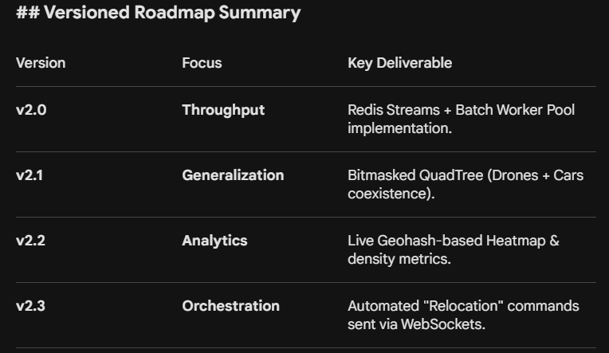

System Flow:
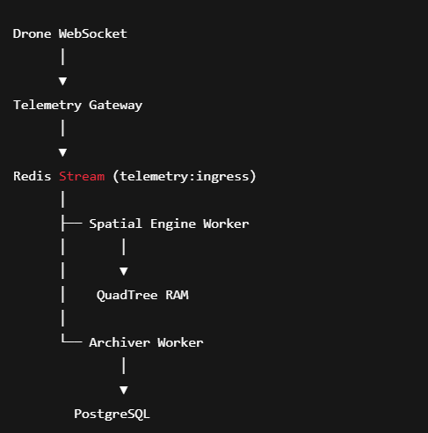

POLARIS: The Enterprise Evolution Roadmap
v2.0: The Streaming Foundation (📍 You Are Here)
The monolithic proof-of-concept proving that real-time ingestion and spatial indexing can be decoupled.
- Architecture: Single Go monolith, Redis Streams (shock absorber), PostgreSQL (ledger), In-memory QuadTree.
- Routing: Straight-line (Euclidean) flight paths.
- Orchestration: Reactive static hubs (e.g., "Guindy needs 3 drones").
- Status: Completed & Verified.

v3.0: The Distributed Split & Real-World Physics
The target for your capstone presentation. This phase proves the system can handle distributed microservices and real-world urban constraints.
- Microservices Split: Break the Go monolith into two independent services to prove distributed capability:
  - Polaris-Gateway: Pure WebSocket handlers dumping JSON into Redis.
  - Polaris-Engine: Consuming from Redis, holding the QuadTree, and serving the /match API.
- Street-Level Routing: Activate the OSRM container. Snap ground vehicles (Class 1, 2, 4) to the actual street networks of Chennai, replacing straight lines with true driving ETAs, accounting for one-way streets and road networks.
- Load Benchmarking: Write a Go stress-test script that spawns 50,000 concurrent WebSockets.
- Deliverable: A Grafana dashboard visualizing end-to-end latency (ping to map update) under extreme load.

v4.0: Predictive Intelligence (The ML Layer)
Moving from reactive orchestration to predictive orchestration. This is where the platform becomes "smart."
- Demand Forecasting: Instead of hardcoding zones, run batch jobs on the telemetry_history table in PostgreSQL.
- Clustering: Implement a K-Means clustering algorithm to analyze historical data and automatically identify shifting demand "hotspots" based on time of day (e.g., morning rush hour vs. midnight logistics).
- Proactive Relocation: The Rebalancer reads the ML predictions and dispatches idle nodes to future hotspots before the deficit actually occurs.
- Deliverable: A UI toggle to view "Predicted Demand Zones" overlaying the live heatmap.

v5.0: The 1-Million Node Architecture (Enterprise Scale)
The production-grade overhaul required to handle massive, state-wide or global fleets without lock contention.
- Spatial Sharding: Abandon the single, global QuadTree. Implement a Geohashing strategy to partition the map. Engine Instance A handles the northern grid, Engine Instance B handles the southern grid.
- Message Broker Upgrade: Migrate from Redis Streams to a highly durable, partitioned log system like Apache Kafka or Redpanda (which integrates beautifully with Go) for massive event throughput.
- Highly Available State: Move the localized in-memory QuadTrees into a distributed, highly available data store (like Redis GEO or a specialized spatial database) so engine nodes become completely stateless and can scale horizontally to infinity.
- Deliverable: Kubernetes deployment manifests allowing instant auto-scaling of the Gateway and Engine pods based on CPU load.

v6.0: The Developer Ecosystem (The Startup Launch)
Transforming the internal tool into a commercial, API-first platform.
- Client SDKs: Build lightweight Go, Python, and Node.js SDKs allowing enterprise customers to integrate their hardware with Polaris in three lines of code.
- Security & Multi-tenancy: Implement mTLS for hardware authentication and JWT-based API access. Ensure strict isolation via the tenant_id so Customer A's dispatchers cannot see Customer B's fleet.
- Open-Source Core: Package the core ingestion and spatial engine as an open-source project (similar to how organizations like Ceph or Rocket.Chat operate), driving community adoption while monetizing the predictive ML and historical analytics features.
- Deliverable: Beautiful, interactive API documentation and a self-serve developer portal.

