

Adversarial Fraud & AML Detection Arena
A MINOR PROJECT REPORT SUBMITTED TO

THE NATIONAL INSTITUTE OF ENGINEERING, MYSURU
(An Autonomous Institute under Visvesvaraya Technological University, Belagavi)

in partial fulfillment for the award of degree of

Bachelor of Engineering
in
Computer Science and Engineering

Submitted By
Anirudh Krishna 4NI24CS022
Golla Venkata Aditya 4NI24CS067
Gourav R 4NI24CS068
Akshay MP 4NI24CS010

Under the guidance of
Dr. B R Vatsala
Associate Professor, Department of CS&E
NIE, Mysuru

Department of Computer Science & Engineering
THE NATIONAL INSTITUTE OF ENGINEERING
(Autonomous Institution) Mysuru - 570 008
2026-27


THE NATIONAL INSTITUTE OF ENGINEERING
(An Autonomous Institute under Visvesvaraya Technological University, Belagavi)

Department of Computer Science & Engineering

CERTIFICATE

This is to certify that the project work entitled “Adversarial Fraud & AML Detection Arena” is a bonafide work carried out by Anirudh Krishna (4NI24CS022), Golla Venkata Aditya (4NI24CS067), Gourav R (4NI24CS068), Akshay MP (4NI24CS010) in partial fulfillment for the award of degree of Bachelor of Engineering in Computer Science and Engineering, of Visvesvaraya Technological University, Belagavi, during the year 2026-
27. It is certified that all corrections / suggestions indicated during internal assessment have been incorporated and the corrected copy has been deposited in the department library. This project report has been approved in partial fulfillment for the award of the said degree as per academic regulations of The National Institute of Engineering (Autonomous Institution).

Dr. B R Vatsala
Associate Professor
Dept. of CSE NIE, Mysuru
Dr. Anitha R Professor and Head Dept. of CS&E
NIE, Mysuru

Name of the Examiners Signature with Date

ABSTRACT
Fraud and anti-money-laundering (AML) detectors are normally validated once, on a fixed dataset of patterns that were already known when the model was trained. Real launderers adapt, so such a score says little about robustness. This project builds an Adversarial Fraud & AML Detection Arena: a closed-loop system in which a gradient-boosted (LightGBM) detector is attacked by a genetic-algorithm adversary that evolves realistic laundering strategies, namely structuring amounts below the reporting threshold, spacing transactions in time and routing funds through intermediate accounts, with a fitness that rewards both evasion and completion of the laundering goal. The strategies the adversary discovers are fed back into the detector's training data, and the two are retrained against each other for several rounds, producing a measurable arms-race curve of detector recall against adversary success.
Four invariants keep the measurement honest: the adversary emits transactions and never features, money is conserved by construction, the decision threshold comes from a fixed alert budget, and the clean holdout never sees adversary data. The system was developed on a synthetic transaction world and then run unchanged on the IBM AML benchmark (HI-Small, 5.08 million transactions). On IBM data the detector reaches a recall of 0.668 at a 0.5% alert budget, yet even a hand-written laundering strategy goes almost unflagged, because the detector largely learned that laundering is paid by ACH, and five rounds of retraining did not close the gap. On synthetic data, retraining raised the detector's recall against its contemporary adversary from 0.125 to 0.510. A Streamlit dashboard presents the transaction flows, evolved strategies and attribution drift round by round. The project also shows that an adversary is an effective auditor: every near-perfect evasion score exposed a flaw in the data, the simulation or the experiment itself.
Keywords: anti-money laundering, adversarial machine learning, genetic algorithm, LightGBM, arms race, IBM AML dataset.

ACKNOWLEDGMENT

We sincerely owe our gratitude to all the persons who helped and guided us in completing this mini project.

We are thankful to Dr. B. S. Nagendra Parashar, Principal, NIE College, Mysuru, for all the support she has rendered.

We thank Dr. Anitha R, Professor and Head, Department of Computer Science and Engineering, for her constant support and encouragement throughout the tenure for the mini project work.

We would like to sincerely thank our guide Dr. B R Vatsala, Associate Professor, Department of Computer Science and Engineering, for providing relevant information, valuable guidance and encouragement to complete this minor project.

Anirudh Krishna 4NI24CS022
Golla Venkata Aditya 4NI24CS067
Gourav R 4NI24CS068
Akshay MP 4NI24CS010

TABLE OF CONTENTS  CONTENTS  Abstract | I
Acknowledgement | II
Table Of Contents | III
List Of Figures | IV
1. Introduction | 1
1.1 Background | 1
1.2 Purpose | 2
1.3 Objectives | 2
2. Literature Review | 3
3. Existing System and Proposed System | 5
3.1 Existing System | 5
3.2 Proposed System | 5
4. System Requirements | 7
4.1 Hardware Requirements | 7
4.2 Software Requirements | 7
5. System Design | 8
5.1 System Architecture | 8
5.2 Use Case Diagram | 11
6. Implementation | 14
6.1 Pseudocode | 14
6.2 Implementation Details | 15
7. Testing | 17
7.1 Testing Strategy | 17
7.2 Automated Test Suite | 17
7.3 Experimental Evaluation | 17
7.4 Defects Found by the Adversary and the Experiments | 26
7.5 Discussion | 27
8. Screenshots | 28
Future Enhancement and Conclusion | 35
References | 36

LIST OF FIGURES

FIG. NO. | DESCRIPTION | PAGE NO.
5.1 | System architecture of the Adversarial Fraud & AML Detection Arena | 8
5.2 | One round of the closed loop and what is measured after it | 11
5.3 | Use case diagram | 12
7.1 | IBM HI-Small: precision-recall curve on the frozen holdout, with the 0.5% operating point | 18
7.2 | IBM HI-Small: recall at the alert budget by typology | 19
7.3 | Synthetic data: detector recall and adversary success over five rounds | 20
7.4 | Synthetic data: cross-play matrix, every detector against every adversary | 21
7.5 | Mean absolute TreeSHAP attribution per feature on the adversary's transactions, detectors D₀ to D₅ | 22
7.6 | Fixed projection of real transactions coloured by each detector's decisions | 23
7.7 | Cross-dataset transfer (left) and feature-group ablation (right) | 24
7.8 | IBM HI-Small: detector recall and adversary success over five rounds | 25
7.9 | IBM HI-Small: cross-play matrix | 26
8.1 | Overview page: the headline result and the four invariants | 28
8.2 | Phase 1 page: the detector and why accuracy is not used | 29
8.3 | Phase 2 page: genetic-algorithm convergence and the naive versus evolved gap | 29
8.4 | Phase 3 page: the arms-race curve with bootstrap intervals | 30
8.5 | Phase 3 page: cross-play matrix and the cost on the clean holdout | 30
8.6 | Phase 4 page: one round, one operation: decoded transfers scored by D_{r} and D_{(r+1)} | 31
8.7 | Phase 4 page: attribution drift per feature per detector | 31
8.8 | Phase 5 page: IBM data cleaning, found by profiling the dataset first | 32
8.9 | Phase 5 page: the detector on real data, recall by typology | 32
8.10 | Phase 5 page: transfer between the synthetic and the IBM world | 33
8.11 | Phase 5 page: why the adversary wins on IBM data, and the arms race beside the synthetic one | 33
8.12 | Phase 5 page: IBM holdout cost and the cross-play matrix | 34
8.13 | Live explorer: set the twelve genes and score the decoded transactions | 34

Chapter 1

INTRODUCTION

1.1 Background
Money laundering is the process of disguising the proceeds of crime so that they appear to come from a legitimate source. It is usually described in three stages: placement, where illegal cash enters the financial system; layering, where the money is moved through many transactions and accounts to hide its origin; and integration, where it re-emerges as apparently clean wealth. Banks are legally required to monitor transactions and report suspicious activity, and cash-type transactions above a reporting threshold (for example $10,000 in the United States) trigger mandatory reports. Launderers therefore split amounts into smaller pieces that stay just below such thresholds, a practice called structuring.
Automated transaction monitoring began as hand-written rules and has moved towards machine-learning models that rank transactions so that a limited team of analysts can review the most suspicious ones. Two properties make this problem unlike ordinary classification. The first is extreme class imbalance: in the IBM AML dataset used in this project only about one transaction in a thousand (0.10%) is laundering, so a model that predicts "not laundering" for everything is 99.9% accurate and completely useless. The second is an adaptive opponent: launderers change their behaviour in response to detection, so a detector that scores well on last year's patterns says little about next year's.
The laundering patterns that detectors are trained to recognise are called typologies. The five used in this project are:
- Fan-out: one account sends money to many accounts.
- Fan-in: many accounts send money to one account.
- Cycle: money passes through a ring of accounts and returns to its origin.
- Gather-scatter: money is gathered into one account and then scattered to many.
- Stack: money is layered through a sequence of intermediate accounts.
The usual way of evaluating such a detector is to train it on a labelled dataset and report a score on a held-out part of the same dataset. That measures how well the detector recognises the patterns it has already been shown. It does not measure how it behaves against a launderer who is actively trying to evade it, which is the situation in which a detector is actually used.

1.2 Purpose
The purpose of this project is to replace the single static evaluation of an AML detector with an arms race. A detector is placed in a closed loop with a genetic-algorithm adversary that evolves evasive laundering strategies against it; the adversary's discoveries are fed back into the detector's training data; and the two are retrained and re-measured over successive rounds. The result is not one accuracy figure but a set of curves and matrices that show whether the detector is becoming harder to fool, whether it forgets earlier lessons, and what each improvement costs on ordinary laundering.
A second purpose is methodological. An evaluation that includes an optimiser searching for weaknesses will exploit any flaw in the data or the simulation just as readily as a real weakness in the detector. The project therefore treats a suspiciously good adversarial score as a defect to be investigated, and records every flaw found this way (Chapter 7).

1.3 Objectives
The objectives set in the project synopsis are:
- To design and train a fraud/AML transaction classifier on the IBM AML dataset, capable of recognising the known laundering typologies: fan-out, fan-in, cycle and gather-scatter transfers.
- To build a genetic-algorithm-based adversarial agent whose genome encodes realistic evasion actions (structuring, timing delays and intermediate-account routing), constrained to plausible transaction behaviour.
- To define a fitness function balancing detection evasion against completion of the adversary's laundering objective, and to evolve evasive strategies across successive generations.
- To implement a closed feedback loop in which evasive strategies are reincorporated into the detector's training data, and to measure detector recall and adversary success rate across multiple retraining rounds.
- To build a visualisation dashboard presenting transaction flows, evolved evasion strategies and the detector's response, demonstrating the arms race as an observable, round-by-round process.
The work was done in phases (scaffold, detector, adversary, closed loop, visualisation, real IBM data), each producing metrics, figures, tests and a written account. The system was first developed on a synthetic transaction generator, where ground truth is known and the pipeline can be debugged cheaply, and was then run unchanged on the IBM AML benchmark.
Chapter 2

LITERATURE REVIEW
Fraud detection and evaluation. Bolton and Hand [1] reviewed the statistical approaches to fraud detection and distinguished supervised methods, which learn from labelled fraud, from unsupervised methods that look for unusual behaviour. Dal Pozzolo et al. [2] studied credit-card fraud detection under realistic conditions and stressed that investigators can inspect only a limited number of alerts, so a detector is better judged on its highest-ranked alerts than on global accuracy. This motivates the fixed alert budget used here: the detector may flag only 0.5% of transactions, and recall is measured at that budget.
Imbalanced data and metrics. Saito and Rehmsmeier [3] showed that the precision-recall plot is more informative than the ROC plot on imbalanced data, because the false-positive rate barely moves when there are hundreds of negatives per positive. This project therefore reports recall at the alert budget and PR-AUC, and labels ROC-AUC as misleading. Dal Pozzolo et al. [4] showed that undersampling the majority class distorts predicted probabilities, which is harmless here because the decision threshold is chosen as a score quantile and only the ranking of scores matters.
Gradient-boosted trees. Chen and Guestrin [5] (XGBoost) and Ke et al. [6] (LightGBM) made gradient-boosted decision trees fast and accurate on large tabular data. They handle skewed features and mixed numerical and categorical inputs without much preprocessing, train in seconds on millions of rows, and score a few dozen rows in microseconds, which matters because the adversary's genetic algorithm must score tens of thousands of candidates. LightGBM was chosen for the detector.
Graph-based AML. Weber et al. [7] applied graph convolutional networks to a labelled Bitcoin transaction graph and compared them with conventional classifiers, illustrating that the relationships between accounts carry much of the signal. This project captures the same signal with hand-engineered account-graph features (degrees, counterparty counts, burst ratios, cycle indicators) feeding a tree model. That is cheaper to evaluate inside an optimisation loop and, through the TreeSHAP method [14], can be explained exactly.
Datasets. Real labelled laundering data cannot be published, so public benchmarks are simulated. PaySim [8] simulates mobile-money transactions for fraud detection. Altman et al. [9] built the AMLworld generator, a multi-agent simulation of a banking world with injected laundering patterns (fan-out, fan-in, cycle, gather-scatter, scatter-gather, bipartite, stack and random), and released it as the IBM AML dataset [16] in several sizes and laundering-rate variants. The IBM dataset is the primary data source of this project; PaySim has no comparable account graph or typology labels and was not used.
Adversarial machine learning. Goodfellow et al. [10] showed that small, deliberate input perturbations can make accurate classifiers fail, and Biggio and Roli [11] surveyed a decade of adversarial machine learning and argued that security-sensitive classifiers must be evaluated against adaptive attackers. Most of that work perturbs continuous inputs such as images. In transaction monitoring an attacker cannot edit features; the attacker can only create transactions, which must obey accounting rules. This is why the adversary here emits transactions and never features, and why money conservation is built into the decoder.
Evolutionary search. Genetic algorithms [12] search a space of candidate solutions by selection, crossover and mutation, and need only a score for each candidate, not a gradient. That suits an adversary whose genome mixes integers and fractions and whose fitness comes from running a black-box detector. DEAP [13] provides the evolutionary machinery used here. Scikit-learn [15] supplies the preprocessing and principal component analysis used in the visualisation.
Table 2.1: Related work and the gap this project addresses
Work | Contribution | Gap addressed by this project
Bolton and Hand [1] | Review of statistical fraud detection | Evaluation against a fixed pattern set, not an adaptive opponent
Dal Pozzolo et al. [2] | Realistic fraud evaluation; limited alert capacity | Capacity is adopted (0.5% budget); the adversary is added
Chen and Guestrin [5]; Ke et al. [6] | Fast gradient-boosted trees | Used as the detector; robustness to evasion is measured
Weber et al. [7] | Graph neural networks for AML on Bitcoin | Account-graph features used instead; evaluated adversarially
Altman et al. [9] | AMLworld generator and IBM AML datasets | Used as the real-data benchmark; shortcut analysis added
Goodfellow et al. [10]; Biggio and Roli [11] | Adversarial examples; security evaluation of classifiers | Attacker restricted to valid, money-conserving transactions
Lundberg et al. [14] | Exact TreeSHAP for tree ensembles | Used to show attribution drift between rounds

In summary, the literature provides the detector technology, the evaluation metrics, the benchmark datasets, the adversarial viewpoint and the search method. What it does not provide, and what this project adds, is a closed loop in which a transaction-level adversary and an AML detector are retrained against each other, measured with a fixed alert budget on a frozen clean holdout, and audited for the dataset and simulation artefacts that such an adversary tends to expose.
Chapter 3

EXISTING SYSTEM AND PROPOSED SYSTEM

3.1 Existing System
In the existing practice, an AML or fraud detector is built in four steps: a labelled historical dataset is collected, a model is trained on the earlier part of it, the model is scored on a later part, and a single figure (often accuracy or ROC-AUC) is reported. Banks combine such models with fixed rules, for example alerts on amounts just below the reporting threshold. The model is retrained periodically on newly labelled cases, which arrive slowly because laundering is confirmed only after investigation.
This arrangement has the following weaknesses:
- It validates only against known patterns. The score describes how well the model recognises laundering like the laundering it was trained on, not laundering that has been adapted to avoid it.
- Its headline metrics mislead at this prevalence. Accuracy is about 99.9% for a model that predicts nothing, and ROC-AUC stays high even when the alert queue is unusable.
- It cannot show robustness. There is no measurement of how much recall falls when the opponent changes strategy, nor of whether retraining on new strategies makes the detector forget old ones.
- It hides dataset shortcuts. If a benchmark contains an artefact, such as one payment format that marks laundering, the score rewards learning the artefact.
- Rules are easy to probe. A fixed threshold rule is trivially evaded by structuring just beneath it.

3.2 Proposed System
The proposed system is the Adversarial Fraud & AML Detection Arena, a closed loop of a detector and an adversary. A LightGBM detector is trained on labelled transactions. A genetic-algorithm adversary evolves populations of laundering strategies whose genes encode structuring, timing and routing; each strategy is decoded into real transactions and scored by the detector through the same feature pipeline that built the training data. Fitness rewards strategies that complete the laundering goal while staying unflagged. The most evasive distinct strategies are folded back into the detector's training set, under guards that stop the detector from collapsing, forgetting or overfitting, and the detector is retrained. Repeating this for several rounds yields an arms-race curve, a cross-play matrix of every detector against every adversary, and the cost of robustness on a frozen clean holdout.
The system's main advantages are:
- Robustness is measured against an adapting opponent, round by round, instead of asserted from one score.
- The adversary can only act through valid transactions, so an evasion is an evasion a real launderer could attempt, and money is conserved by construction.
- The metrics are honest at 0.1% prevalence: recall at a fixed 0.5% alert budget and PR-AUC.
- The loop doubles as an audit tool: an adversary that reaches an implausibly perfect score has found a flaw in the data or simulation, and the decoded transactions show where.
- The same unchanged pipeline runs on synthetic and on real IBM data, so the two can be compared directly.
- Everything is observable through a dashboard that replays each round's flows, strategy and detector response.
Table 3.1: Existing practice compared with the proposed system
Aspect | Existing practice | Proposed arena
Evaluation | One static train/test split | Repeated rounds against an adapting adversary
Headline metric | Accuracy or ROC-AUC | Recall at a fixed 0.5% alert budget, PR-AUC
Opponent | None; known patterns only | Genetic-algorithm adversary evolving evasive strategies
Threshold | Tuned freely | Fixed policy: score quantile spending the alert budget on the clean holdout
Retraining | Periodic, on newly labelled cases | On the adversary's strategies, with caps, slices and time windows
Robustness evidence | None | Arms-race curve, cross-play matrix, confidence intervals
Dataset artefacts | Rewarded silently | Surfaced by the adversary, then fixed structurally
Explanation | Feature importance at best | Exact TreeSHAP attribution drift and decoded transaction flows

Chapter 4

SYSTEM REQUIREMENTS

4.1 Hardware Requirements
The synopsis set the following hardware requirements. The right-hand column records the machine on which the project was actually developed and run.
Table 4.1: Hardware requirements
Item | Minimum (synopsis) | Used in development
Processor | Intel Core i5 / AMD Ryzen 5 or higher | 12 logical cores
Memory (RAM) | 8 GB minimum, 16 GB recommended | 32 GB (largest run: about 4.3 GB per process)
Storage | 15 GB free, SSD recommended | Under 2 GB for data, models and reports
Network | Active internet connection | Needed only to download the dataset and packages
Operating system | Windows 10/11, Linux (Ubuntu 20.04+) or macOS | Windows 11

Run times on this machine give an idea of the compute needed. On the IBM data, building the account graph takes about 46 seconds, training the detector about 28 seconds, evolving one adversary (20,500 candidate evaluations) about 3 minutes, and the five-round closed loop about 25 minutes. On the 2-million-row synthetic ledger the corresponding figures are a 6-minute adversary run and a 29-minute closed loop. No GPU is required.

4.2 Software Requirements
Table 4.2: Software requirements
Component | Choice and version | Purpose
Language | Python 3.12 (pinned; 3.14 avoided because of wheel availability) | All code
Environment | uv | Reproducible virtual environment and command runner
Detector | LightGBM 4.7 | Gradient-boosted classifier
Machine learning | scikit-learn 1.9 | Scaling, PCA, metrics support
Adversarial engine | DEAP 1.4, NumPy | Genetic algorithm; vectorised numerics
Data handling | pandas 3.0, PyArrow | Ledgers and Parquet storage
Dashboard | Streamlit 1.64, Plotly, Matplotlib | Interactive visualisation; report figures
Testing | pytest | 102 automated tests
Notebooks, version control | Jupyter; Git and GitHub | One notebook per phase; history and delivery
Data | IBM AML dataset (HI-Small); synthetic generator | Training and evaluation; PaySim was not used

Chapter 5

SYSTEM DESIGN

5.1 System Architecture
The system has five layers (Fig. 5.1). The data layer produces a canonical, validated ledger from either the synthetic generator or the IBM loader. The feature layer holds a frozen graph of the background ledger, a copy-on-write overlay for candidate laundering transactions, and the single featurize() function used by both. The players are the detector and the adversary. The loop layer orchestrates rounds, retraining and evaluation. The output layer writes JSON metrics and figures that the dashboard reads.
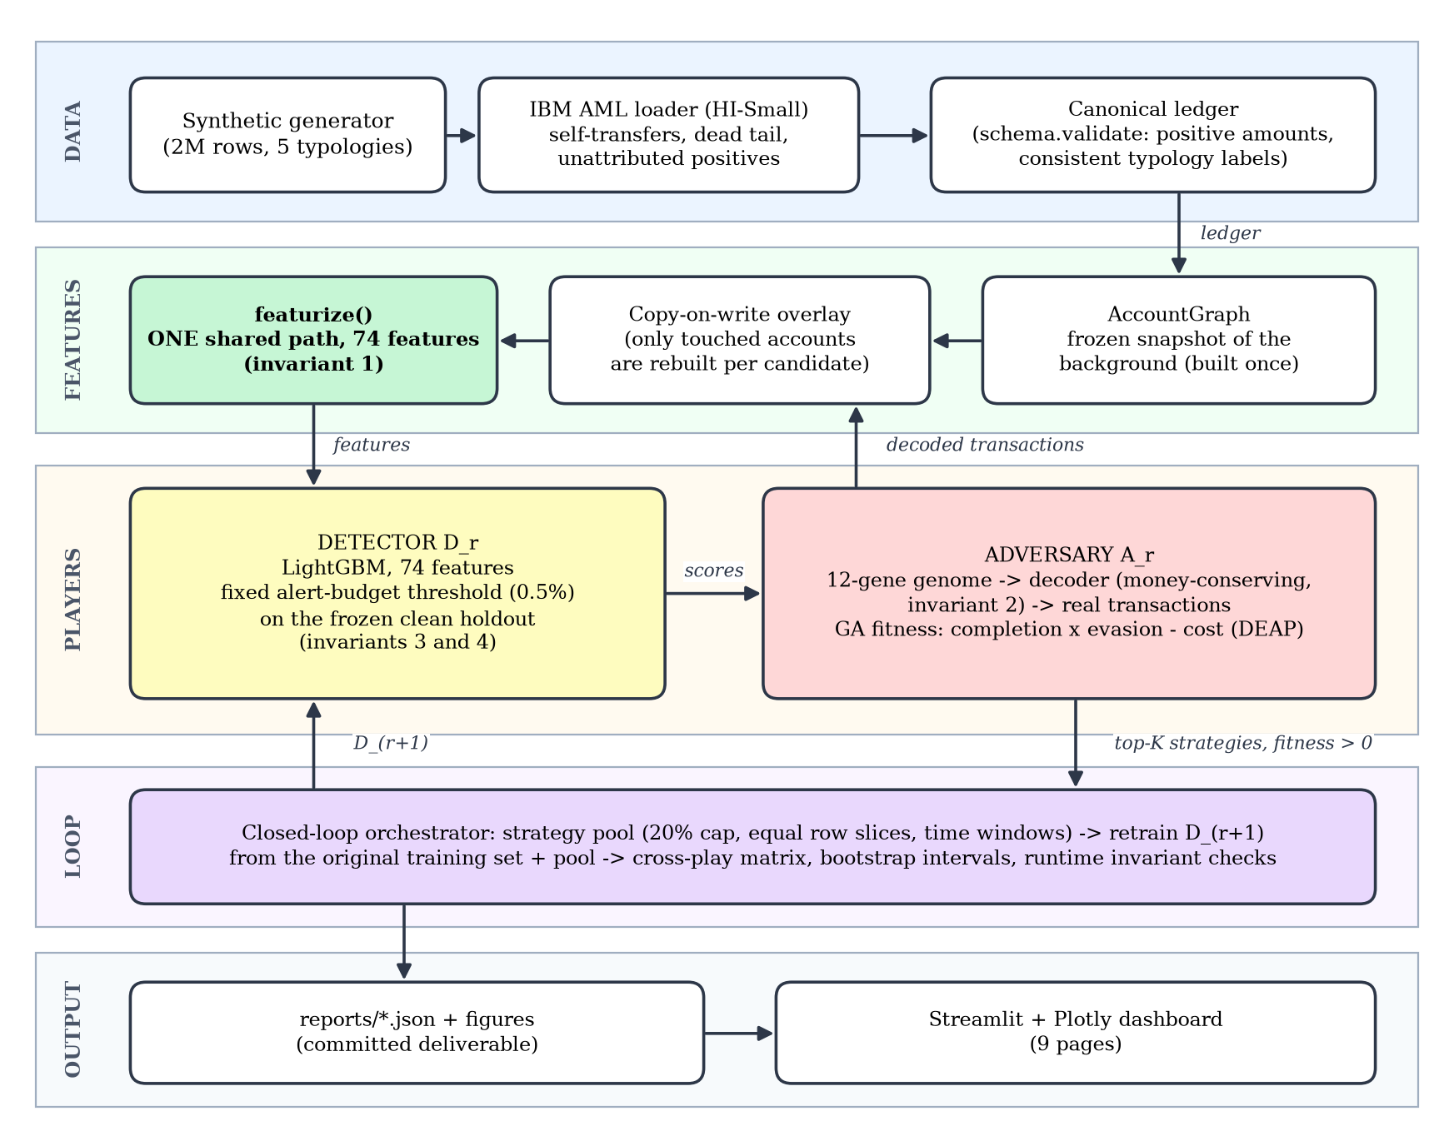
Fig. 5.1: System architecture of the Adversarial Fraud & AML Detection Arena
Canonical ledger
Every data source is normalised into one schema before anything else touches it, and validate() rejects ledgers with non-positive amounts, self-transfers, or typology labels inconsistent with the laundering flag. This stops a plausible-looking but impossible transaction, in particular one produced by the adversary's decoder, from reaching the detector.
Table 5.1: The canonical ledger schema
Field | Meaning
timestamp | Time of the transaction
from_bank, from_account | Sending bank and account
to_bank, to_account | Receiving bank and account
amount_paid, payment_currency | Amount debited and its currency
amount_received, receiving_currency | Amount credited and its currency
payment_format | ACH, cheque, credit card, reinvestment, wire, cash or bitcoin
is_laundering | Ground-truth label (0 or 1)
typology | Fan-out, fan-in, cycle, gather-scatter, stack, or unattributed (real data only)
pattern_id | Groups the transactions of one laundering instance
source | background or adversary: lets a clean holdout be proven clean

Feature engineering
Each transaction is described by 74 features, all computed as of the transaction's own timestamp so that no future information leaks into the past. There are 17 per-transaction features (log amount, low-order digits, distance to the $10,000 threshold, hour, weekday, cross-bank and cross-currency flags, FX loss, payment format) and 57 relational features for the sender and the receiver: counts, volumes and distinct counterparties over 1-hour, 1-day and 7-day windows, burst ratios, flow ratios, account age, time since the previous transaction, repeated-pair counts, a gather-scatter score and 2-, 3- and 4-hop cycle indicators.
Detector and threshold policy
The detector is a LightGBM classifier trained on all positives and 25 negatives per positive, with the positive class weighted by the observed imbalance and early stopping on validation PR-AUC. The decision threshold is not tuned: it is the score that flags exactly 0.5% of the transactions of the frozen clean holdout, mirroring a fixed analyst capacity. Because the same policy is applied to every detector, recall is comparable across rounds.
Adversary genome and decoder
The genome has twelve genes (Table 5.2). It encodes only relative quantities: how many tranches, how unevenly, how close to the threshold. It never encodes absolute amounts. The decoder turns a genome and an episode (move a goal amount from a source account to a destination account by a deadline, using real background accounts as intermediaries) into a list of ordinary transactions, and always allocates exactly the goal amount. Consequently any genome, including any crossover offspring, conserves money.
Table 5.2: The twelve-gene adversary genome
Gene | Range | Meaning
typology_template | 0 to 3 | Fan-out, cycle, gather-scatter or stack routing
n_hops | 1 to 4 | Routing depth through intermediate accounts
n_splits | 1 to 12 | Structuring: tranches per leg
split_skew | 0 to 1 | 0 equal tranches, 1 highly uneven
threshold_hug | 0 to 1 | How close tranches sit below $10,000
mean_delay_h | 0 to 72 h | Mean delay between transactions
delay_jitter | 0 to 1 | Variation of the delays
business_hours_bias | 0 to 1 | Probability of landing in 09:00 to 17:00
mule_pool_size | 1 to 10 | Intermediate accounts available
mule_reuse | 0 to 1 | 0 a fresh account per tranche, 1 reuse one
format_mix | 0 to 1 | 0 low-scrutiny formats, 1 high-scrutiny formats
dormancy_h | 0 to 168 h | Hold time at each intermediate hop

Fitness
A strategy's fitness is completion^{α} × evasion^{β} − γ × cost, with α = β = 1 and γ = 0.1. Completion is the share of the goal that reaches the destination by the deadline; evasion is one minus the share of transferred value that the detector flags; cost combines fees and elapsed time. If less than 95% of the money arrives the fitness is exactly zero, so a strategy cannot score well by moving only part of it. Each candidate is averaged over five episodes so the search cannot overfit one lucky account.
The closed loop
One round (Fig. 5.2) evolves an adversary against the current detector, keeps up to eight mutually distinct strategies with positive fitness, decodes each on training-period episodes, and retrains the next detector from the original training set plus the pool. Retraining from the original set, not from the previous round's augmented set, prevents drift from compounding. Further guards limit the feedback to 20% of the original positives, split into equal row slices per round so no earlier lesson is traded away, and confine each operation to its own time window.
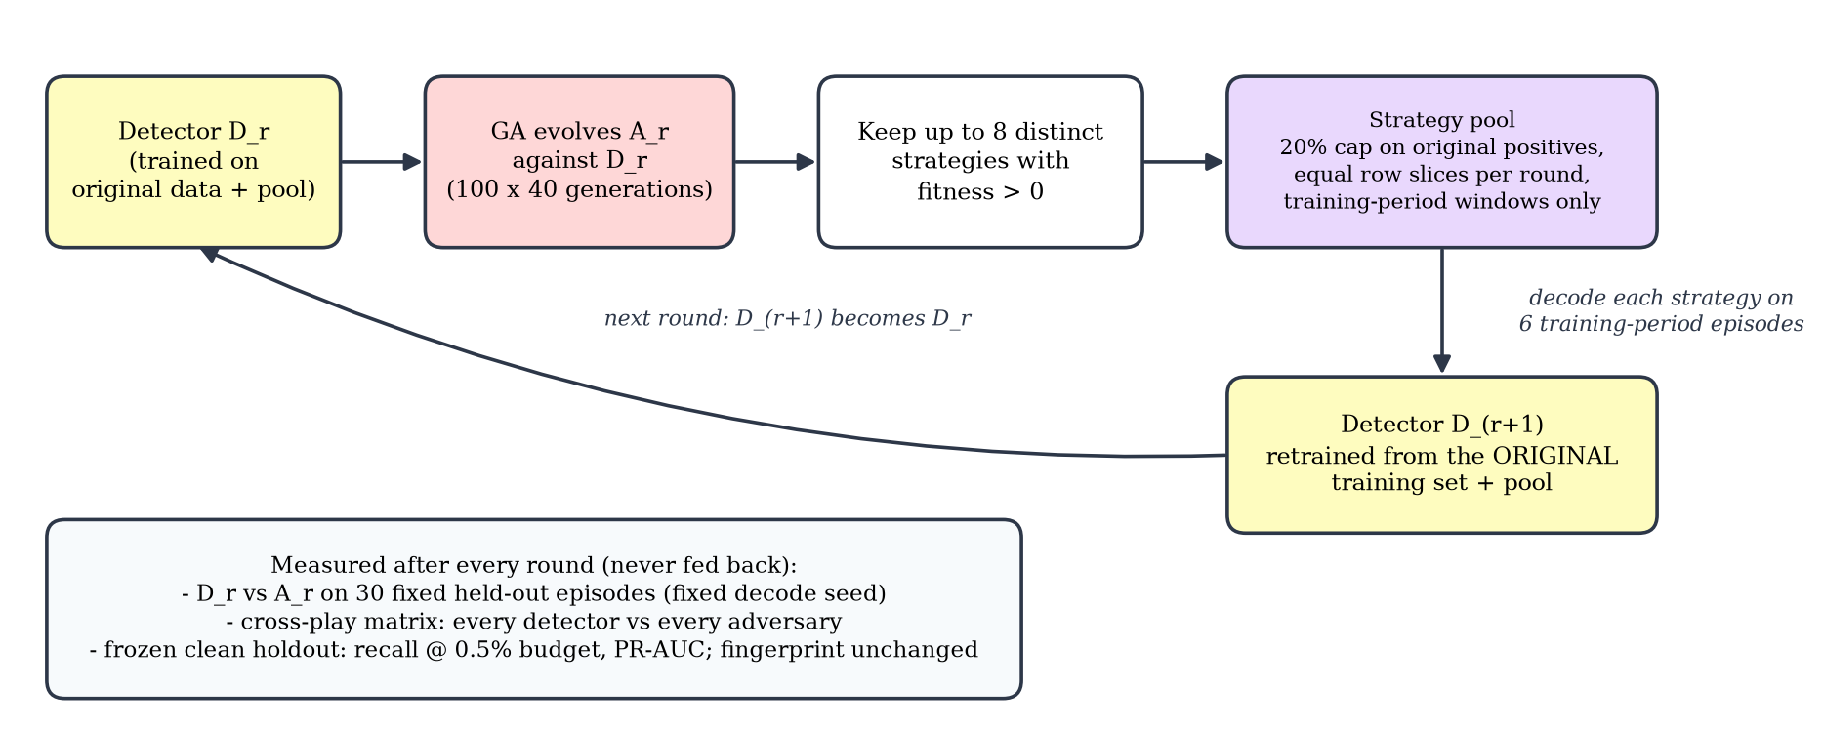
Fig. 5.2: One round of the closed loop and what is measured after it
The four invariants
- The adversary emits transactions, never features. One featurize() serves both training and the adversary's evaluation, and a test checks that the batch path and the overlay path agree.
- Money conservation is a decoder invariant, not a repair step, and is tested on random crossover offspring and, for real data, on random genomes.
- The threshold comes from a fixed policy (0.5% alert budget on the clean holdout) and is never re-tuned per round.
- The clean holdout never sees adversary data. It is carved out chronologically before the adversary exists and its fingerprint is verified unchanged at the end of every run.
Software structure
Table 5.3: Module map
Module | Responsibility
schema.py, config.py | Canonical ledger contract; YAML configuration with an overlay mechanism
data/ | Synthetic generator, IBM loader and cleaning, single entry point load_ledger()
features/ | AccountGraph (frozen plus overlay), rolling windows, the shared featurize()
detector/ | LightGBM wrapper, time-based split, alert-budget threshold, metrics
adversary/ | Genome, decoder, constraints, fitness, DEAP driver
loop/ | Strategy pool, evaluation, orchestrator, re-evaluation with confidence intervals, gate
explain.py | TreeSHAP attribution drift, fixed projection, decoded flows
scripts/ | One command-line script per step
dashboard/ | Streamlit application with nine pages

5.2 Use Case Diagram
Fig. 5.3 shows the use cases of the system. The primary actor is the researcher or student who prepares data, trains the detector, evolves strategies, runs the arms race and reads the results. The dataset source (the IBM files or the synthetic generator) supplies the transactions. A guide or examiner uses the dashboard to view results.
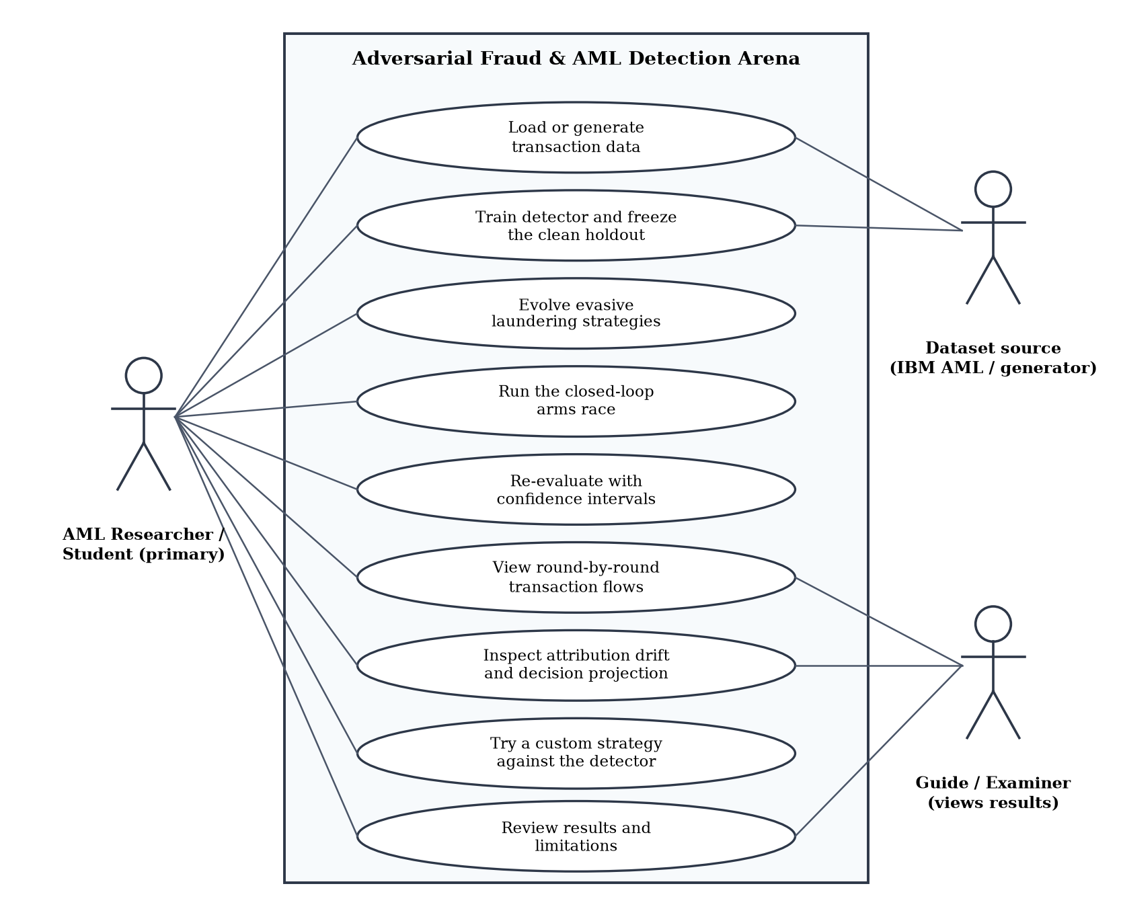
Fig. 5.3: Use case diagram
Table 5.4: Use case descriptions
Use case | Actor | Description
Load or generate transaction data | Researcher, dataset source | Build a validated canonical ledger from the generator or the IBM files, with cleaning
Train detector and freeze the holdout | Researcher | Chronological split, LightGBM training, fixed alert-budget threshold
Evolve evasive strategies | Researcher | Run the genetic algorithm against a detector and report the champion
Run the closed-loop arms race | Researcher | Rounds of evolve, feed back, retrain; cross-play matrix
Re-evaluate with confidence intervals | Researcher | Re-measure a finished run on 200 episodes with bootstrap intervals
View round-by-round transaction flows | Researcher, examiner | Draw a champion's decoded transfers scored by two detectors
Inspect attribution drift and projection | Researcher, examiner | TreeSHAP per feature per detector; fixed PCA plane of decisions
Try a custom strategy | Researcher | Set the twelve genes by slider and score the decoded transactions live
Review results and limitations | Researcher, examiner | Read the headline results and the stated caveats

Chapter 6

IMPLEMENTATION

6.1 Pseudocode
The pseudocode below summarises the core algorithms. Names follow the source code in src/arena/.
Algorithm 1: Alert-budget threshold and the shared feature path
FUNCTION alert_threshold(scores_on_clean_holdout, budget = 0.005):
RETURN the (1 - budget) quantile of scores_on_clean_holdout
# fixed policy: never re-tuned per round; recall is measured at this threshold

FUNCTION featurize(transactions, graph, windows): # the ONLY feature path
FOR each transaction t:
FOR each of sender, receiver:
counts, volumes, distinct counterparties, bursts over windows
computed from events strictly BEFORE t.timestamp # as-of rule
add per-transaction features (amount, threshold gap, hour, format, ...)
add cycle flags of length 2..4 and the gather-scatter score
RETURN feature matrix
Algorithm 2: Copy-on-write overlay
FUNCTION overlay(graph, sub_ledger):
touched <- accounts appearing in sub_ledger
new_state[a] <- merge(graph.state[a], events of sub_ledger for a) for a in touched
RETURN view that reads new_state first and falls through to graph for all other accounts
# cost grows with the number of touched accounts, not with the size of the ledger
Algorithm 3: Money-conserving decoder
FUNCTION decode(genome, episode, rng):
p <- decode_genes(genome); layers <- route(p.template, p.n_hops, src, dst, mules)
holdings <- { src: episode.goal }
FOR each hop layer:
FOR each sender with balance >= MIN_TRANCHE:
tranches <- split(balance, n_splits, split_skew, threshold_hug) # sums to balance
legs <- currency legs from the world's own process (see Algorithm 6)
t <- sender clock + p.dormancy_h (after the first hop)
FOR each tranche:
t <- t + max(delay(mean_delay_h, delay_jitter), MIN_GAP) # no identical times
t <- snap_to_business_hours(t, p.business_hours_bias)
emit transaction(sender, receiver, tranche, legs, pick_format(p.format_mix), t)
next_holdings[receiver] += received amount
holdings <- next_holdings
IF template is cycle: emit a small return transfer from dst to src
RETURN transactions # relative genes only: total always equals the goal
Algorithm 4: Fitness of a candidate strategy
FUNCTION fitness(genome, episodes, detector, graph, tau):
FOR each episode e:
sub <- decode(repair(genome), e)
scores <- detector.score(featurize(sub, overlay(graph, sub)))
evasion <- 1 - (value of transactions with score >= tau) / (total value)
completion <- delivered(sub, e) / e.goal
cost <- fees / e.goal + lambda * elapsed / e.deadline
f_e <- 0 IF completion < 0.95 ELSE max(completion^a * evasion^b - gamma * cost, 0)
RETURN mean over episodes of f_e
Algorithm 5: The closed loop
FUNCTION run_arena(ledger, holdout, D0, rounds = 5):
ASSERT holdout contains no adversary rows; fp <- fingerprint(holdout)
graph <- AccountGraph.build(ledger) # built once; background never changes
FOR r = 0 .. rounds - 1:
A_r <- GA.evolve(fitness, D_r, graph, tau_r, seeds = recent pool genomes)
strategies <- up to 8 distinct genomes of A_r with fitness > 0
pool.add(strategies)
rows <- pool.materialise(cap = 20% of original positives,
equal row slices per round, time-window filters)
D_{r+1} <- fit(original training rows + rows, same fixed hyper-parameters)
tau_{r+1} <- alert_threshold(D_{r+1}.scores(holdout))
cross_play[i][j] <- recall of D_i vs champion A_j (30 fixed episodes, fixed decode seed)
ASSERT fingerprint(holdout) == fp
RETURN curves, cross_play, per-round metrics
Algorithm 6: Real-data rules for the adversary
CLASS RealWorld(ledger): # used only when the ledger is real data
currency <- US Dollar
accounts <- accounts whose every transaction is in that currency
formats <- payment formats observed in the ledger (scrutiny-ordered)
legs(amounts) -> same currency on both sides, received == paid
EpisodeSampler draws source, destination and mules only from RealWorld.accounts
# An operation may therefore do only what the data itself does:
# no currency conversion (which could create money) and no format the world never uses.

6.2 Implementation Details
The implementation is about 10,000 lines of Python (5,100 in the library, 1,300 in scripts, 1,900 in the dashboard and 1,600 in tests), and the following decisions shaped it.
- A frozen graph with copy-on-write overlays. A genetic-algorithm run needs about 20,000 candidate evaluations. Re-featurizing a multi-million-row ledger for each would be impossible, so the background graph is built once and each candidate sees a layered view that rebuilds only the few dozen accounts it touches. On the 422,648-account IBM graph, copying the dictionaries per candidate had cost tens of milliseconds per episode; layering them with a chain of maps brought one candidate evaluation from about 0.58 s to about 0.15 s.
- One thread for small scoring batches. The adversary scores a few dozen rows at a time. Giving each tiny batch to a many-thread prediction call made two concurrent runs contend for the CPU, so batches under 2,000 rows are scored on one thread with identical predictions.
- As-of features. Window queries use a strict left-sided search so a transaction never sees events at its own timestamp. This also means a strategy that emits all transfers at one instant would be invisible to burst features, which the decoder prevents with a minimum gap between transfers.
- Time-based splits only. The ledger is split 60/15/25 chronologically into training, validation and the frozen holdout; a random split would let the detector see an account's future.
- Configuration overlay. A YAML file holds every tunable. Setting ARENA_CONFIG to config/ibm.yaml re-points the same scripts at the IBM data and writes to separate folders, so the real-data results come from exactly the code that produced the synthetic ones.
- IBM loader. It parses the patterns file to attach a typology and pattern identifier to each laundering transaction, drops self-transfers, cuts the days after background traffic stops, and labels positives that the patterns file does not list as unattributed. Every count removed is recorded in the data profile.
- Reproducibility. Seeds are fixed, every comparison uses the same episodes and decode seed, and each script prints a pass or fail gate against explicit thresholds.
Chapter 7

TESTING

7.1 Testing Strategy
Testing has two parts. Automated tests check that the code behaves as designed, above all that each of the four invariants holds. Experimental evaluation measures the detector and adversary on held-out data. The two meet in one rule: every flaw that experiments exposed was turned into an automated regression test, so it cannot return unnoticed.

7.2 Automated Test Suite
The suite contains 102 tests and all of them pass. Tests use small synthetic fixtures built by the same generator as the real pipeline, so they cannot drift out of step with the schema.
Table 7.1: Automated tests (102 in total)
Test file | Tests | What it guards
test_data.py | 18 | Schema validation and rejection of bad ledgers; label consistency; generator realism (FX-loss, amount and timestamp distributions of benign and laundering rows overlap); reproducibility
test_features.py | 9 | As-of correctness; batch path equals overlay path (invariant 1)
test_detector.py | 19 | The threshold spends exactly the alert budget, also with tied scores (invariant 3); metrics; chronological split; the holdout contains no adversary rows (invariant 4); downsampling; ranking quality; model save and load
test_adversary.py | 20 | Genome bounds; money conserved under crossover (invariant 2); plausibility floors; no account sends twice at the same instant; no currency or FX fingerprint on adversary rows; deadline handling; fitness rules (zero completion, completion floor, amount-weighted evasion)
test_loop.py | 18 | Injection cap, equal row slices and no starvation, time windows, per-episode goals, warm start, bootstrap intervals, end-to-end closed loop
test_explain.py | 9 | TreeSHAP contributions sum to the raw score, fixed and outlier-robust projection, flow layout, flows scored by both judges
test_ibm.py | 9 | IBM cleaning (self-transfers, dead tail, unattributed), real-data rules, money conservation over 300 random genomes, configuration overlay

Several tests were written because an earlier version of the experiment had failed. For instance, the loop tests include a regression for the case in which counting adversary operations instead of rows let one round starve the others, and the adversary tests fingerprint the decoder's output so that no constant, such as a fixed fee, can single out adversary rows.

7.3 Experimental Evaluation
Protocol
All splits are chronological. Every metric is computed on the frozen clean holdout, the last 25% of the ledger in time, at its true prevalence. The primary metric is recall at a 0.5% alert budget; PR-AUC is the threshold-free check, and chance level for PR-AUC equals the prevalence (0.12% on IBM). Accuracy is never reported and ROC-AUC is reported only with a warning. Adversary results are measured on fixed held-out episodes from a later period than any episode used for training.
Phase 1: the detector, synthetic and real data
Table 7.2: Detector results on the frozen clean holdout
Frozen clean holdout | Synthetic | IBM HI-Small
Transactions / laundering | 500,001 / 1,132 | 1,121,605 / 1,324
Recall at 0.5% budget | 0.537 | 0.668
PR-AUC | 0.454 | 0.424
Precision at budget | 0.243 | 0.158
ROC-AUC (misleading at this prevalence) | 0.971 | 0.983
Trees | 205 | 395
Phase 1 gate (PR-AUC >= 0.40, recall >= 0.50) | PASS | PASS

On IBM data the cleaned ledger has 4,486,418 transactions, 4,514 of them laundering (0.101%), over 422,648 accounts and 10 days. The detector's recall is 0.668 and its PR-AUC 0.424, about 360 times the chance level of 0.0012. Fig. 7.1 shows the precision-recall curve with the operating point.
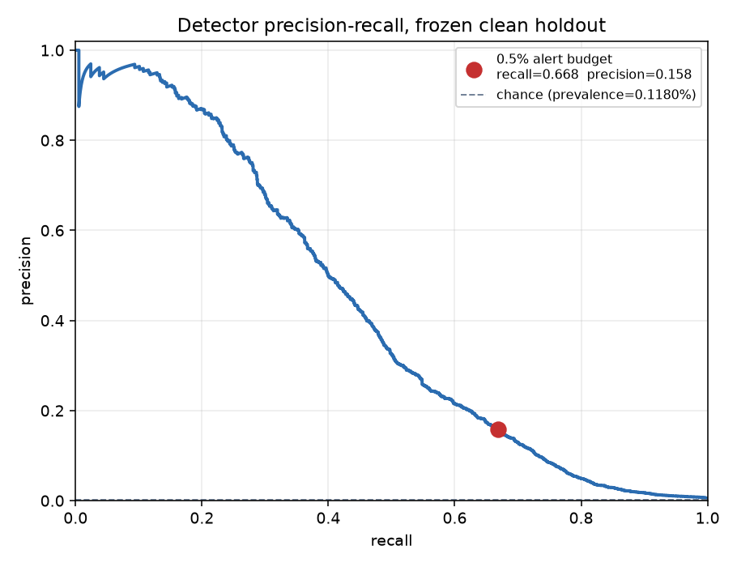
Fig. 7.1: IBM HI-Small: precision-recall curve on the frozen holdout, with the 0.5% operating point
Table 7.3: Recall at the alert budget by laundering typology
Typology | Synthetic recall | IBM recall
Fan-out | 0.414 | 0.906
Fan-in | 0.411 | 0.952
Cycle | 0.481 | 0.937
Gather-scatter | 0.458 | 0.956
Stack | 0.745 | 0.863
Unattributed (IBM only) | n/a | 0.255

The labelled typologies are caught at 0.86 to 0.96 on IBM data. The 44% of IBM positives that the patterns file does not list are caught at only 0.26, so the headline recall averages two very different populations.
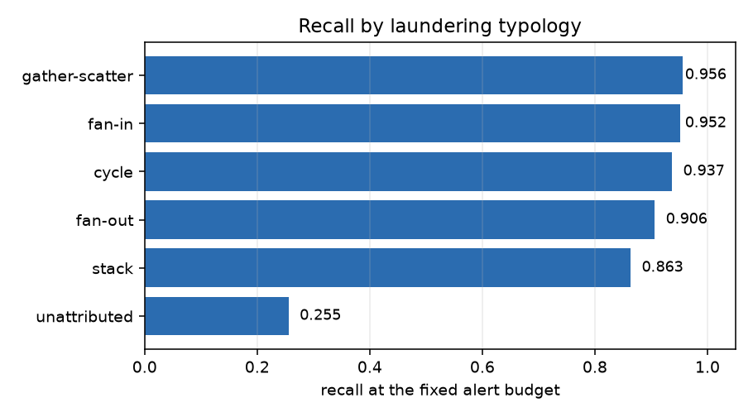
Fig. 7.2: IBM HI-Small: recall at the alert budget by typology
Phase 2: the adversary on synthetic data
Table 7.4: Synthetic data: the evolved strategy against the detector
Strategy | Detector recall on its transactions | Money delivered
Naive, hand-written (3 transfers) | 0.750 | 99.9%
Random genomes (mean) | 0.748 | n/a
Evolved by the GA (stack, 8 tranches, threshold hug 0.67) | 0.231 | 99.9%

The genetic algorithm cut the detector's recall by 52 points while still delivering essentially all of the money. Random, unevolved genomes were no better than the naive strategy (0.748), so the gain comes from selection, not from the genome space itself.
Phase 3: the arms race on synthetic data
Table 7.5: Synthetic data: the arms race over five rounds (200 held-out episodes)
Round | Detector recall against its adversary (95% interval) | Adversary success | Clean recall / PR-AUC
0 | 0.125 (0.11 to 0.14) | 99% | 0.538 / 0.454
1 | 0.275 (0.22 to 0.34) | 72% | 0.519 / 0.437
2 | 0.295 (0.24 to 0.36) | 70% | 0.529 / 0.441
3 | 0.365 (0.30 to 0.44) | 64% | 0.516 / 0.427
4 | 0.510 (0.48 to 0.54) | 56% | 0.523 / 0.430
Final D₅ |  |  | 0.509 / 0.421

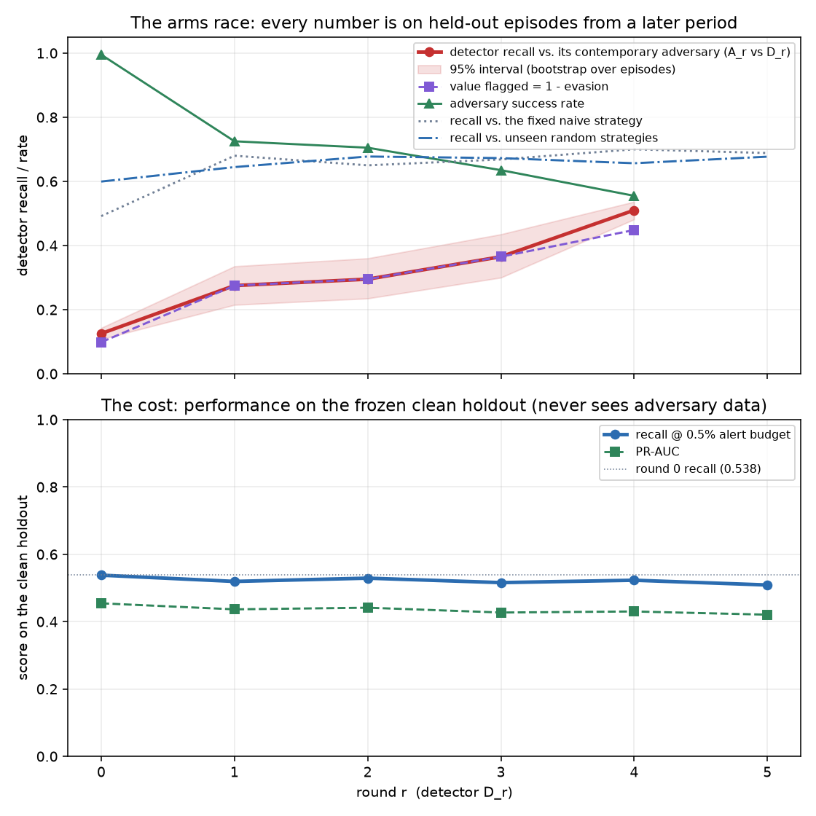
Fig. 7.3: Synthetic data: detector recall and adversary success over five rounds
Feedback improved the detector against the strategies it was shown in every round, at a cost of less than three points of clean recall. It did not get ahead: after five rounds the adversary still succeeds in 56% of episodes. The cross-play matrix (Fig. 7.4) shows the adversary alternating between two families, a multi-hop fan-out and a single large transfer, rather than escalating.
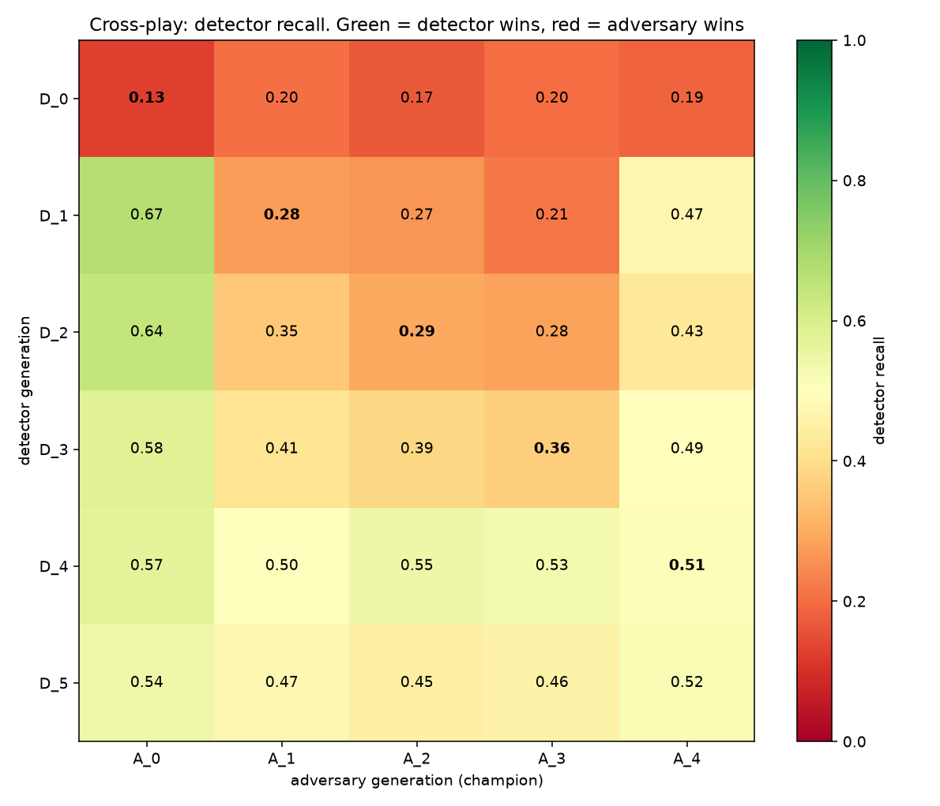
Fig. 7.4: Synthetic data: cross-play matrix, every detector against every adversary
Phase 4: attribution and decisions
For every detector the mean absolute TreeSHAP contribution of each feature was computed on the adversary's transactions, the holdout laundering and holdout benign traffic (Fig. 7.5 shows the adversary's operations). On those operations amount_log rose from 0.85 to 1.70 and snd_out_vol_24h from 0.18 to 0.38, while snd_age_h fell from 0.44 to 0.28 and threshold_gap from 0.42 to 0.30: the detectors learned that the adversary's large transfers are suspicious and that account age and distance from the threshold no longer separate it. amount_mod_100 also rose (0.59 to 0.75); that reflects an artefact of the synthetic generator (Section 7.4), not a discovery.
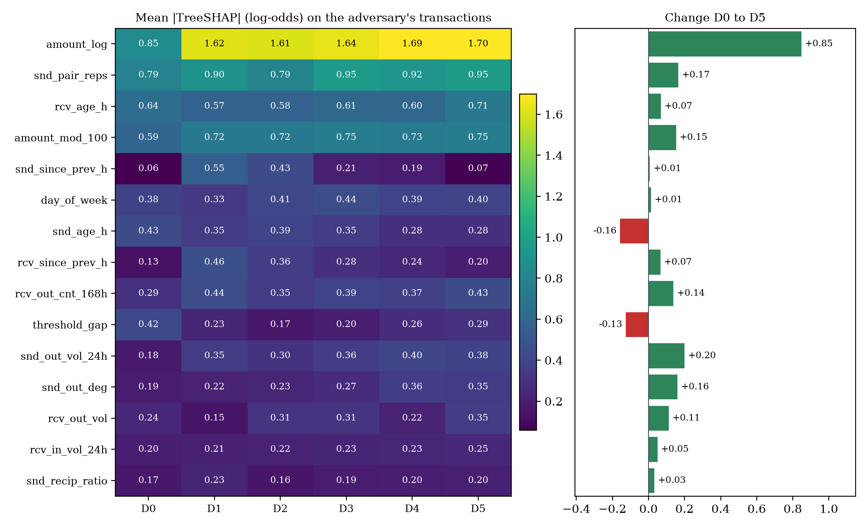
Fig. 7.5: Mean absolute TreeSHAP attribution per feature on the adversary's transactions, detectors D₀ to D₅
Fig. 7.6 places 3,000 holdout benign, 1,132 holdout laundering and 1,023 adversary transactions in one fixed two-component plane and colours them by each detector's decision. D₀ flags 17.4% of the adversary's transactions and D₁ flags 54.5%; after that the picture barely changes, matching the plateau in the cross-play matrix. The plane explains 42.6% of the variance and is a map of where decisions fall, not a picture of the model.
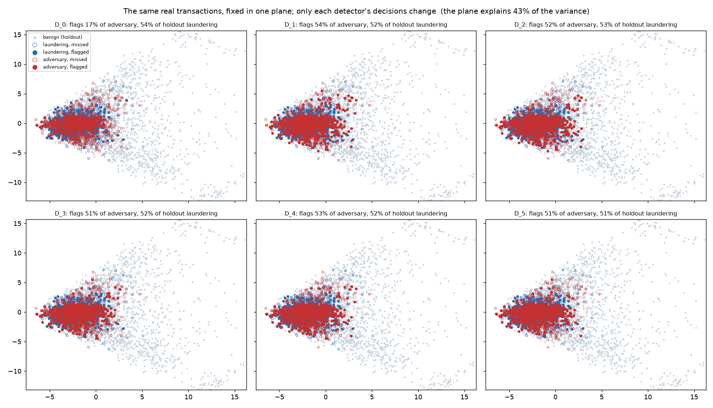
Fig. 7.6: Fixed projection of real transactions coloured by each detector's decisions
Phase 5: real IBM data
Transfer between the two worlds. Each detector was scored on the other dataset's frozen clean holdout, applying the same alert-budget policy to the target's own traffic.
Table 7.6: Cross-dataset transfer
Recall at budget (PR-AUC) | Scored on synthetic | Scored on IBM
Trained on synthetic | 0.537 (0.454) | 0.000 (0.001)
Trained on IBM | 0.016 (0.003) | 0.668 (0.424)

Chance recall at a 0.5% budget is about 0.005, so neither detector recognises the other world's laundering. The synthetic numbers are therefore a check that the pipeline works, and the IBM numbers are the result.
Feature groups. PaySim, the secondary dataset named in the synopsis, has no comparable account graph, so only the 17 per-transaction features would carry over. Retraining on each feature group shows what such a validation would have kept.
Table 7.7: Retraining on one feature group at a time
Recall at budget (PR-AUC) | Synthetic | IBM
All 74 features | 0.537 (0.449) | 0.668 (0.424)
Per-transaction only (17) | 0.155 (0.023) | 0.187 (0.019)
Relational only (57) | 0.455 (0.366) | 0.617 (0.290)
All but payment format (72) | 0.527 (0.444) | 0.636 (0.351)

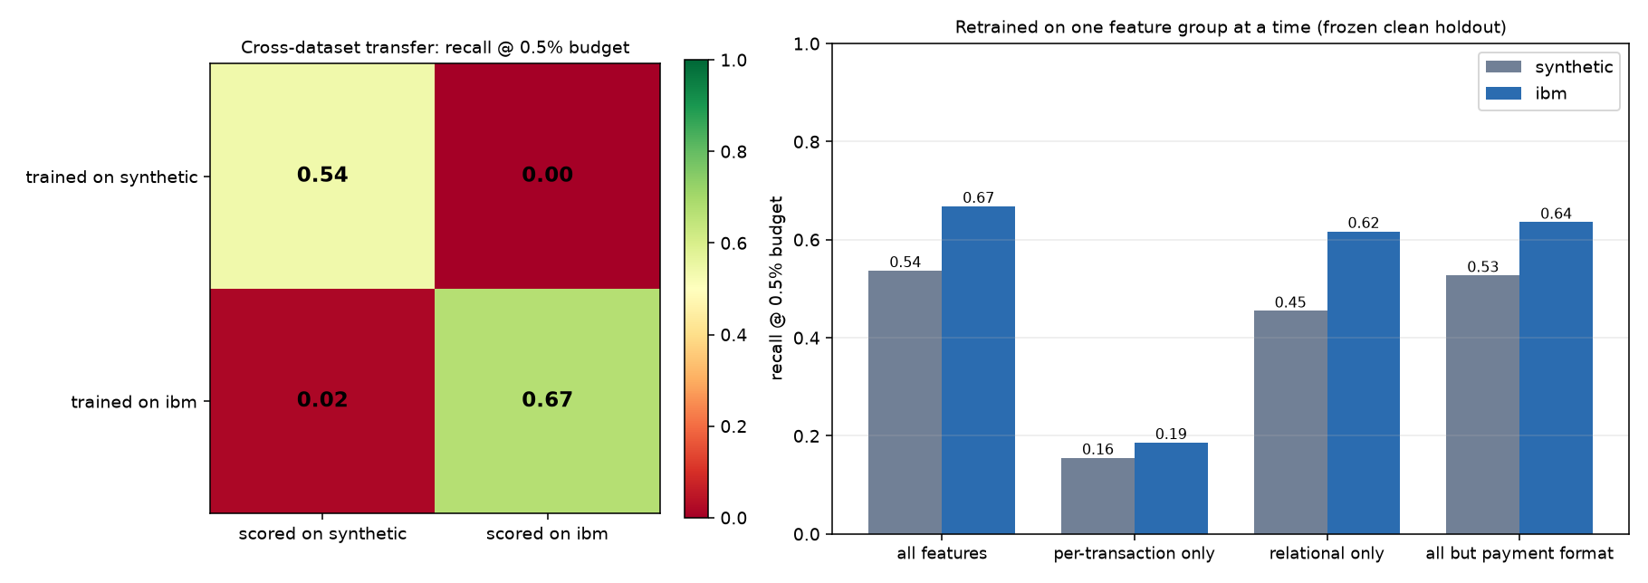
Fig. 7.7: Cross-dataset transfer (left) and feature-group ablation (right)
The adversary on IBM data. The genetic algorithm reaches a fitness of 1.000, but so does the hand-written naive strategy (0.998). The detector's recall on the naive strategy is 0.000, on random genomes 0.006 and on the evolved champion 0.000. The cause is a dataset shortcut: 88% of IBM laundering is paid by ACH against 12% of benign traffic, and the IBM detector leans on it (36% of its gain). Changing only the payment format of the naive strategy's transfers to ACH raises the detector's median score from 0.0006 to 0.62. Retraining without the two payment-format features (60 held-out episodes) gives:
Table 7.8: The effect of removing the payment-format shortcut
Strategy | IBM detector: recall / adversary wins | Retrained without payment format
Naive | 0.000 / 100% | 0.167 / 100%
Naive, paid by ACH | 0.144 / 100% | 0.167 / 100%
Phase 2 champion | 0.000 / 100% | 0.233 / 78%
Clean holdout recall (PR-AUC) | 0.668 (0.424) | 0.636 (0.351)

Removing the shortcut costs three points of recall on IBM's own laundering and makes the detector measurably harder to evade, but it is still evaded in most episodes.
The closed loop on IBM data used the same settings as the synthetic run, with 30 held-out episodes per cell and a 24-hour deadline because HI-Small spans only ten days.
Table 7.9: IBM HI-Small: the arms race over five rounds
Round | Clean recall / PR-AUC | Detector recall against its adversary | Adversary success
0 | 0.668 / 0.424 | 0.000 | 100%
1 | 0.660 / 0.420 | 0.200 | 80%
2 | 0.664 / 0.390 | 0.067 | 93%
3 | 0.657 / 0.407 | 0.125 | 100%
4 | 0.668 / 0.399 | 0.033 | 97%
Final D₅ | 0.669 / 0.382

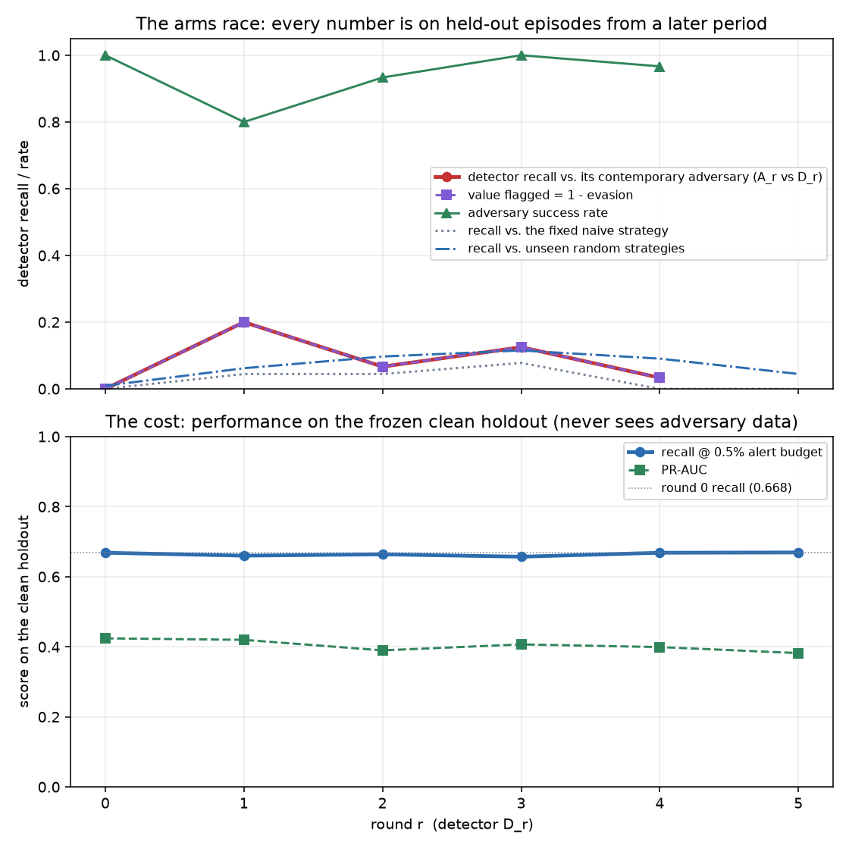
Fig. 7.8: IBM HI-Small: detector recall and adversary success over five rounds
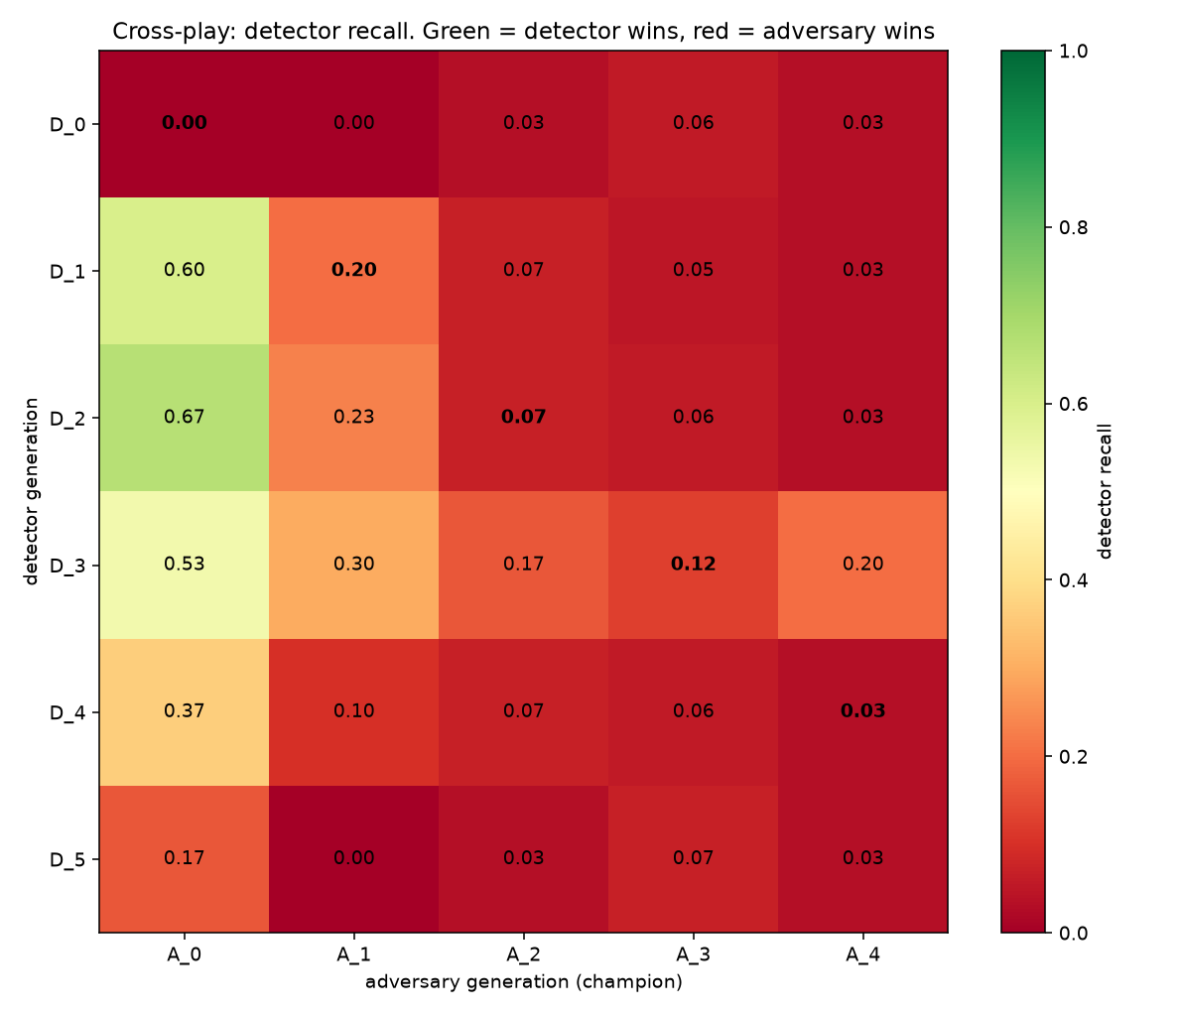
Fig. 7.9: IBM HI-Small: cross-play matrix
The loop's guards held: the holdout was unchanged, the alert budget was exact in every round, feedback stayed within its 20% cap, and the Phase 3 gate passed. But feedback did not help. Each retrained detector learns the strategy it was shown (D₁ catches 0.60 of A₀) and then loses to the next, which finds another way through, and clean-holdout PR-AUC falls from 0.424 to 0.382. On synthetic data the same loop raised recall from 0.125 to 0.510; on IBM it stays between 0.00 and 0.20. With 30 episodes per cell and one seed the figures are indicative, not tight, but the direction is clear: a detector that leans on a dataset shortcut cannot be repaired by patching individual strategies.

7.4 Defects Found by the Adversary and the Experiments
The most important testing result is a list of flaws in the data, simulation and experiment that an ordinary evaluation had passed. In each case the adversary reported an implausibly good score, the decoded transactions were read, and the cause was fixed structurally, by making two paths share code rather than by correcting the output.
Table 7.10: Flaws exposed by the adversary
Stage | Symptom | Cause | Fix
Phase 1 | Detector PR-AUC 1.000 | Three generator leaks: an FX-loss band unique to laundering, laundering amounts above the benign range, laundering timestamps uniform across the clock | Benign and laundering rows routed through shared functions
Phase 2 | Detector recall 0.000 | Twelve transfers at one identical timestamp, invisible to as-of features | Minimum gap between transfers in the decoder
Phase 3, run 1 | Recall 0.000 in round 1 | One $250,000.00 transfer: a fixed round goal, while synthetic laundering is never round | Per-episode goals drawn log-uniformly to the cent
Phase 3, run 2 | Retrained detector too good | Every adversary row had FX loss exactly 0.002 (a fixed fee) | Fee set to 0; currency legs from the world's own process
Phase 3, run 3 | GA fitness 0.999, held-out far lower | Winner's curse: a one-transaction strategy scores five out of five by luck | 200-episode re-evaluation with bootstrap intervals
Phase 5 | IBM evasion 1.000, completion 525 times the goal | Chained currency conversions created money; one account paid in five currencies; a format that IBM has only as a self-transfer | RealWorld rules: one currency, only observed accounts and formats; regression test

7.5 Discussion
The results support the central premise of the project. A detector with 0.668 recall on a held-out IBM test set catches none of the transfers of a simple strategy paid by cheque instead of ACH. A static score describes the dataset's signature as much as the detector's ability. The arms race also shows what retraining can and cannot do: on synthetic data it raised recall against the adversary from 0.125 to 0.510 at little cost, but on IBM data, where the weakness is a dataset shortcut and not a strategy, it did not help, whereas removing the shortcut helped more.
The limits of the evidence are stated plainly. The IBM data is itself simulated; the arms race is one seed per run, with intervals over episodes and not over repeated runs; the adversary reads the detector's exact scores, which a real launderer cannot, so it is stronger than a realistic attacker; and PaySim was not used. Synthetic laundering in the generator is never a round amount while 21.6% of benign amounts are, which is worth about three points of Phase 1 recall; the artefact is absent from the IBM data (round amounts are 0.013% of benign and 0.022% of laundering).
Chapter 8

SCREENSHOTS
The dashboard is a Streamlit application with nine pages: an overview, one page for each of the five phases, a live strategy explorer, an architecture walkthrough and a limitations page. Apart from the live explorer, every page replays the stored results of a finished run and never retrains or re-evolves anything. Run it with uv run streamlit run dashboard/app.py.
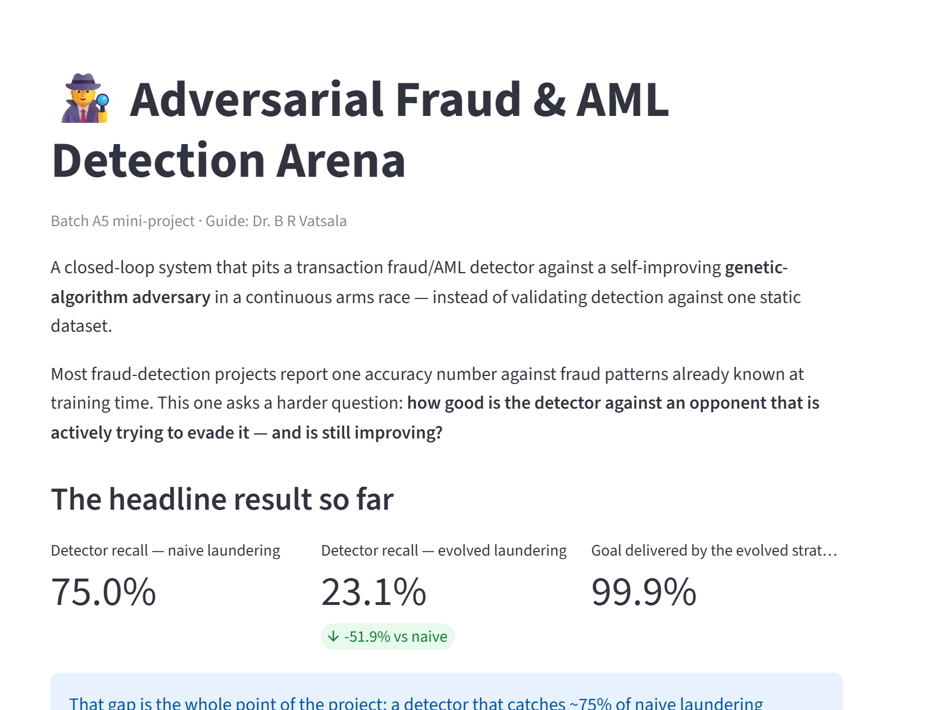
Fig. 8.1: Overview page: the headline result and the four invariants
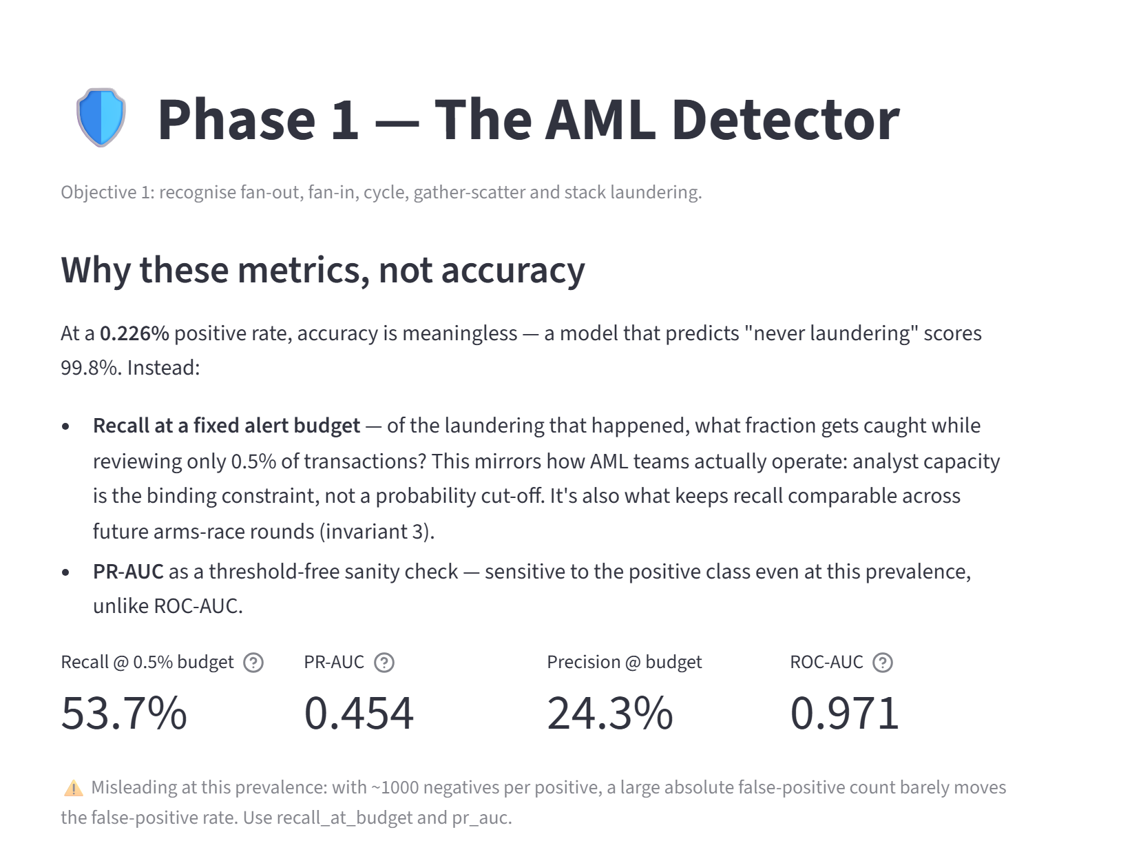
Fig. 8.2: Phase 1 page: the detector and why accuracy is not used
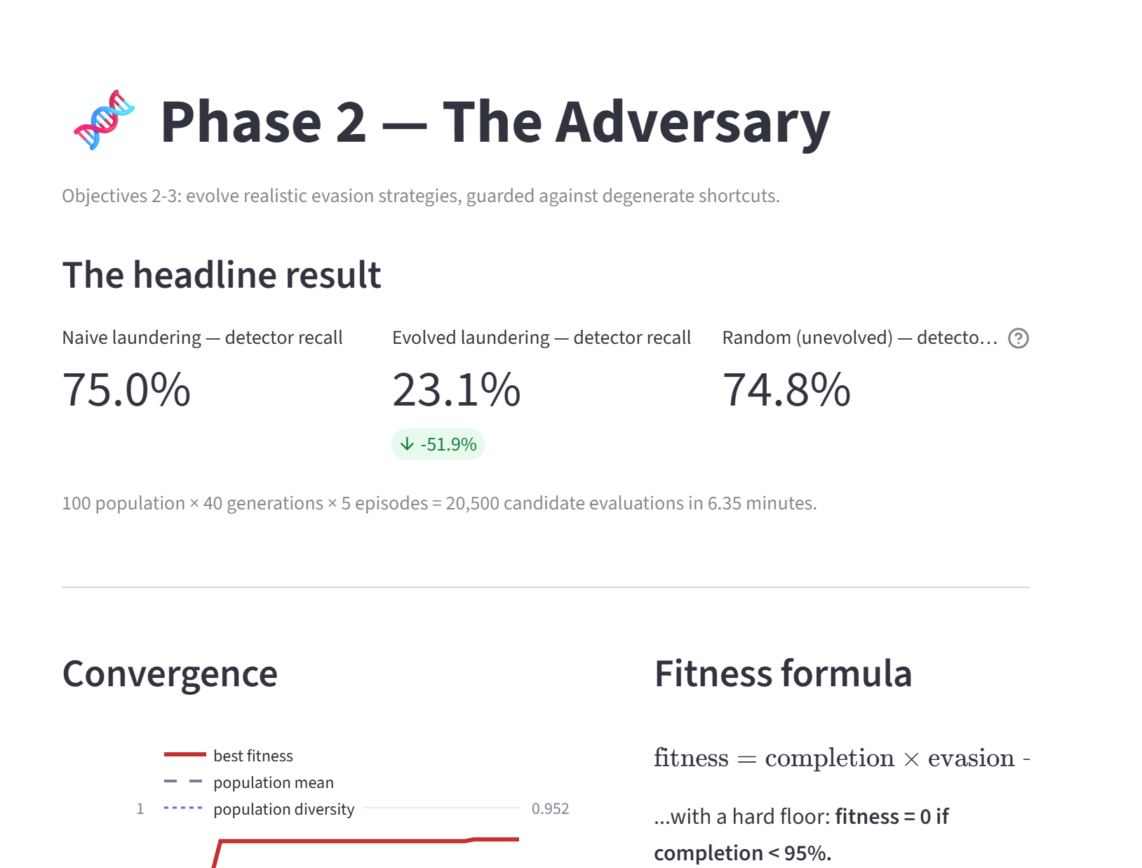
Fig. 8.3: Phase 2 page: genetic-algorithm convergence and the naive versus evolved gap
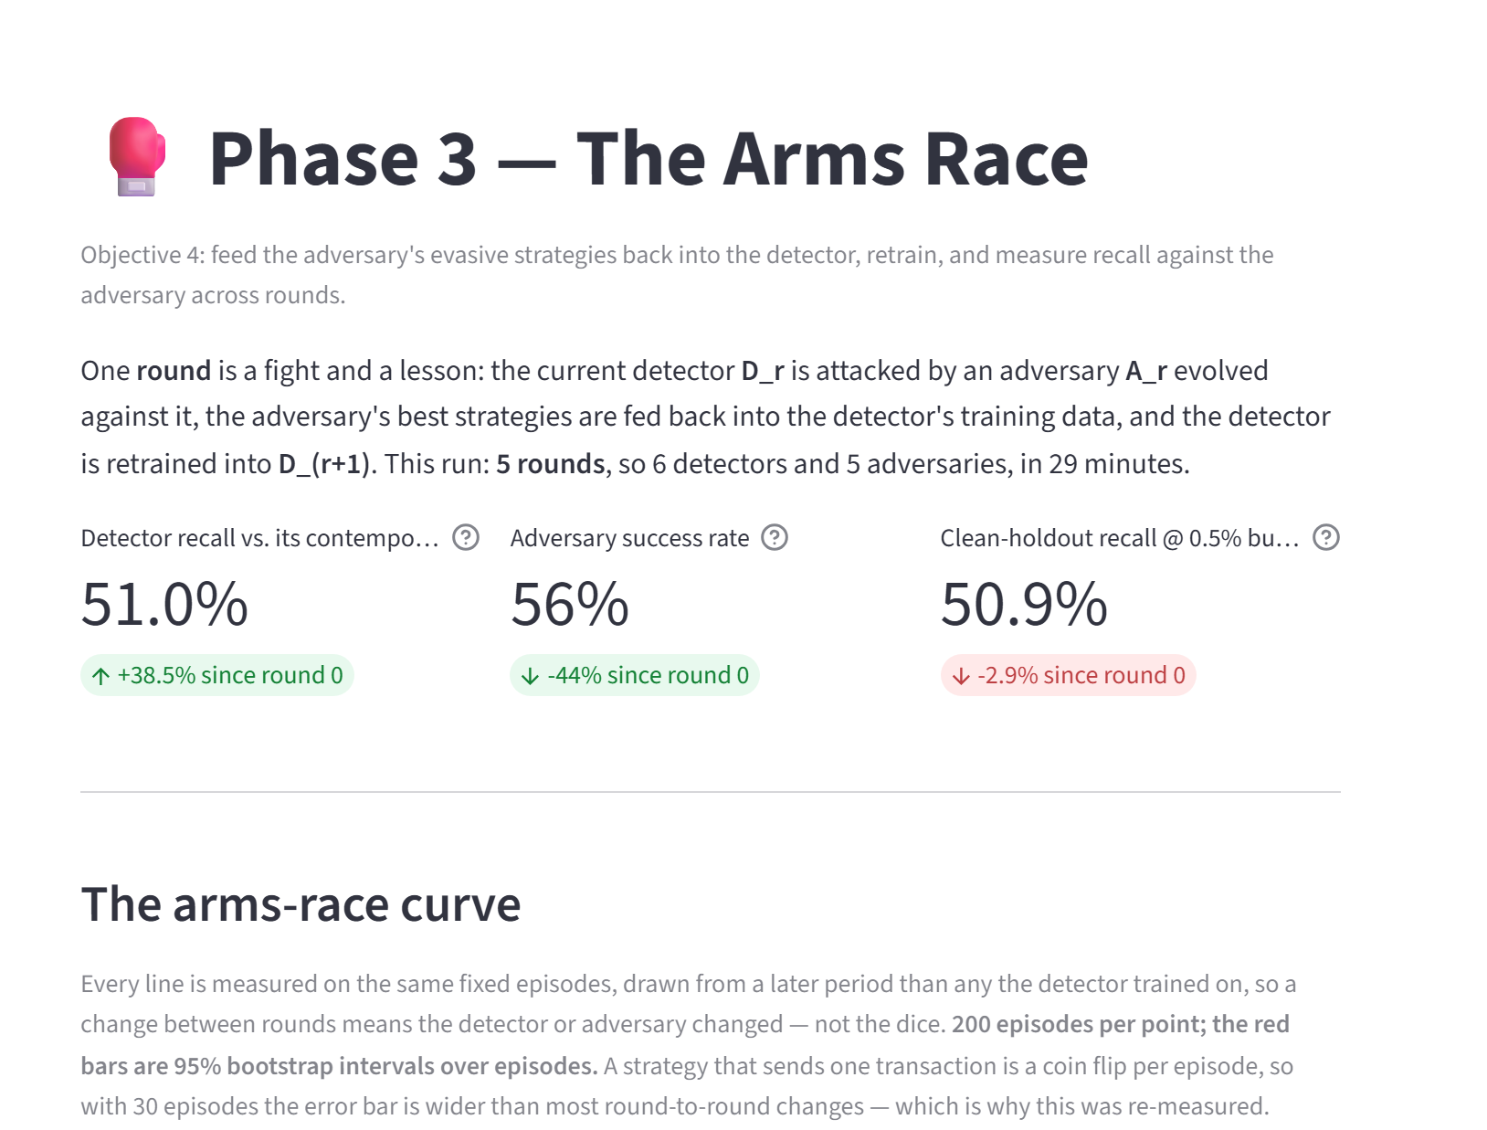
Fig. 8.4: Phase 3 page: the arms-race curve with bootstrap intervals
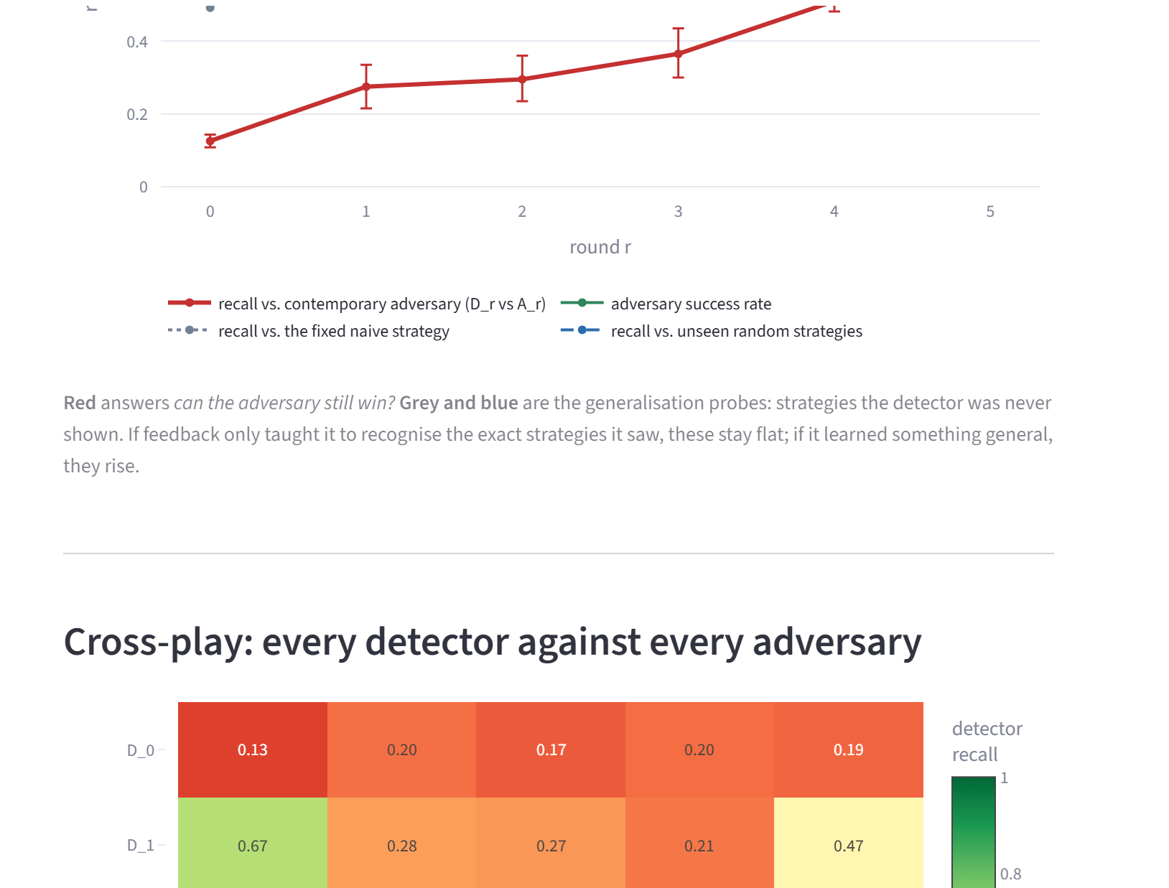
Fig. 8.5: Phase 3 page: cross-play matrix and the cost on the clean holdout
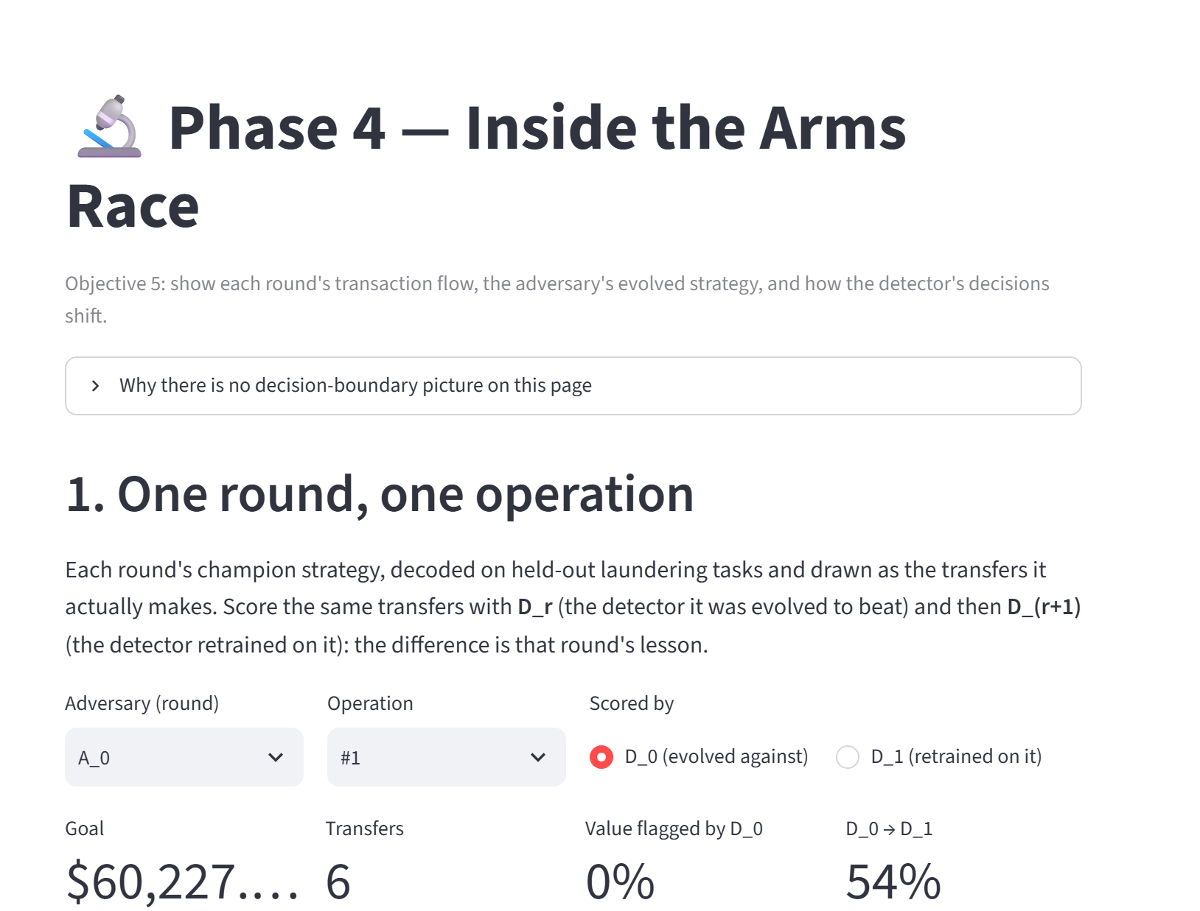
Fig. 8.6: Phase 4 page: one round, one operation: decoded transfers scored by D_{r} and D_{(r+1)}
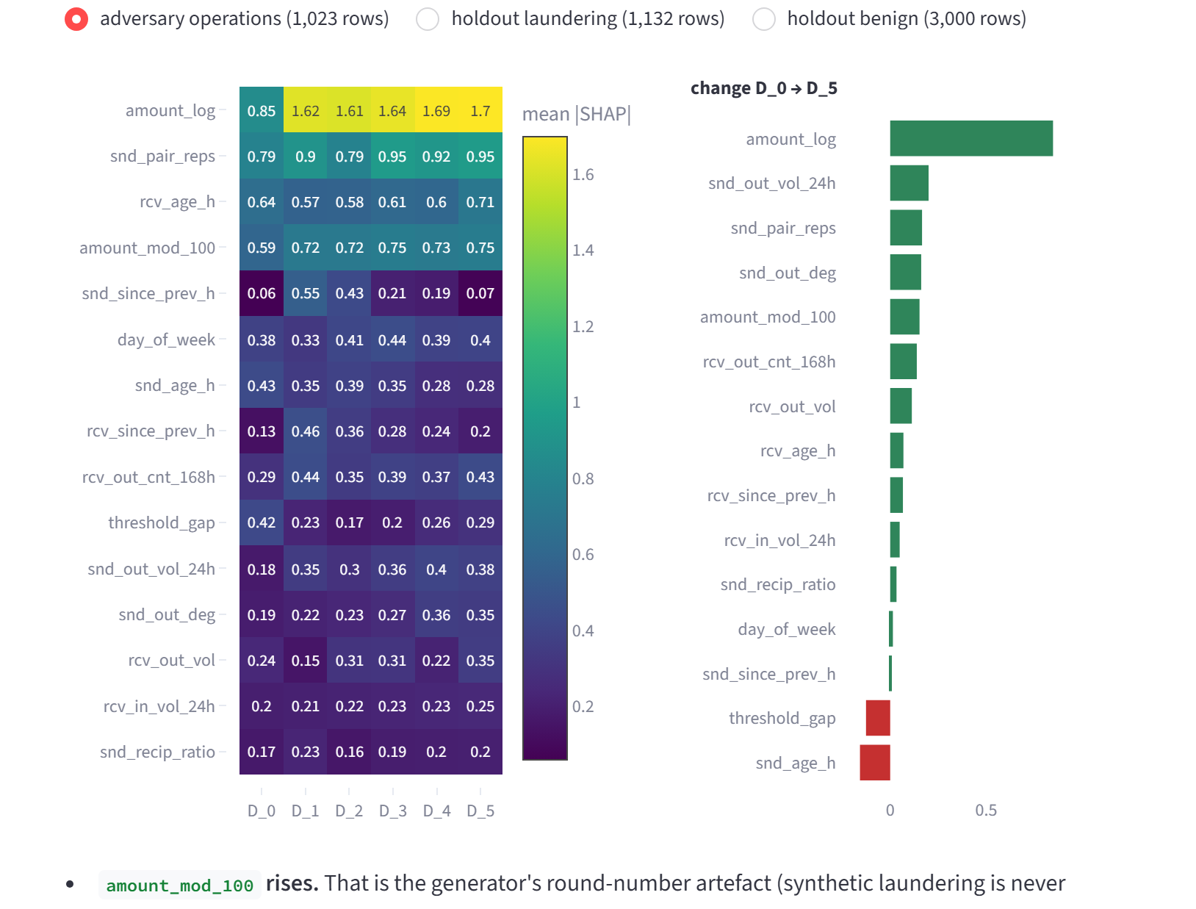
Fig. 8.7: Phase 4 page: attribution drift per feature per detector
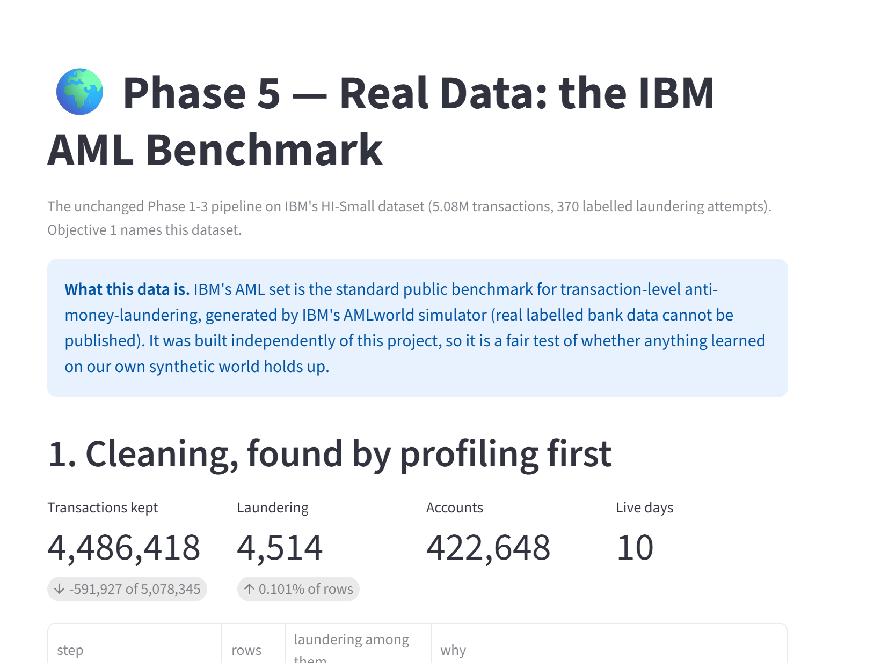
Fig. 8.8: Phase 5 page: IBM data cleaning, found by profiling the dataset first
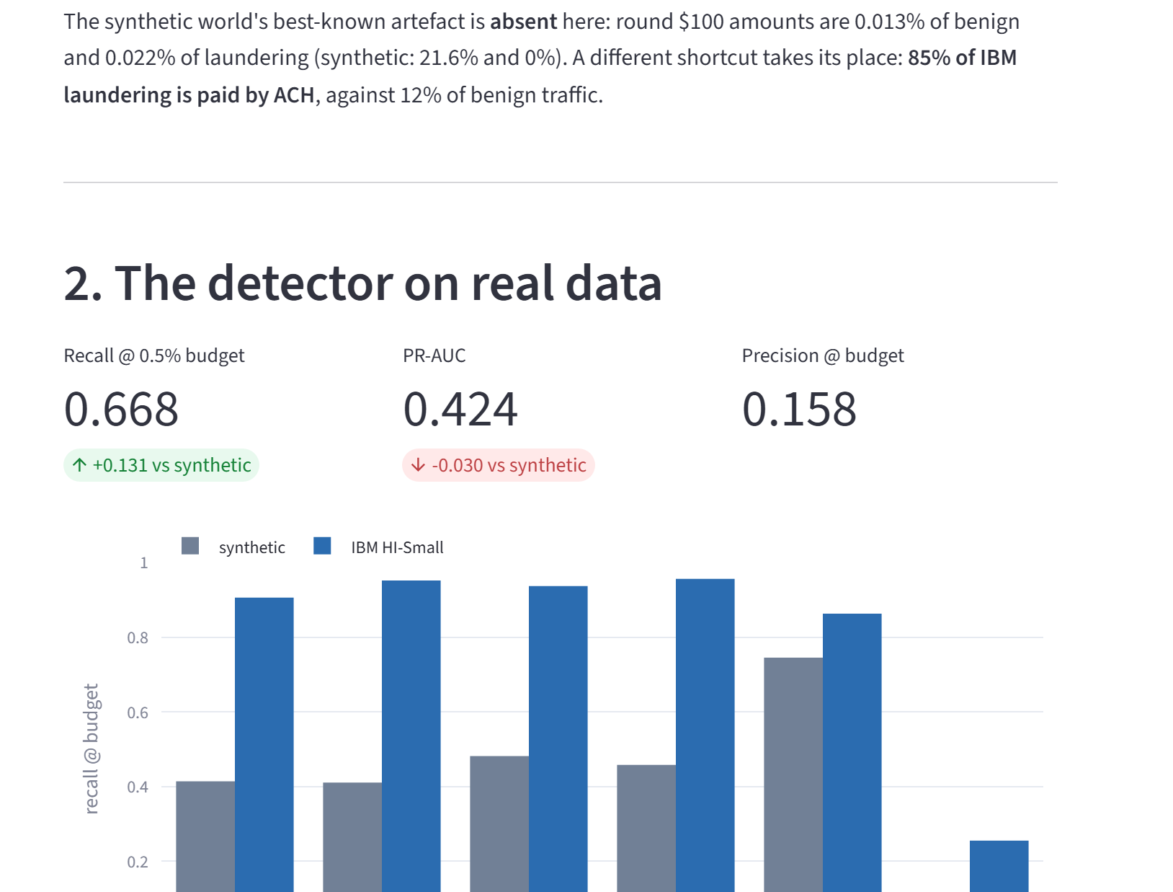
Fig. 8.9: Phase 5 page: the detector on real data, recall by typology
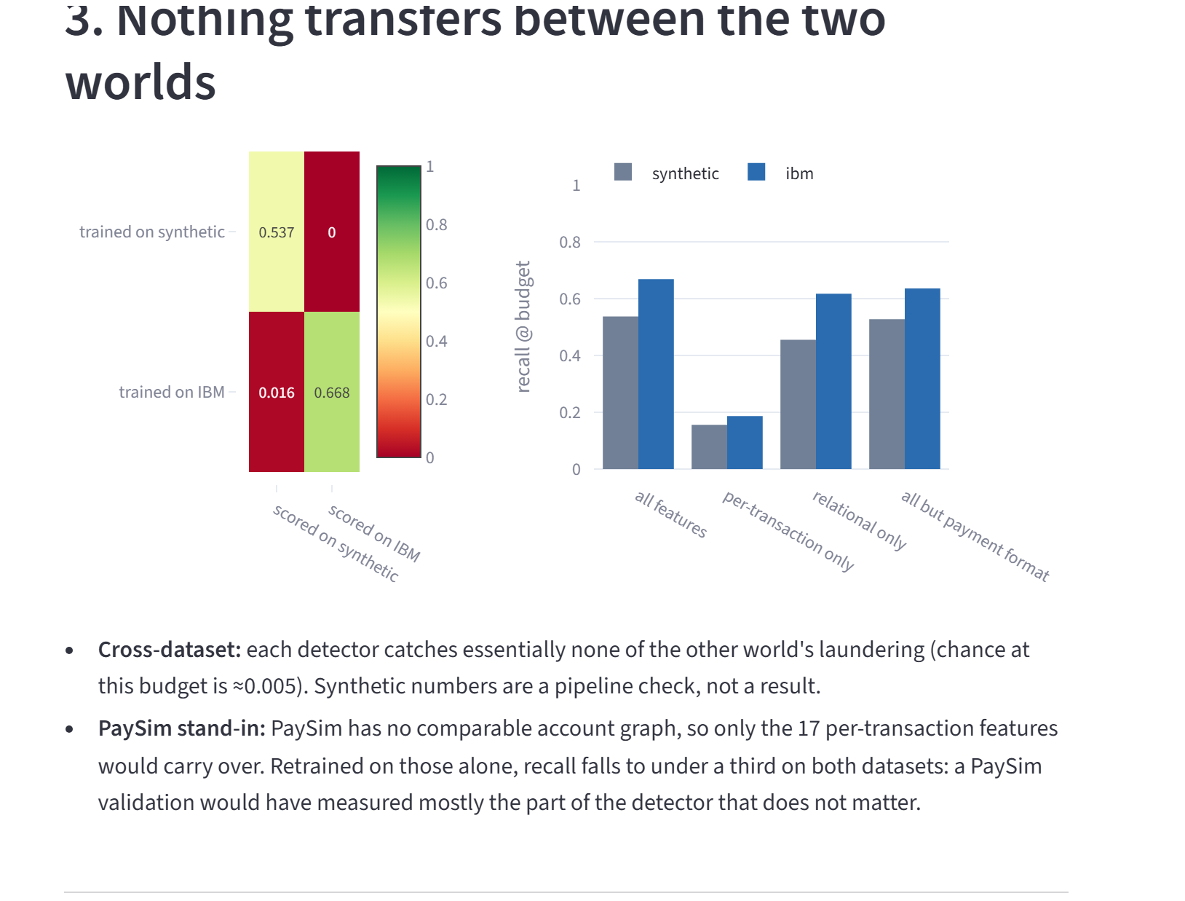
Fig. 8.10: Phase 5 page: transfer between the synthetic and the IBM world
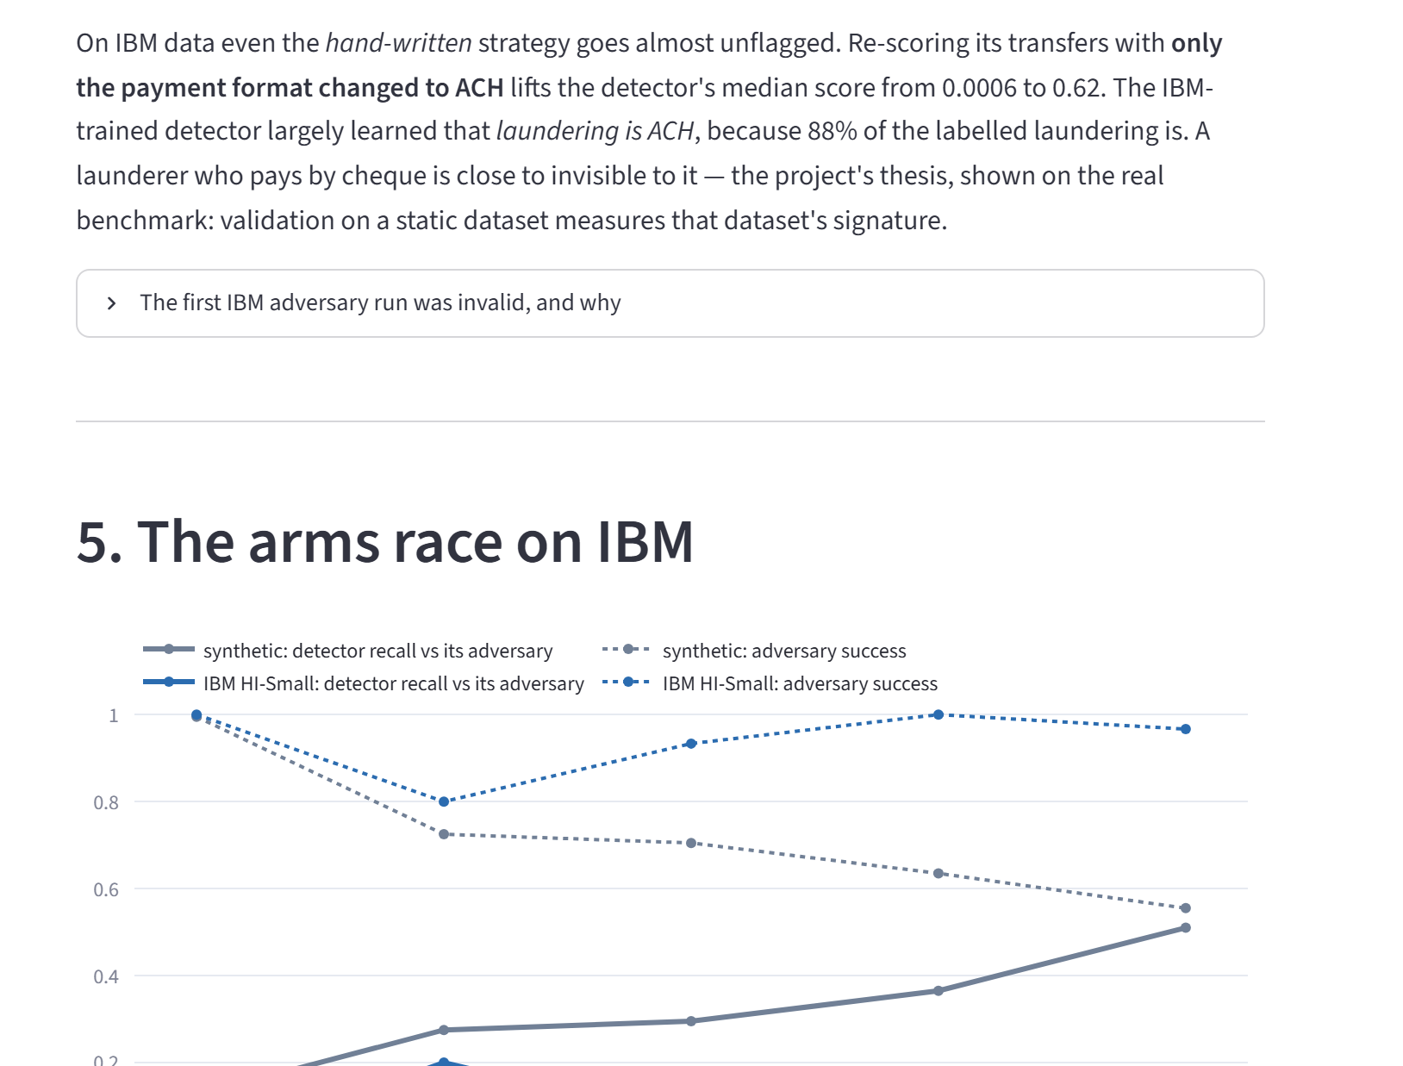
Fig. 8.11: Phase 5 page: why the adversary wins on IBM data, and the arms race beside the synthetic one
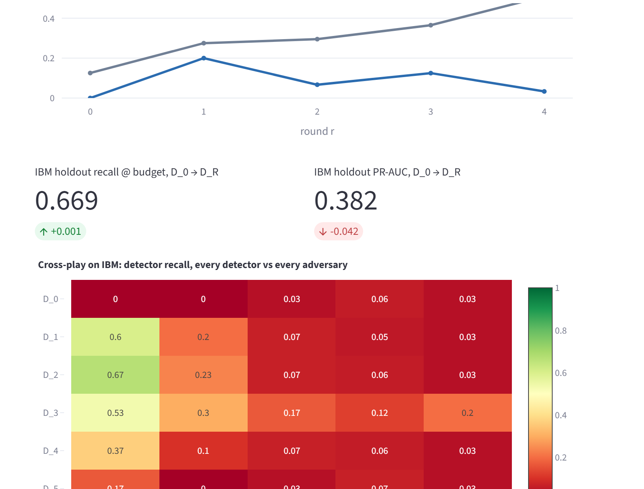
Fig. 8.12: Phase 5 page: IBM holdout cost and the cross-play matrix
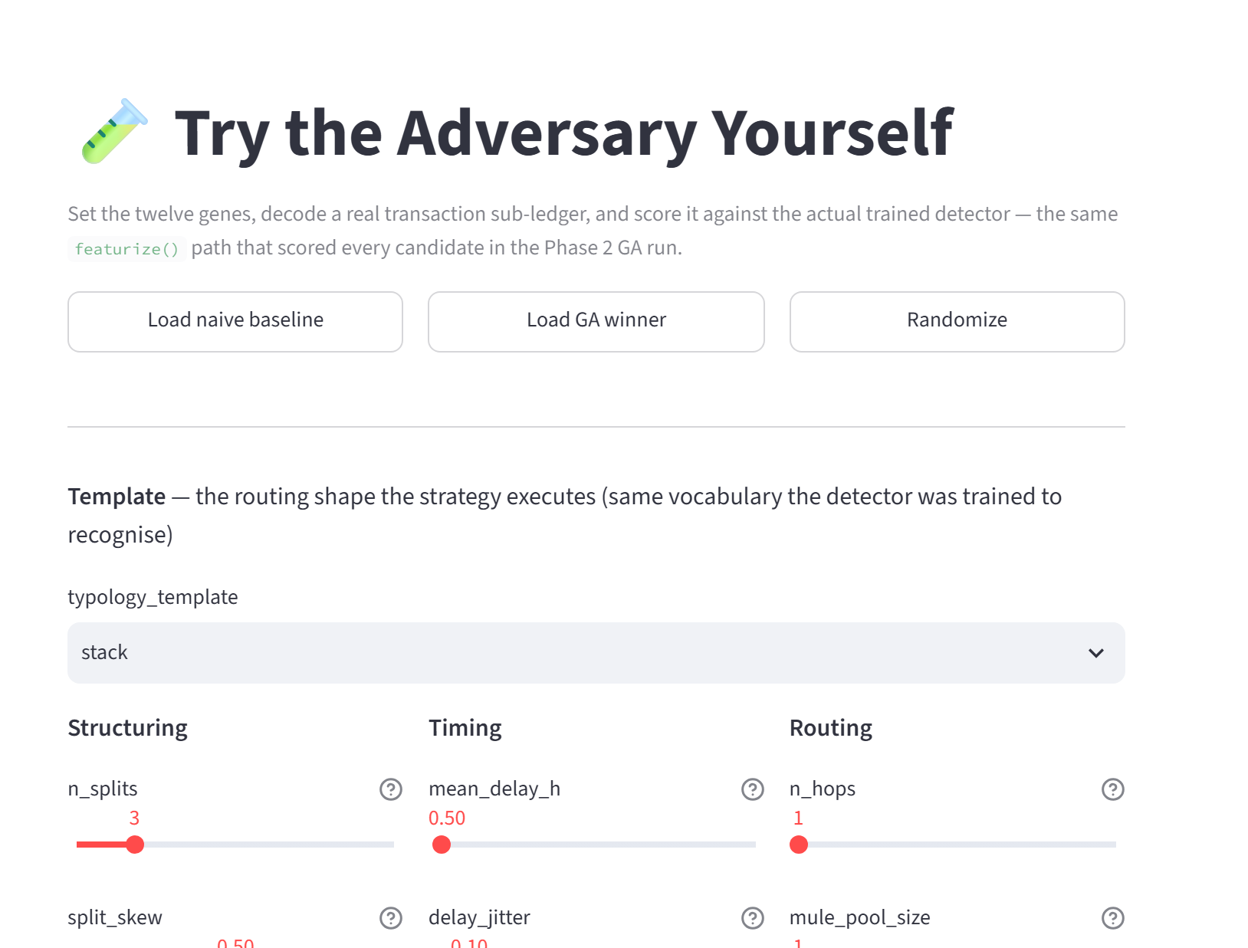
Fig. 8.13: Live explorer: set the twelve genes and score the decoded transactions

FUTURE ENHANCEMENT AND CONCLUSION

Future Enhancements
- A shortcut-resistant detector inside the arms race. The format-blind detector was only evaluated against fixed strategies; running it through the closed loop would show whether removing the shortcut lets feedback work on real data.
- Repeated runs. Repeating the closed loop over several seeds would give intervals over runs, not only over episodes, and a firmer reading of the IBM arms race.
- A realistic attacker. An adversary that sees only the detector's decisions (flag or no flag), not its scores, would be closer to a real launderer and would show how much the current results overstate the attacker.
- More data and models. The larger IBM variants (HI-Medium, LI-Small), PaySim for the per-transaction features, and graph neural network detectors compared with the tree model.
- Richer feedback and a live feed. Negative examples for strategies that failed, and a streaming simulation of transactions in place of the replay.

Conclusion
The Adversarial Fraud & AML Detection Arena does what the synopsis set out to do. It measures an AML detector against an opponent that adapts, round by round, and presents the result as an observable process instead of a single accuracy figure. A LightGBM detector was trained on the IBM AML dataset and recognises its laundering typologies at a recall of 0.668 at a 0.5% alert budget; a genetic-algorithm adversary with a twelve-gene genome evolves structuring, timing and routing strategies that are decoded into valid, money-conserving transactions; a fitness function balances evasion against completion; a closed loop feeds the strategies back and measures detector recall and adversary success over five rounds; and a dashboard shows the flows, strategies and the detector's response.
Three findings stand out. First, static scores overstate robustness: on IBM data a detector with recall 0.668 caught none of the transfers of a simple strategy paid by cheque. Second, feedback helps only when the weakness is a strategy: on synthetic data it raised recall against the adversary from 0.125 to 0.510, while on IBM data, where the weakness is a dataset shortcut, it did not. Third, an adversary is an effective auditor: its implausibly good scores exposed six flaws in the data, simulation and experiment, each of which an ordinary evaluation had passed. The limitations are stated in Section 7.5.

REFERENCES
[1] R. J. Bolton and D. J. Hand, "Statistical fraud detection: A review," Statistical Science, vol. 17, no. 3, 2002.
[2] A. Dal Pozzolo, G. Boracchi, O. Caelen, C. Alippi, and G. Bontempi, "Credit card fraud detection: A realistic modeling and a novel learning strategy," IEEE Transactions on Neural Networks and Learning Systems, vol. 29, no. 8, 2018.
[3] T. Saito and M. Rehmsmeier, "The precision-recall plot is more informative than the ROC plot when evaluating binary classifiers on imbalanced datasets," PLoS ONE, vol. 10, no. 3, 2015.
[4] A. Dal Pozzolo, O. Caelen, R. A. Johnson, and G. Bontempi, "Calibrating probability with undersampling for unbalanced classification," in Proc. IEEE Symposium Series on Computational Intelligence (SSCI), 2015.
[5] T. Chen and C. Guestrin, "XGBoost: A scalable tree boosting system," in Proc. 22nd ACM SIGKDD International Conference on Knowledge Discovery and Data Mining, 2016.
[6] G. Ke et al., "LightGBM: A highly efficient gradient boosting decision tree," in Advances in Neural Information Processing Systems 30 (NIPS), 2017.
[7] M. Weber et al., "Anti-money laundering in Bitcoin: Experimenting with graph convolutional networks for financial forensics," in KDD Workshop on Anomaly Detection in Finance, 2019.
[8] E. A. Lopez-Rojas, A. Elmir, and S. Axelsson, "PaySim: A financial mobile money simulator for fraud detection," in Proc. 28th European Modeling and Simulation Symposium (EMSS), 2016.
[9] E. Altman, J. Blanusa, L. von Niederhausern, B. Egressy, A. Anghel, and K. Atasu, "Realistic synthetic financial transactions for anti-money laundering models," in Advances in Neural Information Processing Systems 36, Datasets and Benchmarks Track, 2023.
[10] I. J. Goodfellow, J. Shlens, and C. Szegedy, "Explaining and harnessing adversarial examples," in Proc. International Conference on Learning Representations (ICLR), 2015.
[11] B. Biggio and F. Roli, "Wild patterns: Ten years after the rise of adversarial machine learning," Pattern Recognition, vol. 84, 2018.
[12] J. H. Holland, Adaptation in Natural and Artificial Systems. Ann Arbor, MI: University of Michigan Press, 1975.
[13] F.-A. Fortin, F.-M. De Rainville, M.-A. Gardner, M. Parizeau, and C. Gagne, "DEAP: Evolutionary algorithms made easy," Journal of Machine Learning Research, vol. 13, 2012.
[14] S. M. Lundberg et al., "From local explanations to global understanding with explainable AI for trees," Nature Machine Intelligence, vol. 2, no. 1, 2020.
[15] F. Pedregosa et al., "Scikit-learn: Machine learning in Python," Journal of Machine Learning Research, vol. 12, 2011.
[16] E. Altman, "IBM Transactions for Anti Money Laundering (AML)," Kaggle dataset, kaggle.com/datasets/ealtman2019/ibm-transactions-for-anti-money-laundering (HI-Small variant used).

