

stock auction: online auction system for stocks and ipo
A DBMS MINOR PROJECT REPORT SUBMITTED TO
THE NATIONAL INSTITUTE OF ENGINEERING, MYSURU
(An Autonomous Institute under Visvesvaraya Technological University, Belagavi)

in partial fulfillment for the award of degree of

Bachelor of Engineering
in

Computer Science and Engineering

Submitted By

Anirudh Krishna: 4NI24CS022

Akshay M P: 4NI24CS010
Aniruddha Shukla: 4NI24CS021
Anurag kumar: 4NI24CS024
Under the guidance of Usha K Patil
Assistant Professor
Department of CS&E NIE, Mysuru

Department of Computer Science & Engineering
THE NATIONAL INSTITUTE OF ENGINEERING
(Autonomous Institution) Mysuru - 570 008
2025-26

THE NATIONAL INSTITUTE OF ENGINEERING
(An Autonomous Institute under Visvesvaraya Technological University, Belagavi)

Department of Computer Science & Engineering

CERTIFICATE

This is to certify that the DBMS Minor project work entitled “stock auction: online auction system for stocks and ipo” is a bonafide work carried out by Anirudh Krishna: 4NI24CS022 ,Akshay M P: 4NI24CS010,Aniruddha Shukla: 4NI24CS021 ,Anurag Kumar: 4NI24CS024 in partial fulfillment for the award of degree of Bachelor of Engineering in Computer Science and Engineering, of Visvesvaraya Technological University, Belagavi, during the year 2025-26. It is certified that all corrections / suggestions indicated during internal assessment have been incorporated and the corrected copy has been deposited in the department library. This project report has been approved in partial fulfillment for the award of the said degree as per academic regulations of The National Institute of Engineering (Autonomous Institution).

Usha k Patil Assistant professor
Dept. of CSE NIE, Mysuru

Dr. Anitha R Professor and Head Dept. of CS&E
Nisha A G
Assistant Professor

Dept. of CSE
NIE, Mysuru
NIE, Mysuru

ABSTRACT
This project presents a real-time Auction Based Securities Allocation Platform designed to simulate the working of IPO bidding and stock auction systems. The platform manages the complete auction lifecycle, including company listing, auction creation, investor registration, bidding, share allocation, portfolio management, and transaction tracking. The system is developed to demonstrate important Database Management System concepts in a practical and interactive manner.

The application is built using React.js for the frontend interface, Node.js and Express.js for backend development, and PostgreSQL as the relational database. The project implements major DBMS concepts such as normalization, relational schema design, referential integrity, foreign key constraints, indexing, query optimization, and ACID-compliant transactions. Secure authentication and role-based access control are also implemented using JWT authentication and encrypted password storage.

The platform provides features such as real-time bidding, live auction monitoring, portfolio tracking, immutable transaction records, and automated share allocation based on bid priority. The system offers a transparent and efficient method for understanding securities auction workflows while demonstrating full-stack integration with a robust database architecture.

This project implements a real-time, auction-based securities allocation platform that simulates the mechanics of Initial Public Offering (IPO) bidding and secondary stock auctions. The system models the complete lifecycle of a securities auction — from company listing and administrator-controlled auction opening, through competitive investor bidding, to atomic price-discovery-based share allocation, portfolio tracking, and immutable transaction recording.
The platform demonstrates applied DBMS concepts including relational schema design, referential integrity enforcement, ACID-compliant multi-step transactions, parameterized query security, and JWT-based role-access control. The system is built on a 10-entity PostgreSQL database backed by an Express REST API (Node.js 18) and a React 18 frontend. Key features include real-time bid-book polling, price-time priority allocation, investor portfolio management, and a dedicated admin panel for auction lifecycle control.

ACKNOWLEDGMENT

I sincerely owe my gratitude to all the persons who helped and guided me in completing this mini project.

I am thankful to Dr. Negendra Parashar, Principal, NIE College, Mysuru, for all the support she has rendered.

I thank Dr. Anitha R, Professor and Head, Department of Computer Science and Engineering, for her constant support and encouragement throughout the tenure for the mini project work.

I would like to sincerely thank my guide Usha K Patil, Assistant Professor, Department of Computer Science and Engineering, for providing relevant information, valuable guidance and encouragement to complete this minor project.

Anirudh Krishna: 4NI24CS022
Akshay M P: 4NI24CS010
Aniruddha Shukla: 4NI24CS021
Anurag Kumar: 4NI24CS023

TABLE OF CONTENTS

CONTENTS

Abstract I
Acknowledgement II
Table Of Contents III
List Of Figures IV

Introduction 05
  - Background
  - Purpose
  - Objectives
  - Existing System and disadvantages
  - Proposed System and advantages
- Literature Review 07
- System Requirements 11
  - Hardware Requirements
  - Software Requirements
  - Functional Requirements
  - Non-Functional Requirements
- System Architecture 13
  - Schema Diagram
  - ER Diagram
- Implementation 15
  - Steps
  - Pseudocode
- Result and Screenshots 25
Conclusion and Future Enhancement 29
References 30

LIST OF FIGURES

FIG. NO. | DESCRIPTION | PAGE NO.
1 | ER Diagram | 14
2 | Schema Diagram | 15
3 | Login Page | 25
4 | Registration Page | 25
5 | Dashboard/ Market Overview | 26
6 | Auctions Page | 26
7 | IPO Auctions Page | 27
8 | Portfolio Page | 27
9  10 | Transaction History Page  Admin Panel Page | 28  28

Chapter 1

INTRODUCTION
The Auction Based Securities Allocation Platform is a web-based application developed to simulate the working of IPO bidding and stock auction systems. The project demonstrates the use of Database Management System concepts in real-time securities allocation and transaction handling.
The platform allows administrators to create and manage auctions while investors can place bids, track portfolios, and monitor transactions. The system ensures secure and efficient handling of data through relational database management and transaction processing.

Background
Stock markets and IPO systems are essential parts of modern financial systems. Traditional auction systems used in securities allocation involve complex processes that are difficult for students to understand practically.
This project was developed to provide an academic model of a real-world securities auction platform using database technologies. The platform demonstrates auction management, share allocation, investor participation, and portfolio tracking using relational database principles

Purpose
The purpose of this project is to design and develop a database-driven securities auction platform that demonstrates the practical implementation of Database Management System concepts in a real-world scenario. The system is intended to simulate the working of IPO bidding and stock auction systems in a simplified and transparent manner for academic understanding.
The project aims to provide a secure environment where administrators can create and manage auctions while investors can participate in real-time bidding activities. The platform is designed to automate the complete auction lifecycle, including bid placement, ranking, share allocation, portfolio management, and transaction recording.
Another important purpose of this project is to demonstrate how relational databases can efficiently manage large amounts of interconnected data while maintaining consistency, integrity, and security. The system also highlights the importance of query optimization, indexing, and transaction management in building efficient database applications.
In addition to DBMS concepts, the project also focuses on full-stack web development using React.js, Node.js, Express.js, and PostgreSQL. The application provides a user-friendly interfacefor investors and administrators while maintaining secure authentication and role-based access control.

Objective
The main objective of the Auction Based Securities Allocation Platform is to design and implement a secure and efficient web-based auction management system using modern technologies and full-stack development tools.
The project focuses on demonstrating the practical implementation of important DBMS concepts such as relational schema design, normalization, indexing, constraints, foreign keys, and transaction processing. The system also aims to provide a clear understanding of how auction systems function in real-world financial environments.
The specific objectives of the project are:
• To design a normalized relational database schema for auction management
• To implement secure user authentication and role-based access control
• To develop a real-time bidding system for investors
• To automate share allocation based on bid ranking and auction rules
• To maintain transaction history and investor portfolio records
• To implement ACID-compliant transactions using PostgreSQL
• To demonstrate query optimization and indexing techniques
• To provide a responsive and user-friendly interface using React.js
• To integrate frontend, backend, and database components efficiently
• To develop an educational platform for understanding securities auction workflows

Existing System Summary
The existing securities allocation systems are highly centralized and difficult to analyze for educational purposes.
Disadvantages:
• Lack of transparency
• Difficult to understand auction workflow
• No academic demonstration platform
• Limited access to internal processes
• Complex implementation for beginners

Limitations Identified from the Analysis

After analyzing the existing securities allocation and auction management systems, several limitations were identified. Most existing systems are highly centralized and do not provide transparency regarding the internal bidding and allocation process. These systems are mainly designed for commercial use and are difficult for students and beginners to understand from an academic perspective.

Many existing platforms do not provide proper visualization of database operations, transaction management, and share allocation mechanisms. The internal workflow of the auction lifecycle, including bid ranking, portfolio updates, and transaction recording, is generally hidden from users. This makes it difficult to study the practical implementation of DBMS concepts in real-world systems.

Another major limitation is the lack of educational platforms that demonstrate the use of normalization, indexing, referential integrity, foreign keys, and ACID transactions in auction-based applications. Existing systems are also complex to implement and require advanced infrastructure and financial integrations.

The analysis also showed that many systems provide limited flexibility for testing and learning purposes. Real-time monitoring, secure authentication, transparent allocation mechanisms, and detailed transaction tracking are not easily accessible for academic projects and demonstrations.

The identified limitations motivated the development of the proposed Auction Based Securities Allocation Platform with improved transparency, security, database management, and educationalusability.

Proposed System: Stock & IPO Auction System
The proposed system, Stock & IPO Auction System, is a full-stack, database-driven web application that simulates the complete lifecycle of a securities auction. The platform is designed to help students and practitioners understand how real-world IPO bidding and stock auction mechanisms work, with complete transparency of the underlying database operations, queries, and allocation logic.

The system allows administrators to create and manage auctions for both secondary-market stocks and new IPO offerings. Investors can register, browse live auctions, place competitive bids, monitor real-time bid rankings, and track their portfolio and transaction history. When an admin closes an auction, the system automatically runs a price-time priority allocation algorithm inside a single ACID transaction — distributing shares, updating portfolios, debiting investor balances, and recording immutable transaction entries atomically.
The Stock & IPO Auction System is developed using React 18 for the frontend, Node.js 18 and Express.js for backend API processing, and PostgreSQL 15 as the relational database. JWT-based authentication enforces role-based access control between investor and admin users. The system demonstrates normalization, indexing, referential integrity, transactions, and constraint enforcement in a practical financial context.

Advantages
• Provides real-time, transparent auction bidding and allocation
• Demonstrates ACID-compliant PostgreSQL transactions for share allocation
• Implements price-time priority — fair and academically verifiable
• Allows investors to track live bid rankings, portfolios, and transactions
• Role-based access control separates admin and investor capabilities
• Fully parameterized SQL queries prevent SQL injection attacks
• Indexed queries ensure fast bid and auction retrieval at scale
• JWT-based stateless authentication improves API security
• 10-table normalized schema demonstrates 3NF database design
• Educational platform for understanding financial auction workflows

• Watchlist feature lets investors track companies of interest
• Bid immutability preserves full audit trail of investor intent
• Polymorphic auction design handles both stock and IPO types
• Live countdown timers and 3-second polling for real-time UX
• Seed data with demo accounts for immediate testing and demonstration
• Complete admin panel for auction lifecycle management
• Atomic rollback on any allocation failure prevents partial state
• bcrypt password hashing ensures secure credential storage
• Responsive React UI works across devices and screen sizes
• Open-source, easily deployable with PostgreSQL and Node.js

Chapter 2

LITERATURE REVIEW

The development of online auction platforms and securities allocation systems has grown significantly with the adoption of digital financial technology. Traditional IPO allocation methods are centralized and non-transparent, creating a need for open, database-driven academic models that can demonstrate the complete auction lifecycle. Research in financial database systems highlights the importance of ACID transactions, referential integrity, and query optimization in handling concurrent bidding scenarios reliably.
Several studies on relational database design in financial applications emphasize the use of normalized schemas, foreign key constraints, and index strategies to maintain data consistency and improve query performance under concurrent load. The use of PostgreSQL for financial applications is well documented due to its support for MVCC, serializable isolation levels, and rich constraint syntax. The price-time priority allocation model used in securities auctions is a standard technique covered in market microstructure literature.
Existing commercial platforms such as BSE's IPO bidding system and NSE's ASBA mechanism demonstrate the practical need for atomic multi-table transactions in share allocation. However, these systems are proprietary and not accessible for academic study. Open-source educational platforms that model the full auction lifecycle — including bid ranking, share allocation, portfolio management, and transaction logging — are limited, motivating the development of this project.
The proposed Stock & IPO Auction System is designed to address these gaps by providing an academically transparent, full-stack implementation of securities auction mechanics. The system uses parameterized SQL queries, bcrypt password hashing, JWT authentication, and PostgreSQL transactions to demonstrate security and reliability principles alongside relational database concepts.
The system architecture follows a standard three-tier model: React 18 frontend, Express.js REST API backend, and PostgreSQL database. This architecture is well-supported in academic literature on web application development and provides a clean separation of concerns for demonstration and testing. The combination of real-time polling, role-based access control, and atomic allocation makes this system a comprehensive reference implementation for database-driven financial applications.

Chapter 3

SYSTEM REQUIREMENTS

Hardware Requirements
    - Processor: Intel Core i5 or above
    - RAM: Minimum 8 GB
    - Storage: Minimum 128 GB HDD/SSD
    - Display: 1366×768 resolution or higher
    - Network: Internet access for testing APIs and email functionality

Software Requirements
    - Operating System: Windows 10 / Ubuntu 20.04 or later
    - Backend Platform: Node.js (v18.x or later)
    - Web Framework: Express.js
    - Database: PostgreSQL
    - Environment Management: dotenv
    - Package Manager: npm (Node Package Manager)
    - Development Tools:
      - Visual Studio Code (Code Editor)
      - Postman (API Testing)
      - Git (Version Control)
    - Node Packages Used:
      - bcrypt (for password encryption)
      - express-session (for session handling)
      - jsonwebtoken (for JWT authentication)
      - pg / node-postgres (for PostgreSQL connectivity)
      - cors, body-parser (middleware utilities)

Functional Requirements:
The functional requirements of the Stock & IPO Auction System define the main operations provided to investors and administrators. The application must allow users to register accounts, log in securely using JWT authentication, and manage their profiles including password changes and balance information. Investors must be able to browse active auctions, view real-time bid books, and place competitive bids on both stock and IPO auction types.

The system must enforce bid validity rules: bids must exceed the current highest bid by at least ₹0.50, quantities must not exceed available shares, and investors must have sufficient balance for their bid. Administrators must be able to create, open, and close auctions. Upon closing, the system must atomically allocate shares using price-time priority, update investor portfolios, debit balances, and record immutable transaction entries.

The platform should provide investors with a portfolio page showing all allocated holdings and a transaction history page for audit purposes. A watchlist feature must allow investors to monitor specific stocks. The admin panel must display all auctions, users, and system statistics. Database operations including user data, bid records, portfolio entries, and transaction logs must be handled securely using parameterized queries to prevent SQL injection.

The administrator must have exclusive access to auction management functions including creating new company listings, setting auction parameters (base price, share count, time window, auction type), and triggering the allocation algorithm. Role-based access control must prevent investors from accessing admin endpoints. The allocation process must be ACID-compliant and must roll back completely on any failure to prevent partial share distribution.

3.4 Non-Functional Requirements

The non-functional requirements of the Stock & IPO Auction System describe quality, performance, security, and reliability aspects. The application must provide fast response times for bid placement and auction retrieval. Database indexes on auction_id, user_id, and status columns must ensure efficient query execution even with large volumes of bids. The 3-second polling mechanism on auction detail pages must not degrade server performance under concurrent user load.
.
The system must maintain ACID compliance for all share allocation transactions. Referential integrity constraints and check constraints must prevent invalid data from entering the database. Bcrypt password hashing and JWT expiration enforce authentication security. All SQL queries must use parameterized form ($1, $2 … placeholders) to eliminate SQL injection vulnerabilities. User balances must be protected by CHECK (balance >= 0) constraints at the database level.

The Stock & IPO Auction System must provide high availability and smooth functionality across modern browsers. The React frontend must be responsive and accessible on different screen sizes. Error handling must provide clear user feedback for bid rejections, authentication failures, and auction state violations. The system must be easy to maintain, with a clear project structure separating frontend, backend, and database layers. The PostgreSQL schema must be designed for scalability, supporting additional companies, auctions, and users without structural changes.

Chapter 4

SYSTEM ARCHITECTURE

4.1 System Design

The system design of the Stock & IPO Auction System focuses on providing a secure, efficient, and educationally transparent platform for securities auction management. The workflow begins with user registration and JWT authentication. After login, investors can browse live auctions, inspect bid books, and place competitive bids. Administrators manage the full auction lifecycle through a dedicated admin panel.

The frontend is developed using React 18 with functional components, React Router for navigation, and Axios for API communication. Ten pages cover the complete user journey: Login, Register, Market Overview, Auctions, IPO Page, Auction Detail, Portfolio, Transactions, Profile, and Admin Panel. The AuthContext manages JWT state, and a 3-second polling interval on auction detail pages keeps the bid book current.

The system includes strict validation at every layer: frontend form validation, backend business-rule checks, and database constraint enforcement. Bid insertion uses a guarded atomic INSERT with a WHERE clause to prevent time-of-check/time-of-use race conditions. The allocation algorithm runs inside a single PostgreSQL transaction with ROLLBACK on any failure, ensuring that partial share distributions are never committed to the database.

4.2 System Architecture
The Online Auction Based Securities Allocation Platform follows a three-tier architecture consisting of the frontend layer, backend layer, and database layer. The frontend layer provides the user interface where investors and administrators interact with the system. Users can log in, view auctions, place bids, monitor IPO listings, manage portfolios, and track transactions through the frontend interface. React.js is used to

build a responsive and interactive frontend that improves user experience and allows smooth navigation between modules.
The backend layer handles all server-side operations and business logic. Node.js and Express.js are used to process requests received from the frontend and communicate with the database system. The backend manages functionalities such as authentication, auction creation, bid processing, IPO management, portfolio allocation, and transaction handling. REST APIs are implemented to ensure efficient communication between frontend and backend modules. Validation and authentication mechanisms are also implemented in the backend to maintain security and data integrity.
The database layer stores all application-related information such as user accounts, company details, auctions, bids, IPO listings, portfolios, and transaction history. A relational database management system such as PostgreSQL or MySQL is used to maintain structured storage of data. Database normalization, foreign keys, constraints, and indexing techniques are implemented to ensure efficient data organization and query performance. The architecture ensures smooth communication between system components while providing security, scalability, reliability, and efficient data management.

4.3 ER Diagram
The Entity Relationship Diagram (ER Diagram) represents the relationship between different entities involved in the Online Auction Based Securities Allocation Platform. The ER diagram helps in understanding how users, companies, auctions, bids, IPOs, portfolios, transactions, and administrators are connected within the database system.
The main entities used in the system are USER, COMPANY, AUCTION, BID, IPO, PORTFOLIO, TRANSACTION, and ADMIN. The USER entity stores investor information and is connected to BID, PORTFOLIO, and TRANSACTION tables through relationships. The COMPANY entity maintains details related to companies participating in auctions and IPO listings. The AUCTION entity manages live and upcoming auctions for different companies.
The BID entity stores bid details submitted by investors during auctions. The IPO entity manages IPO-related information such as price bands and subscription status. The PORTFOLIO entity stores allocated shares and investment information for users. The TRANSACTION entity maintains transaction history and share allocation records. The ADMIN entity handles auction management, monitoring, and system control functionalities.
The ER diagram demonstrates proper implementation of relational database concepts such as primary

keys, foreign keys, relationships, and referential integrity. It helps maintain efficient data organization and ensures smooth communication between database entities.

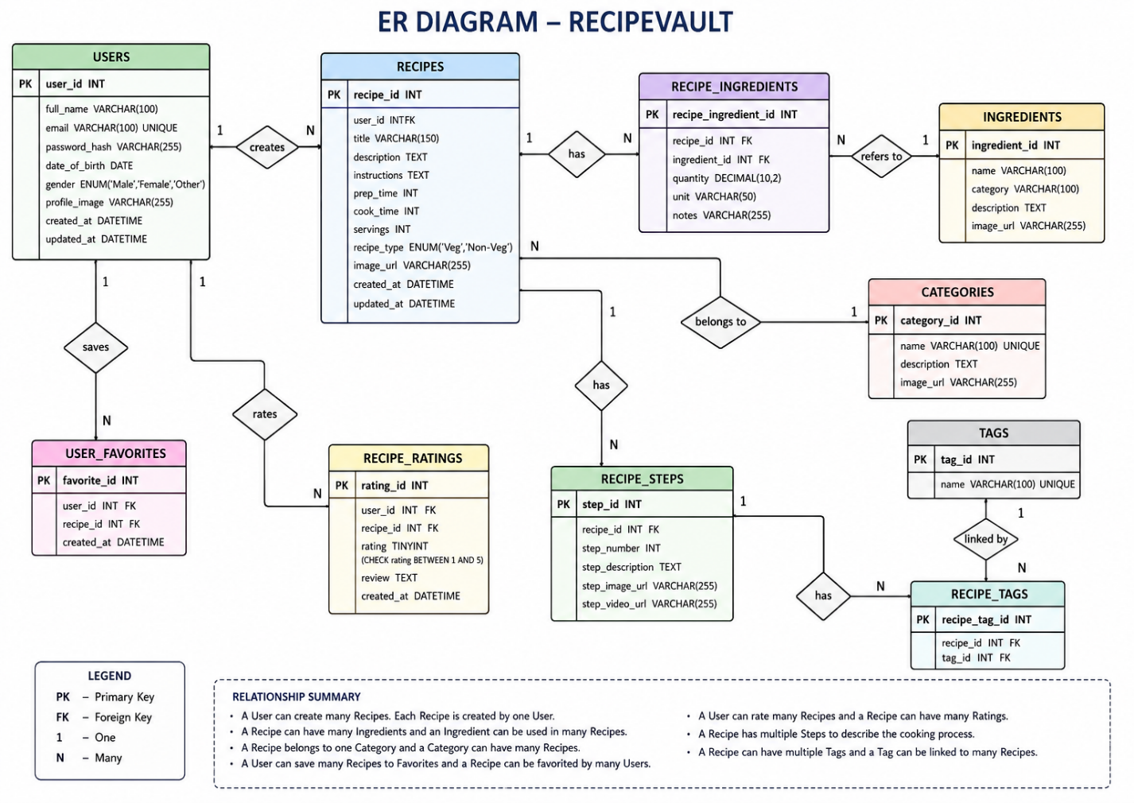

Fig:1 ER Diagram

4.4 Schema Diagram
The schema diagram of the Online Auction Based Securities Allocation Platform represents the structure of database tables and their relationships. The schema defines how application data is stored and managed within the relational database management system. Separate tables are created for users, companies, auctions, bids, IPOs, portfolios, transactions, and administrators.
Primary keys are used to uniquely identify records in each table, while foreign keys establish relationships between related tables. The USER table stores investor details, while the COMPANY table stores company-related information. The AUCTION table maintains auction records and references the COMPANY table using foreign keys.
The BID table stores investor bid details and references both USER and AUCTION tables. The IPO table investment details for investors. The TRANSACTION table maintains allocation records and transaction history. The ADMIN table stores administrator login credentials and management information.
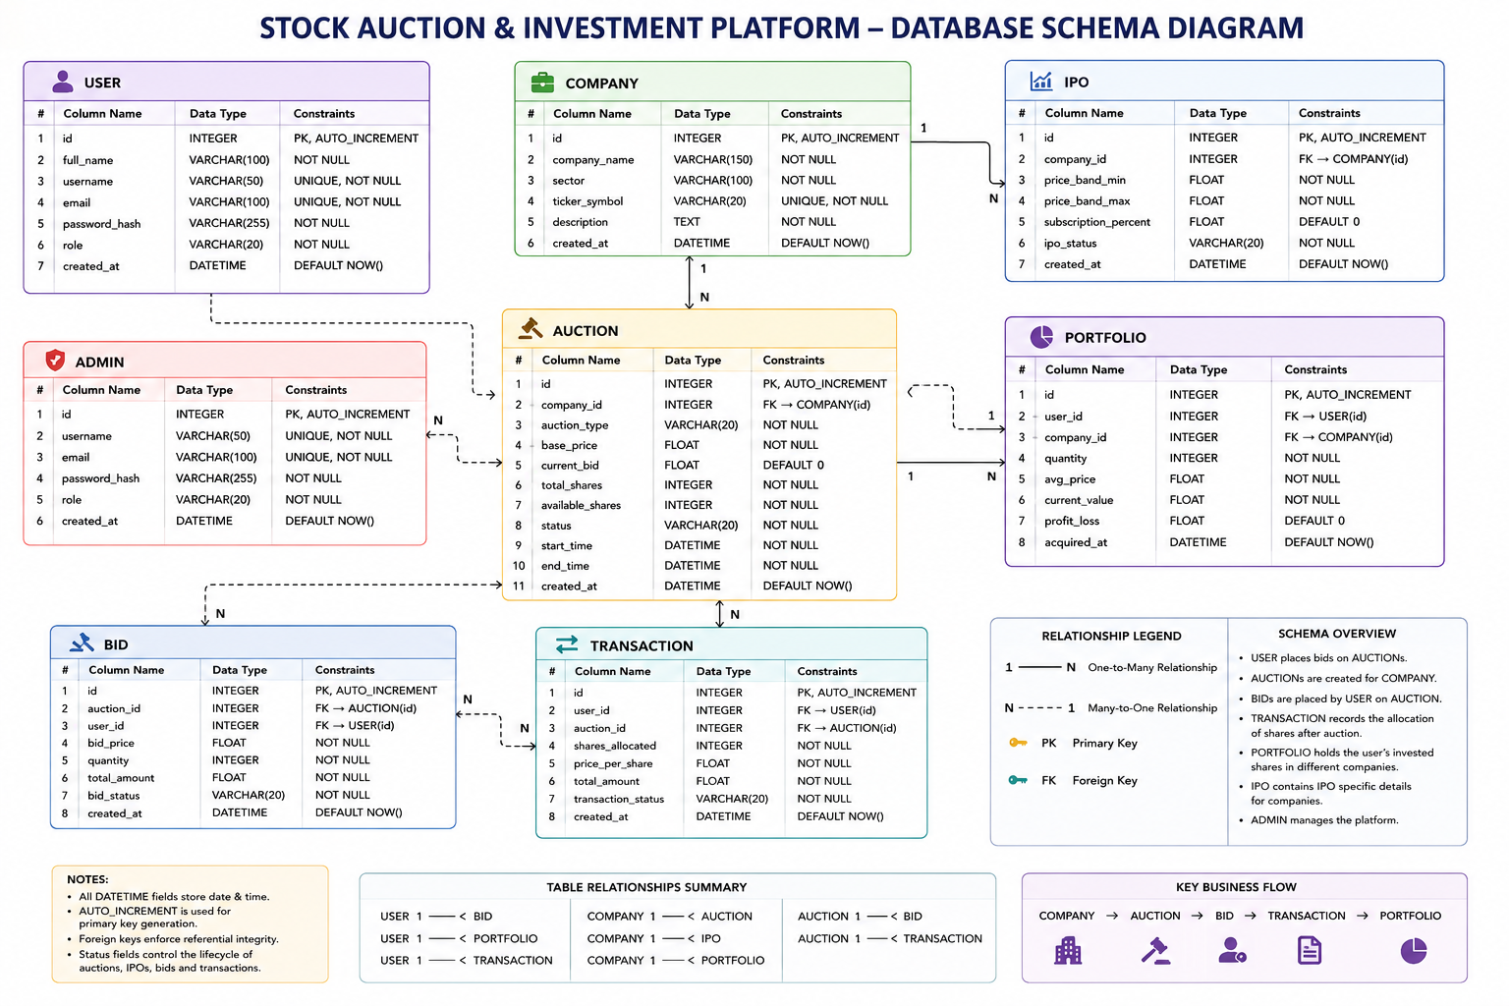
The schema diagram demonstrates implementation of normalization techniques, relational schema design ,constraints, and referential integrity to maintain data consistency and efficient query processing.
Fig:2 Schema Diagram

4.5 Database Schema

The database comprises 10 primary entities with well-defined relationships enforcing referential integrity:

USER
id | full_name | username | email | password_hash | role | created_at

COMPANY
id | company_name | sector | ticker_symbol | description | created_at

STOCK
id | company_id | auction_type |  | base_price | current_bid | total_shares |  | available_shares | status
start_time |  |  | end_time |  |  |  | created_at

IPO
id | auction_id | user_id | bid_price | quantity | total_amount | bid_status | created_at

AUCTION
id | user_id | company_id | quantity | avg_price | current_value | profit_loss | acquired_at

BID
id | user_id | auction_id | shares_allocated |  | price_per_share | total_amount
transaction_status |  |  |  | created_at

BID_RANKING

PORTFOLIO

TRANSACTION

WATCHLIST

Chapter 5

IMPLEMENTATION

Steps involved in implementation are:

The implementation of the Stock & IPO Auction System is carried out using modern web technologies and database management concepts to create a secure, real-time securities auction platform. The application is divided into frontend development, backend API processing, database schema design, authentication handling, bid management, and auction allocation modules. Each module is implemented separately and integrated to ensure smooth end-to-end communication from user interaction to database persistence.
The frontend implementation uses React 18 to build a responsive, component-based interface. Pages include Login, Register, Market Overview, Auctions, IPO Page, Auction Detail, Portfolio, Transactions, Profile, and Admin Panel. React Router handles client-side navigation, Axios manages HTTP requests with JWT Bearer headers, and AuthContext provides global authentication state. Auction detail pages use 3-second polling to keep bid books and countdown timers current in real time.
The backend is implemented using Node.js 18 and Express.js. REST API routes cover authentication (/api/auth), auctions (/api/auctions), bids (/api/bids), portfolio (/api/portfolio), transactions (/api/transactions), and watchlist (/api/watchlist). A JWT middleware guard protects all authenticated endpoints. All SQL is executed through the node-postgres (pg) pool using parameterized queries — no ORM is used, ensuring direct visibility of every database operation.
The database implementation uses PostgreSQL 15 with a 10-table normalized schema. Raw SQL with parameterized placeholders is used throughout to prevent SQL injection. The auction allocation runs inside a single BEGIN/COMMIT/ROLLBACK transaction that ranks bids by price then time, distributes shares, updates portfolio records, debits investor balances, and inserts transaction audit rows atomically. Check constraints, unique constraints, and foreign keys enforce data integrity at the database level.
The bid placement uses a guarded atomic INSERT to prevent race conditions: the INSERT only succeeds if the submitted price is at least ₹0.50 above the current maximum bid, checked inside the same SQL statement. This eliminates the time-of-check/time-of-use window that would allow two simultaneous bids at the same price to both succeed. If the guard fails, zero rows are inserted and the API returns HTTP 409 with an informative message.

After completing frontend, backend, and database implementation, all modules are integrated and tested. Functional testing covers bid placement, auction lifecycle, allocation correctness, portfolio updates, and transaction recording. Edge cases including insufficient balance, closed auctions, duplicate bids, and concurrent bid races are verified. Seed data with four user accounts, six companies, and multiple active auctions allows immediate end-to-end demonstration of the complete system.

5.2 PSEUDOCODE

The frontend implementation of the Stock & IPO Auction System focuses on building a responsive, real-time interface for investors and administrators. React 18 is used with functional components and hooks for efficient state management. The AuthContext stores JWT tokens and user roles, enabling protected routes that redirect unauthenticated users to the login page.

The Login and Register pages submit credentials via Axios POST requests to the backend authentication API. On successful login, the JWT is stored in context and the user is redirected to the Market Overview. Validation is applied on both frontend (form checks) and backend (credential verification) to prevent invalid submissions.

The Auction Detail page is the most interactive component. It displays the company information, live bid book sorted by price then time, a countdown timer showing time remaining, and a Place Bid form. The page re-fetches auction and bid data every 3 seconds using useEffect with an interval, pausing when the browser tab is hidden to conserve resources.
The Portfolio page displays all shares allocated to the current investor with company names, quantities, average purchase prices, and current values. The Transactions page provides an immutable audit trail of all share allocations. The Admin Panel allows administrators to create auctions, view all bids, and close auctions to trigger allocation.
API communication is handled through an Axios instance with a base URL and a request interceptor that attaches the JWT Bearer token to every authenticated request. Error responses from the API (4xx/5xx) are caught and displayed as toast notifications. Loading states and error boundaries are implemented across pages to improve reliability.

5.3 Backend Implementation
The backend of the Stock & IPO Auction System is developed using Node.js 18 and Express.js to manage REST API routing, authentication, bid validation, auction lifecycle control, and the share allocation engine. The server listens on port 5000 and communicates with the React frontend via JSON-encoded HTTP responses.

Express.js routes are organized by domain: /api/auth (register, login, profile), /api/auctions (CRUD + open/close), /api/bids (place, list), /api/portfolio (investor holdings), /api/transactions (audit log), and /api/watchlist (add, remove, list). A JWT middleware function verifies the Bearer token on every protected route and attaches the decoded user payload to the request object for downstream handlers.

Authentication uses bcrypt (cost factor 10) to hash passwords before storage and jsonwebtoken to sign 24-hour JWT tokens on login. Role enforcement is applied at the route level: admin-only routes return HTTP 403 if the token's role field is not 'admin'. The admin role is hard-coded in the database and cannot be self-assigned through the registration endpoint.

Bid placement applies a multi-layer validation gauntlet: positive numbers, open auction status, quantity within available shares, sufficient investor balance, and price above the current maximum. The final check is enforced inside the atomic guarded INSERT, eliminating the race condition that would otherwise allow two simultaneous bids at the same price to both succeed.

The backend communicates with PostgreSQL using the node-postgres (pg) connection pool. All queries use the parameterized $1/$2/... syntax to prevent SQL injection. The auction close endpoint triggers the allocation algorithm, which runs entirely within a single BEGIN/COMMIT transaction. If any step fails, ROLLBACK ensures no partial state is persisted.

The backend implementation of the Stock & IPO Auction System provides efficient request handling, multi-layer bid validation, atomic allocation execution, and secure authentication. It acts as the central coordinator between the React frontend and the PostgreSQL database, ensuring data integrity and consistent application state at all times.

5.4 Database Implementation
The database of the Stock & IPO Auction System is implemented in PostgreSQL 15 using a 10-table normalized relational schema. The schema is designed to be in at least Third Normal Form (3NF), eliminating transitive dependencies and reducing redundancy. All tables use SERIAL primary keys, and relationships are enforced through foreign key constraints with CASCADE delete rules.

The ten tables are: user (accounts, balances, roles), company (listed companies), stock (secondary-market share inventory), ipo (IPO offering windows with price bands), auction (the auction event and its state), bid (every bid placed by investors), bid_ranking (allocation results), portfolio (investor share holdings), transaction (immutable audit log), and watchlist (investor-followed stocks).

Primary keys uniquely identify each record. Foreign keys link bid to auction and user; portfolio to user and stock; transaction to user and auction. UNIQUE constraints on (user_id, stock_id) in portfolio prevent duplicate holdings rows. CHECK constraints enforce positive balances, positive prices, and valid role values. The auction table uses a polymorphic reference_id pointing to either stock or ipo depending on the type column.

Database normalization techniques are applied throughout. The separation of company, stock, and ipo into distinct tables eliminates repeating groups and partial dependencies. The bid_ranking table stores allocation results separately from bids to avoid update anomalies. Indexes on bid(auction_id), bid(user_id), auction(status), portfolio(user_id), and transaction(user_id) are created to optimize the most frequent queries.

The database communicates with the backend through the node-postgres pool using parameterized queries for all operations. The allocation transaction uses a series of SELECT, INSERT, and UPDATE statements coordinated by the application layer inside a single BEGIN/COMMIT block. If any statement fails — for example a balance going negative — the entire block is rolled back via ROLLBACK, ensuring the database remains in a consistent state.
The schema file (schema.sql) serves as the canonical definition of the database structure and includes seed data for immediate demonstration. This approach ensures reproducible deployments and makes the database design fully transparent for academic review. The schema can be re-applied at any time to reset the system to its initial state.

5.5 Steps Involved in Implementation

The implementation process begins with requirement analysis and project planning. The objectives, entities, relationships, and workflow of the auction system are defined. User stories covering investor registration, bid placement, admin auction management, and share allocation are analyzed before development begins.

The next step involves designing the 10-table PostgreSQL schema. Tables are created for user, company, stock, ipo, auction, bid, bid_ranking, portfolio, transaction, and watchlist. Foreign key relationships, unique constraints, check constraints, and indexes are defined to enforce referential integrity and optimize query performance.
Frontend development is then carried out using React 18. The ten application pages are built as functional components with React Router navigation. The AuthContext provides global JWT state management. CSS styling and responsive layouts are implemented for cross-device compatibility. Axios is configured with a base URL and JWT interceptor for authenticated API calls.

Backend development is performed using Node.js 18 and Express.js. REST API routes are implemented for authentication, auctions, bids, portfolio, transactions, and watchlist. JWT middleware guards protected routes. The bid placement endpoint implements atomic guarded INSERT logic. The auction close endpoint implements the full ACID allocation transaction.
Once frontend and backend development are complete, modules are integrated. API communication, JWT flow, real-time polling, and allocation triggers are tested end-to-end. Database queries and constraint enforcement are verified against the complete seed data set.
Finally, testing and debugging are performed. Bid race conditions, insufficient balance rejection, closed auction enforcement, and allocation rollback on failure are all tested. Functional testing, database query testing, and UI testing are completed before final documentation and demonstration preparation.

5.6 Pseudocode
// ====== SYSTEM INITIALIZATION ======
MAIN():
load_config()
connect_database()
start_server(routes)

// ====== USER AUTHENTICATION ======
REGISTER(full_name, username, email, password):
IF DB.users.exists(email):
return ERROR("User Already Exists")

newUser ← {
full_name:full_name,
username:username,
email:email,
password_hash:hash(password),
role:"INVESTOR"
}

DB.users.insert(newUser)

return OK("Registration Successful")

LOGIN(email, password):
user ← DB.users.find_by_email(email)

IF !user OR !verify(password, user.password_hash):
return ERROR("Invalid Credentials")

token ← JWT.sign({
id:user.id,
role:user.role
})

return OK(token)

// ====== ROLE AUTHORIZATION ======
AUTH(token, required_role):
claims ← JWT.verify(token)

IF claims.role ≠ required_role:
return ERROR("Access Denied")

return OK(claims.id)

// ====== COMPANY MANAGEMENT ======

ADD_COMPANY(admin, data):
AUTH(admin, ["ADMIN"])

company ← {
company_name:data.company_name,
sector:data.sector,
ticker_symbol:data.ticker_symbol,
description:data.description
}

DB.company.insert(company)

return OK("Company Added")

VIEW_COMPANIES():
return DB.company.find_all()

// ====== AUCTION MANAGEMENT ======
CREATE_AUCTION(admin, data):
AUTH(admin, ["ADMIN"])

auction ← {
company_id:data.company_id,
auction_type:data.auction_type,
base_price:data.base_price,
current_bid:data.base_price,
total_shares:data.total_shares,
available_shares:data.total_shares,
status:"UPCOMING",
start_time:data.start_time,
end_time:data.end_time
}

DB.auction.insert(auction)

return OK("Auction Created")

START_AUCTION(auction_id):
auction ← DB.auction.find(auction_id)

auction.status ← "LIVE"

DB.auction.update(auction)

return OK("Auction Started")

END_AUCTION(auction_id):

auction ← DB.auction.find(auction_id)

auction.status ← "CLOSED"

DB.auction.update(auction)

ALLOCATE_SHARES(auction_id)

return OK("Auction Closed")

// ====== BIDDING SYSTEM ======
PLACE_BID(user_id, auction_id, bid_price, quantity):
auction ← DB.auction.find(auction_id)

IF auction.status ≠ "LIVE":
return ERROR("Auction Not Active")

IF bid_price <= auction.current_bid:
return ERROR("Bid Must Be Higher")

total_amount ← bid_price * quantity

bid ← {
auction_id:auction_id,
user_id:user_id,
bid_price:bid_price,
quantity:quantity,
total_amount:total_amount,
bid_status:"HIGHEST"
}

DB.bid.insert(bid)

auction.current_bid ← bid_price

DB.auction.update(auction)

return OK("Bid Placed Successfully")

// ====== IPO MANAGEMENT ======
CREATE_IPO(admin, data):
AUTH(admin, ["ADMIN"])

ipo ← {
company_id:data.company_id,
price_band_min:data.price_band_min,
price_band_max:data.price_band_max,

subscription_percent:0,
ipo_status:"OPEN"
}

DB.ipo.insert(ipo)

return OK("IPO Created")

UPDATE_SUBSCRIPTION(ipo_id, percentage):
ipo ← DB.ipo.find(ipo_id)

ipo.subscription_percent ← percentage

DB.ipo.update(ipo)

return OK("Subscription Updated")

// ====== SHARE ALLOCATION ======
ALLOCATE_SHARES(auction_id):
bids ← DB.bid.find_all(auction_id)

FOR EACH bid IN bids:
portfolio ← {
user_id:bid.user_id,
company_id:get_company(auction_id),
quantity:bid.quantity,
avg_price:bid.bid_price,
current_value:bid.total_amount,
profit_loss:0
}

DB.portfolio.insert(portfolio)

return OK("Shares Allocated")

// ====== TRANSACTION SYSTEM ======
CREATE_TRANSACTION(user_id, auction_id, shares, amount):
transaction ← {
user_id:user_id,
auction_id:auction_id,
shares_allocated:shares,

total_amount:amount,
transaction_status:"SUCCESS"
}

DB.transaction.insert(transaction)

return OK("Transaction Completed")

// ====== PORTFOLIO MANAGEMENT ======
VIEW_PORTFOLIO(user_id):

portfolio ← DB.portfolio.find(user_id)

return portfolio

// ====== ADMIN DASHBOARD ======
ADMIN_DASHBOARD():
total_users ← DB.users.count()
total_auctions ← DB.auction.count()
total_bids ← DB.bid.count()
total_transactions ← DB.transaction.count()

return {
users:total_users,
auctions:total_auctions,
bids:total_bids,
transactions:total_transactions
}

// ====== USER DASHBOARD ======
USER_DASHBOARD(user_id):
bids ← DB.bid.find(user_id)

portfolio ← DB.portfolio.find(user_id)

transactions ← DB.transaction.find(user_id)

return {
bids,
portfolio,
transactions
}

Chapter 6

RESULT AND SCREENSHOTS


Screen Shot 1: Login Page

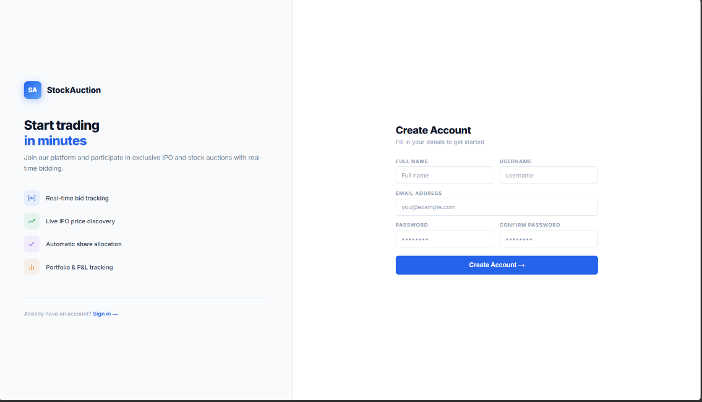

Screen Shot 2: Registration Page

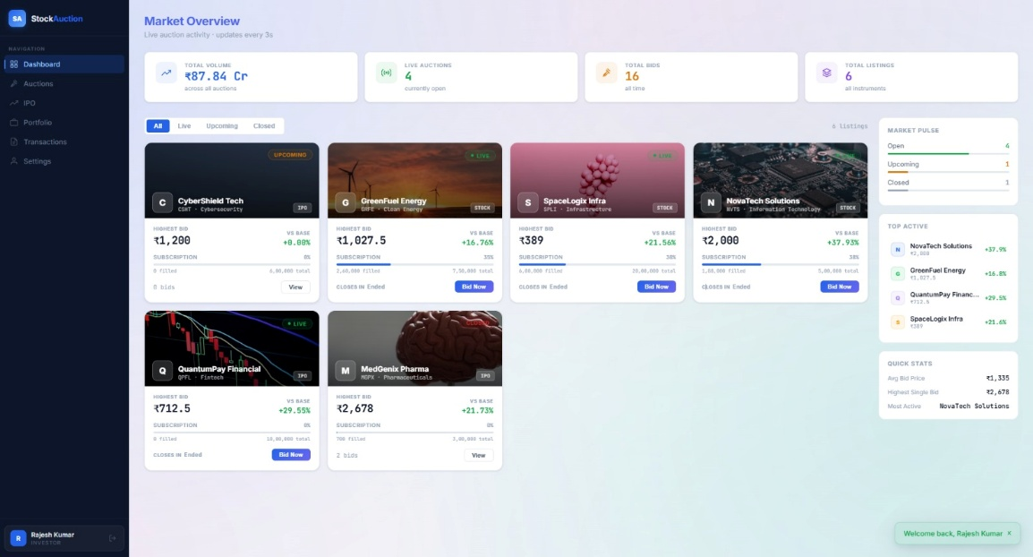

Screen Shot 3: Dashboard / Market Overview

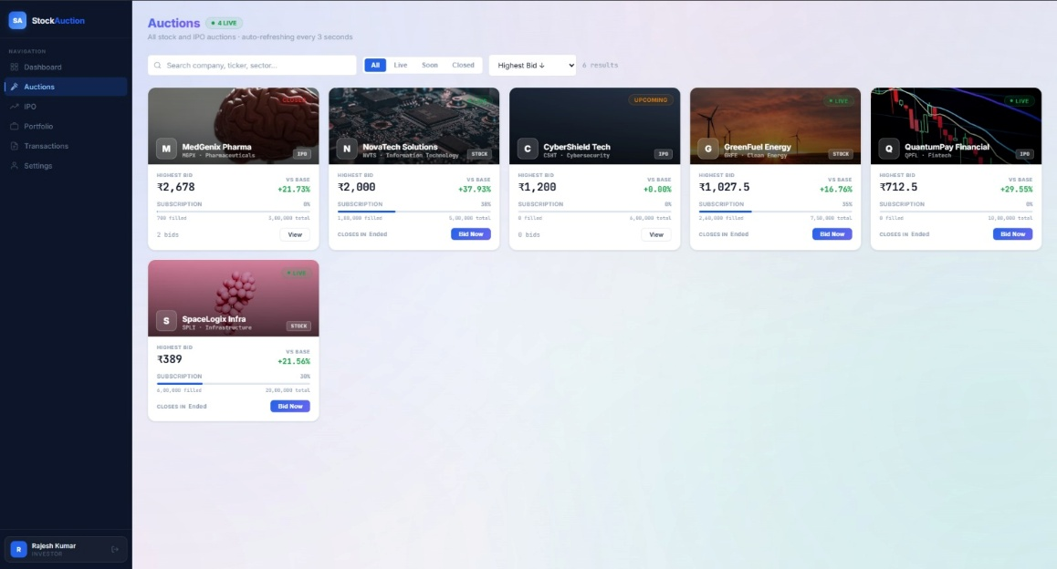

Screen Shot 4: Auctions Page

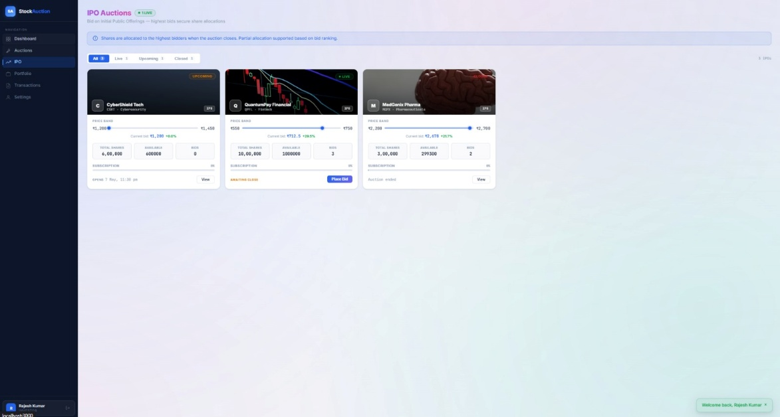

Screen Shot 5: IPO Auctions Page

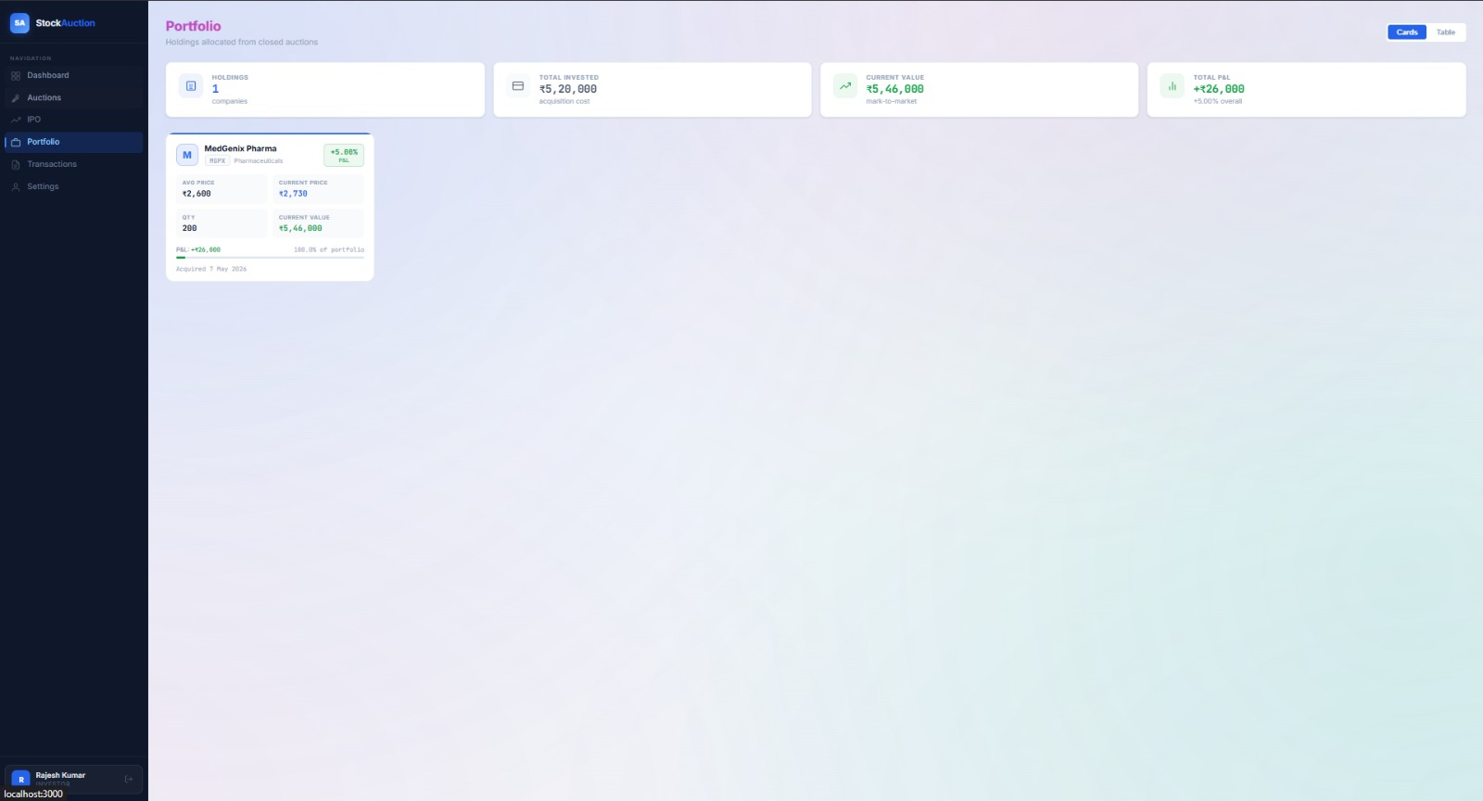

Screen Shot 6: Portfolio Page

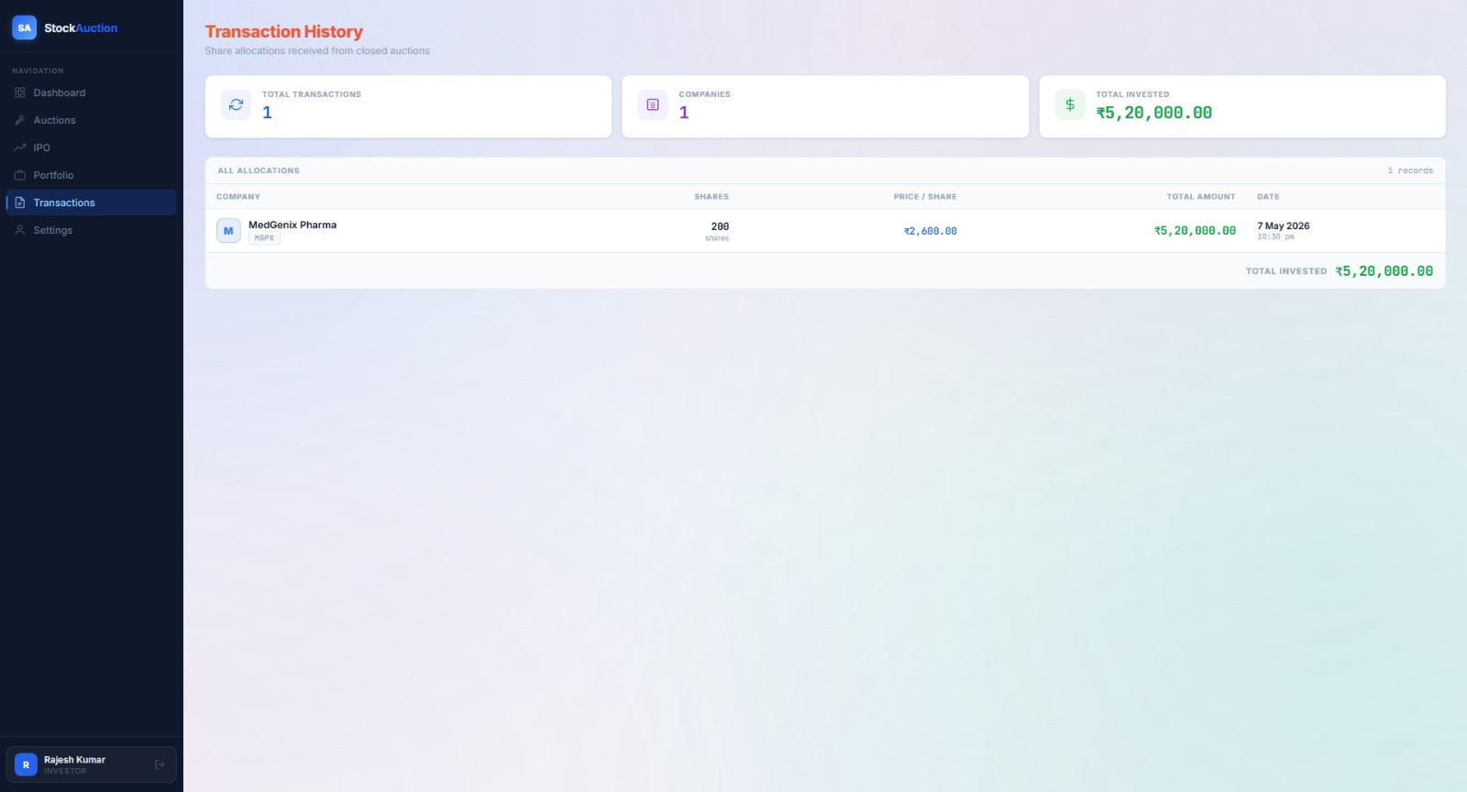

Screen Shot 7: Transaction History Page

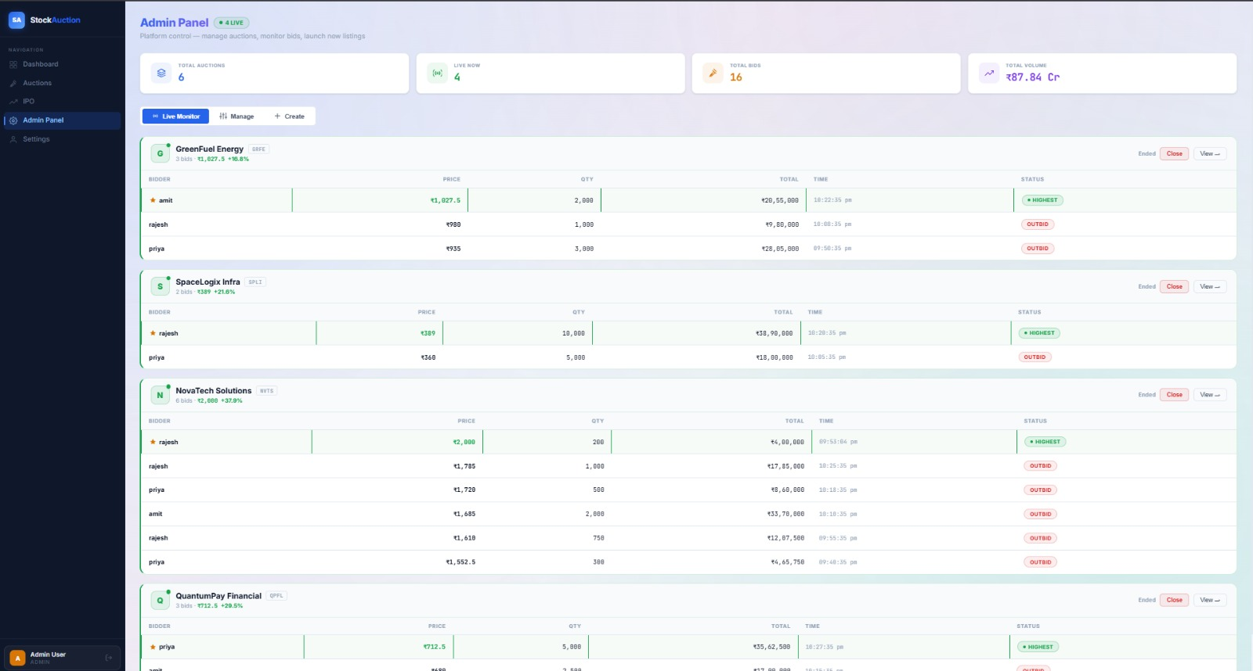

Screen Shot 8: Admin Panel Page

CONCLUSION AND FUTURE ENHANCEMENT

Conclusion

The Auction Based Securities Allocation Platform successfully demonstrates the practical implementation of Database Management System concepts through a real-time stock and IPO auction environment. The project provides a secure and efficient platform where investors can participate in auctions, place bids, monitor live market activity, and manage their portfolios. Administrators can create and manage auctions, monitor bidding activity, and control the allocation process through a dedicated admin panel.

The system is developed using React.js for frontend development, Node.js and Express.js for backend processing, and PostgreSQL/MySQL for database management. Important DBMS concepts such as normalization, relational schema design, constraints, indexing, transactions, and referential integrity are implemented to ensure proper data organization and efficient system performance. REST APIs are used for communication between frontend and backend modules, while authentication and validation techniques help maintain security and reliability.

The project successfully achieves its objectives by providing real-time auction management, automated share allocation, transaction tracking, and portfolio management within a user-friendly interface. The application also demonstrates efficient integration of frontend technologies, backend services, and relational databases. Overall, the project provides a practical understanding of database-driven web application development and highlights the importance of DBMS concepts in real-world financial systems.

Future Enhancement

The Auction Based Securities Allocation Platform can be enhanced further by integrating advanced technologies and additional features to improve functionality and user experience. Real-time WebSocket communication can be implemented to provide instant bid updates and live auction notifications without page refresh. Advanced stock market analytics and graphical representations can also be added to help users analyze bidding trends and investment performance more effectively.

The system can be integrated with real-time stock market APIs to support live market data and actual IPO information. Features such as email notifications, SMS alerts, and two-factor authentication can be implemented to improve security and user communication. Mobile application support can also be added to allow users to participate in auctions using smartphones and tablets.

Future versions of the platform may include AI-based bid prediction systems, automated recommendation features, and advanced portfolio analysis tools. Cloud deployment and Docker containerization can also be implemented to improve scalability, performance, and deployment efficiency. These enhancements will make the platform more powerful, secure, and suitable for handling larger real-world auction environments.

REFERENCES

- Silberschatz, Abraham, Henry F. Korth, and S. Sudarshan. “Database System Concepts.” McGraw-Hill Education.

- Elmasri, Ramez, and Shamkant B. Navathe. “Fundamentals of Database Systems.” Pearson Education.

- PostgreSQL Official Documentation. Available at: https://www.postgresql.org/docs/

- MySQL Official Documentation. Available at: https://dev.mysql.com/doc/

- React.js Official Documentation. Available at: https://react.dev/

- Node.js Official Documentation. Available at: https://nodejs.org/en/docs

- Express.js Official Documentation. Available at: https://expressjs.com/

- REST API Design Best Practices. Available at: https://restfulapi.net/

- JWT Authentication Documentation. Available at: https://jwt.io/

- MDN Web Docs – JavaScript Guide. Available at: https://developer.mozilla.org/

- GeeksforGeeks – Database Management System Tutorials. Available at:

- https://www.geeksforgeeks.org/dbms/

- W3Schools Web Development Tutorials. Available at: https://www.w3schools.com/

- IBM Knowledge Center – Relational Database Concepts. Available at:

- https://www.ibm.com/docs/

- Oracle Database Documentation. Available at: https://docs.oracle.com/en/database/

- Research Papers on Online Auction Systems and Stock Market Management Systems from IEEE Xplore and Google Scholar.

