**UNIVERSITY OF CAMBRIDGE**

**DEPARTMENT OF BIOCHEMISTRY**

DOWNING SITE TENNIS COURT ROAD CAMBRIDGE CB2 1QW UK

CHRISTOPHER HOWE ScD *Professor of Plant and Microbial Biochemistry*

*Direct line* 01223-333688 *Fax* 01223-333345

*Email*  c.j.howe@bioc.cam.ac.uk

9.ii.24

Dear Editor,

We are submitting our manuscript entitled *"Fourfold increase in photocurrent generation of Synechocystis sp. PCC 6803 by exopolysaccharide deprivation"* to be considered for publication as an Article in *Nature Communications.* It provides a significant development in the use of photosynthetic microorganisms for direct electricity production (a literally ‘green’ technology).

There is great excitement at the moment about this ‘Biophotovoltaic’ (BPV) technology, in which electric current is harvested directly from photosynthetic microorganisms (e.g. cyanobacteria) and used to power small electronic devices, such as microprocessors (e.g. Powering a microprocessor by photosynthesis. *Energy & Environmental Science* (2022) 15:2529 <https://www.smithsonianmag.com/smart-news/researchers-use-algae-to-power-computer-for-months-180980100/> ). In effect, these devices are biological solar cells. However, in spite of the exciting potential of this environmentally-friendly technology, we know little about the mechanism of electron output from the cyanobacterial cells. We also need to find ways to increase the output.

Much of the attention on increasing the power output has been directed to using mutant cyanobacterial strains, e.g. *Nature Communications* 13:3067, which described the use of a strain lacking a full outer membrane. However, the mutations used also generally reduce strain viability.

We report here that a cyanobacterial strain unable to produce external polysaccharide provides a four-fold increase in light-dependent current compared to wild type. This increase is due partly to better adherence of mutant cells to the electrode and partly to inherently better current output. Importantly, this strain grows normally under standard conditions. This increase in current is a major step towards achieving the output needed from BPVs that will make them competitive in ’real-world’ applications.

Our paper also shows that extracellular electron transfer in cyanobacteria does not depend on the polysaccharide matrix (as a ‘direct’ route), and demonstrates that transfer depends on a diffusible exogenous mediator (an ‘indirect’ route). This will also greatly help further work to enhance current output, for example in enhancing the production of the exogenous mediator.

Our work will therefore be of great interest to a wide readership, including those working on microbial electricity production (part of a research ‘Spotlight’ recently identified by the UK’s BBSRC), renewable energy generation, photosynthesis, and plant and microbial physiology more broadly. We therefore believe it is particularly appropriate for the wide readership of *Nature Communications*.

We confirm that the article is original and not under consideration for publication by another journal. The results presented in this manuscript are new and have not been published by any of the authors in some other journal. The stated authors have written the article, and all authors have approved the manuscript and agreed with submission to *Nature Communications*. The authors have no conflict of interest to declare. If accepted, the article will not be published elsewhere in the same form, in any language, without the written consent of the publisher. We have not discussed this with you or your colleagues before submission.

We suggest the following people as qualified scientific reviewers:

Professor Yin Li ([yli@im.ac.cn](mailto:yli@im.ac.cn))

CAS Key Laboratory of Microbial Physiological and Metabolic Engineering, State Key Laboratory of Microbial Resources, Institute of Microbiology, Chinese Academy of Sciences, Beijing, China

Dr Bin Lai ([bin.lai@ufz.de](mailto:bin.lai@ufz.de))

**Biophotovoltaics** Working Group, Helmholtz Centre for Environmental Research – UFZ, Leipzig, Germany

Professor Julea Butt (J.Butt@uea.ac.uk)

School of Chemistry, University of East Anglia, United Kingdom

​

Dr Guy Hanke ([g.hanke@qmul.ac.uk](mailto:g.hanke@qmul.ac.uk))

School of Biological and Behavioural Sciences, Queen Mary University of London, London, United Kingdom

Dr Szilvia Tóth ([toth.szilviazita@brc.hu](mailto:toth.szilviazita@brc.hu))

Institute of Plant Biology, HUN-REN Biological Research Centre, Szeged, Temesvári krt. 62, H-6726 Szeged, Hungary

We ask you not to send it to Professor [Shuji Nakanishi](https://www.nature.com/articles/s41467-022-30764-z#auth-Shuji-Nakanishi-Aff1-Aff3-Aff5)  (Innovative Catalysis Science Division, Institute for Open and Transdisciplinary Research Initiatives (ICS-OTRI), Osaka University, Suita, Osaka, Japan) or Drs Seiji Kojima and Yasuaki Okumura (Panasonic Holdings Corp, Kyoto) to avoid possible conflict of interest.

Yours sincerely,

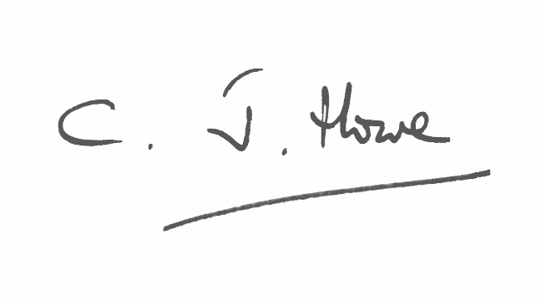

Prof Christopher Howe

Dept of Biochemistry

University of Cambridge, UK

& Stellenbosch Institute for Advanced Study

Stellenbosch University, South Africa

ch26@cam.ac.uk

+44-7801-491797