**CRYO-EM**

* How is an image formed ?
* How do you get 3D from many 2D images ?
* Why is it hard to achieve atomic resolution ?
* How do we assess resolution in cryoEM ?
* What advancements have led to the current “resolution revolution”?

1933: The first transmission electron microscope (TEM)

Transmission vs Scanning Electron Microscopy. (we are going to talk about TEM)

TEM: get the entire structural information clapped down from 2D image (gives projection images through sample) (SEM gives surface images of sample)

EM is just like light microscope, instead of having a lamp we have an electron source. Electrons are focused by an electron lens; electrons are then scattered.

Condenser lenses focus beam on specimen, objective lens focus on specimen and magnify, projector lenses magnify image.

Electrons have smaller wavelength than photons, resolution is much higher, plus they interact strongly with matter. Using electrons, we can detect a single protein complex. Electrons are charged 🡪 ionising radiation, strong interaction with matter.

Lens aberration starts to become the limiting factor for resolution.

Diffraction is what limits the resolution of an imaging system.

Wavelength of visible light is 400-700 nm. Assuming a perfect lens, resolution limited to 200 nm.

The wavelength of electrons at 200 kV is 0.0025 nm.

Resolution🡪 point spread function. If point has broad spread function, broad peak. If point spread function gets narrower 🡪 get more tightly defined Gaussian for that point and the point spread function is defined as the shorter the wavelength, the narrower the spread function 🡪 if broad function not able to resolve two points. If you narrow point spread function you can start to resolve two points. With electrons you have the chance to resolver very small samples.

Electron source is produced by electron gun. Electron source can be thermionic 8structure that is heated up and upon heating and current emits electron, low coherence, low resolution).

Electron gun can be “field emission” type produces highest coherent electron beam. Monomolecular sharp tip to it, highest resolution. All Cryo-EM now use FEG for highest possible quality images at the end.

Three things can happen to an electron

1. Electron passes unscattered through an atom (most electrons just pass straight)
2. Electron cam be slingshot around the nucleus of the atom; electron here is thought as a particle. Electron changes direction but not loses any energy. This is good for cryo-EM. This is only 25 % of scattering event
3. Electrons interact with orbital electrons (75%). Electrons lose their energy, specimen damage by the depositing electron, break covalent bond and cause physical damage. Reduction of energy contributes incoherently to imaging formation 8adds noise) and also damages sample. Bad for cryo-EM

The microscope column is under high vacuum to prevent unwanted electron scattering (with gas molecules in the air)

Instead of using glass lenses (because are matter and electrons interact with matter) but we use electromagnet. Electromagnetic fields can be used as electron lenses. Electrons enter the electromagnetic field and starts spiralling and different electrons are focused to a single point (focusing 🡪 magnifying)

Electromagnetic fields produce by copper wires can cause distortion the “contrast transfer function). This CTF however can be mathematically corrected. In visible light microscopy, phase contrast adds an additional phase shift to the unscattered beam. Much higher contrast in the specimen.

Electron lens imperfections mean that defocusing the objective lens gives phase contrast

The objective lens is used led for defocusing

Defocusing provides contrast

Phase contrast is the result of constructive and destructive interference patterns of scattered electron waves

Summary:

* The gun and condenser lens creates a coherent electron beam
* Electrons are scattered by the sample (object plane)
* Objective lens focuses these scattered electrons
* Scattered electrons are also subjected to additional phase shift derived from imperfections in objective lens (CTF)
* Electrons are then focused in the image plane to create the 2D projections of the sample
* Image is then further magnified by the projector system

**Sample Preparation and Tomography**

Sample requirements:

need a big thing, you need big enough to scatter enough electrons to get an image

Size: 150 kDa +

Purity: homogenous, but different conformations ca be purified in silico

Volume: 3 ul/grid

Concentration: 0.01-1 mg/ml

Sample state: can be relatively native, e.g. membrane proteins in detergent

Specimens are introduced into the microscope on electron microscopy grid.

Plasma treatment makes grids hydrophilic (ionises the surface of carbon 🡪 makes the support film hydrophilic)

Deposit the sample into the glow discharged hydrophilic support grid

Sample is frozen very rapidly so water molecules do not have time to rearrange, no disruption of biological specimen.

Frozen grid then is put under the microscope (cryo transfer holder)

Grids are then inserted into the high-vacuum column via an airlock

Once in the microscope, imaging the cryo-preserved specimen reveals it in its native state

Advantages

* Preserved in a near native/hydrated state
* Preserved high resolution information

Disadvantages

* Radiation sensitive
* Low signal-to-noise
* Slow to screen samples
* Easy to contaminate

Ice contamination is easy: take something frozen and wave around in the air, every water molecule will come into contact over the top of specimen 🡪 really careful not to expose specimen in the atmosphere of the room.

**Data Collection**

Lenses refocus elastically scattered electrons 🡪 provide data for imaging process.

Electron dose must be carefully controlled; inelastically scattered electrons contribute to radiation damage. Radiation damage can be seen in the inability to resolve the central channel of TMV (virus particle)

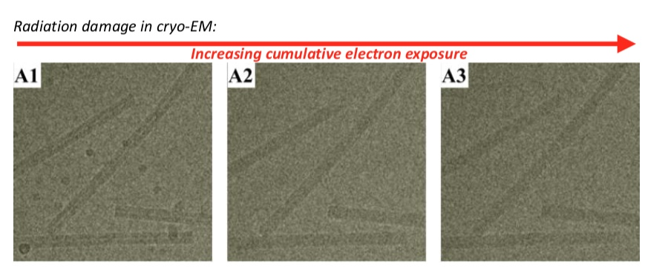

Minimizing radiation damage: “Low dose imaging”

The low dose philosophy lends itself to automated data collection

**Using tomography to get 3D structure from 2D images**

Tilt the specimen at different angles and take lots of images. Each frame is 2D image. Use 10nm gold beads and track them to work out the geometry in 3D space. How the 2D images relate to each other 🡪 by tracking the gold beads, fixed.

*E. coli* is 1 micron thick 🡪 is too thick for cryo-EM.

For thick samples, inelastic scattering becomes too predominant. So if we can filter out inelastically scattered electrons to give amplitude contrast.

**Tomography as a cell biology tool** 🡪 can uniquely visualise molecular cell biology (just one bacterium for example)

* Imaging *Chlamydia* infection, can see the molecular details of the infection process, machinery of pathogenesis
* Thick eukaryotic cells can be sectioned for tomography: focused ion beam milling

**Tomography in Structural Biology**

The resolution revolution applies equally to subtomogram averaging

**Single Particle Analysis: 3D structure from 2D images and the “Resolution Revolution”**

Goal of single particle analysis:

From 10000’s of images of single particle to one 3D structure of high resolution

First challenge is to work out the relative orientation of single particle so that we can recompose to give 3D images.

Second challenge is to extrapolate 3D structure form images

**Workflow:**

1. Collect images

Take image and move to next area, no tilting. Take lots of images.

1. Correct CTF

The objective lens aberrations affect contrast at different resolutions differently: the “contrast Transfer Function”

Correct it with mathematical cartoon representation; central for having high resolution details

1. Pick particles

Manualy pick at first (small dataset), then use them as template to auto pick (computing); manual curation to get rid of false positives. Automated picking after setting a training set.

1. Classify particles

Determine 2D orientation; orientations are defined by rotations and translations of the object to superimpose those particles (we don’t know a priori)

Noisy low contrast images make determining orientations problematic. Then need to make class averages, to clarify signal, all aligned particles in a class are averaged.

1. Obtain an initial model

Need to go from 2D to 3D. Model from the PDB or modelling (remove high resolution features). The initial model could be taken from model PDB (from crystal structure=, to give first hint of the relative orientation). Alternatively, can determine structure orientation ab initio (using fourier transforms and other mathematical tools).

1. Determine orientation by “projection matching”

Find orientation of class averages by matching them to the starting model

1. Reconstruct the 3D model from oriented 2D class averages

Our 2D projections can be back-projected to achieve a 3D structure

The oriented 2D class averages can now be back projected to make a new 3D model based on our data.

1. 3D classification to identify heterogeneity

Take the structure and do 3D classification. Differences between the data sets, start separating out different sample populations

Iterate back to classification

1. Structural validation

Is the structure accurate?