**FPGA Board Memory Game**

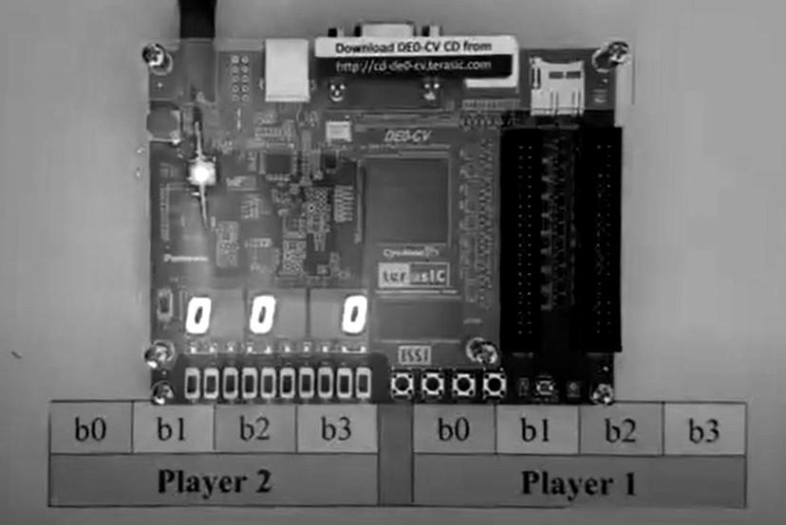

**User Manual**

**Created by the Lil Engineers**

|  |
| --- |
| **Table of Contents** |

|  |  |
| --- | --- |
| Description of System | 3 |
| FPGA Board Labeled Image | 5 |
| Step-by-Step Instructions for Authentication | 6 |
| Step-by-Step Instructions for Game | 8 |

|  |
| --- |
| **Description of System** |

The following FPGA Board will be used to play the memory game. This user manual will simplify your experience so that you can begin playing the memory game without any confusion. The game involves one player so the player will be assigned one set of toggle switches to enter their user ID and password and another set of toggle switches to play the memory game. After some initial security authentication, the player will be able to configure their board and start the memory game.

The game is accessible to 6 players with the use of a user ID and password and to a guest with a different set of rules. In order to get the game started the user will use one of the following IDs and corresponding password.

|  |  |  |
| --- | --- | --- |
| **User** | **User ID** | **Password** |
| Andrew | 8-9-2-6 | 1-2-3-4-5-6 |
| Faiza | 4-4-5-3 | A-B-C-D-E-F |
| Sayra | 7-6-0-7 | E-F-1-2-1-2 |
| Mohammed | 6-0-9-2 | 8-9-A-B-C-D |
| Sinan | 2-8-1-6 | 1-2-A-B-C-D |

The 4 digit user ID and 6 digit password is entered value by value using the password toggle switches and password load button. If the passcode is entered correctly the logged-off LED will turn off and the logged-in LED will turn on.’

Once this initial step is completed the user is ready to begin configuring their game. The player will configure the time each round will last, the speed at which the sequence will be displayed and the level they want to play in. This will be done in the same way for all three settings. The user will use the incrementing or decrementing button to change the timer by increments of 10. The configuration will be locked in using the transition between state button. This will trigger the next configuration to be displayed and the following 2 configurations will also be set using the incrementing, decrementing and the transition between state button.

Once the configuration is set up the player will be put on standby mode that so that the user can start the game when they are ready with the press of the game start button. The player begins the game by pressing the game start button, this will trigger the game to start. The user will then press the RNG button to begin loading and displaying the random sequence on the display screen. The user will then use their toggle switches and player load button to set each value of the sequence they just saw and memorized. An LED will let the user know if they entered the correct number. This will then give the user the ability to load another sequence if their timer hasn’t run out.Once the timer runs out of time the game will enter the game over state which will display the score for the round played and the global or high score on the last screen.

|  |
| --- |
| **FPGA Board Labeled Image** |

The following image will show the segments of the FPGA board that will be used to authenticate and play the memory game.

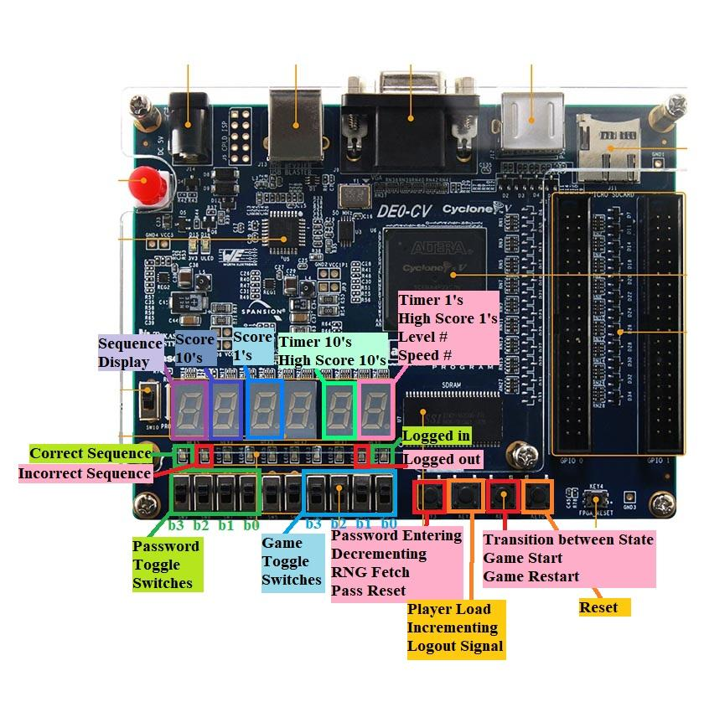

|  |
| --- |
| **Step-by-Step Instructions for Authentication** |

In order to facilitate the user experience in authenticating the player, we will include step-by-step instructions on how to log in to your board so that you can begin playing your game. The board will be authenticated using a specific ID and password for 6 users and the login instruction for guests will be explained in the last step.

**Authenticating your Board:**

1. First, the user must find their name and input their four-digit ID. The users are as follows:
   1. Andrew: 8-9-2-6
   2. Faiza: 4-4-5-3
   3. Sayra: 7-6-0-7
   4. Mohammed: 6-0-9-2
   5. Sinan: 2-8-1-6
2. Next the user will input their user ID one digit at a time by using the four left most toggle switches (Password Switches) to set a value and then using Button 1 (Password Entering Button) to load that value.
   1. The user will set the password toggle switches to the **first number of the user ID**, and then click the password entering button.
   2. Then the user will set the password toggle switches to the **second number of the user ID**, and then click the password entering button.
   3. The user will set the password toggle switches to the **third number of the user ID**, and then click the password entering button.
   4. The user will set the password toggle switches to the **fourth number of the user ID**, and then click the password entering button.
3. The user ID should be locked in and the user can then begin entering the password for the corresponding user:
   1. Andrew: 1-2-3-4-5-6
   2. Faiza: A-B-C-D-E-F
   3. Sayra: E-F-1-2-1-2
   4. Mohammed: 8-9-A-B-C-D
   5. Sinan: 1-2-A-B-C-D
4. Next, the user will input their password one digit at a time by using the four left most toggle switches (Password Switches) to set a value and then using Button 1 (Password Entering Button) to load that value.
   1. The user will set the password toggle switches to the **first value of their password**, and then click the password entering button.
   2. Then the user will set the password toggle switches to the **second value of their password**, and then click the password entering button.
   3. The user will set the password toggle switches to the **third value of their password**, and then click the password entering button.
   4. The user will set the password toggle switches to the **fourth value of their password**, and then click the password entering button.
   5. The user will set the password toggle switches to the **fifth value of their password**, and then click the password entering button.
   6. Then the user will set the password toggle switches to the **sixth value of their password**, and then click the password entering button.
5. If the user entered their user ID and password correctly the logged-out LED will turn off and the logged-in LED will turn on.
6. The user has logged into the board and is ready to begin the game. Move to the following section to learn how to play the game.
   1. At any point in the game, the user can click the reset button, which will log the user out of the board, and clear the displays.
7. A guest can login into the board by entering the user ID and password incorrectly 3 times. Considering the fact that the user ID is 4 digits and the password is 6 digits, that would include 30 incorrect values.
   1. To facilitate this the user will set the password toggle switches to the value ‘F’ and then press the password load button 30 times.
   2. the logged-out LED will turn off and the logged-in LED will turn on
   3. The guest is ready to begin their game

|  |
| --- |
| **Step-by-Step Instructions for Game** |

The game can be played with one player where the player attempts to memorize the displayed random sequence and then enter those values correctly with their toggle switches and load button within the allotted time.

**One Round**

1. The player begins by configuring the time, speed, and level:
   1. The user will first reconfigure the time by using the incrementing or decrementing button which will change the time by 10 seconds, using the corresponding incrementing or decrementing button.(Then they will load the value with the third button (transition between states))
   2. The user will then reconfigure the speed of the flashed sequence by using the incrementing or decrementing button which will change the speed by 0.5 seconds. (Then they will load the value with the third button (transition between states))
      1. Speed 1 - 1.5 seconds per flash
      2. Speed 2 - 1.0 seconds per flash
      3. Speed 3 - 0.5 seconds per flash
   3. The user will then reconfigure the level of the game by using the incrementing or decrementing button which will change the sequence length and score multiplier. (Then they will load the value with the third button (transition between states))
      1. Level 1: Sequence Length of 3 and Score Multiplier x 1
      2. Level 2: Sequence Length of 4 and Score Multiplier x 3
      3. Level 3: Sequence Length of 5 and Score Multiplier x 5
2. The player has now configured the time, speed and level so the game will enter the standby state until the player presses the game start button (button 3).
   1. This will trigger the game to start
   2. The timer will start counting down from the configured time.
   3. The player load and RNG button are functional.
3. The user will press the RNG button to load the random sequence before they can begin entering the sequence with their toggle switches.
4. Once the sequence has been fully displayed the player can then input the sequence with the game toggle switches and load button.
5. Once the user has finished entering their sequence the correct/incorrect sequence LED will flash on, indicating whether or not the sequence has been entered correctly.
6. Now a new RNG sequence can be generated with the RNG button (button 1).